

Title: Trauma, Adverse Childhood Experiences and Policing: Police Perceptions and Responses to Children in Care
Student name: Matthew Coakley
Student number: 1922398
Degree: BSc Professional Policing Practice
Institution: University of Wales Trinity Saint David (UWTSD) Date of submission: June 2026

Word count:6872 (*minus proposal and ethics form)
Acknowledgements
I want to thank my supervisors, colleagues and family for their support and guidance throughout this project. I want to thank my partner, Emma, for her continued support, and my children for pushing me to better myself and teaching me the art of patience. Special thanks to the officers and staff who completed the survey and to the care-experienced young people and practitioners whose insights informed this research.
Declaration
- Declaration: This work has not previously been accepted in substance for any degree and is not being concurrently submitted in candidature for any degree. Signed. COAKLEY date 29/06/2026
- Statement 1: This dissertation is submitted in partial fulfilment of the requirements for the degree of BSc.Signed. COAKLEY date 29/06/2026
- Statement 2: This dissertation is the result of my own independent work/investigation, except where otherwise stated. Other sources are acknowledged, and a bibliography is appended. Signed. COAKLEY date 29/06/2026
- Statement 3: I give consent for my dissertation, if accepted, to be available for photocopying and interlibrary loan, and for the title and summary to be made available to outside organizations. Signed. COAKLEY date 29/06/2026
- Statement 4: I give consent for my dissertation, if accepted, to be available on the university’s IT system to those who have access. Signed. COAKLEY date 29/06/2026

Abstract

This dissertation examines how adverse childhood experiences (ACE’s) can shape behavioral outcomes with children in care and how police perceptions can influence responses during contact with these children. Drawing on a cross-sectional survey of frontline officers and a review of trauma-informed policing literature, the study seeks to identify widespread conceptual awareness of adverse childhood experiences (ACEs) alongside practical readiness to apply trauma-informed approaches in the job role. Findings indicate that short, non-routine training increases awareness but does not reliably change practice; multimodal, recurrent training, combined with clear interagency referral pathways and supervisory support, is associated with greater procedural confidence and welfare-oriented decision-making. The dissertation argues that sustainable change requires organisational recalibration—implementing trauma-informed practice into protocols, performance metrics and interagency co-response models. Recommendations include mandatory refresher training, designated youth liaison roles, fair and inclusive practice, and mixed-method evaluation of new programmes to ensure they work well and can be expanded.

Table of Contents

Acknowledgements
Declaration
Abstract
Table of Contents

Chapter 1: Introduction .................................................................................................3
1.1 Background...............................................................................................................4
1.2 Aims and objectives ..................................................................................................4
Chapter 2: Literature review ......................................................................................... 4
2.1 Prevalence and definitions of ACE’s………………………………………………………………….4
2.2 Neurobiological impacts of ACE’s…………………………………………………….………………5
Chapter 3: Methodology ............................................................................................. 10
Chapter 4: Analysis of survey results ............................................................................ 13
Chapter 5: Conclusion……………………………… .............................................................. 16
Recommendations…………………… ……………………………………………………..………………..20
References ................................................................................................................. 20
Appendices ................................................................................................................. 23

Chapter 1 – Introduction

Adverse childhood experiences (ACEs) are as critical in determining lifelong health, behaviour and impacting social outcomes, with a lot of evidence-based household dysfunction, neglect, elevated risks of mental health, substance misuse and criminal offending in adulthood (Felitti et al., 1998; Anda & Felitti, 2010). More frequently, I will be coming as the first statutory responders, which can place frontline policing. A centre of public safety and child welfare for developing interventions that can both protect and reduce secondary harm to vulnerable individuals (Sweeney et al., 2016; Goodall et al., 2023).
Research demonstrates that ACEs are associated with developmental disruptions, including emotion regulation, attachment difficulties, executive functioning deficits, and conduct problems, as well as involvement in antisocial behaviour (Felitti et al., 1998; NHS England, 2019). They are frequently interpreted as criminal, logical, or disciplinary through professional practitioners' lenses, which can lead to more containment-focused responses adopting a welfare-oriented intervention. The emerging literature on trauma-informed policing to de-escalate encounters and facilitate diversion supports better, more informed safeguarding decisions and services (Bateson et al., 2019; Scott & Graham, 2020).
And the implementation of a more trauma-informed approach in policing. Despite ever-growing policy interest, this remains variable. Evaluations of Aces and self-reported attitudes among officers have indicated an improvement in awareness but also identified persistent gaps in the use of interagency pathways, which are necessary to translate knowledge into practice (Public Health Wales, 2020; Quigg et al., 2025). Studies have highlighted the risk of superficial uptake - Where aces are and can become a checklist rather than being a more comprehensive practise framework - This poses the risk of misapplication or unintended consequences accompanied by systemic supports such as supervised and clear, easy-to-use referral mechanisms, and leadership endorsement (Bateson et al., 2019; ADPH, 2021).
Police perceptions of children in care or children who experience care should warrant particular attention because they are disproportionately present with histories of multiple aspects of social exclusion and poor outcomes (Goodall et al., 2023). Literature emphasises that police officers - whether deficit - or trauma-focused – can shape discretionary decisions, custody, the use of arrest, and referral, with important implications for the immediate safety and long-term trajectories of that person (Scott & Graham, 2020). That implements a bigger policy shift, curricula the current training operational protocols so that more welfare-oriented responses are measurable and sustainable
This dissertation will include a survey of police personnel as part of this evidence base. This will explore the levels of ACE awareness in scenarios involving children in care. It examines the gap between conceptual recognition of ACEs and practical readiness to act and assesses how the use of interagency structures enables or constrains trauma-informed responses. The subsequent chapters will seek to use contemporary scholarship to reform policy, using supervision and evaluation with a model aimed at aligning approaches to the needs of 2 aces and young people who have experienced care.

Chapter 2 – Literature Review
2.1 Prevalence and definitions of ACE’s
With so many children in care or looked after children (LAC) that have been placed outside of their birth families, this can be due to several factors, such as neglect, abuse or many other factors; they are seen as one of the most vulnerable groups within a society. There is a lot of research showing that these children are at a much higher risk of developing mental health disorders, which may, in turn, lead to criminal behaviour or criminal involvement, leading to less favourable outcomes when reaching adulthood. There is a lot of evidence to show that adverse childhood experiences (ACE’s) can be in many forms, such as neglect, abuse, and witnessing incarceration during childhood. This literature review will show and examine how ACE can contribute to the criminalisation of a child who has experienced foster care as they go into adulthood. This will focus on the psychological and social mechanisms that may be involved.
Statistics show that children in care in the UK are disproportionately affected by multiple adverse childhood experiences (ACE’s). ACEs are broken down into 10 types, of which are Abuse- physical, emotional and sexual abuse. Neglect – physical and emotional. Household challenges – mental illness, intimate partner violence, parental separation or divorce, incarceration and substance misuse or dependence. Centre on the Developing Child at Harvard University (2018)
Research indicates that approximately 69% of looked-after children have experienced neglect, 48% physical abuse, 37% emotional abuse, and 23% sexual abuse. These experiences can have lasting effects on their development and well-being. CCATS (2025) shows that LACs with ACEs are in the majority. This can be explained by the fact that there must have been a significant reason that social services felt that a child needed to be placed within the local authority's care rather than to stay with their biological parents.
2.2 Neurobiological impacts of ACE’s
Research on ACEs includes studies on the neurobiological impact this may have on someone who has experienced ACEs. There is evidence that these sorts of experiences can disrupt normal brain development in a child; the main areas affected are emotional regulation, decision-making, and impulse control. The chronic stress associated with an ACE can lead to these alterations, which affect brain structure, specifically the prefrontal cortex and the amygdala. These parts of the brain play a key role in controlling aggression, emotions and impulses. Smith, K.E., and Pollak, S.D (2020) explain how:
"Early life stress has persistent and pervasive effects on prefrontal–hypothalamic–amygdala and dopaminergic circuits that are at least partially mediated by alterations in hypothalamic–pituitary–adrenal axis function."
This brain effect, due to neurobiological changes, can lead individuals to make choices that lead them to engage in criminal behaviours as an adaptive way of coping.
Many children who have experienced ACE can often develop insecure attachment styles, which can lead to many difficulties in forming a healthy relationship. Holmes, J. (1993) states that:
"An insecurely attached child may view the world as a dangerous place in which other people are to be treated with great caution, and see himself as ineffective and unworthy of love”
This affects their ability to manage their emotions due to these attachments, which can lead to a disorder in how they conduct themselves. These disorders can be anxiety, depression, and in many cases, substance abuse, which can start during childhood and lead to adulthood. Due to the challenges that these children face, they are more likely to become involved in criminal activities as a coping mechanism, to take some control of their lives, to gain acceptance from others, and through substance misuse.
Also, social and environmental factors may play a part in this. There can be a lot of instability within the care system, or for someone currently in it or who has been through it. Some aspects that might cause instability for somebody within the care system can be changes within their placement, such as where they live or whom they live with, or they may have different support workers or social workers during their time in care, leading to inconsistency. Children in care may become victims of institutional abuse due to living in care homes with multiple children. A child in care may be placed with multiple foster carers with whom they may form an attachment, and for some reason, this attachment breaks down, with no fault of the child. Reasons may include a bereavement within the foster family, medical conditions of the foster carers, or a change in job choices.
Due to these unstable factors, the development of trust in others and the formation of social bonds may be disrupted; these are protective factors that can prevent someone from engaging in criminal behaviour. Children in care also face additional obstacles, such as stigma surrounding predisposition as a child in care and discrimination. This can lead the child to feel that they are excluded from normal social interactions and social acceptance, which can then increase their risk of becoming criminals or performing acts of criminality. Rogers, J. (2017) echoes this correlation, stating that:
"Children in foster care often experience social stigma, which can lead to feelings of isolation and lower self-esteem. Managing this stigma requires strong peer support and positive relationships."
This stigma can affect how they are perceived in society by civilians and law enforcement. Police officers may have an unconscious bias towards children or adults who have grown up in care. Some may feel that it is inevitable that these children/adults are troubled and will only be a burden upon society.
The link between childhood trauma and becoming an adult criminal or an adult who shows criminal behaviour can be very complex. The life course theory shows and provides a framework for understanding how this may progress. The life course theory proposes that having a negative experience while young can set a path towards criminal behaviour.
"Childhood adversity, including neglect and abuse, can set individuals on a trajectory toward criminal behaviour by disrupting social bonds and increasing exposure to risk factors. However, turning points such as stable employment or positive relationships can alter this path." (Sampson, R. J. and Laub, J.H. 1993).
The social learning theory suggests that experiencing these antisocial behaviours in childhood can increase the likelihood of adopting similar behaviours as adults.
"Learning would be exceedingly laborious if people had to rely solely on the effects of their own actions to inform them what to do. Instead, most human behaviour is learned observationally through modelling: from observing others, one forms an idea of how new behaviours are performed." — Bandura (1977).
This shows that what a child sees or is subjected to can become what they think is the right thing to do. They may mirror these behaviours later in life, leading to criminal actions. For example, if a child witnesses physical assaults in their domestic lives, they may go on to perform assaults on others while not understanding that this behaviour is illegal.
Another factor for LAC is that they are at a very high risk of county lines drug operations, as they appear to be a targeted group of vulnerable individuals. This has been well documented through new articles and TV shows/programs, which not only give insight into these factors for conforming members of society but also for people who will use this for their own personal gain, such as organized criminals. There are many reasons children are chosen by organized criminals to do this including their ability to control them due to size and strength, police perception of children in the hope that they will not be stopped in connection with crime and not only can they recruit/coerce these individuals they may be able also to do this to their friends as well allowing organized criminals to keep expanding the number of children they have in their control.
"County lines drug trafficking involves the exploitation of children and vulnerable adults by criminal networks, forcing them to transport and distribute drugs across different areas." — National Crime Agency (2025).
This vulnerability is not only because of their age but also because of the trauma and experiences that they have been through.
These gangs can entrap and entice these individuals into criminal activities with multiple methods. They can pray on the fact that these individuals do not have stability in life, no strong family support network that would be able to identify the signs and signals of this sort of abuse and their previous experiences with trauma and dramatic events that they have experienced during their ACE.
Research suggests that county lines groom and manipulate LAC in different ways. This is done through the promise or offer of money or other lavish gifts, providing them with protection and a false sense of security that makes the child feel as though they belong to a family/gang (National Crime Agency, 2025).
Debt bondage is also a way of trapping a child in their "workforce". Debt bondage uses fear and intimidation after forcing an individual into debt with no way out other than to do what they are told. Threatening behaviour, such as violence against that person, can also force them into doing the bidding of gang leaders and/or members (Bales, K. 2004).
With some individuals who go into supported living in care as young as 16, they are also at risk of cuckooing, which is where gang members take over an individual's home. In contrast, that person lives there and uses the home as a distribution centre for trafficking drugs and performing criminal activities. With constant presence at their home, there is very little chance that the individual can escape or get the help they need, as they are watched constantly or subject to physical and emotional assaults.
"Cuckooing, where criminals take over the homes of vulnerable individuals, including foster children, for illegal activities, is a growing concern in the UK. Recent reports indicate that 853 suspected cuckooed properties were identified between November 25 and December 1, 2024. While specific statistics on foster children affected by cuckooing are limited, looked-after children are recognised as being at heightened risk due to their vulnerability and lack of stable housing." Home office (2025).
Some statistics show that children aged 11 and above have been recruited into organised county lines operations (Home Office, 2025). Even with police targeting and cracking down on county lines, one of the big problems lies in the fact that these children do not consider themselves as "victims" due to the Manipulation and coercive control.
There is also research to suggest that the impact of ACE on criminal behaviour may vary between males and females. Some studies show that a male who has a high ACE score is more likely to engage in crimes of a violent nature, while females are prone to relationships involving domestic abuse or substance abuse.
Gender differences in the impact of childhood adversity suggest that males are more likely to exhibit externalising behaviours, such as aggression and delinquency. At the same time, females tend to develop internalising disorders, such as anxiety and depression. These pathways contribute to distinct patterns of criminal behaviour in adulthood." (Widom, C.S. 1999).
Understanding that different pathways depend on your gender can be very important for identifying and implementing an intervention. To address the criminalisation of children who have experienced care requires a delicate and Person-centered approach. Trauma-informed care practices look at and try to recognise the type of trauma that an individual has experienced and respond to these in the most appropriate way to treat and help the individuals involved (Tello, M. 2020). Policies implemented by care organisations play a significant role in supporting young individuals. Being able to provide stability within the care system by minimising changes in children's placements and ensuring that individuals have a consistent support network can help minimise the adverse effects of experiencing ACE. Invention programs implemented early on, which focus on building resilience and coping skills, play a huge part in preventing the onset of criminal behaviour. Educating children also plays a vital role in their understanding of what should and should not happen to them. Teachings about the law and socially acceptable behaviour are also very important in giving children the self-knowledge to make better-informed decisions.
In conclusion, there is substantial evidence supporting the theory that ACE can significantly increase the risk of criminal behaviour among individuals who have been in or are part of the care sector. The Neurobiological, psychological and social factors that have resulted from this early trauma can create a very complex web that predisposes those who have experienced the care sector to antisocial behaviours.
"Exposure to multiple adverse childhood experiences significantly increases the likelihood of engaging in criminal behaviour, as these experiences disrupt emotional regulation, social bonding, and impulse control." (Farrington, D.P. 2006).
Addressing these issues requires a methodical and comprehensive approach that can include trauma-informed care, policies and procedures that stabilise the care system, enable targeted interventions when needed, and are specific to those involved. With the ability to recognise and address these ACEs, society will be able to support those individuals in breaking the cycle of trauma and criminality. This research shows that many factors are at play, making the chance of an LAC becoming a law-abiding member of society very slim. The choices these individuals make later in life might be less a choice and more a learned experience. This shows that the failings of the adult may not necessarily be down to them but to others, such as parents and local authority care, which have culminated in how they act as adults.

Chapter 3 – Methodology

In this chapter, I will try to outline the quantitative methodological framework used to examine police constables' perceptions of children in care. I bought the understanding of adverse childhood experiences (ACEs)) Quantitative research is very well suited to systematically measuring attitudes and knowledge across a large sample (Bryman, 2016). This will try to provide an insight into patterns and the relationships within police in practise
research. The aims and objectives of this research are to :
- Officers' understanding and knowledge of the relevant issues and how they are relevant to policing the vulnerable youth.
- Their attitudes towards children in care.
- The relationship between officers' experience, training, and their understanding of trauma-informed approaches.
These will align with previous studies that link ACE awareness to improved law enforcement engagement with at-risk populations (Wolff et al., 2020).
Research design and approach
Adopting a positive paradigm and a deductive approach, the research tests the existence of theories (e.g., trauma-informed policing) and evaluates them using measurable data (Creswell & Creswell, 2018). A cross-sectional survey design will allow data collection at a single point in time across officer demographics, such as police constables, sergeants, and inspectors.
Quantitative methods will be selected for their objectivity and suitability for hypothesis testing (Muijs, 2011). Moreover, these are particularly useful for identifying correlations between officers' exposure to care-related cases and their level of trauma literacy.
Population and sampling strategy
The target population is active-duty officers within Gwent Police, particularly those involved in youth engagement, safeguarding, and frontline response. Stratified random sampling will ensure diverse representation across ranks, roles, and experience levels (Robson & McCartan, 2016). A sample of approximately 100 officers is anticipated, balancing feasibility and statistical power.
Data collection method
Data will be gathered via a structured online survey; this will be a cost-effective and anonymous tool suitable for sensitive topics such as ACEs and officer attitudes (Dillman et al., 2014). The survey will include closed-ended questions, Likert scales, and scenario-based items to gather not only factual knowledge but also attitudinal perspectives. Questions will be informed by validated frameworks such as the original ACEs study (Felitti et al., 1998). I am a model of trauma-informed policing (Substance Abuse and Mental Health Services Administration [SAMHSA], 2014).
Data analysis strategy
Using SPSS, the following techniques will be implemented: descriptive statistics to summarise access awareness and perceptions. Inferential tests: correlations, independent samples, t-tests, and ANOVA to explore variable relationships, and regression analysis to identify predictors of trauma-informed attitudes
These methods will align with previous research, which analyses police engagement and vulnerable populations (Quinn et al., 2022).
Theoretical lens
This study is framed by trauma-informed policing theory, social construction, and a holistic understanding of childhood vulnerability (Garbarino, 2001). ACEs are conceptualised as developmental disruptors that can shape behaviour and institutional interaction (Anda et al., 2006). Police officers' perceptions are treated not only as operational variables but also as reflections of systemic and personal biases (McLoed, 2017).
Ethical considerations: this study complies with the British Society of Criminology ethical guidelines (BSC, 2021):
- Informed consent will be obtained electronically by all those participating in the survey.
- Anonymity and GDPR compliance will be upheld throughout the survey.
- All participants may withdraw their consent to share at any time.
- Ethical approval will be secured from institutional and police governance bodies.
Limitations
Limitations include:
- social desirability bias, as police officers may underreport negative perceptions that they may have.
- Limited generalizability to all quote officers due to sample constraints.
- Absence of qualitative depth, which may potentially limit understanding or underlying attitudes - an area to be addressed in future mixed method studies, conclusion
This chapter has outlined the methodology employed to investigate police officers' perceptions of children in care and their understanding of adverse childhood experiences (ACE), deploying a vigorous quantitative approach. The structure will aim to ensure coherent alignment among research aims, theoretical framing, and data collection strategies, all of which will contribute to a robust and ethically sound inquiry into this pressing topic in contemporary policing and child welfare. By adopting this cross-sectional survey strategy grounded in a positivist paradigm, the study aims to capture objective, measurable insights into police officers' attitudes and their knowledge-level system. Using this approach will allow for the statistical evaluation of people's just laws, regardless of any prior training, exposure, and care, at houses, correlate with the format it is practising. The use of validated, instrument-based, scenario-based options that assess the reliability and contextual relevance of the data collected will ensure that all findings are not only statistically significant but also practically meaningful.
The research, until the phone, please, social constructionist perspectives, provides critical insight for viewers and systemic responses. ACE’s Conceptualised not nearly as developmental risk markers but says indicators of institutional responsibility - Tilly within criminal justice systems, which is a task were protected of maintaining welfare of under patient stop associated police officers views with this framework, the study I will pick for both add thriven in case there is also unconscious bias this will create to deep conversations about professional readiness and also the ethical decision making.
Distributive data collection reflects the practical and policy-oriented goals of the research. You said statistical analysis, including our relation, ANOVA, and aggression technique. This study could identify gaps in the training officers receive, examine call-back patterns by article difference, and identify potential improvements in institutional response. These findings may inform policy changes, training procedures and protocols, as operational Scott aims at fostering Falcon pro to lease in column, particularly in cases involving looked-after children.
Ethical diligence was a cornerstone of the methodological design. Given the sensitivity surrounding officers' perceptions and child welfare, the study incorporates strict protocols for informed consent, data protection, and participant anonymity. This safeguards not only the integrity of research but also ensures that participants feel secure and respected throughout their involvement.
When the dollar G provides a vigorous foundation, the study acknowledges certain limitations: these include the potential for social desirability bias in self-reported attitudes, the restricted generalizability due to sample size and scope, and the inherent limitations of quantitative data in capturing lived experience. These constraints do not diminish the value of the research but rather point to avenues for future inquiry and improvement- particularly through complementary quantitative methods that might add more narrative and depth and personal nuance to the statistical findings.
To summarise, this methodological approach enables A comprehensive and ethically sound examination of the intersections between police practise, child vulnerability, and trauma awareness. By integrating officer perceptions and knowledge of ACE’s, which can contribute to a growing literature advocating for systemic reform and professional development within policing. It is hoped that the findings will empower practitioners and policymakers alike to reconsider how law enforcement can better serve children in care, not only by recognising their past trauma but also by fostering environments of safety, understanding and resilience.

Chapter 4 – Analysis of survey results

This Analysis examined responses from police Officers and other personnel within. Gwent Police. About their own knowledge, attitudes, training, and what they received. Practical responses they have used. In connection with adverse childhood experiences (ACE) and their own interactions with children in care, the data is dominated by officers who primarily work on the frontline, primarily aged between 22 and 40. The gender split. It was nearly even. And police constables. We are a large. Level of responses. (Felitti et al., 1998; Sweeney et al., 2016).
Awareness, Familiarity, and Perceived Impact
· Awareness: Almost. All respondents reported hearing the term ACE. This indicated that. The concept was well known. across all ranks and age groups (Felitti et al., 1998).
· Familiarity: Ranged from. “Slightly” to “very closed quotes. With. Responses clustering at “moderately” to “very”. This showed a solid Awareness, but also an inconsistent understanding of Aces theory and application“ (Sweeney et al., 2016).
· Perceived impact: Respondents generally rated how they affect development and long-term behaviour between mid and high levels, which were based on a 5-point scale; several of these ratings were at a 4-5, reflecting an understanding that ACEs influence childhood development and later outcomes in life (Anda & Felitti, 2010).
Implication: With awareness-based campaigns, a better understanding has been created, but variability in understanding and familiarity implies there is a need for deeper standardised training to translate this awareness into consistency and more evidence-informed practice (Scott & Graham, 2020).
Identification of ACEs and Conceptual Consistency
· Commonly identified ACEs: the most frequently selected items by respondents include exposure to substance misuse, bullying and placement in foster care. This all aligns with the core framework, as described in foundational studies (Felitti et al., 1998).
· Variation in responses: Some of the respondents only listed items such as physical abuse and placement in foster care, an inconsistency in this indicates that there is a classification and under-identification of less severe cases, such as visible abuse, emotional neglect or community violence (Sweeney et al., 2016).
· Consensus areas: The respondents have shown a clear consensus on adversities that household and placement in care are areas; gaps in understanding of wider social adversities show or mirror findings that training will often emphasise core household items more than broader social aspects (ADPH, 2021).
Implication: Training should try to ensure that ACE’s frameworks are taught comprehensively, emphasising not just the household aspects but also the wider social adversities; this can, in turn, reduce the inconsistency in identifying ACEs and inform a more holistic risk assessment (NHS England, 2019).
Attitudes Toward Children in Care and Policing Approach
· Perception of criminality: Many of the respondents we interviewed were more likely to engage and agreed that children in care exhibit criminal behaviour. This perception is consistent with the literature on care-experienced youth and the outcomes (Scott & Graham, 2020).
· Need for a different approach: A high majority of respondents supported the theory that children in care require a different policing approach, 2 a more needs-based intervention, which is supported by trauma-informed policing frameworks (Bateson et al., 2019).
· Confidence to support: Ratings feel that they can support children in care with generally low to moderate confidence, despite this showing theoretical support, 4 matching other evaluations of practice readiness (Sweeney et al., 2016).
Implication: but showed a lack of confidence in being able to implement this, which supports the call for more practical, skills-based training and structured operational guidance (Quigg et al., 2025).
Training Exposure, Quality, and Influence on Decision-Making
· Training prevalence: Most of the respondents reported that they had received some form of ACE training. Though the format, length, and how recent they have received this amongst respondents varied, these differences echo in surveys and show inconsistent delivery of trauma-informed training across police forces (Scott & Graham, 2020).
· Depth and recency issues: Several of the respondents have documented that they have received training on the subject that has not undergone any refreshes or retraining over a period of years, up to date that they are not implementing best practise (NHS England, 2019).
· Training impact: Many of the respondents had stated ACEs. This demonstrates that training can change behaviour in practise and that targeted interventions can produce a more measurable change in practice. (Quigg et al., 2025).
Implication: Mandatory and needed refresher training; this training should include scenario practise, refresh intervals, and trauma-informed behaviours (ADPH, 2021).
Scenario Responses and Operational Choices
· Preferred actions: (Bateson et al., 2019).
· Interpretation: (Scott & Graham, 2020).
· Decision drivers: (Sweeney et al., 2016).
Implication: (ADPH, 2021).
Recommendations for Policy, Training, and Practice
· Mandatory, standardised training: (Quigg et al., 2025).
· Refreshers and updates: (NHS England, 2019).
· Practical toolkits: (ADPH, 2021).
· Monitoring and evaluation: (Scott & Graham, 2020).
· Interagency collaboration: (Bateson et al., 2019).
· Supervisory support and debrief: (Sweeney et al., 2016).
Limitations and Areas for Further Research
· Sample bias: (Scott & Graham, 2020).
· Self-reporting: (Quigg et al., 2025).
· Missing ACE items: (Sweeney et al., 2016).
· Contextual factors: (Bateson et al., 2019).

Chapter 5 – Conclusions

This dissertation has examined the complex interplay between adverse childhood experiences (ACEs), behavioural outcomes among children affected by adversity, and police perceptions and responses during contact with these children. ACEs exert profound, multi-layered effects on cognitive, emotional, social and behavioural development, increasing the likelihood of emotional dysregulation, attachment difficulties, substance use and involvement in antisocial behaviour (Felitti et al., 1998; Anda & Felitti, 2010). These outcomes are probabilistic rather than deterministic, and a trauma-informed lens reframes many behaviours commonly labelled as delinquent as adaptive responses to chronic stress and unmet needs (Sweeney et al., 2016).
Police perceptions shape immediate responses and longer-term trajectories for care-experienced children. Officers who adopt a risk-focused or deficit-oriented frame are more likely to prioritise containment and criminalising responses. At the same time, those who view behaviour through a trauma and developmental lens are more likely to pursue de-escalation, safeguarding and referral to welfare services (Bateson et al., 2019; Goodall et al., 2023). Survey evidence presented in this thesis demonstrates that conceptual awareness of ACEs among officers is widespread. However, a persistent confidence gap undermines consistent trauma-informed application in practice, with many officers reporting low-to-moderate readiness to support children in care despite endorsing differentiated approaches (Quigg et al., 2025; Scott & Graham, 2020).
Training and organisational structures are decisive in translating awareness into practice. Short, episodic and theoretical training produces limited and ephemeral change; by contrast, multi-modal, recurrent and skills-focused programmes — incorporating scenario practice, role-play, supervised field application and succinct decision aids — are associated with improved procedural confidence and more welfare-oriented decision-making (Quigg et al., 2025; Scott & Graham, 2020). Evaluations of regional ACEs training highlight measurable short-term gains in awareness and self-reported competence but caution that single-session interventions without refreshers show limited sustained impact (Public Health Wales / PHW, 2020). Training must therefore be embedded within an ecosystem of operational protocols, accessible referral pathways, and supportive supervision that reinforces trauma-informed choices post-incident (ADPH, 2021).
Interagency collaboration is essential to reduce ambiguity and perceived risk for frontline officers. Clear, reliable pathways to social care, youth liaison officers, mental health crisis teams, and specialised child-protection resources enable officers to prioritise welfare without fear of procedural or legal repercussions (ADPH, 2021). Co-response models, rapid consultation hotlines and memoranda of understanding help operationalise trauma-informed decision-making by providing immediate alternatives to containment and custody, thereby reducing unnecessary criminalising outcomes for care-experienced children (Bateson et al., 2019; Goodall et al., 2023). Evidence from multi-agency pilots suggests that co-response and liaison models can reduce repeat policing contacts and divert young people to appropriate services when implemented with formal governance and resourcing (Scott & Graham, 2020).
Policy and supervisory systems require recalibration to sustain practice change. Policymakers should mandate recurrent trauma-informed training for frontline staff, allocate resources for embedded specialist roles such as youth liaison officers, and
incorporate welfare-focused metrics into performance frameworks to align organisational incentives with child-centred outcomes (Scott & Graham, 2020; Quigg et al., 2025). Supervisory practices should normalise welfare considerations within debriefs and case reviews, using these forums to identify system-level constraints that push officers toward criminalising responses and to disseminate effective alternatives (Sweeney et al., 2016). Reframing performance dashboards to include referrals, safeguarding outcomes, and measures of avoided escalations will shift organisational behaviours toward prevention and welfare.
Ethical and equity considerations must be central to reform. Children in care frequently experience intersecting adversities — poverty, disability, racism and community violence — which compound ACEs’ effects and shape interactions with statutory agencies (NHS England, 2019). Trauma-informed policing must therefore be culturally responsive and intersectional; blanket assumptions about children in care risk entrenching bias and overlooking protective family or community strengths. Training and policy must emphasise cultural competence, anti-racist practice and the importance of strengths-based engagement strategies to build trust and avoid re-traumatisation (Goodall et al., 2023; Sweeney et al., 2016).
Operationalising trauma-informed policing also requires attention to measurement, accountability and resource allocation. Traditional metrics focused on arrests and case closures can incentivise short-term containment rather than welfare-led outcomes. Reconfiguring dashboards and performance reviews to include indicators such as rates of referral to child welfare, repeat police contact with the same child, and subsequent safeguarding outcomes creates institutional incentives aligned with long-term child wellbeing (Scott & Graham, 2020). Piloting and evaluating such measurement frameworks will be essential for demonstrating system-level benefits and securing sustained investment; rigorous evaluation designs should combine administrative outcome data with qualitative field studies to capture contextual moderators of success (Quigg et al., 2025; Bateson et al., 2019).
Research and evaluation should continue to guide iterative improvements. While evidence linking trauma-informed training to improved professionalism and changed attitudes is growing, robust longitudinal studies and mixed-method evaluations are needed to identify which training components and operational models yield sustained change in both officer behaviour and child outcomes (Quigg et al., 2025). Pilot evaluations of co-response models, embedded specialists and digital decision-support tools require rigorous process and outcome assessment before broader implementation to ensure scalability, fidelity and cost-effectiveness (Bateson et al., 2019; Public Health Wales / PHW, 2020).
Limitations identified in this dissertation underscore priorities for further work. The predominance of frontline respondents in the survey limits insight into senior leadership decision-making and strategic priorities; future studies should purposively sample across ranks and specialisms. Reliance on self-report measures risks response and social desirability bias; observational and performance-based assessments would provide stronger validity for claims about practice change (Quigg et al., 2025). Finally, better integration of contextual variables — local resourcing, prevalence of multi-agency partnership arrangements and area-level deprivation — would sharpen causal inference about barriers and enablers of trauma-informed policing (ADPH, 2021).
Practical steps for immediate implementation include rolling out standardised trauma-informed modules across initial and continuous professional development, establishing
rapid consult pathways to child protection partners, appointing dedicated youth liaison or child safeguarding leads within local policing teams, and embedding debriefs that prioritise learning over blame (Scott & Graham, 2020; Bateson et al., 2019). Longer-term reform requires cultural change led by senior leaders who model trauma-informed decision-making and reconfigure accountability systems to reward welfare-oriented outcomes.
In conclusion, improving outcomes for children affected by ACEs who come into contact with policing services requires a systemic, multilayered response. Recognition of ACEs among officers is a necessary starting point, but insufficient on its own. To translate awareness into safer and more effective practice, policing systems must invest in recurrent, practical training; align supervisory and performance systems with welfare-oriented goals; strengthen interagency pathways; embed specialist roles; and commit to ongoing, rigorous evaluation. When police responses are informed by a nuanced understanding of trauma and supported by organisational systems that reduce risk and ambiguity for officers, policing can reduce immediate harm and contribute to longer-term recovery and social inclusion for children in care, thereby advancing both child welfare and community safety (Felitti et al., 1998; ADPH, 2021; Quigg et al., 2025).

Chapter 6 – Recommendations

Recommendations: To translate the findings of this dissertation into more sustained practice change, a well-coordinated programme of training, operational reform, interagency partnership, and constant evaluation is needed. First, a mandatory, multi-tiered training strategy that combines Foundational modules should be implemented and delivered to all frontline police officers and supervisors, emphasising the developmental science of ACEs and providing a clear rationale for trauma-informed responses (Felitti et al., 1998; Sweeney et al., 2016). Advanced modules should target youth liaison officers, supervisors, and decision-making officers to focus on scenario practice, role-play exercises, legal considerations, decision-making under pressure, and the use of in-field aids (Quigg et al., 2025; Scott & Graham, 2020).
Second, embed trauma-informed practice into everyday operational protocols and accountability systems. Standard operating procedures and use of force guidance should ensure that they reference trauma-informed and referral criteria, and dashboards should expand beyond not just arrest metrics but to include welfare-focused indicators such as rates of safeguards in referrals, any repeat contacts and use of diversion outcomes (ADPH, 2021; Scott & Graham, 2020). During supervisory debriefs, this should routinely address learning outcomes rather than just compliance or performance shortfalls (Sweeney et al., 2016).
Third, they are used in order to reduce legal and procedural risk for officers. that decision-making is documented. This requires showing understanding of fast-track and mental health crisis teams, and Co-response models were feasible. This can be supported by joint training and shared data protocols that also respect and uphold confidentiality (ADPH, 2021; Bateson et al., 2019). There is evidence from multi-agency pilots suggesting that these models can reduce repeat policing contacts and improve appropriate diversion and sustainable resourcing (Public Health Wales, 2020; Goodall et al., 2023).
Fourth, create designated policing roles and local champions. To sustain momentum, appointing youth liaison officers, child protection leads, or Aces champions within policing teams, such as neighbourhoods, can provide and enforce expertise and act as a link between police and partner agencies (Scott & Graham, 2020). These roles should have allocated protected time for liaison case consultation and also training delivery.
Fifth, implement and adopt an equity-focused practice. Policy and training, recognising how intersecting disadvantages such as race, disability, poverty, etc., can shape both exposure to ACEs and police interactions (NHS England, 2019). By including care-experienced people and the community, this can reduce the risk of re-traumatisation or bias
Sixth, Prioritise evaluation and continuous improvement. Funding to ensure this remains a long-term objective through mixed-methods evaluations of training, operational pilot use, and system costs (Quigg et al., 2025). Use rapid-cycle evaluation methods to iterate on training content, co-response arrangements, and referral pathways, while publishing results to better build the evidence base for scalable models (Bateson et al., 2019).
Seventh, Secure resourcing and senior leadership endorsement. Ensure that senior leaders visibly endorse trauma-informed priorities and embedded roles, and hold organisational units accountable for welfare-oriented outcomes (Scott & Graham, 2020). Policy levers, including national guidance and commissioner-level targets of this equity, ensure equity and provision across regions (ADPH, 2021).
In order to implement these recommendations, this will require a systems approach that not only aligns training but also operations, partnerships and evaluation ambiguity and risk for police officers, and I resourced to divert and safeguards effectively officers that protect public safety better while promoting long-term outcomes for care-experienced children (Felitti et al., 1998; Goodall et al., 2023).
References

ADPH (Association of Directors of Public Health) 2021, ACES Guidance for the Policing Sector, ADPH, viewed 14 October 2025, https://www.adph.org.uk/wp-content/uploads/2021/12/ACES-Guidance-for-the-policing-Sector.pdf.
Anda, R.F., Felitti, V.J., Bremner, J.D., Walker, J.D., Whitfield, C., Perry, B.D., Dube, S.R. & Giles, W.H. 2006, ‘The enduring effects of abuse and related adverse experiences in childhood’, European Archives of Psychiatry and Clinical Neuroscience, vol. 256, no. 3, pp. 174–186.
Anda, RF & Felitti, VJ 2010, ‘The widespread impact of adverse childhood experiences’, in KM Brandt & JE Sweet (eds), Childhood trauma and adult consequences, 2nd edn, Routledge, London, pp. 45–68.
Bales, K. 2004, Disposable People: New Slavery in the Global Economy, University of California Press, Berkeley, CA.
Bandura, A. 1977, Social Learning Theory, Prentice-Hall, Englewood Cliffs, NJ.
Bateson, K, McManus, MA & Johnson, G. (2019). ‘Understanding the use and misuse of Adverse Childhood Experiences (ACEs) in trauma-informed policing’, Police Journal, vol. 92, no. 3, pp. 1–18.
British Society of Criminology (2021) Statement of Ethics. Available at: https://www.britsoccrim.org (Accessed: 11 July 2025).
Bryman, A. 2016, Social Research Methods, 5th edn, Oxford University Press, Oxford.
CCATS (2025) Adverse Childhood Experiences and Complex Trauma in Looked After Children. Available at: Adverse Childhood Experiences and Complex Trauma in Looked After Children – CCATS (Accessed: 3 May 2025).
Centre on the Developing Child at Harvard University, 2018, What Are ACEs? Moreover, How Do They Relate to Toxic Stress? (Accessed 3 May 2025).
Creswell, J.W. & Creswell, J.D. 2018, Research Design: Qualitative, Quantitative, and Mixed Methods Approaches, 5th edn, SAGE Publications, Thousand Oaks, CA.
Dillman, D.A., Smyth, J.D. & Christian, L.M. 2014, Internet, Phone, Mail, and Mixed-Mode Surveys: The Tailored Design Method, 4th edn, Wiley, Hoboken, NJ.
D.P. (2006) 'Childhood risk factors for criminal behaviour', Criminology & Public Policy, 5(1), pp. 65–79.
Field, A. 2018, Discovering Statistics Using IBM SPSS Statistics, 5th edn, SAGE Publications, London.
Farrington, D.P. 2006, 'Childhood risk factors for criminal behaviour', Criminology & Public Policy, 5(1), pp. 65–79.
Felitti, V.J., Anda, R.F., Nordenberg, D., Williamson, D.F., Spitz, A.M., Edwards, V., Koss, M.P. & Marks, J.S. 1998, ‘Relationship of childhood abuse and household dysfunction to many of the leading causes of death in adults: The Adverse Childhood Experiences (ACE) Study’, American Journal of Preventive Medicine, vol. 14, no. 4, pp. 245–258.
Garbarino, J. 2001, ‘An ecological perspective on the effects of violence on children’, Journal of Community Psychology, vol. 29, no. 3, pp. 361–378.
Goodall, K, Brodie, ZP, Deacon, K, Collins, K & Gillespie-Smith, K 2023, ‘How the police conceptualise and view the relevance of adverse childhood experiences (ACEs) for policing: a qualitative investigation’, Policing: An International Journal, vol. 46, no. 5-6, pp. 878–892, DOI: 10.1108/PIJPSM-02-2023-0023.
Holmes, J. 1993, John Bowlby and Attachment Theory, Routledge, London.
McLeod, J. 2017, ‘Youth care systems and institutional perceptions: Exploring policy gaps’, Child & Youth Services Review, vol. 82, pp. 1–10.
Muijs, D. 2011, Doing Quantitative Research in Education with SPSS, 2nd edn, SAGE Publications, London.
National Crime Agency 2025, County Lines Drug Trafficking, National Crime Agency (Accessed: 27–28 April 2025).
NHS England 2019, ‘Adverse childhood experiences and resilience’, NHS England briefing, viewed 14 October 2025, <https://www.england.nhs.uk>.
Public Health Wales (PHW) 2020, An evaluation of the Adverse Childhood Experience (ACE) Informed Practice Training programme, PHW, viewed 14 October 2025, https://phwwhocc.co.uk/wp-content/uploads/2020/07/3-ACEs-Training-Evaluation-Report.pdf.
Quigg, Z, Wilson, C, McCoy, E., & Butler, N. (2025). The impact of adverse childhood experience and trauma-informed practice training for police in two regions in the United Kingdom’, Policing: An International Journal, vol. 98, no. 1, pp. 221–233, DOI: 10.1177/0032258X241258388.
Quinn, K., Jones, L., Kilpatrick, R., Smith, D. & Clarke, J. 2022, ‘Policing the vulnerable: Trauma-informed approaches in UK law enforcement’, The Police Journal: Theory, Practice and Principles, vol. 95, no. 2, pp. 123–138.
Robson, C. & McCartan, K. 2016, Real World Research, 4th edn, Wiley, Chichester.
Rogers, J. 2017, 'Different and devalued: Managing the stigma of foster care with the benefit of peer support', British Journal of Social Work, vol. 47, no. 4, pp. 1078–1093.
Sampson, R.J. & Laub, J.H. 1993, Crime in the Making: Pathways and Turning Points Through Life, Harvard University Press, Cambridge, MA.
SAMHSA (Substance Abuse and Mental Health Services Administration) 2014, Trauma-Informed Care in Behavioural Health Services: Treatment Improvement Protocol (TIP) Series 57, available at: https://www.ncbi.nlm.nih.gov/books/NBK207201/ (Accessed: 11 July 2025).
Scott, S. & Graham, A. 2020, Moving towards trauma-informed policing: An exploration of police practice and training, SIPR/Teesside University report, viewed 14 October 2025, https://research.tees.ac.uk/files/25287212/ACEs_SIPR_Report_FINAL11.08.20.pdf.
Smith, K.E. & Pollak, S.D. 2020, 'Early life stress and development: potential mechanisms for adverse outcomes', Journal of Neurodevelopmental Disorders, vol. 12, Article 34.
Sweeney, A., Clement, S., Filson, B. & Kennedy, A. 2016, ‘Trauma-informed mental healthcare in the UK: what is it and how can we deliver it?’, Mental Health Review Journal, vol. 21, no. 3, pp. 174–192.
Tello, M. 2020, Trauma-informed care: What it is, and why it is important, Harvard Health (Accessed: 1 May 2025).
Widom, C.S. 1999, 'Childhood victimisation and the risk of delinquency, adult criminality, and violent criminal behaviour', American Journal of Psychiatry, vol. 156, no. 6, pp. 816–825.
Wolff, K.T., Baglivio, M.T. & Piquero, A.R. 2020, ‘Trauma exposure and police encounters: Does ACEs awareness matter?’, Youth Violence and Juvenile Justice, vol. 18, no. 1, pp. 99–116

Appendices

Appendix A: Survey Instrument
Officer Perceptions of Children in Care and Understanding of ACEs
Instructions: Responses are anonymous. \ indicates required question.*
Section 1: Demographics and consent
- What is your age? 18–21; 22–30; 30–40; 40–50; 50–60; 60+
- Do you consent to the use of information you provided? Yes; No
- What is your gender? Male; Female; Prefer not to say
- What is your current rank? Free text
- Have you had professional interaction with children in care in the past 12 months? Yes; No
Section 2 ACE awareness and familiarity
- Have you heard of the term Adverse Childhood Experiences ACEs before? Yes; No
- How familiar are you with the concept of ACEs? Not at all; Slightly; Moderately; Very
- Rate your understanding of how ACEs impact childhood development and long term behaviour Likert 1–5
- Which of the following would you classify as ACEs? Physical abuse; Parental separation/divorce; Exposure to substance misuse; Bullying; Placement in foster care
Section 3 Attitudes towards children in care
- Children in care are more likely to engage in criminal behaviour than other children Strongly disagree; Disagree; Neutral; Agree; Strongly agree
- I feel adequately equipped to support children in care during police interactions Likert 1–5
- I believe children in care require a different policing approach than other youth Likert 1–5
- Training on trauma-informed responses to children in care should be mandatory Strongly agree; Agree; Neutral; Disagree; Strongly disagree
- Have you received training related to ACEs or trauma-informed policing? Yes; No
- If yes, what training did you receive? Free text
Section 4 Decision making and influence of ACEs
- Do you believe ACEs should be considered when making decisions about children in care? Strongly agree; Agree; Neutral; Disagree; Strongly disagree
- Have ACEs ever influenced your decision-making when engaging with children in care? Yes; No; Maybe
Section 5 Scenario based insight
- Scenario: You are called to a disturbance involving a 15-year-old in foster care. They are hostile and refuse to speak. Based on your training and experience, what options would you take?
- Proceed with standard caution and containment protocol
- De-escalate using trauma-informed language and techniques
- Request additional information on child care background
- Seek assistance from child welfare or youth liaison officer

Appendix A Codebook
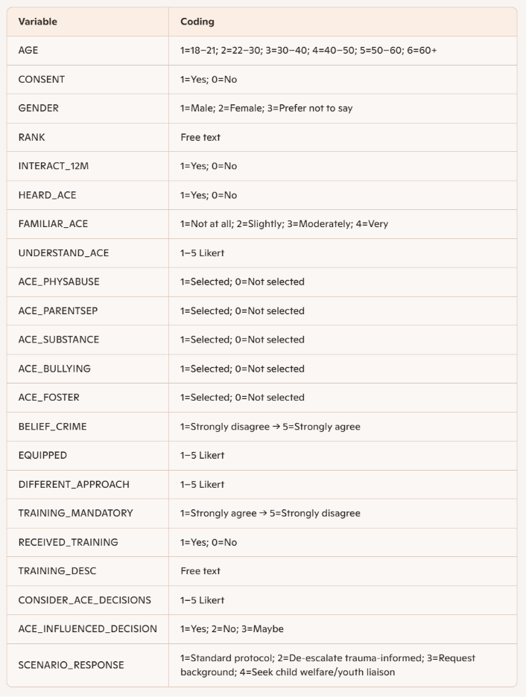

Appendix B SPSS style outputs and tables
Note: Sample size N = 20.

Table B1 Sample characteristics

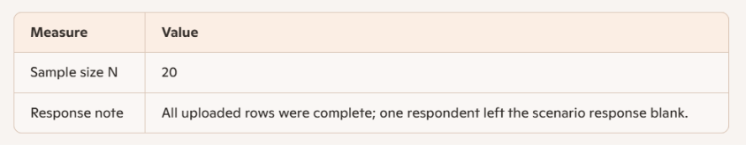
Table B2 Demographics Age Gender Rank Interaction with children in care
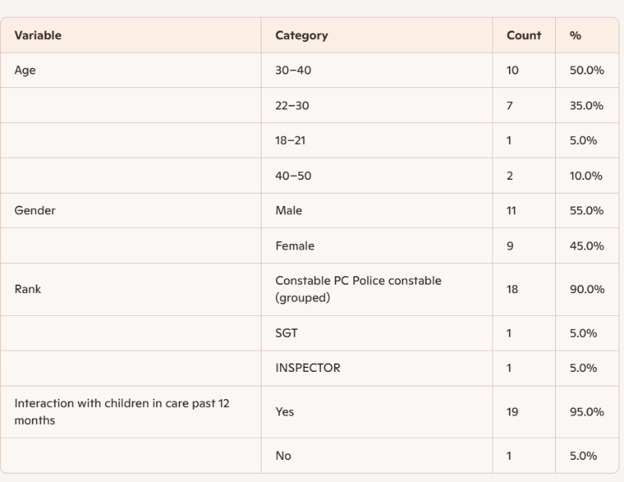

Table B3 ACE recognition
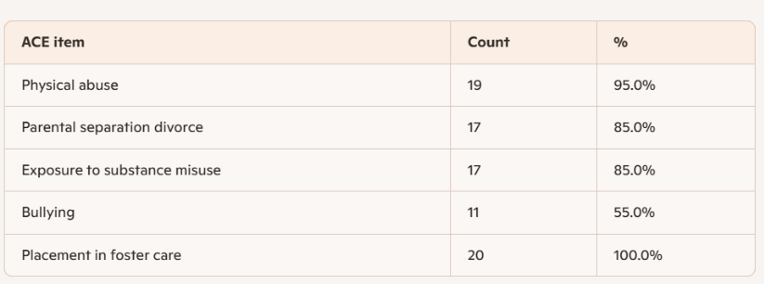

Table B4 Training exposure
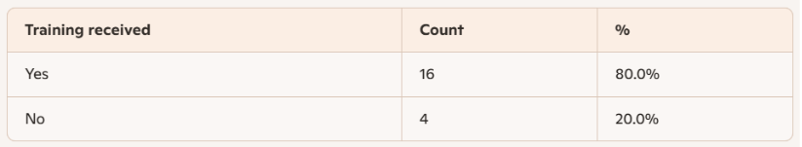

Summary of training descriptions ACE training variants 7; Training school variants 4; PowerPoint presentation 1; Basic understanding 1; Minimal/old training 1; Initial training plus personal research 1; Blank/not specified remaining.

Table B5 Scenario response distribution

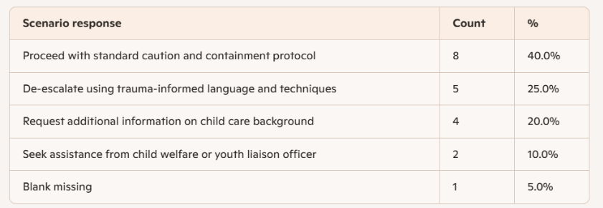

Table B6 Cross tabulation Training Yes No by Scenario response
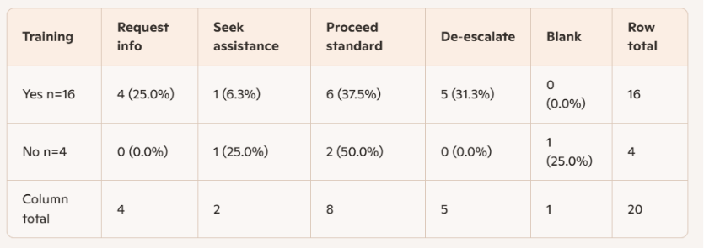
Statistical note Collapsed welfare-oriented responses (request info seek assistance de-escalate) vs containment (proceed standard blank): Welfare Yes=10 No=1; Containment Yes=6 No=3. Fisher’s exact test two-sided p = 0.285 (small sample).

Table B7 Summary statistics self rated understanding and familiarity

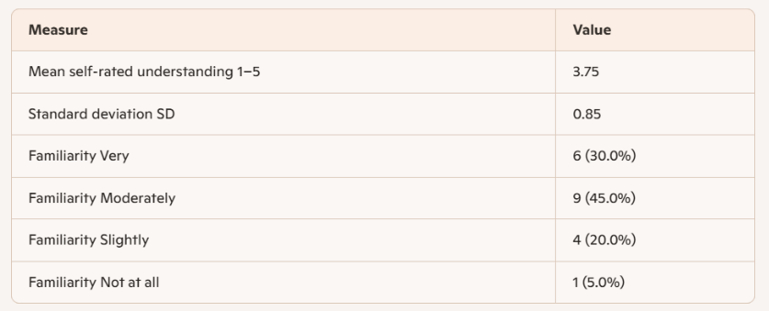

Appendix B Short interpretive summary
- Awareness versus readiness Awareness of ACEs is high but readiness to apply trauma-informed responses is variable; 40% favored standard containment in the scenario.
- Training patterns 80% reported some training but formats and recency vary; trained officers more often chose welfare-oriented options though sample is small.
- Practice implication Findings support recurrent skills-based training and clearer interagency pathways to convert awareness into consistent welfare-oriented practice.

Appendix C Ethics documentation
Status Placeholder for ethics approval documentation and participant information sheet.

