Acknowledgement
I confirm that I have not used any AI tools in the research and creation of this assignment. I confirm that I have not presented any AI generated materials as my own work. I confirm I have copies of my drafts, notes, and other resources I used, which I may be asked to provide in evidence.

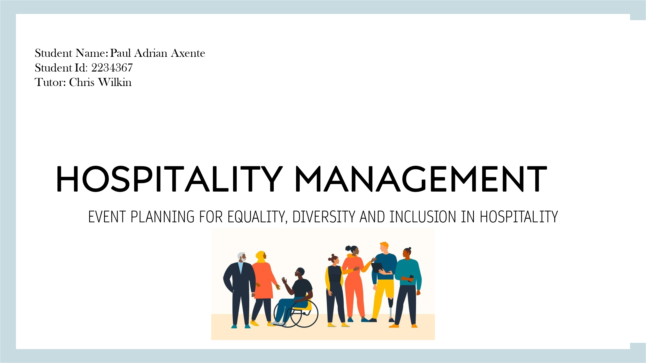

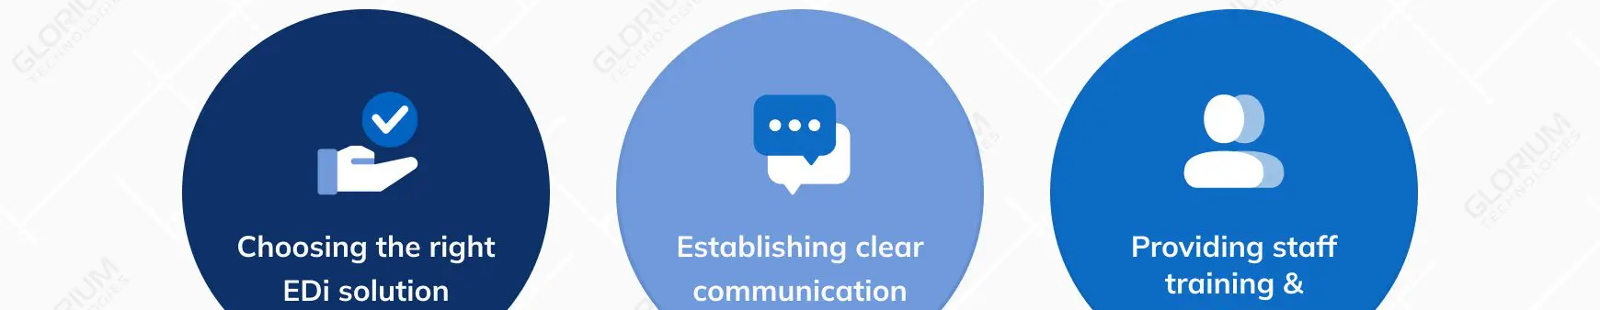

- Event named as “Hospitality Forward: Inclusive Leadership Summit 2025”, which is a unique event occurring for the first time across the industry.
- The main objective is to foster dialogue upon EDI practices along with their implementation within the hospitality businesses (Mohammadi, Bhati and Ng 2023).
- A 1-day immersive summit, which specifically combines the keynote address, leadership workshops & panel discussions specifically designed for the HR leaders & hospitality executives.
Introduction to the event

- Leadership-driven solutions for implementing the EDI initiatives within the hospitality organizations.
- The nature would be collaborative discussions, actionable outcomes & skill-building workshops (Vongvisitsin and Wong 2021).
- Addressing the leadership gap within EDI implementation, which would empower the decision-makers for creating sustainable changes.
Event content & context

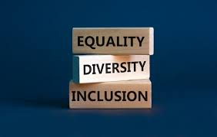
- Target Market: HR Professionals, Hospitality Executives And Training Managers Taken From Resorts, Hotels & Restaurants.
- Demand: A Significantly Rising Need Intended For EDI Awareness As Well As Diversity-driven Recruitment Across The Industry (Calinaud, Kokkranikal and Gebbels 2021).
- Competition: Few Of The Industry-based Events Having The Focus Specifically Upon EDI Leadership, Offering With Unique Opportunities Within The Market.
Market Factors

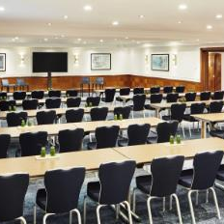
- Location: To Be Held At The London Marriott Hotel, Which Is Renowned For The Premium Services And Its Accessible Facilities.
- Venue Features: Conference Halls With The Capacity Of 150 Participants, Onsite Catering & Breakout Rooms For Various Workshops (Liu-Lastres, Wen and Huang 2023).
- Resources: High-quality AV Systems, Trained Staff For The Event And Amenities That Is Accessible To All Visitors.

- Location: To Be Held At The London Marriott Hotel, Which Is Renowned For The Premium Services And Its Accessible Facilities.
- Venue Features: Conference Halls With The Capacity Of 150 Participants, Onsite Catering & Breakout Rooms For Various Workshops (Liu-Lastres, Wen and Huang 2023).
- Resources: High-quality AV Systems, Trained Staff For The Event And Amenities That Is Accessible To All Visitors.
Operational factors
- Location: To Be Held At The London Marriott Hotel, Which Is Renowned For The Premium Services And Its Accessible Facilities.
- Venue Features: Conference Halls With The Capacity Of 150 Participants, Onsite Catering & Breakout Rooms For Various Workshops (Liu-Lastres, Wen and Huang 2023).
- Resources: High-quality AV Systems, Trained Staff For The Event And Amenities That Is Accessible To All Visitors.
Financial feasibility

- Projected cost:
  - Venue rental: £18,000.
  - Marketing: £6,000.
  - Catering: £11,000.
  - Speaker fees: £18,000.
- Revenue Streams: Ticket sales (£180/person), exhibitor fees from relative vendors as well as sponsorships from the industrial leaders.
- Budget Goal: Generating nearly £45,000 in terms of revenue, which ensures a £10,000 surplus for all the future events.



- Industry analysis: Researches show a notable lack in the formalized EDI leadership training within hospitality, which creates a notable gap.
- Key stakeholders: Government bodies, collaborating with NGOs and the hospitality leaders. This would enhance the credibility (Manoharan et al. 2024).
- Research Methodology: Significant surveys of the hospital leaders and the focus groups aimed at identification of the desired outcomes & major challenges.
Strategic Pre-planning research

Marketing strategy


- Channels: Email campaigns, Targeted LinkedIn advertisements and notable collaborations with various hospitality associations such as AHLA (Ali. Grabarski and Konrad 2022).
- Key messaging: “Lead the Change: Empowering the Leaders in order to Build Inclusive Workplace”.
- Timeline: A 4-month marketing campaign, along with early bird ticket promotions & influencer endorsements.

Highlights of the Event Program


- Keynote Address: Keynote speeches to be given by the EDI leaders, networking dinner & panel discussions (Russen, Dawson and Madera 2021).
- Panel Discussions: Various topics such as “Building Inclusive Hiring Practices” as well as “Navigating Cultural Sensitivity in Hospitality”.
- Workshops: Several practical sessions upon policy creation, inclusive team management & unconscious bias training.

- Probable risks: Delays in logistics, lower attendance in the event as well as budget overruns.
- Strategies for Mitigation: Early sales of tickets, contingency staffing & specific buffer within the budget (Chen et al. 2021).
- Health & safety: Specific adherence to the Covid-19 protocols as well as accessibility standards. C
Risk assessment & contingency planning
- Enhancement of EDI knowledge and specifically foster the collaboration among all the leaders of the industry.
- Appropriate establishment of this as a specific annual event aimed at monitoring the progress and to maintain the dialogue.
- Next steps: Launching the marketing, finalizing all the partnerships and then securing proper sponsorships.
Conclusion & Call to action

references
Mohammadi, Z., Bhati, A. and Ng, E., 2023. 20 years of workplace diversity research in hospitality and tourism: a bibliometric analysis. Equality, Diversity and Inclusion: An International Journal, 42(4), pp.551-571.
Vongvisitsin, T.B. and Wong, A.K.F., 2021. Organisational change towards LGBTQ+ inclusion in hospitality and tourism: Managerial perspectives. Tourism Management, 86, p.104331.
Calinaud, V., Kokkranikal, J. and Gebbels, M., 2021. Career advancement for women in the British hospitality industry: The enabling factors. Work, Employment and Society, 35(4), pp.677-695.
Liu-Lastres, B., Wen, H. and Huang, W.J., 2023. A reflection on the Great Resignation in the hospitality and tourism industry. International Journal of Contemporary Hospitality Management, 35(1), pp.235-249.
Manoharan, A., Hutchinson, C., Treuren, G.J. and Madera, J.M., 2024. Disability employment in the hospitality industry: a systematic literature review. Cornell Hospitality Quarterly, 65(3), pp.362-377.
Ali, M., Grabarski, M.K. and Konrad, A.M., 2022. Women in hospitality and tourism: a study of the top-down and bottom-up dynamics. International Journal of Contemporary Hospitality Management, 34(4), pp.1448-1469.
Russen, M., Dawson, M. and Madera, J.M., 2021. Gender diversity in hospitality and tourism top management teams: A systematic review of the last 10 years. International Journal of Hospitality Management, 95, p.102942.
Chen, H.S., Severt, K., Shin, Y.H. and DiPietro, R.B., 2021. Invisible yet powerful: the unseen obstacles women leaders face in their hospitality careers. Journal of Human Resources in Hospitality & Tourism, 20(2), pp.249-269.
Gerged, A.M., Tran, M. and Beddewela, E.S., 2023. Engendering pro-sustainable performance through a multi-layered gender diversity criterion: Evidence from the hospitality and tourism sector. Journal of Travel Research, 62(5), pp.1047-1076.
Dogru, T., Line, N., Hanks, L., Acikgoz, F., Abbott, J.A., Bakir, S., Berbekova, A., Bilgihan, A., Iskender, A., Kizildag, M. and Lee, M., 2024. The implications of generative artificial intelligence in academic research and higher education in tourism and hospitality. Tourism Economics, 30(5), pp.1083-1094.
Marley, C., Faye, A.D., Hurst, E., Moeller, J. and Pinkerton, A., 2021. Moving beyond ‘you said, we did’: Extending an ethic of hospitality to the student feedback process. Online Postgraduate Education in a Postdigital World: Beyond Technology, pp.1-19.
Tlili, A., Altinay, F., Altinay, Z. and Zhang, Y., 2021. Envisioning the future of technology integration for accessible hospitality and tourism. International Journal of Contemporary Hospitality Management, 33(12), pp.4460-4482.

