

Student name: AVUKU SAI SHARAN
Student ID: 2116880
Module name: Marketing Management – Assessment 1
Module code: LCMB7001
Lecturer name: Tushara Balendran

Contents
INTRODUCTION 3
Apple Mission Statement 3
Apple’s vision statement: 4
COMMUNICATION 4
Integrated Marketing Communication 7
Apple’s IMC 7
Recommendations for Apple 8
Branding 9
Brand Equity 9
Keller’s brand equity model 10
BRAND IDENTITY 10
BRAND MEANING 11
BRAND RESPONSE 11
BRAND RESONANCE 11
Advantages and dis-advantages of Keller’s equity model 12
Customer journey map 13
Customer touchpoints 15
Customer Journey Map 17
Strengths and weaknesses of Apple’s customer journey map. 18
THE TOTAL ENGAGEMENT MODEL 18
Recommendations 19
Conclusion 19
References 20

INTRODUCTION

We have all heard about great personalities like Albert Einstein, Martin Luther King, Pablo Picasso, Richard Branson, Muhammed Ali, but have you ever wondered what they all have in common?
Each one of them chooses to think out of the box and expand on their individual paths to their definitions of success.
It is only with self-belief and hard work that they have earned success. In today's world, almost every occupation is dependent and advancing with technology. It is us indeed who rely on technology for various aspects. The people of this generation strive to achieve new outcomes to promote their individual businesses. But one factor that gets in the way of other
Companies to move forward is their unwillingness or hesitance to embrace a unique trail of thought.

"Think Different" is the proudly presented and most recognizable slogan of the APPLE Company which showcases that the company's confidence is in exploring new channels of creativity and innovation.
Quoting the GOAT Steve Jobs ''The only way to do great work is to love what you do'' This genius followed his mind and transformed Apple into a world leader in telecommunications.
Tim Cook, the current CEO of Apple Inc. continues the success of the company and also lives up to the smartness and perseverance of Apple.

THE STORY BEHIND THE BRAND 'APPLE' - (or) APPLE AND IT'S NAME –

It's been more than 40 years since Apple has made the whole world so proud. There were many speculations for how Apple got its name. It cannot be more fascinating about how Apple got its unique name from the great Steve Jobs. It is simply because Steve Jobs really liked Apples. It
is very convenient for us to believe this and it's the real fact. Back then, Steve Jobs himself revealed to the world about his idea of the name 'Apple'. It was a very casual day when Jobs was on one of his fruitarian diets and out of the blue the thought struck him about the word 'Apple'. Steve
Jobs had then just visited an apple farm and to him, the word 'APPLE' sounded really fun, spirited and not intimidating.
The journey of Apple all through these years is inexplicable. From the flashback of its logo till its advances to date, the hard work and perseverance is clearly seen in the company. Undoubtedly, Apple still remains in the top and continues to achieve success across boundaries.

Apple Mission Statement

It is the purpose of the organization have been set up. The objectives set by the organisation. To achieve profits in the longer run.

Apple’s mission statement is “To bringing the best user experience to customers through innovative hardware, software, and services.” (Tim Cook)

Apple’s vision statement:

“We believe that we are on the face of the earth to make great products and that’s not changing.”

COMMUNICATION

To say in simple words, communication is understanding the meaning from the sender’s perspective.
If you dream to start a career in business, good communication skills hold chief importance in today's business day and age. To understand communication, it is a particular process that involves exchange of data and also some social involvement. It is what most of us do. Success or failure of any business is all about the communication skills of any job seeker, officers, top level managers and also the employees. Having huge success in business depends not only on what you communicate but how well you communicate. Undoubtedly, communication is the most important lifeline of business.

To make it more clearer, I shall explain with an example.
Bhargav, Federica and sharan (myself) are class representatives. And there is a team called student services (Gladius) where they take feedback about classes and any improvements to be be made from students. So, then class representatives have to speak with the all their fellow mates and discuss about the problems and also the solutions if they have any.
Then after discussing they will represent the whole class and speak to the HOD regarding the discussion. However, they wont be able to tell minor grievances instead they say the problems faced by them.

Gladius
Gladius is the Head of the department for MBA students. The idea of gettting feedback from students every semester was a good ad precise idea. He wanted to make sure that all the students shoud get benifitted from the learning and also adjust towards their teaching. He wanted students to imbibe the skills needed in this competitive world.
If there was no thought of having this student services team, then it would be like just another normal college where just students come to the class, listen to what teacher says and go back to home, where there wont be any new learning.

Morever, the team after speaking to the class representatives they decide on what needs to be improved be it either quality of teacher or anything else etc. If there wasn’t this team they would never know whether students are able to understand and cope up with what is happening in class.

The real transmiter here is the CLASS REPRESENTATIVES. They convey the message to the student services team in the form speaking or writing. Here, the class representatives are the real transmitters who helps to communicate the data from them in the form of audable or readble. Gladius wanted the information in written form from the students.
If we have a clear look, Gladius is the source. Conveying the information through class representatives is the signal.
During the conversation between Student services team and class representatives, where the meeting is conducted online, there could be network issues or not audible properly, this kind of disturbances is called noise and it has many forms.
Shannon and weavers’ communication model, it states that an information starts from the person who gets the thought
According to shannon and weavers’ coomunication model, It's a diagram that depicts the standard processes in any type of good communication. The sender of the message is the source of information. The data is then transferred from the mind to the audio visual system, where it is turned into a signal that is sent to the receiver without any noise or interference. The receiver then sends the message to its receiver.

Source (Idea)
↓
Channel (The way through which the information is conveyed by having few distractions during the conversation.)
↓
Signal
↓
The Recipient (Receives the signal)
↓
Final Destination (gets the message)
Finally, the information is collectedand passed on to the student services team i.e. Gladius. There were few disturbances while collecting the information. The message is not accurate because of perpetual opinions. Even a simple message can take on a new significance once it reaches its sender and receiver.
The message
Channel of communication:
- Writing
- Speaking
- Videos
- Graphics
At least some code In common
De-coding
Coding
Behaviour or output
Information or Input
Noise



Hdeifhiefe
Context
Feedback
The Recipient
The Messenger

Integrated Marketing Communication

Philip Kotler’s integrated marketing communications definition, “Carefully integrating and coordinating the company’s many Communications channels to deliver a clear, consistent, and compelling message about the organization and its products”.

When a customer wants to by a product, He or she will evaluate which brand to buy. Here comes IMC into picture, every company will have their own brand touchpoints and also their own style of advertising. The main objective of every company is to deliver a good image and reputation of the company to public. And it also depicts how IMC can help people in solving their problems and they create a good relationship with the company.
Ranging from companies ads, banners, pictures will act as personal selling communications.

Apple’s IMC

Integrated marketing communications plays an important role in the development of the company. Today, we can see Apple’s success and it is just because of IMC activities. Along with IMC, touchpoints where customers go through is also significant.
Apple just don’t sell the products but they also attract customers and make them loyal to the company which expands the company’s position.
The company not just focuses on the updated technology but also on the R & D department and also its marketing communications.
Rather than making usage more difficult, simplifying and upgrading items is a better way to improve and update them is their policy.
This is particularly visible in the customer experience at every contact point.

When a logo is used in product advertising, music and media may only be purchased through iTunes. Advertisement can be seen in adverts, newspapers, and posters. Apple will get to know who is using their products and for what reasons they are using when users register themselves in Apple ID for downloading apples or any other updates regarding the software.
Apple employs software upgrades and Google Play store updates to identify out who is still using its products and understands the importance of simplifying and addressing issues.

The motto of every company is to popularise its products. Apple uses IMC in various channels to increase their sales in iPhone sector. IMC is used so that it reaches to larger audience by making their brand popular. They use beautiful pictures of iPhones on its website to attract its customers.
The firm employs promotion and marketing strategies to gain their attention and interest.

Apple have many marketing communication strategies. To name few, Advertising, Publications, Public relations, Sponsorship etc.

Tools of IMC

Recommendations for Apple

IPhone is a luxury product, which can’t be affordable by all types of people. Apple uses premium pricing strategy. As every product have law of diminishing marginal utility, the price of the product goes down in the next few years of releasing. Then the customers of medium and low income people go and but those previous versions of phone. As a result, the market for new products is shrinking. Apple should manufacture a few moderately priced things for people with low and moderate incomes to increase its number of clients.

Because many countries are now producing minimal cost iPhone replicas, the company may need to come up with new ways to differentiate its products. The company can give one-one customization of phones. Like for the ones who wants vivid colours in their phones and this would cost them extra. If we see iPhone 13 pro max, it has released a new green colour iPhone which attracted many customers’ eyes.

Because older individuals are free and so have a lot of time to read newspapers and watch television, the corporation can target them. To do this, marketing must be directed at the elderly, highlighting phone features that are specifically designed for this audience.

The company might also use the Guerrilla Marketing strategy. Guerrilla marketing is a type of promotion that use unique methods to create surprise and astonishment in order to gain awareness and brand exposure.
It is the best way to attract to customers in the recent times. The firm's brand name and staff morale will both benefit from this marketing strategy, in which the corporation promotes CSR through all accessible venues.

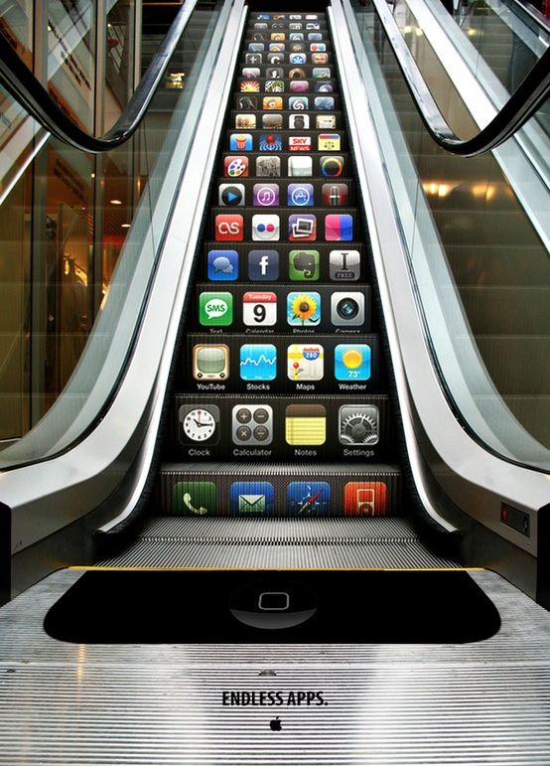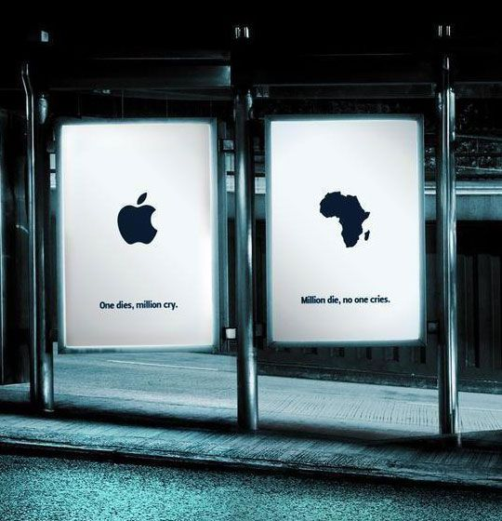

Benefits of this model

LOW COST – Guerrilla marketing is cheaper than advertising on newspaper or TV ads. It is very helpful for more companies.
Spread through word-of-mouth - In today's society, thanks to the large amount of technology and the expanding number of people who have access to internet, consumers may capture a great impression and share it across the world. Marketing efforts may quickly become viral, gaining millions of people's attention.

Branding
It is a name which makes the company identify in the market for their product or service. It is a combination of name, word, sign, symbol etc. Consumers consider branding to be an important component of a product, and it may add value to it. Brands have significance that extends beyond the physical characteristics of a product.

Brand Equity
Brands live only in the minds of customers. "Products are made in the factory, but brands are made in the mind," one well-known marketer famously stated. "A brand is what people say about you when you're not in the room," says Jason Kilar, CEO of the internet video provider Hulu.
Strong brand reputation is very essential for a good brand. Brand equity is the difference between recognising a brand name and responding to a product or its marketing. It's a measurement for evaluating how successfully a brand can create consumer loyalty and trust.

Keller’s brand equity model

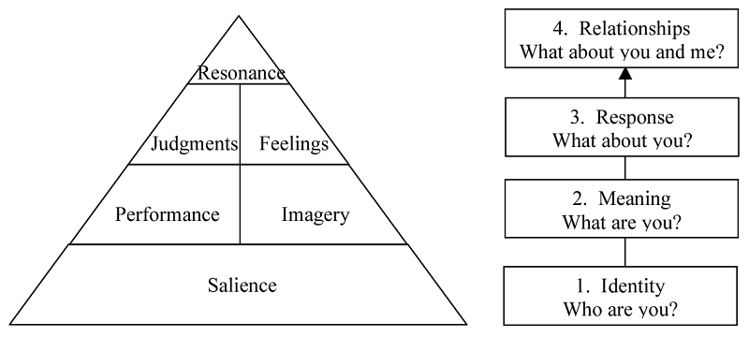

Keller's logic for the strategy is simple to construct a great brand, one must create perfect brand experiences and interactions. Each encounter with your company should leave customers with positive thoughts, feelings, and convictions. When you can exhibit those feelings via your brand, you've developed brand equity, and your consumers' beliefs will spread through word-of-mouth.

BRAND IDENTITY

Salience is the initial stage and the bottom of the pyramid. Salience is moreover like brand recognition just by their logo or slogan.
Every business nowadays focuses on digital marketing of their brand and logo to express what they have to offer, not only on the internet but across all platforms.
Apple as the tagline itself says, “THINK DIFFERENT” they have unique value proposition in the market. It is known for its innovation. Apple depict its products clearly to the customers. Their advertisements and pages on Social media are so appealing. As we know the famous saying, “Pictures speak more than words”, they attract the users in this way. They attract customers with their unique design, features.

BRAND MEANING

The next level of CBBE model is brand meaning. This level explains the customers about what your brand is and what specifically it does to its customers. It may be done by demonstrating how your brand fits your wants or how your brand meets your consumers' demands on a social and psychological level utilising both performance and images.
Performance and imagery - The Company’s meaning is a knowledge of its total consumer perception based on criteria such as Product Features, Product Reliability, Customer Service, Style & Design, and Product Pricing. Apple is always updated to the technology making it monopoly in the innovative sector. Apple is also known for it’s after sale service and they maintain a good relationship with customers.

BRAND RESPONSE

The third level is brand response which is essentially how a brand makes a consumer think or feel about its product. It has 4 steps
- Brand’s quality
- Brand’s credibility
- Brand’s consideration
- Brand’s superiority
This can be done in two ways. One is through consumer’s judgement and a consumer’s feelings.
The feelings they represent when they watch these advertisements such as excited or fun etc.

Apple products are the best ones in the world. But on the other side the products are highly priced and cannot be affordable by medium and low class people.

BRAND RESONANCE

The top level of the pyramid is brand resonance. In the whole equity concept, it is what every firm desires. It's the sensation you get when you merely look at a product and know it's exactly what you're looking for. You know the brand and also the outs and ends of it.
It is established through 4 categories
- Behavioural loyalty – It means that you are regular customer of a particular brand and purchase it very often. Example- everyday used products like paste, salt etc.
- Attitudinal attainment – customers love you brand and they see it as a special purchase
- Sense of community – Branding helps you feel like you're connected to others and a part of a group.
- Active engagement – Following the brand on social media and conveying to people that you are actively engaging with the brand itself.

Apple has been particularly successful in this area because they have been able to adapt to the macro and micro elements impacting the customer and respond quickly to their benefit. Apple is a customer-focused corporation that allowed it simple for them to achieve the top phase of Keller's model. Apple is also committed to upholding its ideals and achieving its objectives of offering customers with the most convenient and high-quality content possible.

Advantages and dis-advantages of Keller’s equity model

Advantages

- This model is aimed to offer customers with brand awareness while also allowing them to evaluate organisations by using their imagination and providing feedback on marketing activities as a result of the knowledge gained at the Keller’s first level that is Salience.

- This model helps in customer retention by creating customer loyalty. If we look at the companies like Apple, Coca-Cola etc. they spend less money on customer retention because their immediate focus is on providing a better experience for the user, these businesses spend less money on customer retention.

- Brands that succeed in drawing consumer resonance benefit not only from their loyalty, but also from a higher price premium or high-impact marketing campaigns

- This model will help in developing their brand, therein they get good feedback regarding the company from customers. Moreover they get the upper hand and they can increase the price of their products.

- No business would be able to survive if it did not make a profit. As a result, when your firm has a strong brand in the market, it benefits from greater and larger profit margins. Apple, for example, engages in promotions that provide premium customers with lifetime experience experiences. Despite the fact that each product's processing would be almost identical to that of any other generic product in their marketplace. Customers of Apple, on the other hand, have to wait a whole year for new products to be introduced under their tent. They are prepared to pay thousands of dollars for Apple devices despite being educated and well-informed.

- Good advertising and other marketing strategies provide INTANGIBLE VALUE to a product. It can give considerable competitive advantages in product categories where most alternatives provide the same benefits on dimensions like image, distribution, and physical design.

Dis-advantages

- Keller's technique has a drawback because due to the method's concentration on consumer markets, it observes things in a higher order, with the pyramid restricting judgements and neglecting the customer's encounter with the sales team.

- The main negative is that it takes a lot of time and money to get to this level, as well as a lot of money to establish the brand's reputation among customers.

- This model focuses more on B2C market rather than B2B market.

Customer journey map

Customer journey map is similar to customer decision making process.
A person wants to buy a product. The process which he goes through while purchasing, before purchase and after purchase.

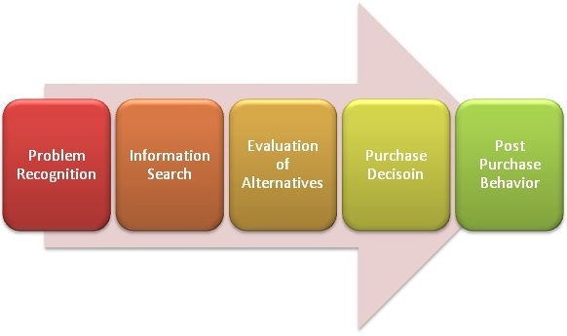

Customer journey map has 5 stages

1) AWARENESS – this is the situation where you will realise you have a need or want of the particular product.
2) CONSIDERATION – After realising your want, you start searching for the information. You will do research about the product and you will evaluate with the other alternatives.
3) DECISION – After you have decided which brand or the product to buy. You will decide how to buy it either online or offline.
4) RETENTION – After you have purchased the product, are you satisfied with the product or not. Whether the brand have matched your requirements.
5) ADVOCACY – After purchasing the product YOU become the advocate for the company. You will communicate about the product with your relatives, friends and many others with regards of the company.

We all know that Apple is a luxurious well known company worldwide. This customer journey map makes customers easy to purchase the product. Below is the one of the customer journey explained.

Stages | Awareness | Consideration | Decision | Retention | Advocacy
 | - Sharan, wants to buy a phone.  Moreover, he goes to his friends and ask them about the latest smart phone.  - After getting to know few popular brands, Sharan goes to social media websites to know about the products.  - He got reviews regarding the brands. | - Now, he’s in dilemma which mobile phone to purchase.  - He will evaluate the positives and the negatives  - Searches on the companies websites  - Compare the design and uniqueness of the mobiles  - Compare prices | - After the research, Sharan decides to buy iPhone 13 pro max  - He went to online sore and added the product to cart.  - He then chooses the payment method  - Made the payment and got confirmation regarding the payment. | - Sharan agreed to the term and conditions of Apple.  - He gets emails and text messages regarding the apples product for any new products etc. | - Finally after purchase Sharan is very happy. He got positive reviews regarding iPhone and he also started to tell about his experience to his friends and relatives
Touch points | - Seeing an advertisement  - Going to e-commerce websites and knowing about the product  - Asking friends or relatives about the product  - Online advertisement |  | - Company’s website  - Product catalogue  - Point of sale  - Reviews of the product  - Checkout page | - Warranty certificate  - E-mail marketing of upcoming products  - Renewals

Emotions
Emotions | 🙂 😐 🙂 🙁 🙂
Pain Points | Information available online is flooded. It is not that easy to get the desired product. There are many alternatives. There are huge number of competitors so it’s not that easy to distinguish. | IPhone being a luxury product, may not be found in all stores except few There are many problems faced by customers while ordering the product. When it comes to payment section, it may not support all types of cards.. Probably there may not be stock available when you want to purchase.

Customer touchpoints

The customer touch point is the available source generated for the consumer to interact with at each stage of the customer journey. These interactions can be of two types: online or offline.
These customer touchpoints have 3 phases:

TOUCHPOINTS BEFORE A PURCHASE

1. Social media: We can just go onto websites like Instagram, Facebook, and Twitter etc. and can search for the companies’ products. There will be many pages and opinions about the product.

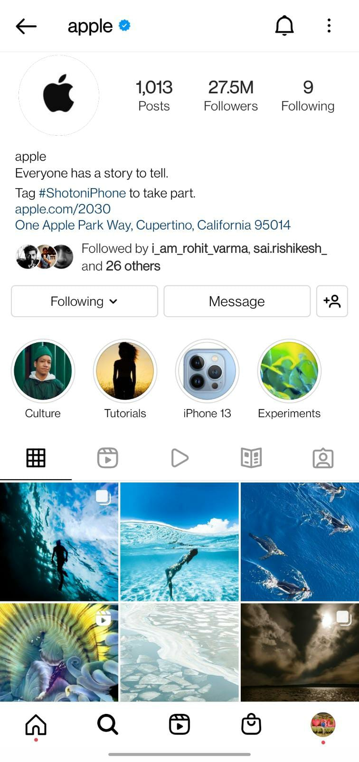

Touch points have been very innovative by Apple. They've always had an emotional connection to their brand's advertising. It was accessible on all social media platforms, online advertising and personalised suggestions when browsing the web, and peer referral was the quickest method to get it.

TOUCHPOINTS DURING THE PURCHASE

Apple’s website is simple, clear, and straightforward to navigate, making it simple to learn about new services, schedule appointments, and locate its stores. Trying and tasting things is made easy thanks to the numerous demo units in each store. I've always felt that sampling is the most effective marketing method when a product is truly great. The sampling approach is supplemented by employees whose job it is to explain things at each shop.
Customers who purchase new computers are eligible for two years of "One to One" training. The One to One programme allows customers to schedule 1-hour, 12-hour, or open training sessions with specialists in each of Apple's software categories. The instructors pay close attention to the customers and know how to help them become self-sufficient in their usage of the equipment and software.
This makes the customers very comfortable.

TOUCHPOINTS POST PURCHASE

Apple has an excellent team working on providing the support for customers be it online or call centre for addressing their queries. After the purchase company sends a thank you email for making the customers feel superior.

Customer Journey Map

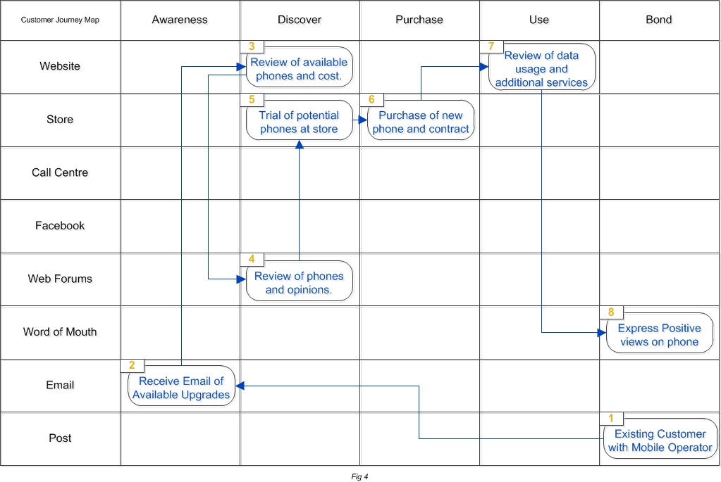

Source: Learner

The above map is one of the Customer Journey Map. The customer journey's flow is numbered step by step here. In the first step, the customer gets a post because he or she has a bond with the company as they are existing customer. The customer is then made aware by e-mail saying about the new collection of phones and also the upgrades. Customer then discovers more about the mobile phones by going through their websites. And then the customer checks the reviews and also the opinions. Then the consumer will go to the store and use it as a free trial to experience the mobile. Later, the customer purchase the new mobile by agreeing the terms and conditions of the company. The customer then uses the mobile and also gets benefits of the additional services offered by the company. For example- Apple’s additional services are cloud services, music streaming etc. the customer feels very happy after buying the product. Moreover, he suggests his friends, relatives, colleagues etc. about the product. He will also rate the phone in reviews section which will be helpful to the other buyers.

Strengths and weaknesses of Apple’s customer journey map.

Strengths

Apple has the best Omni channel customer journey. Which means that the customer can get guidance through different platforms such as social media websites or chat live etc.
It can help many customers at one go instead of making them wait.
Customer journey map for iPhone encourages the business to develop the online product viewing system as well as service delivery.

The emotional satisfaction and user experience process are depicted in Apple's customer journey map, which evaluates the flow between public service and consumer engagement step by step.

Apple made use of customer journey map and perceived the sales of experience from the point of customer rather than the salesperson.

Weakness

Although the Apple customer map is created from the perspective of a single customer, the user behaves differently during the purchase and is influenced by various touchpoints.

The presented map can only be utilised for a limited time, however the customer trip continues indefinitely.

Apple’s customer journey map jus focuses on touchpoints but not the journey of the customer.

THE TOTAL ENGAGEMENT MODEL

This model is all about engaging the customer and making the customers satisfied.
Consumers and customers are viewed as subjects of customer involvement in marketing literature, whereas brands, goods, services, or organisations are the objects. Customer engagement refers to the consumer's variable "presence" in his interaction with the firm or its product. Emotional, bodily, and cognitive presence are all factors in determining presence. Customer engagement is seen to be a higher-order construct with four components: devotion, energy, absorption, and interaction. Due to the complex conditions and changes that a brand faces today, every contact and engagement with customers must be fully capitalised, optimised, and viewed as a chance to develop customers who are engaged and loyal to the company. All the above discussed elements are shown in the Total Engagement Model, which focuses on contrasting the four key factors.

- Customer value proposition – The unique benefits that the company is providing in value proposition. It is the value what the company offers to the customers over their competitors.
- Branding – Apart from the logo and name, branding is what it tells us about who we are and what we stand for in the market.
- Internal culture elements – COPRA culture should create an environment human resources.
- Customer experience - The expectations and the real promises of the company.

This model helps in knowing how to improve long term profits. The synergy should be achieved. They should be working together as a team.

Recommendations

The new customer touchpoints which Apple can focus to increase their brand awareness. In terms of marketing partnerships, Apple should consider handing out reward points to customers when they make a purchase to ensure customer retention and loyalty. To benefit from the experience and attract different customer segments, a new touch point that could be introduced in terms of attracting consumers could be considered sending by email a letter of participation to the most loyal customers, registered in a database at each purchase, and by accumulating a certain number of points could be registered in a lottery, with a draw, and the possibility of winning other Apple products in order to benefit from the experience.
As we know Apple is known for its security of customers. But they can have few third party applications like VOICE CALL RECORDER.
From last few years, the charger for the mobile is not been given with the purchase of the mobile. Then can give it as a BUNDLE PRICING by giving the combination of products such as Air Pods, Charger, Apple Watch at minimal cost.

Conclusion

Previously mentioned about the promotional strategy to be promoted to make the existing brand more popular. As we all know Apple is an excellent product and also very well known worldwide and also the number of employees buy the products is really huge. Their unique software and innovation helps to retain customers. Initially they started with the manufacture of computers, now they do many gadgets. Being luxury product, the prices of the products are very high and the quality of products and design is very unique. Promoting the firm's CSR efforts will encourage existing consumers and potential stakeholders to think positively about the company. It is crucial for customers to emotionally embrace the notion that they are indirectly contributing to society in exchange for the premium they are paying.
However, the company is trying to put in their efforts to make customers happy. The invest more on the R and D department so as to meet customer needs.

References

ANDERSON, J. (2020). candu. Retrieved from Apple’s customer journey explained: https://www.candu.ai/blog/apples-customer-journey-explained
ANDERSON, J. (n.d.). Apple’s customer journey explained. Retrieved from candu: https://www.candu.ai/blog/apples-customer-journey-explained
McCarthy, J. (2017). Apple's 'Think Different' motto used to batter Google in guerrilla ads erected following diversity row. Retrieved from thedrum.com: https://www.thedrum.com/news/2017/08/14/apples-think-different-motto-used-batter-google-guerrilla-ads-erected-following
Roberts, J. (2018, july 23). Mapping your customer journeys across touchpoints: Examples and techniques. Retrieved from https://www.mycustomer.com/: https://www.mycustomer.com/customer-experience/engagement/mapping-your-customer-journeys-across-touchpoints-examples-and
Z., F. (2020). Linkedin. Retrieved from Customer Engagement as a Brand Loyalty indicator: Implementation Aspects in Apple LTD: https://www.linkedin.com/pulse/customer-engagement-brand-loyalty-indicator-aspects-apple-zhevelev/
Juneja, P. (2015). Shannon and Weaver Model of Communication. MSG, 1.
Keller, K. L. (2013). Strategic Brand Management, 4th Edition. new york: pearson.
Keller, P. K. (2015). Marketing Management. Global: Pearson.
Hawker, K. (2019, september 19). Keller’s Brand Equity Model — What It Is & How to Use It. Retrieved from https://medium.com: https://medium.com/@keatonhawker/kellers-brand-equity-model-what-it-is-how-to-use-it-84e42d562299
Keller, K. (2010). Mastering the marketing communications mix: Micro and macro perspectives on integrated marketing communication programs. Journal of Marketing Management, 17(8), 819-847.

Douglas, S., Craig, S., & Nijssen, E. (2008), Integrating branding strategy across markets: Building international brand architecture. Journal of International Marketing, 9(2), 97-114.

Mickalowski, K., 2013. Apple's iPhone Launch: A Case Study in Effective Marketing, Available at: http://www.augie.edu/sites/default/files/u57/pdf/jaciel_subdocs/iPhone.pdf
Pandey, A. & Mittal, A., 2016. Understanding The Marketing Mix Of Smartphone Market From The Consumer Point Of View. IJSTR Journal, August, 5(8), pp. 1-5.
Hernandez, J., 2011. Price Skimming on a Successful Marketing Strategy: Study of Ipad Launching as Apple’s Innovative Product, Available at: http://www4.pucsp.br/icim/ingles/downloads/papers_2011/part_3/part_3_proc_36.pdf

