HRM in the Ritz Hotel London
Topic: Analyse the impacts of socio-economic force on employees’ performance management and monitoring in different work modes: Hospitality HR’s perspective

Student ID : 2243598
Word count: 2016 words

Table of Contents
Introduction and Background 3
Discussion 4
Description of Socio-Economic Factor 4
Industry Trends 6
Emergence of Different Work Modes in Five Years 8
Management of Employee Performances 9
Evaluation and Conclusion 10
References 12

Introduction and Background
The proposal reflects on the trend and practices in the hospitality industry that are particularly suggested to apply by the high-end establishments such as The Ritz Hotel London. The trends will maintain demanding situation for working environment and make higher expectations from the employees (Sharma and Rahim, 2021). The proposal allows effective performance management with monitoring the employees to fulfil the expectations and maintaining the reputation of the hotel for excellence. The report also offers different socio-economic forces that impact directly on the employees regarding management and monitoring. The proposal allows learning of different factors that impact on the performance within different working policies. The Ritz Hotel London is known as the renowned luxury hotel that is located in the heart of London. It is considered as a prime example to maintain the challenges faced by the hospitality system in the HR professionals in the management and monitoring of the employee performance (Rouhani et al., 2024). The hotel offers a wider and diverse range of practices to the workforce that provides a fast-paced process to the banking environment. The HR management of the Ritz Hotel London needs balancing of the needs for the employees with managing the demands of the guests and maintaining effectiveness with the high standards of the services (Rijal, 2022).
The proposal will offer a definite challenging context using the socio-economic forces that can make influential management to the employee motivation, job satisfaction efficiencies, and management of overall performance (Klimkeit et al., 2024). Socio-economic forces are allocated to the broader social and economic aspects that are useful to make shaping of the individual's life and maintenance of the working experiences. There are different factors used to learn about the economic instability, differences in the social factors, and demographic changes that impacts directly on the employee's ability towards performances and job effectively (Kim and Torneo, 2021). Therefore, the proposal helps to learn about the employee performances and struggling resources in the Ritz Hotel that financially occurred to maintain 6the experience stress and make reduction in the job satisfaction that is definitely affecting on the overall performances. For the services in the Ritz Hotel London, socio-economic forces seems manifesting different ways. The employees are coming from the lower socioeconomic backgrounds that face some definite and additional challenges for the adoption in the hotel's high standards and make definite system for the fast-paced environment (Karatas, 2021). Similarly, the employees allocated with the responsibilities are also struggle with balancing the work and personal lifestyles that is leading towards the reduction in the job satisfaction and overall performances.

Discussion

Description of Socio-Economic Factor
Factors | Analysis
Political Factor | Political factors are associated with the services of the governmental policies, political stability measures, and international trade agreements that are applied in the hospitality sector the factors impacts directly on the operations of hotel with influencing the availability of the definite resources, the differences in the cost of labour, and management of the overall working environment 9Jain et al., 2023). For example, the changes within the government policies based on the tourism or hospitality impact on the hotel's revenue streams and management of the definite operational costs. Political stability impacts on the operational ability of the Ritz London for attracting and retaining the employees.
Economic Factor | Economic factors are based on the services of the Ritz Hotel London that are associated with the condition in the macroeconomic trends like changes in the inflation, unemployment rates, and changes in the GDP. The factors impacts directly on the hotel's revenue streams, management of the operational costs, and overall profitability (Hosseini et al., 2022). For instance, there is a higher inflation rates in the hospitality UK that can increase the cost of labour and overall management of the goods. The Ritz Hotel offers lower unemployment rates that is leading towards the higher labour costs. GDP growth seems increasing in the consumer spending and tourism in the UK sector.
Social Factor | Social factors seems influencing The Ritz Hotel London such as management of the demographics, learning of the social attitudes, and management of efficiencies in the cultural values. The factors directly impacts on the hotel's target market, customer management and preferences, and overall reputation management. For example, there are some changes in demographics like management of the age distribution or family structures that help in the hotel's marketing strategies and measures to the service offerings (Hinson et al., 2024). Social attitudes helps in the management of the luxury travel, sustainability issues, and customer service that directly impacts on the hotel's brand image and management of efficiency in the customer loyalty.
Technological Factor | Technological factors impacts directly on the Ritz Hotel London such as make advancements in the use of digital technology. It helps in the management of automation and consideration of the data analysis. The factors impacts on the operational management and efficiency, customer service, and management of the definite competitiveness. There is an increase in the online booking platforms that can increase on the visibility and accessibility of the hotel services. There are some advancements in the automation can maintain efficiency in the streamlining system of the operational processes (Buitek et al., 2024). Data analysis is helpful for the hotel to make better understanding of the customer preferences and related behaviour.
Environmental Factor | Environmental factors for the Ritz Hotel London is based on the changes in the climatic conditions, inclusion of the natural disasters, and emergence of the sustainable initiatives. The factors impacts on the operations, reputation management, and overall sustainability. For example, the climate change leads towards the increase in the energy costs and maintaining the needs of the sustainable practices, whereas, the natural disasters make disruptions in the operations and impact on the overall hotel's reputation (Sharma and Rahim, 2021). Sustainability initiatives works for the reduction in the environmental impact with the improvements in the brand image.
Legal Factor | Legal factors for the services in the Ritz Hotel London are based on the management of the laws and regulations and work for the completion of the employment, health and safety, with the consumer protection. The factors impacts on the reputation and performance management system. The Ritz Hotel face changes in the employment laws that impact on the costs of labour and employee management strategies, where the implicated regulations are helpful for the provision of the employee well-being (Rouhani et al., 2024).

Industry Trends
For the hospitality industry UK, there are several luxury hotels such as The Ritz Hotel London that are faces significant challenges in the management of employee retention and turnover. According to the Bureau of Labour Statistics, there is a leisure and hospitality sector faced a definite turnover rate of 6.5% as of February 2024 that is considered the highest within the industries (Rouhani et al., 2024). The average employee retention rate in the UK hospitality industry is almost 85% that is estimated as 20% of employees are anticipated for leaving the jobs in the next two years.
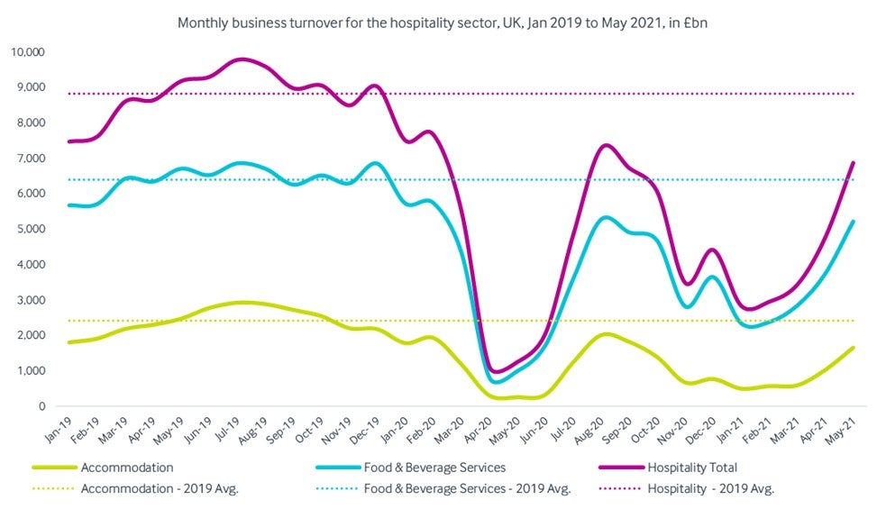
Source: (Rijal, 2022)
The higher turnover rate seems attributing to different factors:
- Demanding environment: Luxury hotels like The Ritz offers high expectations from the workers that lead towards the stressful and demanding workplace.
- Compensation and Advantages: There are some poor compensation and benefits that offer a high employee turnover in the overall industry (Rijal, 2022).
- Lack of career growth opportunities: Employees feel limited within the career growth opportunities that is leading towards job dissatisfaction and turnover.
For addressing the challenges, the Ritz Hotel needs offering of the competitive salaries, definite bonuses, and benefits for attracting top talent from the industry. It needs provision of the flexible scheduling options to maintain effectiveness in the work-life balance and make improvements in the employee satisfaction and overall retention.

Emergence of Different Work Modes in Five Years
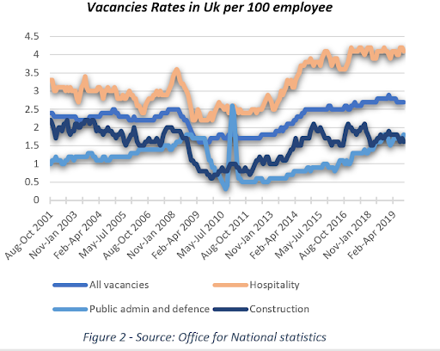
Source: (Klimkeit et al., 2024)
In the last five years, the hospitality industry in the UK implemented different working modes that are associated with the socio-economic factors like emergence of the COVID-19 pandemic, changes in the technological advancements, and changing in the employee preferences. Some significant developments are given as under:
Hybrid Working Arrangements
The increase in the hybrid working arrangements helped the employees to manage their time between working in the remotely manners and in-person. The trend has created in the COVID-19 pandemic where the hospitality venues have provided efficient Wi-Fi, charging points, isolated spaces, and quality products (Klimkeit et al., 2024).
Flexible Scheduling System
For addressing the work-life balance issues and effectiveness in the retaining of the employees, the hospitality organisations such as The Ritz Hotel have implemented flexible options in the scheduling management. It allowed employees to have part-time work, job sharing options, and flexible start with potential end times.
Remote Working Options
The hospitality roles have implicated the transitioned towards the remote working environments. It helped in the management of the customer service, sales and marketing, and administrative abilities. There are some definite advancements in the management of technology that allows the employees to manage duties with the stable internet connections (Kim and Torneo, 2021).

Management of Employee Performances
The Ritz Hotel is successful for providing the higher standards of employee with the training and development sessions. The hotel has gained a ranking #1 for the provision of the 'Training Top 125 Winners'. It offers extensive on-boarding facilities and certification programs for the existing and new hires. There are some potential daily line-ups for reinforcing the service standards and make efficiency for the collection and working on the employee feedback (Karatas, 2021). The provision of the ongoing training is helpful for the hotel to make continuous development of the employee skills in deliberate manner. The focus on the training ensures that the employees are equipped with possibilities and delivering of the Ritz's signature service within different modes.
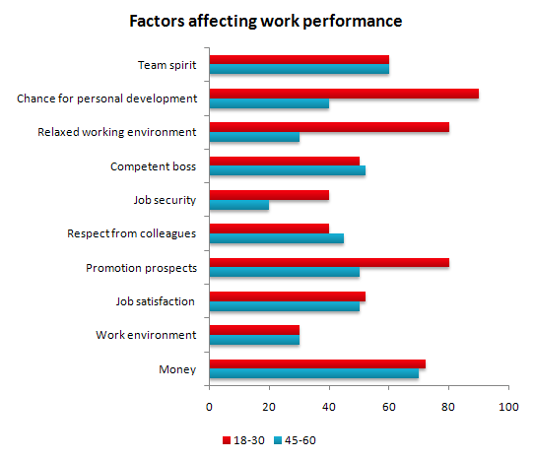
Source: (Jain et al., 2023)
The Ritz also offers effective recognition of the outstanding employee performance using provision of the small awards in the related departments and also managing and arranging of the larger hotel-level rewards. For example, the Ritz hotel offers awards to the members annually as considering the "Five-Star Team" while receiving the special recognition system (Jain et al., 2023). The recognition helps in motivating the employees and reinforcing abilities to deliver excellent services in the hospitality industry UK.

Evaluation and Conclusion
It has elaborated in the proposal report that for addressing the emerging challenges faced by The Ritz Hotel London, the HR department needs development of the effective strategies for management of the services. It needs effective monitoring of the employee performance within the different working conditions. The challenges should be identified as the specific socio-economic factors that directly impact on the employee performance and development of the targeted interventions for the support of the employees. Therefore, the services of the Ritz Hotel London must ensure that the employees are motivated, satisfied with the services, and make effectiveness in the performances that works to maintain positive reputation and successful elaboration in the competitive hospitality industry. The analysis has explored that the implication of the factors impacts on the consideration of the socio-economic forces based on the employees' performance. It helps in the management and monitoring of the workforce using different work modes and implementation of the focus on the successful manners in the hospitality industry with the services of the Ritz Hotel London. There are certain ways of examination that allows socio-economic forces to become influence with the employee performance and make effective discussion of the strategies for the success of the HR professionals and using mitigation of the effects for the promotion of the employee success.
From the learning of the socio-economic factors, the Ritz Hotel seem converting the changes in the economic values where the employees face some potential financial stress with respect to the economic instability. It impacts negatively on the maintenance of the job satisfaction and management of the overall performance. The process seem in mitigating the financial support and offer several benefits that are helpful for the employees to manage all the financial burdens. The Ritz Hotel London seemed offering the services of the diverse workforce that have influenced by certain social inequality and effect on the employee motivation and job satisfaction. Therefore, the employees coming from the lower socioeconomic backgrounds seems facing the additional challenges for the adaptation and fulfilment of the high standards and management of efficiency in the fast-paced environment. For addressing the system, the hotel needs implementation of the targeted initiatives to support the employees coming from different backgrounds. The hotel also needs provision of the flexible working arrangements and providing support to the family of the employees within the services that is helpful for the employees to manage all the emerging challenges.

References
Buitek, E.К., Kaliyeva, S.A., Turginbayeva, A.N., Meldakhanova, M.K. and Shaikh, A.A., 2023. How much does an employer's attractiveness matter to youth employment? Evidence from a developing country. Asia-Pacific Journal of Business Administration.
Hinson, R.E., Mensah, I., Amoako, G.K., Mensah, E.A., Coffie, I. and Khosa, E., 2024. Hospitality and Tourism Marketing: Building Customer Driven Hospitality and Tourism Organizations. CRC Press.
Hosseini, S.A., Moghaddam, A., Damganian, H. and Shafiei Nikabadi, M., 2022. The effect of perceived corporate social responsibility and sustainable human resources on employee engagement with the moderating role of the employer brand. Employee Responsibilities and Rights Journal, pp.1-21.
Jain, V., Wirtz, J., Salunke, P., Nunkoo, R. and Sharma, A., 2023. Luxury hospitality: A systematic literature review and research agenda. International Journal of Hospitality Management, 115, p.103597.
Karatas, B., 2021. The Project of Development of Human Resource Management System for a Chosen Company.
Kim, M.Y. and Torneo, A., 2021. The roles of strategic human resource management and person–environment fit on nonprofit public service motivation. Public Integrity, 23(1), pp.33-51.
Klimkeit, D., Wang, P. and Zhang, H., 2024. Global Management of Human Resources. In International Management in Service Firms: Environments, Strategies and Operations (pp. 627-664). Cham: Springer International Publishing.
Rijal, R., 2022. Factors influencing employee retention in the Nepalese hotel industry: The pathways to future research. Quest Journal of Management and Social Sciences, 4(1), pp.110-125.
Rouhani, S., Rezvani, M. and Madadi, Y., 2024. Human Resource Management Through Artificial Intelligence Model in the Healthcare. Qeios.
Sharma, B. and Rahim, M.A., 2021. TQM and HRM: an integrated approach to organizational success. Journal of Comparative International Management, 24(1), pp.27-41.

