Construction and Research of Network & Data Center Management Systems
Big Data Storage and Processing
ACCA6001 Network and Datacenter Management
Simon Thomas P146671
School of Applied Computing
Dr. Carleen Campbell

Abstract – The use of an enterprise network is ever more becoming the standard infrastructure for expanding companies that utilize large quantities of data. The same is also occurring with Big Data and processing with the increased population, social media and Internet of Things. How the two subjects relate to each other is an interesting subject of study.
Keywords – Data Center, Network Management, Network Security, Enterprise Network Design, Big Data and Processing

Introduction
With the advancements in system infrastructure and the growth of public hosted and hybrid cloud networks, most companies have centralized their own private network infrastructure over the past ten years with many companies who are going through a development transition doing the same thing. The use of centralizing an enterprise network and data center management[1] has the purpose of making the management of the corporate network more untroublesome while also insuring upkeep of other services such as file storage and backup.
While it is established that companies will outsource this management system to a contracted Data management company, it has become a form of practice that the management of the network and datacenter in does internal. There are also hybrid systems utilizing both internal services and management as well as the contraction of external services from technology companies an example would be Microsoft[2], but this would depend on the finances and resources of the company developing the management system.

This report will be a culmination of two tasks, the structure will be as follows firstly the research that will be used to complete the tasks. This research will include information on enterprise network, data center and how their facility to manage, store and process big data, secondly this report will cover the task of designing and implementing of an enterprise network and data center that will be hypothetically used by the University of Wales Trinity St David’s (UWTSD) and their partnered campuses. The final section of this report will be the relation between the designed enterprise network on the chosen research topic with a conclusion stating the overall experience of the tasks completed and what could be done in the future.

What is an Enterprise Network
An enterprise network is a large networking infrastructure that covers a corporations’ network capabilities including services provided and data. This large-scale network would consist of a number of data centers in strategic locations in conjunction with the corporations’ location. This connection between the over data center and the corporate locations would be done over one of two ways either over a Wide Area Network [3] or it can be used with or in conjunction with an Internet Service Provider [4]. The purpose of an enterprise network is essentially the plan and implementation of a network that covers a large infrastructure, storage space and necessary host connections so that a service and data can be provided and maintained constantly and securely [5]. Many technology companies provide solutions for enterprise networks example would be Cisco’s Digital Network Architecture (DNA) [5] and Microsoft System Center 2016 [6].

What is a Data Centre
A Data Center [7], [8] is a building or self-contained area within a building used to house Information Technology equipment such as servers alongside other associated components including network, storage and telecommunication. A data center has the capabilities of an uninterruptable power supply and a high bandwidth connectivity. A critical point is resilience which means that redundancy of the network, power and other substructures are a common practice to ensure continuousness. A data center is not someones office or your neighbours garage, it is not simply a location that house computers equipment. A data center is there to manage, store, process, manipulate or transmit digital data at a large scale. Which is housed or situated at a location that is controlled and protected, if it isn’t doing any of those things then it isn’t a data center[8].
The purpose of a data center is to store, process, manage and transmit large amounts of data. Corporate processes, government services, transport organizations and telecommunications all rely on a large enterprise network that are made up of data centers. Many everyday activities are only possible due to data center processes, this would include social application on smartphones, sending emails and less obvious things such as shopping online[8].

Datacenter Architechture
There are several separate areas that make up a data center most obvious is the server room this room is typically located at the center of the building or the self-contained unit and is the room or area that contain the vast number of computers that perform the processing and storage. The next area is the control room located near the server room it is where the onsite IT staff monitor the servers and security personal are station, the other areas are then used for redundancy and the physical security. As an enterprise network has great important for a company’s productivity, redundancy is something that is constantly mentioned when researching data centers.
Availability through Redundancy
A data center meaning is providing its network uninterrupted access to processing and storage space. The data center company SAP [7] provides a 99.995% availability to their partners and clients, this low downtime comes from the data centers’ redundancy, according to a SAP document on data centers it states that each utility that is required for the data center to function such as, providing electricity and cooling for the servers has redundancy put in place. For power supply a SAP data center is connected to two power grid sectors so in the event of a power outage in a location the servers will still have power, but they also employ battery’s and diesel generators on site to prevent down time between the switching of power grids. Electronic processing is known to create heat when in use, as with the power supply the cooling has a redundancy and for this SAP uses high efficiency water cooling which used a number of water pumps with redundant partners to pump cooled water around the server room and to heat exchangers located on the building roof.
In the event that the water supply fails the data center houses several water tanks that can take over from the water company to continually maintain the temperature in the server room. A more simpler redundancy system but just as important is the access to the internet, this is the network that all data is transmitted on and ensure that this correction is uninterrupted is vital to business survivability. For this data centers will utilize a number of different links between the server room and the internet.
Security
Security in networking is one of the most important aspects, humanity has evolved to the point where the internet and networking is utilised for the storage and productivity of corporations large and small. In the event of data being stolen or controlled by a third party it can destroy a company no matter the size and ruin the lives of all employed. As with all security within networking there are two types of security that can be utilized. Hardware based which uses Firewall Switches and other physical means such as lock, security cameras and alarms. The other being software which is the use of anti-virus/ malware software as well as software-based firewalls. For a data center which is typically its own building its physical security is just as complexed and its software. Physical security services would include cameras placed around and throughout the interior of the site, to ensure that there are no unauthorized personal onsite. The theft of data or the unauthorized access to the big data is more common practice than people would think. Corporate data of any kind is very valuable not just to the corporation but also their clients.
Another form of physical security is door locks typically the closer to the server room the more complex the lock and the more layers there are. For example, to gain access to the data center a person will only require a key or access card with permission, but to access the Server Room it will require both an access card with the correct permissions and a biometric scan either a thumb or finger print to confirm that you are the person who is accessing the room with the previously scanned access card [9]. As mentioned with software based security there are two types anti virus software[10] which is used to scan files that is stored on a system comparing that file to a malware database and if any file matches that of a known malware the file is quarantined. A Firewall[11] is typically a software that is built in to routers and switches, there are also switches that are designed to be a firewall device such as the Cisco ASA 5505 are used as an access control that inspects incoming traffic packets and utilised policy rules to determine whether the packet should be allowed entry or not.
A prominent standard of information security policy uses the CIA Triad [12]–[14] which stands for Confidentiality, Integrity and Availability. Each part of the triad represent a section that is seen to be required for security. Confidentiality is similar to privacy the measures are undertaken with the design of preventing sensitive information being seen by the wrong people. Integrity maintains the consistency, accuracy and trustworthiness of data over its life cycle. Data cannot be altered in transit and steps must be taken to ensure that third parties are not able to change the data in transit as well. Availability is best insured in a few ways firstly is the rigorous maintenance of all the hardware and that any faulty hardware is repaired as soon as possible. Secondly is redundancy as mentioned previously redundancy is a method of utilizing more than one piece of hardware at a location such as, if a switch is being used to connect servers, a second or even third switch is also being used in the event of a switch failure. Lastly is a backup a more common practice now due to cloud computing, as part of the availability a backup of all data must be kept in the event the primary data is lost or corrupted.

Mesh Topology
A Mesh Topology [15] is a network setup where each computer device is interconnected with at least one other device as seen below (Fig1), this allows for most transitions to be distributed even in the event of connections going down. In data centers due to the number of devices that are housed within a mesh topology is used to guarantee that no connection is lost due to faulty equipment or accidents.
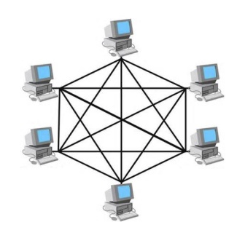
Mesh Topology example (Fig1) [15].
Three Layer Hierarchy
As its name suggests the approach to the hierarchy that is used in data centers is one that utilizes three layers Core, Distribution also called Aggregation and Access[15]. The layered approach is used as the foundation for data center design as it can improve scalability, performance, flexibility, resiliency, and maintenance. Fig2[16] shows the basic layered design
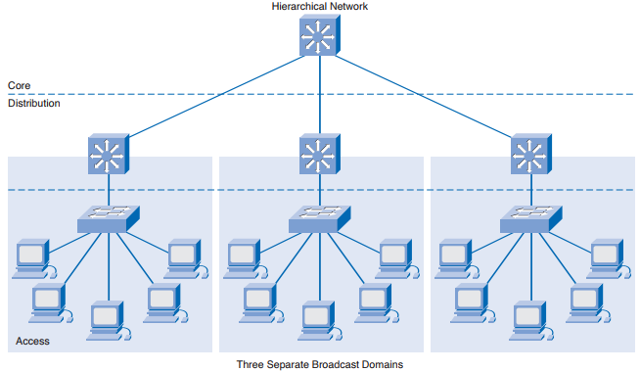
Three Layer Hierarchy example (Fig2)[16].
Core layer – Is the backbone of the network that provides high speed packet switching for incoming and outgoing data, the core layer provides connectivity to multiple ports and devices on the Distribution layer and provides resilient routing. The core layer runs interior routing protocols such as EIGRP and load balancing between Core and Distribution layers[15]. This layer consists of Routers, Firewalls and layer 3 switches, the ratio of these devices in the hierarchy would depend on the scale of the network.
Distribution/ Aggregation layer – this layer provides the middle connection between the Core and Access layers, services that come under this layer includes definitions of layer 2 domains, spanning tree protocol (STP) and security switching such as intrusion detection[15]. This layer consists of layer 3 switches as they can utilize routing capabilities at the increased security that comes with it.
Access layer – this layer is where the servers, computers and other end devices are physically connected to network[15]. This layer is mostly consistent of layer 2 and 3 Switches which can fulfil the various domains and requirements of the network.

The Four V's of Big Data
The concept of Big Data as it is currently seen was established in the early 2000s by Gartner, assumed under the title of the three Vs from a research note published by Doug Laney in 2001[17]. At that point the three Vs stood for Data Volume, Data Velocity and Data Varity.
Data Volume represents the increased magnitude of available data that is being created and stored by users and corporation. Data Velocity is the amount of data that is being exchanged with Internet of Things the velocity of data is only going to increase with currently no evidence to show otherwise. Data Variety in the different forms of data, with the use of social media and corporation such as health care going digital the different data types that are a part of big data is also in the same situation. Some time later the technology company IBM introduced a fourth V (Fig3) which stands for Data Veracity, this section on big data is the increasing uncertainty that surrounds data. As people and companys’ use more and more data it is becoming more difficult to be sure if the data it had is trusted and accurate[18].
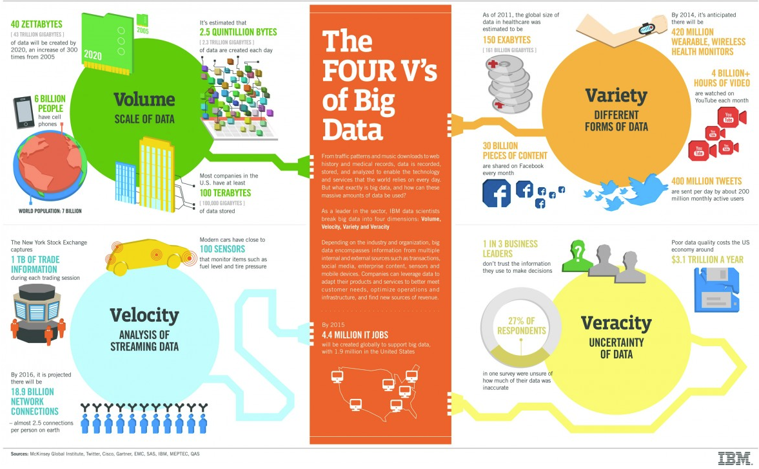
Infographic of the Four Vs Fig3[18].

Design of Enterprise Network
This section of the report will cover the task to design an enterprise network for the University of Wales Trinity St David and its partnered campuses. The task of making the network had the designer make assumption on how the network would look and what requirements will be needed to make the network be utilizable by the University.
Server Farms
As with any enterprise network, the design had to include the following server farms.
Internet Server Farm – This was assumed to be used in the network to provide a connection to services found on the Internet such as Domain Name System and Email.
Extranet Server Farm – This would provide the network with services accessible to all campuses such as access to the corporate information and backups. It is assumed in this situation that the Extranet Server farm is located off campus, more than likely in a data center.
Intranet Server Farm – This would provide data to the network with data only accessible to the corporation, as Swansea was set up as the main campus the Intranet is assumed to be located here in its server room.
While these three server farms were outlined it was also assumed that each campus would have a local server to store files locally and provide information and service locally if required these included System Logs and Dynamic Host Configuration Protocol.

Remote Access
For the enterprise network remote access would be required due to the large scale of the infrastructure. The campus Administrator and a high management member of staff would both have Telnet access to the router and switches of their respected campus as well as remote access to the Extranet farm via Secure Shell (SSH).
Private Wireless Area Network
As this network is going to be across multiple campuses a Private Wireless Area Network (WAN) is going to be used. Most of the campuses are located in the United Kingdom and a private WAN can be established across the nation to provide a direct link between the campuses. This will improve the availably bandwidth and ensure that standards that need to be held by the universities are kept. One of the partnered campuses is located in Malaysia it is assumed that the distance between the campus location is too great for the Private WAN and so a direct line would be established through an Internet Service Provider to provide the campus with the required connections.
Services
For an enterprise network it is assumed that there would be several services utilized by the campuses and server farms. For this design services would include Load balancing, which would allow the computing resources located at each campus and Datacenter to be used in a manner that would allow throughput to be maximized and response time to be minimized.
Security services
This enterprise network will utilize security as mentioned in the research portion of this report. It is assumed that the design will include at each location physical security such as locks, cameras and security personnel, internally the network would feature the basic software antivirus and firewall. But would also operate a Firewall Switch the use of an access list as well as encrypted passwords and the shutting down of ports.
Storage services
For this enterprise network two storage services will be used first is Storage Area Network (SAN), which is a form of file system that employs a network structure to provide ease of access to data as well as the simplicity to expand storage if and when required. This service is to provide staff will access to the necessary files while also allowing UWTSD the ability to scale the storage through the network when required. The second service is a secondary backup location while Swansea campus is the main campus and is assumed to house a Backup server, the best policy to have is the use of a secondary offsite location and for this enterprise network the data center will have that service.
Concept design
The image below shows the basic layout and design of the enterprise network for UWTSD, the structure for the Internet is a basic set up for the servers. The internet is not managed by UWTSD and it is assumed the purpose the Internet Server Farm is to simply provide the services needed in the enterprise network. The Extranet farm may not be managed by UWTSD but it is assumed that the administrator can set requirements that the data center must follow. The Data center network uses a firewall for security and two layers 2 switches for redundancy.

As Swansea campus was stated from the start as the main campus it was assumed to be the location of the intranet farm for this reason Swansea campus was designed first with the other campuses being a copy of the hierarchy. Swansea campus can be seen to utilize a firewall two layer 3 core switches for redundancy, two layer 3 layer distribution switch also for redundancy and 2 layer 2 access switch for the same reason.
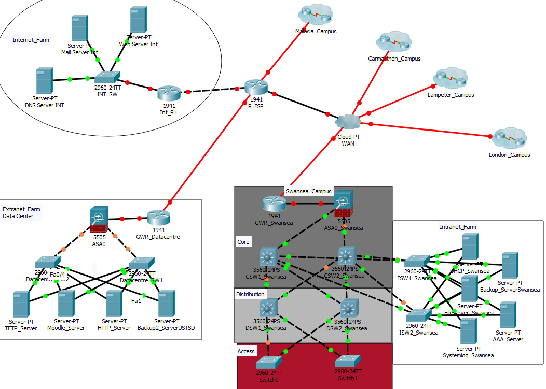
Concept design for UWTSD Fig4.

Implementation of Enterprise Network
When implementing the design in to the Cisco Packet Tracer software it required the assistance of several videos and guides to figure how to build an enterprise network in Packet Tracer the most helpful was done by Srinivas Dhareddy[19]. Using this guide, I was able to create a basic network that utilized services for an enterprise network. Seen image below Fig5.
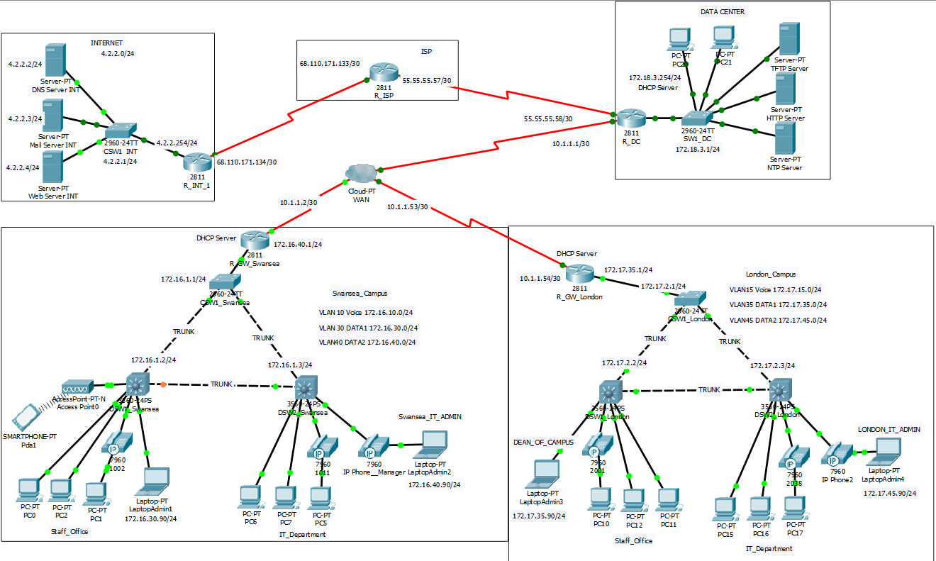
Enterprise Network for Swansea and London Fig5.
The next step in the implementation of the enterprise network was to combine the network design for UWTSD with the enterprise network made with the guides. The image below is the finished enterprise network Fig6.
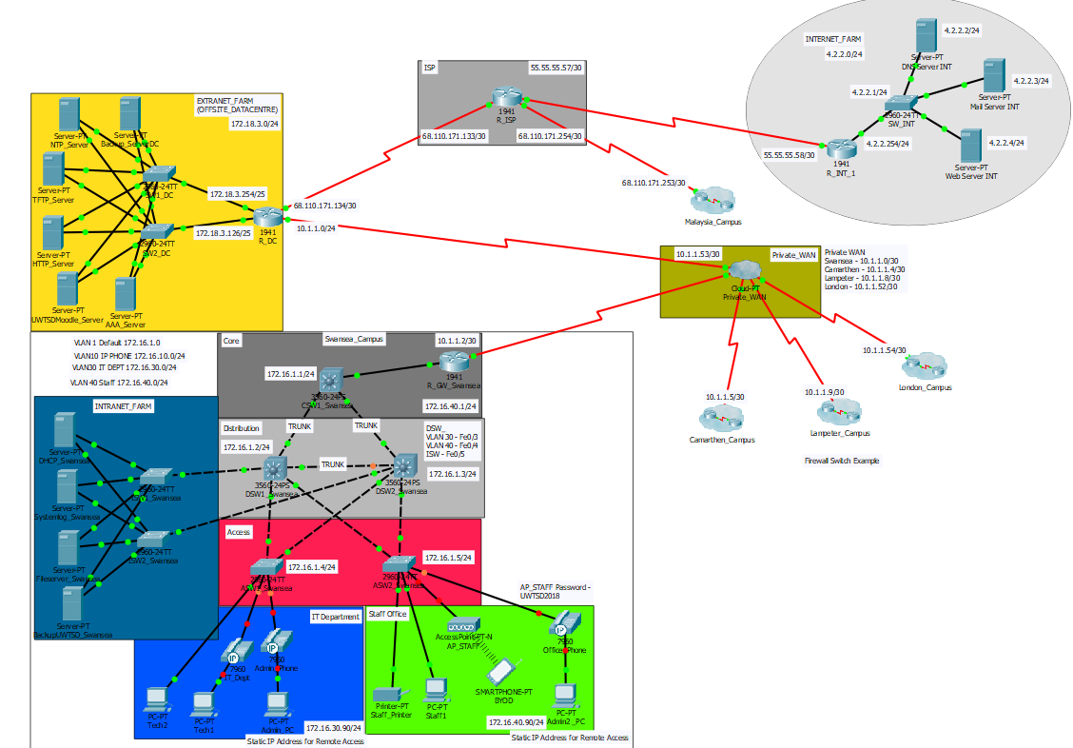
UWTSD Enterprise Network Fig6.

Results
After the implementation of UWTSD network with what was used in the research and guides to construct the network there were a few problems with it this included connections not being established, VLAN mismatches and DHCP errors. While on the basis the IP address seems to be correct and most of the ports are set up correctly there appears to be an issue with how the VLANs have been set up on each Switches. Troubleshooting hasn’t seemed to be a success and that is believed to be for two reasons firstly the knowledge at the current time gives the impression insufficient to the problem at hand and secondly using the foundation of a network that only meet a few requirements of the task were impractical.

Conclusion
To conclude after researching and discussing enterprise networks and big data, UWTSD currently stores and processes a large quantity of data that includes the records and files of staff and students that attend the university. At the current scale to manage it would seem unreasonable to think that UWTSD could be seen in the same bracket as technology companies such as Facebook and the NHS that process and store billions of records daily. With the scaling aside, the fundaments of having big data and processing are relatable in redundancy and security. Both systems demanded a near perfect network that would prevent access to the data that is stored, they also relate to security both enterprise data and the big data are crucial for the survivability of a company and security above all else. In the future it would be great to go over this enterprise network again to establish where it went wrong with knowledge gained with experience, also to utilize this task in future employment if required as its seen as a network that can provide security, scalability and security.

References
[1] Cisco, “Data Center Management: The Key Ingredient for Reducing Server Power While Increasing Data Center Capacity,” 2010.
[2] Microsoft, “System Center 2016,” 2016.
[3] Cisco Networking Academy Program., Connecting networks companion guide. Cisco Press, 2014.
[4] R. D. Doverspike, K. K. Ramakrishnan, and C. Chase, Guide to Reliable Internet Services and Applications. 2010.
[5] A. Reid, J. Lorenz, and C. Schmidt, “Exploring the Enterprise Network Infrastructure Objectives,” in Introducing Routing and Switching in the Enterprise, CCNA Discovery Learning Guide, Cisco, 2008.
[6] Microsoft, “System Center 2016 – Datacentre Management | Microsoft.” [Online]. Available: https://www.microsoft.com/en-gb/cloud-platform/system-center. [Accessed: 09-Jan-2018].
[7] SAP, “How a Data Center Works.” [Online]. Available: http://www.sapdatacenter.com/article/data_center_functionality/. [Accessed: 09-Jan-2018].
[8] E. Fryer, “Er, what IS a data centre?,” 2013.
[9] G Suite, Inside a Google data center - YouTube. 2014.
[10] J. Koret and E. Bachaalany, The Antivirus Hacker’s Handbook. Wiley.
[11] Cisco Systems, “INTRODUCTION TO FIREWALL SECURITY.”
[12] A. Saman Shojae Chaeikar et al., “Definitions and Criteria of CIA Security Triangle in Electronic Voting System,” Int. J. Adv. Comput. Sci. Inf. Technol., vol. 1, no. 1, 2012.
[13] Kinamik, “The CIA triad: Have you thought about Integrity?,” 2007.
[14] TATA, “Information Security: The CIA Triad | TCS Cyber Security Community,” 2015. [Online]. Available: https://securitycommunity.tcs.com/infosecsoapbox/articles/2015/10/27/information-security-cia-triad. [Accessed: 09-Jan-2018].
[15] Cisco Systems, “Cisco Data Center Infrastructure 2.5 Design Guide.”
[16] K. Stewart, “Introducing Network Design Concepts Objectives,” in Designing and Supporting Computer Networks, 2008.
[17] D. Laney, “3-D Data Management: Controlling Data Volume, Velocity and Variety,” 2001.
[18] IBM, “Infographic: The Four V’s of Big Data | IBM Big Data &amp; Analytics Hub,” IBM. [Online]. Available: http://www.ibmbigdatahub.com/infographic/four-vs-big-data. [Accessed: 09-Jan-2018].
[19] S. Dhareddy, Enterprise Network Design in CISCO Packet Tracer (6.1.1) - YouTube. 2014.

Figure Gallery
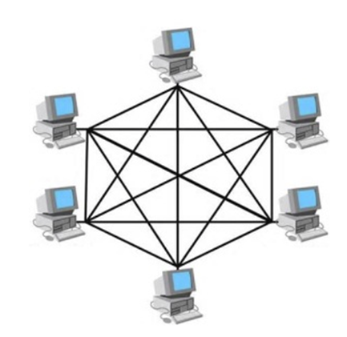
Mesh Topology example (Fig1) [15]
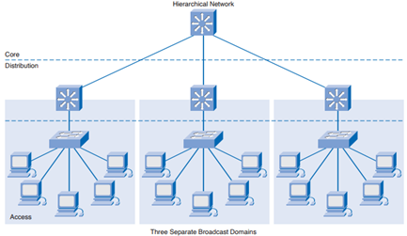
Three Layer Hierarchy example (Fig2)[16].

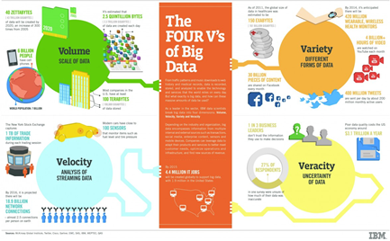
Infographic of the Four Vs Fig3[18].
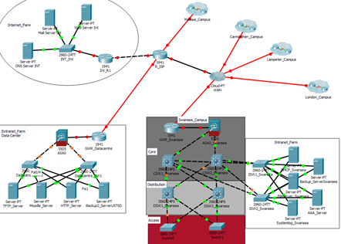
Concept design for UWTSD Fig4.

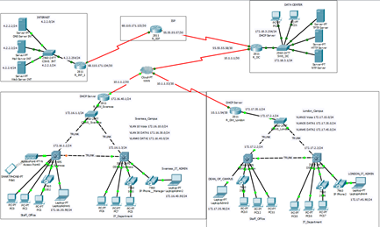
Enterprise Network for Swansea and London Fig5.
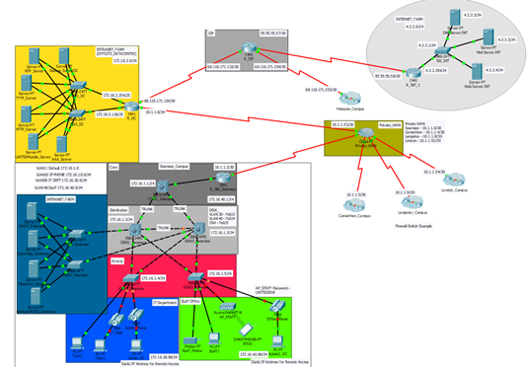
UWTSD Enterprise Network Fig6.

marking criteria and Student FEEDBACK

This section details the assessment criteria. The extent to which these are demonstrated by you determines your mark. The marks available for each criterion are shown. Lecturers will use the space provided to comment on the achievement of the task(s), including those areas in which you have performed well and areas that would benefit from development/improvement.

Common Assessment Criteria Applied (Assignment 1) | Marks available | Marks  awarded
1. Research-informed Literature
Extent of research and/or own reading, selection of credible sources, application of appropriate referencing conventions.
Some areas of the research informed literature could be referenced. More credible reference sources could be utilised. Referencing convention used. (Grade mark: 66.67%) | 15 | 10
2. Knowledge and Understanding of Subject
Extent of knowledge and understanding of concepts and underlying principles associated with the discipline.
Exhibits understanding of the research informed literature. (Grade mark: 66.67%) | 15 | 10
3. Analysis
Analysis, evaluation and synthesis; logic, argument and judgement; analytical reflection; organisation of ideas and evidence
Your abstract could be improved, it should be a concise summary of a body of information of your report. Its purpose is to make it possible for potential readers to quickly find out if the work is relevant to their needs and worth reading. Your conclusion could be improved by summarised more key areas of the report and clearly indicate what improvement could be done in the future to improve your finding. (Grade mark: 63.33%) | 30 | 19
4. Practical Application and Deployment
Deployment of methods, materials, tools and techniques; application of concepts; formulation of innovative and creative solutions to solve problems.
A great blueprint for a network design showing the redundancy and failover is considered. The lack of continuity in the configuration hinders the testing of the DHCP and Pings across the network. Had these been in place the marks would have reflected this. No consideration to remote access or VPN is shown within the design however. All campuses and explanations over the firewall are evident and clearly defined. Overall a good design but lacking in configuration. (Grade mark: 63.33%) | 30 | 19
5. Skills for Professional Practice
Attributes in professional practice: individual and collaborative working; deployment of appropriate media; presentation and organisation.
Work could be formatted to look more presentable. Some spelling and grammatical errors.  (Grade mark: 60.00%) | 10 | 6

Assignment Mark (Assessment marks are subject to ratification at the Exam Board. These comments and marks are to give feedback on module work and are for guidance only until they are confirmed. ) | Late Submission Penalties (tick if appropriate) |  | 64%
 | Up to four weeks late |  | 64%
 | First Attempt? |  | 64%

