Investigating the Functions of Operating Systems and Command-Line Interfaces: A Comparative Analysis of Windows and Linux
Name: Aaron Ahmed Student No: 2419108
Course Name: ACC04022
Module Name: Computer Architecture and Operating Systems

1. Introduction
The operating system is as the for any computing environment, managing hardware resources and enabling services users to have contacts with their systems efficiently. Along with the operating systems that is used today in Windows and Linux, each offering many features, interfaces, and capabilities tailored to the users needs, if for personal, professional, or technical purposes.

This report shows a inclusive contrast of Windows and Linux, with a specific focus on their command-line interfaces (CLI) and capabilities.

For graphical user interfaces (GUIs) control users' interaction, the command-line interface is still as an essential tool for advanced users such as developers, system administrators, and cybersecurity professionals. The CLI allows for exact control over the operating system, allows users to perform complex tasks efficiently and automate processes. Understanding how to use CLI environments in both Windows and Linux is therefore a important skill to be able to improve productivity and managing systems successfully.

2. Key Functions of General Operating Systems
Operating Systems manages a computer by conrolling different type of proccesses such as memory, files, and hardware devices. This provides a user interface where loks all the imprtant peice of inurement locked up. This is also one of the best types of secure systems that can save users from getting encrypted data stolen and taken out to the open. This also saves information that is secured and placed in the safe place such as the hardware where information is put in a place to be protected and harder for hackers to steal from the user.
One of the core responsibilities of os is to make it secure for users to feel secure while they are using their own device. Another secure feature is that files will be placed in order A-z making sure all the work is in order for the user to find the folder they are looking for more easily.
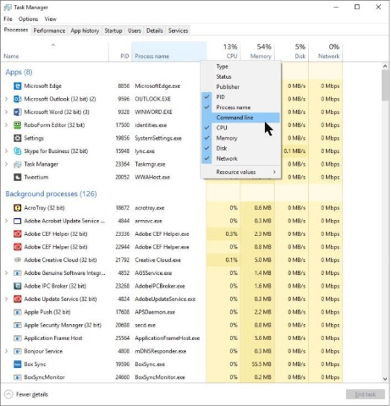
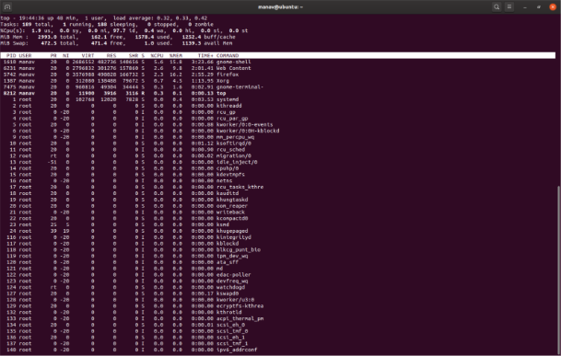

b. Memory Management
Memory management pertains to the manner in which the operating system manages RAM allocation, swapping, paging, and caching. Effective memory management guarantees that each process receives the necessary memory without disrupting others, and it aids in the prevention of memory leaks and system crashes. Windows: The Resource Monitor located in the Performance tab of Task Manager provides comprehensive information regarding memory utilization and available resources.
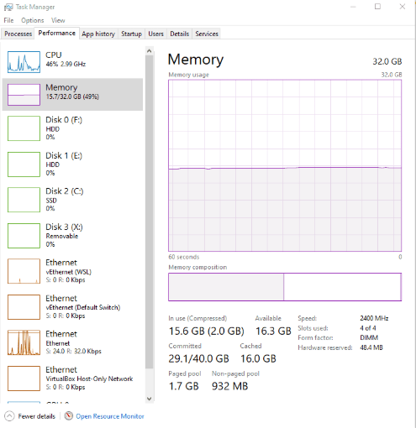
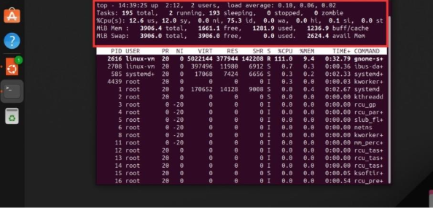

c. File System Management
File system management allows the operating system to arrange, store, access, and protect data on storage devices. It manages directory structures, permissions, metadata, and file read/write functions. Windows: File Explorer provides a visual representation of the hierarchical directory structure and file attributes.
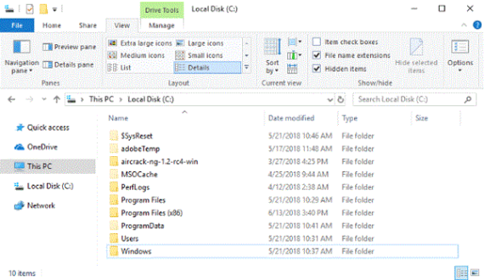
.
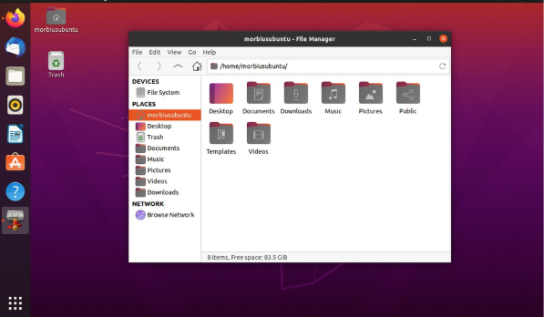

d. Device Management
The operating system engages with all hardware components by converting high-level commands into low-level instructions that the hardware can understand. This encompasses the management of keyboards, printers, displays, hard drives, and external peripherals. Windows: The Device Manager enables users to see and manage hardware devices, as well as to update or resolve issues with their drivers.

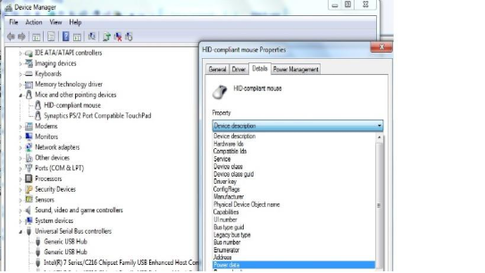
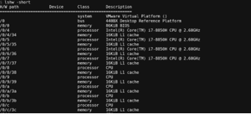

e. User Interface (UI)
The user interface (UI) helps interaction with the operating system through either a Graphical User Interface (GUI) or a Command-Line Interface (CLI). GUIs are user-friendly, in contrast to CLIs, which excel in automation and complex tasks. Windows: The more prevalent graphical user desktop features the Start menu, taskbar, directory structure explorer, and command box.
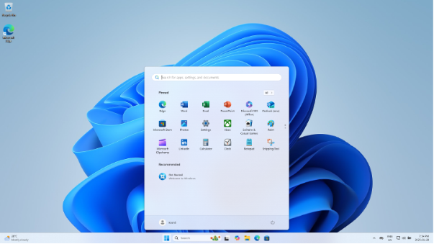
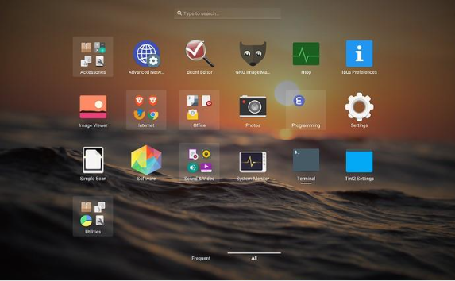

f. Security and Access Control
Operating systems play a crucial role in enhancing system security by helping the implementation of mechanisms following user authentication, file system permissions, encryption, and role-based access control. These protective measures guarantee that only authorised users can access sensitive data or perform critical tasks. Windows: Windows includes security features such as User Account Control (UAC), BitLocker encryption, and file permissions accessible through the Windows interface.
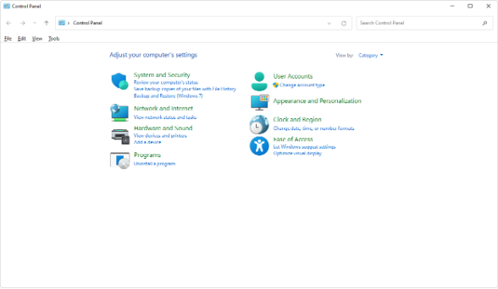
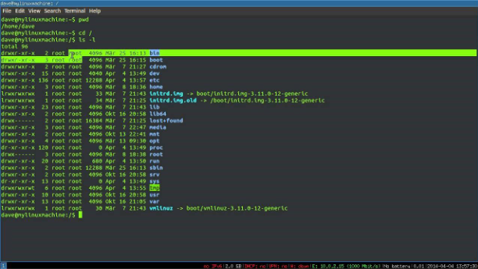
3. Use of Windows OS CLI Commands
The Windows Command-Line Interface (CLI), commonly referred to as the Command Prompt (cmd.exe), serves as a powerful tool that allows users to interact with the operating system through text-based commands. It is indispensable for tasks such as administrative work, debugging, and automation.

1. dir – List Directory Contents
Command:
dir
Description:
The dir command shows the names of all files and subdirectories within the current directory. It provides details about the file type, size, and the date it was last modified. Use Case: This command can be particularly useful when navigating through multiple directories or when verifying the existence of a file prior to performing operations such as copying or cutting.
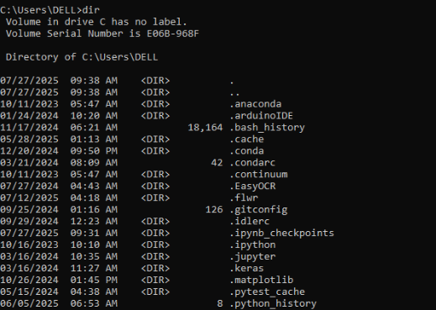
2. cd – Change Directory
Command:
cd Documents
Description:
The cd (change directory) command allows you to navigate to a specific folder within the file system. Use Case: This is necessary for accessing files located in different folders or directories via the CLI.
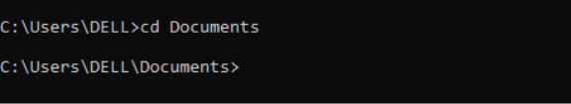
3. copy – Copy Files
Command:
copy file1.txt E:\Backup\
Description:
The command known as copy is used for duplicating a file to an alternate location.
Use Case:
It is widely employed for backing up files or for transferring data across different folders and disks.
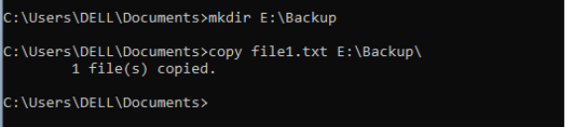
4. del – Delete Files
Command:
del file1.txt
Description:
Permanently removes the designated file from the current directory.
Use Case:
This command is used for swiftly dropping outdated or unneeded files directly from the command line.
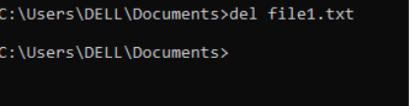
5. ipconfig – Display Network Configuration
Command:
Ipconfig
Description:
Displays more details such as your network interfaces, the default gateway, the subnet mask, and the IP address. Use Case:
Necessary ford is playing and diagnosing network problems or verifying IP address allocations.
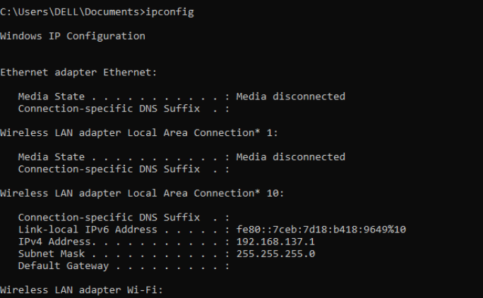
6. ping – Test Network Connectivity
Command:
ping google.com
Description:
Transmits test packets to an IP address or domain to assess network connectivity methods
. Use Case:
Utilised to understand network problems and to verify if an external host is accessible or not.
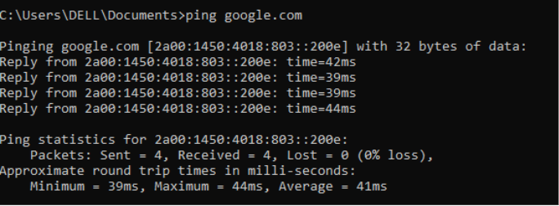
7. tasklist – List Running Processes
Command:
Task-list
Description:
Displays a comprehensive list of all active processes along with their respective memory usage.
Use Case: This can be beneficial for monitoring resource consumption or naming processes that need to be ended.
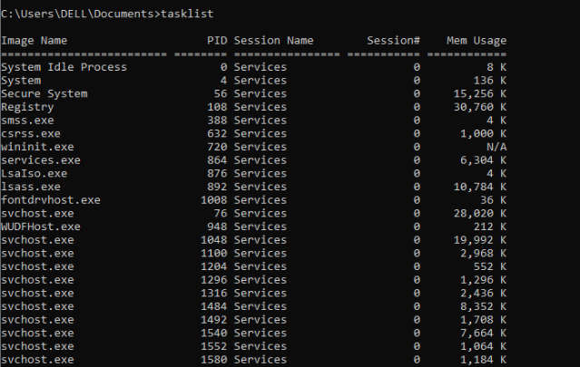
8. systeminfo – Display System Information
Command:
Systeminfo
Description:
Comprehensive overview of the system, including the operating system version, total installed memory, boot time, and more relevant details.
Use Case: Ideal for conducting audits or supporting a record of system configurations.
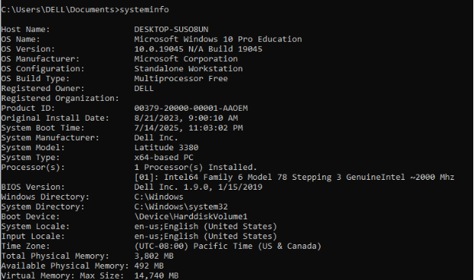
9. netstat – View Active Connections
Command:
netstat –an
Description:
Shows all current network connections along with their respective ports, detailing the protocol in use and the status of the connection.
Use Case: Frequently used in security evaluations and for verifying open or listening ports.
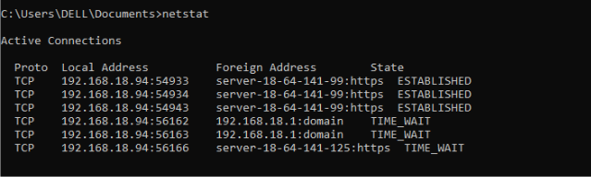
10. shutdown – Shut Down or Restart the System
Command:
shutdown /s /t 0
Description:
Immediately powers down the system. The /s command is appointed for shutdown, while /t 0 configures the timer to 0 seconds.
Use Case: This is beneficial for remotely turning off computers or for automating shutdown procedures within scripts.
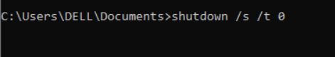

4. Use of Linux OS CLI Commands
1. ls – List Directory Contents
Command:
ls
Description:
Shows all files and folders in the present working directory.
Explanation: This command serves to swiftly display the contents of a directory. It is beneficial for managing files and confirming the structure of the directory.
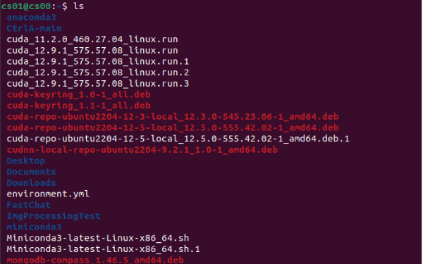
2. cd – Change Directory
Command:
cd Documents
Description:
Changes the current working directory to Documents.

3. cp – Copy Files or Directories
Command:
cp file1.txt backup/
Description:
Copies the file file1.txt into the backup directory. Explanation: This command is used to replicate files or directories. To perform a recursive copy of directories, include the -r possibility.
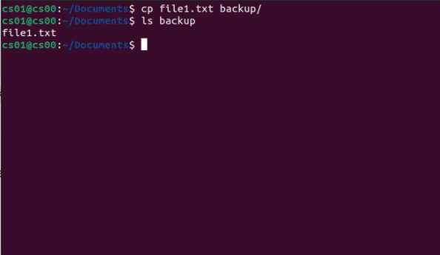
4. rm – Remove Files or Directories
Command:
rm oldfile.txt
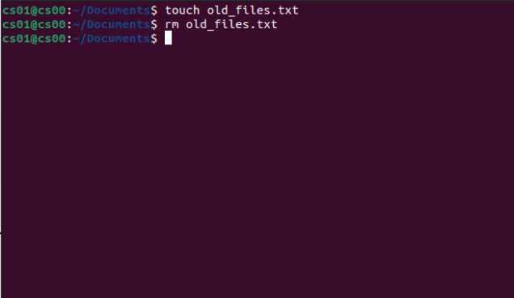
5. ifconfig – View Network Configuration
Command:
Ifconfig
Description:
Shows current network interfaces and IP addresses.
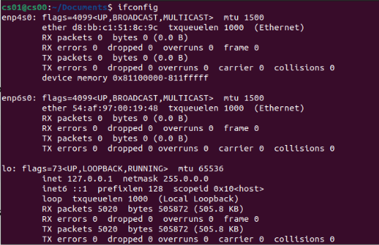
6. top – View Running Processes
Command:
top
Description:
Live observation of system processes, CPU, and memory use.
Explanation: Beneficial for tracking system performance and finding resource-intensive processes. Press q to quit.
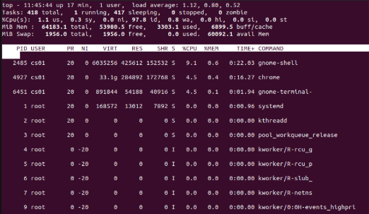
7. uname -a – Show System Information
Command:
uname –a

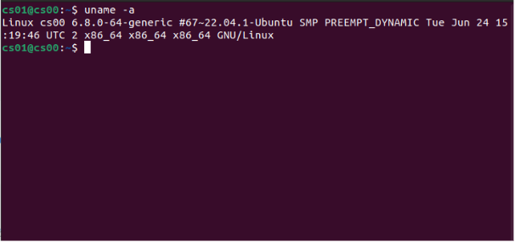
8. df -h – Disk Usage
Command:
df –h
Description:
Displays utilised and available disk space in a format that is easy to read.
Explanation: Helps in deciding the amount of storage being still and whether any partition is approaching its maximum capacity.
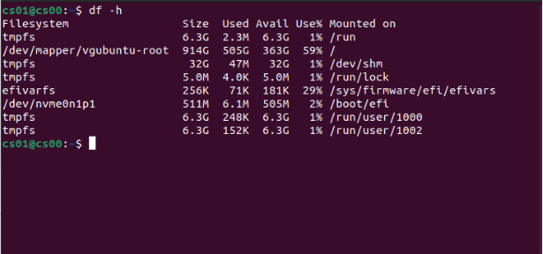
9. ps – List Active Processes
Command:
ps aux

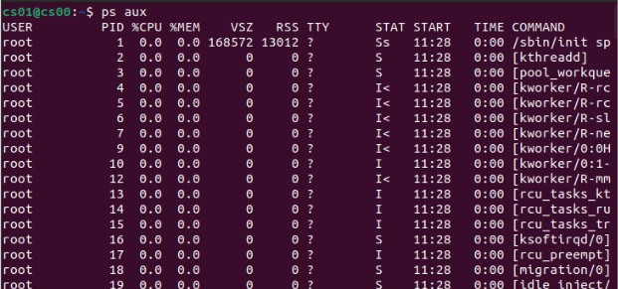
10. shutdown – Power Off the System
Command:
sudo shutdown now
Description:
The system is shut down at once.
Explanation: This command is used to safely power off the system. To start an immediate reboot, use shutdown -r now.
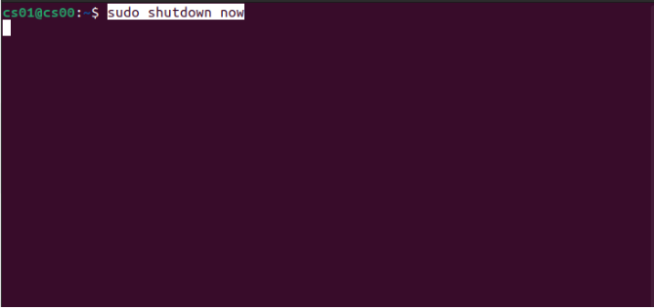
5. Use of Windows OS Scripts
Example using Batch script
@echo off
echo Displaying IP Config
ifconfig
pause

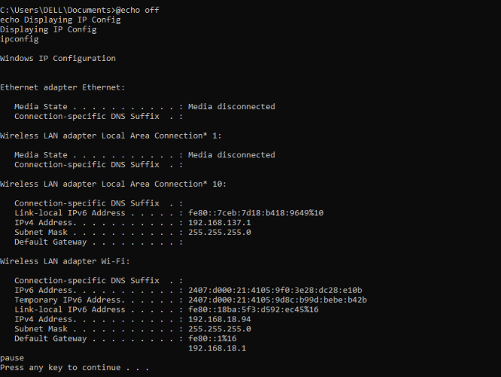
6. Use of Linux OS Scripts
Example Bash script:
#!/bin/bash
echo "System Information"
uname -a

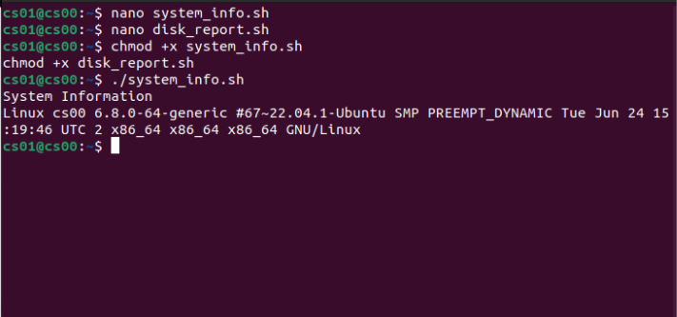
Another example:
#!/bin/bash
echo "Disk Usage Report"
df -h > disk_usage.txt

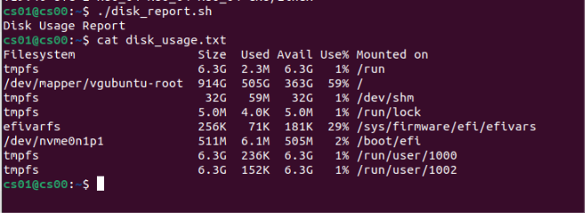

7. Conclusion
To conclude this report has shown the main functions of the general-purpose operating systems, with the focus on being how both Windows and Linux tool these functions through their own tools, interfaces, and design. The comparative analysis not only outlined key concepts such as process management, memory allowance, file systems, device communication, user interaction, and security, but also can show their practical request through command-line and scripting methods.

Even though Windows and Linux perform with similar basic roles, they are still quite different majorly in them towards their system management. Windows focuses on use through a developed Graphical User Interface (GUI), enabling users to navigate and manage the system without needing to high level technical knowledge. Built in tools such as Task Manager, Resource Monitor, Device Manager, and File Explorer simplify system interaction for both everyday users. Also, automation is provided through PowerShell and traditional Batch scripting, although these are often viewed as a smaller flexible compared to Unix-based alternatives.

On the other hand, Linux shows a command-line-oriented go ahead. While this may present a steeper learning curve, it gives a stronger control, flexibility, and transparency. For users to interact directly with a low-level system function using tools such as top, free, chmod, lsblk, and sudo. Its Bash shell and scripting capabilities allows efficient automation and precise system arrangements. Overall, Linux is specifically better for system administrators, developers, and cybersecurity professionals who need an important level of control over their computing environment.

References:
- Silberschatz, P. B. Galvin, and G. Gagne, Operating System Concepts, 10th ed. Hoboken, NJ, USA: Wiley, 2018.
- Microsoft Corporation, "Windows Command Line documentation," Microsoft Learn, 2024. [Online]. Available: https://learn.microsoft.com/en-us/windows/terminal/
- The Linux Foundation, "Introduction to Linux," edX, 2024. [Online]. Available: https://www.edx.org/course/introduction-to-linux
- J. Shotts, The Linux Command Line: A Complete Introduction, 2nd ed. San Francisco, CA, USA: No Starch Press, 2019.
- Microsoft Corporation, "PowerShell Documentation," Microsoft Learn, 2024. [Online]. Available: https://learn.microsoft.com/en-us/powershell/
- Sommerville, Software Engineering, 10th ed. Harlow, UK: Pearson, 2015.

