

Undergraduate assignment feedback form
(to be completed by marker)

Student Name:
Katherine Dillon
Module Code: HUSK 6004  Module title: Roderic Bowen Centre: Archives and Research | Student number: 1501864
For completion by marker:
Comments:

Marker’s signature: |  | Date:
Provisional mark:
NB. All marks are provisional until confirmed by the final examination board.

A selection of equine anatomical plates from The Anatomy of a Horse, by George Stubbs (1724 -1806) and hand drawn plates from The Beauties and Defects of the Horse, Comparatively Delineated in a Series of Coloured Plates, by Henry Thomas Alken (1785 – 1851).
It was not until the 1930’s that the eighteenth-century artist George Stubbs who, while highly regarded for his equine portraiture, was appreciated for his equine anatomical illustrations. The writer and poet Geoffrey Grigson (1905 -1985) wrote that Stubbs was something other than a “horse painter,” he was a “painter who painted horses;” according to Grigson, this was an entirely different genre. To Grigson, Stubbs was a “scientific painter” and a “naturalist.” Drawing attention to Stubbs’ work, The Anatomy of a Horse, printed in 1766, Grigson described the evolution of the works of Stubbs, from an artist who made a living from commissions to that of a respected anatomist, a passion to which he had aspired since he was a child.
Stubbs is arguably most well-known for his paintings of equines and, it is his anatomical works on horses that make his portraits so realistic. His deconstruction of carcasses enabled him to understand the structural make-up of the horse. There is little doubt that he would have drawn his inspiration for methodology from the human anatomist Bernhard Siegfried Albinus, as his Tabluae Sceleti et Musculorum Corporis Humani was published in 1747, when Stubbs had work as an anatomist in York. In the preface to his work, Albinus described his methods of dissection and “reassembly” of the skeleton, a technique later adopted by Stubbs.

The Anatomy of the Horse, 1766, by George Stubbs (1724 – 1806).
George Stubbs’ book, The Anatomy of the Horse, took ten years to create and, contains eighteen diagrams of a horse in various stages of anatomical composition and, in varying positions. The diagrams each have a matching text with keys connecting the text to the diagram, enabling the reader to study the diagram while referring to the text for detail.
Each diagram is the print of an engraving done in Stubbs’ own hand, a skill he had been perfecting for around ten years before he compiled his book. He had been unable to find an engraver who was willing to produce work for him due to their lack of understanding of the subject.
Stubbs’ illustrations show the frame of the horse through various stages of development. Stubbs’ friend and fellow artist Ozias Humphry, related in his memoirs how Stubbs, through dissection, took the body apart, wrote down the details and, reconstructed the animal in the form of a drawing. Stubbs carefully recorded every stage of the process while peeling the layers back to the skeleton.

Image One
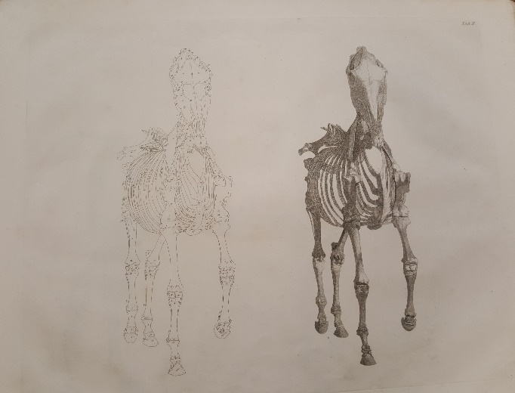
The sixth plate from The Anatomy of the Horse by George Stubbs, 1766.
Second Anatomical Table. Engraving and Key

Image one is from the Second Anatomical Table and is the sixth plate from Stubbs’ The Anatomy of the Horse. According to Humphry, Stubbs would have made the drawing of the skeleton before he began the process of dissection. The carcass of the horse was left hanging in the room that Stubbs had set aside for this purpose, sometimes for up to six or seven weeks after the blood was drained from the animal via the jugular vein. The plate shows the frontal view of two skeletons of a horse alongside each other, in motion. The skeleton on the left side of the plate show the keys that allude to the corresponding text. When studying the drawing alongside the keys it is possible for the reader to interpret Stubbs’ illustration. By using hooks and iron tackles the body was fashioned into the position which Stubbs required for the illustration. The engraving for this illustration was done using strokes of the engraving tool (burin) that showed the whiteness of the bone.

Image Two
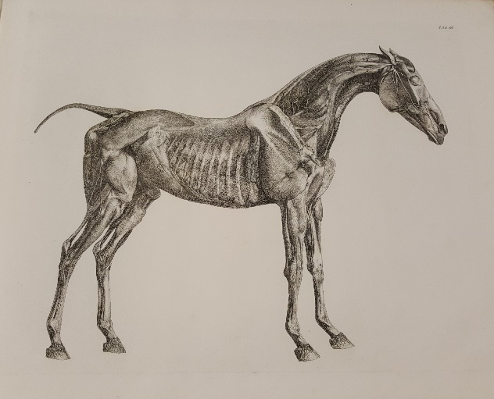
The Tenth plate from The Anatomy of the Horse by George Stubbs, 1766.
Fourth Anatomical Table. Engraving.

Image two is an example of the next stage of Stubbs’ work and, is taken from the fourth anatomical table. It is said that Albinus inspired Stubbs to prepare by firstly making the drawing of the skeleton. After the skeleton had been sketched he would draw the soft tissue, rebuilding the layers over the naked skeleton by referring to the explanations he had carefully recorded. In this image it is possible to see the minute detail of the nerves within the hoof. The shoulder bone is prominent in this instance and, it is possible to see how Stubbs has begun to build up the muscles over the skeleton. Some of the larger veins can be seen, particularly in the neck; Stubbs was thought to inject the veins and arteries with hot wax to keep their shape. The engraving in this image is far more intricate than that of the skeleton as, the lines used for etching muscles requires far denser etching than it does for bone.
Image Three
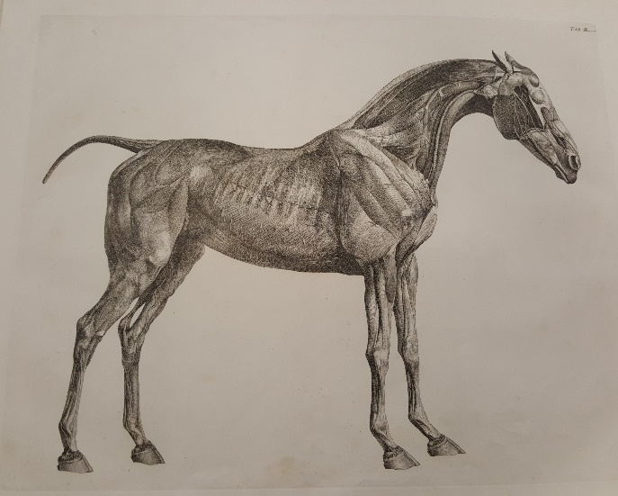
The seventh plate from The Anatomy of the Horse, by George Stubbs, 1766.
Second Anatomical Table. Engraving.
The engraving in image three shows the muscular make-up of the equine in greater clarity. Because of the detail shown by the more intricate use of the engraving tool, it is possible to see the contour of the muscles of the animal. In this image it looks as if layers of tracing paper have been placed on top of one another as, the outline of the ribs and the main arteries match precisely with those visible in the previous image. By building up layer after layer of soft tissue, Stubbs’ skeleton is looking more lifelike with every stage. The muscles over the shoulder bone and rump have now taken on a greater substance showing in detail, how they are intertwined yet, individual to each other.

The Beauties and Defects of the Horse, Comparatively Delineated in a Series of Coloured Plates, 1812, by Henry Thomas Alken (1785 – 1851).
In contrast to Stubbs, Henry Alken’s, The Beauties and Defects in the figure of the Horse, depicted in a series of hand coloured sketches, using lithography as a medium, is a prime example of how George Stubbs may have influenced later artists. Alken published his work in 1816, fifty years after Stubbs published The Anatomy of the Horse. Alken intended his work as a guide for young artists and for potential purchasers of sport-horses, as each of his plates provide good and bad examples of the points of a horse, placing emphasis on the muscular conformation of the animal.
Image Four
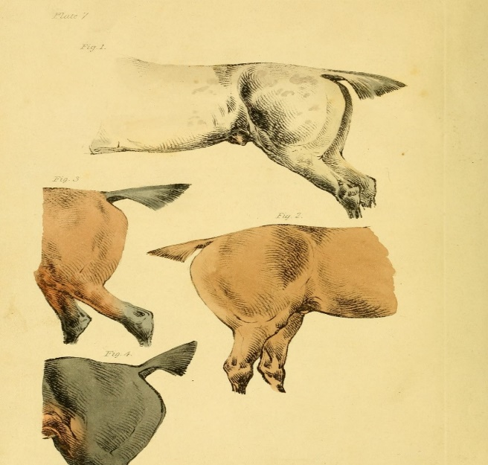
Plate V from The Beauties and Defects in the Figure of the Horse, by Henry Thomas Alken
This image is of the hindquarters of a selection of horses, drawn and coloured by Alken, also using the method of lithography. The corresponding text for the figures in this illustration, tells the reader how the muscular make-up of his subjects would be of benefit to the buyer. For example, the horse in figure two would be particularly suitable for a “pleasant ride” because he is “heavy and round in the flank and thigh” and, while the subject of figure three could not be described as an object of beauty, the formation of the thigh and hock would be an attribute to a horse suitable for hunting.
Image Five
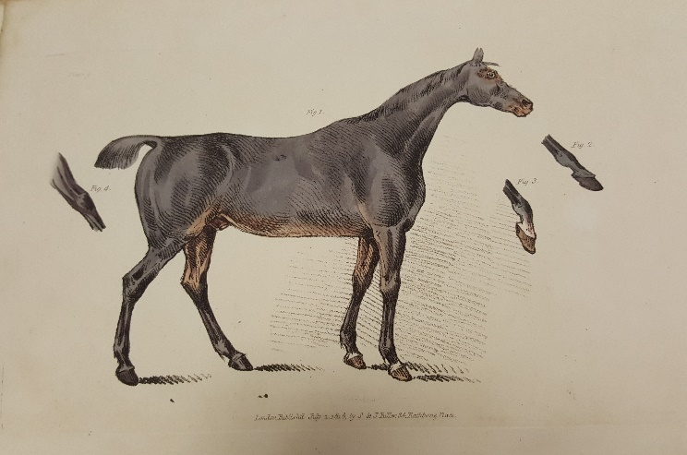
Plate IX from The Beauties and Defects in the Figure of the Horse, by Henry Thomas Alken
This example shows Alken’s image of one of the “finest examples” of a horse in England at the time. Although Alken was not a portraitist in the vein of Stubbs, he was an artist of horses and, he clearly has some understanding of the how the muscles are placed. He has added highlights and shadows to emphasise the contours. Like Stubbs, Alken provided text to match the illustration; taking pains to explain how figures two, three and four of this image, show the flex of the joint in movement. Alken was familiar with this horse, he said that it was ten years old and, experienced on the hunting field and in harness. While we may observe this specimen and conclude that his head looks rather out of proportion, in his text, Alken refers to the small size of the head but, says that it was highly fashionable at the time.
Stubbs had a lifelong desire to approach the painting of the horse with a more naturalistic style while using scientific methods. His knowledge of the anatomy of the horse enabled him to reproduce lifelike images of the horse accurately in paintings for his many patrons. The racehorse Whistlejacket, owned by the Marquess of Rockingham is depicted in a life size image, by Stubbs, exhibited at the National Gallery in London. More recently, inspired by the painting of Whistlejacket and by the illustrations in The Anatomy of the Horse, a bronze sculpture of the skeleton of a horse, by German artist Hans Haack was displayed at Trafalgar Square showing how the skills of George Stubbs are still admired today.

Bibliography
Secondary Sources
Alken. H. T., The Beauties and Defects in the Figure of the Horse, Comparatively Delineated in a Series of Coloured Plates (London: S & J Fuller, 1816).
Grigson. G., “The Greatness of George Stubbs,” The Spectator, February 24th, 1939. Pg. 25 [online] available at http://archive.spectator.co.uk/article/24th-february-1939/25/the-greatness-of-george-stubbs [accessed on 14th February 2018].
"Grigson, Geoffrey Edward Harvey (1905–1985), poet and writer." Oxford Dictionary of National Biography. (2004) Oxford University Press. Available at http://www.oxforddnb.com/view/10.1093/ref:odnb/9780198614128.001.0001/odnb-9780198614128-e-31176 (accessed on 11th May 2018).
Morrison. V., The Art of George Stubbs (New Jersey: Wellfleet Press, 1989).
Stubbs. G., The Anatomy of a Horse: Including a particular description of the bones, cartilages, muscles, fascias, ligaments, nerves, arteries, veins and glands: in eighteen tables, all done from nature (London: J. Purser, 1766). Roderic Bowen Archive, call number, HPPI 131.

Newspaper

Wroe. N., “Horse Play: What Hans Haacke’s fourth plinth tells us about art and the City” The Guardian, February 27th, 2015 [online] available at https://www.theguardian.com/artanddesign/2015/feb/27/hans-haacke-horseplay-city [accessed on May 12th, 2018].
Website
The Metropolitan Museum of Art, The Beauties and Defects in the Figure of the Horse [online] available at https://www.metmuseum.org/art/collection/search/344752 [accessed on May 15th, 2018].
The National Gallery, Whistlejacket [online] available at https://www.nationalgallery.org.uk/paintings/george-stubbs-whistlejacket [accessed on May 12th, 2018].

Images

Alken. H. T., The Beauties and Defects in the Figure of the Horse, Comparatively Delineated in a Series of Coloured Plates, Plate five. (London: S & J Fuller, 1816).

Alken. H. T., The Beauties and Defects in the Figure of the Horse, Comparatively Delineated in a Series of Coloured Plates, Plate nine. (London: S & J Fuller, 1816).

Stubbs. G., The Anatomy of a Horse: Including a particular description of the bones, cartilages, muscles, fascias, ligaments, nerves, arteries, veins and glands: in eighteen tables, all done from nature, Second Anatomical Table, Sixth plate, TAB II (London: J. Purser, 1766). Roderic Bowen Archive, call number, HPPI 131.

Stubbs. G., The Anatomy of a Horse: Including a particular description of the bones, cartilages, muscles, fascias, ligaments, nerves, arteries, veins and glands: in eighteen tables, all done from nature, Second Anatomical Table, Tenth plate, TAB IV (London: J. Purser, 1766). Roderic Bowen Archive, call number, HPPI 131.

Stubbs. G., The Anatomy of a Horse: Including a particular description of the bones, cartilages, muscles, fascias, ligaments, nerves, arteries, veins and glands: in eighteen tables, all done from nature, Second Anatomical Table, Seventh plate, TAB II (London: J. Purser, 1766). Roderic Bowen Archive, call number, HPPI 131.

V. Morrison, The Art of George Stubbs (New Jersey: Wellfleet Press, 1989). Pg. 7.
"Grigson, Geoffrey Edward Harvey (1905–1985), poet and writer." Oxford Dictionary of National Biography. (2004) Oxford University Press. Available at http://www.oxforddnb.com/view/10.1093/ref:odnb/9780198614128.001.0001/odnb-9780198614128-e-31176 (accessed on 11th May 2018).
G. Grigson, “The Greatness of George Stubbs,” The Spectator, February 24th, 1939. Pg. 25 [online] available at http://archive.spectator.co.uk/article/24th-february-1939/25/the-greatness-of-george-stubbs [accessed on 14th February 2018].
V. Morrison, The Art of George Stubbs (New Jersey: Wellfleet Press, 1989). Pg. 22.
Ibid. Pg. 12.
Ibid. Pg. 25.
G. Stubbs, The Anatomy of a Horse: Including a particular description of the bones, cartilages, muscles, fascias, ligaments, nerves, arteries, veins and glands: in eighteen tables, all done from nature (London: J. Purser, 1766). Roderic Bowen Archive, call number, HPPI 131.
V. Morrison, The Art of George Stubbs (New Jersey: Wellfleet Press, 1989) Pg. 39.
Ibid. Pg. 29.
Ibid.
Ibid. Pg. 8.
Ibid. Pg. 21.
G. Stubbs, The Anatomy of a Horse: Including a particular description of the bones, cartilages, muscles, fascias, ligaments, nerves, arteries, veins and glands: in eighteen tables, all done from nature, Second Anatomical Table, Sixth plate, TAB II (London: J. Purser, 1766). Roderic Bowen Archive, call number, HPPI 131.
V. Morrison, The Art of George Stubbs (New Jersey: Wellfleet Press, 1989). Pg. 29.
Ibid.
G. Stubbs, The Anatomy of a Horse: Including a particular description of the bones, cartilages, muscles, fascias, ligaments, nerves, arteries, veins and glands: in eighteen tables, all done from nature, Second Anatomical Table, Tenth plate, TAB IV (London: J. Purser, 1766). Roderic Bowen Archive, call number, HPPI 131.
V. Morrison, The Art of George Stubbs (New Jersey: Wellfleet Press, 1989). Pg. 25
Ibid. Pg. 21.
Ibid. Pg. 29.
G. Stubbs, The Anatomy of a Horse: Including a particular description of the bones, cartilages, muscles, fascias, ligaments, nerves, arteries, veins and glands: in eighteen tables, all done from nature, Second Anatomical Table, Seventh plate, TAB II (London: J. Purser, 1766). Roderic Bowen Archive, call number, HPPI 131.
H. T. Alken, The Beauties and Defects in the Figure of the Horse, Comparatively Delineated in a Series of Coloured Plates (London: S & J Fuller, 1816).
The Metropolitan Museum of Art, The Beauties and Defects in the Figure of the Horse [online] available at https://www.metmuseum.org/art/collection/search/344752 [accessed on May 15th, 2018].
Ibid. Plate five.
The Metropolitan Museum of Art, The Beauties and Defects in the Figure of the Horse [online] available at https://www.metmuseum.org/art/collection/search/344752 [accessed on May 15th, 2018].
H. T. Alken, The Beauties and Defects in the Figure of the Horse, Comparatively Delineated in a Series of Coloured Plates, Plate IX (London: S & J Fuller, 1816).
H. T. Alken, The Beauties and Defects in the Figure of the Horse, Comparatively Delineated in a Series of Coloured Plates (London: S & J Fuller, 1816).
Ibid. Plate 9.
H. T. Alken, The Beauties and Defects in the Figure of the Horse, Comparatively Delineated in a Series of Coloured Plates, Plate IX (London: S & J Fuller, 1816).
The National Gallery, Whistlejacket [online] available at https://www.nationalgallery.org.uk/paintings/george-stubbs-whistlejacket [accessed on May 12th, 2018].
N. Wroe, “Horse Play: What Hans Haacke’s fourth plinth tells us about art and the City” The Guardian, February 27th, 2015 [online] available at https://www.theguardian.com/artanddesign/2015/feb/27/hans-haacke-horseplay-city [accessed on May 12th, 2018].

