Background Research

Where and what is Townhill?
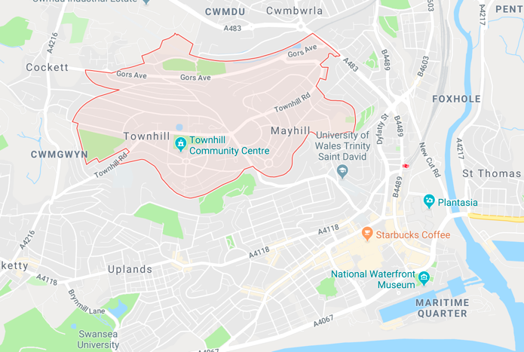
Townhill is the main hill north of Swansea city. Townhill residents make up 3.4% of the Swansea population. Back in 1996 the EU classed the area as the third most deprived area in all 908 areas in wales (Wales Online (2017).

Facilities available?

There are three main sporting facilities where activities can take place and they are the meadow view sports complex, the Phoenix centre, and the Townhill community centre.

How and why is it a deprived area?

There are multiple reasons why Townhill is a deprived area. The different factors include property ownership or rentals, education, and employment rates. Firstly, the percentage of people who have a mortgage on a house is at 30.6% in the Townhill area. Compared to the rest of wales this is lower. Also, the percentage of those who rent a house in Townhill is at 19.6% of the area which is a significant amount higher than the rest of wales. This shows that lots of people are not able to afford to have a mortgage on a house in the area. Secondly, the number of people that do not have any qualifications is at 23.9% which is very close to the percentage of the whole of wales. This shows that a high number of people are uneducated however not as much as the rest of wales. Finally, in terms of employment, 17.5% of people in Townhill are claiming benefits and are unemployed (ILIVEHERE 2018).

What is doorstep sport?

Doorstep Sport Clubs are fun, informal sports clubs that operate at the right time, for the right price, in the right place and in the right style. A Doorstep Sport Club gives a vibrant and varied sporting opportunity to young people in disadvantaged communities that is designed to develop their motivation and ability to adopt a sporting habit for life. Doorstep Sport Clubs exist in many different forms and are hosted by different types of organisations. However, at their core, they provide young people aged 14-25 years living in areas of high deprivation with accessible and affordable opportunities to take part in sport within their local community. Providing vibrant, varied, fun and sociable sessions, with a strong emphasis on youth leadership (Doorstep sport

Local Authority | Swansea
Year | 2017 -18
Student Name | Theo Wortelhock
Project Focus | street games
Time of year | Summer- APRIL - JULY
Funding from street games | £2000
PLANNED ACTIVITIES

Identified  Activity / Project INCLDING NAME / LOCATION / DAY /TIME | How will the project be developed? what will it look like? how will it be promoted? who will deliver it? | WHO ARE THE PARTNERS THAT WILL HELP DEVELOP THE SESSION? WHAT WILL BE THEIR INVOLVEMENT? | WHAT WILL SUCCESS LOOK LIKE. start / middle / end of plan
Door step sport  Touch Rugby | The project will be developed by making sure that the kids are improving week by week. This will happen because the coach will set goals for each week to see if the kids can reach them. Furthermore, the session it’s self will consist of several different skill games such as passing, and running, and using game scenarios too. This event will be promoted by handing out flyers and leaflets to the local community in Townhill. Also, hopefully by putting the name of ospreys on the leaflet will make more children want to come and play. There will be an employed ospreys coach that will come and coach for the one session per week and will be paid. | Ospreys rugby club will be the partners that will develop it. There will be a coach from the ospreys to coach the session each week for ten weeks. They will also help promote the sessions by stating that they will provide one item of free merchandise for each child. | Success at the start will be if at least 80-100 children attend the first session and then return every week. In the middle success will be if attendance is the same, and also if there have been a few children that have stood out to the osprey’s coach as a potential academy player, throughout the program so far. The end will be successful if at least 80 children complete the ten weeks with a certificate.
Door step sport  5 a side football | This project will be developed by introducing 5 a side football to the kids in the local area. The project will start a series of sessions that will teach the basic skills. Then slowly progress as the kids get taught more and also get more confident in their ability. Then the plan for the final week is to have multiple 5 a side matches going on to create a small tournament. This project will be promoted through flyers again. But linking in with Swansea city FC and a coach from the academy will be paid to come and take the sessions for ten weeks. | Swansea FC will be the partners of this project as it will help promote the sessions having a high-profile team as the main focus of the sessions. They will also be coaching the sessions. This will help us promote as people are more likely to want to be involved. | A successful start to the program will be if 80- 100 kids turn up. Also, if they enjoy the session and want to return. Half way through the ten weeks the goal is to still have the same number of kids taking part. Finally, at the end, it would be great if the tournament ran smoothly and everyone has fun.
US Girls  HIIT Session | This project will include sessions in the Townhill community centre sports hall. The sessions will consist of having different exercises such as press ups, sit ups, star jumps and all kinds of High intensity fitness exercises. These sessions will be promoted by using word of mouth and flyers being handed out in the local area. Also, by social media on the US girl’s website. They will also be able to mention on the flyers that Carl Mainwaring from Mainway Fitness will be coaching the sessions, more people will be wanting to be coached by a professional fitness instructor. | This project will be partnered with Mainway Fitness, this will mean that there will be an experienced instructor to give the very best packed sessions. | A successful session would be if at least 20 girls turn up to start. Also, that they come back for the second week too. In the middle of the project it would be great if the girls start to reach the targets that they set themselves and beat them. Finally, at the end of the project girls should feel a sense of happiness and self-achievement.
Club One  Biathlon | Using the local pool at Swansea university this will be the location for the swimming sessions that will be developed. The pool will be hired out so that the pool can be used to practice swimming. Also, there is a vast area around the university sight that can be used for running around. This will be advertised and promoted by using flyers and social media. The Swansea university staff will help oversee the sessions. | This project will be partnered by sport wales and also by the Swansea university sports staff. | The beginning of the course will look to teach the basics of swimming and running, then as the sessions go on, there will be targets to reach in terms of distance and time.
Costings

Activity / project / session | Resources Needed | Estimated spend | Estimated Income Generated For / by the activity / session
Touch Rugby | Coach to provide instruction  1000 Sporting Promotional flyers  Facility used: Phoenix centre Townhill | 10 sessions @ £10 = £100  £200  10 sessions @ 21.50  =£215  Total spend- £515 | £2 per session per person  Total income per session- £200
5 a side football | Coach to provide instruction  1000 Sporting Promotional flyers  Facility used: The Phoenix Centre Townhill | 10 sessions @ £10 =£100  £200  10 sessions @ 21.50  =£215  Total spend- £515 | £2 per session per person  Total income per session- £200
HIIT session | Coach to provide instruction  500 Sporting Promotional flyers  Facility used: The Phoenix Centre Townhill | 10 sessions @ £10 = £100  £100  10 sessions @ 21.50  =£215  Total spend- £415 | £5 per session per person  Total income per session- £500
Biathlon | Coach to provide instruction  Facility used: Swansea International pool. | 10 sessions @ £10 =  £100  £3.25 per person  Total spend- £100 | £5 per person  Total income per session- £100
 |  | Total Cost of plan-  = £ 1,545 | Estimated funds available-  £2000 + Totals from above  = £1,000

Current barriers to sports participation in deprived communities

Firstly, there are lots of barriers to sports participation in deprived communities as, living in poverty can have a big effect on being able to get access to sport and physical activity. These barriers are, cost, lack of facilities, and disability. There are also different types of barriers that underpin the barriers stated above such as socio-cultural barriers, practical barriers and knowledge barriers.

Moving on, the first barrier to participation, that will be discussed is, how much it costs to participate in sport. According to the London schools of economics and political science cost is the biggest barrier to participation because a third of our population of young people in the UK live in poverty. Of the 9 million young people aged 14–24 living in the UK, approximately 30% are living in poverty. This includes 1.9 million young people with an income considerably below the poverty threshold (The London School of economics and political science 2016). Examples of what specific costs are preventing people from participation are things like paying for gym membership, activity club monthly or yearly fees. These are both big barriers to those who want to take part in sport but can’t because they live in poverty.

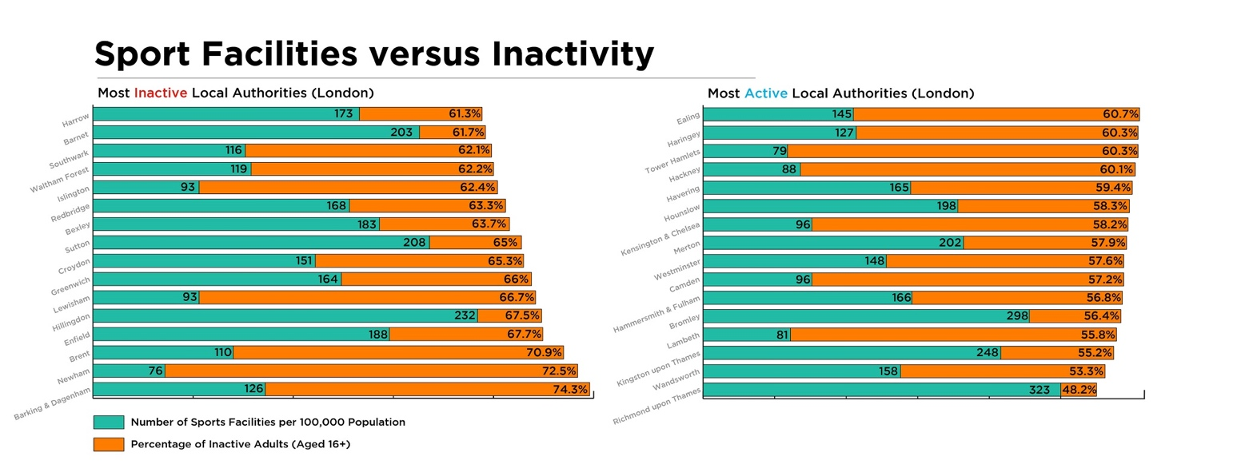
Secondly, living in a poor area usually means that there aren’t many facilities available to participate in sport either. London sport says that the number of facilities per 100,000 people is lower than average across the rest of the country. Figure 1, shows the number of sports facilities per 100,000 people in different areas of London compared to the number of inactive adults in each area from ages 16 and above. This shows that the most active area of London is Richmond upon Thames, this could be because per 100,000 people they have 323 different facilities available. The most inactive area of London is Barking and Dagenham. 74.3% of the population is inactive and they have 126 facilities per 100,000 people. This therefore shows that the more facilities are in the area the more people are active (London Sport 2016). Increasing facilities therefore is a very important aspect in order to increase participation especially in deprived areas.
Figure 1

Furthermore, another big factor that affects participation is fear. Poor area conditions have a huge impact. Income poverty, lack of confidence and motivation, fear of crime, peer pressure, and poor supervision all act as major ways that stop people from partaking. Fear definitely dampens enthusiasm for using local parks or sports facilities, and for allowing younger people to attend clubs. It also acts as a barrier to older children joining in positive games (Street Games 2016).

Next, there are three different types of barriers that a deprived community will face. The first are Socio-cultural Barriers and they refer to specific social and cultural practices, beliefs and traditions within a community or society and how these impact on self-perceptions and the perceptions of others. Of particular significance in this area are discourses of sport and physical activity dominated by exclusive notions of elitism and masculinity. A lack of positive role models can have an effect to people wanting to take part.

Practical Barriers refer to the physical, medical and economic challenges to activity that individuals come across in their daily lives. Issues such as cost, safety, access, time pressures and health issues were significant for each group. The main practical barrier, is cost. As spoken about earlier in this essay, cost can prevent access to facilities. This can prevent people from therefore exercising.

Knowledge Barriers include the link between higher educational achievement and higher levels of physical activity. Knowledge gaps also appear to be closely relate with socio-cultural factors, what people think of themselves and what people think of others. Evidence shows that individuals in specific groups might not be fully aware of all the benefits of physical activity due to the lack of education and knowledge. There is also evidence to suggest that some service providers might not be fully equipped to provide for and understand the needs of specific groups for example older people, people with disabilities and specific members of ethnic minority communities (Northern Ireland Assembly 2010).

Furthermore, children with disability may take part less in physical activity compared to their typically developing friends. Taking part regular physical activity by children, including those with disability, enhances body composition, bone health, psychological health, and promotes social interaction. There are also therapeutic benefits to participation in regular activity for children with disability. They could have delayed gross motor development, less able to balance, reduced coordination skills and poor cardiovascular fitness compared to their peers with typical development, all of which could potentially be improved by participation in physical activity and the correct support for their needs.

To Conclude, there are many barriers to participation in deprived areas. Which in turn stop people on an everyday basis from taking part in physical activity. However, there are ways in which we as a nation can gather together to help those who struggle to access facilities or even to get out of bed in the morning. There are also people like doorstep sport who run programmes to help those who are less fortunate and are not able to take part for financial or socio- cultural reasons.

References

ILIVEHERE (2018) Socio-economic statistics for Townhill, Swansea, Available at: https://www.ilivehere.co.uk/statistics-townhill-swansea-39123.html (Accessed: 22nd March 2018).

London Sport (2016) The Impact of Facilities on Sport Participation in London, Available at: https://data.londonsport.org/insights/the-impact-of-facilities-in-london/(Accessed: 22nd March 2018).

Northern Ireland Assembly (2010) Barriers to sport and participation, Available at: http://archive.niassembly.gov.uk/researchandlibrary/2010/1810.pdf (Accessed: 22nd March 2018).

Street Games (2016) Moving the goal posts, Available at: http://sticerd.lse.ac.uk/dps/case/cr/casereport95.pdf (Accessed: 22nd March 2018).

Street Games (2018) Doorstep Sport Club,, Available at: http://www.streetgames.org/our-work/doorstep-sport-clubs (Accessed: 22nd March ).

The London School of economics and political science (2016) Cost is the biggest barrier to young people's participation in sport because a third live in poverty, Available at: http://www.lse.ac.uk/website-archive/newsAndMedia/newsArchives/2015/12/Cost-is-the-biggest-barrier-to-young-peoples-participation-in-sport-because-a-third-live-in-poverty.aspx (Accessed: 22nd March 2018).

Wales Online (2017) Life on the Hill: What it's really like to live on one of Wales' most famous estates, Available at: https://www.walesonline.co.uk/news/wales-news/life-the-hill-what-its-12735227 (Accessed: 22nd March 2018).

