

LOCATION: Swansea | LLEOLIAD: abertawe
LEVEL 5 | LEFEL 5
EXAMINATION PERIOD | CYFNOD ARHOLIADAU
MAY 2024 | MAI 2024

MODULE CODE: ACDA5001
Electrical Engineering

TIME: 2 HOURS
answer ALL THE questions

Equipment or materials required – Calculator
Adnoddau neu ddefnyddiau sydd eu hangen - Cyfrifiannell

ANSWER ALL THE QUESTIONS

Question 1 [25 Marks]
- A supply voltage of $V_{1}=15V$ is given to the circuit shown in fig:1. Determine the following
- The load current, [8 Marks]
- Value of load resistor, when maximum power is transferred across the load,
[3 Marks]
- Simplified circuit diagram for the circuit shown in fig.1 [3 Marks]
- The maximum power transferred across the load ($P_{L})$. [3 Marks]
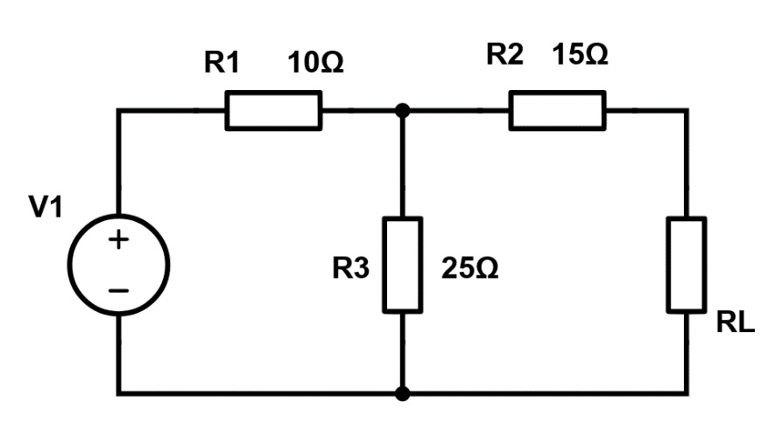
Fig:10
Solution:
- The Load Current,
Voltage across 25$Ω$ resistor,
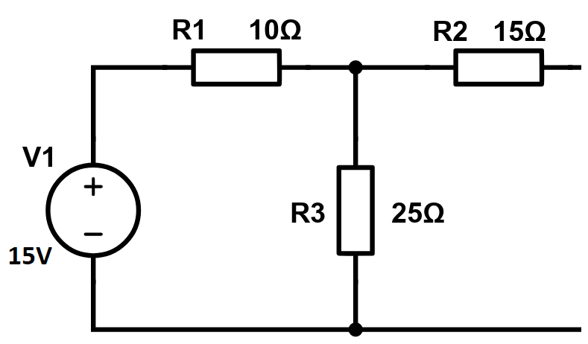
To find current in the loop,$I=\frac{15}{35}=0.4286A$ [2 marks]

$V_{25Ω}=0.4286×25=10.715V=V_{th}$ [2 marks]
To Find $R_{th}$
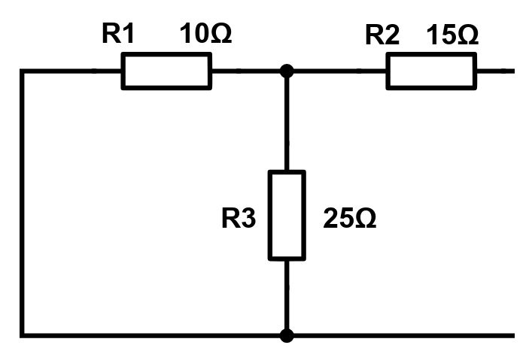
$R_{1}$ parallel to $R_{3}$=7.143Ω
7.143Ω series with $R_{2}$=22.143 Ω
$R_{th}=22.143Ω$ [2 marks]
$I_{L}=\frac{V_{th}}{R_{th}+R_{L}}=\frac{10.715}{22.143+22.143}=0.242A$ [2 marks]
- Value of load resistor, when maximum power is transferred across the load,
According to Maximum power transfer theorem, maximum power will be transferred across the load, when the Load resistor is equal to internal resistance. Hence Internal resistance is $22.143 Ω$ [3 marks]
- Simplified circuit diagram for the circuit shown in fig.1
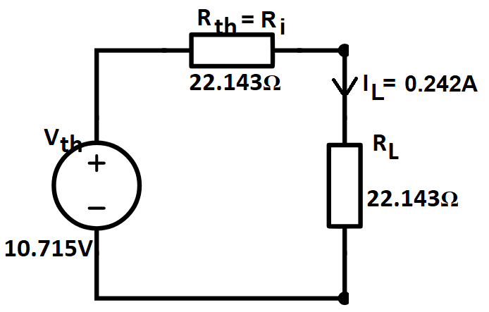 [3 marks]
- The maximum power transferred across the load ($P_{L})$.
$P_{L}=I_{L}^{2}R_{L}={0.242}^{2}×22.143=1.2968W$ [3 marks]
$This is the maximum power transfered across the load$.
- Define Norton’s Theorem, with the aid of its equivalent Circuit. [5 Marks]
Solution:
Norton’s Theorem states that, Any two terminals of an network consisting of active and passive elements can be replaced by an equivalent current source and an equivalent parallel resistor. The magnitude of the current is equal to the short circuit current and the equivalent parallel resistor is the equivalent resistance. [3 marks]
Equivalent Circuit
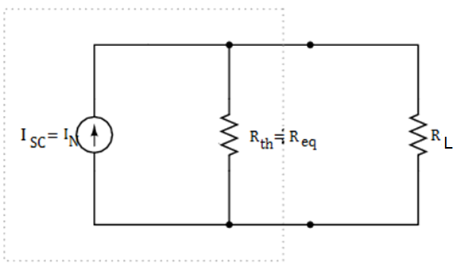 [2 marks]
- Calculate the voltage $V_{DC}$ across the open circuited terminal of the circuit shown in fig:2. [3 Marks]
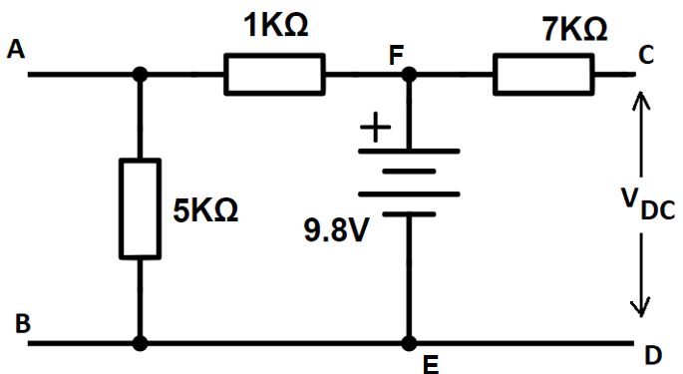
Fig:2
Solution:
The Voltage across $V_{DC}$ is 9.8V as DC is Open circuited, the voltage across EF will be the voltage DC [3 marks]
Question 2 [25 Marks]
- A 415V, three phase AC motor has a power output of 12.75kW and operates at a power factor of 0.77 lagging and with an efficiency of 85%. If the motor is delta-connected, determine the following,
- The Power input [5 Marks]
- The Line current [4 Marks]
- The Phase current [4 Marks]
Solution:
- The Power input
$Efficiency=\frac{Power Output}{Power Input}$ [1 mark]
$\frac{85}{100}=\frac{12750}{Power input}$ [2 marks]
$Power Input=\frac{12750 ×100}{85}=15000W$ [2 marks]
- The Line current
$I_{L}=\frac{P}{\sqrt{3}\left(415\right)\left(0.77\right)}$ [2 marks]
$I_{L}=\frac{15000}{\sqrt{3}(415)(0.77)}=27.10A$ [2 marks]
- The Phase current
$I_{P}=\frac{I_{L}}{\sqrt{3}}$ [2 marks]
$I_{P}=\frac{27.10}{\sqrt{3}}=15.65A$ [2 marks]
- An Alternating voltage is given by the equation $V=100Sin (200πt-90)$. Calculate the following.
- The amplitude [2 Marks]
- The peak to peak voltage [2 Marks]
- The RMS voltage [3 Marks]
- The periodic time [3 Marks]
- The Frequency [2 Marks]
Solution:
- Amplitude
$V=V_{m}sin(ωt+ϕ)$
$Given,$ $V=100sin(200πt-0.25)$
$V_{m}=100V$ [2 marks]
- Peak to peak voltage
$Peak to Peak Voltage = 2×Amplitude$
$=2×100=200V$ [2 marks]
- RMS value
$V_{RMS}=\frac{V_{m}}{\sqrt{2}}$ [1 mark]
$V_{RMS}=\frac{100}{\sqrt{2}}=70.71V$ [2 marks]
- the periodic Time
$T=\frac{1}{f}$
We know that $ω=2πf=200π$ [1 mark]
$2πf=200π$ [1 mark]
$2f=200$
$f=100Hz$
$T=\frac{1}{f}$= $\frac{1}{100}=10ms$ [1 mark]
- Frequency
$f=100Hz$ [2 marks]
Question 3 [25 Marks]
- A Coil of inductance $318.3mH$ is connected in series with a $200 Ω$ resistor to a $240V, 50Hz$ supply. Calculate the following.
- Inductive reactance of the coil [3 marks]
- Impedance of the circuit [3 marks]
- Current in the circuit [2 marks]
- Potential difference across each components [4 marks]
- Circuit phase angle [3 marks]
Solution:
- Inductive reactance of the coil
Inductive Reactance $X_{L}=2πfL$ [1 Mark]
$X_{L}=$2$π×50×0.3183=100Ω$ [2 Marks]
- Impedance of the circuit
$Z=\sqrt{R^{2}+X_{L}^{2}}$ [1 Mark]
$Z=\sqrt{{200}^{2}+{100}^{2}}=223.6Ω$ [2 Marks]
- Current in the circuit
$I=\frac{V}{Z}$ $=\frac{240}{223.6}=1.073A$ [2 Marks]
- Potential difference across each components
Potential difference across the coil,
$V_{L}=IX_{L}=1.073×100=107.3V$ [2 Marks]
Potential difference across the resistor,
$V_{R}=IR=1.073×200=214.6V$ [2 Marks]
- Circuit phase angle
Φ=$\tan^{-1}\left(\frac{X_{L}}{R}\right)$ [1 Mark]
$Φ=\tan^{-1}\left(\frac{100}{200}\right)={26.57}^{0}$ [2 Marks]
- Find the RMS value and Phase of the current, $I=25+j40 A$ [4 Marks]
Solution:
$r=I_{rms}=\sqrt{X^{2}+Y^{2}}=\sqrt{{25}^{2}+{40}^{2}}=47.17A$ [2 Marks]
$ϕ=\tan^{-1}\left(\frac{Y}{X}\right)=\tan^{-1}\left(\frac{40}{25}\right)={58}^{0}$ [2 Marks]
- Differentiate Active power, Reactive power and Apparent power [ minimum of two differences [6 Marks]
Solution:
 | Active power | Reactive power | Apparent Power
Definition | The actual power consumed by a circuits due to the resistive load is called real power. | The portion of the apparent power observed by the reactive elements ($X_{L} or X_{C}$) in a circuit is called reactive power. | It is the amount of power delivered to a circuit.
Formula | P=$VI Cos∅$ | Q=$VI Sin∅$ | S=$VI$
[Each Point 2 marks Maximum of 6 marks]
Question 4 [25 Marks]
- List any 5 types of DC Generators. [5 Marks]
Solutions:
- Separately Excited DC Generators
- Self-Excited DC Generators
- Series Wound Generators
- Shunt Wound Generators
- Compound Wound Generators [Each 1 mark, max 5 Marks]
- A Transformer has a rated output of 200KVA at a power factor of 0.8. Determine the real power and the reactive power. [5 Marks]
Solution:
Power Factor = 0.7=$Cosϕ$
Real power = P=VI $Cosϕ$
Apparent Power = Rated power= 200KVA =VI
P=200×1000×0.8=160000W [2 Marks]
We know that, $Cosϕ=0.8$
$ϕ={Cos}^{-1}\left(0.8\right)={36.89}^{o}$ [1 Mark]
Reactive power=$VISinϕ$= 200×1000 $Sin({36.89}^{o})$=200000×0.600=120.06kVAR [2 Marks]
- Describe the functions of the following components used in DC Generator
- Field System [3 Marks]
- Yoke [3 Marks]
- Commutator [3 Marks]
- Carbon brush [3 Marks]
- Armature [3 Marks]
Solution:
  - Field System
It consists of number of poles bolted inside the circular frame, provide uniform magnetic field. [1 Mark]
The mmf (magnetomotive force) produced by the field windings provides a magnetic flux that passes through the pole pieces, the air gap, the armature and the frame. [2 Marks]
  - Yoke
It is also called as magnetic frame, It acts as Protecting cover for DC machine, provide mechanical support and carries the magnetic poles. [3 Marks]
  - Commutator
Commutator acts as a mechanical rectifier which converts the AC induced emf in the armature winding into DC across the brushes. [3 Marks]
  - Carbon Brushes
The purpose of the brushes is to collect the current from commutator to external load circuit. [3 Marks]
  - Armature
The armature consists of coils of wire wound around a metal core. When the armature rotates within the magnetic field created by the stationary field magnets, an electromagnetic force (EMF) is induced in the armature coils due to electromagnetic induction. [2 Marks]
The armature converts the mechanical energy of rotation into electrical energy in the form of direct current (DC) [1 Mark]

Diwedd/End

