
LCLM4006 Enterprise & Entrepreneurship
Task 1: Individual Written Business Plan
Student Name: Vladut Tofan
Student ID: 2512495

Executive Summary
GreenThread Collective Ltd is an eco-friendly company that aims at repairing, designing and reselling clothes to target the Gen-Z market and university students, as well as young professionals. This is a reaction to the increasing needs for cheaper and environmentally friendly alternatives to fast fashion. GreenThread will need £50,000 in terms of seed capital, which will be obtained from angel investors and founder contributions. Income will be derived from repairing, alterations, resale, redesigned clothes, and community workshops.

Table of Contents
Introduction 4
Overview of the business idea 4
Value Proposition 4
Customer Segments 5
Legal Structure and Management 5
Market Research 6
PESTEL Analysis 6
Competition analysis 7
Marketing Communications 8
Financials 9
Sources of Finance 9
Conclusion 10
Reference List 11

Introduction
This business plan introduces GreenThread Collective, which is an innovative business model of a sustainable fashion repair and resale venture that aims at solving the issues related to the negative environmental impact and social implications of the fast fashion industry. GreenThread Collective will offer convenient services for repairing, altering, redesigning, and reselling garments for environmentally aware consumers, specifically Generation Z and professionals. This report includes market research for the business idea, marketing communications analysis, as well as sources of financing and cost structure for understanding its feasibility.

Overview of the business idea
GreenThread Collective will offer clothing repair, alteration, redesign and resale services that will add life to clothes and create both economic and social value. The business will offer convenient clothing repair, alteration, redesign and curated resale services for customers looking for cost-effective and sustainable solutions rather than buying new clothes. Customers will be able to submit their clothes for repair and alteration both from the physical location of the business and using an online booking facility. Unwanted clothes that can be used will be fixed, designed again and sold.

Value Proposition
The value proposition of the business will depend on the combination of sustainability, affordability and convenience. GreenThread Collective will allow customers to keep their existing clothes and fix them rather than throw them away and buy something else. Customers will also have access to quality pre-owned clothing at a lower price than many sustainable fashion options. In contrast to the usual secondhand retailers, which are focused on selling donated clothing items, GreenThread Collective will create value by repairing and redesigning the clothes before reselling them. Furthermore, this company will organise various repair and tailoring classes, thus giving local people an opportunity to learn some useful skills and get involved in the circular economy. Therefore, the sustainability aspect is integrated into the main activity of the company instead of becoming a separate project.

Customer Segments
The main target market will consist of Gen Z customers, including students and young professionals, who focus on fashion but at the same time understand the negative impacts of fast fashion on the environment (Papasolomou et al., 2023). It can be assumed that such customers value affordable prices, uniqueness of the clothing items and sustainability. The secondary target market will include eco-friendly consumers of all ages requiring repair or alteration services. There may be partnerships between GreenThread Collective and fashion brands in the future.

Legal Structure and Management
The business will function as a private limited company called GreenThread Collective Ltd. This kind of organisation is perfect for the business as it protects the founders from any liabilities while forming a framework that can bring in additional funding (Rasyidi, 2022). Initially, the organisation will have a structure made up of a Managing Director who will be in charge of strategies and finances, an Operations and Sustainability Manager who will manage repairs and circular activities, and a Marketing and Communications Manager who will be in charge of customer relations and workshops (refer to image below). The structure will include a small group of repair technicians and trainees who will work for the company and help with its growth through adequate production and sales activities.
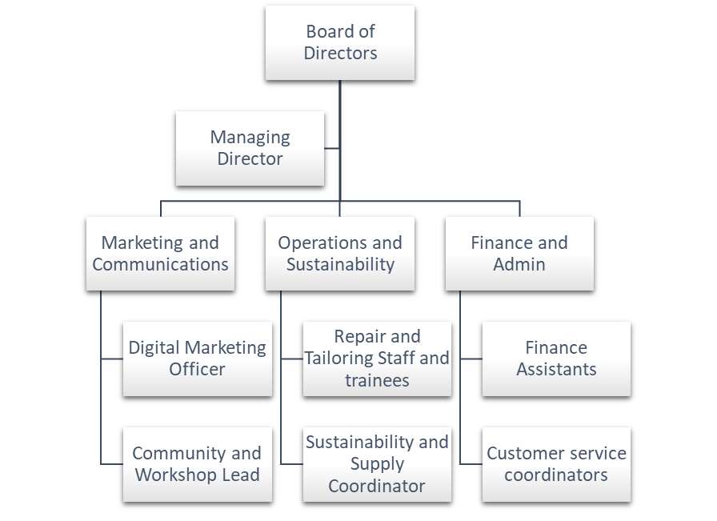
Figure 1: Management Structure
(Source: created by self)

Market Research

PESTEL Analysis
Factors | Attributes | Opportunity or threat
Political | The government's attention is moving towards a circular economy, with textiles identified as a priority sector and potential extended producer responsibility measures under consideration. This creates a favourable policy direction for a business focused on repair, reuse and resale, although future compliance requirements may increase costs for fashion businesses (Frei et al., 2020). | Opportunity
Economic | In economic terms, the high cost of living in the UK makes used clothes and repair services an appealing option compared to buying brand-new clothing. The UK Consumer Price Index (CPI) is at 142.40 in 2026, with an annual inflation rate of 2.8% (ons.gov.uk, 2026). Thus, GreenThread needs to showcase its worth by providing affordable repair and good-quality redesigned clothing at reasonable prices. | Both
Social | The UK market has seen a shifting consumer view about sustainability and second-hand fashion bring business opportunities. 54% of UK people are willing to buy pre-owned clothing, and three out of five consumers say that they will use a repair service (wrap.ngo, 2026). | Opportunity
Technological | In terms of technology, digital booking, social media marketing and resales online would overcome customer acquisition obstacles for the business, allowing it to use its physical skills together with the digital convenience. However, existing online resale platforms have a developed digital network, which means the business needs to compete based on its curating qualities, skills in repair and interaction with the community (Waty, 2022). | Both
Environmental | This market opportunity is particularly attractive as the repair and resale promote the textile circular economy. According to WRAP, four out of five repaired clothes replace a new purchase, showing the environmental benefits of repair. | Opportunity
Legal | From a legal point of view, GreenThread Collective has to abide by the laws of the United Kingdom. Being a private limited company, it would be subject to the Companies Act 2006. In addition, the Environmental Protection Act 1990 and its respective waste laws are applicable here. | Opportunity
Table 1: PESTEL Analysis
(Source: self-developed)

Competition analysis
The competition is made up of Vinted and Depop, which are huge peer-to-peer resale platforms, as well as charity stores and specialised repairs offered by SOJO and The Seam (Wicker, 2024). Although these competitors prove high customer demand, they mainly concentrate on resale or repairs separately. What differentiates GreenThread is the fact that the company provides all-in-one services, including professional repair, alterations, customisation, curating resale and community skills workshops. Hence, from the PESTLE analysis, we can conclude that the market is favourable but competitive for GreenThread. The greatest strength for GreenThread as a strategy is making sustainability a feasible and personalised service.

Marketing Communications
The promotion strategy chosen by GreenThread Collective will include integrated marketing communications. The main target audience for such an approach will be Generation Z, college students, and young professionals. Promotional activity will take place through social media platforms such as Instagram and TikTok as visual media can be used to showcase fashion item restoration and changes (Guarda et al., 2021). The short video will convey the following message: "repair, redesign, and rewear, sustainable fashion". The message itself will show the correlation between sustainability and affordability, as well as personal fashion.
User-generated content will help increase trustworthiness and engagement. Local sustainable fashion designers will showcase the process of fashion item restoration and resale, and customers will be able to post photos of redesigned items using branded hashtags. Such an approach is especially relevant for younger audiences, who are more likely to engage with user-generated content (Baier et al., 2025).
Moreover, the company will utilise the partnership with universities, ambassadors and the workshops held in the community to engage directly with the target customers. The pop-up repair sessions and the free introductory sessions can help to motivate the clients to try out the service by highlighting the usefulness of the service. Marketing through emails and the loyalty programmes of the customers can ensure their repeat purchases and discounts on repair, resale and workshops. Lastly, targeted digital advertisements will be conducted to approach customers who are passionate about sustainable fashion, resale clothing and local services.

Financials

Sources of Finance
GreenThread Collective startup will need £50,000 of seed capital in order to commence with the clothing repair, redesign and resale activities. The proposed fundraising formula would be £35,000 from impact-oriented angel investors and £15,000 from the founder, thus combining investor confidence and founder dedication. The selection of angel investors is based on their ability not just to provide funding but also to offer their expertise and connections for the business (Sariri, 2022). The founder’s investment into the business shows his commitment and the sharing of the risk involved. The impact orientation and community approach further strengthen the justification for fundraising with impact-oriented investors.
Revenue generation will come from clothing repair and alteration charges, commission on curated resale, sales of redesigned garments and paid community workshops. The key cost structure of the business will consist of premises, specialised equipment, personnel, marketing, technology and preparatory stock. The following calculations are the key costs to expect during the first month of operations.
Cost Structure

Cost item | Estimated cost (£)
Premises deposit and first-month rent | 6,000
Sewing and repair equipment | 8,000
Initial refurbishment and workshop setup | 5,000
Staff wages and training | 10,000
Website and online booking system | 3,000
Marketing and launch campaign | 5,000
Initial resale stock and materials | 4,000
Insurance, registration and professional fees | 2,000
Contingency reserve | 7,000
Total | 50,000
Table 2: Cost Structure
(Source: self-developed)

Conclusion
The GreenThread Collective provides a business solution to the environmental issues that are inherent in the fast fashion industry. The concept of repair, redesign, and resale makes it possible to create value for those customers who are interested in green business models and who are budget-conscious at the same time. With the help of the right marketing approach, legal framework, and investment worth £50,000, this project can be implemented successfully.

Reference List
Baier, D., Decker, R. and Asenova, Y., (2025). Collecting and analyzing user-generated content for decision support in marketing management: an overview of methods and use cases. Schmalenbach Journal of Business Research, 77(3), pp.419-455.
Frei, R., Jack, L. and Krzyzaniak, S.A., (2020). Sustainable reverse supply chains and circular economy in multichannel retail returns. Business Strategy and the Environment, 29(5), pp.1925-1940.
Guarda, T., Augusto, M.F., Victor, J.A., Mazón, L.M., Lopes, I. and Oliveira, P., (2021). The impact of TikTok on digital marketing. In Marketing and Smart Technologies: Proceedings of ICMarkTech 2020 (pp. 35-44). Singapore: Springer Singapore.
ons.gov.uk, (2026). Inflation and price indices. Inflation and price indices - Office for National Statistics. Available at: https://www.ons.gov.uk/economy/inflationandpriceindices (Accessed: 15 July 2026).
Papasolomou, I., Melanthiou, Y. and Tsamouridis, A., (2023). The fast fashion vs environment debate: Consumers’ level of awareness, feelings, and behaviour towards sustainability within the fast-fashion sector. Journal of marketing communications, 29(2), pp.191-209.
Rasyidi, A.F., (2022). Private Limited Company in Indonesian Positive Law: Elaborating The Basic Concept of Corporate Law, Comparison to Other Countries and Its Development. Jurnal Penelitian Hukum De Jure, 22(4), pp.465-482.
Sariri, A., (2022), October. Are angel investors more likely than venture capitalists to drive entrepreneurial experimentation. In Academy of Management Proceedings (Vol. 2022, No. 1). Academy of Management Briarcliff Manor, NY 10510.
Waty, E., So, I.G., Indrajit, R.E. and Abdinagoro, S.B., (2022). Networking capabilities and digital adoption of business agility: the mediating role of business model innovation. International Journal of eBusiness and eGovernment Studies, 14(2), pp.224-241.
Wicker, A. (2024). The trendy second-hand clothing market is huge and still growing – yet nobody is turning a profit, BBC News. BBC. Available at: https://www.bbc.com/worklife/article/20240301-international-second-hand-clothing-market-profitable (Accessed: 15 July 2026).
wrap.ngo, (2026). Cultivating a culture of clothing reuse report. WRAP. Available at: https://www.wrap.ngo/resources/report/cultivating-culture-clothing-reuse-report (Accessed: 15 July 2026).

