A Bring Your Own Device (BYOD) framework for Hyper-Fort

Author – Gareth Evans
Student ID : 1810612
Course: Cyber Security and Networking (Part time)
Module: ACCA4018 (Networking)

Contents
1. Introduction 2
2. Theory of BYOD 2
2.1 Working with BYOD 2
2.2 Using the CIA Triad 3
2.3 Advantages and Disadvantages of BYOD 4
2.4 Monitoring personal device usage 4
3. Working with your device 5
3.1 How will staff in the office access their data? 5
3.2 How will staff working remotely be able to work? 6
3.3 How does VPN work? 7
3.4 Explaining the network 8
4. Keeping data safe and accessible 9
4.1 Answering any concerns 9
5. Conclusion 10
Bibliography 11

Abstract

The following report explores the concept of Bring Your Own Device, a policy that many companies are introducing despite the negative publicity that comes with it. It can pose a security threat to any company if not used correctly, however this report will demonstrate how a business such as Hyper-Fort can effectively use BYOD to bring great benefits. The challenges that face Hyper-Fort will be discussed but also how they can overcome these challenges and build a secure network that allows staff to connect on any device at any location.

Introduction

Bring Your Own device is a recent concept that companies are adopting, allowing staff to be able to work from their own devices, whether that be a laptop or a smart phone, and the popularity of Bring Your Own Device (BYOD) is soaring. It is expected that as many as 85% of companies are expected to have their own BYOD policy by 2020 [1]. A competent BYOD policy can bring great benefits to any work place that implements it correctly; however with these benefits come many challenges. The concern lies with companies that work with confidential data. If staff are allowed to work on their own devices in their own home, how can this data be secure? The policy can only work if it follows the fundamentals of the CIA triad:
- Confidentiality
- Integrity
- Availability
By following these ideas, staff of Hyper-fort will be able to use their own devices both in work and remotely, benefiting the company and the staff themselves. This report will discuss how Hyper-fort, a company that relies heavily on cloud and wireless services, can implement the CIA triad into their BYOD policy and allow users to distinguish between personal data and work data.

2. Theory of BYOD

2.1 Working with BYOD

The ability to access work data anywhere on any device is a desirable concept to all companies, cutting costs and increasing productivity. Staff are able to work on devices they are familiar with whether they are in the office or working from home, however BYOD is not without its criticism. Android malware encounters grew 2,577% in 2012, leading to BYOD being referred to as Bring Your Own Malware [2], with the constant threat of malware evolving, how can BYOD assure Hyper-fort that their data is safe? Hyper-fort must consider the following:
- How do staff retain data on their mobile devices?
- How can staff blend personal usage and work usage when in the office?
- How likely is the situation of a data leak?
- How are the different types of devices and operating systems going to be managed?
- Who will manage the devices remotely?
- In the event of a lost device or staff leaver, how will work data be retrieved?

For example, a member of staff who has worked at Hyper-fort for many years has retired, they carried out a huge amount of work since the BYOD policy was introduced, what will Hyper-fort do to ensure that the work data this member of staff is no longer available to them?

2.2 Using the CIA Triad
As mentioned above, the CIA triad is the foundation principle that Hyper-fort should follow to keep data safe.
Confidentiality is another term for privacy; this idea prevents the disclosure of information to people without authorisation and is essential to keeping data safe. The three most popular methods to ensure data confidentiality is:
- Encryption – Techopedia defines encryption as the process of using an algorithm to modify data so that it is unreadable to users that do not possess the encryption key (unauthorised users) [3]
- Authentication – Verifying the identity of a user
- Access control – Prevents unauthorised access to a network/database
Access control must be implemented by Hyper-fort, it can be essential to preventing a data leak or finding the root cause of a data leak, therefore the thee A’s must be considered:
- Authentication – Verifies the identity of a user by making them login credentials to access a resource
- Authorisation – Determines what resources a user can access, what actions they can perform and when they are able to access them
- Accounting – Monitors what a user accesses, the frequency they access it and any modifications made
Even if one of the above principles is compromised, the other two principles can be used to find the cause of the issue and the damage done.
Integrity is the accuracy, consistency and trustworthiness of data. The need for integrity can depend on the organisation; in the case of Hyper-fort, integrity is essential. Loss of integrity can render data unreliable and unusable, having a massive impact on organisations.
Methods to ensure data integrity include access control, hashing, data validation checks and data consistency checks.
Availability involves ensuring the data and services are available when needed. Cyberattacks often affect the availability of data, so high awareness of the damage these attacks can do to Hyper-fort are essential.

The policies created for Hyper-fort attached in appendix B all follow the principles of the CIA triad, as should any further amendments to the policies.

2.3 Advantages and Disadvantages of BYOD

Later sections and the attached appendices with discuss how Hyper-fort will be able to get around these issues discussed above.
Advantages | Disadvantages
- Reduces technology expenses by eliminating the need to provide employees with devices  - Take advantage of new technology supplied by a member of staff  - Convenience for staff that can carry one device that is for both work and personal use  - Employees can work in their preferred Operating System  - Staff will be working on machines they are used to, no need for training  - Mobile devices can be managed using Mobile Device Management (MDM), which will be installed on all users devices  - Outline employer best practice | - Confidentiality and security concerns for work data on personal devices  - Employees being able to work outside of working hours  - Employees retaining data  - Liability for an employee’s wrongful use  - Mitigation strategies for when a device is lost or stolen  - Employee’s personal data/lives carrying over when in work hours due to availability of personal data
[4]

2.4 Monitoring personal device usage

If a mobile device has access to your business computing systems, you should have some level for control over it. [5]
The above statement highlights the need for a Mobile Device Management software (MDM). The primary use of MDM is to be able to monitor activity on a personal device that has access to business data and most importantly, having the ability to wipe data remotely in the situation where a device is stolen or compromised. It is key that Hyper-Fort choose a MDM that is going to meet the needs for the staff that are the administrators and have control over the MDM portal.
In the case of Hyper-Fort, there should not be the need for a remote wipe of a device as all users will be accessing the work data through a remote desktop, meaning that no data will be stored on a local machine as mentioned in appendix B. The ability to copy business data over to the personal device storage will be disabled.
Due to the remote desktop environment, any type of device will be able to work as they will all be using the same applications that are stored on the server, in this case, the remote desktop connection will come from Microsoft, this will be discussed further into the report.
After looking into the requirements for Hyper-Fort to be able to use BYOD, the MDM software Miradore [6] has been chosen. It is a cloud-based software which falls in line with the heavy reliance on cloud services by Hyper-Fort. It gives the administrators control over configurations and analytics, allowing them to restrict application use, track location and maintain data. It enforces data compliance through passcodes, screen locks, role-based access and encrypting content. Consider a scenario where a member of staff that works in the finance department of Hyper-Fort, they will have access only to data that is relevant to their role due to firewall restrictions, what happens if they lose their device? Using Miradore, staff can quickly lock down the applications stored on the device or even remove them, ensuring all content is safe. VPN will also be preventing remote access as users outside of the office will require VPN to be able to access the Hyper-Fort intranet, however the additional security of MDM is vital to ensuring data is only accessible to the staff that need it.
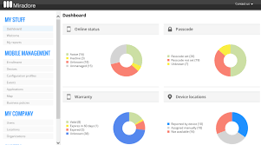
Other MDM solutions were considered, such as ManageEngine MDM and Mobilock Pro, however these restrict the device platforms, Hyper-Fort needs the flexibility of Miradore and the assurance that admin staff can manage multiple users and deploy new policies all from one portal. It may come at a cost to Hyper-Fort, but the savings from the BYOD policy and the security guarantee provided by Miradore make this the most suitable software to tackle to BYOD question.
Figure 1 - Miradore Portal [11]

3. Working with your device

3.1 How will staff in the office access their data?

The important aspect of BYOD is that users can access only the data that they need to access, therefore a critical part of the BYOD policy will be role-based access. This will come down to authentication and authorisation. It is assumed that members of staff will be:
- Assigned credentials to log in to the remote desktop environment (username and password)
- Assigned a VPN token for remote working to provide a bridge to the Hyper-Fort Intranet
- Have their personal devices registered on Miradore by the Hyper-Fort IT staff
- Informed of the BYOD guidelines (See appendix B)
- Informed of best practice on keeping data secure

Consider figure 2 below, this is how office staff will connect through their own device:
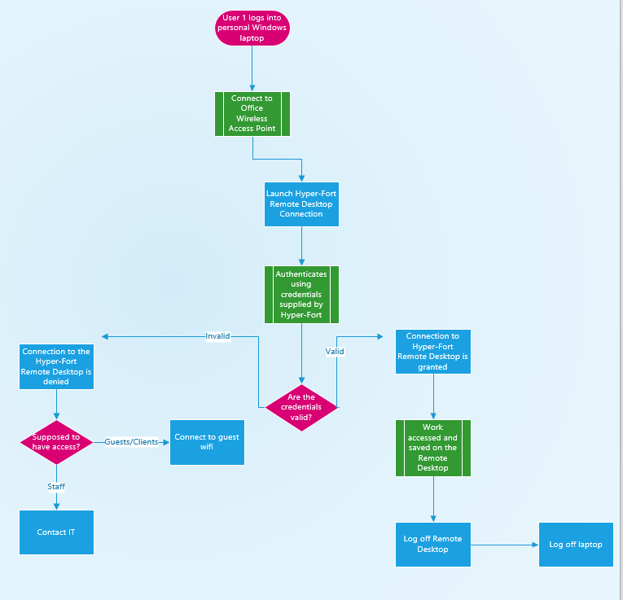
Figure 2 - how staff in the office will connect

3.2 How will staff working remotely be able to work?

Figure 3 below shows the steps the user takes to log in using VPN when working remotely. This process varies as it requires another method of authentication to set up the tunnel that allows the user to connect to the Hyper-Fort network
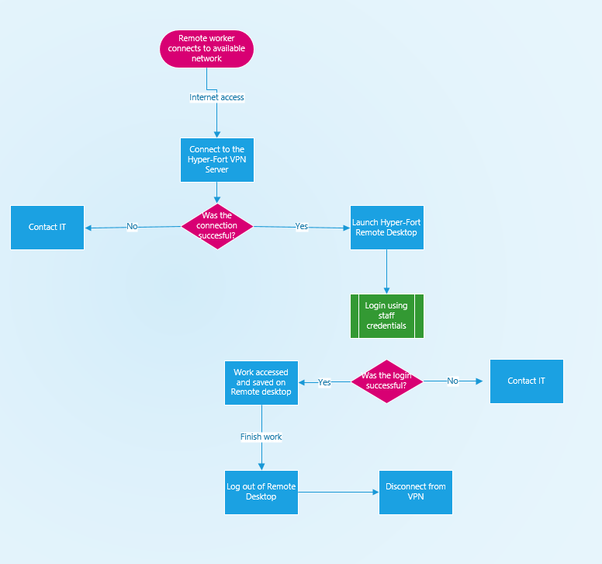
Figure 3, How a VPN user connects remotely

3.3 How does VPN work?

VPN stands for Virtual Private Network and is an essential method of authentication for members of staff that will be working remotely. Using an RSA token (supplied by Hyper-Fort), staff will be able to access their work remotely using any network by routing their connection through the VPN server seen in appendix (). The main components that ensure a VPN connection is secure are:
- Encryption
- Authentication [7]
Encryption scrambles data in transit, making the data meaningless to any unauthorised users, only a user with the “key” can access the data, with the type of encryption affecting the availability of the key. Private key encryption uses a single shared code to scramble and unscramble data, whereas public key encryption uses a private code to encrypt the signal. [7]
Using figure 3 as reference, staff will first have to log into VPN using their assigned RSA tokens, these tokens provide the authentication needed to access their data. Staff will set a pin personal to them, this will be the first half of their password, with the second half being a random six-digit code generated on the RSA token. Tokens will be monitored by IT staff and can be disabled when necessary. The VPN server will be connected to the internet, with the device accessing the internet through the VPN server. It is the connection between the device and the VPN server that is encrypted.

3.4 Explaining the network

This section will explain the diagram attached in appendix A. The diagram represents the Hyper-Fort network, measures taken for it to be secured and how users can use it. Starting in the Server room, this room contains the different servers that allow the Hyper-Fort network to function. This room must be locked down and only accessible to staff that need access, hence the security door and the RFID reader. There is a total of 7 servers found in this server room:
- DHCP Server – This server (also referred to as Dynamic Host Configuration Protocol) acts as a protocol that assigns IP addresses to device the network. It eliminates the need for a network administrator by managing the configuration of these IP addresses. The server identifies any relocated devices by using it’s MAC address [8]
- AAA / Syslog Server – This server performs 2 functions, the AAA server (Authentication, Authorisation and Accounting) authenticates users, authorises whether users can access a service, and keeps accounts of what/when users access. The Syslog server receives events from network devices, for example; user having their access denied to a session, giving administrators visibility to actions on the Hyper-Fort network
- Mail Server – This service allows outgoing messages to be sent and incoming messages to be delivered. Outgoing messages are referred to as Simple Mail Transfer Protocol (SMTP) servers. Incoming mail servers in the case of Hyper-Fort are referred to as Internet Message Access Protocol (IMAP) servers. These work alongside the Hyper-Fort email client to allow communication through emails
- DNS Server - The Domain Name Service (DNS) server is designed to translate domain names into IP addresses. The internet understands IP addresses, if a domain is entered into a browser, the DNS server translates the name into the correct IP address. For example: www.hyper-fort.com might read as 192.105.201.1, the alphabetic version makes it easier to remember [9]
- File Storage Server – This server simply acts as a location for storage of work-related files that can be accessed by devices that have connected to the Hyper-Fort network
- FTP Server – File Transfer Protocol (FTP) servers are used to assist the transfer of file between devices on a network. Hyper-Fort rely heavily on cloud services, so files are likely to be transferred between devices and online cloud storage
- VPN Server – Virtual Private Network (VPN) is used by remote workers to access the network when working away from the office. It provides a secure tunnel to the network using an extra method of authentication, so if a remote worker has internet access, authorisation and an RSA token, they can access the network anywhere
These servers are all connected to Switch0 seen in appendix A. This switch is connected to the two Office Wireless access point (WAP) and the guest wi-fi access point, allowing the services provided by the servers to function on devices connected to the routers. The guest wi-fi there to allow people visiting network access but does not grant them access to data on the server due to firewall restrictions that will be put in place by Hyper-Fort. All WAP’s will use WPA2-PSK to provide security, meaning devices can only access the network through the router with the relevant passwords. Hyper-Fort are to implement firewall restrictions on their network that will apply the role-based access rules, meaning staff can only access relevant data, this is seen in the diagram.
To prevent cyber-attacks, the network includes several levels of security that are shown in the diagram. All unused ports on Switch0 are shut down, therefore access is only given through ports that are already being used up by the servers. There is a backup switch and back up WAP in case of any damage to the primary network devices. These devices can be seen on the diagram and are shut down to prevent unauthorised access, they will only be activated when needed.
A backup server is seen in the diagram in appendix A, this is an off-site server that is there in the scenario of damage to the server room on site. Files and data will be automatically backed up to this off-site server. Data on these servers will only be accessible when staff need access and will be accessed wirelessly by staff.

4. Keeping data safe and accessible

4.1 Answering any concerns

- What if staff lose their device or it is stolen? No data is kept locally on devices and the ability to copy data from the remote desktop to the local machine will be locked down. Any applications related to work on the device can be wiped using the MDM Miradore so there are no traces of work-related data
- What if staff lose their RSA token? Tokens can be disabled on the RSA console that will me accessible to IT staff. On the console, the RSA pin can be changed, allocated to other staff and disabled/re-enabled in the event a token is lost or damaged
- How can it be ensured that staff only access work data on work times? As discussed in the policies attached, social media sites will be blocked by firewall rules unless staff are working on the social media presence of Hyper-Fort. These rules will apply on the Hyper-Fort network and so will apply to all staff connected to the network, regardless if remote or in the office
- What is preventing staff from accessing data they are unauthorised to access? A domain controller is in place within the Active Directory on the server, this applies the role-based access mentioned previously. Staff will only be able to access their departmental data relevant to their role, this will be recognised by the credentials they use to log in
- What if staff need access to other departments data? This will need to be authorised by a senior in the department they want access to and the department the staff work in
- What keeps the network secure? Access is only given to those with the valid credentials, staff can only log in during work hours and strict firewall rules put in place by Hyper-Fort
- How resilient is the network? As seen in the diagram attached, there are back up devices available, if the switch in the server room is offline, the backup switch is used to maintain connectivity. If there is an onsite issue and all servers in the server room are down, the offsite backup server can be used to continue some work
- Do staff working remotely pose a security threat? No, they cannot access the Hyper-Fort servers without setting up a VPN, specifically the VPN protocol SSTP. This uses symmetric key encryption in which only two parties can decode the data in transit. [10]

5. Conclusion

Implementing BYOD correctly can bring huge benefits to Hyper-Fort and its staff, however it’s guidelines must be maintained. There are challenges facing Hyper-Fort but using this report and the policies attached in appendix B to lay down the security will allow the IT administrators working at Hyper-Fort to monitor activity and prevent the leakage of business data. Staff will be able to work on any device anywhere they want within working hours whilst all activity can be monitored by the administrators. If implemented in the correct way, the benefits will massively outweigh any drawbacks or concerns that Hyper-Fort may have about allowing staff to work on their personal devices.

Bibliography

[1] | G. Bonuccelli, “What is BYOD?,” www.parallels.com, 2014.
[2] | O. Santos, “BYOD, Many Call It Bring Your Own Malware,” Cisco.com, 2013.
[3] | “Techopedia,” [Online]. Available: www.techopedia.com/definition/5507/encryption. [Accessed 01 December 2018].
[4] | H. J. Cohen, “Bring Your Own Device To Work Policy,” 10 May 2017. [Online]. Available: http://nihra.org/images/meeting/051017/byod_barrett_mcnagny.pdf. [Accessed 02 December 2018].
[5] | S. Cassidy, “Mobile device management,” PC Pro, p. 108, 2015.
[6] | Link to Miradore product Available: www.miradore.com/product/.
[7] | R. Kovac, “VPN Basics,” Communicatio News, vol. 36, no. 4, p. April, 1999.
[8] | M. Rouse, “DHCP (Dynamic Host Configuration Protocol),” SearchNetworking, July 2017. [Online]. Available: https://searchnetworking.techtarget.com/definition/DHCP.
[9] | V. Beal, “DNS,” Webopedia, [Online]. Available: www.webopedia.com/term/d/dns.hmtl. [Accessed 20 December 2018].
[10] | J. Mason, “VPN Beginner's guide,” thebestvpn.com, 23 11 2017. [Online]. Available: www.thebestvpn.com/what-is-vpn-beginners-guide/. [Accessed 16 12 2018].
[11] | “Miradore Online,” Capterra, [Online]. Available: https://www.capterra.com/p/146147/Miradore-Online/. [Accessed 09 December 2018].

