

Portfolio of evidence
Term 1 assignment

Created by:

Andrei Razvan Nistor 1818628

Lecturer:

Dr. Guinar Ali

Introduction

This report will be about communication. In the following row I will guide you throw the understanding of communication, types of communication and some communication theories. Will also explain how commutation can become effective and what is the purpose of it.

Communication

Most people are born being able to speak. It takes some time to fully get there but at some point, most of us begin to talk. But is that enough to be able to communicate? What does communication truly mean? I will try to answer this question.
Communication can be easily defined by the process of sharing information with another person or group (skillsyouneed, 2011). All communications must have a message, a sender and minimum one receiver. It might sound simpler, but it is a complex process. There are many factors than can disturb or alter a communication. The sender encodes the message and it sends it to the receiver. Asa you maybe think about the receiver must be able to decode the message in order to understand the massage. In face to face communication things are simple but the message can be altered by environmental noise but being face to face you can use gestures of your body to make sure the receiver understands the massage. However, on writing communication there are many more factors that can influence the process, but I will show you some proper examples.
As you probably understood there are many types of communication:
- Verbal communication:
It refers to speaking communication. Can be made face to face, over the phone, over the internet, over the radio and many other media.
- Non-verbal Communication:
It is communication made without speaking. Can be made with body language, gestures, how we dress, how we act and it can be made even by scent.
- Written communication:
It is made by letters, e-mail, books, magazines, social media, internet.
- Visualization:
This communication is based on maps, logos, paintings etc.

Communication is essential in everything we do, having a huge impact when misunderstood. Being able to understand and to make yourself understood by everyone can be classified as a skill. So yes, effective communication is a skill mostly used in management or in sales but not only. It is used in any workplace and in schools.
Effective communication is crucial in business organization. If you are a manager or just a simple employee effective communication helps you transmit you massage clear and for everyone to understand. According to (skillsyouneed, 2019) there are a few barriers to effective communication:
- Emotional blockage (being shy, religion, politics etc.)
- Use of slang
- Absence of attention or signification
- Language differences
- Psychological barriers (stress, anger, happiness)
- Physical barriers (usually appears on writing or nonverbal communication)
For effective communication you need to pass all those examples given and try to keep the massage as simple as you can. Giving to many information at the same time can be overwhelming for the receiver who might not fully understand the message. This happens everyday to someone, having to much information at one can lead to misunderstanding and even to bad decisions.
Over the years many people write about communications and how to improve it by making theories about communication. These are some of the essential communication theories:
- Schramm model of communication (Study, 2019)
In his work, he mentioned that communication has three big components: the source, the message and the destination. His model of communication was accepted in 1954 by Wilbur Schramm who says that communication is a two-way process.
The following logo shows Scharamm’s model of communication:
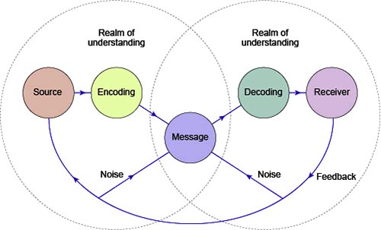
Source: QS Study

As you can see is more to it than just three components:
- Source is represented by the sender
- Encoding is the person who prepares the massage to be sent
- Decoder is the person who receive the encoded message and then makes it understandable
- Receiver is the person who receive the final stage of the message
- Message is the information sent by the sender
- Feedback is the confirmation that message was delivered
- Noise is the interference the massage gets on its way to the receiver

- Shannon and Weaver model of communication (Study, 2019)
In 1949 the engineer Warren Weaver and mathematician Claude Shannon come up with mathematical theory about communication. Their model is based on three principals: simplicity, generality and quantifiably. Being an engineer Weaver created this model to improve telephonic communication, but later Shannon used it elaborate effective communication.
The following image shows the Shannon and Weaver model of communication:
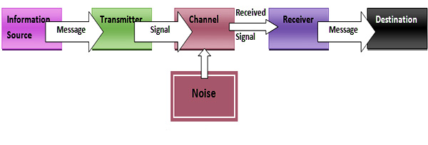
Source: QS Study
Their model of communication is made of:
- A source that produces the massage
- A transmitter who transforms the massage into signals
- A channel on which the signal is going throw
- A receiver who transform the massage back from signals
- A destination where the massage is received
- Noise that can alter or make the massage hard to be transmitted

- Berlo’s S-M-C-R model of communication (study, 2019)
In 1960 David K. Berlo a communication theorist published in his book ‘’ The Process of Communication ‘’ a new model of Communication. His model is made from four parts:
- S = Source can be a person, a group or even a company. There are several things that can control how the source will send the message:
- Communication skills (writing, drawing or speaking)
- Understanding of the message
- Position and attitude for audience
- Education, religion, politics, culture, salary etc.
- M = Message which is the material sent from de source
- C = Chanel is the way the message is sent (telegraph, radio etc.)
- R = Receiver the last part of the model and it is the audience or the person who receives the massage.
The following image show Berlo’s model of communication:
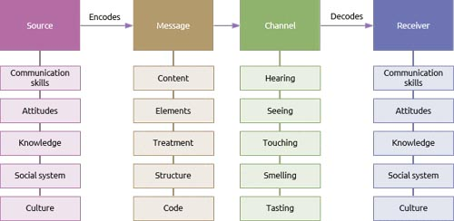
Source: QS Study

In the following rows I will show you some examples of communication problems and how can be improved using one of the models that I presented to you. This are some scenarios from my workplace, a distribution centre.
Example one:
One day, at the beginning of the shift a line manager come to us started explaining what he wants us to do. No problem except the fact that he said, in 10 minutes worth of speaking, over ten tasks that need to be fulfilled. At some point some of us lost focus about what he was saying and started making noises that made us lost focus as well. He noticed that but he kept on talking about his plan and the tasks we need to do. He finally finishes talking and asked us if we understood what we need to do. Some of us said yes even though they didn’t understand either. Hearing that the manager started walking toward his office, leaving us to do the tasks he wanted to be done.
Not understanding exactly what he wanted we started doing our normal daily duties. Twenty minutes before the end of shift he came back to us to see if we finish his tasks. He was surprized that we finish the task but in our own way, which wasn’t the way he wanted. The next shift after us needed to redo all the task, costing the company extra charges.
Conclusion
This example can easily be explained with Shannon and Weaver model of communication. Sending to much information at once makes it hard for the receiver to fully understand the massage. At the same time the noise made by my colleagues was the key factor in not understanding the massage. But if the manager would’ve had effective communication skills, he would’ve noticed that, at some point we lost focus of the message. If he would’ve stopped at that point and explain a bit more about the tasks, we would’ve understood the massage and we could’ve finished the tasks according to his plan.

Example two:
A couple of months ago the company I am working for hired a new line manager. She was a young attractive woman coming from a different country. She was in United Kingdom for less then two years and her level of English was enough at that time, according to the operational manager. She worked before as a manager but for a small shop. Everything went well until she receives the task to manage our department in the distribution centre. She tried a different approach with us being friendly and smiling all the time. In the same day, we encounter some difficulties downloading a container of item: we hade the wrong products. Not having the required experience, she said it is ok and to carry on with the downloading, after speaking with her boss. After a while her boss, the op manager, came down to see exactly wat happened. When he sees all the merchandise being palletise, he got angry and pick up his phone to ring the line manager. He was upset because he told her that it’s all right to send the merchandise back.
Conclusion:
This incident can be explained by Berlo’s model of communication. Speaking other language than your native language can become a barrier. Not understanding correctly, the message sent can lead to false interpretation. A better response to that phone call that she did, would’ve been the op. manager to come and see with his own eyes the problem. He should’ve been aware that the line manager is speaking a different native language than his and could’ve react appropriately.

Conclusions

‘’Communication is the key to success ‘’ (StudyModeResearch, 2010) this is one of most common quotes around the world. Having great communication skills is essential when you are working with or around different people. In order to have effective communication, first you need to understand the message followed by choosing the proper way to send the massage so that everyone can understand the message. Not being able to send the correct message can lead to false interpretation and misunderstandings.

References
skillsyouneed, 2011. What is Communication?. [Online]
Available at: https://www.skillsyouneed.com/ips/what-is-communication.html
[Accessed 05 08 2019].
skillsyouneed, 2019. Barriers to Effective Communication. [Online]
Available at: https://www.skillsyouneed.com/ips/barriers-communication.html
[Accessed 10 8 2019].
StudyModeResearch, 2010. Communication Is the Key to Success. [Online]
Available at: https://www.studymode.com/essays/Communication-Is-The-Key-To-Success-442309.html
[Accessed 27 08 2019].
study, Q., 2019. Berlo’s S-M-C-R Communication Model. [Online]
Available at: https://www.qsstudy.com/business-studies/berloas-s-m-c-r-model-communication
[Accessed 15 08 2019].
Study, Q., 2019. Schramm Model of Comunication. [Online]
Available at: https://www.qsstudy.com/business-studies/schramms-model-communication
[Accessed 15 08 2019].
Study, Q., 2019. Shannon and Weaver Model of Communication. [Online]
Available at: https://www.qsstudy.com/business-studies/shannon-weaver-model-communication
[Accessed 15 08 2019].

Please find attached the in-class exercises of term 1



