Launch of reusable silicon bags
Blog posts for company XYZ

BY

KALINA BONEVA
(2007655)

MODULE: MARKETING FUNDAMENTALS
MODULE CODE: LCBB4004
LECTURER: EFUA ADAMS

Introduction
With the growing concerns about the waste produced by humans, the efforts for recycling and sustainable productions are increased (Huysman et al., 2017; Giacovelli, 2018). In this regards, businesses around the globe have started to focus on the lifecycle of the products (Villarrubia-Gómez, Cornell and Fabres, 2018). The efforts in this regards are aligned to achieve the objective of waste minimisation throughout the lifecycle of the product. Besides this, the impact of the waste generated by the product is also a matter of concern (Babafemi et al., 2018; Awoyera and Adesina, 2020). The demand for these products or services is generated by the markets. With an increased focus on sustainability and environment protection, consumers are concerned about their purchase (Thakur et al., 2018; Wagner, 2018). This is relatively more important in the development market such as the United Kingdom (UK). As far as land pollution is concerned, more than 80 per cent of this is caused by any form of plastic (Chen and Yan, 2020). Out of this, a substantial share is taken by non-reusable plastic bags (Hahladakis, Iacovidou and Gerassimidou, 2020). Considering this as an area of opportunity, Company XYZ would be launching reusable silicon bags. This paper will present the blogs that have been created to engage the targeted audience during the first six weeks of the product launch.

WEEK 1: The waste-free challenge – Company XYZ
Owning our environmental responsibility like always, we have recently launched The Waste-Free Challenge within our organisation. Product designers and engineers from within the company have been taken on board to develop products that can add value to the environment. In this regard, the company developed a presented a roadmap to convey its aspirations towards environmental sustainability. We, at Company XYZ, aim to play our visible role to minimise the waste caused by human activities. Considering this, our target is to select something that considerably causes landfill waste and is difficult to recycle. The brainstorming session for the product development initially considered various products; however, the board finally agreed to develop the alternative for non-reusable plastic bags. This is one of the primary areas of concerns because more than 80 per cent of land waste is caused by various forms of plastic products. Besides, this type of waste is also causing water pollution (Li, Tse and Fok, 2016). According to the statistics, 74 per cent of global marine waste is generated by plastics and is a serious threat to marine life (Elias, 2017).
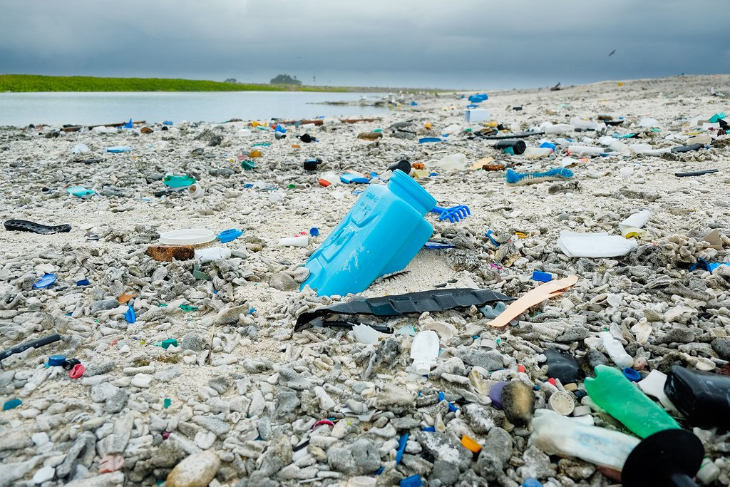
Considering the business economics, it is either difficult or uneconomical to recycle most plastic products. This is why most of the plastic waste either goes to landfills or find its way to the oceans (Van Sebille et al., 2015). After the brainstorming of our team, the company has decided to develop an eco-friendly alternative for plastic bags and small cabinets that are mostly used for food handling. Stay tuned for the updates!

WEEK 2: The eco-friendly choice you will love!
Linking back to The Waste-Free Challenge that we have discussed in the last week, our product designers came up with an innovative and creative idea of replacing plastic bags and containers with silicon bags. For this, the company has developed the prototypes and the blueprints for the production line have been finalized. This is one of few products that attracted the whole board as we at Company XYZ are always concerned about the environment. Anything that has the potential to minimise the waste or to reduce the environmental impact, we adopt it quickly without wasting too much time on economics. Responding to the years of trust that we have built, we are proudly launching Eco-Bags™ for our valued customers. This is a great addition to our existing environment-friendly product line.
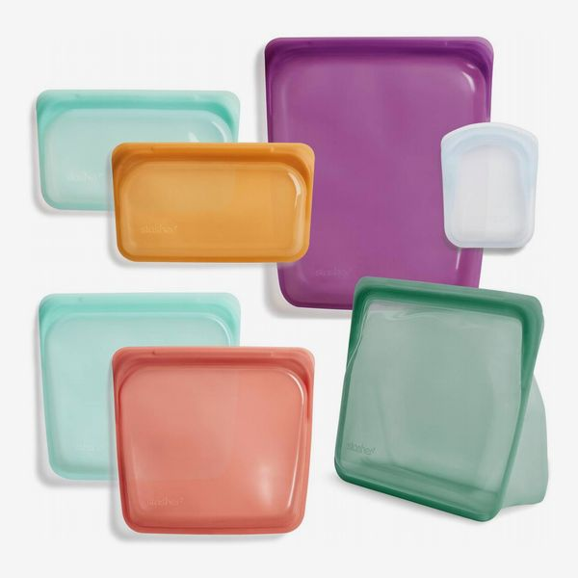
Eco-Bags™ is based on food-grade silicone material and is completely safe to use for any food item. This is endlessly reusable. This means, you can simply wash the bag after its first use and it is ready to be your partner for your next journey where you want to carry the food with you. Unlike other operators in the same market, we are considering to launch these bags in various shapes, sizes, colours and other aesthetic options to make them something that you will love to carry with you. We understand all your needs and would craft them to perfection.

WEEK 3: Eco-Bags™ is here! Get your next food partner now!
In continuation of our commitment towards environmental sustainability, we are proud to commercially launch Eco-Bags™. These bags are the perfect alternative to plastic bags made out of polyethene. Besides this, these may also be used as a perfect replacement for the plastic containers that you must be using in your home. The product is made out of 100 per cent of food-grade silicone material. If you have a little background in chemistry, silicon is a safe replacement for plastic and in terms of processing, with few alterations, it can be used to produce the same articles that are manufactured using plastic. As far as the use is considered, these are high strength and high heat resistant. This means, Eco-Bags™ that you will buy from our online stores can withstand heat up to 400 degrees Celsius ( Aybee et al., 2014). Amazing!? Unlike the existing plastic containers that you must be reluctant to use for hot food, these bags can be conveniently used for any type of food, either frozen or hot.
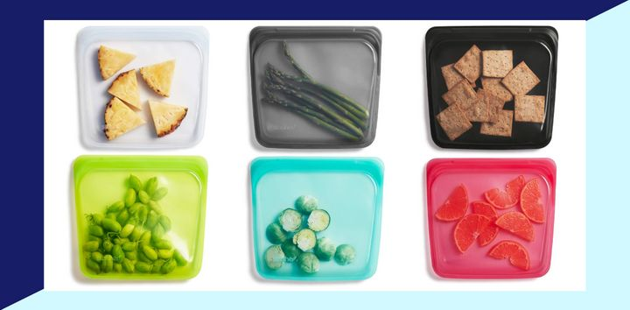
If you are planning to give your school going to a new partner in their lunch box, we have a lot of options to choose from. Order now!

WEEK 4: Eco-Bags™ - Specifically designed for children
We always listen to our customers. This is a drive of everything that we do at Company XYZ. We are grateful for an amazing response to the Eco-Bags™ that have been launched only a week ago. We are proud to say that with the help of all our customers, we have stopped another 2 million plastic bags and a container that could become part of landfills. The planet must be thankful to all of us!
In the product reviews, many of you have requested to include a designer range of silicon bags that can be specifically a point of attraction for children. We completely understand the concerns and this is why we are launching another all-new range of designer Eco-Bags™.
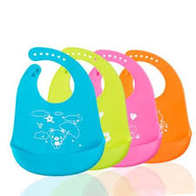
Designed by our talented engineers and product designer, this would be something that your children will love to carry. Besides eight options for size and shapes of the existing range, this new line adds 5 different shapes including animals, superheroes and food. The whole range comes with 12 new bright colours to make it a treat for your children. We hope that this new addition would bring a smile to the faces of your school goings. At the same time, we must also ensure that our children should understand how the planet is getting polluted by our activities and how our small effort can bring change. While you will handle this masterpiece in their hands, please explain to them the contribution that they would be making to save the environment and millions of marine lives. In this way, we would be ensured to keep this initiative alive for our upcoming generations. Also, we want to ensure that your children should be as proud of using this product as we are to develop this.

WEEK 5: Eco-Bags™ - Now available across the country
Sometimes, when you are planning to buy something, you want to feel it in your hands first. We at Company XYZ completely understand this and that is why we are partnering with major retail stores across the country to launch our iconic Eco-Bags™ on the physical retail stores. Our whole range of the products is now available in your city’s retail stores across the country.
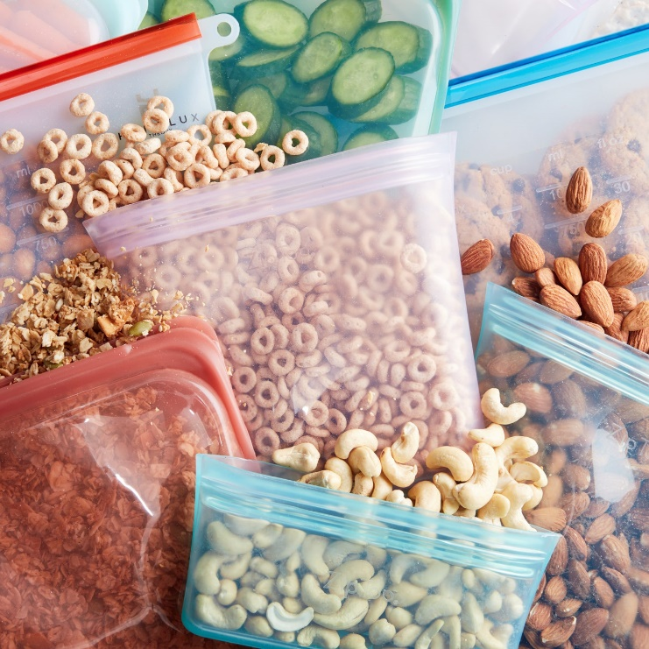
We are proud to announce that Eco-Bags™ is among the few brands that have made their ways this far. The whole journey was not possible with an amazing response and extensive support of our customers. Starting from our initial development a few weeks ago only, we have made several alterations to the shapes, sizes and colours of these bags. We want to make sure that the products are as per the requirements of our valued customers. We also understand that in our commitment towards the environmental impact, we are not alone and the whole society is standing with us to make this change happen. Together, if we cannot recycle the existing waste, we are sure that we can stop millions of tons that is likely to go into the landfills in the form of plastic waste. This will not only avoid the waste but will save marine life and would also avoid air pollution caused by the landfills and waste burning. So what you are waiting for? Visit your nearby retail store right now and feel this beautifully crafted product in your hands!

WEEK 6: Free gifts with your next purchase
In five weeks of its launch, Eco-Bags™ has become one of the hot-selling articles on our online stores and in retail channels as well. To meet the demands, we are planning the expansion options for our production facility. This is a proud moment for each one of us at Company XYZ. We do not see this simply as a business opportunity; rather, we are happy for the waste that we are controlling for the planet, for the environment and our next generation. This was not possible without the support, feedback and wonderful response from our valued customers. To celebrate our achievement with the customers, we are offering gifts with your next purchase of Eco-Bags™.

Wondering how will this work? It is as simple as A.B.C. You simply need to order online for your required variant of Eco-Bags™. Select the required size, shape or colour as per your needs. On the checkout page, you will be provided with three gifts options listed as Option 1, Option 2 and Option 3. You can select any option and let us surprise you when you get the delivery of your order. If you are planning to purchase the Eco-Bags™ lunchboxes in the form of containers for your children, we would suggest you go with Option 1 as this order will come with something to bring a smile to your child’s face. This is a limited time offer and you can claim your gift by placing your order right now!

References
Awoyera, P. O. and Adesina, A. (2020) ‘Plastic wastes to construction products: Status, limitations and future perspective’, Case Studies in Construction Materials.
Babafemi, A. J. et al. (2018) ‘Engineering properties of concrete with waste recycled plastic: A review’, Sustainability (Switzerland).
Chen, X. and Yan, N. (2020) ‘A brief overview of renewable plastics’, Materials Today Sustainability.
Elias, S. A. (2017) ‘Plastics in the ocean’, in Encyclopedia of the Anthropocene.
Giacovelli, C. (2018) Single-use plastic: A roadmap for sustainability, United Nation Environment Programme.
Hahladakis, J. N., Iacovidou, E. and Gerassimidou, S. (2020) ‘Plastic waste in a circular economy’, in Plastic Waste and Recycling.
Huysman, S. et al. (2017) ‘Performance indicators for a circular economy: A case study on post-industrial plastic waste’, Resources, Conservation and Recycling. doi:
Li, W. C., Tse, H. F. and Fok, L. (2016) ‘Plastic waste in the marine environment: A review of sources, occurrence and effects’, Science of the Total Environment.
Van Sebille, E. et al. (2015) ‘A global inventory of small floating plastic debris’, Environmental Research Letters.
Thakur, S. et al. (2018) ‘Sustainability of bioplastics: Opportunities and challenges’, Current Opinion in Green and Sustainable Chemistry.
Villarrubia-Gómez, P., Cornell, S. E. and Fabres, J. (2018) ‘Marine plastic pollution as a planetary boundary threat – The drifting piece in the sustainability puzzle’, Marine Policy.
Wagner, T. P. (2018) ‘Sustainability and plastic waste’, in Encyclopedia of Food Security and Sustainability.
Zeybee et al. (2014) ‘Environmental Effect on Biodegradability of Plastic and Paper Bags’, IOSR Journal of Environmental Science, Toxicology and Food Technology.

