Using a Research Approach in Human Resources

Report Title: An analysis of the induction process at organisation X, a high street fashion retailer, in order to identify any issues which might be related to staff turnover and to make recommendations for improvement.

Name: Maria Mellen Jimenez

CIPD Membership Number: 57501591

Date: 01/08/2021

Word count: 2148

By signing below, I confirm that the work/evidence presented is my own, unaided work. I understand the regulations pertaining to candidate malpractice and the action that may be taken as a result.

Signed: 
Date: 01/08/2021.

Executive summary

This report offers an analysis of the current induction process at the organisation X, a multinational high street fashion retailer, and it has been prepared for the HR Manager and the Managing Director.

A range of reliable secondary sources were analysed to be able to understand the process fully and its importance regarding employee turnover. After analysing the data produced by the responses from two different surveys sent to the employees, which may be found in the appendices, and contrasting it with the results from previous research, it is evident that there is no ‘buddy’ system in place, although the new starters feel welcomed and supported by other employees.

It is unclear for both employees and some managers that the length of the induction is four weeks, as the majority believes it is a process that lasts only a few hours, is rushed and with constant interruptions. In addition, some managers consider that they are not confident with it, which could be linked to their training.

It is also patent that the induction is focused on administration and compliance; some suggestions from the employees regarding its contents were a Welcome Pack and the focus on Company Values, along with the improvement of the Health and Safety training video.

The recommendations for improvement the induction process are as follows:

- The redesign of the induction as a staged process, including social media and the improvement of technology used for training.

- The focus on Company Values, Benefits and Career Progression.

- A budget allocation to support the department on the onboarding process, to ensure ‘buddy’ system is in place.

- The improvement of the induction training that managers are obtaining.

The report has also identified some limitations. Even if the participation was very high (92%) considering the timescale was only one week, the sample size was reduced, as only one store out of fifty-eight took part in the study.

Contents

Executive Summary 2
1. Introduction (terms of reference) 4
2. Literature Review 5
- What induction is and how it is related to staff retention 5
- Best-practice guide for successful inductions 5
- Example of successful induction: The Co-operative Group 5
3. Methodology 7
4. Findings/Discussion 8
5. Conclusions 12
6. Recommendations for change 13
Limitations 14
References 15
Appendices 16

1. Introduction (terms of reference)

X organisation is a multinational high street fashion retailer which sells clothing and accessories in specialised stores, with a turnover of £826 million for the year ended in January 2020, just before the Covid-19 pandemic (Companies House, 2020). The headcount for the company in the UK was stable with over 3000 full time employees. However, organisation’s internal data shows that the staff turnover during the year 2020 increased to over 50%, which had a direct impact on business costs.

According to the CIPD (2020), an effective induction programme benefits both the employer and the employee, as not only will it reduce staff turnover and absenteeism, but also will increase employee commitment and job satisfaction.

Aim

The aim of this research is to improve our induction process in order to reduce staff turnover.

Objectives

- To conduct primary research within the organisation.

- To analyse secondary data/literature.

- To focus on the top three most frequent disadvantages in order to improve the induction process.

- To make recommendations with the amendments that would need to be accomplished so that the induction process is more effective.

2. Literature Review

A number of reliable sources has been analysed in order to get a better understanding of the induction processes and best practice, including previous research on induction programmes in retail.
- What is induction and how is it related to staff retention?
The CIPD defines induction as the process that the employees go through to adjust to their new jobs and working environment. It must be a tool to integrate new starters into and across the organisation (CIPD, 2020), but it will vary depending on the size or the organisation and job role.
As Acevedo et al (2011) explain in their research, both employers and employees benefit from induction programmes, as they have proved to have reduced absenteeism and turnover, and increased job satisfaction and employee commitment. Induction programmes allow the new employees to understand their role, know more about their organisation, including Health and Safety and workplace facilities, and meet new co-workers. But also, inductions may be beneficial for existing team members who have a new role or those who have been away from work for a long period of time (Mindtools, 2021).
The CIPD (2020) states that line managers are responsible for their employees’ induction, although the HR and L&D specialists are in charge of its design, development and evaluation.
- Best-practice guide for successful inductions
Mindtools (2021) clarifies several steps in order to achieve a successful induction. The first stage would be planification, which happens during the design process. Several questions must be answered in order to create an adequate induction programme, such as the employee’s experience, weekly working hours, first impressions, work environment, equipment to provide them with or company policies, among others.
The following step would be to create a checklist, assigning the tasks to the different stages, which could be Pre-start, First Day, First Week and First Month. A template of an induction checklist can be downloaded from the Mindtools website. It is vital, though, to provide information on areas of compliance, like Health and Safety, company policies (CIPD, 2020), conditions of employment, organisation’s mission statement and values, benefits, and role specifications. It would be useful to keep a record of the training provided.
The final step would be evaluation, where feedback is gathered from the new recruits (CIPD, 2020). In addition, key measures of success must be identified, and the evaluation of the process must be done against them.
- Example of a successful induction: The Co-operative Group
In Pollit’s article “Co-operative Group induction inspires enthusiastic and engaged employees” (2013) it is described that the induction process at the Manchester headquarters was seen as an old-fashioned process where new starters did not learn much about the new brand, as per feedback from employees. Furthermore, the staff turnover in the headquarters was high, as 15% of the employees per year were leaving, increasing this percentage to 28 after three years.
After carrying out some research, with feedback from the main stakeholders, a new induction policy was created, outlining the responsibilities of the recruiting managers and the employees, with a checklist of the tasks to be carried over.
They also created a colourful welcome pack with essential information about the organisation and a new induction workshop with learning methods which involved more participation.
The results of this new process turned out to be a success, showing that the employee engagement in the head office rose to 85% from a previous 78%. The staff turnover decreased to just over 4%, which lead to a reduction on costs in terms of recruitment and training.

3. Methodology

For the purpose of this research, I have adopted a positivist research approach, by gathering facts with the intention of making general conclusions (Anderson, 2009).
Primary research was carried out through qualitative methods (Taylor et al, 2016), specifically through two different surveys, one designed for managers and another one for the rest of the employees, with some common questions. They were sent via email all of the 25 staff in the same store. Surveys are considered to be more convenient for participants since they may fill them in when they have some free time (Perkins & Woodhams, 2016), and they are also faster to hand out than other methods like interviews. On the other hand, this type of cross-sectional design may be unsuitable in terms of the questions asked, as poor questions may lead to poor quality data collected.
The method of collection of data was both reliable and valid as there was a great response to the survey: 92% of the participants submitted their answers.
The surveys were created and analysed using Google Forms, which allowed the participants to remain anonymous and to decline taking part in the study. They both contained closed and open questions; these last ones would enable us to gather the respondent’s personal opinion. Ethical matters were also considered (Appendix 1).

4. Findings/Discussion

The study had a high participation (92%), in particular from the management team. The responses from both surveys (Appendix B) were analysed.
In terms of employee (non-managerial) length of service, 35.2% of them have been in the company for less than a year, leading to low staff retention / high turnover. This issue might be influenced directly by a poor induction process (CIPD, 2020). Also, contrasting these results with secondary data from the Co-operative Group Induction (Pollitt, 2013) we may see a resemblance, where 15% of their staff were leaving every year. After designing and implementing a new induction program, staff turnover at the Co-op Head Office decreased to 4.5%.

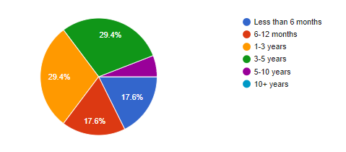 Employee survey (2021) Table 1

On the other hand, the general satisfaction with the company is greater:

Employee survey (2021)
In terms of the figure of the ‘buddy’, from the survey we find that 82.4% of the employees were not assigned a buddy during the first week, although 71.4% of them were supported by a manager of a sales assistant, leaving a 14.3% on their own with a radio to call for assistance.
Our current induction program is designed to last 4 weeks; however, when asked about the duration of the induction process, both managers’ and employees’ most popular answer is “A few hours”. Surprisingly, this percentage is quite high on the management team, which may lead us to believe that there is an issue with communication and training (Table 2).

Employee and manager survey (2021)
Table 2

Regarding confidence, employees were asked to assess the level of self-confidence that the manager responsible for their induction showed. 64.7% of them felt that the manager was confident with the induction, whereas 35.3% expressed that their manager had to be supported by a senior manager (Table 3).
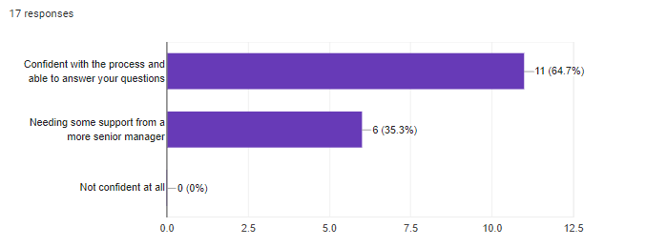
Employee Survey (2021)
Table 3
Unexpectedly, the response received from the management team was not as positive, as only 20% felt fully confident with the process. When asked if they believed there was anything missing in their training as a manager which concerns the induction process, from the answers on Appendix B, we can gather that the main issue is that it is not fully covered in their training, so managers end up not preparing enough for the process, as we can see below:
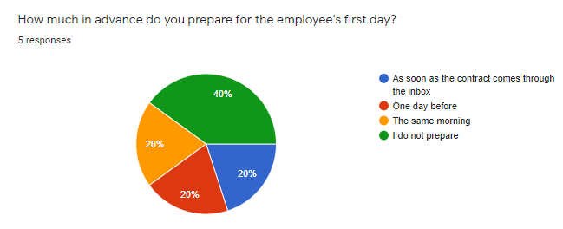
Manager survey (2021)
Table 4

Employees were also asked about what they believe is missing from the induction process, a few aspects arose:
- Training and Development
- Company values
- Different roles within the store
- Store opening hours

They were also enquired about what the induction should include:

Employee and Manager survey (2021)
Table 5
And lastly, when both parts replied to the question regarding what they would change of the process, the main trends were:
- To improve the H&S training video, as it does not work.
- To focus on induction during the manager’s training.
- To ensure the manager is focused on the induction to avoid interruptions.
- To ensure the process is not rushed.

5. Conclusions

A few concerns have emerged after analysing the results from both surveys, even though the employees felt welcomed by the team during their first day and a high percentage would recommend the company as a good place to work.

Firstly, there is no ‘buddy system’ in place. As the CIPD (2020) states, this is a way of providing informal support for the new employees to help them settle in, so they can understand the learning and development opportunities that might be available for them.

The induction process is rushed, and the manager is constantly interrupted having to deal with other issues in the store, instead of focusing on ensuring that the new starter is provided with a positive experience (CIPD, 2020). This could be linked to the manager’s confidence with the whole process. Whereas the employees consider that the majority of managers have the knowledge and skills to provide a good induction, only a low percentage of the managers feel confident with the process. It is not clear for most of the participants how long the process lasts, which might take us to some issues on the training provided to the managers.

Looking at the answers provided from the respondents related to the contents they believed should be included in the induction, another topic worth mentioning is the Company Values and Welcome Pack. The induction is mainly focused on administration and compliance, and this should be avoided (CIPD, 2020). Looking at the materials that the Co-op developed, like a Welcome Pack, containing the main Company Values, could lead to an improvement on employee engagement (Pollitt, 2013).

Some of them also mentioned the issue with the Health and Safety training video, which was undergoing some technical problems, so the manager has to demonstrate different scenarios, some of them in small spaces. Once again, we would like that the employees have a positive first day experience, and even more now with Covid-19 restrictions still in place where social distance must be maintained.

6. Recommendations for change

Based on the results of the literature review and primary research, the following recommendations are made:

- HR should focus on the redesign of the induction process, making it a clear staged process, introducing social media and improving the technology used for compulsory training as Health and Safety. Primary research (CIPD, 2014) indicates that the creation of a Welcome Pack with some basic information about the organisation and the induction process, including a phone call from the HR area manager before the new starter begin their journey with our company will make them feel as part of it already. This would incur a cost in the region of £18,000, as research by Pollitt (2013) indicates in the case of the Co-op.

- As a part of the redesign of the induction, HR must focus on how to transmit the Company Values and Benefits, such as Career Progression, as this could also improve the retention rate (Wilkinson & Taylor, 2016).

- HR to allocate an hours’ budget for the purposes of supporting the department/store when onboarding new starters, to ensure the manager is focused and the new employees can shadow their ‘buddies’ during the first week (CIPD, 2020).

- The Learning and Development team must look into the way the training is instructed in terms of induction. The management team should have clear directives on how the process takes place, starting by its duration, and the main aspects that should be covered in each stage of the process. L&D and store managers must work together to agree a purpose and set up SMART objectives for each specific learning need, to subsequently plan and implement learning events, evaluating them afterwards. (Perkins, 2016).

Limitations

There was a high participation in the survey (92%), where the complete management team were involved in the survey, considering the timeframe for the respondents to provide with their answers was only one week.
There were limitations in terms of sample size, as only one store in the country out of 58 took part in the study. However, this sample produced interesting results to be able to point out some issues and to make recommendations.

References

- Acevedo, J.M.; Yancey, G.B. (2011) Assessing new employee orientation programs. Journal of Workplace Learning, Vol. 23 Iss 5 pp. 349 – 354. Accessed on 14/07/21.

- Anderson, V. (2009) ‘Approaches to gathering data in HR research’, in Anderson, V. (2009) Research Methods in Human Resource Management. CIPD: London. Accessed on 16/07/21.

- Companies House (2020). Available at: https://find-and-update.company-information.service.gov.uk/company/02245999/filing-history. Accessed on 10/07/21.

- CIPD (2014) Rethinking Staff Inductions. Available at: https://www.cipd.co.uk/podcasts/rethinking-staff-inductions. Accessed on 23/07/21.

- CIPD (2020) Induction. Available at: https://www.cipd.co.uk/knowledge/fundamentals/people/recruitment/induction-factsheet. Accessed on 10/07/21.

- Mindtools (2021) Successful Inductions. Available at: https://www.mindtools.com/pages/article/newTMM_99.htm. Accessed on 14/07/21.

- Perkins, G. (2016) ‘Human Resource Development’ in Taylor, S., & Woodhams, C., (2016) Studying Human Resources Management. 2nd ed. London: CIPD. Accessed on 22/07/21.

- Perkins, G. & Woodhams, C., (2016). 'Using Information in Human Resources' in Taylor, S., & Woodhams, C., (2016) Studying Human Resources Management. 2nd ed. London: CIPD. Accessed on 14/07/21.

- Pollitt, D. (2013) Co-operative Group induction inspires enthusiastic and engaged employees. Human Resource Management International Digest, Vol. 21, No. 5. Accessed on 13/07/21.

- Wilkinson, K. & Taylor, S. (2016) in ‘Resourcing and Talent Planning’, in Taylor, S. & Woodhams, C., (2016) Studying Human Resources Management. 2nd ed. London: CIPD. Accessed on 23/07/21.

Appendices

APPENDIX A

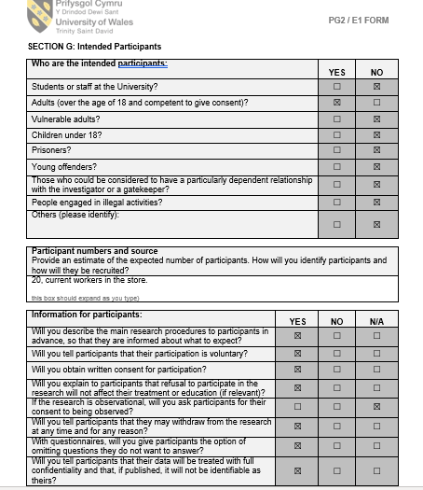

APPENDIX B


