Exam Solutions

Main Session 2019/20

Module Number: PSDM 5014

Title: Control and Instrumentation

Module leader: L Williams

Question 1 – Solutions

a)
i) 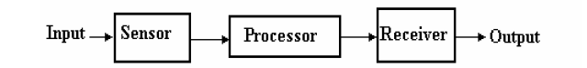

(5 marks)

ii)
Sensor – also called a detector, measures a physical quantity and converts it into a signal which can be read
Processor or signal conditioner – converts the sensor signal into another electrical signal which is more useable. E.g. amplify, filter, compensate
Receiver – this could be an analogue meter or a digital display
(5 marks)

b)
(i) Range, Span and FSD
The range of a transducer is its maximum and minimum values. The span is the difference between these two values. For example, a thermocouple may have a range between -100⁰C and 1250⁰C. This gives it a span of 1350⁰C. The Full Scale Deflection (FSD) is a term that comes from the old moving coil type of instrument. FSD is the maximum output value of the transducer.
(ii) Resolution
This is defined as the smallest change a transducer can measure. It is usually expressed as a ‘plus or minus’ value. For example a pressure transducer may have a resolution of +0.01Bar Therefore, a reading of 2.5Bar could actually be between 2.49Bar and 2.51Bar
(iii) Accuracy
This is usually given as a percentage according to the following equation

%accuracy = + resolution x 100%
span

For example, a transducer may have a span of 10V with a resolution of +0.025V. This gives an accuracy of 0.025 x 100 /10 = + 0.25%

(iv) Static Sensitivity
The sensitivity of a transducer is given by the equation

static sensitivity = output range of transducer
input range of measureand

(10 marks)

c)
i. Hysteresis error - The term hysteresis error is used for the difference in outputs given from the same value of quantity being measured according to whether that value has been reached by a continuously increasing change or a continuously decreasing change.
[2 marks for suitable description]

ii. Non-linearity error - The term non-linearity error is used for the error that occurs as a result of assuming a linear relationship between the input and output over the working range. , i.e. a graph of output plotted against input is assumed to give a straight line.. Linearity error is usually expressed as a percentage error of full range or full scale output.
[2 marks for suitable description]

d)
i) 2% of 30 = 0.6 bar
At 18 bar the gauge can read between 17.4 bar and 18.6 bar
(3 marks)

ii) V = 0.4f
V/I = 2mA/mV

1500rpm = 1500/60 = 25Hz

V = 0.4 x 25 = 10mV

I = 2 x 20 = 20mA
(7 marks)

Question 2 – Solutions

a)
i) Static system characteristics are the values given when the steady state condition occurs.

[2 marks]

ii) Dynamic system characteristics refer to the behaviour a system exhibits to a change in input until the steady state condition is achieved.
[2 marks]

b) Steps for solving dynamic system:
- Dynamic System represented in differential equations in time domain
- Laplace transform of model
- Design in S-domain, solve algebra equation
- Reverse Laplace transform and get the solution
[8 marks]

c)
The closed loop transfer function $\frac{θo}{θi}= \frac{G}{1+GH}$ [4 marks]

$G(s)= \frac{0.8Kp}{1+Ts}$ and H(s) = 1

Therefore $\frac{θo}{θi}= \frac{\frac{0.8Kp}{1+0.6s}}{1+\frac{0.5Kp}{1+0.6s} }$ multiply top and bottom by 1+0.6s

$$\frac{θo}{θi}= \frac{0.8Kp}{1+0.6s+0.8Kp}$$

$\frac{θo}{θi}= \frac{0.8Kp}{1+0.8Kp+0.6s}$ divide top and bottom by 1+0.8Kp

$\frac{θo}{θi}= \frac{\frac{0.8Kp}{1+0.8Kp}}{1+\frac{0.6s}{1+0.8Kp} }$ [8 marks]

Therefore the time constant term can be found by comparing with standard form
i.e.

CL time constant = $0.14= \frac{0.6}{ 1+0.8Kp }$

$$0.14= \frac{0.6}{ 1+0.8Kp }$$

Solving Kp = 4.11

Gain at Kp = 4.11 is $\frac{0.8Kp}{ 1+0.8Kp }$ = 0.76

[4 marks]

b) Since Kp in numerator and denominator a decrease in Kp will decrease the closed loop gain i.e. put Kp = 3, 2, 1 etc. and solve.

[6 marks]

Question 3 – Solutions

a) The solution can be summarized as follows:-

- A toaster is an example of an open loop control application. Its process is controlled entirely by time setting only and no feedback is provided, i.e. the toast is burning etc. One advantage of such an open loop control process is this simplicity as it makes the system more cost effective than closed loop alternatives.
[1 mark for application of open-loop]
[1 mark for advantage of open-loop]
[1 mark for disadvantage of open-loop]

- The typical home heating system is an example of a closed loop control system. This is supported by the fact that once your home or even water has reached its required temperature setting then the system switches off. To improve the system the effect of hysteresis is utilized to prevent continuous switching around the temperature set point, so the heating is only activated once more, when a couple degree temperature drop is obtained. A clear advantage of closed loop control is the ability to adapt to changes in the process. With the disadvantage being the increased system complexity and typically increased system costs.

[1 mark for application of open-loop]
[1 mark for advantage of closed-loop]
[1 mark for disadvantage of closed-loop]
[PART A TOTAL MARKS 6]

b)

Control Law

Process
Feedback Element
Correction Element
+
_
Comparison
Error
Output
Feedback
Input

[2 marks for correct diagram]
1 Comparison element
This element compares the required value of the variable being controlled with the measured value of what is being achieved and produces an error signal.
Error signal = reference value signal - measured value signal
The symbol used for an element at which signals are summed is a segmented circle, inputs going into segments. The inputs are all added, hence the feedback input is marked as negative and the reference signal positive so that the sum gives the difference between the signals. A feedback loop is a means whereby a signal related to the actual condition being achieved is fed back to modify the input signal to a process. The feedback is said to be negative feedback when the signal, which is fed back, subtracts from the input value. It is negative feedback that is required to control a system. Positive feedback occurs when the signal fed back adds to the input signal.
[2 marks for correct description]

2 Control law implementation element
The control law element determines what action to take when an error signal is received. The control law used by the element may be just to supply a signal, which switches on or off when there is an error, as in a room thermostat, or perhaps a signal, which is proportional to the size of the error and thus proportionally opens or closes a valve according to the size of the error. Control plans may be hard-wired systems in which the control plan is permanently fixed by the way the elements are connected together or programmable systems where the control plan is stored within a memory unit and may be altered by reprogramming it. Programmable systems offer greater flexibility.
[2 marks for correct description]

3 Correction element
The correction element or, as it is often called, the final control element, produces a change in the process which aims to correct or change the controlled condition. Thus it might be a switch, which is used to switch on a heater and so increases the temperature of the process or perhaps a valve, which opens and allows more liquid to enter the process. The term actuator is used for the element of a correction unit that provides the power to carry out the control action.
[2 marks for correct description]

4 Process element
The process is what is being controlled. It might be a room in a house with its temperature being controlled or a tank of water with its level being controlled.
[2 marks for correct description]

5. Feedback element
The feedback element produces a signal related to the variable condition of the process that is being controlled. It might be a temperature sensor with suitable signal processing or perhaps a ball float with a lever.
[2 marks for correct description]

[PART B TOTAL MARKS 12]

c)
i. Answer to include proportional control decreases rise time, increases overshoot affects settling time and can decrease steady state error.
[2 marks for correct points]

ii. Integral control decreases rise time, increases overshoot increases settling time and eliminates steady state error.
[2 marks for correct points]

iii. Derivative control cause a small change to rise time, decreases overshoot, decreases settling time an effect no change to steady state error.

[2 marks for correct points]

[PART C TOTAL MARKS 6]

d. First recall the standard 1st order representation equation of G(s) = k/1+Ʈs

- Therefore for system 1
Ʈ = 0.5 sec [2 mark]

ii For system 2 Ʈ = 120/1+0.5k sec

[8 mark]

[PART D TOTAL MARKS 10]

Question 4

- The frequency given is 100Hz convert to rad/s using 2$πf$
w = 2πf = 2 π x 100 = 628 rad/s (2 marks)

At this angular frequency the magnitude in dB can be read from the first plot to be -23dB
Using the equation :
Gain (dB) = 20 log (observed/actual) (4 marks)
-18 = 20 log (observed/0.2)
-18/20 = log (observed/0.2)
-0.9 = log (observed/0.2)
10^{-.09} = (observed/0.2)
0.126 x 0.2 = observed = 0.025 m/s² from the graph the phase is approx. 160⁰ lagging (9 marks)

b)
Students to discuss the use of a low pass filter to remove high frequency noise.
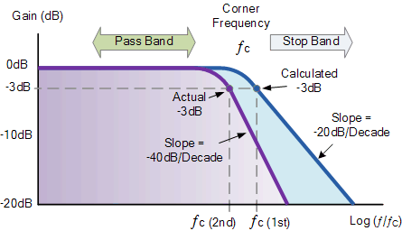
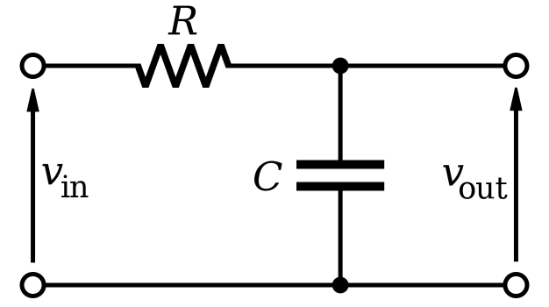

(6 marks)
The filter attenuates high frequency components before sampling to restrict the bandwidth of a signal, this is particularly useful in data logging for storage reasons and to avoid distortion due to aliasing. (6 marks)
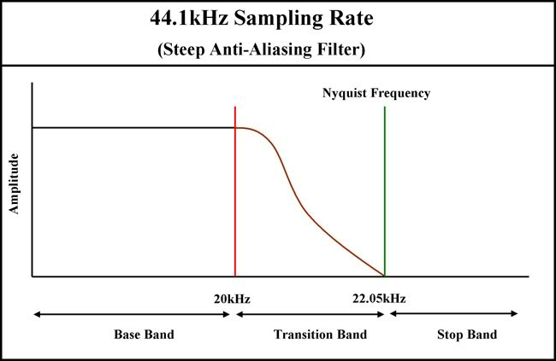
Aliasing occurs in data acquisition where an incorrect sampling rate causes distortion of the frequency information as shown below. (2 marks)
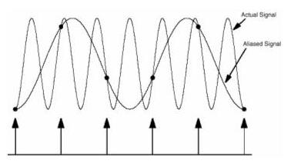
The samples of several different sine waves can be identical when at least one of them is at a frequency above half the sample rate. (2 mark)
The minimum sample rate must be twice the maximum frequency in the signal (f_{s} > 2 f_{max}) in order to enable reconstruction of the original waveform. This is the Nyquist – Shannon sampling theorem.
(3 marks)
(19 marks)

