Problem Solving and Decision-Making Approach in the Workplace

Student Name: | Desislava Yildirim
Student Number: | 1811811
Module no: | BMSK4004
Submission date: | 10/01/2020
Module Title: | Problem Solving and Decision Making
Lecturer: | Yajesh Kumar

Table of Contents
Introduction 0
Description of the organization 0
Search Strategy 0
Discussion 0
Alternative solutions to the problem 0
Develop a plan for implementing the solution 0
Communicate the plan to stakeholders 0
Monitoring and reviewing to ensure successful implementation of the solution 0
Conclusion 0
SWOT 0
PEST analysis 0
Porter’s five forces 0 0
Fishbone Diagram 0
PMI TOOL 0 0
References 0

Introduction
Problem resolution and decision-making are essential business and life competencies. Problem-solving often includes decision-making, management and leadership skills which are particularly fundamental in decision-making. Methods and strategies are significant to enhance decision-making and decision reliability. Some individuals take decisions more easily, and these persons should, therefore, concentrate on improving the value of their decisions. More experienced decision-makers often can make quality decisions, but then must be more consistent in the evaluation process. Problem-solving and decision making are interrelated strongly, and each needs the imagination to establish alternatives, which are especially useful with the brainstorming approach. Most people do is solve problems and make a choice. They are often nervous and very quick for a long time "under the pressure point." But they respond with a judgment that seemed to work previously, once they find a new problem or choice they must take. This strategy makes it easy to get caught in a loop to over and over fix the same issue. Thus, a systematic strategy to problem-solving and decision-making is often beneficial. All challenges can neither be solved through the decisions or the rational approach. This article discusses how to solve problems and make decisions for the chosen company “Doctors 4 You” that encounter various challenges in terms of problem-solving and making decision. The purpose of this article is to address the prevention of disease and waiting for patients during service. This essay would recommend various approaches to help Doctors 4 You company solve the daily obstacles. The result of this study will be notified by key stakeholders such as clinic owner, manager and workers, alongside effective monitoring and analysis strategies such as infection control check and waiting time assessment will be established to guarantee that the decision is properly implemented and a solution to the issue is found.

Description of the organization
Doctors 4 You is a private healthcare provider based in North London. It is an organization consisting of around 15 employees. Doctors 4 You is a UK based private clinic and offers independent healthcare service. The organization is registered with CQC and all its doctors are fully qualified, and GMC registered.
The clinic has different speciality doctors and provides same-day doctor appointments, blood tests, ultrasound scans, ECG etc. Patients normally book their appointment by phone or online and all patients are self-paid. The doctors of the organization have also practised in Romania, Bulgaria and Turkey.

Search Strategy
The article will use different literature studies, qualitative and quantitative data, journals and articles that will be collected from primary and secondary sources. The material or the evidence for the article will be collected from different online databases such as NCBI, Google Scholar, PubMed and official sources. There are certain keywords that can help in easing the task of obtaining relevant literature such as “decision-making”, “problem-solving” and “Resolving problems and decision-making approach in the workplace.” Also, the different tools such as SWOT analysis, PESTLE analyses, and Fishbone diagram and Porter’s five forces will be used for the decision-making processes. Secondary data will be obtained from Care Quality Commission report, clinic website and other available data. SWOT analysis enables to evaluate a company's strength, a business proposal or idea; PEST analysis allows to evaluate a market's potential and suitability. Good decision-making involves a combination of skills: imaginative production and possibilities evaluation, clarity of judgment, decision-making firmness, and effective execution.

Discussion
The decision-making process is the process of designing a choice by making a judgment, collecting data and reviewing achievable access (Rawson et al. 2016). By associating applicable data and defining choices, the use of a step-by-step decision-making process will help a person make more organized, informed choices. The function of protocols and microbiology guidance, instructions for antimicrobial prescription and medical microbiology facilities play a major role in the infection control decision-making process, given the fact that high ranking practitioners take liability for the overall management and caring of patients (Rawson et al. 2016).
Waiting times in outpatient procedures, like major surgery, is a significant concern and is also on the radar for policymakers. The patient waiting periods are often discussed to reduce them by allocating additional support, but the findings are not clear (Lungu, Ruggieri and Nuti 2019). At the same moment, researchers found large regional differences in the distribution of elective treatment that were not guided by patient needs or desires but by other variables. To assess this problem, a correlation analysis was conducted on waiting times and the treatment rates for nine procedures in the 34 districts in Tuscany (Lungu, Ruggieri and Nuti 2019). The findings demonstrated a high level of variability in both patient levels and waiting times, particularly for orthopaedic surgeries such as knee replacement, knee arthroscopy, and hip replacement. The study carried out for the nine measures indicates that the 34 districts in the waiting time-treatment rate system are in different positions, indicating that there is no clear correlation among rates and waiting times (Lungu, Ruggieri and Nuti 2019).
In order to prevent oversimplified strategies which do not solve the issue but often lead to greater spending, legislators and Medicare executives must adopt a two-step approach that first identify the form of context and secondly analyses the impact of components like resource efficiency, access to resources, priorities of patients and adequacy of care (Lungu, Ruggieri and Nuti 2019).
Change of behaviour is the use of empirically proven approaches to enhance behaviour or modify it (Bowmer et al. 2017). There are typically three main aspects of authority in health care facilities linked to behavioural management and infection control - Intrapersonal factors involving personal characteristics – knowledge, skills, attitudes, perceptions of healthcare personnel; Interpersonal factors involving colleagues, family members, ideals; and finally the Organizational factors that involve guidelines, standards, and policies. Including all the three levels of aspects in initiatives to control infections is key to health care prevention programs. An effective problem-solving process generally includes the seven steps (Bowmer et al. 2017).
- Problem identification
- Analysis of the issue
- Developing potential solutions and interventions
- The fourth step involves solving the problem and evaluating & identifying alternative approaches
- The fifth step is reviewing the solutions
- Next step is implementing the best appropriate solution
- The final step is evaluating the result
Health care professionals (HCP) should have the required knowledge, experience and resources to incorporate appropriate infection control procedures at an individual level (Bowmer et al. 2017). Studies show that improving HCP's knowledge base will affect their attitudes and inspire them to improve behaviour, by having access to data which facilitates understanding and problem-solving. Though, improving knowledge alone would not be adequate to effectively control infections and might not be appropriate to influence consistent shift, particularly given the multi-factorial nature of the health-related infections issue (Bowmer et al. 2017).
- It has been shown that implementing and developing skills, peer-to-peer role modelling, and interpersonal teams influence the adoption of key practices for infection control (Bowmer et al. 2017).
- Health care facilities can operate at an institutional level to foster interpersonal qualities such as respect for management, interdisciplinary collaboration, and interaction. Furthermore, measures should be taken to enhance job satisfaction for HCP (Bowmer et al. 2017).
- Attempts should also be made to develop and incorporate technologies across the institution that enable, strengthen and help promote good practices (like prescribing practices) to incorporate infection control and prevention into all facets of care (Bowmer et al. 2017).
It involves ensuring the services needed to ensure that HCP has safe and easy access to materials (e.g. rubbing based alcohol) (Bowmer et al. 2017). Healthcare organizations need to develop integrated structures that foster knowledge sharing and provide an environment to HCP that encourages and supports proper behaviour (like decision-making processes for antimicrobial stewardship) (Hughes and Field 2015). There is some proof on the inter-institutional level that inter-facilitate cooperation, like engagement in cooperative quality improvement partnerships with multicentre, may affect organizational training and organizational culture in ways that promote better HCP infection control practices (Hughes and Field 2015).

Alternative solutions to the problem
Proper, specifically adhered to disinfection and sanitation procedures are essential to keeping control of personal and environmental pathogens. Although these guidelines are in place in medical facilities, there are still discrepancies in the health care setting that enable for the proliferation of pathogens such as Clostridium difficile, MRSA, Staphylococcus aureus, and Acinetobacter baumannii. Though with contemporary effective siphonic toilets, it has been shown that bacteria, like Escherichia coli, remain effective for 4 – 6 hours in the aerosol phase. Smooth materials like curtains and upholstery often obtain inadequate sanitization and can host a range of pathogens.
There are various modern ways of Infection control. Using disposable curtains is one way to reduce illness proliferation, but with optimal disinfectants and implementation practices, there will be fewer wastes, more cost-effective, and more eco-friendly ways of managing these threats. Improving hand hygiene is one of the simplest and most effective ways to reduce the transmission of HAIs. Enhanced hand hygiene adherence with the need for alcohol-based hand rubbers was shown to decrease the nosocomial infection level by much more than 40%. Modern-day, cutting-edge antimicrobial hand hygiene items show a great commitment to even further reduce the spread of disease by bodily contact due to their wider efficacy, persistence, and acceptance by workers who often prevent sterilizing due to skin irritation.
Prevention and control of infections (IPC) is a rational approach and long-term solution aimed at preventing clinicians and health workers from harm caused by infection. It is focused on the improvement of infectious diseases, epidemiology, social science, and the healthcare system (WHO 2019). In the area of patient safety and quality universal healthcare coverage, IPC holds a special position as it is important for healthcare professionals and clinicians at every single healthcare conference. None of the country or any health care facility can pretend to be safe from the issue of healthcare-associated diseases, even inside the most developed and elegant healthcare systems (WHO 2019).
Throughout the Division of Service Delivery and Safety (SDS) of the WHO, a new IPC division has been developed to provide a robust, unified IPC role focused on improving national and international IPC capability and promoting health care standards (WHO 2019). Based on the pillars and successes of the Clean Care program, the system represents Safer Care (2005-2015) and the strong leadership and technical expertise shown by the current WHO disease control group, most notably during the Ebola virus response and early recovery research (WHO 2019).
Long patient wait times are a big impediment to doctor/patient trust. In an era of consolidation, litigation, regulation, and an increasingly sceptical populace, that’s a dangerous situation indeed. What seems like an integral part of our practice may be a time-wasting mistake that we make repeatedly out of habit.
Though there are certain ways that can help in solving the issue of the patient wait time. Such as distribution of task, using applications to make schedules, techniques for harnessing employee ideas are just some ideas that can help in reducing the time for the patient wait time.
Doing paperwork for collecting information during the entry time takes a lot of time, as many clinics ask the patients to fill up their form but, some patients take a lot of time to fill the form. To resolve this, some new applications should be developed that will be automatically filled up by the patient itself, whether from home or at the clinic. So, it will be attached to the databases of the healthcare facilities. This will help in reducing the patient wait time. In the present moment to book an appointment, people often prefer text or call during the busy moment rather than standing in a line, that consumes a lot of time. There should be online forms that can be filled up by the patient to make an appointment. This will help in reducing the phone call or text charges and lessen the patient time. As a patient fills up a form, it will automatically be registered by the health system and the appointment will be booked. There are also times when in a queue, two types of the patient occur, one with a severe chronic condition, one with an acute disease. When the healthcare professional checks the patient with a critical chronic condition, it makes them consume a lot of time, which makes the other patient wait. Thus, there should be either two professionals (senior and junior healthcare professional) present at the same time who will distribute the patients according to their severity of the condition. It will help in reducing the load from the healthcare professional and will also help to reduce the wait time for the patient.

Develop a plan for implementing the solution
An evidence-based infection control practice is very important for worldwide healthcare facilities though, it is hard to implement. Implementing the infection control practice in a healthcare organization can help in monitoring and improving the best practices that will be majorly focused on the patients. To implement the best infection control approach with the help of decision-making process, it is necessary to follow certain steps such as –
- Educate the staff members on the Effective infection control approaches that require a significant amount of consistent staff education on appropriate exercises and the organization's infection control policies.
- It is necessary the infection control committee should be a multidisciplinary group. As per research, the group should comprise of certain members such as the hospital epidemiologist, infection prevention specialists, a microbiologist and representatives (like the clinic owner, price manager and workers).
- The initial step of the infection prevention specialists is to collect relevant data on the incidence and number of infections in the healthcare organization. It is also important for them to collaborate with the microbiologist and form a baseline for surgical site, urinary tract and another type of the infections. They should develop antibiotic susceptibilities and resistance patterns — including multiple drug-resistant bacteria.
- The next phase is to analyse the data for trends and risks. In the analysis process, the reports will help to identify the healthcare divisions where the most type of infections occurred and will also comprise of the professionals who were able to manage the problem and will regulate them to similar kind of issues.
- After the analysis, the information is required to be communicated to other departments and other professionals to increase and guarantee awareness regarding the issues.
- After the team recognizes the rise in infections, they must develop an action plan to control the rate of the disease. Analysis of the information allows the healthcare facilities to improve their awareness, practices and techniques.
- There remain specific other tasks such as the monitoring of the hand hygiene process, monitoring the sterilization and other significant functions that will help in the improvement of the infection control.
- The final approach should be to stay up to date with the WHO, CDC healthcare policies, and the related infection control policies.
World Health Organization considers the patient waiting time as a significant issue of the healthcare facilities. In order to reduce the patient waiting time, the healthcare facilities should implement various approaches such as (Sun et al. 2017).
- Healthcare facilities should start using appointment methods so that people can start booking their appointment with their doctors from a long time so that on the day of the appointment they won’t need to wait (Sun et al. 2017).
- Healthcare facilities or private clinics should comprise of at least more than two doctors so that the patient load can be distributed, and the wait time can be reduced (Sun et al. 2017).
- There are also many times when large hospitals require patients to pay first then visit the doctor, and it is also a waste of time. It should be like after the doctor’s consultation; the patient should pay the money to the doctor “one bullet and two birds.” (Sun et al. 2017)

Communicate the plan to stakeholders
The key stakeholders of the organization Doctors 4 You are the clinic owner, price manager and workers. It is important to manage the stakeholders and communicate the whole infection control approach and the patient waiting time reduction approach to them so that they can help in successful implementation of the approach. Though to do that, a stakeholder management plan is required that will list the points of interest and influence along the other.
The infection control and patient waiting time reduction project manager will be responsible for the stakeholder management plan, though the plan will be distributed to every member involved with the project and to people who meet the stakeholders on a regular basis. In certain circumstances, the plan will be sent to the top authorities. Though, the stakeholder management plan is not distributed to the people who have been listed in the stakeholder’s plan.
The stakeholder management plan generally is developed through the information and findings which are obtained from the analysis and implementation process. The stakeholder management plan should comprise of all the essential members like the clinic owner, price manager and workers who need to receive communications, involving type, frequency, and details. It might be a better plan to develop the communications plan, instantly just after the management plan has been developed, or to divide the task into two part of a single plan. Like the management plan, the communication plan will also not be shared to the stakeholders directly; however, as time passes the stakeholders will become habituated to obtain the result of the plan.

Monitoring and reviewing to ensure successful implementation of the solution
It is important to involve all the stakeholders in the monitoring, review and evaluation techniques to ensure that the approach is successfully implemented.
Successful monitoring provides timely and reliable information to enable a person to monitor progress towards results and make changes as required to implementing arrangements. Monitor progress carefully and consistently through execution at regular intervals. Planning for implementation will identify the information to be obtained and the reporting system used. Guidance from data collection professionals may lead to a reliable and accurate approach during the planning process. Other elements of implementation like risk management will be informed by monitoring.
Audit component as part of a planning system to evaluate execution advancement at crucial milestones or in response to a topic. Reviews are a' snapshot' of an initiative's life and tend to focus on technical issues, policymaking efficiency, and project management frameworks, as well as electoral outcomes. Analysis results and feedback must be used to enhance compliance.
The degree to which desired and unexpected strategy results are accomplished and how they impacted stakeholders in determining the progress of an initiative. Evaluation schedules will define and chart benchmark statistics, as well as provide continuous exposure to reliable data resources through initiative's life-long tracking. Information may be quantitative or qualitative. People who manage an evaluation process must concentrate on inquiring good research questions to evaluate the data collected. An assessment's legitimacy is strengthened by solid evidence, technical and ethical guidelines, and the evaluator's level of autonomy. Efficacious evaluation is the outcome of the initiative's life-long planning system. Conclusion
For Doctors 4 You to incorporate proper infection control approaches, they need to involve different things such as educators who will provide patient education, personal caretakers, and healthcare professionals, evidence-based preventive approaches and necessary stakeholders. Such methods should include effective and comprehensive hand hygiene procedures, as suggested using PPE or segregation, and the use of antibiotics in a careful manner. Various papers also reported that over half of patients have been waiting for more than 1 hour, with heavy patient load combined with few doctors and nurses being the leading causes of this long waiting time. Healthcare professionals also need practice on the different ways in which waiting times can be lowered, such as using a computer program to help patients in allocating appointments and triage systems to address patients with an immediate need for care (Oche and Adamu 2013).

SWOT
Decision for infection control and reduction of patient wait time
Strength | Weakness
- Less number of harmful diseases occurring in the patients  - Less number of healthcare-associated infections  - Distribution of patients among different experts will help them to reduce the workload, and reduce the patient wait time. | Not controlling the infection rate will increase the incidence rate of the HAI and will make the healthcare workers and the patients get harmful diseases.  Not improving the patient wait time will make it hectic for both the patients as well as the healthcare professionals.
Opportunities | Threats
Partnership and collaboration among the research and clinical team will be well established. | Not controlling the infection rate will increase the incidence rate of the HAI and will make the healthcare workers and the patients get harmful diseases.  Not improving the patient wait time will make it hectic for both the patients as well as the healthcare professionals.

PEST analysis
- Political (P) – Quality of care to be promoted by the government; Different legislative initiatives for modifications in the healthcare system; Governmental strategies
- Economic (E) – How is the overall investment by the government targeted?
- Social (S) – Ageing population; Lifestyle changes; modifying the workplace setting
- Technological (T) – New technologies and applications; Telemedicine approach; evidence-based interventions

Porter’s five forces

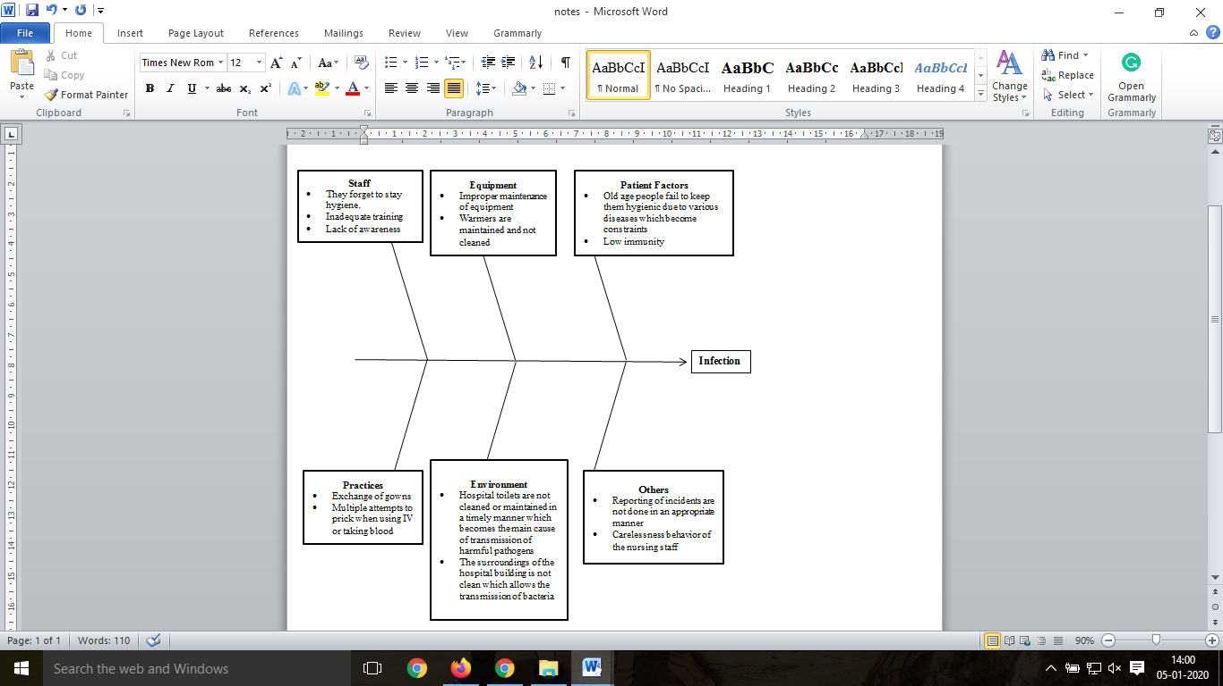
Fishbone Diagram
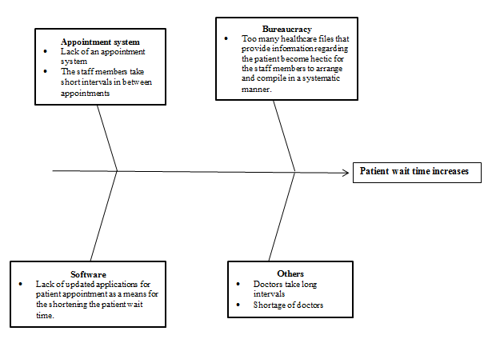

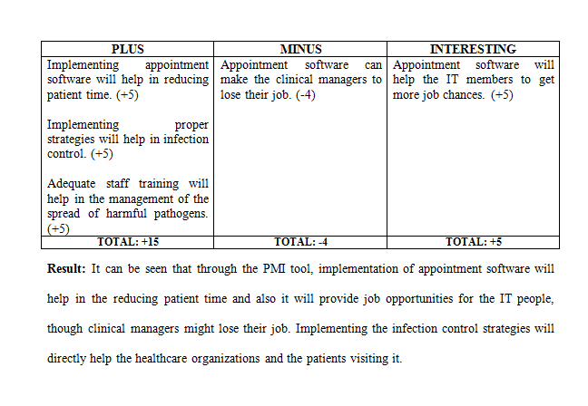
PMI TOOL

References
Berríos-Torres, S.I., Umscheid, C.A., Bratzler, D.W., Leas, B., Stone, E.C., Kelz, R.R., Reinke, C.E., Morgan, S., Solomkin, J.S., Mazuski, J.E. and Dellinger, E.P., 2017. Centers for Disease Control and Prevention guideline for the prevention of surgical site infection, 2017. JAMA surgery, 152(8), pp.784-791.
Bowmer, G., Latchford, G., Duff, A., Denton, M., Dye, L., Lawton, C. and Lee, T., 2017. Adherence to infection prevention and control guidelines: A vignette-based study of decision-making and risk-taking in young adults with cystic fibrosis. Journal of Cystic Fibrosis, 16(1), pp.146-150.
Dingle, K.E., Didelot, X., Quan, T.P., Eyre, D.W., Stoesser, N., Golubchik, T., Harding, R.M., Wilson, D.J., Griffiths, D., Vaughan, A. and Finney, J.M., 2017. Effects of control interventions on Clostridium difficile infection in England: an observational study. The Lancet Infectious Diseases, 17(4), pp.411-421.
Gjolaj, L.N., Campos, G.G., Olier-Pino, A.I. and Fernandez, G.L., 2015. Delivering patient value by using process improvement tools to decrease patient wait time in an outpatient oncology infusion unit. Journal of oncology practice, 12(1), pp. e95-e100.
Gürel, E. and Tat, M., 2017. SWOT analysis: A theoretical review. Journal of International Social Research, 10(51).
Hughes, G. and Field, N., 2015. The epidemiology of sexually transmitted infections in the UK: impact of behavior, services and interventions. Future microbiology, 10(1), pp.35-51.
Koohang, A., Riggio, M.T., Paliszkiewicz, J. and Nord, J.H., 2017. SECURITY POLICIES AND DATA PROTECTION OF MOBILE DEVICES IN THE WORKPLACE. Issues in Information Systems, 18(1).
Kuhar, D., Pollock, D., Yokoe, D., Howell, M. and Chopra, V., 2018. Healthcare infection control practices advisory committee (HICPAC).
Lungu, D.A., Ruggieri, T.G. and Nuti, S., 2019. Decision making tools for managing waiting times and treatment rates in elective surgery. BMC health services research, 19(1), p.369.
Oche, M.O. and Adamu, H., 2013. Determinants of patient waiting time in the general outpatient department of a tertiary health institution in north Western Nigeria. Annals of medical and health sciences research, 3(4), pp.588-592.
Rawson, T.M., Charani, E., Moore, L.S.P., Hernandez, B., Castro-Sánchez, E., Herrero, P., Georgiou, P. and Holmes, A.H., 2016. Mapping the decision pathways of acute infection management in secondary care among UK medical physicians: a qualitative study. BMC medicine, 14(1), p.208.
Rosenthal, V.D., Al-Abdely, H.M., El-Kholy, A.A., AlKhawaja, S.A.A., Leblebicioglu, H., Mehta, Y., Rai, V., Hung, N.V., Kanj, S.S., Salama, M.F. and Salgado-Yepez, E., 2016. International Nosocomial Infection Control Consortium report, data summary of 50 countries for 2010-2015: Device-associated module. American journal of infection control, 44(12), pp.1495-1504.
Singh, N., Mittal, T. and Gupta, M., 2018. A Tale of Policies and Breaches: Analytical Approach to Construct Social Media Policy. In Information Technology Risk Management and Compliance in Modern Organizations (pp. 176-212). IGI Global.
Sun, J., Lin, Q., Zhao, P., Zhang, Q., Xu, K., Chen, H., Hu, C.J., Stuntz, M., Li, H. and Liu, Y., 2017. Reducing waiting time and raising outpatient satisfaction in a Chinese public tertiary general hospital-an interrupted time series study. BMC public health, 17(1), p.668.
Sutrisno, A., Kwon, H.M., Gunawan, I., Eldridge, S. and Lee, T.R., 2016. Integrating SWOT analysis into the FMEA methodology to improve corrective action decision making.
Tewksbury, C., Dumon, K., Hesson, L., Kotwicki, M., Pickett-Blakely, O., Stavola, S., Warner-Grimsley, S., Zipay, J. and Williams, N., 2016. Use of an electronic patient tracking system in an outpatient bariatric surgery setting and patient wait times. Surgery for Obesity and Related Diseases, 12(7), pp. S153-S154.
WHO (2019)? Infection prevention and control. [online] World Health Organization. Available at: https://www.who.int/infection-prevention/about/ipc/en/ [Accessed 30 Nov. 2019].
Xavier, G., Crane, J., Follen, M., Wilcox, W., Pulitzer, S. and Noon, C., 2018. Using Poisson Modeling and Queuing Theory to Optimize Staffing and Decrease Patient Wait Time in the Emergency Department. Open Journal of Emergency Medicine, 6(03), p.54.

