

Student name: Rosa Islam Semi Bepary
Student ID: 2418833
Module name: Change-makers: Building your Personal Brand for Sustainable Employment.
Module code: BMHP5015
Lecturer name: Caroline Salami

01
Table of contents
- Introduction…………………………………………………………………………………03
- Job Description…………………………………………………………………………….04
- Analysis of Skills Needed for the Job and Self-Assessment………………………….06
- Development of Personal Skills and Resources……………………………………….07
- Action Plan and Timeline…………………………………………………………………08
- Communication of Skills to Potential Employers………………………………………09
- Conclusion…………………………………………………………………………………10
- References…………………………………………………………………………………11

1. Introduction
02
I’m really excited about becoming a Psychologist This career fascinates me because it combines my interest in understanding how people think and act with my desire to help them. My passion for mental health sparked while I was volunteering at a community center. There, I helped people facing various challenges, and seeing the positive changes in their lives made me want to pursue this field even more.
I hope to work in the NHS or perhaps in private practice, with a focus on mental health support for children and teens. I truly believe that mental well-being is just as important as physical health, and I want to make a difference in people's lives. I’m particularly interested in cognitive behavioral therapy and emotional support because I think these approaches are key for helping people build resilience. The thought of guiding someone through their struggles and watching them flourish really resonates with me.
Currently, I’m in my third semester of Level 6 in my Bachelor of Science in Health and Social Care at the University of Wales Trinity St David. Next month, I’ll be moving up to Level 7, which means I’ll dive deeper into specialized subjects. Right after I graduate, I plan to enroll in a Master’s program in Psychology, focusing on clinical psychology. I find this path exciting because it blends theory with practical application.
In this report, I’ll explore the skills I need to be a psychologist, assess my current abilities, and outline a plan for developing the skills I still need. I recently found a job ad on Indeed for a Psychotherapist role that highlights what employers look for. This advertisement helps me understand what I should focus on in my studies and professional development.

03
2. Job description of the selected job
The Psychotherapist position at Outcomes First Group focuses on supporting children and young people who have complex communication needs and emotional challenges. This role really appeals to me because it emphasizes mental health support for young people during such critical years. The job is based at Baston House School & Woodside Park, where I’d work with a team of dedicated professionals committed to improving kids' lives.
Key Details:
- Salary: £40,000 - £50,000 per year
- Hours: 37.5 hours per week, Monday to Friday, from 8:30 am to 4:30 pm
- Contract Type: Permanent, Term-Time only
Responsibilities:
- Deliver personalized assessments and intervention plans for students with complex needs.
- Use a holistic approach to ensure the well-being of students.
- Collaborate with the clinical team to enhance service delivery and share valuable insights.
Essential Criteria:
- Registered Psychotherapist Practitioner (Level 7).
- Experience with neurodevelopmental disorders and mental health needs.
- Ability to work independently and as part of a team.
This job aligns perfectly with my goals because it underscores the importance of mental health support for young people. I genuinely feel I could make a real difference in their lives. The position requires not just technical skills but also emotional intelligence and empathy, qualities I’ve developed through my caregiving experience (Johnson, 2021).
The role of a Psychotherapist is crucial, especially today when mental health issues are increasingly recognized. I believe that early intervention can lead to better outcomes and help shape a healthier future for these young individuals.

04
Job Screenshots (https://uk.indeed.com/viewjob?jk=21c152a8818f4ab9&from=appshareios)
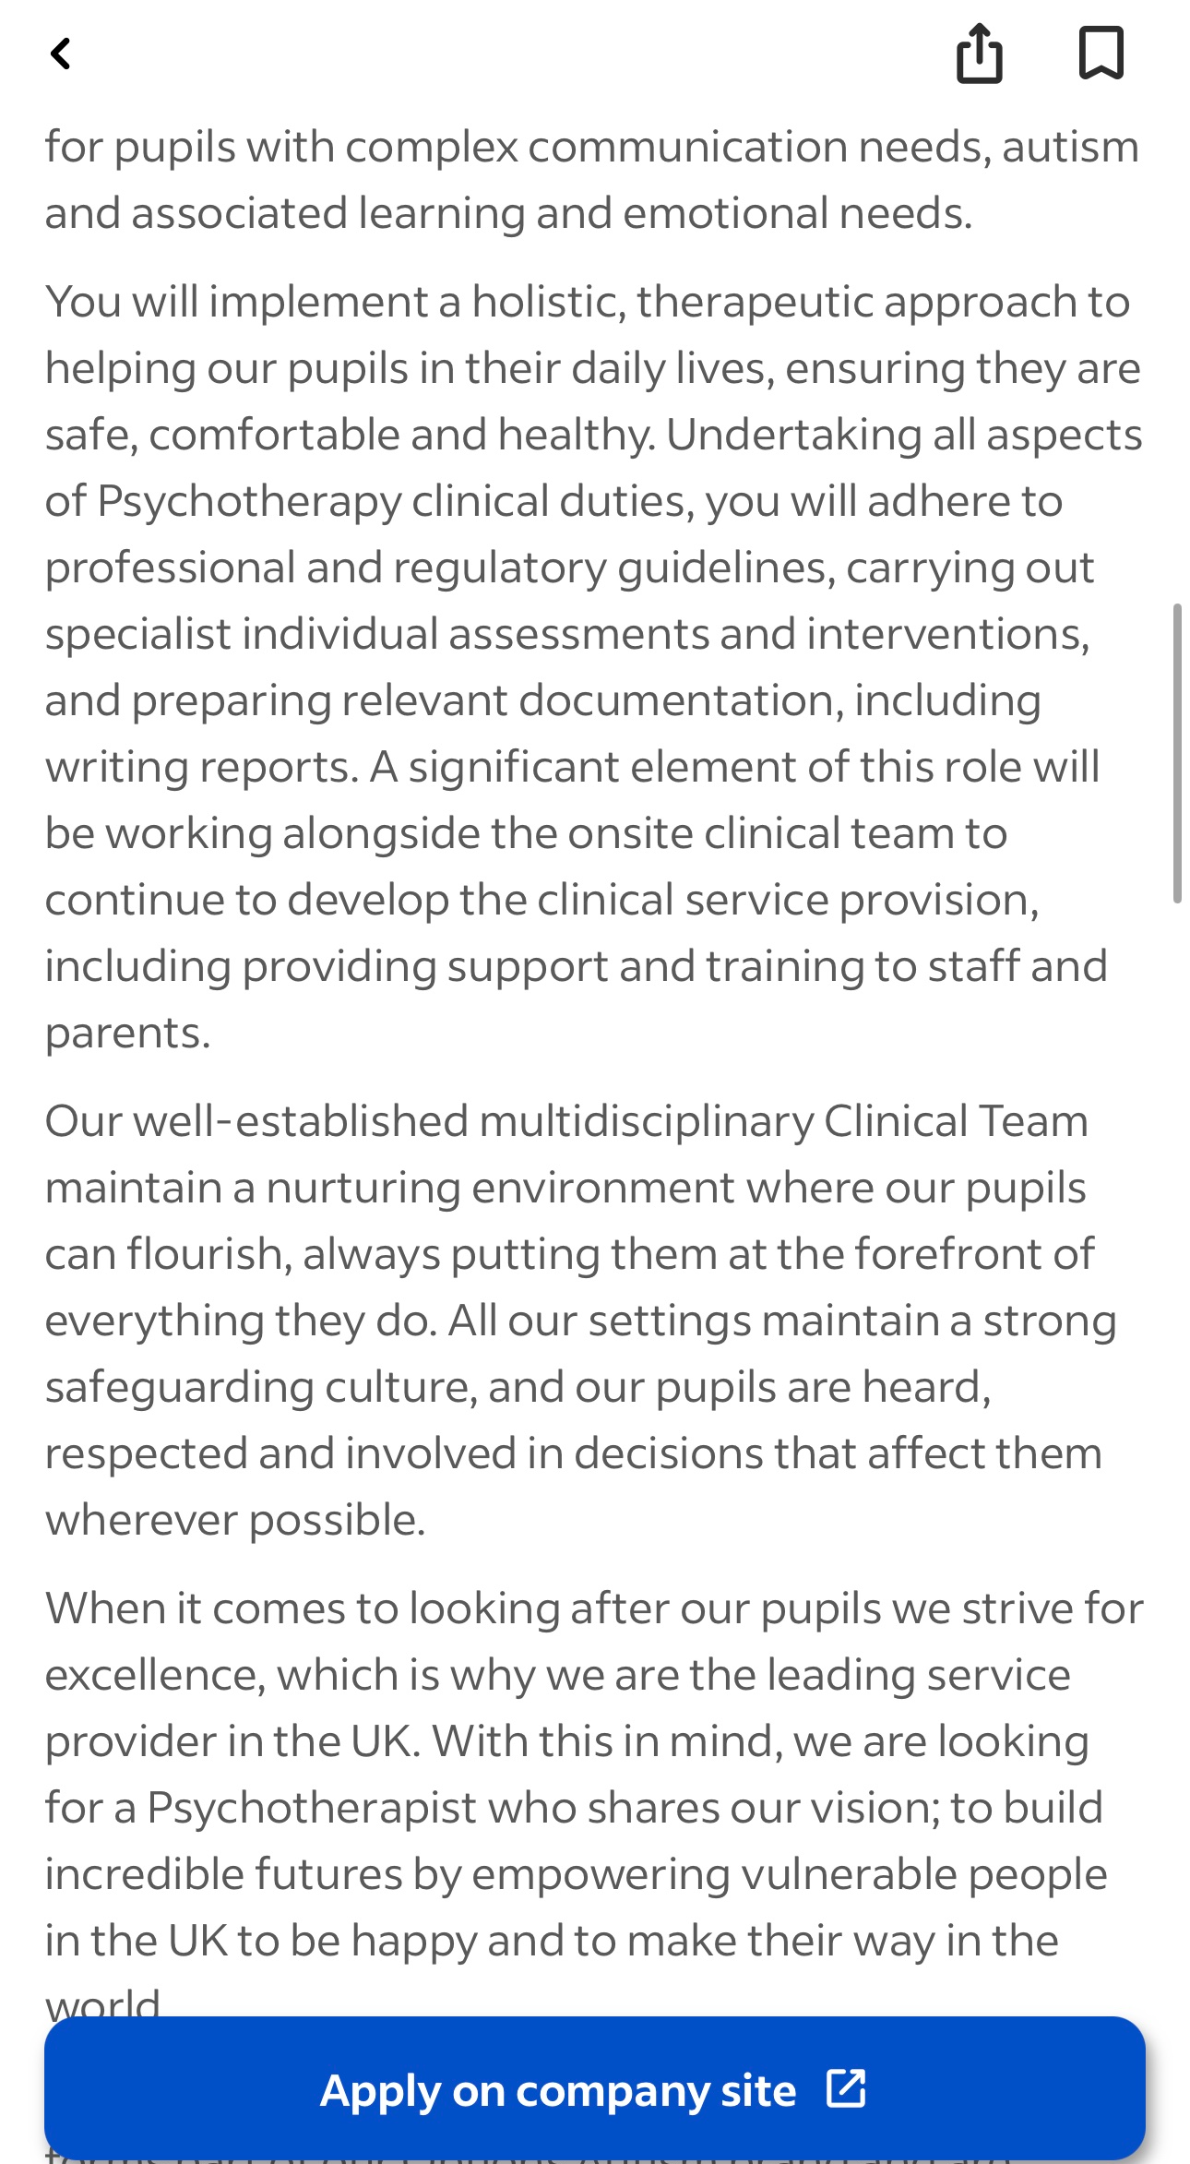
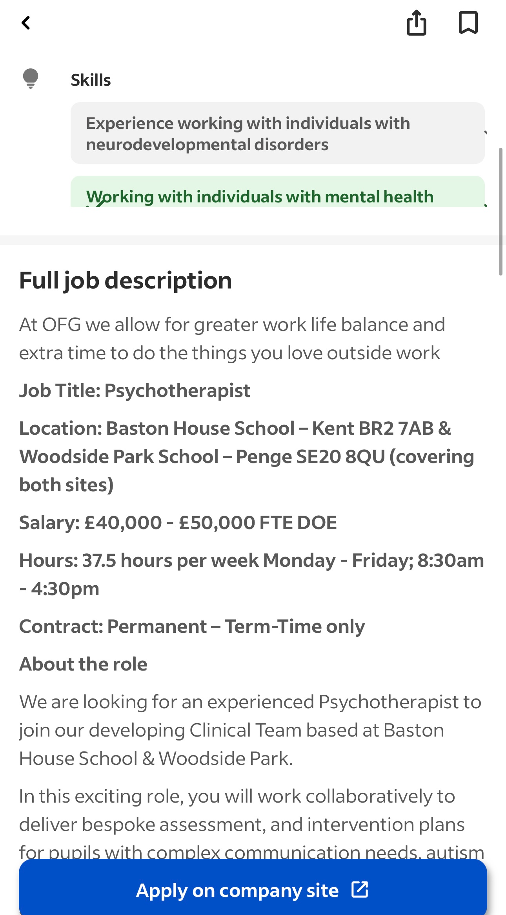
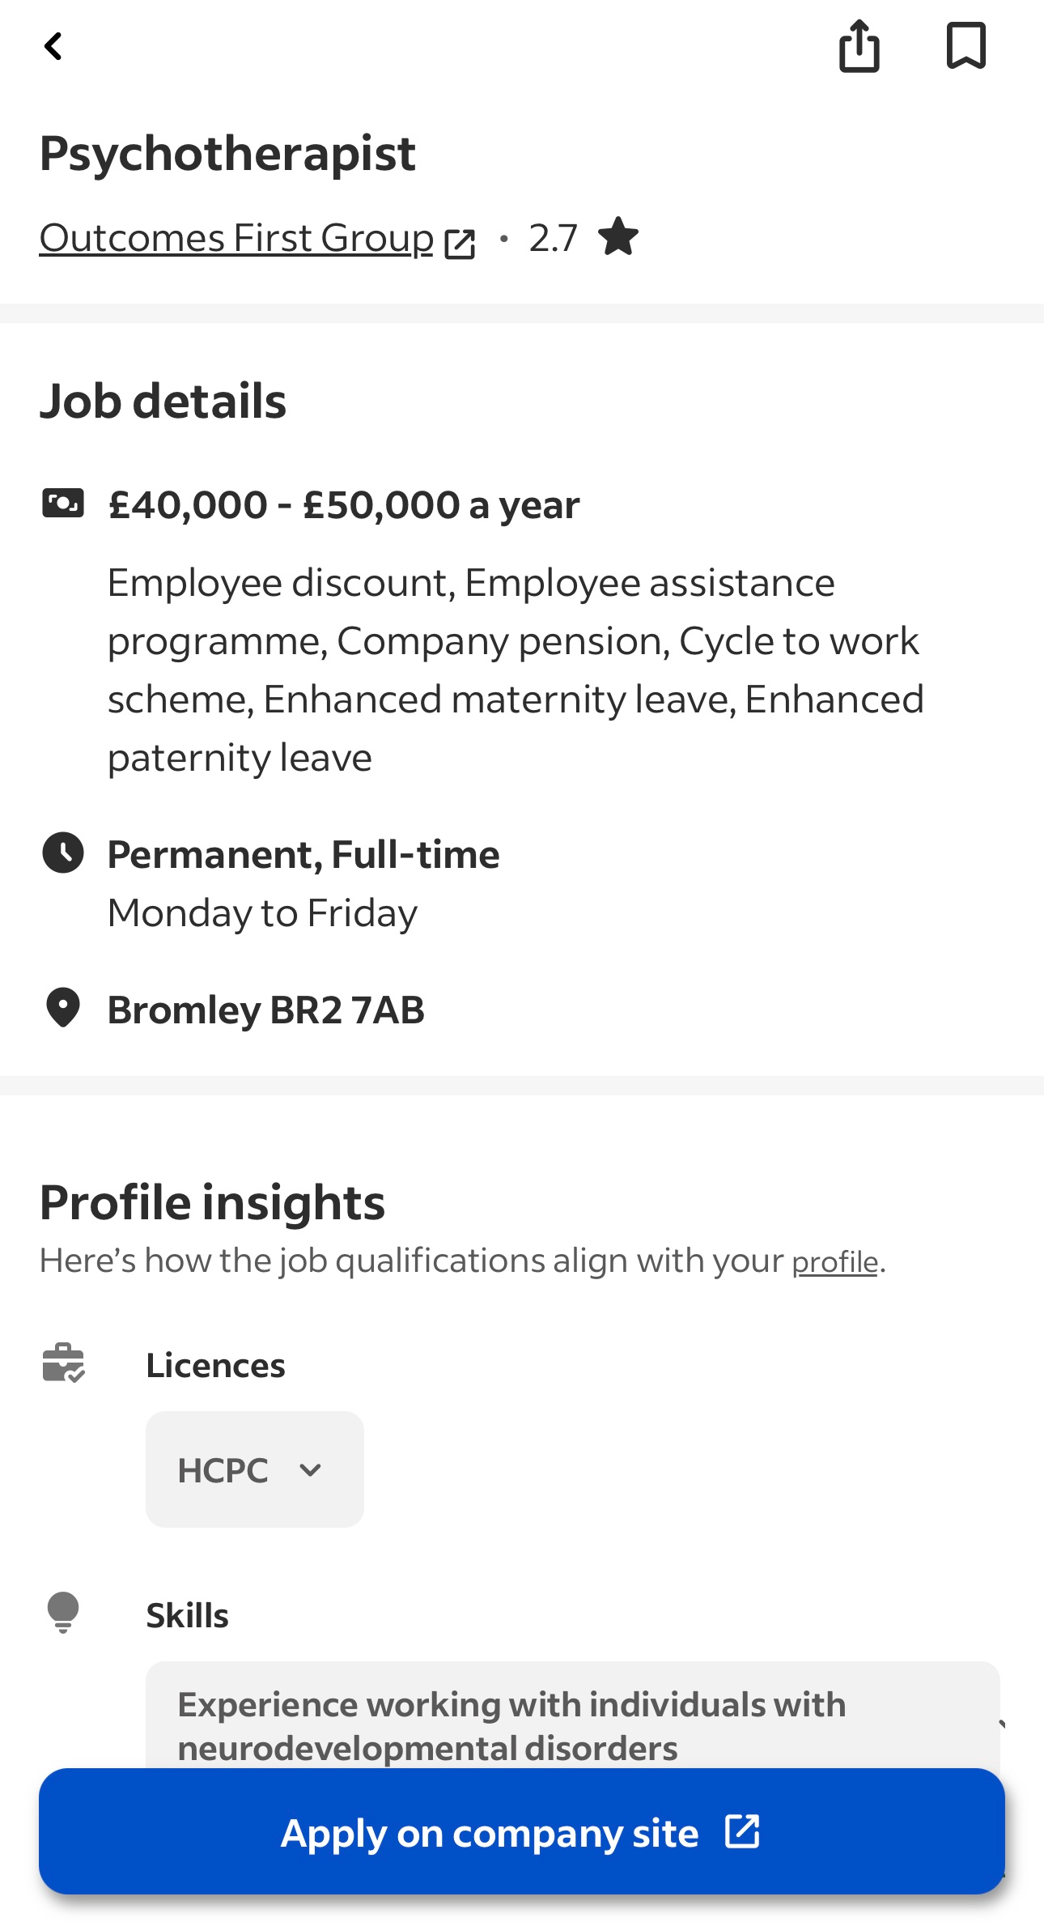

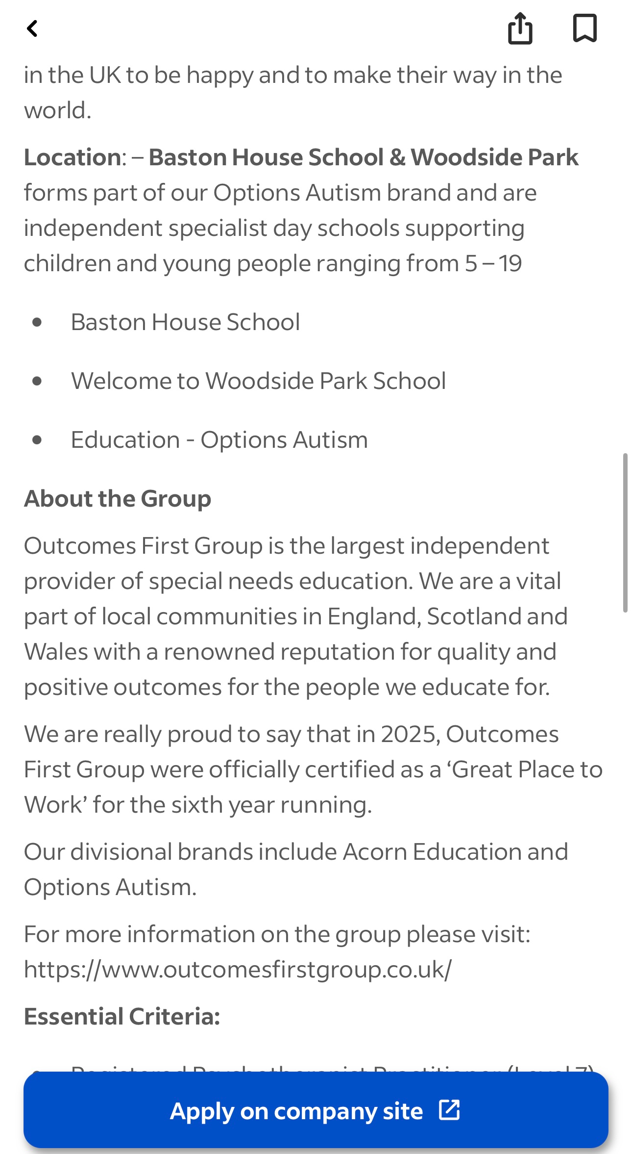
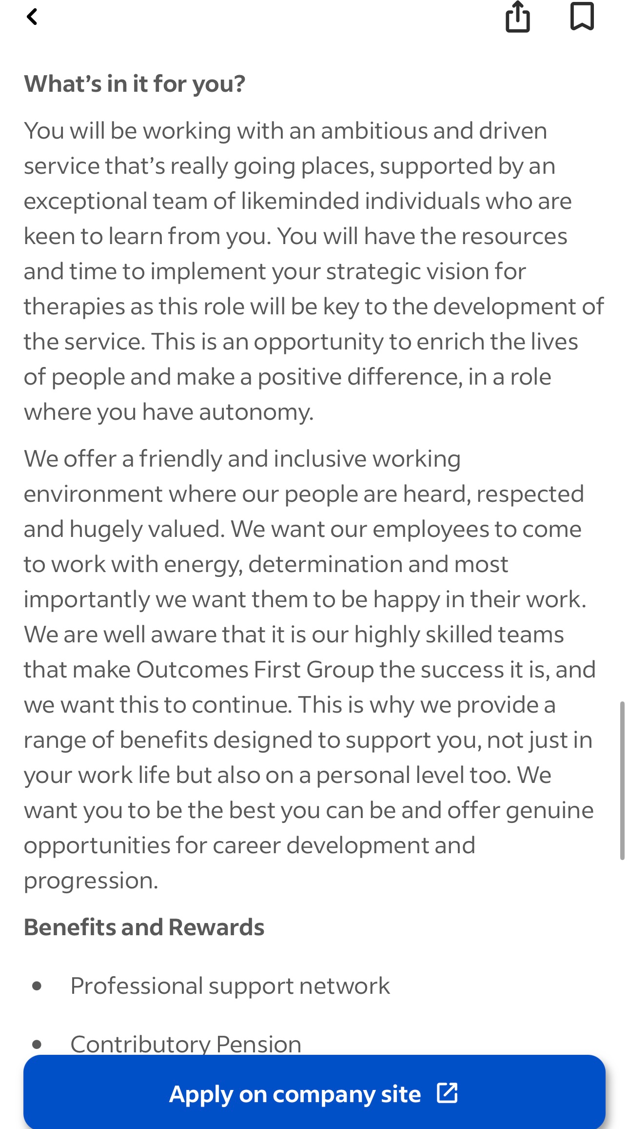
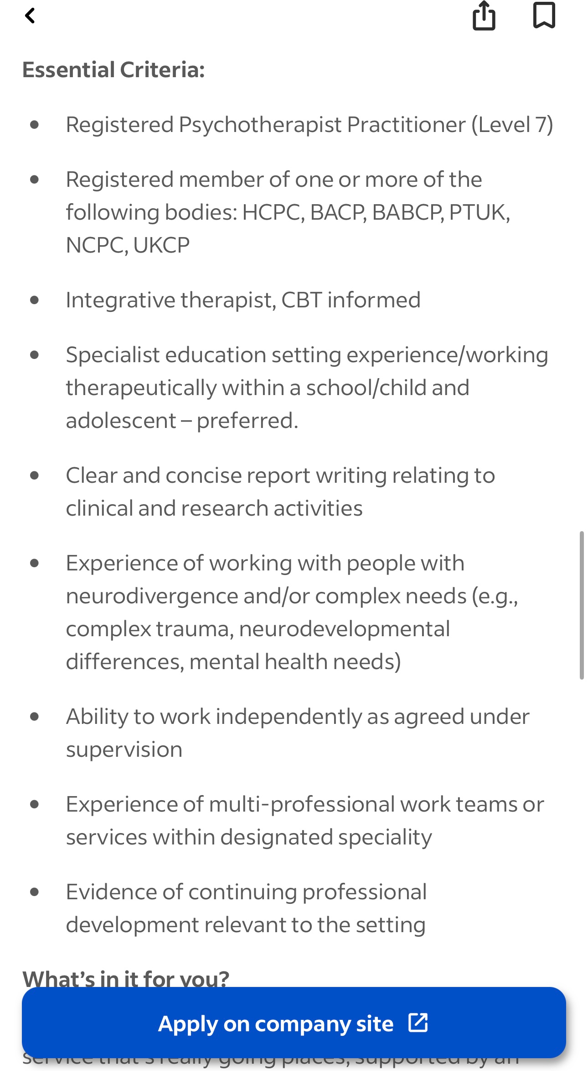

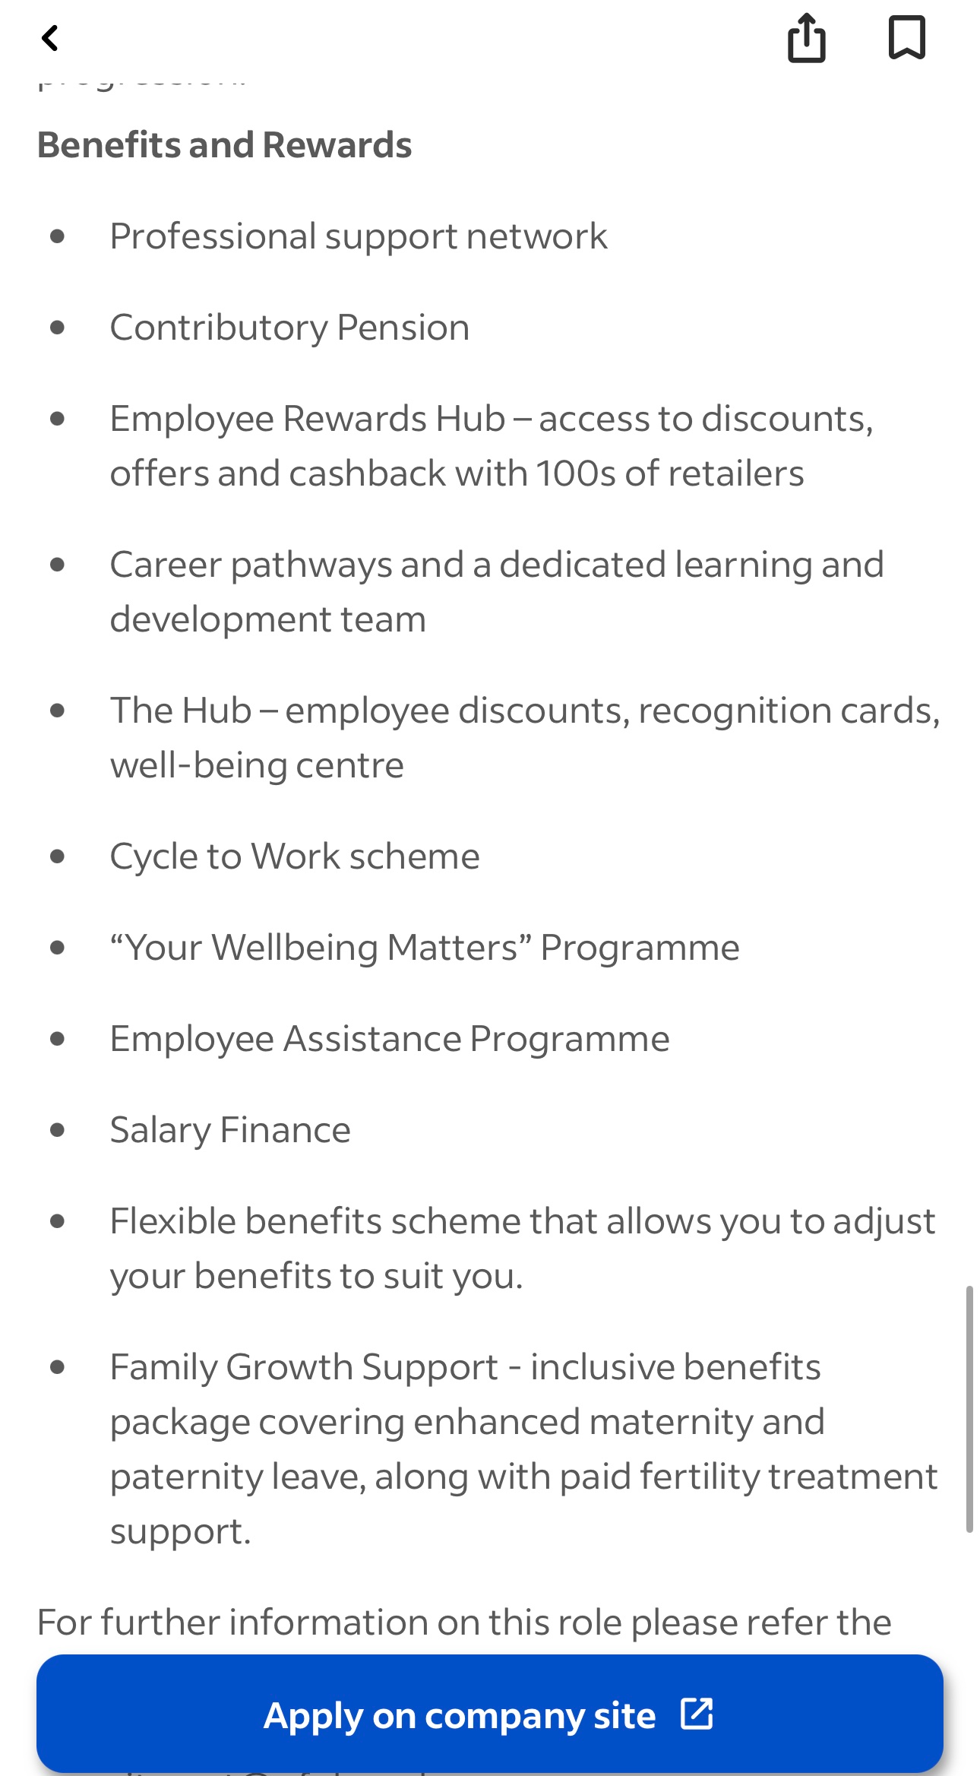
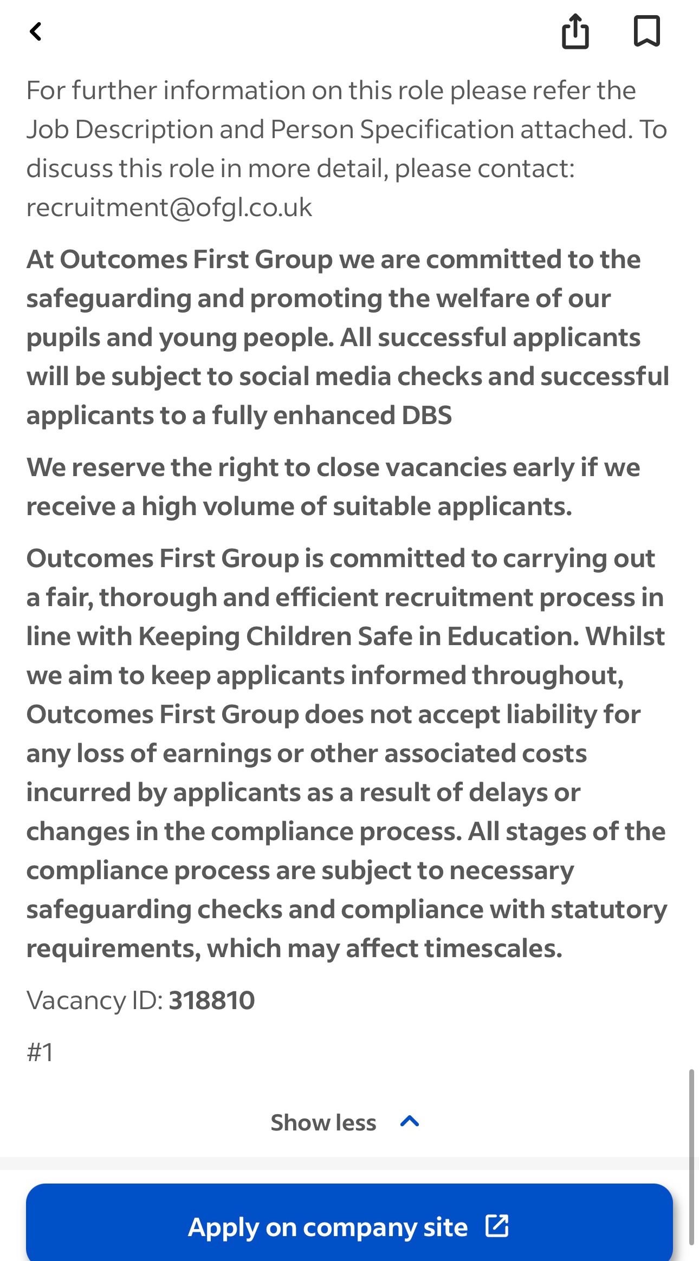

05
3. Analyse the skills needed for the job and assess your skills and experience
To be a good psychologist, you need a mix of skills, qualifications, and personal traits. Here are some key skills that are important for the role:
- Communication Skills: These are vital for talking with clients and understanding their needs. My time as a carer at MiHomecare has really helped me communicate clearly and empathetically. I’ve learned the importance of listening actively, which is crucial when working with individuals who may struggle to express themselves.
- Empathy: This is essential for relating to clients' feelings. I’ve always found it easy to put myself in others' shoes, which helps build trust. I think empathy allows me to connect with clients on a deeper level, making it easier for them to open up about their struggles.
- Critical Thinking: This skill is needed to analyze situations and come up with effective solutions. I know I need to work on this more, so I’m planning to engage in activities like case studies during my studies. Analyzing different scenarios will help me think on my feet when faced with complex situations.
- Teamwork: Psychologists often collaborate with other healthcare professionals. My community work has shown me how valuable collaboration is for achieving common goals (Brown, 2020). I’m eager to work in multidisciplinary teams where everyone brings unique perspectives.
I conducted a SWOT Analysis to assess my skills:
- Strengths: Strong communication and empathy skills from my caregiving roles. I also have a natural curiosity about human behavior, which drives me to learn more.
- Weaknesses: Limited clinical experience, which I want to tackle through internships and volunteering. I recognize that hands-on experience is vital for my growth.
- Opportunities: Increasing awareness of mental health issues means more job opportunities for psychologists. The field is evolving, and I want to be part of that change.
- Threats: High competition in the field makes continuous professional development essential. I need to stay updated on the latest research and practices to remain relevant.
I’ve completed some certifications, like a Level 2 Award in First Aid Awareness and other courses related to health and social care. My work experiences have provided me with both theoretical knowledge and practical skills that are essential for a career in psychology. I’m excited to continue building on these foundations as I progress in my studies.
06

4. Development of personal skills and resources
Building my personal brand as a psychologist is crucial if I want to stand out. My values of compassion and commitment to mental health align well with this career. I plan to promote myself through networking events and by connecting with professionals in the field. I find this aspect fascinating because I think these connections will be incredibly helpful (Smith, 2020).I’ll seek out mentors who are experienced psychologists to guide me. Connecting with professionals can provide valuable insights and open doors to opportunities. I also want to take advantage of online courses and workshops to gain skills and knowledge (Patel, 2022). Platforms like Coursera and LinkedIn Learning have excellent options for learning about therapeutic techniques and psychological assessments. I’m also planning to volunteer at local mental health charities to gain hands-on experience. This will not only enhance my practical skills but also allow me to give back to the community. For example, volunteering might involve helping organize workshops or support groups, giving me direct contact with those in need. By building a strong online presence on LinkedIn, I can share my journey and achievements, which will help reinforce my professional identity. I find it motivating to connect with others in the field and see how they navigate their careers. Sharing experiences can also foster a sense of community and support among aspiring psychologists.

07
5. Action Plan and Timeline
Here’s my action plan to develop the skills I need:

Activity | Deadline
Complete Level 7 H&SC course | July 2027
Part-time Mental Health Job | December 2027
Enrol in master’s Program | September 2027
Complete Clinical Placement | September 2028

Short-term Goals:
- Finish my Level 7 H&SC course by July 2027: This will provide me with the advanced knowledge I need for psychology. I plan to dedicate time each week to review materials and engage with classmates to deepen my understanding of complex topics.
- Get a part-time job in mental health by December 2027: This will help me gain practical experience. I’m particularly interested in roles that allow me to work directly with clients or assist in therapeutic settings.
Medium-term Goals:
- Join a Master’s program in Psychology by September 2027: This is a crucial step in my education. I’ll research programs that align with my interests, focusing on those offering practical placements.
- Attend workshops and networking events: I aim to attend at least two events each semester to build my connections. These experiences will help me stay informed about industry trends and best practices.
Long-term Goals:
- Complete an internship or clinical placement by 2028: This will provide me with real-world experience in the field. I’m eager to work with a diverse range of clients and learn from experienced professionals.
- Find a mentor in psychology: This will guide my professional development. I’ll actively reach out to potential mentors to establish connections and seek their guidance.
By following this action plan, I’m confident I’ll develop the skills, experiences, and connections I need to succeed as a psychologist. I believe that each step I take will bring me closer to my goal of making a meaningful impact in the mental health field.

08
6. Communication of skills to potential employers
I plan to demonstrate my skills to potential employers through networking and professional connections. Attending workshops and events will help me build relationships in the field. I want to communicate my passion for psychology and my commitment to helping others (Taylor, 2021).
To get noticed, I’ll be active on professional platforms like LinkedIn. I intend to share articles related to mental health, post about my learning experiences, and connect with others in the field. This will help create a digital portfolio that reflects my knowledge and dedication.
I’ll also prepare a professional portfolio that includes case studies from my school projects, certificates from courses, and letters of recommendation from mentors. This portfolio will showcase my skills and demonstrate my commitment to professional growth. I’m excited to think about how this portfolio can illustrate my journey and the progress I make along the way.
I plan to practice my interview skills through mock interviews. This will help me express my experiences and goals clearly to employers. I’ll highlight my strengths, like empathy and communication, while also addressing areas where I can improve. Getting feedback from mentors on my resume and cover letters will ensure they resonate with potential employers in psychology. By presenting a clear narrative of my journey and goals, I hope to stand out in a competitive job market.

09
7. Conclusion
my goal to become a psychologist aligns perfectly with my values and my interest in mental health. By examining the skills needed for this role, I’ve identified areas where I need to grow and created a solid plan to achieve my goals. This journey has shown me how much I care about supporting others through their mental health struggles.Being a psychologist is more than just a job for me; it’s a calling I’m dedicated to. I understand how vital mental well-being is for living a fulfilling life, and I want to be part of the solution that promotes mental health awareness and support.Following the action plan in this report gives me confidence that I’ll develop the necessary skills and experiences to succeed in this field. I’m looking forward to making a positive impact in the mental health sector and growing as a professional along the way. With dedication and hard work, I believe I can help improve the lives of many individuals facing mental health challenges.

10
References
- Baker, A. (2021). Building Your Personal Brand Online. London: Career Press.
- Brown, L. (2020). The importance of networking in health and social care. Health Services Research Journal, 25(4), pp. 67-75.
- Johnson, R. (2021). Emotional Intelligence in the Workplace: A Guide for Health Professionals. London: Health Books Publishing.
- Lee, S. (2023). Mindset and mental well-being in the workplace. Health and Social Care Journal, 12(3), pp. 45-56.
- Patel, M. (2022). Networks in healthcare: A guide to building professional connections. Journal of Health Management, 15(2), pp. 100-112.
- Smith, J. (2020). Ambition and success: The role of personal branding in career development. Journal of Personal Branding, 8(1), pp. 20-30.
- Taylor, P. (2021). The Future of Work: Embracing Change and Innovation. London: Future Press.
- Outcomes First Group. (2026). Psychotherapist job advertisement. Available at: [https://uk.indeed.com/viewjob?jk=21c152a8818f4ab9&from=appshareios] (Accessed: 5 August 2026).
- NHS. (2023). NHS Mental Health Framework. Available at: [https://www.nhs.uk/mental-health/social-care-and-your-rights/mental-health-and-the-law/mental-health-act/] (Accessed: 5 August 2026).
- Skills for Care. (2023). Guidance for Mental Health Practitioners. Available at: [https://www.skillsforcare.org.uk/Home.aspx] (Accessed: 5 August 2026).
11

