Method Overview
The practical significance of information security is to let information assets eliminate all kinds of interference, reduce potential security risks and hidden dangers, and avoid being damaged. The attributes of information security are mainly reflected in five aspects: first, it refers to the confidentiality of information, information is only used by the authorized person in the process of being used, information should be ensured not to be illegally accessed in the process of transmission or storage, even if unauthorized users get information, they cannot understand and use the relevant content of information; second, it refers to the integrity of information, ensuring the accuracy and integrity of information To prevent data from being illegally tampered and deleted; the third is the availability of information to ensure that legitimate users can obtain or use information resources when they need it, and will not be improperly rejected in the process of use; the fourth is the nonrepudiation of information, which means to prevent users from denying their behavior through the effective establishment of responsibility mechanism; the fifth is the auditability of information, which means the operation of users The communication process can be traced back, and the corresponding evidence can be provided to prevent the occurrence of repudiation. This paper mainly introduces three information security models.

1.1 ITIL
The full name of ITIL (Information Technology Infrastructure Library) is information technology infrastructure library, which is usually referred to as infrastructure library.The original intention of ITIL is mainly applicable to enterprise IT service management (ITSM). In the late 1990s, ITIL's ideas and methods were gradually widely quoted, and its content and form were further developed.

With the development of information technology, companies and organizations begin to realize that they are increasingly relying on it to achieve their business goals. ITIL is developed under the premise of such a fact that it is generally recognized, and this dependence on it makes the demand of enterprises for high-quality IT services related to their goals more and more intense. In the past few years, the focus of IT enterprises has shifted from developing IT applications to managing IT services. An information system must be fully utilized by users. When the system breaks down or needs to be modified, it must also be effectively supported by maintenance and operation management. Only when the above two points are met, can it system help to achieve the enterprise's planned objectives.

The emergence of ITIL has undoubtedly solved the problems plaguing IT enterprises to a great extent. It provides an objective, real, rigorous, efficient, quantifiable and easy to manage standard and specification for service management practice of enterprises. According to the latest specification of ITIL, it is mainly composed of six modules: business management module, service management module, ICT infrastructure management module, service management planning and implementation module, application management module and security management module. The core module is service management module, which includes two process groups of "service provision" and "service support". The implementation of ITIL standard for the existing information system of IT enterprises is conducive to the close combination of IT system and business, so as to greatly improve the return on investment of IT infrastructure. ITIL has been widely recognized and supported in the field of global IT service management. No matter how different the development ideas and it solutions of various enterprises are, their goals are the same, that is, to combine it with business closely, to build and manage it system with business as the core, so as to make it serve business better.

The goal of ITIL® is to provide a framework of best practices that organizations can use as a guideline for managing their IT organization.

There are five core titles:
• Service Strategy
• Service Design
• Service Transition
• Service Operation
• Continual Service Improvement

The latest version of ITIL is v3.0. The core content of ITIL consists of eleven processes, covering five life cycles, namely strategy phase, design phase, transformation phase, operation phase and improvement phase. In essence, ITIL is not an official standard, but a best practice based on the actual production environment. Based on it infrastructure, ITIL provides a general framework for the activities of IT department. These activities are divided into different processes. These processes work together to make it service management more mature.

The core module of ITIL is service management module, which includes ten processes and one function. These processes and functions can be further summed up as two process groups: service providing process group and service supporting process group. The service support process group summarizes a management function related to management, and also includes five operation level processes: accident management, problem management, configuration management, change management and release management. The service provision process group is also very important, which covers service level management, services financial management, capability management and it management Service continuity management and availability management are five "tactical" processes related to it management. The content structure of ITIL Service management module is shown in Figure 1.

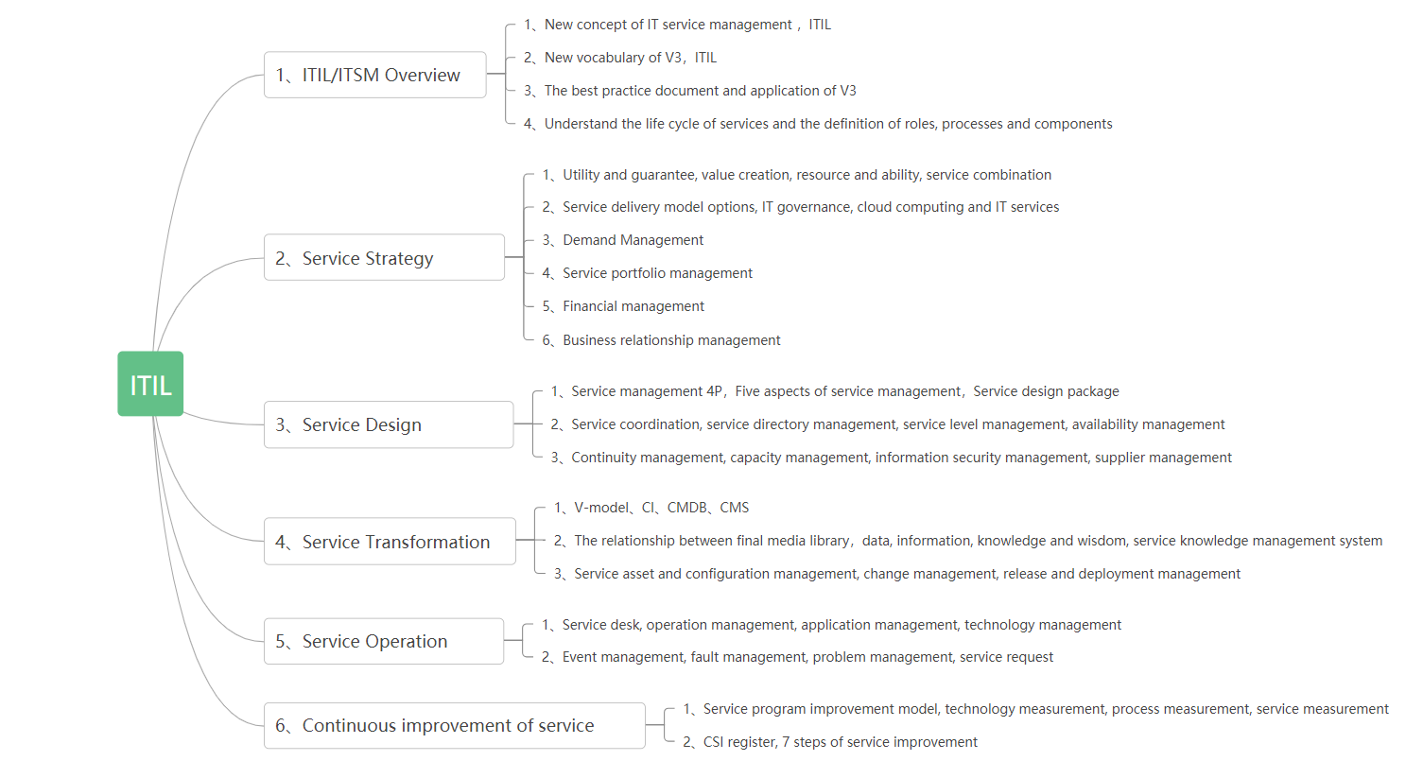

Figure 1. Content structure of ITIL Service Management Module

1.1.1 Conclusion：
ITIL can improve the operation efficiency of IT department by 25-30%, and bring the following business value:

1、Ensure that it processes support business processes and improve the quality of business operations as a whole;

2、Provide more reliable business support through accident management process, change management process and service desk;

3 、Customers have more reasonable expectations for it and are more aware of the cost they need to pay to achieve these expectations;

4、Improve the productivity of customers and business personnel;

5、Provide more timely and effective business continuity services;

6、Establish a more harmonious working relationship between customers and it service providers;

7、Improve customer satisfaction

1.2 ISO 27000
ISO 27000 originated from the British BS 7799 standard series, among which ISO 27001 is "Specification for information security management system" Systems is a set of specifications for the establishment of information security management system (ISMS) within an organization. It describes in detail the models and requirements for the establishment, implementation, operation, monitoring, evaluation, maintenance and improvement of information security management system, which can be used to guide relevant personnel to apply ISO 27002, its ultimate goal is to establish an information security management system suitable for the actual requirements of the organization through a standardized process. ISO 27002 puts forward guidelines and general principles for initiating, implementing, maintaining and improving information security management within an organization, including 11 elements, 39 control objectives and 133 control measures; in terms of overall framework, ISO / IEC 27000 standard family includes 27000 as the core standard of the system, describes the basic principles and terms of information security management system in detail, to define the concept of personal data protection standards and establish a framework for personal data protection. ISO 27001 "information security management system requirements" mainly puts forward the basic requirements of information security management system; ISO 27002 "information security management practice rules" provides the basic criteria and basic scheme for the construction of information security management system.

From the perspective of management requirements, the management requirements cover the management rules of personal data protection. From the perspective of management, personal data security can be guaranteed, mainly including service ability security and transaction service security. At present, among the ISO 27000 standard family, the management requirement standard is ISO 27005 information security risk management, which mainly puts forward the standards for risk assessment and risk management in information security management system.

Data security implementation guidelines, including ISO 27003 "information security management system guidelines", mainly provide guidance for the establishment, implementation, maintenance and improvement of information security management system. ISO / iec27032 "Information Security Governance Guide" helps organizations manage information security from three aspects: business objectives, compliance issues and legal obligations.

The evaluation guidelines include: it specifies the specific requirements of information security management system (ISMS) audit certification bodies; ISO 27007 "isms audit guidelines" provides guidance on management information system (ISMS) audit procedures, audit and the competency of ISMS auditors.

1.2.1 Conclusion:
compared with other standards, ISO 27000 focuses on the role of management in information system. The purpose of ISO 27000 series standards is to ensure the continuity of business, reduce business risks and maximize investment returns, and to ensure the business security of the organization. However, in the implementation of ISO 27000, risk assessment methods are difficult to select, difficult to implement, time-consuming and high cost. How to select control measures is difficult, and how to select control measures with focus and pertinence is more difficult.

1.3 IATF

The information assurance technical framework (IATF) is formulated and released by the National Security Agency (NSA) of the United States. Its predecessor is the network security framework (NSF). Since 1998, NSA has been focusing on the current situation of information technology and the needs of information security in the United States, and established NSF. In 1999, NSA renamed NSF as IATF and released IATF 2.0. Until now, with the progress of information technology and the deepening understanding of information security in the United States, IATF is still constantly improving and revising.
IATF is a series of guidelines to ensure the security of information and information facilities. It defines a process for the construction of information assurance system and its software and hardware components. According to the so-called defense in depth strategy, it provides a multi-level and in-depth security measure to ensure the security of user information and information system.

IATF divides the information assurance technology level of information system into four technical frameworks focus areas: local computing environment, enclave boundaries, networks & infrastructures and supporting infrastructures, as shown in Figure 2. In each focus area, IATF describes its unique security requirements and corresponding controllable technical measures. The purpose of IATF's four focus areas is to make people understand different aspects of network security, comprehensively analyze the security requirements of information system, and consider the appropriate security defense mechanism.
Among the four focus areas, the local computing environment includes servers, clients and their installed applications, operating systems, etc.; the regional boundary refers to the collection of local computing devices connected through LANs, adopting a single security policy and regardless of physical location; the network and infrastructure provide regional interconnection, including operational area network (OAN), metropolitan area network (MAN) and campus Area networks (CAN) and local area networks (LANs), involving a wide range of social groups and local users; supporting infrastructure provides a supporting basis for the information assurance mechanism of network, regional and computing environment.
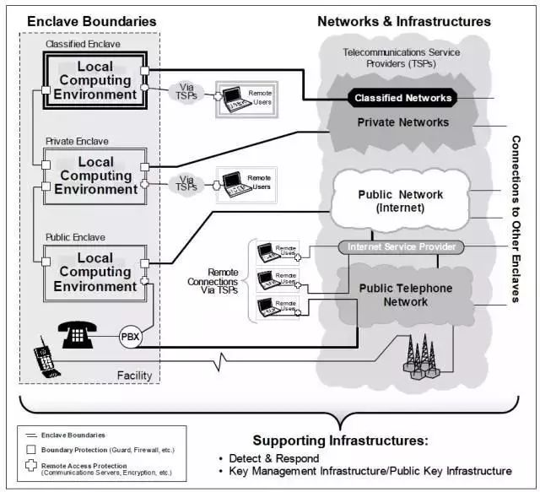
Figure 2. In each focus area

The core idea of IATF information assurance is defense in depth strategy, which provides an all-round and multi-level guiding ideology for the information assurance system. By adopting multi-level and implementing the assurance mechanism in each technical framework area, it can minimize risks, prevent attacks, and ensure the security of user information and its information system. The defense in depth strategy of IATF is shown in Figure 3, in which people, technology and operation are the main core factors, which are essential elements to ensure information and system security

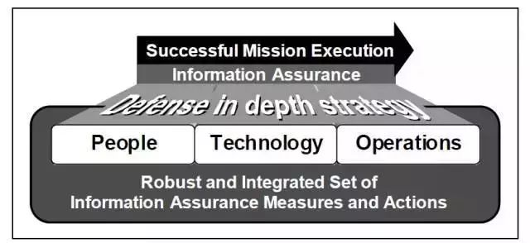
Figure 3. Defense in depth strategy of IATF

1.3.1 Conclusion:
IATF provides a set of general principles to guide ISSE. IATF robustness strategy provides the minimum requirements for architecture, but the incompleteness of strategy and its U.S. specific requirements need to be considered. Game theory can provide optimal design for security architecture in theory. Unfortunately, it has not developed enough as a dependency in the field of information security. Survivability analysis technology is useful for architecture evaluation, but it is limited to the architecture including network. The economic model has practical and non-technical purposes. It combines human factors and system views into security architecture analysis.

By analyzing the principles and characteristics of the above three frameworks, we can find that they have their own advantages and disadvantages and their own scope of adaptation. ITIL focuses on the service management of life cycle. By organically combining resources with enterprise service process and business process, it constructs a series of management processes of event log change configuration problems, and forms a unified it service management system The ultimate goal of 27000 series is to ensure business continuity, reduce business risks and maximize investment returns. The requirements to be met are commitment to relative security, endogenous requirements and additional security requirements. The purpose of IATF is to provide technical guidance for the protection of information and information technology facilities of the U.S. government and industry.

2 Case Analysis

2.1 The company's security governance and strategic planning:
First of all, the company's security problems, because most of the network is wireless and based on the cloud, which makes its network vulnerability, it is easy to be attacked, once there is a problem, the entire company's client will be affected.

The company has a large number of users, which leads to the audit problem of user identity. Once many users log in at the same time, the system is easy to collapse, and the user information needs to be strictly audited.

2.2 Design of information security system

2.2.1 General objective of information security system
The overall goal of the company's information security system is to ensure the security of important information assets, make information assets better used by authorized users accurately, and ensure the security and continuity of business. The construction of information security system not only makes information controllable, but also makes information management more balanced, institutionalized and standardized. In the face of increasingly complex security environment, through continuous system improvement, the risk is reduced to a controllable range.

2.2.2 Information security system model
According to the analysis of the company's problems and the characteristics of demand, this paper combines the idea of IATF in-depth defense security system model and P2DR security system model. In order to make the security system more efficient and sustainable for the protection of network and information assets, we need to integrate human, technology and operation in a harmonious management process.
In order to make the information security system more standardized and targeted to protect information security, we need to start from the characteristics of information security itself, also need to refer to the current situation of T company's information network security system and the classic models at home and abroad, and integrate the IATF in-depth defense technology system to design the T company's information network security system, as shown in the figure below:
Information security technology
Information security operation and maintenance system
Information security policy system

2.2.3 Company information security strategy system
Starting from the actual situation of the company's information security, through the analysis of problems, risks and needs, combined with the mainstream management standards and practices, the improvement of the security management strategy is completed from several aspects: the main goal of the company's security strategy system is to formulate Programmatic Policies and strategies, elaborate the enterprise's information security strategy, and deploy the relevant information security operation process To guide the configuration of local strategies, policies and systems. The security policy system needs to guide the security organization constructively, from structure to mode. The specific parameters and operation status of the enterprise's safety facilities and equipment should conform to the corresponding configuration standards, and take it as the relevant basic norms in the process management of the enterprise, which should not be violated in the operation process.

Guidelines

Security incident management
System development and maintenance
Communication and operation
Physical environment
Safety operation process management
Safety operation and maintenance management regulations and methods
Technical standards and specifications

2.2.4 Information security technology system
The overall framework of information security technology system mainly includes four aspects: physical layer protection, network layer protection, system layer protection and application layer protection.

The specific measures involved include: The Deployment of Intrusion Prevention System, Firewall System and VPN System; The Deployment of Anti-virus System, Vulnerability Scanning System, System Reinforcement and Data Disaster Recovery Backup Center.

2.2.4.1 Deployment of firewall system
For the deployment of firewall, from the perspective of the company, the firewall is deployed at the boundary of the network connection with other companies. The company's internal and external network can be isolated by reasonably configuring the access control rules of firewall.

For the key core devices that need to be protected, such as core business servers, file servers, 0A servers, etc., strict access control should be carried out. Users can only access port 80 or port 8080, that is, HTTP or HTTPS. When intranet information users access the data of information center, they need to verify the account and password. Intranet users can only access the Internet by means of HTTP, HTTPS, FTP and mail. Other ways of access are basically eliminated. Only strict access rule control can ensure the security of internal network. For users who need to do mobile office, VPN function integrated with firewall can be used to encrypt transmission through tunnel. In the process of transmission, in and out of the data information are encrypted in the form of ciphertext to prevent the information from being intercepted, eavesdropped or deleted.

2.2.4.2 Deployment of intrusion prevention system
In the security design of T company, IPS is deployed on the core line. After the deployment of IPS system, the network will have the following functions: deep intrusion protection function, which can actively intercept hacker attacks, worms, viruses, dos and other malicious traffic; fine flow control, which can block the traffic of unauthorized users, carry out legal management of network resources, and ensure the smooth flow of the network; comprehensive supervision of users' online behavior, to avoid spam applications and popularity P2P download.

2.2.4.3 Anti-virus system deployment
In the gateway of T company, the deployment of Web Gateway anti-virus system can real-time remove the virus generated in the process of network access to users, and realize URL address filtering and malicious file filtering; the company's important servers, such as file server, mail server, 0A server, should be focused on protection, so as to avoid public security in the process of file transmission and data use The spread of the virus within the Department. When deploying an anti-virus system on the application server, make sure that the system will not host viruses. Installing the client anti-virus system on the client can not only help users to prevent virus, but also reduce the workload of system management personnel.

2.2.4.4 Deployment of vulnerability scanning system
For this company, due to its relatively large data and complex network structure, it is recommended to use embedded deployment. After the correct configuration is completed, access to the network for use, and the scanning scope generally includes all network IP.

2.2.4.5 VPN system deployment
According to the actual situation of the company, from its own business development direction, setting up MPLS VPN should be said to be the most effective. Compared with the early special line network, MPLS has many advantages. For example, it is cheaper in economy, faster in data transmission and better in expansibility.

2.2.4.6 Data disaster recovery and backup
Local backup and remote disaster recovery are the two most common backup methods. The so-called local backup, as the name suggests, is to back up in the place where the data is stored. This backup method is relatively fast and can quickly restore the damaged data or system. But it also has the characteristics of insufficient security. In case of natural disasters or irresistible events, the backup data will be lost and damaged, and the final data and system cannot be recovered. The advantages and disadvantages of remote disaster recovery are just opposite to those of local backup. For remote disaster recovery, generally, the location where the backup is completed and stored will be far away. Normally, it is more than 400 km, which has a good resistance to possible force majeure. The company's information network is best based on local and remote disaster recovery, in order to really protect the security of data.

2.2.5 Company information security operation system
Information security operation system is more reflected in the institutionalized and standardized management of information security. From the perspective of management, it is composed of three aspects: safe operation mechanism, technical specifications and equipment specifications. The details are as follows:

2.2.5.1 Safe operation mechanism
For some enterprises can access to the need for confidential information personnel, but also need a set of strict system to regulate. These mechanisms can include the following aspects:

- Safety management standard for information construction of the company
- Company information asset management system
- Company Computer Emergency Planning Guide
- Safety management system for key personnel in the company's data center
- Company network border security protection regulations
- Management measures for virus prevention of the company

2.2.5.2 Technical specifications
For different security products, it is necessary to develop different technical specifications, which can be used as guidance for relevant security personnel. It mainly includes the following aspects: network technical specifications, system installation specifications, equipment technical implementation specifications.

2.2.5.3 Equipment operation specification
In the reasonable and scientific use of the equipment, there needs to be a specification, which can restrict the behavior of safety technology and management personnel, and protect the normal operation of the equipment by putting forward clear use standards, mainly including the following aspects:
- Specification for use of network equipment
- Server usage specification
- Specification for use of safety equipment

2.3 Service level agreement (SLA):
In order to guarantee the performance and reliability of the service, it is defined as a mutual agreement between service providers and users or between service providers under a certain cost (usually this cost is the main factor driving the quality of the service provided). In the past, SLA was mainly used by service providers to ensure network quality. Typical matrix parameters describing network state generally include network availability, packet loss rate and transmission delay. With the development of e-commerce, the function of SLA is gradually extended to the solution field of application services and provided to users in the form of reference. Service providers need to provide end-to-end SLA for users on the basis of previous work.

In the cooperation with Caribbean coffee, the scheme provided in this paper is a little insufficient in the provision of SLA parameters, but if it is feasible and involves the actual cooperation with the company, it is believed that the provision of parameters will no longer be a problem.

