

To What Extent Does Customer Service Quality Influence Repeat Business Intention and Competitive Advantage Among UK Service Sector Consumers?

Module: BMMB7003 Dissertation
Programme: MBA

Student Name: Ramim Ahmed
Student Number: 2516509

Campus: Swansea
Supervisor: David Greenshields

Declaration
This work has not previously been accepted in substance for any degree and is not being concurrently submitted in candidature for any degree.
Signed: ............. Ramim Ahmed................... (candidate) Date: ........23/09/2026.............

Statement 1
This work is the result of my own investigations, except where otherwise stated. Other sources are acknowledged by footnotes giving explicit references. A bibliography is appended.
Signed: ................ Ramim Ahmed................ (candidate) Date: ........23/09/2026.............

Statement 2
I hereby give consent for my work, if accepted, to be available for photocopying and for inter-library loan, and for the title and summary to be made available to outside organisations.
Signed: ................ Ramim Ahmed................ (candidate) Date: ........23/09/2026.............

Acknowledgements
I would like to thank David Greenshields for his guidance, patience and support throughout the process of this dissertation and express my heartfelt gratitude for the same. He has been a dedicated and supportive supervisor throughout this research, making numerous contributions to this work in thoughtfully providing feedback, encouraging, and being generous with his time. I am so grateful for his guidance and trust in me throughout this journey and am forever grateful for it.
I would also like to express my gratitude to Swansea Business School and the University of Wales Trinity Saint David for providing the knowledge, resources and support that I gained during the completion of my MBA studies.
My thanks go to all the participants who kindly gave their time to complete the survey. They have been so willing to offer their responses to this research and their responses are the basis of this study.
Lastly, I would like to express my gratitude to my relatives and friends who have been constantly involved in my studies with patience and encouragement, and who have believed in me. They have been a source of strength to me and this success has been as much their as it is mine.

Ramim Ahmed

Abstract
This study aims to determine the impact of the service quality dimensions on customer repeat intention and service competitiveness advantage. The data was collected from the United Kingdom service sector industry because although there has been a lot of SERVQUAL research, it has been demonstrated in a single industry or country, thus limiting conclusions about the mediation between service quality, satisfaction, and competitive advantage. The study was based on the Parasuraman et al (1985) gaps model and the Barney (1991) resource-based view theories. The four hypotheses formulated were tested using a positivist approach. Data analysis was done using correlation, multiple regression, and Baron and Kenny’s mediation procedure. Questions were generated from the SERVQUAL framework and presented in a QSR Online survey tool as a questionnaire. After screening for eligibility, incomplete answers and attention checks, 62 of 167 finished the questionnaire and provided complete, eligible answers for use in the analyses. The analysis revealed that empathy was the only dimension that significantly predicted competitive advantage while controlling other service dimensions (β=.457, p=.006). Service quality had a strong positive relationship with satisfaction (β=.696, p<.001) and satisfaction with competitive advantage (β=.541, p<.001). However, satisfaction did not mediate service quality and competitive advantage. The study also revealed that satisfaction with service quality has the highest direct effect on competitive advantage (β=.698, p<.001). Therefore, rejecting the initial hypotheses that assumed full mediation holds in service sectors. This research recommends that the United Kingdom service sector organisations should invest more in employee empathy training at the operational level. The study also suggests developing other measures alongside satisfaction with service quality, such as repeat purchase, referrals, and online reviews, to predict competitive advantage. This study has several limitations, including a small convenience sample and ceiling effects. There is a need to test the model in larger samples and more heterogeneous settings.

Table of Contents
Declaration 2
Acknowledgements 3
Abstract 4
Table of Contents 5
Chapter 1: Introduction 9
1.1 Background and Research Context 9
1.2 Research Aim and Objectives 12
1.3. Research Questions 14
1.4. Significance of the Study 14
1.5. Dissertation Structure 16
Chapter 2: Literature Review 17
2.1 Introduction 17
2.2 Service Quality: Conceptual Foundations and Measurement 17
2.2.1 The Gaps Model and SERVQUAL Instrument 17
2.2.2 Cross-Sector Application 18
2.3 Service Quality and Competitive Advantage 19
2.3.1 The Resource-Based View 19
2.3.2 UK Market Context 20
2.4 Customer Satisfaction as Mediator 21
2.4.1 Theoretical Basis for Mediation 21
2.4.2 Mediation Evidence Across Sectors 21
2.5 Repeat Business Intention and Loyalty Outcomes 22
2.5.1 From Satisfaction to Behavioural Intention 22
2.5.2 Loyalty and Retention in Service Contexts 23
2.6 Electronic Word of Mouth and Digital Reputation 23
2.6.1 eWOM as a Competitive Mechanism 23
2.7 Relationship Marketing and Moments of Truth 26
2.7.1 Foundational Theory 26
2.8 Conceptual Framework and Research Hypotheses 28
2.9. Chapter Summary 29
Chapter 3: Methodology 31
3.1 Introduction 31
3.2 Research Rationale 31
3.3 Research Philosophy 31
3.4 Research Approach 32
3.5 Methodological Choice 32
3.6. Research Strategy 32
3.7. Time Horizon 34
3.8. Data Collection Instrument 35
3.9. Population and Sampling 37
3.10. Data Analysis Procedures 38
3.11. Reliability and Validity 38
3.12. Limitations of the Research Methods 39
3.13. Research Ethics 39
3.14 Chapter Summary 40
Chapter 4: Data Analysis and Findings 41
4.1 Introduction 41
4.2 Data Screening and Response Profile 41
4.3. Demographic Profile of Respondents 43
4.4 Question-by-Question Response Profile 47
4.5 Reliability Analysis 51
4.6 Descriptive Statistics and Normality 52
4.7 Correlation Analysis 56
4.8 Multiple Regression Analysis (RQ1) 58
4.9 The Satisfaction Pathway and Mediation Analysis (H1, H2, H3) 59
4.10 Group Comparisons (H4, RQ3) 62
4.11 Supplementary Cross-Tabulation 63
4.12 Summary of Findings 64
Chapter 5: Discussion of Findings 65
5.1 Introduction 65
5.2 Discussion of Findings 65
5.2.1 Which service quality dimensions matter most (Objective 1, RQ1) 65
5.2.2 The satisfaction pathway (Objective 2, RQ1, H1 and H2) 66
5.2.3 Why satisfaction did not mediate the relationship (Objective 3, RQ2, H3) 67
5.2.4 No robust demographic differences (Objective 3, RQ3, H4) 67
5.3 Chapter Summary 68
Chapter 6: Conclusions and Recommendations 69
6.1 Introduction 69
6.2 Revisiting the Gap, Aim and Method 69
6.3 Summary of Key Findings and Fit with the Literature 69
6.4 Theoretical Contribution 70
6.5. Recommendations for UK Service Sector Practice 71
6.6. Limitations and Future Research 73
6.7. Concluding Statement 74
References 75
Appendices 95
Appendix A: Research Instrument (Questionnaire) 95

Chapter 1: Introduction

1.1 Background and Research Context
Much research in marketing has been devoted to the link between service quality and continued competitive performance. Yet its impact remains largely uncharted territory for the UK service organisations, not only in a specific industry but also in terms of service quality in the service sector. Organisations are required to provide consumers with a higher level of service, communication and interaction, especially in retail, hospitality, financial services, healthcare and travel. These expectations have grown in significance as customers have seen more service providers and now are able to compare experiences. All of this is happening in an incredibly complex digital landscape, an extremely tough economy and a marketplace of consumer choice. For this reason, it is essential that service organisations take their customers' perception of the quality of the services they provide more seriously and how this perception may affect their future behaviour.
Considering service quality is relevant since the consumer's experience may impact the consumer's decision to remain with an organisation or to go towards other organisations that offer a similar service. If a customer thinks a service organisation has matched or surpassed their expectations, this can lead to satisfaction, and a longer relationship. Negative service experiences, on the other hand, can lead to decreased repeat purchase and can also impact on the communication of the experience to others. To this end organisations must be aware of the various characteristics of service quality that will enable them to deliver their services effectively and to create a positive customer experience that will facilitate repeat business. This is important not only on the customer retention side but also for the ability of organisations to distinguish themselves in competitive markets.
However, it has become more important in the UK service sector with the fact that customer expectations and satisfaction levels are not static. The Institute of Customer Service (ICS) (2024) reported a national decline in customer satisfaction scores in the UK, further underlining the need to determine the service quality factors that drive customer retention and differentiation. But a drop in satisfaction can present problems to organisations as customers might be less likely to continue relationships with service providers. Hence, it is crucial to understand the linkage between service quality, customer satisfaction and customers' behaviours after the services, as this is crucial to the competitive stance of service organisations.
In the digitalisation of services there is also added complexity for organisations. There are more opportunities for customers to engage with organisations via websites, mobile apps, online customer service and digital review sites. Therefore, the whole service experience does not necessarily mean that it has to be between an employee and a customer. Rather, service quality perceptions can form at multiple service encounters. It is therefore crucial that service organisations are aware of the aspects of service quality that are important to customers. This becomes pertinent in a variety of industries, because the type of customer service can vary significantly from one to another, but the importance of reliable, responsive and satisfactory service may remain.
According to Parasuraman, Zeithaml and Berry (1985) in their Gaps Model, service quality is a relational concept which is based on the gap between the expectations and experiences of the customer. Thus, the model emphasizes the gap between the customers' expectations of a service and the customers' perceptions of the service they received. If there is a large discrepancy between the two, this could leave the customer with a negative view of the service. An organisation is exposed to such perception gaps and thus, the risk to lose loyal customers and to have a chance to compete. It is not just what the organisation feels it is doing well that constitutes good service. Instead, it is also shaped by customer perceptions and assessments of the actual customer service experiences.
The Gaps Model offers a suitable theoretical framework to examine why service quality might effect on competitive performance. Without appreciating customer expectations, it's possible that the service provided will not align with the value the customers seek. But where the service delivery is weak, dissatisfaction may result even if an organisation has tried to set the right standards of service. Such gaps can impact on customer perceptions, and consequently, can impact on future behavioural intentions. Due to the reported decline in consumer satisfaction in the UK (Institute of Customer Service, 2024), it is vital to examine the link between service quality and repeat customer and competitive advantage.
Another problem relates to the approach of the past studies on these relationships. Studies in the research literature are mostly confined within a single sector or in a non-UK context which restricts generalisability to UK organisations working in multiple sectors. There is little evidence of the mediation pathway between service quality, satisfaction and competitive advantage through UK consumers and most studies apply SERVQUAL to a hospitality or banking sample in an Asian or European market. This leaves a research gap, as results from one sector and/or region may not be sufficient to account for the experience of consumers in the wider UK service economy. The nature of the relationship between service quality and customer outcomes will differ from one service organisation to another and vary depending on the types of service they offer and the customer interactions they provide, so further study is needed to explore the relationship in a broader context.
This gap is relevant to SERVQUAL because the instrument offers a systematic way of looking at customer perceptions of service quality in terms of predetermined dimensions. But to fully understand if the improvements in perceived quality will lead to outcomes important to organisations, it is necessary to investigate service quality in relation to other factors. Customer satisfaction might offer a key connection between service quality perceptions and behavioural or competitive outcomes. While a customer might have a favourable perception of a number of aspects, their organisational implications can be more significant in their satisfaction, willingness to buy again, likelihood to recommend the organisation and positive online review behaviour. Accordingly, along with service quality perceptions, the connection between service quality perceptions and the other competitive advantage indicators is the focus of this study. The cross-sector study design aims to give a wider understanding of these relationships between UK service consumers. It's not about focusing on any service industry but on consumers' experiences in a variety of service industries. This enables the researchers to study if specific service quality dimensions are always related to positive customer outcomes. It also affords a chance to look at whether there are demographic and contextual differences that might impact these relationships. This is important, since customer expectations are not necessarily the same for all customers, and the specific conditions of the customers' experience of the service might affect customer perceptions of service quality and satisfaction.

1.2 Research Aim and Objectives
This study is primarily designed to examine the level of effect that customer service quality dimensions have on repeat business intentions and perceived competitive advantage of customers of service sector in the UK in various industries. The study aims to determine which aspects of service quality are more closely related to customer experiences and if they relate to behavioural intentions that can lead to an organisation's competitive edge. The emphasis on repeat business intention is relevant as it is one thing that can be considered as one of the outcomes of service organisations, namely customer retention. Consumers saying that they’ll return to or buy from an organisation again can be used as an indicator of the potential for continued customer relationships. The competitive advantage is measured simultaneously by means of indicators like repeat purchase intention, referral likelihood and positive online review behaviour. These indicators reflect a more holistic perspective on customer experiences that might impact outcomes that are relevant to the organisation's performance.
There are four objectives:
Objective 1: To identify which service quality dimensions within the Gaps Model are most strongly associated with positive customer service experiences among consumers in the UK service sector.
This goal is to find out which dimensions are most highly correlated with customer judgments of their service experiences. It serves as a foundation for analysis to see if there are some services quality dimensions that seem to be more relevant than others in the cross-sectoral context in the UK.
Objective 2: To examine the relationship between perceived service quality and repeat business intention using a structured survey instrument adapted from the SERVQUAL scale.
This objective investigates if there is a correlation between positive perception of service quality and consumers' intentions to re-use a service provider. A structured survey instrument based on SERVQUAL scale for measuring service quality perceptions can be used to evaluate the perceptions systematically among the selected respondents.
Objective 3: To examine whether customer satisfaction mediates the relationship between perceived service quality and competitive advantage indicators, including repeat purchase intention, referral likelihood and positive online review behaviour.
This goal is not simply to see how service quality is related to competitive outcomes but rather how customer satisfaction may serve as a mediator. Specifically, it examines the possibility that the perception of service quality can affect competitive advantage indicators, at least in part, by its effect on customer satisfaction.
Objective 4: To develop evidence-based recommendations for UK service organisations to improve customer retention and competitive positioning through better service quality delivery.
The last goal has to do with how the results are applied. The study aims to identify service quality dimensions and customer outcomes with meaningful relationships to provide recommendations which can support service organisations in improving customer retention and their competitive positioning.

1.3. Research Questions
The study has a primary research question, which reads: To what extent do customer service quality dimensions have an impact on intention to return to the business and competitive advantage of consumers in the service sector in the UK? This question is a combination of the key variables of the research and an overall goal to investigate the relationship between customers' perceptions of service quality and their future behavioural intentions and perceived competitive outcomes. To explore this question in more detail, three subsidiary research questions are considered:
RQ1: Which SERVQUAL dimensions most strongly predict repeat business intention among UK service consumers?
RQ2: Does customer satisfaction mediate the relationship between service quality perceptions and competitive advantage indicators?
RQ3: Do demographic and contextual variables, including age, gender, sector of experience and organisation size, moderate service quality perceptions and outcomes?

1.4. Significance of the Study
This research makes three main types of contribution. Theoretically, it is a development of the Gaps Model and SERVQUAL instrument to a wide and cross-sector UK consumer context. It takes a particular look at the mediation process from service quality perceptions to customer satisfaction to competitive advantage indicators, which is less studied in the UK context. The study examines the relationships between these in combination to gain a more fine-grained understanding of what customer perceptions about service quality might be related to and outcomes that are relevant to competitive performance. The study's focus on the relationship between expectations, service experiences and customer outcomes is also a theoretical contribution. The Gaps Model offers a foundation for comprehending service quality as a relation between the expectations and experiences, whereas SERVQUAL offers a structured approach for analysing service quality dimensions. The application of these perspectives to a cross-sector sample of consumers in the UK enables the study to explore their applicability outside of the sectors and geographical areas typically examined in existing research. The study is methodologically demonstrated using the Baron and Kenny (1986) mediation procedure in a standard SPSS analysis framework which has shown that mediation can be examined using a conventional statistical analysis approach without the need to use a structural equation modelling approach. This offers a good analytical framework for determining if customer satisfaction acts as a mediator between perceptions of service quality and indicators of competitive advantage. The methodological approach also helps accomplish the overall goal of the study, which is to investigate a variety of variables in the same research design rather than examining a single variable, such as service quality and customer outcomes independently. From a practical point of view, the research results give UK service organisations evidence of what service quality dimensions are closest to customer retention and differentiation. This can be important in a service context where customers have many options and where negative experiences can impact future behavioural intentions. Knowing which dimensions are related to positive customer experiences should help organisations to know where they may focus their service delivery more effectively. There are also implications for customers' satisfaction and competitiveness on the practical side. This could suggest that satisfaction is a key component of the service quality to customer outcomes relationship and that organisations should view satisfaction as a mediator. Likewise, an analysis of referral likelihood and positive online review behaviour offer information on customer behaviour that goes beyond just repeat purchases. These outcomes are relevant because customers' experiences can impact their future actions and the way that they share their experiences with other prospective customers. The study is important overall as it integrates service quality, customer satisfaction and competitive advantage in a cross-sector environment in the UK. The research thus speaks to the gap identified and also offers an empirical foundation to understanding how customer retention and differentiation for the service organisation can be improved by enhancing service quality delivery.

1.5. Dissertation Structure
The dissertation is organised into six chapters. Chapter 2 presents the literature reviewed on a variety of topics including service quality, competitive advantage, customer satisfaction as a mediator, intention to repeat and electronic word of mouth (eWOM) and relationship marketing. Then from this review the conceptual framework and the research hypotheses are created. The literature review sets the theoretical and empirical background for the research and forms a basis for the analysis of the relationship between the key variables. A methodology of the study is discussed in Chapter 3 which details the research philosophy, research design, instrument development, sampling strategy, data analysis procedures and ethical considerations. This chapter describes the design of the study and the data collection and analysis for the studies conducted in order to respond to the research aim, objectives and questions. It also provides the conceptual underpinning for evaluation of the suggested relationships between service quality, satisfaction and competitive advantage. The results are found and discussed in Chapter 4 and Chapter 5 in light of the literature and theoretical frameworks outlined in Chapter 2. Chapter 4 concentrates on the presentation and analysis of the empirical findings and Chapter 5 discusses the implications of the findings in the context of the literature and theories. Hence, the statistical findings are related to the key issues identified in the previous chapters. Finally, the key conclusions are summarised, limitations of the study are discussed and practical implications for service organisations in the UK are offered in Chapter 6. The concluding chapter discusses the extent of achievement of the research aim and objectives, and summarizes the major findings related to service quality, customer satisfaction, intention to re-patronize and competitive advantage. It also pinpoints the study's limitations and offers recommendations based on the evidence produced in the research.

Chapter 2: Literature Review

2.1 Introduction
This chapter reviews the literature that underpins the study: the relationship between service quality and competitive advantage among UK service sector consumers and whether satisfaction explains that relationship. It covers the conceptual foundations of service quality and SERVQUAL, the theoretical link to competitive advantage from the resource-based view and evidence for satisfaction as a mediator, how service quality translates into repeat business intention and loyalty, and the role of electronic word of mouth (eWOM) and relationship marketing. Since research on eWOM is disproportionately concentrated in the influencer marketing literature, this strand is reviewed in detail in section 2.6, since the credibility and referral mechanisms identified there can be directly applied to the review and recommendation indicators measured here. The chapter closes with the conceptual framework and four hypotheses.

2.2 Service Quality: Conceptual Foundations and Measurement

2.2.1 The Gaps Model and SERVQUAL Instrument
Service quality comes from the Gaps Model of Parasuraman, Zeithaml and Berry (1985), which explains perceived service quality as the outcome of gaps between customer expectations and management's perception of them, between that perception and specifications set, between specifications and delivery, between delivery and communication and between expected and perceived service itself. Parasuraman, Zeithaml and Berry (1988) operationalised this as the SERVQUAL instrument, measuring five dimensions: tangibles, reliability, responsiveness, assurance and empathy. Al-Tamimi and Al-Amiri (2003) provided one of the first applications of it outside the United States, confirming its usefulness for UAE Islamic banks, and the instrument has since been re-validated in other settings, including Nepali resorts (Adhikari, Wagley and Dahal, 2023), higher education (Alemu, 2023; Valencia-Arias et al., 2023), retail (S, Sharma, Malviya, Hamida and Zala, 2023), dental services (Sharka et al., 2024), oncology care (Singh and Sidhu, 2023) and public sector banking (Shetty et al., 2022).
Cronin and Taylor (1992) challenged the original gap-score approach, arguing that a perceptions-only measure (SERVPERF) performs at least as well and is easier to apply, which is why this study's instrument (Chapter 3) measures perceptions only. Prasad and Verma's (2022) systematic review confirms this is the dominant contemporary choice, Wider et al's (2024) bibliometric analysis shows that the SERVQUAL literature is still growing, particularly in education and financial services, and Özispa's (2025) review of gap-model adaptations confirms that the five-dimension logic is the dominant lens for operationalising service quality.
SERVQUAL has not gone unchallenged. Buttle's (1996) widely cited review questioned whether customers form the stable pre-consumption expectations that the instrument assumes, and Carman's (1990) empirical work found the dimensions emerging from survey data vary by setting. Grönroos (1984) distinguished technical quality (what is received) from functional quality (how it is delivered). Wang, Masukujjaman, Alam, Ahmad, Lin and Ho (2023) found the dimensions' relative weight differed for non-banking financial institutions in an emerging economy; Zaim, Nadia, Ghani, Bahry and Ali (2024) extended the instrument into e-SERVQUAL for online retail; Tyagi, Kumar, Gulyani and Gahlawat (2023) developed a comparable e-SERV-EX scale - evidence that the dimensions need adaptation across channels. While these criticisms do not invalidate SERVQUAL, still the most widely applied instrument, they justify treating the importance of each dimension as an empirical question for this study's UK, cross-sector sample, which is tested in Chapter 4.

2.2.2 Cross-Sector Application
Much SERVQUAL literature focuses on a single sector. In banking, Gonu, Agyei, Richard and Asare-Larbi (2023) examined customer orientation, service quality and satisfaction in an emerging market, while Kappil and Santhi (2025) analysed e-banking, Sugiarto and Octaviana (2021) tested SERVQUAL against satisfaction in a single bank, Thakur and Devi (2025) compared public and private banks and Mugova and Kiliswa (2025) examined multi-channel retail banking. Yum and Yoo (2023) extend this into mobile social media services, confirming that service quality shapes loyalty through satisfaction even in app-mediated delivery. In hospitality and tourism, Arli, van Esch and Weaven (2024) applied SERVQUAL to online food delivery, and Chi and Phan (2025) have meta-analysed corporate social responsibility, service quality, perceived value and loyalty. In healthcare, Swathi, Barkur and Somu (2023) have assessed service quality's effect on patient satisfaction in an Indian hospital. None of these studies compare multiple sectors within one sample - the gap that this study's five-sector UK design fills, which underlies the decision to test age band, gender, sector and organisation size for a moderating effect through H4.

2.3 Service Quality and Competitive Advantage

2.3.1 The Resource-Based View
The link between service quality and competitive advantage is established through the resource-based view (RBV) of the firm. Barney (1991) argued that sustained competitive advantage derives from resources that are valuable, rare, imperfectly imitable and non-substitutable (VRIN). Superior service delivery capability meets these criteria: valuable, as it supports retention and revenue; rare, as it depends on culture and frontline skill; and hard to imitate, as no other mechanism reliably reproduces the same loyalty outcomes. Kero and Bogale's (2023) systematic review confirms RBV remains the dominant lens for explaining sustained firm-level advantage, while Ristyawan, Putro and Siallagan's (2023) synthesis highlights that firms increasingly balance static resource positions with dynamic reconfiguration, reinforced by Navarro-García, Ledesma-Chaves, Gil-Cordero and De-Juan-Vigaray's (2024) PLS-SEM and fsQCA evidence that both static and dynamic capabilities jointly shape perceived competitive advantage in exporting firms.
More recent applications extend RBV into service and digital contexts. Cuthbertson and Furseth (2022) argue that digital services strengthen the link between RBV, the knowledge-based view and innovation capability; Abbasi Kamardi, Amoozad Mahdiraji, Masoumi and Jafari-Sadeghi (2022) show how IT-sector firms in an emerging economy build sustainable advantage from an RBV lens; Fakhreddin, Foroudi and Kooli (2024) show how key account management contributes to competitive advantage and firm performance; and Susilowati, Suharti and Sugiarto (2025) find service-driven capabilities act as advantage drivers within Indonesian healthcare, a context comparable to one of this study's five sectors. Faramarzi, Worm and Ulaga's (2023) meta-analysis confirms a service-oriented strategy measurably improves firm performance; Duah, Abeeku Bamfo and Serbe Marfo (2024) show that marketing capability affects performance through resource orchestration; and Derya Çelik and Ülkü Uzunçarşılı's (2023) find competitive advantage mediates organisational ambidexterity, innovation capability and performance in Turkish manufacturing and service industries. Kayhan Tajeddini, Gamage, Tajdini, Qalati and Siddiqui (2023) show how entrepreneurial orientation and bricolage help retail firms sustain advantage, and Rua and Santos's (2022) brand positioning and market orientation mediate branding and competitive advantage, reinforcing service delivery capability as the VRIN resource that Barney (1991) describes. Paredes and Olander Roese's (2024) show how retail innovation capability depends on balancing exploration and exploitation, while do Adro and Fernandes's (2019) review of social innovation confirms that non-traditional resource combinations can equally generate rare, hard-to-imitate advantage.

2.3.2 UK Market Context
The Institute of Customer Service tracks UK customer satisfaction through the UK Customer Satisfaction Index (UKCSI). The January 2024 UKCSI stood at 76.0 out of 100, down 1.7 points and its lowest level in nine years, with every one of thirteen tracked sectors recording a lower score than twelve months earlier; July 2024 fell further, to 75.8, its lowest reading since July 2010 (Institute of Customer Service, 2024). Jefferies, Wellings, Morris, This is stated by Dayan and Lobont's (2023) analysis of the King's Fund and British Social Attitudes, which revealed that satisfaction with NHS and social care is at its lowest point ever in 2023, due to long waiting times and shortage of staff, one of the five sectors examined in this study. This further reinforces the relevance of the study for the UK context: knowledge of what aspects of service quality are most important to understanding consumers' behaviour is relevant because satisfaction cannot be taken for granted in a market where satisfaction is gained increasingly through the service rather than the price, and the importance of a number of elements is becoming more prominent.

2.4 Customer Satisfaction as Mediator

2.4.1 Theoretical Basis for Mediation
That satisfaction sits between service quality and its behavioural consequences, rather than service quality directly acting on behaviour, has been an assumption following logically from the SERVQUAL and SERVPERF traditions in section 2.2.1. Testing this rigorously requires a formal mediation procedure, and this study follows Baron and Kenny's (1986) widely used four-step approach, which requires showing, in sequence, that the independent variable predicts the outcome, predicts the proposed mediator, that the mediator predicts the outcome controlling for the independent variable and that the independent variable's effect reduces once the mediator is included. Hayes (2022) explains this regression-based logic, extended through bootstrapped confidence intervals, is a reliable, accessible method without requiring full structural equation modelling, which is why it is retained for testing H3 (Chapter 3), applied to the dataset in Chapter 4.

2.4.2 Mediation Evidence Across Sectors
Empirical support for satisfaction as a mediator between service quality and loyalty is well-established, though concentrated in certain sectors. Mosahab, Mahamad and Ramayah (2010), studying banking, found satisfaction fully mediated service quality and loyalty. This has since been replicated widely: Fida, Ahmed, Al-Balushi and Singh (2020) confirm the mediating role of satisfaction in Islamic banks in Oman; Al-Hawari and Ward (2006) find automated service quality affects Australian banks' financial performance through satisfaction; Arshad Khan and Alhumoudi (2022) confirm a comparable effect for e-banking; Gazi et al. (2024) find satisfaction mediates service quality, efficiency and reliability against retention and loyalty in emerging-market e-banking; and Soeharso (2024) demonstrate that satisfaction mediates service quality and repurchase intention in online shopping. Beyond banking, Ha, Nguyen and Doan (2023) find switching costs mediate service value, quality, satisfaction and loyalty and Davies, Bustinza, Parry and Jovanovic (2023) show, via moderated mediation, how digital and service capabilities jointly influence firm financial performance.
Not every study confirms full mediation, directly relevant to the unexpected finding in Chapter 4. Shehadeh, Almohtaseb, Aldehayyat and Abu-AlSondos (2023) find a digital-transformation mediating pathway that operates only under certain moderating conditions, while Rua and Santos (2022, section 2.3.1) find positioning and market orientation, not satisfaction, carry the mediating weight between branding and competitive advantage. Whether full mediation holds in a cross-sector UK sample is exactly what H3 tests, extending this literature (Chapter 4; Chapter 5) into an uncovered context. Sanchez-Franco's (2009) e-banking study adds that the satisfaction-trust-commitment chain is itself moderated by relationship involvement, while Pechter and Kuusik (2023) show Net Promoter Score, a proxy for this study's referral-likelihood indicator, is shaped by how recently the customer experienced the service, a timing effect that this study's cross-sectional design controls for by asking about a recent experience specifically.

2.5 Repeat Business Intention and Loyalty Outcomes

2.5.1 From Satisfaction to Behavioural Intention
Cronin and Taylor (1992), in the same study proposing SERVPERF, found that satisfaction had a stronger direct influence on purchase intention than service quality perceptions alone, early evidence for treating satisfaction as an important link between quality and future behaviour. This underpins the study's decision (Chapter 3) to measure repeat purchase intention, referral likelihood and positive online review intention as a linked set of indicators rather than a single loyalty construct. Sharma and Singh's (2021) review confirms this chain is robust across contexts and Zaato, Zainol, Khan, Rehman, Faridi and Khan (2023) similarly find that satisfaction mediates antecedent factors and brand loyalty within e-commerce, reinforcing the behavioural-intention pathway measured here.

2.5.2 Loyalty and Retention in Service Contexts
Retention is widely treated as one of the clearest commercial payoffs of high service quality. So, Yang and Li's (2024) fifteen-year meta-analytic structural equation model confirms that satisfaction and perceived quality remain the strongest predictors of loyalty across the hospitality literature, while Ali Alsheikh, Binti Abd Halim, Ayassrah, Alnawafleh and A Tambi (2018) have identified comparable antecedents in the Malaysian and Jordanian hotel industry. Fook and Dastane's (2021) multiple mediation analysis shows that loyalty programmes operate through several mediating mechanisms, and Wang and Li's (2023) synthesis of five influencing factors of tourist loyalty confirms the loyalty-retention chain generalises beyond any single setting. Pereira, Cordeiro, Schmitt, Gabriela, Eugenia and Gonçalves's (2025) extension of this into the digital environment identifies factors sustaining online loyalty and retention, relevant to the blended physical-digital encounters in this study's questionnaire. Sohaib's (2022) study of repurchase intentions in banking finds that service-related reasons, not price alone, explain why customers return, supporting repeat purchase intention as one of the three indicators measured here, alongside referral likelihood and review intention (section 2.6).

2.6 Electronic Word of Mouth and Digital Reputation

2.6.1 eWOM as a Competitive Mechanism
Alongside direct repeat purchase, a second way in which service quality generates competitive advantage is electronic word of mouth (eWOM): reviews, ratings and recommendations that customers share online. Ismagilova, Slade, Rana and Dwivedi's (2019) meta-analysis confirm that the credibility and volume of online consumer communication measurably affects other consumers' purchase decisions, establishing eWOM as a mechanism through which one customer's experience influences outcomes beyond that single transaction. Filieri's (2015) diagnosticity-adoption framework explains why some reviews are more persuasive than others, and Hajli's (2015) social commerce work confirms that trust generated through online interaction directly shapes purchase intentions, supporting positive review intention as a distinct outcome in this study's questionnaire.
Since eWOM literature is disproportionately concentrated in social media influencers, this sub-field merits particular attention, since the credibility, trust and parasocial mechanisms it identifies apply equally to the peer-to-peer reviews and referrals measured here. Ohanian's (1990) foundational celebrity endorser credibility scale (expertise, trustworthiness, attractiveness) remains the theoretical starting point and has been extended repeatedly into digital contexts. De Veirman, Cauberghe and Hudders's (2017) show that follower count and product congruence jointly shape brand attitude; Djafarova and Rushworth's (2017) find that Instagram influencer credibility shapes young female consumers' purchase decisions; and Sokolova and Kefi's (2020) confirm that credibility and parasocial interaction both drive purchase intentions among Instagram and YouTube audiences. This parasocial mechanism recurs across a large evidence body: Hwang and Zhang's (2018) link parasocial relationships to purchase and eWOM intentions; Ki and Kim's (2019) explain the mechanism through consumers' desire to mimic admired figures; Yuan and Lou's (2020) and Reinikainen, Munnukka, Maity and Luoma-aho's (2020) confirm that source credibility and perceived fairness foster parasocial bonds shaping trust; Sokolova and Perez's (2021) extend it to fitness-influencer exercise intentions; and Garg and Bakshi's (2024) confirm the same for beauty-vlogger credibility. Ashraf, Hameed and Saeed's (2023) and Chen and Lu's (2024) show this pathway is strong in the most recent research, linking influencer power, brand attachment and credibility to purchase intention and word-of-mouth.
A parallel strand investigates credibility and trust directly. Coutinho, Dias and Pereira (2023) and Liu and Zheng (2024) both confirm influencer credibility strongly and directly affects purchase intention; Mabkhot, Isa and Mabkhot (2022) perform a similar study within Saudi Arabia; Foroughi, Iranmanesh, Nilashi, Ghobakhloo, Asadi and Khoshkam (2023) confirm it via PLS and fsQCA; and Karthick S. (2024) and Shaheen, Khataan, Awad, Yahia Shams Eldin and Elnour (2025) find comparable effects within emerging markets. Al-Khawaldeh (2023) re-examines the two-step flow model to explain influencers as opinion leaders, Rayasam and Khattri (2022) show attitude to the endorsement itself forms brand attitude, and L. Dey, Alwi, Babu, Roy and Muhammad (2022) find attitude to a brand event can similarly shift purchase intention, while Sánchez-Fernández and Jiménez-Castillo (2021) show emotional attachment and information value jointly explain influencer intentions. Alcántara-Pilar, Rodriguez-López, Kalinić and Liébana-Cabanillas (2024) extend to TikTok, and Vilas Chavare, Nayak, Birau and Alapati (2024) find brand attitude complements credibility for Generation Z, the demographic dominating this study's sample (Chapter 4).
Trust here is not unconditional. Weismueller, Harrigan, Wang and Soutar (2020) find disclosure interacts with source credibility; Schouten, Janssen and Verspaget (2020) find identification and endorser fit moderate credibility's effect. Audrezet, de Kerviler and Guidry Moulard (2020) argue authenticity is under threat as influencers balance self-presentation against commercial pressure, a tension Hudders, De Jans and De Veirman (2020) frame within social media stars' commercialisation, while Hudders and Lou (2023) catalogue this area's bright and dark sides. Pervaiz, Khan and Khan (2023) and Rajput and Gandhi (2024) confirm credibility still mediates purchase intention as platforms evolve, and a disclosure-language study (ResearchGate, n.d.) found sponsorship wording affects recognition and behavioural intent. Trust, once lost, is hard to regain. Similarly, the reputation of service organisations is at risk of suffering from negative eWOM as a result of poor service, rather than undergoing the positive review generation process explored in this study.
Further research also indicates that the mechanism holds true across different platforms and cultural contexts. Jin, Muqaddam and Ryu (2019) coin 'Instafamous'; Ki, Cuevas, Chong and Lim (2020) treat influencers as human brands fulfilling psychological needs; Vrontis, Makrides, Christofi and Thrassou's (2021) systematic review and Joshi, Lim, Jagani and Kumar's (2023) overview confirm this field's TCCM structure, applied by Guled and Rajkumar (2026) in their bibliometric review. Chetioui, Benlafqih and Lebdaoui (2020) confirm the pathway within fashion marketing; Godey et al. (2016) and Ulas and Akinci Vural (2019) find luxury social media efforts shape brand equity; and Najar, Wani and Rather (2024) extend credibility-to-trust into destination marketing via meaning-transfer. Terenzia and Ramadanty (2025), Thamrin and Utami (2023) and Akhmad (2025) provide further evidence across pageant campaigns, comparative forms, and a Generation Z narrative review.
Very recent studies extend into 2025-2026. Adaba, Frimpong and Mwainyekule (2025) analyse influencers' effect on purchase intention and behaviour; Jain (2025) confirms attitude to influencers shapes purchase intention; Batmunkh (2025) examines switching behaviour in retail banking, relevant to this study's advantage measures; and Jabbour Al Maalouf, Maged, Elie and Fattouh (2026) and Zeqiri, Gleason, Todor and Zegullaj (2026) confirm the pathway among Generation Z. Jaitly and Gautam (2021) tie to customer engagement and brand perception, Sakshi (2020) frames social media as the future of marketing, and Shetu (2023) shows user-generated content drives Generation Z to online purchase confirming credibility, trust, parasocial engagement and authentic communication are the mechanisms this study's review and referral indicators are designed to capture within a mainstream service context.

2.7 Relationship Marketing and Moments of Truth

2.7.1 Foundational Theory
Another relevant strand here is the service encounter or “moment of truth” that is the specific place where a customer comes into direct contact with an organisation, and develops, or reaffirms, their judgment about the quality of the service. Bitner et al. (1990) analysed critical incidents and determined that customers' evaluations are frequently driven by a few salient events and are not necessarily a result of the balance of the impression. This is directly relevant to the results of empathy discussed in Chapter 5. This could explain why empathy (as opposed to any more general dimension like tangibles) is the most powerful predictor of behavioural intention in this study: if moments of personalised attention are more likely to affect customer judgements, then empathy would seem to have the most influential effect. The discovery accordingly indicates that the treatment customers receive while interacting with employees can be of great significance, especially when employees show understanding and cater to the customer's needs.
This reasoning has been expanded in relationship marketing to the relationship between the customer and the company. Vivek, Beatty and Morgan (2012) regard customer engagement as going beyond the transaction, which Gahler, Klein and Paul (2023) further develop by analyzing customer experience in an omnichannel context. This is especially true for “mixed” physical/digital experiences, like those that the respondents in this study described, which could include multiple service experiences rather than a single one. Gao, de Haan, Melero-Polo and Sese (2022) also differentiate between structural lock-in and true affective experience with regard to retention; the latter is found to be more sustainable. This distinction is important because sometimes, repeat behaviour can result from negative customer service experiences, simply because customers have no other choice or are reluctant to change.
In the same way, the meta-analysis carried out by Santini, Ladeira, Pinto, Herter, Sampaio and Babin's (2020) indicates that social media engagement can be conceptualized in a consistent manner and Simon and Tossan (2018) demonstrate that brand-consumer social sharing enhances engagement with brand-hosted media. That said, a meta-analysis by Rohit, Kumar Rakesh and Shainesh (2025) shows that these mechanisms have a measurable impact on increasing engagement in the service sector. All of these studies suggest that relationships with customers are increasingly built in both face-to-face service and online interactions. In a qualitative study on customer journey in retail, Poorrezaei, Pich and Resnick (2023) also find that customer's assessment of retail service is based on the touchpoints that exhibit a sense of relationship quality. This helps reinforce the idea that service quality is a concept that should be viewed as a part of the entire customer experience and not as separate individual operational metrics.
Skaržauskaitė's (2013) value co-creation overview also further supports the findings of this study regarding the customer being an active participant in shaping value as related to the empathy. The customer isn't just a passive recipient of a service, but also an active participant who interacts with and responds to the service. The marketing investment should be measured by the financial return, which is the basis of all the practical and financially justifiable recommendations that have been made in this study in Chapter 6, as put forward by Seggie, Cavusgil and Phelan (2007). Last but not least Sheth's (2020) Covid-19 analysis reveals that the increased digital dependence, increased customer treatment sensitivity remained beyond the crisis. This is an additional piece of context for the growing importance of empathy for service consumers in the UK.
This critical-incident concept also helps to support the recommendations from Chapter 6. Since the customer experience of a few incidents can have a disproportionate impact on their perception of the business, training on a 1-to-1 basis between staff and customers might be a more effective use of resources than blanket investment in all areas of service delivery. This offers a tangible link between the theoretical significance of service encounters and evidence in this study related to empathy and behavioural intention.

2.8 Conceptual Framework and Research Hypotheses
Synthesising the literature, this study proposes that perceived service quality (as measured across the five SERVQUAL dimensions of tangibles, reliability, responsiveness, assurance and empathy (Parasuraman, Zeithaml and Berry, 1988)) influences competitive advantage (operationalised as repeat purchase intention, referral likelihood and positive online review intention (Cronin and Taylor, 1992; Ismagilova, Slade, Rana and Dwivedi, 2019)), and this relationship may be explained (in whole or in part) by customer satisfaction (Baron and Kenny, 1986; Mosahab, Mahamad and Ramayah, 2010). The theoretical link between service quality and sustained competitive advantage is grounded in the resource-based view (Barney, 1991), and the significance of individual service encounters shaping these judgements draws on the critical incident literature (Bitner, Booms and Tetreault, 1990).
From this synthesis, four directional hypotheses are derived:
H1: Higher perceived service quality across SERVQUAL dimensions is positively associated with greater customer satisfaction among UK service sector consumers.
H2: Customer satisfaction is positively associated with repeat business intention, referral likelihood, and positive online review intention.
H3: Customer satisfaction fully mediates the relationship between service quality perceptions and competitive advantage outcome indicators.
H4: Demographic and contextual variables, including age band, gender, service sector and organisational size, moderate the strength of the relationship between service quality dimensions and customer satisfaction.

2.9. Chapter Summary
This chapter reviewed the main theoretical and empirical foundations of the study. Service quality was defined using the Gaps Model and measured through the SERVQUAL framework. Previous cross-sector applications were also considered, while some of the limitations of SERVQUAL were acknowledged through the work of Buttle (1996), Carman (1990) and Grönroos's (1984) technical-functional model. The resource-based view (Barney, 1991), supported by extensive dynamic-capabilities literature, established service quality as a strategic asset, contextualised against UK-specific evidence of declining customer satisfaction (Institute of Customer Service, 2024; Jefferies et al., 2023). Satisfaction's mediating role was introduced via Baron and Kenny (1986), and the link from satisfaction to behavioural outcomes, including loyalty, retention, eWOM and influencer-credibility research, completed the picture. Four hypotheses were derived and are tested utilising the methodology outlined next.

Chapter 3: Methodology

3.1 Introduction
This chapter outlines the research philosophy, design, data collection, sampling and analytical procedures used to address the aim and objectives from Chapter 1, and explains how H1-H4 (Chapter 2) are tested. It follows the research onion (Saunders, Lewis and Thornhill, 2023), moving out from philosophy through approach, methodological choice, strategy and time horizon, to the specific data collection and analysis techniques (Figure 3.1). Sections 3.2-3.7 work through the onion; 3.8-3.10 cover the questionnaire, sampling and analysis; 3.11-3.13 address reliability, validity, limitations and ethics.

3.2 Research Rationale
The research questions ask how strongly service quality relates to repeat business intention, whether satisfaction explains that relationship, and whether it differs across consumer groups. Answering these issues requires data to be measured, compared and tested statistically across a large, varied sample, so a quantitative approach is suitable, following Saunders, Lewis and Thornhill's (2023) guidance that questions testing relationships between variables are suited to a quantitative, deductive design. A qualitative alternative, such as interviews, is rejected: it would not measure the SERVQUAL, satisfaction and competitive advantage indicators consistently across a large cross-sector sample, nor support the H3 mediation test. Mixed methods were considered, but the dissertation handbook advises against combining approaches without strong justification, and time does not allow for them.

3.3 Research Philosophy
This study adopts a positivist philosophy, assuming an objective, measurable reality studied via observable, quantifiable data (Saunders, Lewis and Thornhill, 2023). This fits well as service quality, satisfaction and behavioural intention are treated as measurable constructs (SERVQUAL) rather than meanings to be interpreted; Ali (2024) confirms positivism is the conventional choice for testing measurable relationships. Interpretivism, fitting a study of why consumers feel loyal, is set aside as it does not support statistical hypothesis testing; critical realism was considered but positivism better fits a study measuring relationship strength rather than deeper causal mechanisms.

3.4 Research Approach
A deductive approach is used, beginning with the Gaps Model and SERVQUAL (Parasuraman, Zeithaml and Berry, 1988) and testing pre-defined hypotheses with new data (Saunders, Lewis and Thornhill, 2023), rather than inductive or abductive approaches. Given well-established models exist, testing their fit to a UK cross-sector context is the most efficient choice.

3.5 Methodological Choice
A mono-method quantitative design is adopted for this study, with only numerical survey data being collected rather than combining quantitative and qualitative approaches. This approach keeps the research practical and manageable within the available time, while still allowing the research questions to be addressed and the four hypotheses to be tested.

3.6. Research Strategy
A structured, self-completed questionnaire was used for a survey strategy. This enables efficient data collection from a cross-sector sample and facilitates sectoral and demographic comparisons. The survey strategy is most suitable for the current study as the research aims to provide standardised information from a relatively large number of service consumers in the UK. The survey uses the same questions and answers for all participants, enabling a consistent measurement of the perceived service quality, the perceived customer satisfaction and the perceived competitive advantage indicators. This feature of self-completion also enables the respondents to answer the questions themselves without having to communicate directly with the researcher. This is also helpful for the current research as the participants are asked to assess their experiences of their own services. Participants may think of their latest experience of service relevant to the subject and then answer with the given answer categories. This makes the data more comparable from one respondent to the next, and more amenable to the subsequent statistical analysis. The cross-sector focus of the research is also reflected in the survey strategy. Experiences may come from various types of service sectors such as retail, hospitality, financial services, travel/tourism and health. The absence of a particular organisation or sector being the focus of the research means that the gathering of responses via a standardised questionnaire enables the possibility of investigating whether similar relationships can be found across service contexts. It also provides for the collection of demographic and contextual information along with the primary service quality measures. A case study approach was not chosen as it would have been too restrictive to study just one organisation to answer the questions and achieve the cross-sector comparison needed for Objective 1 and RQ3. A case study might give an in-depth knowledge of service quality in a specific organisation, its operations and customer relationships. This would, however, not reflect the overall aim of the current research, which focuses on consumers' experiences in several service sectors. By limiting the study to a single organisation, the opportunity to make comparisons between perceptions of service quality in different contexts would therefore be limited. The use of an experimental design was also deemed to be unsuitable due to the difficulty of manipulating actual service quality experiences of consumers, and the ethical issues involved. An experiment would involve the researcher to either make or control the various service conditions and subsequently measure response of the participants to those conditions. This wouldn't capture the natural service experiences that are central to this research. Additionally, the deliberate provision of poor service experiences may present practical and ethical challenges. The survey strategy circumvents these issues by asking the respondents about their experiences, which have already taken place. The other benefit of the survey approach is that it is possible to perform the statistical testing necessitated by H1-H4. The structured responses can be transformed into numerical data and analysed with SPSS. This is a direct link between the data collection plan and quantitative methodology outlined earlier in this chapter. The survey provides the data needed for performing correlation, regression, mediation and group comparison analysis. This is why the survey strategy was chosen, as it is a viable way of gathering standardised quantitative data from a multi-sector service consumer group in the UK. It is also in line with a positivist philosophy and a deductive approach used in this research. Most importantly, it enables the study to pursue the research questions without limiting the research to a specific organisation or having to manipulate service experience within the consumers of the organisation.

3.7. Time Horizon
The study is cross-sectional as the data is collected at a specific point in time and not over a longer period of time. The cross sectional time horizon offers a freeze-frame picture of respondents' perceptions of service quality, customer satisfaction and behavioural intentions as of the time of the data collected. This method is appropriate to the current study as the study is not interested in the change of individual consumers' perceptions over a period of years but rather in the relationship of these variables. A cross sectional design also fits in with the practicality of the dissertation. Data can be gathered during a specified time, and the data can be analysed within the research time frame. This is especially necessary given the numerous variables and statistical procedures conducted in the study such as reliability analysis, correlation analysis, mediation analysis, and comparisons of demographic and contextual groups. Having only one period of data collection makes the research process more manageable. A longitudinal study would give more evidence of cause and effect, although this was not feasible within the research time frame. Longitudinal research would involve obtaining data from the same respondents over time. This may help to better understand if changes in perceived service quality are related to satisfaction or intention to repeat. But, it would also take significantly longer to recruit, follow-up and analyse the data. In addition, there would be a chance of drop-outs in the later phases of research. Hence, it was decided to use a cross-sectional study design for this size and scope of study (Saunders, Lewis and Thornhill, 2023). It enables the research questions to be tested within the dissertation's time frame and provides enough data for the proposed statistical analysis. The design is especially appropriate to analyse the relationship between the study variables within the chosen sample. But a cross-sectional time horizon also entails an important methodological constraint. With all substantive variables measured at roughly the same time, the results can determine relationships but not necessarily the direction of causality with certainty. For instance, when increased perceived service quality is correlated with increased repeat business intention, it cannot be concluded that service quality caused an increased repeat business intention. Likewise, the mediation analysis can reveal evidence supportive to the relationship that is being proposed, but the cross-sectional design does not ensure temporal causation. This does not impede the study on its research questions but should be kept in mind when results are interpreted. The limitations of the cross-sectional research are thus recognised as a limitation of the conclusions that can be drawn from the statistical results. This constraint is explored in more detail in 3.12.

3.8. Data Collection Instrument
Data was gathered using an online structured questionnaire created and pilot-tested for this study (see Appendix). There were six sections of the questionnaire. To ensure that the information gathered would meet the research purpose and test the hypotheses H1-H4, the structure of the questionnaire was designed to be clear and easily controlled by the respondents. Section A was used to screen eligibility and any adult (18+) in the UK who had previously used a paid UK service in the last six months were permitted to progress. The screening process was useful for ensuring that the participants were part of the target population before the substantive questions. The six-month period was also designed to make sure that the respondents were recalling a service experience that was relatively recent, and not an experience that might have been too long ago. In Section B classification details such as age band, gender, sector of last experience of service, organisation size, employment status and qualification were collected. These variables were added as support for the H4 moderating tests. They also can give information about the composition of the achieved sample which can be presented as descriptive statistics in Chapter 4. The gathering of this information enables the study to examine if there are any differences in service quality perceptions and outcomes between each of the various categories of demographic and contextual. In Section C, Perceived Service Quality was assessed using 22 items covering the five SERVQUAL dimensions namely Tangibles, Reliability, Responsiveness, Assurance and Empathy which was used by Parasuraman, Zeithaml and Berry (1988). The key explanatory variables in the study are these five dimensions. Using multiple items for each SERVQUAL dimension enables research to measure various aspects of perceived service quality instead of a general evaluation. Three items were used to measure overall satisfaction in section D. Satisfaction was assessed separately as it is a key variable in the proposed mediation relationship. By isolating the service quality and satisfaction, it is possible to analyse the relationship between customers' perceptions of service quality and their behavioural intentions through satisfaction. Repeat purchase intention, referral likelihood and positive online review intention were three measures of competitive advantage that were assessed through four items in Section E. The indicators have been chosen as they are the various possible ways in which customers' service experiences may play out. Referral likelihood and intention to write a positive online review are also related to the intention to repeat purchase which is directly linked to customer retention and may also influence the organisation's competitive position. Finally, there was one attention check question in Section F to rule out possible careless answers. The attention check served as a second means of response quality assessment. Responses that did not pass the attention check could be dropped prior to the overall data analysis, minimizing the risk that the careless responses may affect the results. Substantive questions were scored with a 5-point Likert scale, from 1 Strongly Disagree to 5 Strongly Agree. The same response scale for the whole substantive sections allows for consistency and conversion of the answers into a numerical unit that is used for statistical analysis. In this study, perceptions only were measured because Cronin and Taylor (1992) had argued that the perceptions-only measures work as well or better than a gap-score measures and is easier to apply. This was argued in section 2.2.1 and due to this, the questionnaire was designed to get the perception of the respondents to determine the service that they had received instead of getting separate expectation and perception scores. Questionnaire also tested with small, select group of respondents to check for clarity in wording, cross-device function and length of completion. After the pilot, some minor wording changes were made. The pilot was thus employed as a realistic quality check prior to the main data collection. It assisted in determining if the questions were understood as they were intended to be understood and if the online questionnaire was working properly on various types of devices. It also gave an idea of the approximate time it took to complete the survey.

3.9. Population and Sampling
The target population consisted of UK-based consumers aged 18+ who had used a paid UK service within the previous six months. The study covered five sectors: retail, hospitality, financial services, travel and tourism, and healthcare. These sectors were chosen to ensure a broader representation of the typical UK consumer service landscape, as opposed to the single-sector focus of prior studies identified in Chapter 2. The screening questions in Section A were used to confirm informed consent and the eligibility criteria of UK service consumption. A comprehensive list of all UK consumers was not available for sampling purposes. Thus, a convenience sample was recruited, including respondents in the researcher’s social and professional networks and those who provided their details via snowball sampling. Golzar, Noor and Tajik (2022) explain that convenience sampling could be considered an appropriate strategy in circumstances when time and resources are limited, and a reliable sampling frame is unavailable, although its limitations are also acknowledged in section 3.12. Ortiz (2020) highlights quantitative research’s potential value in cases when the population cannot be sampled reliably but relationships still need to be assessed systematically.
Based on the dissertation handbook's guideline of 150-200 completed responses, the target was set at 150 usable responses after screening. This was also consistent with the ten-respondents-per-item guidance for correlation and regression analysis and broadly aligned with Christopher Westland's (2010) sample-size benchmarks for SEM, although the present study uses regression rather than full SEM.

3.10. Data Analysis Procedures
The completed responses were exported to SPSS for analysis. Descriptive statistics, including frequencies, percentages, means and standard deviations, were used to describe the sample and the individual scales. Reliability was assessed using Cronbach's alpha for each SERVQUAL dimension, the satisfaction scale and the competitive advantage scale, with 0.7 used as the minimum acceptable value (Nunnally and Bernstein, 1994).
Before conducting the correlation and regression analyses, the data were checked against the main assumptions, including normality, linearity and the absence of serious multicollinearity among the five SERVQUAL dimensions. H1 and H2 were examined using correlation and multiple regression. H3 was tested using the four-step mediation procedure proposed by Baron and Kenny (1986). Hayes (2022) also supports regression-based mediation, which can be extended through bootstrapped confidence intervals using the PROCESS macro, without requiring a full SEM approach. This was considered a suitable and accessible method for an SPSS-based dissertation. H4 was examined by comparing scores across demographic and contextual groups, using independent-samples t-tests where there were two groups and one-way ANOVA where there were more than two groups. Incomplete responses and responses that failed the Section F attention check were excluded before the analysis.

3.11. Reliability and Validity
Content validity was supported using the SERVQUAL framework, which Ladhari (2009) found to retain strong predictive validity across different service sectors. Face validity was checked by piloting (section 3.8). Cheung, Cooper-Thomas, Lau and Wang (2023) set out best-practice reporting standards, followed here by reporting alpha, descriptives and correlations together in Chapter 4. Internal consistency was confirmed via Cronbach's alpha (section 3.10); the Section F attention-check item further supports data quality by allowing careless responses to be identified and removed. Test-retest reliability is not assessed, owing to time constraints, a limitation returned to in section 3.12. Podsakoff, Podsakoff, Williams, Huang and Yang (2024) note common method bias remains a persistent threat in single-respondent designs, reinforcing the need for the attention-check and screening procedures in Chapter 4.

3.12. Limitations of the Research Methods
There are several limitations associated with the research methods used in this study. The use of convenience sampling means that the achieved sample cannot be assumed to be fully representative of the wider population. Therefore, the findings should be viewed as indicative rather than directly generalisable (Golzar, Noor and Tajik, 2022). Since the same respondents provided answers for both service quality perceptions and intention-related measures, there is also a possibility of common method bias, which may have increased the strength of some observed relationships.
The cross-sectional design discussed in Section 3.7 also means that the study can identify associations between variables but cannot establish the direction of causality. In addition, distributing the questionnaire online may have resulted in greater participation from consumers who are more comfortable using digital platforms. Test-retest reliability was also not assessed in this study, as discussed in Section 3.11. These limitations are taken into account when interpreting the findings in Chapters 4 and 5 and are discussed further in Chapter 6.

3.13. Research Ethics
This study received ethical approval from the University of Wales Trinity Saint David. Participation was voluntary, and participants were informed that they could withdraw before submitting the questionnaire without providing a reason. The questionnaire clearly explained the purpose of the study and required participants to confirm their consent before taking part.
No personally identifiable information was collected; responses are anonymous. Data are stored securely in password-protected cloud storage under GDPR, accessible only to the researcher and supervisor, used solely for this dissertation. Participants were not asked to name their provider, further protecting anonymity. A debrief statement thanked participants and provided a contact email, set out in full in the completed ethics form.

3.14 Chapter Summary
This chapter outlined a positivist, deductive, quantitative design, using a cross-sectional survey of a non-probability convenience sample of UK service consumers, and the SPSS-based correlation, regression and mediation procedures used to test H1-H4. It also addressed reliability, validity, limitations and ethical approval. The next chapter presents the findings.

Chapter 4: Data Analysis and Findings

4.1 Introduction
This chapter presents the quantitative findings addressing the research questions and testing the four hypotheses from Chapter 2, using SPSS Statistics version 27 on the cleaned dataset (section 4.2). It reports data screening and respondent profile, question-level results, scale reliability, descriptive statistics and correlations, then the regression, mediation, group comparison and cross-tabulation analyses, closing with a summary linked to each research question and hypothesis, with interpretation given alongside each result.

4.2 Data Screening and Response Profile
167 people opened and started the questionnaire. The final sample that could be analysed was 62. There were three reasons for this reduction. First, the eligibility screen in section A excluded respondents who were not based in the UK, who were under 18 years of age or who had not used a paid UK service in the last 6 months, these individuals were outside the scope of the study. Second, there were a significant number of responses that were not complete, that is, where respondents started but did not complete all of the items in the service quality, satisfaction and competitive advantage scales; within the context of the analysis, which requires full, complete composite scores for correlation, regression and mediation tests, the partial responses were not included. Third, a few responses failed the attention-check question, which were thrown out to preserve data quality. 62 out of the 64 completed responses received were eligible for analysis, with 2 responses being returned as incomplete. Of the 64 complete responses received, 62 were eligible for analysis, as 2 responses were considered incomplete. This is recognised as a limitation, as some subgroups (such as travel and tourism and healthcare) were small, due to the sample being spread across 5 sectors (discussed further in sections 4.10 and 5.2.4 and revisited in the limitations).

Table 4.1: Data screening funnel
Step | Rule applied | Removed | Remaining
0 | Responses collected | - | 167
1 | Did not consent | 2 | 165
2 | Failed eligibility screen A1 (age/UK) | 7 | 158
3 | Failed eligibility screen A2 (recent paid service) | 40 | 118
4 | Incomplete responses (missing scale items) | 47 | 71
5 | Careless straight-line responses | 6 | 65
6 | Multivariate outliers (Mahalanobis p < .001) | 3 | 62
 | Final analytic sample |  | 62
The attention-check item in Section F failed to perform its designed screening purpose and was consequently included in the descriptive analysis for transparency but excluded from other stages, as discussed in Chapter 6. There were two respondents with one field left blank each (B4 and B6). In those cases, the blank response was only excluded from analyses that included the affected item. The final sample comprised 62 respondents, as opposed to the target of 150 respondents. This limitation impacted the statistical power of the study and the generalisability of its findings to the larger population (Golzar, Noor and Tajik, 2022).

4.3. Demographic Profile of Respondents
The demographics of the final sample are described in Table 4.2 and Figures 4.1-4.6. The majority of respondents were aged 18-24 (40.3%) and 25-34 (48.4%). Female respondents comprised the slightly larger portion of the sample (54.8%), as compared to males (45.2%). The hospitality sector accounted for the largest proportion of respondents (41.9%), followed by retail (22.6%) and financial services (22.6%). Travel/tourism and healthcare sectors each comprised 6.5% of the sample. Most respondents reported that they usually accessed small or medium organisations when utilising the service, and that they were employed full-time and had an undergraduate degree.
The skew towards younger and more tech-savvy respondents is explained by the convenience sampling method discussed in Chapter 3. This characteristic is also noted as a limitation impacting the study’s external validity (Golzar, Noor and Tajik, 2022).
Table 4.2: Demographic profile of respondents (N = 62)
Variable | Category | n | %
Age band | 18 to 24 | 25 | 40.3
 | 25 to 34 | 30 | 48.4
 | 35 to 44 | 4 | 6.5
 | 45 to 54 | 2 | 3.2
 | 65 or over | 1 | 1.6
Gender | Male | 28 | 45.2
 | Female | 34 | 54.8
Sector | Retail | 14 | 22.6
 | Hospitality | 26 | 41.9
 | Financial services | 14 | 22.6
 | Travel and tourism | 4 | 6.5
 | Healthcare | 4 | 6.5
Organisation size | Small (<50) | 24 | 38.7
 | Medium (50-249) | 28 | 45.2
 | Large (250+) | 9 | 14.5
 | Missing | 1 | 1.6
Employment | Student | 5 | 8.1
 | Employed full-time | 22 | 35.5
 | Employed part-time | 14 | 22.6
 | Self-employed | 18 | 29.0
 | Unemployed | 3 | 4.8
Qualification | Secondary school | 11 | 17.7
 | Sixth form or college | 14 | 22.6
 | Undergraduate degree | 23 | 37.1
 | Postgraduate degree | 10 | 16.1
 | Doctoral degree | 1 | 1.6
 | Professional qualification | 2 | 3.2
 | Missing | 1 | 1.6
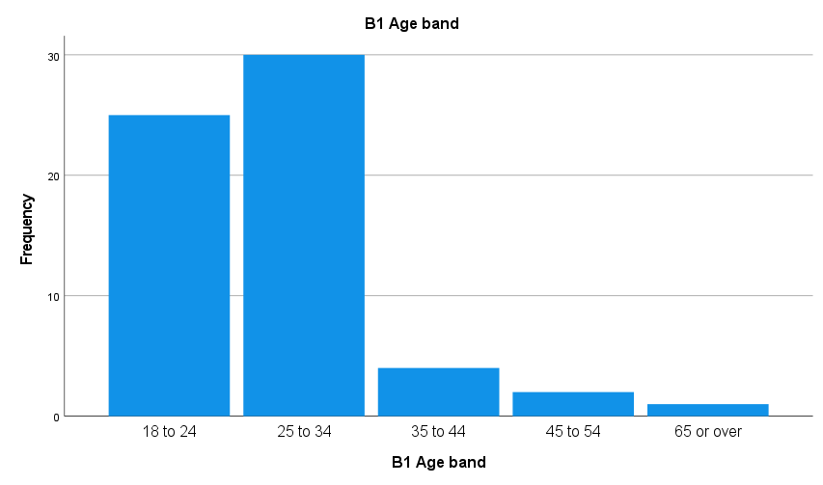
Figure 4.1: Age band of respondents
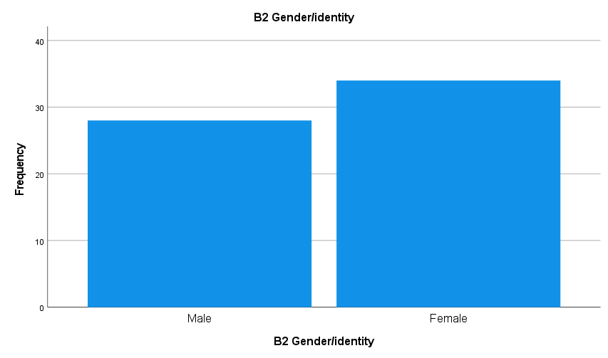
Figure 4.2: Gender of respondents
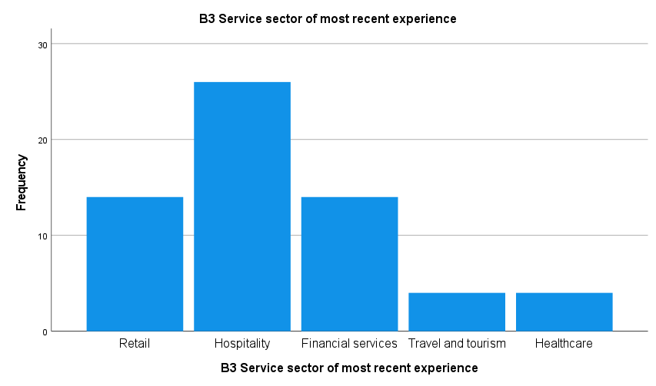
Figure 4.3: Service sector of most recent experience
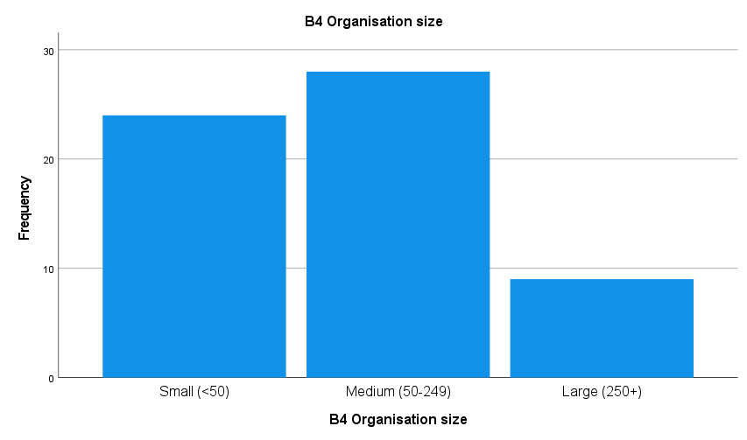
Figure 4.4: Organisation size
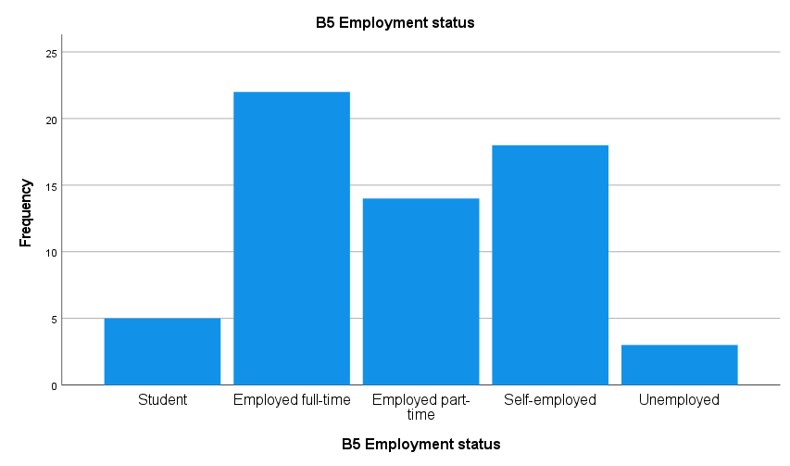
Figure 4.5: Employment status
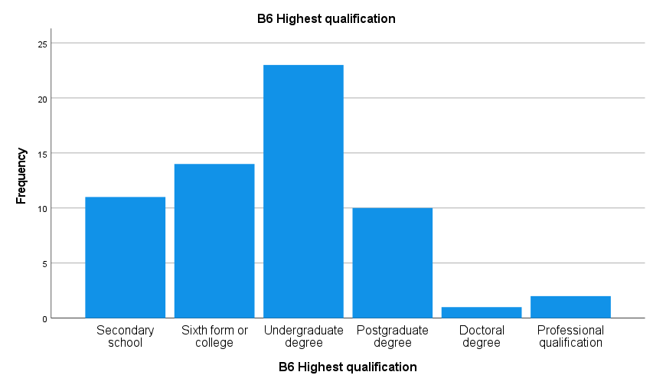
Figure 4.6: Highest qualification

4.4 Question-by-Question Response Profile
This section presents the response distribution for each of the 29 substantive questionnaire items (N = 62). The items are grouped across the five SERVQUAL dimensions, the three-item satisfaction scale, and the four-item competitive advantage scale. Each table shows the percentage of responses at each Likert point (SD = Strongly Disagree, D = Disagree, N = Neither, A = Agree, SA = Strongly Agree), together with the item mean. These results form the basis of the composite scores presented in Table 4.3 and Table 4.4.
Table 4.13: Tangibles - item response distribution (%) and mean (N = 62)
Item | Question (abbreviated) | SD% | D% | N% | A% | SA% | Mean
C1 | Modern, up-to-date facilities | 0.0 | 0.0 | 4.8 | 50.0 | 45.2 | 4.40
C2 | Visually appealing environment | 0.0 | 0.0 | 4.8 | 64.5 | 30.6 | 4.26
C3 | Professional staff presentation | 0.0 | 0.0 | 4.8 | 37.1 | 58.1 | 4.53
C4 | Clear, appropriate materials | 0.0 | 1.6 | 6.5 | 58.1 | 33.9 | 4.24
C3 (staff professionalism) recorded the highest mean (4.53) and top-2 agreement (95.2%); C4 (clarity of materials) recorded the lowest mean (4.24) and the only bottom-2 disagreement (1.6%). The dimension mean (4.36) is the lowest of the five, consistent with the weak alpha (.477, Table 4.3).
Table 4.14: Reliability - item response distribution (%) and mean (N = 62)
Item | Question (abbreviated) | SD% | D% | N% | A% | SA% | Mean
C5 | Kept promises on timing | 1.6 | 0.0 | 6.5 | 46.8 | 45.2 | 4.34
C6 | Genuine interest resolving problems | 0.0 | 1.6 | 3.2 | 54.8 | 40.3 | 4.34
C7 | Correct service first time | 0.0 | 0.0 | 3.2 | 51.6 | 45.2 | 4.42
C8 | Completed service on time | 0.0 | 0.0 | 6.5 | 51.6 | 41.9 | 4.35
C9 | Accurate, error-free records | 0.0 | 0.0 | 1.6 | 54.8 | 43.5 | 4.42
C9 achieved the highest top-2 agreement (96.8%) and mean (4.42); C5 (timing promises) recorded the lowest mean (4.34) and only bottom-2 disagreement (1.6%). Accuracy was rated slightly above punctuality.
Table 4.15: Responsiveness - item response distribution (%) and mean (N = 62)
Item | Question (abbreviated) | SD% | D% | N% | A% | SA% | Mean
C10 | Told clearly when service performed | 0.0 | 0.0 | 4.8 | 46.8 | 48.4 | 4.44
C11 | Prompt, timely service | 0.0 | 0.0 | 4.8 | 56.5 | 38.7 | 4.34
C12 | Always willing to help | 0.0 | 1.6 | 1.6 | 62.9 | 33.9 | 4.29
C13 | Never too busy to respond | 1.6 | 0.0 | 8.1 | 40.3 | 50.0 | 4.37
C12 recorded the highest top-2 agreement (95.2%) though not the highest mean; C13 recorded the lowest mean (4.29), suggesting perceived staff availability under pressure is weaker than willingness in principle.
Table 4.16: Assurance - item response distribution (%) and mean (N = 62)
Item | Question (abbreviated) | SD% | D% | N% | A% | SA% | Mean
C14 | Behaviour instilled confidence | 0.0 | 1.6 | 4.8 | 45.2 | 48.4 | 4.40
C15 | Felt safe and secure | 0.0 | 0.0 | 6.5 | 41.9 | 51.6 | 4.45
C16 | Polite and courteous staff | 0.0 | 0.0 | 4.8 | 43.5 | 51.6 | 4.47
C17 | Staff had sufficient knowledge | 0.0 | 1.6 | 3.2 | 41.9 | 53.2 | 4.47
C15 and C17 scored strongly, with C15 recording the highest mean (4.47); C14 recorded the lowest mean (4.40), though still with high top-2 agreement (93.6%). Assurance items scored consistently highly, reflecting the dimension's solid reliability (alpha = .723, Table 4.3).
Table 4.17: Empathy - item response distribution (%) and mean (N = 62)
Item | Question (abbreviated) | SD% | D% | N% | A% | SA% | Mean
C18 | Individualised attention | 0.0 | 0.0 | 4.8 | 33.9 | 61.3 | 4.56
C19 | Convenient operating times/ways | 0.0 | 0.0 | 4.8 | 50.0 | 45.2 | 4.40
C20 | Personal attention and care | 0.0 | 1.6 | 1.6 | 46.8 | 50.0 | 4.45
C21 | Best interests at heart | 1.6 | 0.0 | 1.6 | 41.9 | 54.8 | 4.48
C22 | Understood specific needs | 0.0 | 1.6 | 1.6 | 46.8 | 50.0 | 4.45
C18 (individualised attention) recorded the highest mean of any SERVQUAL item in the questionnaire (4.56) with 95.2% top-2 agreement; C19 recorded the lowest mean within the dimension (4.40). Empathy items scoring the highest average of the five dimensions (4.47) foreshadows the regression finding in section 4.7 that empathy alone remains a significant unique predictor of competitive advantage.
Table 4.18: Customer Satisfaction - item response distribution (%) and mean (N = 62)
Item | Question (abbreviated) | SD% | D% | N% | A% | SA% | Mean
D1 | Overall satisfied | 1.6 | 0.0 | 0.0 | 33.9 | 64.5 | 4.60
D2 | Met expectations | 0.0 | 0.0 | 4.8 | 58.1 | 37.1 | 4.32
D3 | High standard vs others | 0.0 | 0.0 | 0.0 | 33.9 | 66.1 | 4.66
D3 recorded both the highest mean of any item in this section (4.66) and 100.0% top-2 agreement, the only item in the questionnaire to achieve unanimous agreement or strong agreement. D2 recorded the lowest mean of the three (4.32), consistent with the weak reliability of the satisfaction scale (alpha = .506, Table 4.3).
Table 4.19: Competitive Advantage - item response distribution (%) and mean (N = 62)
Item | Question (abbreviated) | SD% | D% | N% | A% | SA% | Mean
E1 | Intend to use again | 1.6 | 0.0 | 4.8 | 22.6 | 71.0 | 4.61
E2 | Would recommend | 0.0 | 1.6 | 6.5 | 53.2 | 38.7 | 4.29
E3 | Likely to leave positive review | 0.0 | 0.0 | 4.8 | 30.6 | 64.5 | 4.60
E4 | Would choose over competitor | 0.0 | 0.0 | 1.6 | 35.5 | 62.9 | 4.61
E1 and E4 both had a mean of 4.61, which was the highest within the group, while E4 recorded 98.4% top-2 agreement. E2 (referral likelihood) had the lowest mean at 4.29, as well as the lowest top-2 figure at 91.9%. This suggests that respondents were somewhat more willing to return to the provider themselves than to actively recommend it to other people.

4.5 Reliability Analysis
Internal consistency was assessed using Cronbach's alpha, with 0.70 used as the threshold (Nunnally and Bernstein, 1994; Table 4.3). The overall 22-item service quality scale showed excellent reliability (alpha = .907). Four dimensions, together with the competitive advantage scale, also met the required threshold. However, tangibles (alpha = .477) and satisfaction (alpha = .506) were below the threshold, and deleting any single item did not increase either scale above 0.70. These two scales are therefore interpreted with caution throughout the analysis, and this limitation is discussed further in Chapter 6. The strong reliability of the overall scale supports the use of service quality as the main predictor in the regression and mediation analyses (Parasuraman, Zeithaml and Berry, 1988).
Table 4.3: Reliability of measurement scales
Scale | Number of items | Cronbach's alpha
Tangibles | 4 | .477 (below threshold)
Reliability | 5 | .748
Responsiveness | 4 | .724
Assurance | 4 | .723
Empathy | 5 | .729
Overall service quality | 22 | .907
Customer satisfaction | 3 | .506 (below threshold)
Competitive advantage | 4 | .734

4.6 Descriptive Statistics and Normality
The descriptive statistics for the eight composite variables (Table 4.4) show generally high mean scores, ranging from 4.36 to 4.53. The standard deviations were also relatively small, ranging from .35 to .47. All variables showed negative skew, suggesting a ceiling effect. This pattern can also be seen in the histograms for service quality, satisfaction and competitive advantage (Figures 4.7-4.9).
Table 4.4: Descriptive statistics of composite variables (N = 62)
Variable | Min | Max | Mean | SD | Skewness | Kurtosis
Tangibles | 3.50 | 5.00 | 4.36 | .369 | -.515 | -.127
Reliability | 3.00 | 5.00 | 4.37 | .435 | -.963 | 1.563
Responsiveness | 2.50 | 5.00 | 4.36 | .470 | -1.429 | 3.463
Assurance | 3.00 | 5.00 | 4.45 | .466 | -.827 | .290
Empathy | 2.40 | 5.00 | 4.47 | .432 | -1.882 | 7.482
Overall service quality | 2.90 | 4.97 | 4.43 | .346 | -1.659 | 5.239
Customer satisfaction | 3.00 | 5.00 | 4.53 | .407 | -1.084 | 2.005
Competitive advantage | 2.50 | 5.00 | 4.53 | .471 | -1.539 | 4.164
The Shapiro-Wilk tests (Table 4.5) showed that all three key variables departed significantly from a normal distribution (p < .001). This was consistent with the skewed histograms and Q-Q plots presented in Figures 4.10-4.12. Despite this, parametric tests were retained as the main analyses because they are reasonably robust to moderate non-normality at this sample size. Spearman's correlations were also conducted alongside Pearson's correlations as a robustness check (Saunders, Lewis and Thornhill, 2023). The issue of non-normality and the ceiling effect is considered again in Chapter 6.
Table 4.5: Tests of normality
Variable | Shapiro-Wilk statistic | df | p
Overall service quality | .881 | 62 | < .001
Customer satisfaction | .871 | 62 | < .001
Competitive advantage | .842 | 62 | < .001
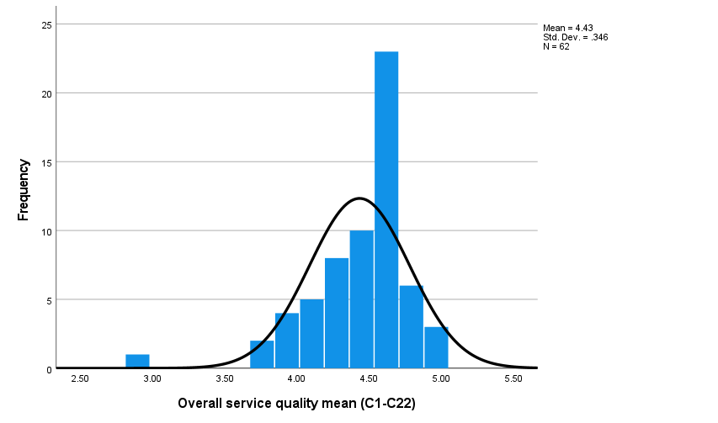
Figure 4.7: Distribution of overall service quality scores
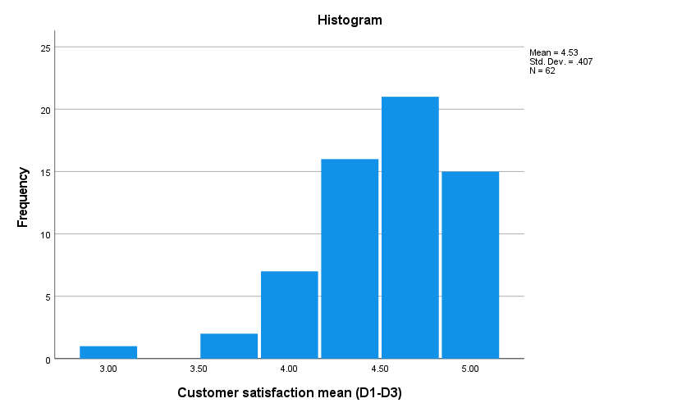
Figure 4.8: Distribution of customer satisfaction scores
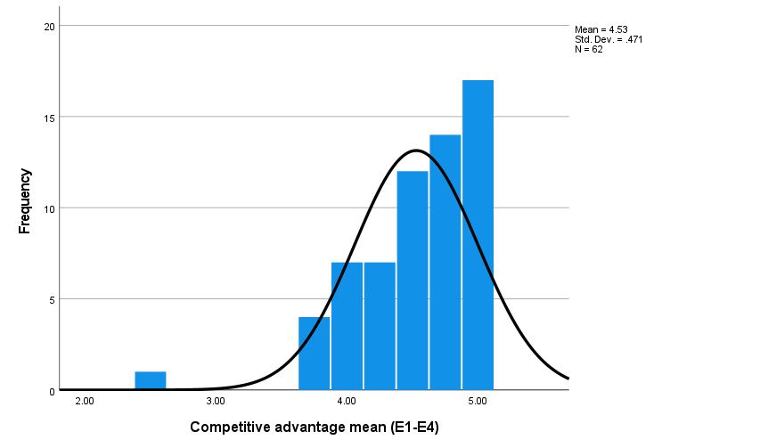
Figure 4.9: Distribution of competitive advantage scores
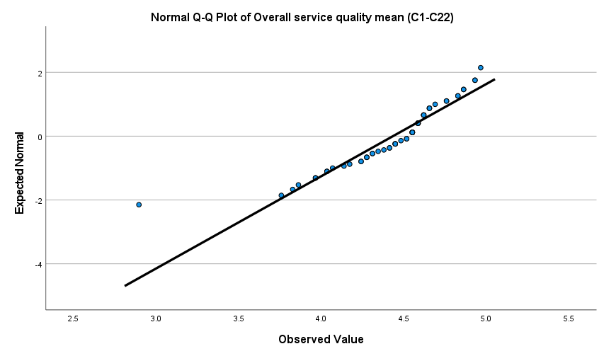
Figure 4.10: Normal Q-Q plot of overall service quality
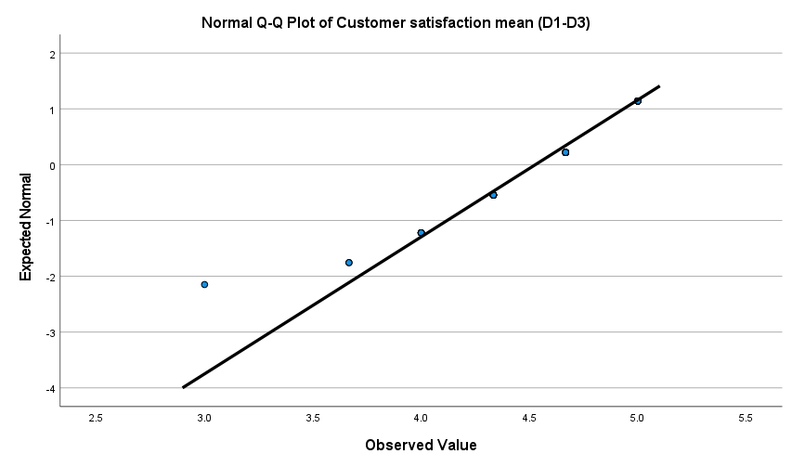
Figure 4.11: Normal Q-Q plot of customer satisfaction
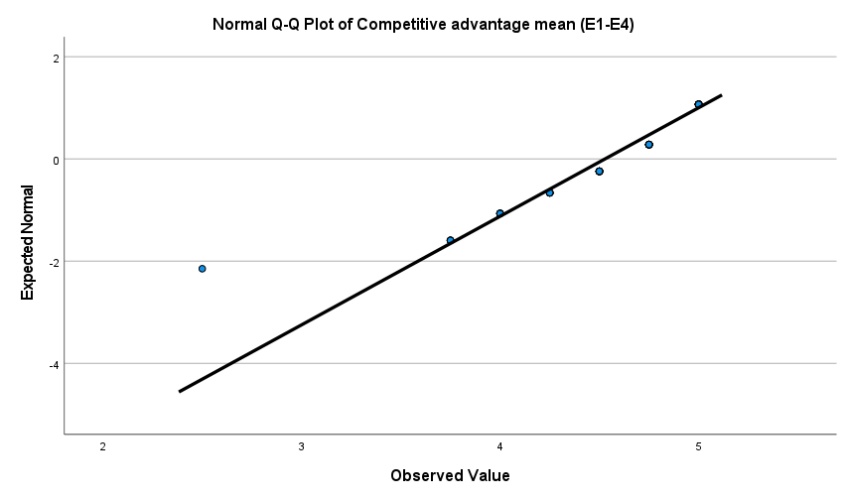
Figure 4.12: Normal Q-Q plot of competitive advantage

4.7 Correlation Analysis
The Pearson correlation results (Table 4.6) were all positive and statistically significant. Service quality was strongly related to satisfaction (r = .696, p < .001) and competitive advantage (r = .736, p < .001), while satisfaction was also positively related to competitive advantage (r = .541, p < .001). The Spearman's correlations (rho = .646, .635, .440) supported these relationships, suggesting that the findings were not simply an artefact of the non-normal distribution. The five SERVQUAL dimensions were also strongly related to each other, with the strongest correlation found between reliability and responsiveness (r = .852). This raised the possibility of multicollinearity, which was examined further in the regression analysis. The findings are broadly consistent with earlier evidence showing that service quality can influence behavioural intentions as well as satisfaction (Cronin and Taylor, 1992).
Table 4.6: Pearson correlations between composite variables (N = 62)
 | 1 | 2 | 3 | 4 | 5 | 6 | 7 | 8
1 Tang. | 1
2 Reli. | .471 | 1
3 Resp. | .492 | .852 | 1
4 Assu. | .438 | .579 | .695 | 1
5 Empa. | .465 | .610 | .754 | .629 | 1
6 SQ | .641 | .814 | .907 | .793 | .874 | 1
7 Sat. | .466 | .374 | .545 | .428 | .654 | .696 | 1
8 CA | .324 | .444 | .556 | .525 | .635 | .736 | .541 | 1
Note: 1 = Tangibles, 2 = Reliability, 3 = Responsiveness, 4 = Assurance, 5 = Empathy, 6 = Overall service quality, 7 = Customer satisfaction, 8 = Competitive advantage. All correlations significant at p < .01 except tangibles with competitive advantage, significant at p < .05.

4.8 Multiple Regression Analysis (RQ1)
To address RQ1, a multiple regression analysis was carried out using competitive advantage as the dependent variable and the five SERVQUAL dimensions as predictors. The model was statistically significant and explained 43.3% of the variance in competitive advantage (R-squared = .433, adjusted R-squared = .383, F(5, 56) = 8.558, p < .001). The Durbin-Watson value of 2.363 also suggested that there was no problematic autocorrelation in the data. The regression coefficients are shown in Table 4.7, while Figure 4.13 presents the relationship between service quality and competitive advantage.
Table 4.7: Multiple regression predicting competitive advantage
Predictor | B | SE B | Beta | t | p | VIF
(Constant) | 1.200 | .652 | - | 1.840 | .071 | -
Tangibles | -.012 | .152 | -.009 | -.078 | .938 | 1.402
Reliability | -.049 | .211 | -.046 | -.234 | .816 | 3.751
Responsiveness | .134 | .246 | .133 | .544 | .589 | 5.930
Assurance | .177 | .146 | .175 | 1.210 | .232 | 2.071
Empathy | .498 | .174 | .457 | 2.866 | .006 | 2.510
Empathy was the only dimension to emerge as a significant unique predictor (Beta = .457, p = .006). None of the other dimensions reached statistical significance once the effects of the remaining dimensions were controlled for. However, this result needs to be interpreted alongside the collinearity statistics. The VIF values for responsiveness (5.930) and reliability (3.751), together with the strong inter-correlations reported in section 4.7, indicate that the dimensions overlap considerably. This can increase standard errors and makes empathy's stronger contribution suggestive rather than definitive. Therefore, in answer to RQ1, empathy was the strongest unique predictor in this sample, although this finding differs from hotel-sector evidence where reliability and assurance were identified as leading dimensions (Markovic and Raspor Jankovic, 2013). It can suggest that personalised service is particularly important for this cross-sector UK sample. Also, items C18 to C22 (Appendix A) of the questionnaire measure individualised attention, the ease with which the product is operated, personal care, having the customer's best interests at heart and understanding of specific needs; it is the strength of these items that accounts for the role of empathy as the top predictor.
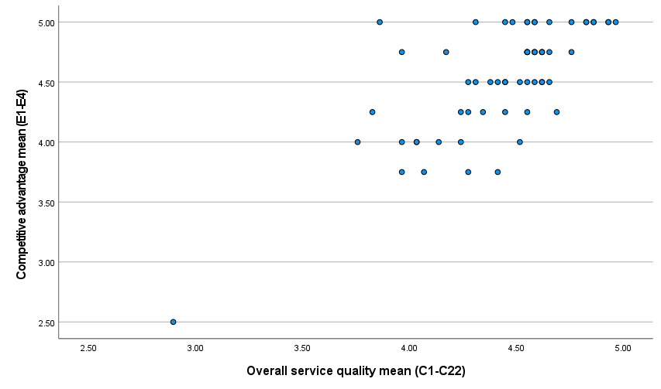
Figure 4.13: Scatterplot of overall service quality and competitive advantage

4.9 The Satisfaction Pathway and Mediation Analysis (H1, H2, H3)
H1, which proposed an association between service quality and satisfaction, was supported by a strong and significant regression result (Beta = .696, t = 7.507, p < .001, R-squared = .484). This is consistent with the basic logic of the SERVQUAL model (Parasuraman, Zeithaml and Berry, 1988; Cronin and Taylor, 1992). H2, which proposed an association between satisfaction and competitive advantage, was also supported (Beta = .541, t = 4.984, p < .001, R-squared = .293). This is also in line with the established relationship between satisfaction and loyalty-related outcomes (Fornell, Morgeson and Hult, 2016). Figure 4.14 presents this relationship.
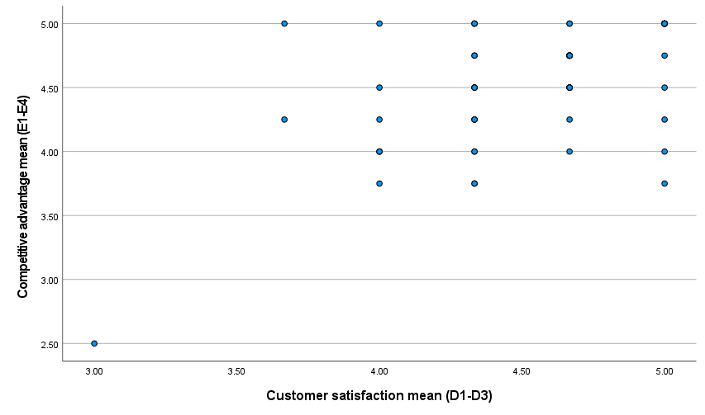
Figure 4.14: Scatterplot of customer satisfaction and competitive advantage
H3 proposed that satisfaction would fully mediate the relationship between service quality and competitive advantage. This was tested using the four-step Baron and Kenny (1986) procedure (Table 4.8). The total effect (path c = 1.003, p < .001) and the effect of service quality on satisfaction (path a = .820, p < .001) were both significant. However, when service quality and satisfaction were entered into the model together, satisfaction did not significantly predict competitive advantage (path b = .064, p = .653). At the same time, service quality remained a strong and significant predictor (path c' = .950, p < .001). Explained variance increased only slightly, from 54.2% to 54.4%. Since the mediator-outcome condition was not satisfied, H3 is rejected.

Table 4.8: Mediation analysis (Baron and Kenny) for service quality, satisfaction and competitive advantage
Path | Relationship | B (SE) | Beta | t | p
a | Service quality to satisfaction | .820 (.109) | .696 | 7.507 | < .001
b | Satisfaction to competitive advantage (controlling SQ) | .064 (.141) | .055 | .452 | .653
c (total) | Service quality to competitive advantage | 1.003 (.119) | .736 | 8.433 | < .001
c' (direct) | Service quality to competitive advantage (controlling satisfaction) | .950 (.167) | .698 | 5.701 | < .001
These results suggest that, within this sample, service quality is more directly associated with competitive advantage rather than operating through satisfaction. This differs from earlier banking-sector evidence of full mediation (Mosahab, Mahamad and Ramayah, 2010), although it is closer to evidence suggesting that satisfaction can have direct strategic importance (Fornell, Morgeson and Hult, 2016). Two characteristics of the data may help explain this result. First, the correlation between service quality and satisfaction was already very high. Second, the ceiling effect reduced the amount of variation available in both variables. An additional analysis might provide further evidence about the small indirect effect (Hayes, 2022), but the Baron and Kenny criteria are sufficient for the decision made here to reject H3.

4.10 Group Comparisons (H4, RQ3)
RQ3 and H4 examined whether demographic and contextual characteristics influence perceptions of service quality and its outcomes. Since the relatively small subgroup sizes did not provide a strong basis for estimating interaction terms, H4 was examined through group comparisons. One-way ANOVA was used for sector and organisation size, while independent-samples t-tests were used for gender. This represents a limitation in terms of testing formal moderation.
Across sectors (Table 4.9), only overall service quality reached conventional statistical significance (F(4, 57) = 2.727, p = .038). However, this result was not particularly robust. Levene's test indicated unequal variances (p = .013), and the Welch-adjusted result was only marginally significant (p = .048). In addition, none of the pairwise Tukey comparisons reached significance, while two sectors had only four respondents each. No significant differences were found for satisfaction or competitive advantage across sectors.
Table 4.9: Mean scores and one-way ANOVA by service sector
Outcome | Retail | Hospitality | Financial | Travel | Healthcare | F(4,57) | p
Service quality | 4.40 | 4.55 | 4.29 | 4.11 | 4.59 | 2.727 | .038
Satisfaction | 4.64 | 4.53 | 4.36 | 4.50 | 4.75 | 1.213 | .316
Competitive adv. | 4.63 | 4.60 | 4.27 | 4.69 | 4.50 | 1.523 | .208
There were also no significant differences according to organisation size or gender (Table 4.10). All p-values were above .37 for organisation size and above .57 for gender. Overall, these findings provide no robust evidence that perceptions of service quality or its outcomes differ systematically according to the demographic and contextual characteristics measured in this study. Therefore, H4 is not supported.
Table 4.10: Group comparisons by organisation size and gender
Outcome | Org size F(2,58) | p | Gender t(60) | p
Service quality | .643 | .530 | .120 | .905
Satisfaction | .989 | .378 | .361 | .719
Competitive advantage | .251 | .779 | -.561 | .577

4.11 Supplementary Cross-Tabulation
For completeness, a chi-square test was conducted between service sector and gender. The result was not significant (chi-square(4) = 3.895, p = .420). However, 40% of the cells had an expected count below five, meaning that the assumptions for the chi-square test were not fully met. Therefore, the ANOVA and t-tests reported in section 4.10 remain the more appropriate analyses, while the cross-tabulation is included only as a supplementary check.
Table 4.11: Chi-square test of service sector by gender
Test | Value | df | p
Pearson chi-square | 3.895 | 4 | .420
N of valid cases | 62 | - | -

4.12 Summary of Findings
This chapter has presented the analysis of 62 valid responses. Overall, the scales showed acceptable to strong reliability, although tangibles and satisfaction fell below the required threshold. The results also showed high and negatively skewed scores, with service quality strongly related to both satisfaction and competitive advantage. Empathy was the only significant unique predictor in the regression analysis, although this result needs to be considered carefully because of multicollinearity between the SERVQUAL dimensions. The satisfaction pathway was supported, but the proposed mediating role of satisfaction was not. Instead, service quality showed a direct relationship with competitive advantage. Finally, no robust group differences were identified. Table 4.12 summarises the outcome of each hypothesis.
Table 4.12: Summary of hypothesis testing
Hypothesis | Statement (abbreviated) | Result
H1 | Service quality is positively associated with satisfaction | Supported
H2 | Satisfaction is positively associated with the competitive advantage outcomes | Supported
H3 | Satisfaction fully mediates service quality and competitive advantage | Rejected
H4 | Demographic and contextual variables moderate the relationships | Not supported
RQ1 is addressed through the regression analysis, where empathy emerged as the strongest unique predictor despite the overlap between the SERVQUAL dimensions. RQ2 is addressed by mediation analysis, which indicates a direct rather than mediated relationship. RQ3 is addressed through the group comparisons, which did not provide robust evidence of moderation. These findings are considered in relation to the existing literature in Chapter 5.

Chapter 5: Discussion of Findings

5.1 Introduction
This chapter summarises the key findings that were presented in Chapter 4 and evaluates their implications in the light of the literature review that was conducted in Chapter 2. Each of the research questions and hypotheses was addressed below in line the four objectives that were stated in Chapter 1. Specifically, the focus was on identifying the key SERVQUAL dimensions (Objective 1), exploring the satisfaction pathway (Objective 2), determining the mediating role of satisfaction for competitive advantage (Objective 3), and assessing the impact of demographics and contexts (Objective 4). The concluding remarks, theoretical and managerial implications, as well as the limitations of the study were discussed in Chapter 6.

5.2 Discussion of Findings

5.2.1 Which service quality dimensions matter most (Objective 1, RQ1)
The first objective was to identify which SERVQUAL dimensions are not associated with negative service experiences. The regression analysis reported in section 4.7 showed that empathy was the only dimension to remain a significant unique predictor of competitive advantage after controlling for the other four dimensions (Beta = .457, p = .006). At the same time, the overall model explained 43.3% of the variance, and all five dimensions were positively related to the outcome when considered individually. This result therefore needs to be interpreted with some care. The strong inter-correlations between the dimensions, especially reliability and responsiveness (r = .852), resulted in VIF values as high as 5.930. This makes it difficult for the regression model to separate the contribution of one dimension from the others when they tend to change together. Therefore, it would be too strong to conclude that tangibles, reliability, responsiveness and assurance are unimportant. Rather, empathy appears to provide additional explanatory value beyond what is already captured by the other dimensions.
This finding is also consistent with the question-level results in section 4.4. The empathy dimension had the highest average mean among the five dimensions (4.47), while item C18, which measured individualised attention, had the highest mean of any SERVQUAL item at 4.56. This differs from Markovic and Raspor Jankovic (2013), whose study of Croatian hotels identified reliability and assurance as the leading dimensions rather than empathy. However, the difference does not necessarily represent a contradiction. A single-sector hospitality setting may place greater emphasis on consistency and competence, while this study's cross-sector UK sample, which was mainly made up of hospitality and retail respondents but also included financial services, reflects a wider range of service experiences. In such a setting, feeling personally recognised and receiving individual attention, which are central aspects of empathy in the SERVQUAL framework, may be more important in distinguishing a positive service experience from an average one.

5.2.2 The satisfaction pathway (Objective 2, RQ1, H1 and H2)
The second objective was to examine the relationship between perceived service quality and repeat business intention. Both hypotheses relating to this pathway were supported. H1, which proposed that higher service quality is associated with greater satisfaction, received strong support (Beta = .696, p < .001). H2, which proposed that satisfaction is positively associated with competitive advantage outcomes, was also supported (Beta = .541, p < .001). These findings support the basic logic of the SERVQUAL model (Parasuraman, Zeithaml and Berry, 1988) and provide similar evidence within a cross-sector UK sample, rather than a single-sector or non-UK setting. In practical terms, respondents rated their most recent service experiences very positively across all composite measures, with means above 4.3 out of 5. This is also consistent with the very high top two agreement levels reported for the individual items in section 4.4. For example, D1, measuring overall satisfaction, recorded 98.4% top two agreement, while D3, which asked respondents to compare the provider favourably with others they had used, recorded 100.0% top two agreement.

5.2.3 Why satisfaction did not mediate the relationship (Objective 3, RQ2, H3)
The third objective was to examine whether customer satisfaction mediates the relationship between service quality and competitive advantage. This is one of the more important findings of the study because it did not follow the pattern anticipated from the literature review. H3 proposed full mediation, but the Baron and Kenny (1986) procedure did not support this. When service quality and satisfaction were entered into the model together, satisfaction was no longer a significant predictor of competitive advantage (path b = .064, p = .653), while service quality continued to show a strong and significant direct effect (path c' = .950, p < .001). In this sample, therefore, service quality appears to be linked to future customer behaviour more directly, rather than first creating satisfaction which then leads to the behavioural outcome.
This result differs from the banking-sector study by Mosahab, Mahamad and Ramayah (2010), which found that satisfaction fully mediated the relationship between service quality and loyalty. There are two features of the present data that may help explain this difference. First, service quality and satisfaction were strongly correlated (r = .696), meaning that there was relatively little independent variation in satisfaction after service quality was included in the model. Second, the ceiling effect discussed in section 4.6, with mean scores ranging from 4.36 to 4.53 out of 5 and standard deviations below .5, restricted the range of responses. This may have made it more difficult for a mediating relationship to appear clearly in the analysis. This does not suggest that satisfaction is unimportant. Instead, within this sample, service quality appears to translate into repeat business intention and recommendation behaviour relatively directly, without necessarily passing through a separately measurable level of satisfaction.

5.2.4 No robust demographic differences (Objective 3, RQ3, H4)
H4 proposed that demographic and contextual variables would moderate the relationship between service quality and its outcomes. The results did not support this hypothesis. The only comparison that reached conventional significance was service quality across sectors (F(4, 57) = 2.727, p = .038). However, this finding became less convincing after further testing. Levene's test indicated unequal variances, the Welch-adjusted result was only marginally significant, and none of the individual pairwise comparisons were significant. No significant differences were found according to organisation size or gender (Table 4.10). Overall, the study did not find convincing evidence that age, gender, sector or organisation size changed how UK consumers experienced or responded to service quality in this sample. However, this should not be taken as proof that these characteristics have no influence at all. The sample size of 62 was relatively small, and some subgroups, including travel and tourism and healthcare, contained only four respondents. This is because, as described in section 4.2, after the first 167 responses were screened to yield 62 full and complete responses, the statistical power of these small subgroups is an important consideration which is discussed again in Chapter 6.

5.3 Chapter Summary
This chapter has discussed the findings from Chapter 4 in relation to the literature reviewed in Chapter 2. Empathy emerged as the strongest unique predictor of competitive advantage, although there was considerable overlap between the SERVQUAL dimensions. Both stages of the satisfaction pathway, H1 and H2, were supported. However, the proposed mediating role of satisfaction, H3, was not supported, with the results instead indicating a direct relationship between service quality and competitive advantage. Finally, no robust demographic or sector-based moderating effects were identified for H4. These findings provide the basis for the overall conclusions, theoretical contributions, management recommendations and limitations discussed in Chapter 6.

Chapter 6: Conclusions and Recommendations

6.1 Introduction
This chapter concludes the dissertation. It revisits the research gap, aim and method, summarises the main findings in relation to the literature reviewed in Chapter 2, discusses the theoretical contribution, provides evidence-based recommendations for managers in the UK service sector, and concludes with the study's limitations and possible directions for future research.

6.2 Revisiting the Gap, Aim and Method
Chapter 1 identified a gap in the service quality literature, particularly the concentration of SERVQUAL evidence within single-sector or non-UK settings. As a result, the mediation pathway linking service quality, satisfaction and competitive advantage has received comparatively less attention within a UK cross-sector context. This study addressed this gap by examining how different service quality dimensions are related to repeat business intention and competitive advantage among UK consumers across retail, hospitality, financial services, travel and healthcare. A positivist, deductive and quantitative research design was adopted (Saunders, Lewis and Thornhill, 2023), using a structured questionnaire based on SERVQUAL and distributed through convenience and snowball sampling. Following the screening process, 62 valid cases (N = 62) were retained from 167 initial responses. Although below the original target of 150, the final sample was used for the correlation, regression and mediation analyses presented in Chapter 4.

6.3 Summary of Key Findings and Fit with the Literature
Three findings are particularly noteworthy. First, service quality was strongly associated with satisfaction (Beta = .696, p < .001), while satisfaction was also strongly associated with competitive advantage (Beta = .541, p < .001). This supports the general SERVQUAL-satisfaction-behaviour pathway (Parasuraman, Zeithaml and Berry, 1988; Cronin and Taylor, 1992). Secondly, empathy was the only dimension that remained a significant unique predictor of competitive advantage when controlling for the other dimensions (Beta = .457, p = .006). This contrasts with the hotel-sector findings of Markovic and Raspor Jankovic (2013), whereby reliability and assurance were more prominent. At the same time, it is in line with the question-level findings from this study (section 4.4), whereby empathy items had the highest average mean (4.47) and item C18 registered the highest individual mean overall (4.56). Thirdly, satisfaction did not mediate the relationship between service quality and competitive advantage. Rather, service quality continued to exert a strong and significant direct effect (path c' = .950, p <.001). This is very different from the full-mediation evidence reported by Mosahab, Mahamad and Ramayah (2010) in the banking sector. This suggests that the mediation pathway identified in earlier research may not be applicable in exactly the same way in a different context, especially with this younger and digitally-engaged UK sample. The findings are also consistent with the context-dependent nature of SERVQUAL, particularly in relation to empathy, while the lack of robust demographic moderation is consistent with evidence that convenience-sampled and digitally skewed groups can produce compressed response patterns (Golzar, Noor and Tajik, 2022).
The correlation and regression findings in sections 4.6-4.7, where service quality was strongly associated with satisfaction (r = .696) and competitive advantage (r = .736), are broadly within the range reported across the SERVQUAL literature. Therefore, the overall structure of the model receives support, but the specific causal ordering implied by full mediation is not confirmed by this study. This distinction is important for the practical implications discussed in section 6.5, because it affects which outcomes managers may need to monitor, while it does not require the wider SERVQUAL framework to be rejected.

6.4 Theoretical Contribution
This study makes three main contributions to the existing theory. First, it extends the Gaps Model and SERVQUAL (Parasuraman, Zeithaml and Berry, 1988) to a cross-sector UK sample, an area that has received less attention compared with single-sector and non-UK studies. Second, it contributes to the literature, including Fornell, Morgeson and Hult (2016), that questions whether the mediating role of satisfaction should be assumed across all contexts. Third, it provides further evidence that the relative importance of the five SERVQUAL dimensions can vary according to the sector and consumer context. In this study, empathy emerged as the dominant predictor, rather than reliability or assurance, which differs from the hotel-sector findings reported by Markovic and Raspor Jankovic (2013).

6.5. Recommendations for UK Service Sector Practice
Five evidence-based recommendations can be drawn from the findings of this study. Where the recommendations involve changes in staff behaviour, they are framed using the behaviour change wheel (Michie, van Stralen and West, 2011), which distinguishes between capability, opportunity and motivation. Each recommendation therefore focuses on a specific change in capability or opportunity rather than simply telling employees to 'be more empathetic', as behaviour change research suggests that general instructions alone are unlikely to produce lasting changes.
First, UK service managers should place greater emphasis on individualised recognition in frontline training, rather than focusing mainly on technical competence. Empathy was the only dimension that remained significant after controlling for the other dimensions (Beta = .457, p = .006), while individualised attention (C18) recorded the highest mean of all items (4.56). Based on this finding, training could focus more on recalling customer history, adapting recommendations and personalising communication instead of relying mainly on scripted interactions. One relatively low-cost approach would be to ask staff to refer to one relevant detail from a customer's previous interaction during each encounter, with this being reviewed through monthly checks.
Second, since service quality appears to influence behaviour directly rather than operating only through satisfaction, managers should avoid using satisfaction surveys as the sole early-warning indicator of potential commercial problems. Organisations could instead measure behavioural indicators such as actual repeat purchases, referrals and review activity, and satisfaction scores. These could be added to a regular dashboard and reviewed at the same frequency. This would give managers a wider perspective of the responses to the service, rather than just satisfaction data.
Thirdly, the lower result of referral likelihood also requires consideration. As detailed in Section 4.4, E2 had the lowest mean and top-two agreement of the four competitive advantage items at 91.9%, compared to 93.6-98.4% for the other three items. It is therefore possible to develop a simple referral prompt in place at a point in the service journey where customer satisfaction appears likely to be high, such as immediately after successfully resolving an enquiry. This could be more effective than simply assuming that satisfied customers will automatically recommend the provider without any prompting.
Fourthly, the lower internal consistency found for tangibles and satisfaction (alpha .477 and .506, Table 4.3) highlights the caution that organisations using internally-developed satisfaction questionnaires should adopt in interpreting their findings. Organisations may want to validate their measures prior to making any substantial investment decisions based on their survey results using an established scale such as SERVQUAL. Otherwise, a poorly performing internal scale may present misleading information and encourage the allocation of resources to the wrong areas.
Lastly, as no robust differences were found across sectors, organisation sizes or demographic groups, UK service organisations could take empathy-led service design and behavioural tracking as wider cross-sector initiatives. Rather than assuming that every customer segment requires a completely different approach, organisations could first assess whether there is sufficient evidence to justify more costly, sector-specific interventions. This could limit the adoption of unnecessary customisations where there is no yet evidence to support them.

6.6. Limitations and Future Research
The final sample of 62 respondents was considerably below the original target of 150. This reduced the statistical power of the group comparisons discussed in Section 4.9 and likely contributed to the non-significant H4 findings. While the sample was adequate for the correlation and regression analyses, some subgroups, particularly travel/tourism and healthcare, were too small for strong comparisons between groups. Additionally, two scales, tangibles (alpha = .477) and satisfaction (alpha = .506), were below the 0.70 reliability threshold (Nunnally and Bernstein, 1994). Since no individual items raised either scale above this threshold, findings involving these measures should be interpreted with additional caution.
Another limitation is the apparent ceiling effect in the data. All composite variables had mean scores above 4.3 out of 5, while the Shapiro-Wilk tests exhibited significant deviations from normality (p < .001). This might be partially explained by the younger and more digitally-engaged profile of the convenience sample, which may also have been more satisfied with the service experiences they reported (Golzar, Noor and Tajik, 2022). The cross-sectional design limits the conclusions that can be drawn since it is only able to identify associations, not the direction of the relationships. The study also relied on respondents' reported behavioural intentions rather than directly observed customer behaviour. Therefore, the intentions stated by the respondents may not always yield tangible future actions.
Future research may build upon the present study in three main directions. Firstly, it would be interesting to replicate the findings in a larger and more representative sample of the UK population, possibly obtained via a paid research panel. Such an approach would allow validating the observed empathy-dominant and direct-effect pattern on a bigger scale and ruling out the ceiling-effect hypothesis. Secondly, a bootstrapped mediation analysis using the PROCESS package (Hayes, 2022) would be a valuable addition to the present study, as it would provide a confidence interval estimation for the indirect effect and potentially confirm the putative mediation mechanism. Finally, a longitudinal design following the same participants across multiple service encounters would allow addressing the direct-effect hypothesis described in Section 5.2.3 in more detail. It would enable a dynamic assessment of the link between satisfaction and behavioural outcomes, thus highlighting whether the observed pattern of mediation is specific to the context or represents a general relationship.

6.7. Concluding Statement
The study set out to expand theoretical understanding of the ways in which service quality drives competitive advantage by examining the role of satisfaction as a mediating variable in the UK context. The research question has been successfully addressed and yielded mixed but valuable insights. Service quality, and empathy-driven aspects in particular, were found to have a substantial influence on customers’ intention to repurchase and willingness to recommend and post positive online reviews. Nevertheless, the hypothesised mediation mechanism did not appear to be consistent with the observed data, possibly due to the presence of alternative explanatory mechanisms. Thus, the study contributes to the existing knowledge by providing UK-specific managerial guidance on the importance of cultivating empathetic approaches to customer experience design while also advising considering behavioural metrics alongside traditional satisfaction measurements.

References
Abbasi Kamardi, A., Amoozad Mahdiraji, H., Masoumi, S. and Jafari-Sadeghi, V. (2022). Developing sustainable competitive advantages from the lens of resource-based view: Evidence from IT sector of an emerging economy. Journal of Strategic Marketing, 33(6), pp.1-23. doi:10.1080/0965254x.2022.2160485.
Adaba, G.B., Frimpong, F. and Mwainyekule, L. (2025). Empirical Analysis of Social Media Influencers’ Effect on Consumer Purchase Intentions and Behaviour. Platforms, 3(3), p.11. doi:10.3390/platforms3030011.
Adhikari, Y., Wagley, M.P. and Dahal, N. (2023). Developing the contextualized SERVQUAL instrument for measuring the service quality of Nepali resorts: An application of the modified Delphi technique. SAGE Open, 13(3). doi:10.1177/21582440231195952.
Akhmad, U.S.M. (2025). A narrative review of influencer marketing: The role of credibility and emotional engagement in shaping gen Z’s purchase intentions. The Proceedings of the ASEAN School of Business Network International Conference, 2, pp.335-345. doi:10.64458/asbnic.v2.81.
Al-Khawaldeh, N.E.-D. (2023). Exploring the role of social media influencers in influencing consumers: Revisiting two-step flow of communication model. Journal of Southwest Jiaotong University, 58(1). doi:10.35741/issn.0258-2724.58.1.71.
Al-Tamimi, H.A.H. and Al-Amiri, A. (2003). Analysing service quality in the UAE Islamic banks. Journal of Financial Services Marketing, 8(2), pp.119-132. doi:10.1057/palgrave.fsm.4770112.
Alcántara-Pilar, J.M., Rodriguez-López, M.E., Kalinić, Z. and Liébana-Cabanillas, F. (2024). From likes to loyalty: Exploring the impact of influencer credibility on purchase intentions in TikTok. Journal of Retailing and Consumer Services, [online] 78(103709), p.103709. doi:10.1016/j.jretconser.2024.103709.
Alemu, A. (2023). Assessing service quality in tertiary education using adapted SERVQUAL scale. Cogent Education, 10(2). doi:10.1080/2331186x.2023.2259733.
Ali Alsheikh, G.A., Binti Abd Halim, M.S., Y. A. Ayassrah, A., Alnawafleh, E.A.T. and A Tambi, A.M. Bin (2018). Investigation of Factors Influencing Customer Loyalty in Malaysia and Jordan Hotel Industry. Journal of Business and Hotel Management, 07(02). doi:10.4172/2169-0286.1000181.
Ali, I.M. (2024). A guide for Positivist Research Paradigm: From philosophy to methodology. Idealogy Journal, 9(2), pp.187-196. doi:10.24191/idealogy.v9i2.596.
Al‐Hawari, M. and Ward, T. (2006). The effect of automated service quality on Australian banks” financial performance and the mediating role of customer satisfaction. Marketing Intelligence & Planning, 24(2), pp.127-147. doi:10.1108/02634500610653991.
Arli, D., Esch, P. van and Weaven, S. (2024). The impact of SERVQUAL on consumers’ satisfaction, loyalty, and intention to use online food delivery services. Journal of Promotion Management, 30(7), pp.1-30. doi:10.1080/10496491.2024.2372858.
Arshad Khan, M. and Alhumoudi, H.A. (2022). Performance of e-banking and the mediating effect of customer satisfaction: A structural equation model approach. Sustainability, 14(12), p.7224. doi:10.3390/su14127224.
Ashraf, A., Hameed, I. and Saeed, S.A. (2023). How do social media influencers inspire consumers” purchase decisions? The mediating role of parasocial relationships. International Journal of Consumer Studies, 47(4), pp.1416-1433. doi:10.1111/ijcs.12917.
Audrezet, A., de Kerviler, G. and Guidry Moulard, J. (2020). Authenticity under threat: When social media influencers need to go beyond self-presentation. Journal of Business Research, [online] 117(1), pp.557-569. doi:https://doi.org/10.1016/j.jbusres.2018.07.008.
Batmunkh, G. (2025). An investigation of the switching behavior and why customers switch banks in the retailing banking sector. Frontiers in Communication, [online] 10. doi:10.3389/fcomm.2025.1548050.
Chandra, S., Verma, S., Lim, W.M., Kumar, S. and Donthu, N. (2022). Personalization in personalized marketing: Trends and ways forward. Psychology & Marketing, 39(8), pp.1529-1562.
Chen, C.-F. and Lu, H.-H. (2024). Transforming a social media influencer’s influential power to followers’ word of mouth and purchase intention: The role of brand attachment, brand credibility, and parasocial relationship. Journal of Brand Management, 31. doi:10.1057/s41262-023-00349-2.
Chetioui, Y., Benlafqih, H. and Lebdaoui, H. (2020). How fashion influencers contribute to consumers” purchase intention. Journal of Fashion Marketing and Management: An International Journal, [online] 24(3), pp.361-380. doi:https://doi.org/10.1108/JFMM-08-2019-0157.
Cheung, G.W., Cooper-Thomas, H.D., Lau, R.S. and Wang, L.C. (2023). Reporting reliability, convergent and discriminant validity with structural equation modeling: A review and best-practice recommendations. Asia Pacific Journal of Management, 1(1). doi:10.1007/s10490-023-09871-y.
Chi, H.-K. and Phan, H.-T. (2025). Revealing the role of corporate social responsibility, service quality, and perceived value in determining customer loyalty: A meta-analysis study. Sustainability, [online] 17(10), p.4304. doi:10.3390/su17104304.
Christopher Westland, J. (2010). Lower bounds on sample size in structural equation modeling. Electronic Commerce Research and Applications, 9(6), pp.476-487. doi:10.1016/j.elerap.2010.07.003.
Coutinho, F., Dias, Á. and Pereira, L. (2023). Credibility of social media influencers: Impact on purchase intention. Human Technology, 19(2), pp.220-237. doi:10.14254/1795-6889.2023.19-2.5.
Cuthbertson, R.W. and Furseth, P.I. (2022). Digital services and competitive advantage: Strengthening the links between RBV, KBV, and innovation. Journal of Business Research, 152, pp.168-176.
Davies, P., Bustinza, O.F., Parry, G. and Jovanovic, M. (2023). Unpacking the relationship between digital capabilities, services capabilities, and firm financial performance: A moderated mediation model. Industrial Marketing Management, 115, pp.1-10. doi:10.1016/j.indmarman.2023.09.005.
De Veirman, M., Cauberghe, V. and Hudders, L. (2017). Marketing through instagram influencers: The impact of number of followers and product divergence on brand attitude. International Journal of Advertising, 36(5), pp.798-828. doi:https://doi.org/10.1080/02650487.2017.1348035.
Derya Çelik and Ülkü Uzunçarşılı (2023). Is the effect of organizational ambidexterity and technological innovation capability on firm performance mediated by competitive advantage? An empirical research on Turkish manufacturing and service industries. SAGE Open, 13(4). doi:10.1177/21582440231206367.
Djafarova, E. and Rushworth, C. (2017). Exploring the credibility of online celebrities” instagram profiles in influencing the purchase decisions of young female users. Computers in Human Behavior, 68(1), pp.1-7. doi:https://doi.org/10.1016/j.chb.2016.11.009.
do Adro, F. and Fernandes, C.I. (2019). Social innovation: A systematic literature review and future agenda research. International Review on Public and Nonprofit Marketing. doi:10.1007/s12208-019-00241-3.
Duah, F.A., Abeeku Bamfo, B. and Serbe Marfo, J. (2024). Marketing capability and firm performance: The mediating role of resource orchestration capability. Cogent Social Sciences, 10(1). doi:10.1080/23311886.2024.2318880.
Fakhreddin, F., Foroudi, P. and Kooli, K. (2024). The influence of key account management on competitive advantage and firm performance: A dynamic capability approach. Industrial Marketing Management, [online] 124, pp.266-286. doi:10.1016/j.indmarman.2024.12.002.
Faramarzi, A., Worm, S. and Ulaga, W. (2023). Service strategy’s effect on firm performance: A meta-analysis of the servitization literature. Journal of the Academy of Marketing Science, 52(4), pp.1018-1044. doi:10.1007/s11747-023-00971-1.
Fida, B.A., Ahmed, U., Al-Balushi, Y. and Singh, D. (2020). Impact of service quality on customer loyalty and customer satisfaction in islamic banks in the sultanate of Oman. SAGE Open, [online] 10(2), p.215824402091951. doi:10.1177/2158244020919517.
Field, A. (2013). Discovering statistics using IBM SPSS statistics. Pflege, 27(6).
Filieri, R. (2015). What makes online reviews helpful? A diagnosticity-adoption framework to explain informational and normative influences in e-WOM. Journal of Business Research, 68(6), pp.1261-1270.
Fook, A.C.W. and Dastane, O. (2021). Effectiveness of loyalty programs in customer retention: A multiple mediation analysis. Jindal Journal of Business Research, 10(1), pp.7-32. doi:10.1177/22786821211000182.
Foroughi, B., Iranmanesh, M., Mehrbakhsh Nilashi, Morteza Ghobakhloo, Asadi, S. and Khoshkam, M. (2023). Determinants of followers” purchase intentions toward brands endorsed by social media influencers: Findings from PLS and fsQCA. Journal of Consumer Behaviour, 23(2). doi:10.1002/cb.2252.
Gahler, M., Klein, J.F. and Paul, M. (2023). Customer experience: Conceptualization, measurement, and application in omnichannel environments. Journal of Service Research, 26(2). doi:https://doi.org/10.1177/10946705221126590.
Gao, L., de Haan, E., Melero-Polo, I. and Sese, F.J. (2022). Winning your customers’ minds and hearts: Disentangling the effects of lock-in and affective customer experience on retention. Journal of the Academy of Marketing Science, 51(1). doi:10.1007/s11747-022-00898-z.
Garg, M. and Bakshi, A. (2024). Exploring the impact of beauty vloggers’ credible attributes, Parasocial Interaction, and trust on consumer purchase intention in influencer marketing. Humanities and Social Sciences Communications, 11(1), pp.1-14. doi:10.1057/s41599-024-02760-9.
Gazi, Md.A.I., Masud, A. Al, Sobhani, F.A., Islam, Md.A., Rita, T., Chaity, N.S., Das, M. and Senathirajah, A.R.S. (2024). Exploring the mediating effect of customer satisfaction on the relationships between service quality, efficiency, and reliability and customer retention, loyalty in e-banking performance in emerging markets. Cogent Business & Management, 12(1). doi:10.1080/23311975.2024.2433707.
Godey, B., Manthiou, A., Pederzoli, D., Rokka, J., Aiello, G., Donvito, R. and Singh, R. (2016). Social media marketing efforts of luxury brands: Influence on brand equity and consumer behavior. Journal of Business Research, 69(12), pp.5833-5841. doi:https://doi.org/10.1016/j.jbusres.2016.04.181.
Gonu, E., Agyei, P.M., Richard, O.K. and Asare-Larbi, M. (2023). Customer orientation, service quality and customer satisfaction interplay in the banking sector: An emerging market perspective. Cogent Business & Management, 10(1).
Guled, A. and Rajkumar, C. (2026). Social media influencer marketing and consumer behaviour: A systematic review, bibliometric analysis, and future research agenda using the TCCM framework. International Journal of Business and Management (IJBM), 5(1), pp.485-515. doi:10.56879/ijbm.v5i1.27.
Ha, M.-T., Nguyen, G.-D. and Doan, B.-S. (2023). Understanding the mediating effect of switching costs on service value, quality, satisfaction, and loyalty. Humanities and Social Sciences Communications, [online] 10(1), pp.1-14. doi:10.1057/s41599-023-01797-6.
Hajli, N. (2015). Social commerce constructs and consumer’s intention to buy. International Journal of Information Management, 35(2), pp.183-191. doi:https://doi.org/10.1016/j.ijinfomgt.2014.12.005.
Hudders, L., De Jans, S. and De Veirman, M. (2020). The commercialization of Social Media Stars: A literature review and conceptual framework on the strategic use of Social Media Influencers. International Journal of Advertising, 40(3), pp.327-375.
Hudders, L. and Lou, C. (2023). The rosy world of influencer marketing? Its bright and dark sides, and future research recommendations. International Journal of Advertising, [online] 42(1), pp.151-161. doi:10.1080/02650487.2022.2137318.
Hwang, K. and Zhang, Q. (2018). Influence of parasocial relationship between digital celebrities and their followers on followers’ purchase and electronic word-of-mouth intentions, and persuasion knowledge. Computers in Human Behavior, [online] 87, pp.155-173. doi:https://doi.org/10.1016/j.chb.2018.05.029.
Ismagilova, E., Slade, E.L., Rana, N.P. and Dwivedi, Y.K. (2019). The effect of electronic word of mouth communications on intention to buy: A meta-analysis. Information Systems Frontiers, [online] 22(5), pp.1203-1226. doi:10.1007/s10796-019-09924-y.
Jabbour Al Maalouf, N., Maged, E., Elie, S. and Fattouh, D. (2026). Demystifying the path from posts to purchases: A mixed-methods examination of how social media influencers sway users’ attitudes and online buying intention. Social Sciences & Humanities Open, [online] 13, p.102632. doi:10.1016/j.ssaho.2026.102632.
Jain,, R. (2025). Impact of consumer’s attitude towards social media influencers on purchase intention. Journal of Informatics Education and Research, [online] 5(1). doi:10.52783/jier.v5i1.2194.
Jaitly, R.C. and Gautam, O. (2021). Impact of social media influencers on customer engagement and brand perception. International Journal of Internet Marketing and Advertising, [online] 15(2), p.220. doi:10.1504/ijima.2021.114336.
Jefferies, D., Wellings, D., Morris, J., Dayan, M. and Lobont, C. (2023). Public satisfaction with the NHS and Social Care in 2023 | BSA | the king’s fund. [online] The King’s Fund. Available at: https://www.kingsfund.org.uk/insight-and-analysis/reports/public-satisfaction-nhs-social-care-2023 [Accessed 21 Sept. 2026].
Jin, S.V., Muqaddam, A. and Ryu, E. (2019). Instafamous and Social Media Influencer Marketing. Marketing Intelligence & Planning, 37(5), pp.567-579. doi:https://doi.org/10.1108/MIP-09-2018-0375.
Johnson, R. and Wichern, D. (1982). Applied multivariate statistical analysis. [online] Available at: https://mathematics.foi.hr/Applied%20Multivariate%20Statistical%20Analysis%20by%20Johnson%20and%20Wichern.pdf [Accessed 22 Sept. 2026].
Joshi, Y., Lim, W.M., Jagani, K. and Kumar, S. (2023). Social media influencer marketing: Foundations, trends, and ways forward. Electronic Commerce Research, [online] 15(1), pp.1-55. doi:10.1007/s10660-023-09719-z.
Kappil, F.T. and Santhi, P. (2025). Navigating the digital wave: An in-depth analysis of service quality and user satisfaction in e-banking. Humanities and Social Sciences Communications, [online] 12(1). doi:10.1057/s41599-025-05968-5.
Karthick S, F.S.J.T. (2024). Trust and purchase intention in influencer marketing: A study on social media consumers in emerging markets. South Eastern European Journal of Public Health, [online] pp.1279-1295. doi:10.70135/seejph.vi.6372.
Kayhan Tajeddini, Thilini Chathurika Gamage, Javad Tajdini, Sikandar Ali Qalati and Siddiqui, F. (2023). Achieving sustained competitive advantage in retail and consumer service firms: The role of entrepreneurial orientation and entrepreneurial bricolage. Journal of Retailing and Consumer Services, [online] 75, pp.103495-103495. doi:10.1016/j.jretconser.2023.103495.
Ke, Q., Isaac, D. and Dalton, P. (2008). The determinants of business performance of estate agency in England and Wales. Property Management, [online] 26(4), pp.255-272. doi:10.1108/02637470810894894.
Kero, C.A. and Bogale, A.T. (2023). A systematic review of resource-based view and dynamic capabilities of firms and future research avenues. International Journal of Sustainable Development and Planning, 18(10), pp.3137-3154. doi:10.18280/ijsdp.181016.
Ki, C.-W., Cuevas, L.M., Chong, S.M. and Lim, H. (2020). Influencer marketing: Social media influencers as human brands attaching to followers and yielding positive marketing results by fulfilling needs. Journal of Retailing and Consumer Services, 55(102133), p.102133. doi:https://doi.org/10.1016/j.jretconser.2020.102133.
Ki, C.W. and Kim, Y.K. (2019). The mechanism by which social media influencers persuade consumers: The role of consumers’ desire to mimic. Psychology & Marketing, [online] 36(10), pp.905-922. doi:10.1002/mar.21244.
L. Dey, B., Alwi, S.F.S., Babu, M.M., Roy, S.K. and Muhammad, S.S. (2022). Brexit or brand it? The effects of attitude towards Brexit and reshored brands on consumer purchase intention. British Journal of Management, 34(3), pp.1215-1237. doi:10.1111/1467-8551.12663.
Leguina, A. (2015). A primer on partial least squares structural equation modeling (PLS-SEM). International Journal of Research & Method in Education, [online] 38(2), pp.220-221. doi:10.1080/1743727x.2015.1005806.
Liu, X. and Zheng, X. (2024). The persuasive power of social media influencers in brand credibility and purchase intention. Humanities and Social Sciences Communications, [online] 11(1), pp.1-12. doi:10.1057/s41599-023-02512-1.
Lou, C. and Yuan, S. (2019). Influencer marketing: How message value and credibility affect consumer trust of branded content on social media. Journal of Interactive Advertising, [online] 19(1), pp.58-73. doi:https://doi.org/10.1080/15252019.2018.1533501.
Mabkhot, H., Isa, N.M. and Mabkhot, A. (2022). The influence of the credibility of social media influencers SMIs on the consumers’ purchase intentions: Evidence from Saudi Arabia. Sustainability, [online] 14(19), p.12323. doi:10.3390/su141912323.
Michie, S., van Stralen, M.M. and West, R. (2011). The behaviour change wheel: A new method for characterising and designing behaviour change interventions. Implementation Science, [online] 6(42). doi:https://doi.org/10.1186/1748-5908-6-42.
Mugova, S. and Kiliswa, N.G. (2025). The mediating role of customer satisfaction in the relationship between service quality and customer loyalty in multi-channel retail banking. Cogent Business & Management, [online] 12(1). doi:https://www.open-access.bcu.ac.uk/16413/1/Journal_ArticleAccepted.pdf.
Najar, A.H., Wani, I.S. and Rather, A.H. (2024). Impact of social media influencers credibility on destination brand trust and destination purchase intention: Extending meaning transfer model? Global Business Review. doi:10.1177/09721509241225354.
Navarro-García, A., Ledesma-Chaves, P., Gil-Cordero, E. and María Dolores De-Juan-Vigaray (2024). Intangible resources, static and dynamic capabilities and perceived competitive advantage in exporting firms. A PLS-SEM/fsQCA approach. Technological Forecasting and Social Change, 198, pp.123001-123001. doi:10.1016/j.techfore.2023.123001.
Ohanian, R. (1990). Construction and validation of a scale to measure celebrity endorsers” perceived expertise, trustworthiness, and attractiveness. Journal of Advertising, [online] 19(3), pp.39-52. doi:https://doi.org/10.1080/00913367.1990.10673191.
Ortiz, D.G. (2020). Research design: Qualitative, quantitative, and mixed methods approaches. Qualitative Research Journal, 6(2), pp.205-207. doi:10.3316/qrj0602205.
Paredes, K.M.B. and Olander Roese, M. (2024). Towards innovation capability in retail services: Managing the tensions of exploration and exploitation. The International Review of Retail, Distribution and Consumer Research, [online] 34(5), pp.551-570. doi:10.1080/09593969.2024.2312892.
Pearson (2026). Research methods for business students. [online] www.pearson.com. Available at: https://www.pearson.com/en-gb/subject-catalog/p/research-methods-for-business-students/P200000010080/9781292402727 [Accessed 22 Sept. 2026].
Pechter, J. and Kuusik, A. (2023). NPS from the customer’s perspective: The influence of the recent experience. International Journal of Market Research, 66(2-3), pp.261-277. doi:10.1177/14707853231214188.
Pereira, Schmitt, B., Cordeiro, B.A., Schmitt, B., Gabriela, M., Eugenia, S. and Gonçalves, M.C. (2025). Factors of customer loyalty and retention in the digital environment. Journal of Theoretical and Applied Electronic Commerce Research, [online] 20(2), p.71. Available at: https://www.mdpi.com/0718-1876/20/2/71 [Accessed 22 Sept. 2026].
Pervaiz, S., Khan, S. and Khan, M.A. (2023). The impact of Social Media Influencers on purchase intention: Examining the mediating role of credibility in Sindh, Pakistan. Journal of humanities, social and management sciences, 4(2), pp.78-95. doi:10.47264/idea.jhsms/4.2.5.
Phakiti, A. (2018). Confirmatory factor analysis and structural equation modeling. The Palgrave Handbook of Applied Linguistics Research Methodology, [online] pp.459-500. doi:10.1057/978-1-137-59900-1_21.
Podsakoff, P.M., MacKenzie, S.B., Lee, J.-Y. and Podsakoff, N.P. (2003). Common method biases in behavioral research: A critical review of the literature and recommended remedies. Journal of Applied Psychology, 88(5), pp.879-903.
Podsakoff, P.M., Podsakoff, N.P., Williams, L.J., Huang, C. and Yang, J. (2024). Common method bias: It’s bad, it’s complex, it’s widespread, and it’s not easy to fix. Annual Review of Organizational Psychology and Organizational Behavior, 11(1), pp.17-61. doi:10.1146/annurev-orgpsych-110721-040030.
Poorrezaei, M., Pich, C. and Resnick, S. (2023). A framework to improve retail customer experience : A qualitative study exploring the customer journey - WRAP: Warwick Research Archive Portal. [online] Warwick.ac.uk. Available at: https://wrap.warwick.ac.uk/id/eprint/180150/ [Accessed 21 Sept. 2026].
Prasad, R.K. and Verma, S. (2022). Service quality measures: Systematic literature review and future research directions. International Journal of Management Practice, 15(1), p.9. doi:10.1504/ijmp.2022.119921.
Rajput, A. and Gandhi, A. (2024). The branding power of social media influencers: An interactive marketing approach. Cogent Business & Management, [online] 11(1). doi:10.1080/23311975.2024.2380807.
Rayasam, L.S. and Khattri, V. (2022). Social media influencer endorsement - how attitude towards endorsement affects brand attitude. International Journal of Online Marketing, 12(1), pp.0-0. doi:10.4018/ijom.299403.
Reinikainen, H., Munnukka, J., Maity, D. and Luoma-aho, V. (2020). ‘You really are a great big sister’ - parasocial relationships, credibility, and the moderating role of audience comments in influencer marketing. Journal of Marketing Management, 36(3-4), pp.279-298. doi:10.1080/0267257x.2019.1708781.
ResearchGate. (n.d.). Disclosing Instagram influencer advertising: The effects of disclosure language on advertising recognition, attitudes, and behavioral intent. [online] Available at: https://www.researchgate.net/publication/319167174_Disclosing_Instagram_Influencer_Advertising_The_Effects_of_Disclosure_Language_on_Advertising_Recognition_Attitudes_and_Behavioral_Intent [Accessed 22 Sept. 2026].
Ristyawan, M.R., Putro, U.S. and Siallagan, M. (2023). Decision making mechanism in resource based theory: A literature review, synthesis, and future research. Cogent Business & Management, 10(2). doi:10.1080/23311975.2023.2247217.
Rohit, S., Kumar Rakesh, R. and Shainesh, G. (2025). Service marketing mix and customer engagement: A meta-analysis. Journal of Business Research, [online] 194, p.115363. doi:10.1016/j.jbusres.2025.115363.
Rua, O.L. and Santos, C. (2022). Linking brand and competitive advantage: The mediating effect of positioning and market orientation. European Research on Management and Business Economics, [online] 28(2), p.100194. Available at: https://www.sciencedirect.com/science/article/pii/S244488342100053X [Accessed 21 Sept. 2026].
S, S.R.M., Sharma, S., Malviya, B., Hamida, A.G.B. and Zala, D.M. (2023). Service quality towards retail stores on expected and perceived service quality. International Journal of Professional Business Review, [online] 8(4), pp.e01243-e01243. doi:10.26668/businessreview/2023.v8i4.1243.
Sakshi (2020). Social media: The future of marketing. International Journal of Contemporary Research and Review, 1(1).
Sanchez-Franco, M.J. (2009). The moderating effects of involvement on the relationships between satisfaction, trust and commitment in e-Banking. Journal of Interactive Marketing, 23(3), pp.247-258. doi:10.1016/j.intmar.2009.04.007.
Santini, F. de O., Ladeira, W.J., Pinto, D.C., Herter, M.M., Sampaio, C.H. and Babin, B.J. (2020). Customer engagement in social media: A framework and meta-analysis. Journal of the Academy of Marketing Science, 48(6), pp.1211-1228. doi:10.1007/s11747-020-00731-5.
Schouten, A.P., Janssen, L. and Verspaget, M. (2020). Celebrity vs. influencer endorsements in advertising: The role of identification, credibility, and product-endorser fit. International Journal of Advertising, [online] 39(2), pp.258-281. doi:https://doi.org/10.1080/02650487.2019.1634898.
Seggie, S.H., Cavusgil, E. and Phelan, S.E. (2007). Measurement of return on marketing investment: A conceptual framework and the future of marketing metrics. Industrial Marketing Management, 36(6), pp.834-841. doi:10.1016/j.indmarman.2006.11.001.
Shaheen, A., Khataan, A., Awad, A., Yahia Shams Eldin, A. and Elnour, A. (2025). The role of influencer content value and credibility in purchase intention. Innovative Marketing, [online] 21(3), pp.14-30. doi:10.21511/im.21(3).2025.02.
Sharka, R., Sedayo, L., Morad, M. and Abuljadayel, J. (2024). Measuring the impact of dental service quality on revisit intention using an extended SERVQUAL model. Frontiers in Oral Health, [online] 5. doi:10.3389/froh.2024.1362659.
Sharma, D.R. and Singh, B. (2021). Understanding the relationship between customer satisfaction, customer engagement and repeat purchase behaviour. Vision: The Journal of Business Perspective, [online] 27(4), p.097226292199259. doi:10.1177/0972262921992593.
Shehadeh, M., Almohtaseb, A., Aldehayyat, J. and Abu-AlSondos, I.A. (2023). Digital Transformation and competitive advantage in the service sector: A moderated-mediation model. Sustainability, [online] 15(3), p.2077. doi:10.3390/su15032077.
Sheth, J. (2020). Impact of Covid-19 on consumer behavior: Will the old habits return or die? Journal of Business Research, [online] 117(1), pp.280-283. doi:https://doi.org/10.1016/j.jbusres.2020.05.059.
Shetty, D.K., Perule, N., Potti, S.R., Jain, M., Malarout, N., Devesh, S., Vaz, S.F., Singla, B. and Naik, N. (2022). A study of service quality in Indian public sector banks using modified SERVQUAL model. Cogent Business & Management, 9(1). doi:10.1080/23311975.2022.2152539.
Shetu, S.N. (2023). User‐generated content and micro‐celebrity posts encourage generation Z consumers to search social media for online purchase: A study on Dhaka City, Bangladesh. EJISDC: The Electronic Journal on Information Systems in Developing Countries, 90(2). doi:10.1002/isd2.12300.
Simon, F. and Tossan, V. (2018). Does brand-consumer social sharing matter? A relational framework of customer engagement to brand-hosted social media. Journal of Business Research, 85, pp.175-184. doi:10.1016/j.jbusres.2017.12.050.
Singh, K. (2021). Service quality and customer satisfaction in hospitality, leisure, sport and tourism: An assessment of research in web of science. Journal of Quality Assurance in Hospitality & Tourism, [online] 24(1), pp.1-27. doi:10.1080/1528008x.2021.2012735.
Singh, P. and Sidhu, A.S. (2023). Measuring patient’s expectations and realisations using SERVQUAL: A review of Oncology Services in Punjab, India. Asian Pacific journal of cancer prevention, 24(10), pp.3327-3334. doi:10.31557/apjcp.2023.24.10.3327.
Singh, S., Jasial, S.S., Misra, R. and Bansal, A. (2023). Online retail service quality: What matters most for customer satisfaction? FIIB Business Review, 13(5), pp.600-615. doi:10.1177/23197145231151736.
Skaržauskaitė, M. (2013). Measuring and managing value co-creation process: Overview of existing theoretical models. Social Technologies, 3(1), pp.115-129. doi:10.13165/st-13-3-1-08.
So, K.K.F., Yang, Y. and Li, X.R. (2024). Fifteen years of research on customer loyalty formation: A meta-analytic structural equation model. Cornell Hospitality Quarterly, 66(2). doi:10.1177/19389655241276506.
Soeharso, S.Y. (2024). Customer satisfaction as a mediator between service quality to repurchase intention in online shopping. Cogent Business & Management, 11(1). doi:10.1080/23311975.2024.2336304.
Sohaib, M. (2022). An investigation of repurchase intentions in the banking industry: What reason do they return? SAGE Open, 12(1), p.215824402110672. doi:10.1177/21582440211067228.
Sokolova, K. and Kefi, H. (2020). Instagram and YouTube bloggers promote it, why should I buy? How credibility and parasocial interaction influence purchase intentions. Journal of Retailing and Consumer Services, 53(1). doi:https://doi.org/10.1016/j.jretconser.2019.01.011.
Sokolova, K. and Perez, C. (2021). You follow fitness influencers on YouTube. But do you actually exercise? How parasocial relationships, and watching fitness influencers, relate to intentions to exercise. Journal of Retailing and Consumer Services, [online] 58(102276), p.102276. doi:10.1016/j.jretconser.2020.102276.
Sugiarto, S. and Octaviana, V. (2021). Service quality (SERVQUAL) dimensions on customer satisfaction: Empirical evidence from bank study. Golden Ratio of Marketing and Applied Psychology of Business, [online] 1(2), pp.93-106. doi:10.52970/grmapb.v1i2.103.
Susilowati, K., Suharti, L. and Sugiarto, A. (2025). Service-driven capabilities as competitive advantage drivers: Evidence from Indonesian healthcare organizations. Problems and Perspectives in Management, 23(3), pp.328-341. doi:10.21511/ppm.23(3).2025.24.
Swathi, K.S., Barkur, G. and Somu, G. (2023). Assessment of healthcare service quality effect on patient satisfaction and care outcomes: A case study in India. Cogent Business & Management, 10(3). doi:10.1080/23311975.2023.2264579.
Sánchez-Fernández, R. and Jiménez-Castillo, D. (2021). How social media influencers affect behavioural intentions towards recommended brands: The role of emotional attachment and information value. Journal of Marketing Management, [online] 37(11-12), pp.1123-1147. doi:10.1080/0267257x.2020.1866648.
Terenzia, C. and Ramadanty, S. (2025). Exploring the role of pageant influencers on social media campaign in Indonesia. BIS Humanities and Social Science, 2, p.V225042. doi:10.31603/bishss.319.
Thakur, T. and Devi, D. (2025). A comparative study of customer satisfaction in public vs private banks using SERVQUAL model. International Journal of Management Public Policy and Research, [online] 4(4), pp.143-158. doi:10.55829/9w5kfv72.
Thamrin, E.M. and Utami, G.S. (2023). Influencer marketing and traditional marketing in Indonesia. Ultimacomm: Jurnal Ilmu Komunikasi, [online] 15(1), pp.32-44. doi:10.31937/ultimacomm.v15i1.2992.
Tyagi, V.K., Kumar, S., Gulyani, M. and Gahlawat, R. (2023). E-SERV-EX: A multi-item scale for measuring customer expectations from the online retail services. NMIMS Management Review, 31(2), pp.131-144. doi:10.1177/09711023231197795.
Türegün, M. (2019). Partial least squares-structural equation modeling (PLS-SEM) analysis of team success using R. International Journal of Sport, Exercise & Training Sciences, pp.201-213. doi:10.18826/useeabd.628653.
Ulas, S. and Akinci Vural, Z.B. (2019). Social media usage practices of luxury brands: A case of luxury automobile brands’ corporate social media applications. Online Journal of Communication and Media Technologies, 9(1). doi:10.29333/ojcmt/5723.
Ullah, A.A., Mehmood, W., Amin, S. and Abbas, Y.A. (2022). Human capital and organizational performance: A moderation study through innovative leadership. Journal of Innovation & Knowledge, [online] 7(4), p.100261. doi:10.1016/j.jik.2022.100261.
Valencia-Arias, A., Cartagena Rendón, C., Palacios-Moya, L., Benjumea-Arias, M., Pelaez Cavero, J.B., Moreno-López, G. and Gallegos-Ruiz, A.L. (2023). Model proposal for service quality assessment of higher education: Evidence from a developing country. Education Sciences, [online] 13(1), p.83. doi:10.3390/educsci13010083.
Vilas Chavare, P., Nayak, S., Birau, R. and Alapati, V. (2024). Does brand attitude complement influencer credibility in shaping purchase intention of Indian GenZ consumers? F1000Research, 13, p.1343. doi:10.12688/f1000research.157553.2.
Vivek, S.D., Beatty, S.E. and Morgan, R.M. (2012). Customer Engagement: Exploring Customer Relationships beyond Purchase. Journal of Marketing Theory and Practice, 20(2), pp.122-146. doi:https://doi.org/10.2753/MTP1069-6679200201.
Vrontis, D., Makrides, A., Christofi, M. and Thrassou, A. (2021). Social media influencer marketing: A systematic review, Integrative Framework and Future Research Agenda. International Journal of Consumer Studies, [online] 45(4), pp.617-644. doi:https://doi.org/10.1111/ijcs.12647.
Wang, C.-K., Masukujjaman, M., Alam, S.S., Ahmad, I., Lin, C.-Y. and Ho, Y.-H. (2023). The effects of service quality performance on customer satisfaction for non-banking financial institutions in an emerging economy. International Journal of Financial Studies, 11(1), p.33. doi:10.3390/ijfs11010033.
Wang, L. and Li, X. (2023). The five influencing factors of tourist loyalty: A meta-analysis. The five influencing factors of tourist loyalty: A meta-analysis, [online] 18(4), pp.e0283963-e0283963. doi:10.1371/journal.pone.0283963.
Weismueller, J., Harrigan, P., Wang, S. and Soutar, G.N. (2020). Influencer endorsements: How advertising disclosure and source credibility affect consumer purchase intention on social media. Australasian Marketing Journal (AMJ), 28(4), pp.160-170. doi:https://doi.org/10.1016/j.ausmj.2020.03.002.
Wider, W., Foong Ping, T., Tan, Y.P., Lin, J., Muhammad Ashraf, F., Wong, L.S., Cloyd M., T.J. and Far Abid, H.S. (2024). Service quality (SERVQUAL) model in private higher education institutions: A bibliometric analysis of past, present, and future prospects. Social Sciences & Humanities Open, [online] 9, p.100805. doi:10.1016/j.ssaho.2024.100805.
Wolf, E.J., Harrington, K.M., Clark, S.L. and Miller, M.W. (2013). Sample size requirements for structural equation models: An evaluation of power, bias, and solution propriety. Educational and Psychological Measurement, 73(6), pp.913-934. doi:10.1177/0013164413495237.
Yuan, S. and Lou, C. (2020). How social media influencers foster relationships with followers: The roles of source credibility and fairness in parasocial relationship and product interest. Journal of Interactive Advertising, 20(2), pp.1-42. doi:https://doi.org/10.1080/15252019.2020.1769514.
Yum, K. and Kim, J. (2024). The influence of perceived value, customer satisfaction, and trust on loyalty in entertainment platforms. Applied Sciences, [online] 14(13), pp.5763-5763. doi:10.3390/app14135763.
Yum, K. and Yoo, B. (2023). The impact of service quality on customer loyalty through customer satisfaction in mobile Social Media. Sustainability, [online] 15(14), p.11214. doi:10.3390/su151411214.
Zaato, S.G., Zainol, N.R., Khan, S., Rehman, A.U., Faridi, M.R. and Khan, A.A. (2023). The mediating role of customer satisfaction between antecedent factors and brand loyalty for the shopee application. Behavioral Sciences, [online] 13(7), p.563. doi:10.3390/bs13070563.
Zaim, M., Nadia, S., Ghani, A., Bahry, N.S. and Ali, A.M. (2024). Exploring e-customer satisfaction using e-SERVQUAL among online shoppers. Information Management and Business Review, [online] 16(3S(I)a), pp.1004-1012. doi:10.22610/imbr.v16i3S(I)a.4189.
Zeqiri, J., Gleason, K., Todor, R.D. and Zegullaj, F. (2026). Influencer marketing and purchase intentions among generation Z in emerging markets: A regional consumer context. Journal of Marketing Communications, pp.1-23. doi:10.1080/13527266.2026.2667896.
Özispa, N. (2025). Service quality gap models: Trends and industry adaptations. Journal of Service Theory and Practice, [online] 36(4), pp.770-786. doi:10.1108/JSTP-03-2025-0122.

Appendices

Appendix A: Research Instrument (Questionnaire)
BMMB7003 Dissertation Research Survey - University of Wales Trinity Saint David
The following is the full questionnaire used to collect the primary data described in Chapter 3. It was administered online. The five-point Likert scale (1 = Strongly Disagree to 5 = Strongly Agree) was used for all rating items in Sections C, D, E, and F.
Participant Information and Consent
This survey is being conducted as part of a dissertation research project at the University of Wales Trinity Saint David. The purpose of this study is to understand how customer service quality influences repeat business intention and competitive advantage among UK service sector consumers.
Your participation is entirely voluntary. You may withdraw at any time without giving a reason. No personally identifiable information will be collected. All responses are completely anonymous and will be stored securely in accordance with GDPR requirements. Data will only be used for academic research purposes.
By proceeding to the next section, you confirm that you have read this information and consent to participate.
Section A: Eligibility Screening
Please answer the following questions before proceeding.
A1. Are you aged 18 or over and currently based in the UK?
□ Yes
□ No (If No, you do not qualify for this survey. Thank you for your time.)
A2. Have you used a paid service from any UK service provider within the past six months? This includes any sector such as retail, hospitality, financial services, travel, or healthcare.
□ Yes
□ No (If No, you do not qualify for this survey. Thank you for your time.)
Section B: Classification Questions
These questions help us understand the profile of respondents. All answers are anonymous.
B1. What is your age band?
□ 18 to 24
□ 25 to 34
□ 35 to 44
□ 45 to 54
□ 55 to 64
□ 65 or over
□ Prefer not to say
B2. What is your gender or identity?
□ Male
□ Female
□ Non-binary
□ Prefer to self-describe: _______________
□ Prefer not to say
B3. Which service sector did your most recent paid service experience take place in?
□ Retail (e.g. shops, supermarkets, online retail)
□ Hospitality (e.g. restaurants, hotels, cafes)
□ Financial services (e.g. banking, insurance)
□ Travel and tourism (e.g. airlines, train services, travel agents)
□ Healthcare (e.g. private clinic, dental, optician)
□ Other (please specify): _______________
B4. How would you describe the size of the organisation you used?
□ Small (fewer than 50 employees)
□ Medium (50 to 249 employees)
□ Large (250 or more employees)
□ I am not sure
B5. What is your current organisational position or employment status?
□ Student
□ Employed full-time
□ Employed part-time
□ Self-employed
□ Unemployed
□ Retired
□ Other (please specify): _______________
B6. What is your highest level of qualification?
□ Secondary school (GCSE or equivalent)
□ Sixth form or college (A-Level or equivalent)
□ Undergraduate degree (Bachelor's)
□ Postgraduate degree (Master's or equivalent)
□ Doctoral degree (PhD or equivalent)
□ Professional qualification (e.g. ACCA, CIPD)
□ Other (please specify): _______________
Section C: Service Quality Perceptions (SERVQUAL)
The following statements relate to your most recent paid service experience with a UK provider. Please indicate how strongly you agree or disagree with each statement based on that experience.
Scale: 1 = Strongly Disagree 2 = Disagree 3 = Neither Agree nor Disagree 4 = Agree 5 = Strongly Agree
Tangibles
These questions relate to the physical appearance, facilities, staff presentation, and communication materials of the service provider.
C1. The service provider had modern and up-to-date equipment or facilities.
1 □ 2 □ 3 □ 4 □ 5 □
C2. The physical environment or online interface of the service provider was visually appealing and well presented.
1 □ 2 □ 3 □ 4 □ 5 □
C3. The employees or representatives of the service provider appeared professional and appropriately presented.
1 □ 2 □ 3 □ 4 □ 5 □
C4. The materials associated with the service (e.g. documents, website, packaging, signage) were clear and visually appropriate.
1 □ 2 □ 3 □ 4 □ 5 □
Reliability
These questions relate to whether the service provider delivered what was promised, accurately and consistently.
C5. When the service provider promised to do something by a certain time, they did so.
1 □ 2 □ 3 □ 4 □ 5 □
C6. When I had a problem, the service provider showed genuine interest in resolving it.
1 □ 2 □ 3 □ 4 □ 5 □
C7. The service provider delivered the service correctly the first time, without errors.
1 □ 2 □ 3 □ 4 □ 5 □
C8. The service provider delivered or completed the service at the time they had stated they would.
1 □ 2 □ 3 □ 4 □ 5 □
C9. The service provider kept accurate and error-free records of my transaction or service history.
1 □ 2 □ 3 □ 4 □ 5 □
Responsiveness
These questions relate to how willing and prompt the service provider was in helping you.
C10. Employees or representatives told me clearly when services would be performed or delivered.
1 □ 2 □ 3 □ 4 □ 5 □
C11. Employees or representatives provided prompt and timely service without unnecessary delay.
1 □ 2 □ 3 □ 4 □ 5 □
C12. Employees or representatives were always willing to help me when I needed assistance.
1 □ 2 □ 3 □ 4 □ 5 □
C13. Employees or representatives were never too busy to respond to my requests or questions.
1 □ 2 □ 3 □ 4 □ 5 □
Assurance
These questions relate to the knowledge, courtesy, and trustworthiness of the service provider's staff.
C14. The behaviour of employees or representatives instilled confidence in me as a customer.
1 □ 2 □ 3 □ 4 □ 5 □
C15. I felt safe and secure in my transactions and interactions with this service provider.
1 □ 2 □ 3 □ 4 □ 5 □
C16. Employees or representatives were consistently polite and courteous in their dealings with me.
1 □ 2 □ 3 □ 4 □ 5 □
C17. Employees or representatives had sufficient knowledge to answer my questions confidently.
1 □ 2 □ 3 □ 4 □ 5 □
Empathy
These questions relate to the individualised care and attention the service provider gave you.
C18. The service provider gave me individualised attention rather than treating me as just another customer.
1 □ 2 □ 3 □ 4 □ 5 □
C19. The service provider operated at times or in ways that were convenient for me as a customer.
1 □ 2 □ 3 □ 4 □ 5 □
C20. The service provider had employees or representatives who gave me personal attention and care.
1 □ 2 □ 3 □ 4 □ 5 □
C21. The service provider appeared to have my best interests as a customer at heart.
1 □ 2 □ 3 □ 4 □ 5 □
C22. The employees or representatives of the service provider understood my specific needs and requirements.
1 □ 2 □ 3 □ 4 □ 5 □
Section D: Customer Satisfaction
The following statements relate to your overall level of satisfaction with the service experience you described above. Please use the same scale: 1 = Strongly Disagree to 5 = Strongly Agree.
D1. Overall, I was satisfied with the service I received from this provider.
1 □ 2 □ 3 □ 4 □ 5 □
D2. The service I received met my expectations.
1 □ 2 □ 3 □ 4 □ 5 □
D3. Compared to other providers I have used, this service was of a high standard.
1 □ 2 □ 3 □ 4 □ 5 □
Section E: Competitive Advantage Indicators
The following statements relate to your likely behaviour following this service experience. These questions help us understand how service quality influences provider reputation and customer loyalty. Please use the same scale: 1 = Strongly Disagree to 5 = Strongly Agree.
E1. I intend to use this service provider again in the future.
1 □ 2 □ 3 □ 4 □ 5 □
E2. I would recommend this service provider to friends, family, or colleagues.
1 □ 2 □ 3 □ 4 □ 5 □
E3. I would be likely to leave a positive review about this service provider on an online platform (e.g. Google, Trustpilot, TripAdvisor).
1 □ 2 □ 3 □ 4 □ 5 □
E4. I would choose this service provider over a competitor if I needed the same service again.
1 □ 2 □ 3 □ 4 □ 5 □
Section F: Attention Check
This question is included to ensure data quality. Please read it carefully before answering.
F1. For this question only, please select "Disagree" regardless of your opinion.
1 □ 2 □ 3 □ 4 □ 5 □

Survey Responses

SPSS Analysis

