MARKETING PLAN
PREMIER INN
Portfolio Of Submission.

Student Name: | Govinda Khanal
Student Number: | 2239355
Module Name: | Marketing Essentials
Module Number: | BMIH4009
Module Tutor: | Scott James

Table of Contents
1. Introduction 2
2. Situation Analysis 2
Company: SWOT Analysis 2
Customers: Segmentation and Targeting Plan 3
Competitors: 4
Perceptual Positioning Map 4
Bowman’s Strategic Clock 4
Collaboration 4
Climate: PESTLE Analysis 5
Marketing Mix 6
3. Objectives 7
4. Strategy 7
5. Tactics of Premier Inn. 8
7. Control 11
8. Conclusion 11
References 12

1. Introduction
Premier Inn is a hotel chain company based in the UK that provides hotel services on a global basis. Communication strategy is an important marketing plan that enhances communication between a company and its target customers. The purpose of this report is a communication strategy for Premier Inn to mitigate its issue of ineffective customer retention due to the high pricing of the products and services. This study uses SWOT, PESTLE, Business strategy, etc. to analyse the external and internal environment of Premier Inn.

2. Situation Analysis

Company: SWOT Analysis
Strength  - Vast organisational structure- 800 hotels worldwide (Premier Inn, 2023)  - Various locations of hotels | Weakness  - Staff shortage in supply chain management  - Limited global presence
Opportunity  - Market share gain from competitors.  - Business expansion globally | Threat  - Low-quality service due to staff shortage.  - Slow economic growth due to limited global presence.
Table 1: SWOT analysis

Customers: Segmentation and Targeting Plan
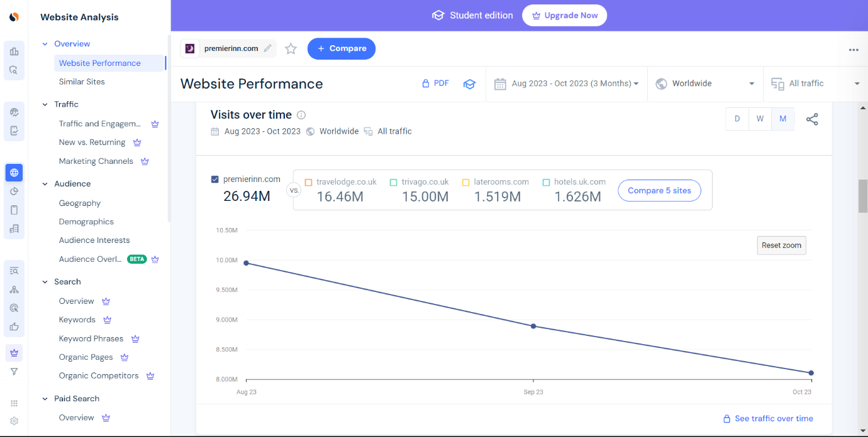

Figure 1: Similar web analysis Premier Inn.
(Source: https://pro.similarweb.com/?_gl=1*zw9zut*_ga*ODkxMzk4OTg0LjE2OTg1NzM5NDk.*_ga_V5DSP51YD0*MTcwMTYyMzMyMy41LjAuMTcwMTYyMzMyMy42MC4wLjA.#/digitalsuite/websiteanalysis/overview/website-performance/*/999/3m?webSource=Total&key=premierinn.com )

S- Segmentation | T- Targeting | P-Positioning
- Demographic Segmentation  - Psychographic Segmentation  - Behavioural Segmentation | - Customers aged between 35 to 55 years, both male and female belonging to the upper and upper-middle section  - Customers who are associated with the business.  - Leisure travellers. | - High quality  - High price

Table 2: STP of Premier Inn

Competitors:

Perceptual Positioning Map
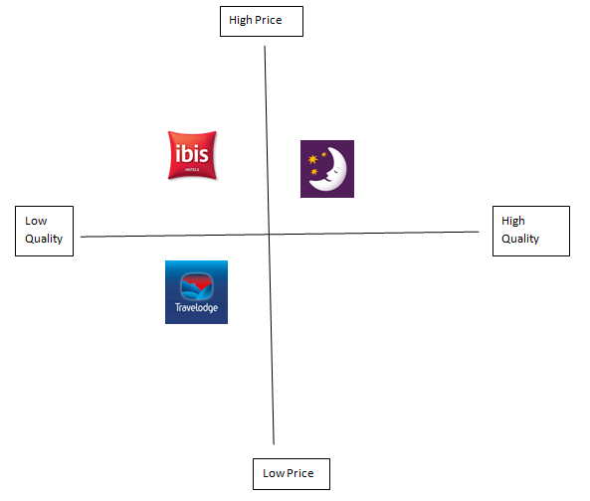
Figure 2: Perceptual Positioning Map of Premier Inn
(Source: Self-developed)
As per the figure, Premier Inn follows high prices and high-quality positioning within the UK. However, its competitors such as Travelodge follow low prices and low quality positioning. Therefore, Premier can face a competitive disadvantage in terms of low-quality rooms for customer attraction.

Bowman’s Strategic Clock
The average room rate of Premier Inn is approximately 71.8 British pounds per night in 2022-2023 (Statista, 2023). In this context, the average room rate of Travelodge was 52.77 British pounds in 2021 (Statista, 2023). Therefore, it can be stated that Premier follows focused differentiation in Bowman’s strategic clock.

Collaboration
Premier Inn has two types of stakeholders they are as follows:

Internal stakeholders of Premier Inn
Owners:
Whitbread is the owner of Premier Inn. It is the UK’s biggest hotel brand which is also growing in other countries. It is the most powerful stakeholder of Premier Inn as it has invested a huge amount of money in it and wants to see it succeed well.
Employees:
Premier Inn employs almost 30,000 people in over 12,00 hotels across the UK. It has a reputation for being employee-friendly and being able to meet high standards across a range of employee conditions (Premier Inn, 2023).
External stakeholders of Premier Inn
Customers/guests:
The most important external stakeholders of Premier Inn are the customers who book their rooms. They would want to be able to find the hotel easily and have easy access to the services offered by it. They would want quality services and good value for their money. They would also want it to offer competitive rates (Trip Advisor, 2023).
Suppliers/partners:
Premier Inn works with many suppliers/partners. These organizations would want to earn a profit from the services they provide to it. They would also want it to pay them on time. They would want it to be financially stable so that they can earn a good rate of return on their investment.

Climate: PESTLE Analysis
Factors | Justification | Impact
Political | Follows constitutional monarchy with parliamentary democracy (Gov. UK, 2023) | Moderate
Economic | Inflation rate- 6.7% in September 2023 (Statista, 2023)
Social | GDP per capita- 45,850.4 U.S. dollars in 2022 (Worldbank.org, 2023)
Technological | Social media penetration - 21% in 2023 (Statista, 2023)
Legal | Consumer Rights Act 2015 for consumer protection (Citizens Advice.org, 2023)
Environmental | Carbon dioxide emission- 339.5 million metric tonnes in 2021 (Statista, 2023)
Table 3: PESTLE Analysis of the UK

Marketing Mix
Strategies | Justification
Product | Different types of rooms for different customers. For instance, its family rooms have a king-size bed for adults, two pull-out or sofa beds for kids, and a travel cot for a baby (Premier Inn, 2023).
Pricing | Premier Inn has a value pricing strategy that aims to provide customers with great value for their money. Similarly, it also pursues a price discrimination strategy with its lowest rates being often for rooms on Friday, Saturday, and Sunday nights (Premier Inn, 2023).
Place | Premier Inn has over 840 hotels across the UK and in countries such as Ireland, the United Arab Emirates, Qatar, and Germany (Whitbread, 2023). It has over 83,500 rooms. Customers can book rooms directly via the hotel’s website and the app. Likewise, they can do so via third parties such as Booking.com, Lastminute.com, and some others.
Promotion | Premier Inn utilizes various channels, including television, print, outdoor, and digital media, to convey its brand message and promote its offerings. Premier Inn has a long history of supporting sports, with sponsorship of various events and teams. These sponsorships have helped it gain exposure to millions of sports fans, enhancing its brand visibility and driving customer engagement (Premier Inn, 2023)
Table 4: Marketing Mix of Premier Inn.

3. Objectives
S- Specific | M- Measurable | A- Attainable | R- Relevant | T- Timebound
To increase the sales of Premier Inn by 15% by the end of 2025 | This can be measured in terms of increased revenue | This can be attained by improving the rate of customer engagement | This is relevant for boosting organisational performance | 2 years
Table 5: SMART Objectives for Premier Inn
Aim
Based on the above SMART Objectives, the present marketing plan aims at boosting the sales of Premier Inn in terms of increasing sales by 15% by 2025 by engaging more customers and achieving more revenue.

4. Strategy
Premier model not only offers a distinct competitive advantage but also facilitates the delivery of a compelling customer proposition. This proposition is designed to resonate strongly with customers, catering to their needs in both the existing and post-pandemic environments. Their strategy involves sustained growth and innovation within the core UK. This will be achieved by harnessing the competitive advantages inherent in the Whitbread operating model. Leveraging the strength of the Premier Inn brand, capitalizing on market-leading direct distribution, and seizing enhanced structural opportunities arising from a significant reduction in UK supply, aiming to further enhance and expand the Premier Inn brand (Whitbread PLC, 2023).
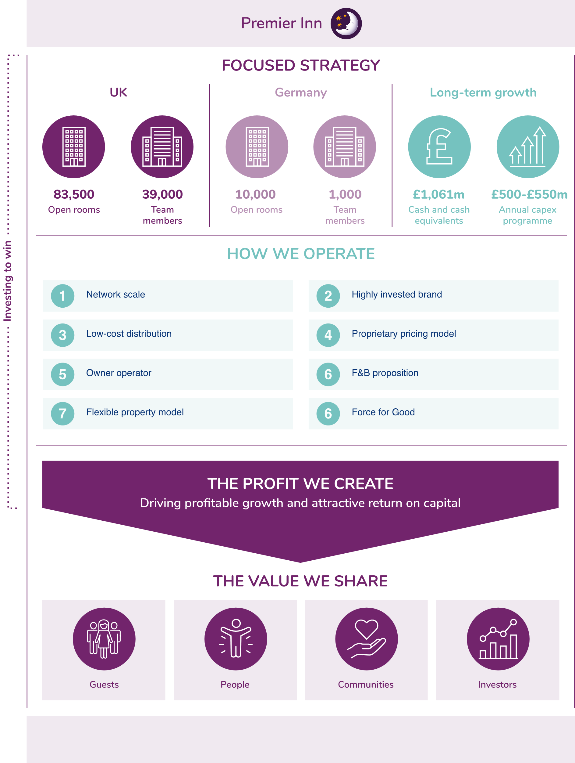

Figure: Premier Inn Strategy.
(Source: Whitbread PLC, 2023)

5. Tactics of Premier Inn.
R: Reach:
Premier Inn's investment in Hotel Ads has yielded significant and quantifiable outcomes. Specifically, Hotel Ads have emerged as a potent instrument for reaching a fresh customer base, showcasing a 40% higher booking ratio compared to paid search ads. The effectiveness of Hotel Ads in fostering direct relationships with customers has directly influenced and improved the company's financial performance, contributing positively to its bottom line (Marketing Strategies, 2015).

A: Act:
Initiating touchpoints begins with digital media platforms like Facebook, Twitter, YouTube, etc., due to their extensive user reach (Naderian and Baharun, 2015). Premier Inn's strategy should prioritize infusing advertisements and brand messages on these channels with elements of passion and care. Furthermore, the focus should remain on creating customer-engaging content that addresses relevant issues. This approach ensures that customers not only notice the content but also develop a positive attitude towards Premier Inn. Establishing a positive attitude serves as the foundation for a favourable customer experience (George Business Review, 2023).

C: Convert:
By fostering additional connections with Travel Management Companies (TMCs) and improving the attractiveness of our Business Account and Business Booker portal, Premier Inn has successfully boosted the influx of business guests. Simultaneously, it has contributed to incremental growth in RevPAR (Revenue Per Available Room) through the implementation of our Business Flex rates (Gill, 2023).

E: Engage:
Premier Inn strategically adopted Google Hotel Ads to enhance convenience for travellers and provide hotels with greater control over their online presence. This initiative aimed to tap into new customer segments and generate high-quality traffic while simultaneously increasing direct bookings through the hotel's official website. Google Hotel Ads are seamlessly integrated into various platforms, including desktops, tablets, and mobile devices, ensuring visibility wherever potential customers are searching for accommodations (Marketing Strategies, 2015).

6. Action
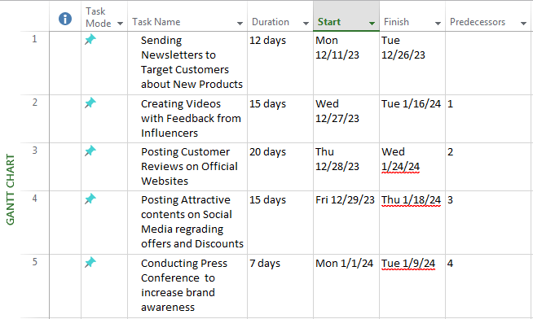
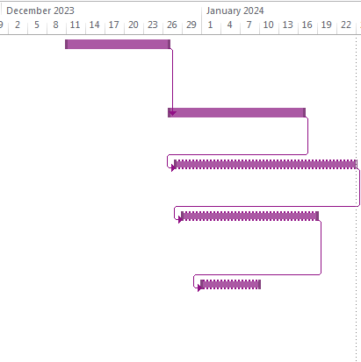
Figure 4: Gantt Chart for Marketing Schedule
Premier can initiate direct marketing through various marketing strategies such as customer feedback and email generation for target customers. This company can also arrange for press conferences to maintain transparency among customers as well as stakeholders to initiate effective communication. Premier Inn can also implement digital marketing strategies such as social media marketing through influencers and video content creation. Moreover, this company can print testimonials of customers on the flyers to implement effective print media strategies within the communication strategy.

7. Control
Premier Inn can measure marketing value by analysing KPIs such as cost per lead (CPL) and cost per acquisition (CPA). As stated by Zhang et al. (2022), cost per lead and cost per acquisition can analyse the importance of having a clearly defined target audience to implement an effective communication strategy. Therefore, measuring CPL and CPA can help Premier Inn to implement its objective of increasing the gross sales ratio by 15% by 2025. It can also help this company to implement an effective communication strategy to mitigate its issue of high pricing which affects customer retention.

8. Conclusion
Based on the above study, it can be concluded that Premier Inn is facing marketing challenges such as ineffective customer retention and high pricing of room services. Therefore, Premier Inn can improve its marketing strategies by implementing vouchers and discounts through digital marketing to mitigate the issue of ineffective customer retention. Moreover, this company can implement effective marketing strategies for communication through direct marketing techniques such as emails and calling action for target customer attraction.

References
- Citizensadvice.org (2023) [Online] The Consumer Rights Act 2015. Available at: https://www.citizensadvice.org.uk/about-us/our-work/citizens-advice-consumer-work/the-consumer-rights-act-2015/#:~:text=The%20Consumer%20Rights%20Act%20came,out%20more%20quickly%20and%20cheaply. (Accessed : 12 November 2023)
- Gov.uk (2023) [Online] How government works. Available at: https://www.gov.uk/government/how-government-works (Accessed: 12 November 2023)
- Gunawan, I., (2022). CUSTOMER LOYALTY: The Effect Customer Satisfaction, Experiential Marketing and Product Quality. KINERJA: Jurnal Manajemen Organisasi dan Industri, 1(1), pp.35-50.
- Premier Inn (2023) [Online] Book a cosy autumn break. Available at: https://www.premierinn.com/gb/en/home.html (Accessed: 12 November 2023).
- Premier Inn (2022) About us, available at: https://www.premierinn.com/gb/en/why.html (Accessed: 26 October 2023)
- Premierinn (2023) [Online] International development. Available at: https://www.premierinn.com/gb/en/business/international-development.html (Accessed:12 November 2023)
- Statista (2023) [Online] Average daily rate (ADR) of Travelodge hotels in the United Kingdom (UK) from 2016 to 2021. Available at: https://www.statista.com/statistics/1118591/travelodge-average-daily-rate-uk/#:~:text=The%20average%20daily%20rate%20 (Accessed: 12 November 2023)
- Statista (2023) [Online] Average room rate of Premier Inn hotels in the United Kingdom (UK) from 2009/10 to 2022/23. Available at: https://www.statista.com/statistics/740692/premier-inn-arr-average-room-rate/ (Accessed: 12 November 2023)
- Premier Inn (2023) About us, available at: https://www.premierinn.com/gb/en/why.html (Accessed: 27 October 2023)
- Whitbread (2023) About us, available at: https://www.whitbreadcareers.com/about-us (Accessed: 27 October 2023).
- Trip Advisor (2023) Premier Inn Kins Lynn Hotel, available at: https://www.tripadvisor.ca/Hotel_Review-g315936-d571022-Reviews-Premier_Inn_Kings_Lynn_hotel-King_s_Lynn_Norfolk_East_Anglia_England.html (Accessed: 27 October 2023)

- Statista (2023) [Online] Carbon dioxide emissions in the United Kingdom (UK) from 1990 to 2021.
- Statista (2023) [Online] Social network user penetration in the United Kingdom (UK) from 2019 to 2028. Available at: https://www.statista.com/statistics/553582/predicted-social-network-user-penetration-rate-in-the-united-kingdom-uk/#:~:text=In%202023%2C%20around%2091%20percent,percent%20on%20the%20previous%20year. (Accessed:12 November 2023).
- Theglobaleconomy (2023) [Online] United Kingdom: Political stability. Available at: https://www.theglobaleconomy.com/United-Kingdom/wb_political_stability/ (Accessed: 12 November 2023).
- Whitbread PLC (2023) Our business model and strategy. Available at: https://www.whitbread.co.uk/about-us/our-business-model/ (Accessed: 12 November 2023)
- Marketing Strategies (2015) Premier Inn captures 40% more bookings from new customers with Google Hotel Ads. Available at: https://www.thinkwithgoogle.com/intl/en-emea/marketing-strategies/search/premier-inn-captures-40-more-bookings-with-google-hotel-ads/#:~:text=into%20the%20future-,Premier%20Inn%20has%20seen%20its%20investment%20in%20Hotel%20Ads%20deliver,higher%20than%20paid%20search%20ads. (Accessed: 1 December 2023).
- George Business Review (2023) Developing Individual Teams and Organizations. Available at: https://www.george-business-review.com/developing-individual-teams-and-organizations/#List_of_references (Accessed: 2 December 2023).
- Gill, R. (2023) Premier Inn profits from focus on business travel. Available at: https://www.businesstravelnewseurope.com/Accommodation/Premier-Inn-profits-from-business-travel-focus (Accessed: 1 December 2023).
- Worldbank.org (2023) [Online] Selected Countries and Economies. Available at: https://data.worldbank.org/indicator/NY.GDP.PCAP.CD?locations=GB (Accessed on 12 November 2023)
- Zhang, E.Y. and Cui, C.Y. (2022). MARKETING YOUR DESTINATION FROM A THOUSAND MILES AWAY. International Case Studies in Tourism Marketing, p.20.

