Engineering management

Project Planning

Engineering Management
Management, Innovation and Sustainability

ACHA5012
ACMA5007

Mark Sandford

Sunday 23rd November 2025
@ 22-00

Oscar Davis (2410215)

Contents Page:
- An Introduction to the project…………………………………………………………………………………3

- List all team member’s roles and responsibilities within the project. Identify the skills and personality traits required for your role, make reference ‘Belbin’s’ model………..4

- A list of overall group tasks and associated timings…………………………………………………..6

- A detailed list of your tasks…………………………………………………………………………………….7

- Identify significant milestones for the whole project……………………………………………..10

- Identify two areas of concern within your section of the project and suggest suitable methods to mitigate the risk………………………………………………………………………………….11

- Generate an overall summary Gantt chart for the whole project and generate a second more detailed plan for the section of the project that you are responsible for. The plan should identify significant milestones………………………………………………………12

- Reference Page………………………………………………………………………………………………………………….15

- An Introduction to the project

The aim of this project is to design an active air rear wing system for a car in order to achieve greater downforce and deceleration ability by increasing drag. Our team will work together to find the best overall solution for the given task with each member having a separate field of topics and tasks to investigate.

- List all team member’s roles and responsibilities within the project. Identify the skills and personality traits required for your role, make reference to ‘Belbin’s’ model.

Names and Roles

Oscar Davis: Aero Simulation

Mikel Olaberria: Research

Callum Francis-Beck: Team leader and CAD designer

Callum Clement: Control systems

Responsibilities

Oscar Davis: It will be my responsibility within the group to produce in-depth simulations for the active aero wing using CAD simulation. I will need to analyse the simulations and give detailed feedback to the team. I have been allocated this role within the team because I have a good understanding of CAD as well as strong communication skills which will be needed to give clear and detailed feedback to my team.

Mikel: To research different designs of wings and select the appropriate profiles for our desired performance outcome. Giving us clear instruction on what things to consider when designing our wing and running simulated tests. He must also take feedback from simulation results to determine what is best to research to improve said results.

Callum Francis-Beck: As Team leader he needs to guide us for the optimal results and ensure that everyone is doing their job adequately so that the team function as one. He must create designs for wings based on given research and test results whilst working around limitations like the range of motion and component sizes.

Callum Clement: To produce code that allows the wing to move with the supplied movement data given and ensure that the model operates as it should. He must have a thorough understanding of how to use the coding software and have the ability to change the input and output functions to give required outcomes.

My Role

For this project it is my role to produce simulated wind tunnel results for the active aero test wing. This will include using a CAD model, designed by another team member, in a CAD wind tunnel simulator in order to give us data on the effectiveness of the rear wing we have designed. This will enable us to get an idea of the wing’s performance, capabilities, and also determine any areas of which we can modify and improve.

I have been allocated this role because of my skillset in this field.

Cad understanding
I have experience using CAD and understand many of the process on the software. This allows me to perform the necessary procedures for the tasks at hand, such as creating the wind tunnel and assembling the components for experiments. Simple problems like parts getting deleted or saved incorrectly as well as strategy changes can occur so it’s vital to be able to change plans and processes without any issues.

Problem solving and Improvisation
I have the ability to diagnose problems and identifying them at the source. This is key when working with CAD as issues tend to crop up that don’t have a step-by-step solution, often requiring improvisation to resolve. Sometimes in order to fix issues with CAD you have to think outside the box, using a trial-and-error type strategy to locate the root cause which may not be obvious. Using these skills allows problems to be short lived and merely a bump in the road in the grand scheme.

Attention to Detail
I pay a great deal of attention to minor details and thoroughly check my work for any faults. This ensures that all tasks I carry out will have great accuracy and will be correct. This also limits margines for error and allows my role to run efficiently with no wasted time, which could impact the rest of the team and their tasks within the project.

These skills guarantee that the data I produce will be accurate for the team’s usage.

In terms of Belbin’s model (2025), at first I saw myself as an action-oriented team member, an ‘Implementer’, this is because I am someone who implements methods and organization.
After completing the Belbin’s team test I have now realised that I am actually more people orientated, a ‘Team Worker’, when it comes to working as a team and want everyone to have a strong and confident understanding in their roles. If people are struggling, such as the team leader, if the group doesn’t step in and help the project will not go to plan.

I have strong people skills and confident when working as a team, however I have difficulty with authority and am very stubborn, for example if someone suggests an idea I don’t agree with I tend to argue against. I must improve upon this by being more open minded in order to improve the groups outcome and avoid conflict.

What are the nine Belbin Team Roles?
https://www.belbin.com/about/belbin-team-roles

- A list of overall group tasks and associated timings

Assign roles:
Our first task was to assign roles to each team member. We did this based on each of our personal choices along side skill and experience in said role.
Duration: 1 day
Algorithm selection:
To proceed with creating a code to run our wing, we then selected which algorithm we were going to be using for the duration of the project. We did this based on which algorithms were easiest to use and would give us the least number of issues to program.
Duration: 1 day
Hardware Selection​:
To have a complete base set up for our model, we then selected the hardware which was achieved based on what was readily available and what was the simplest to program.
Duration: 2 days
Aerodynamic selection and design​:
Different aero wings have different purposes; we chose our wing’s function to be an airbrake as is it has a basic range of motion and requires less difficulty to design.
Duration: 1 week
Prototype design​:
A 3D printed physical model of the designed wing and a base plate with which our hardware components could be attached to.
Duration: 3 days
Vehicle Simulation :
Simulating our wing design on CAD software to give us an understanding of the wings capabilities and how it can be improved upon.
Duration: 1 week
Final specifications:
Refining our design to give us optimal results.​

4) A detailed list of your tasks including

My Tasks

Create the cad simulation set up:
To generate the simulation results I will first need to create a usable simulation on SolidWorks. I will use the Flow Simulation software to generate simulated air flow travelling over the modelled CAD wing which will give us the data of the wing’s performance.
The purpose of this task is to give the team an understanding of the wings characteristics when used and how it can further be improved for performance.
This will include creating a wing tunnel on SolidWorks and assembling it with the wing model, which was designed by another team member. The two components will be assembled so that the wing is in an appropriate position within the tunnel.
I estimate this to take 10 hours.
7/11/25

Run a variety of different simulation tests:
In order to generate accurate figures, I will run a variety of different tests simulating different conditions whilst the wing is in use such as travelling full speed along a straight and hard braking before a corner.
This is to gather all relevant data for the wing to guarantee more precise figures and end results.
This will include running different air flow speeds over the wing as well as changing the angle of the wing to portray a realistic active aero wing’s movements when applied.
I expect this to take 40 hours
8/11/25 – 28/11/25

Examine Results:
To make sense of the tests I will examine the data with the aim of finding trends and looking out for units that seem incorrect or faulty.
This will allow me to identify any areas within the wing or the test simulation that can be improved upon with the purpose of making the wing as optimal as possible.
This will include checking the data for things that seem irregular from other test results and also comparing it to real life figures from similar wing tests.
I estimate this to take 50 hours
29/11/25 – 15/2/26

Make Improvements:
This is where I will use the data found to make improvements to the wing’s performance.
This will include researching potential improvements and trailing different modifications.
I estimate this to take 20 hours

Give clear feedback to team:
Once the data has been examined, it can then be simplified and given to teammates.
This allows the team to gather research and ideas to work out how improve the calculated figures and forces the team to work together and gives us the best chance of refining our project to be as effective as possible.
Giving feedback will include highlighting the areas for discussion such as faulty units and providing the feedback in as simple terms as possible to avoid confusion and keep the target goals clear and understandable.
I estimate this to take 50 hours
31/3/26 – 31/4/26

Bill of Materials

Software Costs:
According to Solid People (2025), I will require the use of SolidWorks for the duration of my project. The standard SolidWorks package costs £1781. This can purchase and set up ready for use within a day.
=£1781
SOLIDWORKS Pricing
https://solidpeople.co.uk/solidworks-pricing/

Hardware:
SolidWorks requires a PC with Windows 10, 32GB+ of RAM and a high-end GPU to run comfortably, Crucial UK (2025). A PC with these capabilities will cost anywhere from £1300, alongside a monitor, keyboard and mouse, this will bring the cost up to around £1450, depending on the quality you wish for. If ordered online, the devices should arrive and be set up ready for use within a week depending on where it was ordered from. On the contrary, if the devices are collected in person they can read for use within a day.
= £1450
Cost ranges for PC builds
https://uk.crucial.com/articles/pc-builders/how-to-build-a-computer#:~:text=Low%2Dend%20build:%20$300%20%2D,SSD%2C%20high%2Dend%20GPU.

Labour Costs:
The average starting salary for engineering graduates starts at £24000 annually, IT Jobs Watch (2025). This is much cheaper than loaning a CAD engineer for a limited time which can cost £35000 per 6 months. Someone can be employed and working within a week. This specific project is estimated to take about 4 months to complete.
= £24000
Computer-Aided Design Engineer (CAD Engineer)
UK
https://www.itjobswatch.co.uk/contracts/uk/cad%20engineer.do#:~:text=The%20median%20Computer%2DAided%20Design,with%20the%20previous%20two%20years.

5) Identify significant milestones for the whole project.

Group Milestones:
- Create a working code which is capable of connecting to our hardware and controlling our model in desired ways.
- Design and produce a working prototype model, complete with a base plate which can hold our hardware equipment (Servomotor and Arduino) and the wing itself with a full range of motion and specific attachments to the Servomotor.
- Program the code with supplied driving data which can be used to run the aero wing in specific movements at specified times.
- Simulate the wing using CAD software and improve the profiles and dimensions of the wing based on the test results from the simulation and relevant research.
- Refine the design of the wing and have a complete finished moving model which is able to move directly as is programmed with no error or inconsistency.

Gate way:
Creating a Working CAD Flow Simulation set up before Testing the Wing for Accurate Results.
Objectives | Description | Numerical Target | Pass Criteria | Outcome
No Errors: | Error Lines or Warning around the simulation | 100% | 100% | Pass
Consistent Data: | Repeated test data to be consistent | 100% | 100% | Pass
Correct Area Dimensions: | For the Wind Tunnel width to be a required amount larger than wing | 3x Length of Wing = 180mm | + / -' 10mm | Pass
Correct Length Dimensions: | Wind Tunnel to be 3x longer than the width | 3x Width of Tunnel = 540mm | + / -' 30mm | Pass
Software Compatibility: | Software must be combatable with the simulation and be able to run correctly | 100% | Run 10 test with 100% compatibility | Pass

Seeing as each outcome has passed. I can proceed to test the wing in the simulation.

- Identify two areas of concern within your section of the project and suggest suitable methods to mitigate the risk.

The Accuracy of Operator:

Accuracies such as typing in Figueres incorrectly and simulating the model incorrectly leaving inaccurate results for the project are easy to look over and will be checked multiple times to ensure accuracy. Not taking things into consideration such as frictional drag just be taken into consideration when taking results and should be compared to other relevant sources of information.

The Accuracy of the Simulation Results Compared to Physical Tests:
There will be differences between the simulated and physical model of the wing. Although the simulated model of the wing will be flawless in every dimension, giving optimal accuracy, the physical model will have slight imperfections from the manufacturing and handling of the model. Thus, giving slightly inaccurate results than the ones derived from the simulated tests. To overcome this, I will refer the found results to real results as well as research into multiple different sources from similar sources tests.

- Generate an overall summary Gantt chart for the whole project and generate a second more detailed plan for the section of the project that you are responsible for. The plan should identify significant milestones and gateways.
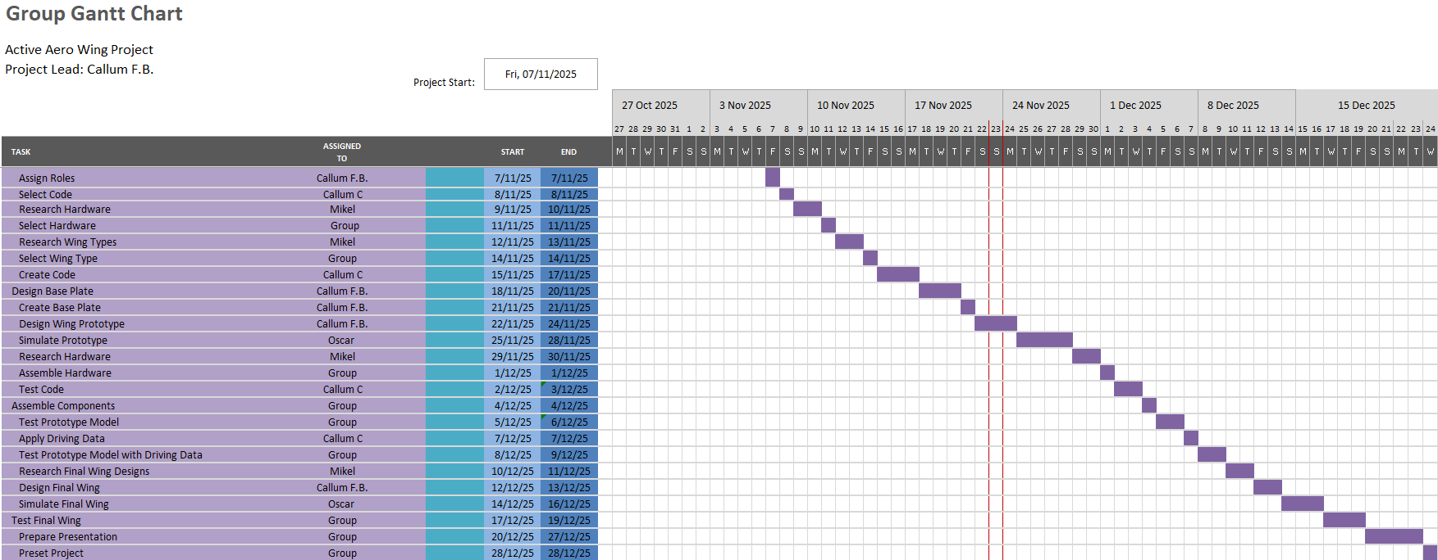
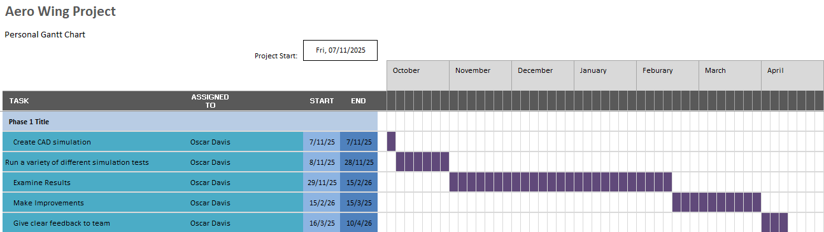
Significant Milestones for my Tasks within the Group:

The first milestone within my role is to create a working CAD flow simulation. This includes a wing model and wind tunnel model assembly which is able to run a large range of different airflow tests. The set up of the simulation should take no more than 3 hours. The intention of the setup is to create a reliable resource that can be depended on throughout the project.
The next milestone is to run a variety of different airflows over the wing in number of different wing positions to imitate the real movements during use. The testing period will need to be accurate and so will take between a week – 2 weeks to complete. The test results will determine the overall outcome of the project as it shows what must change to improve our design.
The last milestone is to highlight the key values of data which I believe can be improved upon. This is very important as must to share with the rest of the team and if not done correctly, it could jeopardise the project. This should take between 1 and 2 days.

Gateways:

Verifying Data before using it
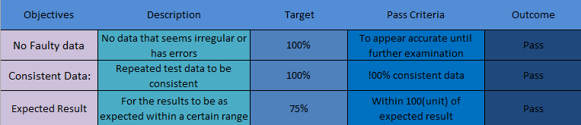

Not Sharing data with Team before Examination

Edit if needed

Complete task

Check Over

If Yes
If Yes
If No

Does it pass criteria
Pass

Edit

- Reference Page

Bill of materials

Software Costs
Solid People, 2025. SOLIDWORKS Pricing. [online] Available at: https://solidpeople.co.uk/solidworks-pricing/ [Accessed 23 November 2025].

Hardware Costs
Crucial UK, 2025. How to Build a Computer: Cost Ranges for PC Builds. [online] Available at: https://uk.crucial.com/articles/pc-builders/how-to-build-a-computer#:~:text=Low%2Dend%20build:%20$300%20%2D,SSD%2C%20high%2Dend%20GPU [Accessed 23 November 2025].

Labour Costs
IT Jobs Watch, 2025. Computer-Aided Design Engineer (CAD Engineer) UK. [online] Available at: https://www.itjobswatch.co.uk/contracts/uk/cad%20engineer.do#:~:text=The%20median%20Computer%2DAided%20Design,with%20the%20previous%20two%20years [Accessed 23 November 2025].

My Role:
Belbin, R.M., 2025. About Belbin Team Roles. [online] Available at: https://www.belbin.com/about/belbin-team-roles [Accessed 23 November 2025].

