Complementary Therapies

Assignment 1- Supporting paper

Student name: Catiana Braganca
Student ID:1922202

Module name: Complementary Therapies
Module code: BMHP5001
Lecturer Name: Mentesnot Mengesha

Table of Contents:

- Introduction
- Herbal Medicine-History
- Most common Uses
- Efficacy and Effectiveness
- Contraindications
- Conclusion
- References

- INTRODUCTION:

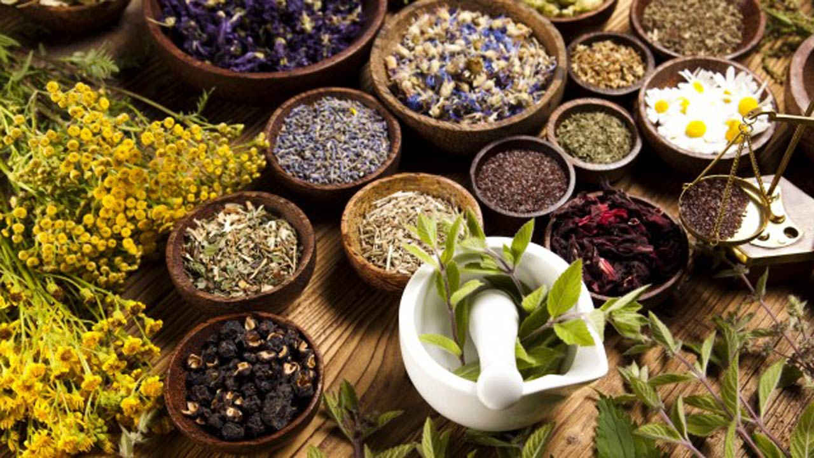
(Paul Joseph Nanna,2018)
In this report I will be explaining the concept of herbal medicines, I will also describe how it is used, the efficacy and effectiveness for people that suffer from illness that normally can´t be heal only by conventional medicine it has to be alongside traditional medicine but always with a consent of a doctor or specialist.
In the development of this report, I will extract information from different research and literature review to evidence what I am writing.
To conclude I will explain what I learned about herbal medicines and how can be helpful and important for people.
Herbal medicine also called phytotherapy is the science of using remedies from herbs to cure the illness. As a result, some medicinal plants can cause powerful actions, (Digitalis and Belladonna) to the others that has very gentle action as for example chamomile tea, mint tea.
It doesn´t mean that the Chamomile and mint tea are insufficient but these plants can´t make powerful effects like the ones that we see at the moment after an injection of digitalis or strophanthin. ( A Meuss Current science,2000)

- Herbal medicine - History

The history of herbal medicine was discovered over 5,000 years ago, it was created the first written record of medicinal plants on clay tablets by the Sumerians.
In 1500 BC the Ancient Egyptians wrote the Ebers Papyrus, although it wasn´t the first written document, but continues to be used today different types of herbs with various ingredients and guidelines, for example cumin, coriander, garlic, willow, and others. Another oral herbal tradition made from India that they have written a record of is called Ayurveda, it has 5,000 years old, then it comes many other essentials ayurvedic texts that were written down around 400 BCE. (Herbal Academy,2009).
In Home Africa and different Africa countries used from many years ago different types of herbs for treatment of various diseases, has been said that herbal medicine has been expanding in popularity. Except in Nigeria that the issue of herbal medicine was not well recognized as a consequence all the practitioners around this country have died without registered the herbal of medicines for descendants. (GuardianNewspaper,2021)

- Most common uses for herbal medicine:
Has been evidenced by research that herbal medicines are used in different countries that are related on tradition of use, one example is Australia. They said that in German seventy percent of people have used natural medicines for herbal preparations being the most used type. (Journal of Ethnopharmacology, (2017) volume 207, 31 July, pp 220-225)
Herbal medicine is used as a traditional medicine and alternative therapy aims to return the body to a state of natural balance so that it can heal itself. However, the results of the herbs act different in the parts of the body.
Some of the types of herbs that are frequently used in herbal medicine and the traditional uses are:
- Garlic helps to reduce the risk of heart disease, also is used to fight cold and sinusitis.
- Ginger has been shown by various studies to be beneficial in treating nausea, motion sickness and morning sickness.
- Ginkgo biloba is used to treat poor blood circulation and tinnitus (Department of Health, State Government of Victoria, 2021)
Common Medicinal Herbs:
- Chamomile is commonly used in the U.S as a tea for anxiety and relaxation, in the Europe they used it for wound healing and to reduce inflammation or swelling. There are less studies that have looked at how well it works for any condition,
- Chamomile for the skin can be used for skin irritation from radiation cancer treatments.
- Echinacea is used to treat or prevent colds, flu, infections, and wound healing. It has demonstrated by studies that Echinacea shows some benefits for upper respiratory infections.
- Feverfew was naturally used to treat fever but now it is frequently used to prevent migraines and treat arthritis
- Saint John´s wort is used as an antidepressant. It has been shown by studies that this herbal medicine has a small effect during the period above of 12 weeks. (University of Rochester Medical Center, 2021)
- Valerian is other herbal medicine used to reduce anxiety and treat people that has sleep less, Research recommends valerian as being helpful sleep aid, but the proof is not compatible to affirm it. Valerian is used as a flavouring in the U.S for root beer and other foods. (University of Rochester Medical Center, 2021)

Why people use herbal medicine?
People use herbal medicine as a complementary and alternative medicine to treat illness. A study conducted from Germany extracts qualitative analysis and results from young, middle aged and elderly participants about the preference of herbal medicine, type of illness. As a result, preventing illness and promote health were less discussed between all participants it was more important for elderly people, they discussed that herbal medicine were involved with mild or moderate diseases also used to start a treatment before applying conventional medicine. The elderly people were dissatisfied with the conventional treatment because they had positive aspects and good experiences with herbal medicine, also family traditions were the frequent mention reason for them to choose herbal medicine as a treatment.

- Efficacy and Effectiveness of herbal Medicines
In the group presentation my main topic was about efficacy of herbal medicine to understand what the efficacy and effectiveness of herbal medicine is first you have to understand what is the difference between efficacy and effectiveness?
“Efficacy is the capacity for producing a desired result or effect” (Dictionary,2021)
“Effectiveness is the quality of being successful in achieving what is wanted” (Cambridge University Press,2021)
The Herbal Medicine is the most used in the Chinese herbal Medicine to treat different types of illness the one I will be focus in is the Breast Cancer, has been evidenced by studies that the effectiveness of Chinese herbal medicine on breast cancer patient is beneficial on clinics regarding tumor response and survival ( Venice Wing-Thung Ho et al.2021)
According to the recent article research it has been shown that herbal medicine do have risks but also might bring benefits. Herbal Medicine is used for minor and self-limiting indication, for example respiratory tract infections, however they only can be accepted as beneficial for people that demonstrate conditions if they can be shown to do more good than harm including appropriate cost. ( BMJ, 2003)

- Contraindication

Contraindication is a sign that someone should not continue with a particular medicine or treatment because it is or might be harmful to the person ( Cambridge University Press,2021) Has been said by scientists that Herbal remedies such as St John´s wort, ginseng and ginkgo biloba when combined with conventional drugs can be harmful. There are examples of patients that had suffered severe problems after taking herbal medicines alongside drugs in addition to antidepressants and medication for HIV, epilepsy, heart disease. Awortwe said that “If you are taking herbal remedies you should disclose it to your clinician,” . “A potential interaction and its consequences can be very detrimental to the health of the patient.” (Mixing herbal remedies and conventional drugs could be harmful,2018)
Herbs should only be used, when necessary, because of the different effects, the same herb that you can use before sleep cannot be used in the morning. It is advisable before taking any herbal remedies to consult with a qualified herbalist if you are taking any prescribed medication. (NaturalHealthNews,2011)
There is contraindication that might occur in the pregnancy and breastfeeding while using herbal medicines that´s why is important to ask for advice in a professional can be in a GP, herbalist, or homeopath. (Woodland Herbs, n.d)
Research shows that herbal medicines can have dangerous side effects which are Kidney or live damage and are sometimes contaminated with steroids, pesticides, antibiotics, or harmful metals. According to what the study found, the reason of the herbal medicine cause kidney and liver damage is they include toxic chemicals, heavy metals or react harmfully with other drugs. (Guardian News and Media,2021)

- Conclusion:
In this assignment I could conclude that Herbal medicines might give benefits but at the same time can harm the person, it depends on the type of herb that you use some are more potential than others, when herbal medicines are combined with alongside prescribed medication it can cause severe problems and bad reactions in the body. It is always good to talk with an herbal specialist or doctor if it is possible for you to take herbal medicines if you are taking already a medication. Although people think that herbal medicine is safe because it is natural is not true because it can be dangerous when using in a wrong way.
I could understand with this topic that there are different types of herbs that are used for many illnesses it can be on the body or in the mind. In my opinion herbal Medicine is an important and interesting topic there are many things that I didn´t knew before that I learned now by investigating different articles, websites and journals.

- References:

- A Meuss current science(2000) “ Herbal Medicine” (78) pp 35-39 Available at: RFWeiss.pdf (cnhnetwork.com) Accessed: (09/12/2021)
- BMJ(2003) “Herbal Medicine put into context” [online] October 18, 327(7420) pp.881-882 Available at: Herbal medicines put into context (nih.gov) Accessed: ( 09/ 12/ 2021)
- Cambridge University Press (2021) “Effectiveness” Available at: EFFECTIVENESS | meaning in the Cambridge English Dictionary Accessed: ( 10/12/2021)
- Department of Health, State Government of Victoria(2021) “Medicinal uses for specific herbs” [online] Available at: Herbal medicine - Better Health Channel Accessed: 10/12/2021
- Dictionary (2021) “Efficacy” Available at: Efficacy Definition & Meaning | Dictionary.com Accessed: ( 11/12/2021)
- Herbal Academy(2009) “The first written records of herbalism” Available at: Herbal History (theherbalacademy.com) Accessed : (11/12/2021)
- Journal of Ethnopharmacology, (2017) “Herbal Medicinal products-Evidence and Tradition from a historical perspective” (207) pp 220-225 Available at: Herbal medicinal products – Evidence and tradition from a historical perspective - ScienceDirect Accessed: (12/12/2021)
- Paul Joseph Nanna, (2018) “History and Benefits of herbal medicine” Available at: History and benefits of herbal medicine | The Guardian Nigeria News - Nigeria and World News — Features — The Guardian Nigeria News – Nigeria and World News Accessed:(13/13/2021)
- The Guardian(2021) “Mixing herbal remedies and conventional drugs ´could be harmful´ Available at: Mixing herbal remedies and conventional drugs 'could be harmful' | Medical research | The Guardian Accessed: ( 14/12/2021)
- The Guardian(2021) “Herbal medicines can have dangerous side effects, research reveals” Available at: Herbal medicines can have dangerous side effects, research reveals | Health | The Guardian Accessed: (14/12/2021)
- University of Rochester Medical Center(2021) “A Guide to Common Medicinal Herbs” Available at: A Guide to Common Medicinal Herbs - Health Encyclopedia - University of Rochester Medical Center Accessed: (14/12/2021)

- Venice Wing-Thung Ho et al.(2021)” Efficacy and Safety of Chinese Herbal Medicine on Treatment of Breast Cancer: A Meta-analysis of Randomized Controlled Trials” Available at: Efficacy and Safety of Chinese Herbal Medicine on Treatment of Breast Cancer: A Meta-analysis of Randomized Controlled Trials - PubMed (nih.gov) Accessed: (15/12/2021)
- Woodland Herbs (n.d) “Cautious & Contraindications” Available at: Cautions & Contraindications | Woodland Herbs Blog Accessed: (15/12/2021)

