Lab – Understanding Ethernet Cable Standards
Topology
Addressing Table
Device | Interface | IP Address | Subnet Mask | Default Gateway
PC-A | NIC | 192.168.10.1 | 255.255.255.0 | N/A
PC-B | NIC | 192.168.10.2 | 255.255.255.0 | N/A
Objectives
Part 1: Analyze Ethernet Cabling Standards and Pinouts
Part 2: Build an Ethernet Crossover Cable
Part 3: Test an Ethernet Crossover Cable
Background / Scenario
In this lab, you will build and terminate an Ethernet crossover cable and test it by connecting two PCs together and pinging between them. You will first analyze the Telecommunications Industry Association/Electronic Industries Association (TIA/EIA) 568-A and 568-B standards and how they apply to Ethernet cables. You will then construct an Ethernet crossover cable and test it. Finally, you will use the cable you just constructed to connect two PCs together and test it by pinging between them.
Note: With autosensing capabilities available on many devices, such as the Cisco 1941 Integrated Services Router (ISR) switch, you may see straight-through cables connecting like devices.
Required Resources
- One length of cable, either Category 5 or 5e. Cable length should be 0.6 to 0.9m (2 to 3 ft.)
- 2 RJ-45 connectors
- RJ-45 crimping tool
- Wire cutter
- Wire stripper
- Ethernet cable tester (optional)
- 2 PCs (Windows 7 or 8)
- Analyze Ethernet Cabling Standards and Pinouts
The TIA/EIA has specified unshielded twisted pair (UTP) cabling standards for use in LAN cabling environments. TIA/EIA 568-A and 568-B stipulates the commercial cabling standards for LAN installations; these are the standards most commonly used in LAN cabling for organizations and they determine which color wire is used on each pin.
With a crossover cable, the second and third pairs on the RJ-45 connector at one end of the cable are reversed at the other end, which reverses the send and receive pairs. The cable pinouts are the 568-A standard on one end and the 568-B standard on the other end. Crossover cables are normally used to connect hubs to hubs or switches to switches, but they can also be used to directly connect two hosts to create a simple network.
Reflection:
Write a research report (Max word count 600) on Cat 5e and 6 Ethernet cable standards.
  - Analyze diagrams and tables for the TIA/EIA 568-A standard Ethernet cable.
The following table and diagrams display the color scheme and pinouts, as well as the function of the four pairs of wires used for the 568-A standard.
Note: In LAN installations using 100Base-T (100 Mb/s), only two pairs out of the four are used.
568-A 10/100/1000Base-TX Ethernet
Pin Number | Pair Number | Wire Color | 10Base-T Signal  100Base-TX Signal | 1000Base-T Signal
1 | 2 | White/Green | Transmit | BI_DA+
2 | 2 | Green | Transmit | BI_DA-
3 | 3 | White/Orange | Receive | BI_DB+
4 | 1 | Blue | Not Used | BI_DC+
5 | 1 | White/Blue | Not Used | BI_DC-
6 | 3 | Orange | Receive | BI_DB-
7 | 4 | White/Brown | Not Used | BI_DD+
8 | 4 | Brown | Not Used | BI_DD-

The following diagrams display how the wire color and pinouts align with an RJ-45 jack for the 568-A standard.
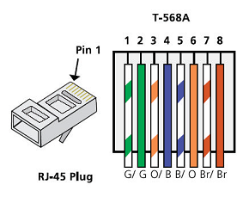
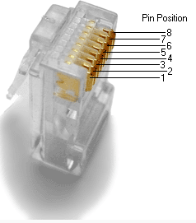
  - Analyze diagrams and tables for the TIA/EIA 568-B standard Ethernet cable.
The following table and diagram display the color scheme and pinouts for the 568-B standard.
568-B 10/100/1000-BaseTX Ethernet
Pin Number | Pair Number | Wire Color | 10Base-T Signal  100Base-TX Signal | 1000Base-T Signal
1 | 2 | White/Orange | Transmit | BI_DA+
2 | 2 | Orange | Transmit | BI_DA-
3 | 3 | White/Green | Receive | BI_DB+
4 | 1 | Blue | Not Used | BI_DC+
5 | 1 | White/Blue | Not Used | BI_DC-
6 | 3 | Green | Receive | BI_DB-
7 | 4 | White/Brown | Not Used | BI_DD+
8 | 4 | Brown | Not Used | BI_DD-
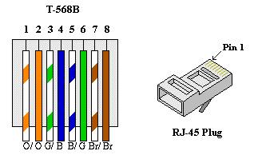

- Build an Ethernet Crossover Cable
A crossover cable has the second and third pairs on the RJ-45 connector at one end, reversed at the other end (refer to the table in Part 1, Step 2). The cable pinouts are the 568-A standard on one end and the 568-B standard on the other end. The two following diagrams illustrate this concept.
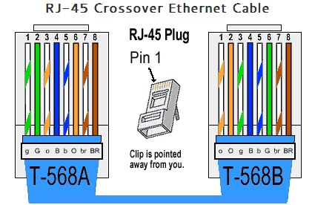
  - Build and terminate a TIA/EIA 568-A cable end.
    - Determine the cable length required. (Your instructor will let you know the cable length you should make.)
Note: If you were making a cable in a production environment, the general guideline is to add another 12 in. (30.48 cm) to the length.
    - Cut off a piece of cable to the desired length and using your wire stripper, remove 5.08 cm (2 in.) of the cable jacket from both ends.
    - Hold the four pairs of twisted cables tightly where the jacket was cut away. Reorganize the cable pairs into the order of the 568-A wiring standard. Refer to the diagrams, if necessary. Take as much care as possible to maintain the twists in the cable; this provides noise cancellation.
    - Flatten, straighten, and line up the wires using your thumb and forefinger.
    - Ensure that the cable wires are still in the correct order for the 568-A standard. Using your wire cutters, trim the four pairs in a straight line to within 1.25 to 1.9 cm (1/2 to 3/4 in.).
    - Place an RJ-45 connector on the end of your cable, with the prong on the underside pointing downward. Firmly insert the wires into the RJ-45 connector. All wires should be seen at the end of the connector in their proper positions. If the wires are not extending to the end of the connector, take the cable out, rearrange the wires as necessary, and reinsert the wires back into the RJ-45 connector.
    - If everything is correct, insert the RJ-45 connector with cable into the crimper. Crimp down hard enough to force the contacts on the RJ-45 connector through the insulation on the wires, thus completing the conducting path. See the following diagram for an example.
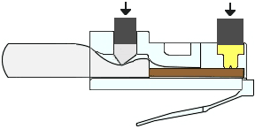
  - Build and terminate a TIA/EIA 568-B cable end.
Repeat steps 1a to 1g using the 568-B color wiring scheme for the other end.
- Test an Ethernet Crossover Cable
  - Test the cable.
Many cable testers will test for length and mapping of wires. If the cable tester has a wire map feature, it verifies which pins on one end of the cable are connected to which pins on the other end.
If your instructor has a cable tester, test the crossover cable for functionality. If it fails, check with your instructor first as to whether you should re-cable the ends and re-test.
  - Connect two PCs together via NICs using your Ethernet crossover cable.
    - Working with a lab partner, set your PC to one of the IP addresses shown in the Addressing Table (see page 1). For example, if your PC is PC-A, your IP address should be set to 192.168.10.1 with a 24-bit subnet mask. You partner’s IP address should be 192.168.10.2. The default gateway address can be left empty.
    - Using the crossover cable, you made, connect the two PCs together via their NICs.
    - On the PC-A command prompt, ping the PC-B IP address.
Note: The Windows firewall may have to be temporarily disabled for pings to be successful. If the firewall is disabled, make sure you re-enable it at the conclusion of this lab.
    - Repeat the process and ping from PC-B to PC-A.
Assuming IP addressing and firewall are not issuing, your pings should be successful if the cables were properly made.
Reflection
  - Which part of making cables did you find the most difficult?
I enjoyed the hands-on work but due to my old failing eyes I found if difficult to see the colors lined up in the right order to fit in, so my cable did not work.
  - Why do you have to learn how to make a cable if you can easily buy pre-made cables?
Its good practice to learn how to make cables incase you need one that is very long as pre-made ones have a limit on the distance, 90 meters is the max length and 5 meters is the shortest, and you may need to custom a cable.
Research report on Cat 5e and 6 Ethernet cable standards
A Small Report on CAT cables
Introduction
An introduction on the differences of CAT5 to CAT6a cables and some of the features between them.

CAT5 (Category 5)
CAT5 (Category 5) cables are multi-pair (normally 4 pair) which is a high performance cable that has a pair of twisted conductors, mainly used for data transmissions, a basic CAT5 cable is designed for 100 MHz, this cable is normally used for Ethernet networks anywhere from 10 to 100 Mbps The CAT5 is no longer recognised by the TIA/EIA, the CAT5 is still widely used for 100Base-T and 1000Base-T networks, it became the standard for Ethernet cabling. [1]

CAT5e (Category 5e)
CAT5e (Category 5e) cables known as Enhanced CAT5(Category 5) is to support full duplex, very fast operations and Gigabit Ethernet, the CAT5e cable is designed for 100MHz up to 350 MHz The difference between both CAT5 and CAT5e is the specification, one has a Cat 5e can support network operating speeds of 10 Mbps, 100 Mbps or 1000 Mbps. Cat5e cable When used for voice and data applications, Category 5e has a cable length limitation of 100 meters. [1]

CAT6 (Category 6)
CAT6 (Category 6) cable gives a much higher performance than any of the other CAT cable, it also features a stringent and crosstalk specifications, the CAT6 cable is designed for 250MHz and up to 550MHz. Cat 6 cables are more tightly wound than either Cat 5 or Cat 5e and they often have an outer foil or braided shielding. The shielding protects the twisted pairs of wires inside the Ethernet cable
The data transmission and performance of the components such as jacks, cables and patch panels must meet all CAT6 standard for transmissions to work. While all CAT6 parts must be backward compatible with CAT3, CAT5 and CAT5e. [1]

CAT6a (Category 6a)
CAT6a (Category 6a Augmented ) is a 10 Gigabit Ethernet can send large amounts of data at a very high speed up to 500 MHz up to 550MHz, the CAT6a is twice as fast as the CAT6 both have twisted copper cables in pairs and the CAT6a is also thicker than other CAT Cables which means the cable is harder to bend which can cause problems. The CAT6a must also be backwards compatible with CAT3, CAT5 and CAT5e. [1]

CATEGORY | STANDARD BANWITH | MAX DATA RATE | SHIELDING
CAT5e | 100MHz UP TO (350) | 1000Mbbps | UTP OR STP
CAT6 | 250MHz UP TO (550) | 1000Mbbps | UTP OR STP
CAT6a | 500MHZ UP TO (550) | 10Gbps | UTP OR STP
Figure 1: [2]

Conclusion
The CAT 6a is the best for data transfer, stronger and better shielded but comes at a cost flexibility and expense, where as the CAT5e is cheaper and can do a good job and can carry a good work load at a fair pace.

References

[1] | Q. D. T. D. Company, " Telecommunications Cabling Standard," [Online]. Available: https://www.csd.uoc.gr/~hy435/material/Cabling%20Standard%20-%20ANSI-TIA-EIA%20568%20B%20-%20Commercial%20Building%20Telecommunications%20Cabling%20Standard.pdf.
[2] | c. industries, "cablek industries," 2019. [Online]. Available: http://www.cablek.com/technical-reference/cat-5---5e--6--6a---7--8-standards. [Accessed 9 December 2019].

