

Evaluating Netflix’s Strategic Position and Competitive Advantage in the UK Streaming Market

Programme: Master of Business Administration
Module: Strategic Management
Module Code: LCMB7003

Lecturer Name: Balendran Kandasamy

Student Name: Mehedi Kobir
Student ID: 2521541

Word Count: 5202
Submission Date: 12th August 2026

AI Acknowledgement
Module: LCMB7003 Strategic Management
I confirm that I have not used any AI tools in preparing this report. This is an individual assignment consisting of research, analysis and writing. All sources used have been cited and referenced appropriately and I am responsible for the originality, accuracy and integrity of this work.
Name: Mehedi Kobir
Student ID: 2521541
Date: 12/08/2026

Executive Summary
This report critically examines Netflix’s position in the UK streaming market and makes recommendations to contribute to building a sustainable competitive advantage. Four aspects, namely the strength of the brand, the global scale, unique product offerings and their personalization and reach of extensive customer base, are identified as strategic resources for Netflix. But market saturation, price sensitivity, regulatory changes and the increased competition from Amazon Prime Video, Disney+, and YouTube, among others, add to these strategic challenges. PESTEL, VRIO and SWOT analysis shows that there is a growing need for differentiation, engagement and monetisation of services instead of a growth in subscribers going forward. Thus, stronger differentiation by using unique UK content, improved personalisation and a well-controlled advertising-supported model are recommended. The Balanced Scorecard and McKinsey 7S help to align performance and implementation, and the SAFe evaluation helps to identify the suitability, acceptability and feasibility of this direction. A Gibbs reflective account analyses the learning experience, first assumptions, difficulties faced, understanding strategic frameworks and the use of evidence to inform strategic decision making and suggests ways in which learning from the analysis could be enhanced in future practice.

Table of Contents
1. Introduction 1
2. Organisational Context and Overview 1
3. External and Internal Analysis 2
3.1 External Environment: PESTEL Analysis 3
3.2 Internal Environment: VRIO Analysis 6
3.3 SWOT Analysis and Strategic Synthesis 8
4. Comprehensive and Holistic View 9
4.1 Critical Evaluation of Netflix’s CSR Strategy 9
4.2 Balanced Scorecard 11
5. Strategic Choices and Implementation 12
6. Reflective Account — Gibbs Reflective Cycle 16
7. Conclusion 19
8. References 20

1. Introduction
The report thoroughly analyses Netflix's competitive landscape in the streaming sector in the UK and outlines strategies for further gaining a competitive edge. Netflix is a good case organisation as it has been in existence for over 25 years, offering a rich historical background and extensive corporate, industry and market data on which to rigorously analyse strategies (Sarandos, 2023). The UK market is chosen as the geographical focus as it is one of the leading markets in the world for Netflix, and is a mature and highly competitive streaming market with good availability of reliable market evidence. However, Netflix's penetration of UK households has remained fairly consistent, at around 59%, and differentiation, engagement and monetisation are now growing in significance (Ofcom, 2025). The report looks at Netflix's value proposition, PESTEL, VRIO and SWOT findings, followed by strategic choices, implementation priorities, and finishing with a Gibbs reflective account, which outlines the analytical process.

2. Organisational Context and Overview
Netflix started as a DVD-by-mail company and in 2023, after 25 years, it shuttered its DVD division as it focused on digital entertainment (Sarandos, 2023). While it's still making moves in subscription streaming and original films and series, it's also making strides in ads-supported plans, games and live programming, painting a picture of a more comprehensive entertainment platform (Netflix, 2025). The focus of this report is on Netflix in the UK streaming market, which can be compared to other companies in one well-established and important geographical market. Netflix's corporate mission is to “entertain the world”, and their strategic goal is to be the first place that members turn to for entertainment, with engagement, content quality, product innovation and customer satisfaction being key components of retention and their ability to create value over the long term (Sarandos and Peters, 2024; Netflix, 2025). It has a subscription-based business model that includes a cheaper advertising-supported option, a content acquisition, original production, digital distribution, and personalised discovery. This offers value proposition of choice, convenience, exclusive content, personalisation and flexible access and global distribution enables locally produced content to create value for markets outside of their borders (Netflix, 2025). But the competition in the UK is fierce and not just within the Amazon Prime Video and Disney+ ecosystem, it reaches the BBC iPlayer, ITVX, NOW/Sky, Apple TV+, Paramount+ and YouTube. Despite this fragmentation, Netflix still retained the lead position in the UK in 2025, with 17.4 million households (59%), ahead of Amazon Prime Video (46%) and Disney+ (25%) and it accounted for almost half of all UK SVoD viewing back in 2024 (Ofcom 2025). Netflix is thus coming into the analysis with the leadership position and, as its UK SVoD penetration has stalled, their future appears to be dependent on differentiation, engagement and monetisation more than just growing a subscriber base.
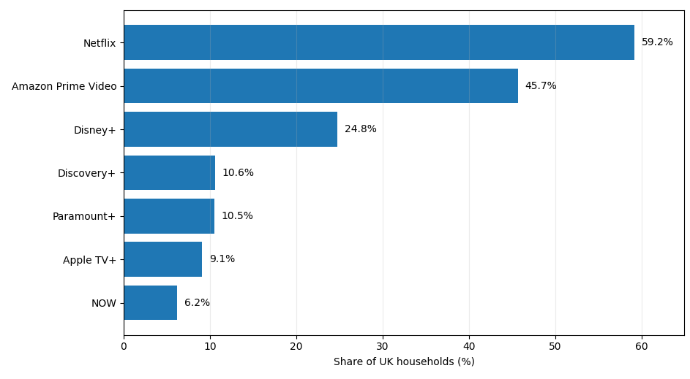
Figure 1: UK Household Access to Major SVoD Services, Q1 2025
Source: Barb (2025)

3. External and Internal Analysis
Netflix UK's competitive position is contingent on the relationship between macro-environmental change and valuable organisational resources. Therefore, PESTEL is used to uncover threats and opportunities that could impact Netflix UK and VRIO is used to analyse the strengths and weaknesses that will help or hinder Netflix UK in its ability to respond. SWOT then combines these on the basis of the strategic implications that are of greatest importance.

3.1 External Environment: PESTEL Analysis
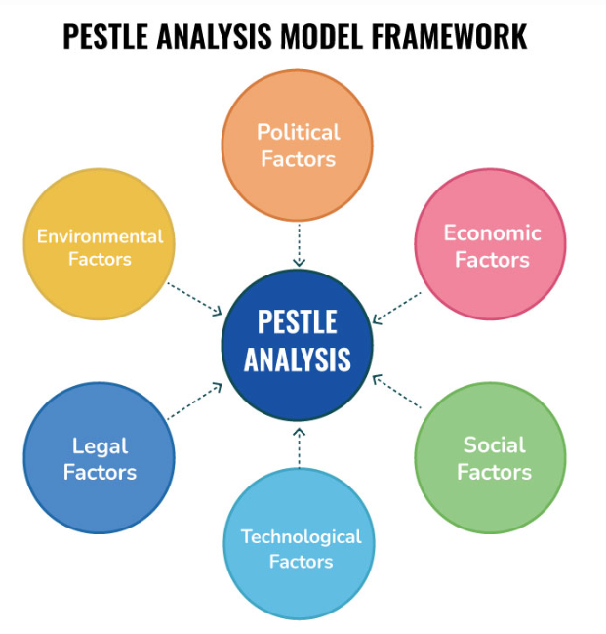
Figure 2: PESTEL Analysis (Speaking Nerd, 2021)
Political
The UK is a relatively favourable political climate for investment in the screen sector. The Creative Industries Sector Plan has allocated £380m towards innovation, skills and regional growth and will seek to increase the annual value of creative-industry business investment from around £17bn to £31bn by 2035 (Department for Culture, Media and Sport, 2025). The value of films produced in the UK and high end television programmes in 2024 was also £5.6 billion, 31% higher than in 2023 (BFI, 2025). This leads to access to talent and infrastructure as Netflix spends a lot of money on production in the UK. But the competitors get benefits as well and it is a big opportunity and not a unique one.
Economic
Strategic difficulties are greater due to economic pressure. The CPI rate of inflation for the UK rose by 4.1% in the year to September 2025, which could lead to more focus on discretionary entertainment spending (ONS, 2025). Among those that used Netflix in the past, 24% felt that they did not use it enough to justify the cost, 23% felt the price had increased and 22% felt that it is too expensive (Ofcom, 2025). However, Netflix's cheaper ad package is part of the solution. There were 17.6 million UK households with Netflix in Q3 2025 and 35% of these households used Netflix's advertising tier (BARB, 2025). So, there is a substantial pressure on affordability that isn't being met, but there is an opportunity through advertising to monetise further without having to increase subscription prices.
Social
The most significant social issue is the maturing and fracturing of ‘UK viewing'. SVoD penetration remained at 68 of UK households in Q1 2025 (unchanged from 2021) indicating there is limited scope for subscriber growth from the category. Netflix is still powerful, but users are splitting their attention over a variety of entertainment. The UK is the second most-watched service behind the BBC, with YouTube being the favourite choice for young people as their first TV viewing destination (Ofcom, 2025). This is a battle not only between Disney+ and Prime Video, but creator-led video, social and gaming, which are free. However, there are opportunities for local content too: By March 2025, Netflix's UK-produced drama Adolescence had achieved a reach of 12.2 million UK viewers (Ofcom, 2025). Social trends, then, represent a big threat to engagement, and an opportunity for differentiation.
Technological
Netflix's competitive model continues to be based on technology. It has a set of recommendation systems that rely on large-scale behavioural data to personalise content discovery, and Netflix is working on a “foundation-model” approach which it aims to make more efficient and effective at making recommendations. In addition, the firm is developing ad technology as well as measurement, frequency management and campaign optimisation (Netflix, 2025), all of which are proprietary. These skills complement the increasing use of the UK advertising tier (BARB: 2025). But, technological superiority is not always a hard-won advantage. Amazon and Google/YouTube have tons of data, cloud and advertising capabilities, and Disney can afford to invest heavily into developing the platform. Moreover, the use of AI and customer data further enhances privacy and cyber security and operational risks. Technology, then, is a big opportunity but Netflix needs to continue to innovate to ensure that they maintain their differentiation.
Environmental
Environmental factors are currently not an immediate competitive driver, but are of strategic relevance as content production is indeed a significant driver of emissions. By 2030, Netflix will significantly lower their emission from operations and production (Netflix, 2024). Growth may then come at a price of compromising sustainability pledges if production is expanded in the UK.This could then lead to a trade-off between growth and sustainability pledges. Lower carbon production practices and supplier practices can lower operational exposure and enhance stakeholder's legitimacy. The environmental stresses are therefore considered a medium impact threat and opportunity.
Legal
The UK Parliament's Media Act 2024 introduces new regulation for major services in the UK's on-demand sector, such as its provisions on audience protection and accessibility (GOV.UK, 2024). Ofcom's recent implementation activity has focused on a number of issues such as subtitling, audio description, signing and better consumer protection for designated services (Ofcom, 2025). Compliance thus imposes extra costs on the companies and reduces flexibility that has been and still is a hallmark of global streaming companies. Firmer standards could also help to build consumer confidence and decrease the regulatory differences between broadcasters and streaming services, however. Legal change is thus primarily a high impact threat, but with Netflix's financial and technological might, it will be easier to comply with than for smaller competitors.
Netflix UK's key strengths are likely to be in advertising, personalisation, and production conditions and demand for unique local content, as well as within the UK. The most tangible risks to its future are from an audience that is becoming more fragmented, from regulations that are continuing to be expanded by Ofcom, and from a market maturing and pressure from affordability (BARB, 2025; Ofcom, 2025). So retention, engagement and monetisation is becoming a bigger component of growth than just increasing the household penetration rate.

3.2 Internal Environment: VRIO Analysis
Netflix has massive financial, technological and content resources to counter these external pressures. On a global scale, it had over 300 million paid subscribers at the end of 2024 with revenue growing by 16% and the operating margin at 27% (Netflix, 2025). But, VRIO analysis is required as valuable resources are not necessarily uncommon or hard for competitors to replicate.
Table 1: VRIO Analysis of Netflix
Resource/capability | Valuable | Rare | Difficult to imitate | Organised | Strategic implication
Brand and large installed customer base | Yes | Partial | No | Yes | Temporary competitive advantage
Original content and intellectual property | Yes | Partial | Partial | Yes | Strong temporary advantage
Data, AI and personalisation | Yes | Partial | Partial | Yes | Temporary/renewable advantage
Global scale and distribution capability | Yes | Yes | Relatively | Yes | Strongest potential sustained advantage
UK production network and content capability | Yes | Partial | Partial | Yes | Temporary differentiation advantage
Advertising technology capability | Yes | Partial | No | Developing strongly | Emerging advantage/competitive parity
Source: (Netflix, 2024; Netflix, 2025; BARB, 2025)
Brand and Customer Scale
Netflix's installed user base is worth the effort because it reduces the barriers to acquiring customers, and provides a large base of users for technology and content investment. It has a significantly greater reach in the UK than the majority of direct SVoD rivals (BARB, 2025). But brand recognition isn't uncommon in the entertainment industry, and there's not much of a switcher's obstacle. So, scaling provides a big but mainly short term benefit.
Content and Intellectual Property
Original, exclusive content enhances the differentiation and lessens direct competition with other services. Netflix has been able to do so with its significant production investment in the UK (Netflix, 2024) and has proved this with programmes like Adolescence (Ofcom, 2025). However, the performance of the content is not guaranteed and Disney, Amazon and broadcasters can have other productions. Content is thus an area with great potential as an advantage but without certainty of a lasting advantage.
Data, Technology and Global Scale
The one feature that Netflix has that's really protected is the relationship between global distribution, scale of the audience and personalisation. While Netflix can be replicated, it's not something that can be replicated easily, as it takes time and money to copy the rest of the Netflix customer data, global distribution, production connections and scale (Netflix, 2025). This system is a more challenging technology to mimic than any single technology and can be Netflix's best competitive edge going forward.
Advertising Capability
As Netflix's ad tier in the UK becomes more widespread, proprietary advertising technology becomes even more valuable (BARB, 2025). But, like any skill, there are specific ways that advertising can be done and some knowledge that is hard to copy, especially when it comes to Google and Amazon. It ought therefore to be considered an emerging complementary asset and not something that can stand alone as an advantage.
Internal Strengths and Weaknesses
In general, the main advantages of Netflix are: It's a large company, Netflix streams worldwide, Netflix has the ability to produce its own content, Netflix has the money and technical expertise to integrate. It has the main drawbacks of a constant need for investment, unpredictable content returns, and growing ease of replication of individual digital assets. Sustainable advantage thus relies on a synergistic use of resources as compared to the competition.

3.3 SWOT Analysis and Strategic Synthesis
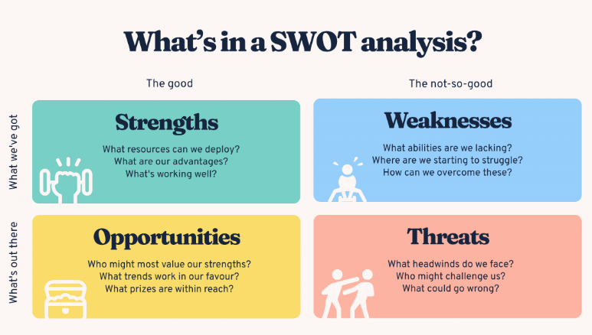
Figure 3: SWOT Analysis (Bitesize, 2024)
Strengths
The main advantages Netflix UK has over its rivals are it has a large installed user base, it is an international brand, it has the financial capabilities and it has an advanced personalisation system and an international distribution network. It has 17.6 million UK-home viewers, presenting a good size, and a global membership base and profitability means that it can invest heavily in technology and content (BARB, 2025; Netflix, 2025). Successful, locally produced programmes can also be exported internationally (Netflix, 2024), which further demonstrates the UK's production potential.
Weaknesses
Netflix has always relied on investing in “the right kind of programming and technology” and its profits from any specific production are always unpredictable (Netflix, 2025). In addition, it is now trivially easy to duplicate what recommendation systems can do, and to make advertising technology more competitive (Hsiao, Feng and Lamkhede, 2025). There is also some evidence of subscription downgrading in the UK, suggesting there is not much scope for price power despite achieving good market penetration.

Opportunities
The first is advertising monetisation, the second is the use of AI for personalisation, the third is the development of the creative industry in the UK and the fourth is the export of UK content that can be developed on a global scale. Adoption of advertising tier is predicted to be 35% of Netflix UK households by Q3 2025 (BARB, 2025) and government backing and a high production spend in the UK ensures the availability of creative talent and infrastructure (BFI, 2025; Department for Culture, Media and Sport, 2025).
Threats
Netflix is vulnerable to the growing level of SVoD maturity, affordability concerns, regulatory growth and increased competition for eyeballs. Substitution has been steady at 68% for UK SVoD since 2021, and the rise in television viewing on YouTube highlights substitution going beyond the traditional streamers. The Media Act also makes compliance requirements more onerous (GOV.UK, 2024).
Thus, as Netflix enters a more mature and complex UK market, it should aim to engage, retain and monetise advertising while maintaining the affordability and differentiation of its offering, by leveraging its scale, content and technology.

4. Comprehensive and Holistic View

4.1 Critical Evaluation of Netflix’s CSR Strategy
Current CSR Strategy
The corporate social responsibility (CSR) approach of Netflix is integrated in the operating model of the company. On the environmental side, the company sees film and TV media production being a significant portion of their carbon emissions and will strive to reduce these emissions as a whole by 2030 through energy efficiency, production electrification and renewable energy usage (Stewart, 2023). Netflix is also vocal about inclusion, representation and opportunities in creative careers in their social media. In 2022, its global workforce comprised 49.6% women and its director level-and-above workforce consisted of 51.4% women; and about 60% of the companies it spent with were underrepresented suppliers (Myers, 2023). Until 2023, the Netflix Fund for Creative Equity had pledged over US$29 million to more than 100 programmes in over 35 countries (Bajaria, 2023). Ethics policies, supplier guidelines, governance policies and human rights pledges are all tools used to encourage responsible corporate behaviour (Sarandos and Peters, 2024).
Alignment with Business Objectives
Netflix's alignment with its CSR activity and business goals is significant since a number of CSR priorities support the relevance of its content, access to talent, client interactions and brand legitimacy. Diversity and inclusion go hand-in-hand with Netflix's global entertainment concept. A wider creative talent base can be more powerful in supporting the company's ability to cater to a wider audience. Netflix has analyzed 629 films and series from 2018-2021, finding that 55% of those had a female lead or co-lead, and 47% of those looked at from 2020-2021 had a lead or co-lead from an underrepresented racial or ethnic group (Bajaria, 2023). This alignment can help to differentiate, and enhance the reputation and ability to attract talent for an employer.
In addition to reducing risk, environmental responsibility can be considered in the context of stakeholder management. Adopting cleaner production can mitigate the risk of being regulated, facing critical comments from the media and having higher expectations from stakeholders. Sustainability also can help to drive engagement: Netflix reported that over 70% of members (165 million households) watched at least one sustainability-related story in 2022 (Stewart, 2023). Governance programs also enhance the ethical decision-making, accountability of suppliers and stakeholder trust (Sarandos and Peters, 2024).
Critical Limitations and Overall Judgement
The alignment is yet to be completed. While some individual productions might be cleaner, expanding the volume of productions can mean an increase in total emissions as well. The tension between growth and decarbonisation is created by the fact that some individual productions might be cleaner, but at the same time, the larger the volume of production, the higher the total emissions. Representation is also unequal, as Netflix admits there are gaps that impact Latinx, Middle Eastern and North African, Indigenous, Native Hawaiian and PNI, and disabled communities (Bajaria, 2023). Netflix exhibits moderate, but partial alignment: CSR is seen as having strong value for reputation, attracting talent and making content more relevant, and risk management, but there is not a strong sense of the value of CSR in the longer term in terms of measurable reductions in emissions, representation and governance.

4.2 Balanced Scorecard
The Balanced Scorecard can help to convert the Netflix UK's strategy into the related financial and non-financial priorities. Recent studies highlight the need to use its four perspectives in an interconnected manner and not as separate entities.
Financial Perspective
The priorities of the Financial perspective are related to profitable growth, advertising monetisation, lifetime value of customers, the return on investment on content, and the operating efficiency. In fact, there are several KPIs to consider for this type of app, such as UK revenue growth, advertising yield, contribution margin and content ROI. The programs should include pricing optimisation, intelligent content marketing and valuable advertising opportunities. These actions are signs of whether or not engagement and technology yield financial benefits over a period of time (Kumar et al., 2024).
Customer Perspective
Focus on Customer perspective should be on Retention, engagement, satisfaction and perceived value. In the mature streaming marketplace, it's more strategic to measure churn, view engagement, customer satisfaction and customer recommendation rates than it is to measure subscriber growth (Netflix, 2025). There are a number of personalised aspects that should be included in the initiatives, such as personalised content discovery, a unique British program structure and controlled advertising frequency. The goal is to enhance the lifetime value of the customers without compromising their experience.
Internal Business Processes Perspective
The effectiveness of recommendations, the reliability of services, the efficiency of content production, reliability of delivering advertising and engagement from advertising created by titles originating in the UK should be measured in Internal Business Processes (Satiya, 2025). Some of the initiatives involve using AI to generate recommendations, enhanced content analytics, better advertising measurement and streamlined production processes. These measures indicate if technology and content investments are making a difference to the customer (Hsiao, Feng and Lamkhede, 2025).
Learning and Growth Perspective
Learning and Growth needs to evaluate the development of Netflix's capabilities for the future competition. Examples of KPIs relevant to this include AI skills, advertising technology skills, employee development, the diversity of creative talents, speed of internal mobility and innovation. These capacities can be enhanced by specialist training, cross functional innovation and creative-equity programmes (Myers, 2023; Bajaria, 2023).
Most importantly, the four perspectives need to be in a coherent system. Great talent, AI and advertising skills can help to streamline internal processes; stronger internal processes can lead to more relevant and engaging content; better customer outcomes should lead to better retention and lifetime value; and better retention and lifetime value can lead to better financial performance. This is a causal logic that is related to the strategy of the Balanced Scorecard (Kumar et al., 2024). The value to Netflix UK is not in the ability to make more KPIs, it's about connecting capability development, value to customers, and long-term financial performance.

5. Strategic Choices and Implementation
Evaluation of Current Business-Level Strategy
Netflix UK, currently, has a business-level strategy of broad differentiation. It's based on unique content, name recognition, personalisation, platform usability and the ability to deliver world-class, yet locally relevant, content. Differentiation is suitable if there is a meaningful difference in value for the customers apart from prices, but is only sustainable if it is constantly renewed because digital competitors can quickly copy and paste individual value-adding elements (Grant, 2021; Knudsen et al., 2021). YouTube's ability to offer prime time content to viewers further undermines the idea that such content is only available in unique platforms (Budzinski, Gaenssle and Lindstädt-Dreusicke, 2021).
Alternative Strategic Choices
While cost leadership might lead to making products more affordable and potentially beat out price-sensitive markets, ongoing investments in content and technology can make pure low-cost strategies limiting. A focus strategy might increase brand loyalty in these niche markets within the UK, but this would have a negative effect on Netflix's ability to utilise the wider market and global distribution economics of its services. The enhanced differentiation is the greatest fit as it builds on existing content, data and brand capabilities, while offering adaptation to evolving audience preferences (Whittington et al., 2023; Grant, 2021). But, differentiation has to be dynamic, as digitalisation is capable of reducing the period of competitive advantages (Knudsen et al., 2021).
Recommended Strategic Option
Netflix UK must now look to improve their positioning with a single offer – a unique British offering, improved personalisation with AI and a carefully planned ad supported offering. The goal isn't diversification, rather it is renovation to the current value proposition. This method is both relevant to content and equips for superior discovery and monetisation, without compromising the customer experience, as also does strategic coherence between market position and organisational capabilities (Whittington et al., 2023).
SAFe Evaluation
The recommendation can be implemented using SAFe, thus showing a high level of strategic fit. The suitability is high, since more differentiation is required with the streaming maturity and increasing competition in the audience's focus, and research confirms that Netflix not only faces competition from the subscription providers, but also from YouTube and television (Budzinski, Gaenssle and Lindstädt-Dreusicke, 2021). Acceptability is positive due to the potential benefit to investors of increased engagement and advertising monetisation, but so is the potential benefit to customers in terms of personalisation and local content returns, so as is the risk of over-advertising or underdelivering content returns. Feasibility is also good because Netflix has content, data, technology and distribution. Attractiveness should not be the only aspect of the strategic evaluation to consider when testing environmental fit, and there are impacts to stakeholders to consider as well as resource availability (Whittington et al., 2023).
Financial and Organisational Impact
In terms of money, improved differentiation should lead to better revenue quality by retaining more customers, better monetisation of ads, more profitable customer lifetime value, and higher productivity of content, than predominantly by attracting new customers. So, more integration is required between creative, data and advertising skills, organisationally, in order to implement the strategy. Studies on the digital transformation (DT) of the organization show that it is not only a matter of technology and its use, but also a matter of organizational transformation (Plekhanov, Franke and Netland, 2023). Therefore, Netflix needs to boost the correlation and linkage between innovation, engagement and financial outcome consistent to its Balanced Score Card concerns.
Strategic Gap Analysis
The biggest divide is the difference between Netflix UK's current strength and what they need to be able to do to further increase their value in an established market. The need for a balance in monetisation – between subscription and advertising value; the need for consistently differentiated UK titles to be produced as a content investment; the need for personalisation to advance with its competitors developing their algorithms and the need for advertising skills to grow without spoiling the experience of the viewers. Gap analysis should thus be used to transform the vision of the future state into capability development measures and actions. Managerial actions, enabling conditions and organisational capabilities are needed to be effective (Tawse and Tabesh, 2021).
McKinsey 7S Implementation Analysis
The McKinsey 7S model indicates that it is a business decision, not a strategic decision, and requires the alignment of the organisation. Strategy needs to incorporate differentiated content, personalisation and responsible advertising. Structure should enable the UK content, marketing, data and advertising teams to collaborate. Recommendation analytics, content-performance evaluation, advertising measurement, and monitoring of customer-experience should be incorporated into systems.
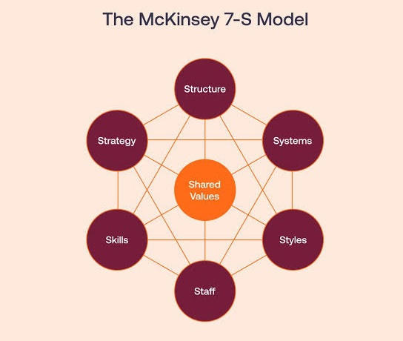
Figure 4: McKinsey 7S Model (Malik, 2024)
The skills need to grow in their Artificial Intelligence, Advertising Technology and Local Creative Development skills and the Staff policies need to hire and nurture those skills. Leadership Style should allow for experimentation, and commercial discipline when investing. Emphasis on creativity, innovation and customer value should be continued with Shared Values. The recent studies prove that organisational change is a process which requires the alignment of the 7S elements; organisational change cannot be achieved by the improvement of only one element (Tryczak, Lis and Czyżewicz, 2024; Tawse and Tabesh, 2021).
Implementation Challenges and Solutions
Implementation challenges involve the growth of content costs, customer resistance to advertising, capability gaps and speedy competition imitation. Netflix should therefore only invest in stages, review content portfolios, limit the use of advertising frequency, continuously test customers, and develop capabilities according to the needs of specific customers. However, competitive advantages are not necessarily sustainable in a digital world as the difference in competitive advantages may diminish over time; thus, the process of digitalisation needs to involve continuous strategic change rather than a single organisation change programme (Knudsen et al., 2021).

6. Reflective Account — Gibbs Reflective Cycle
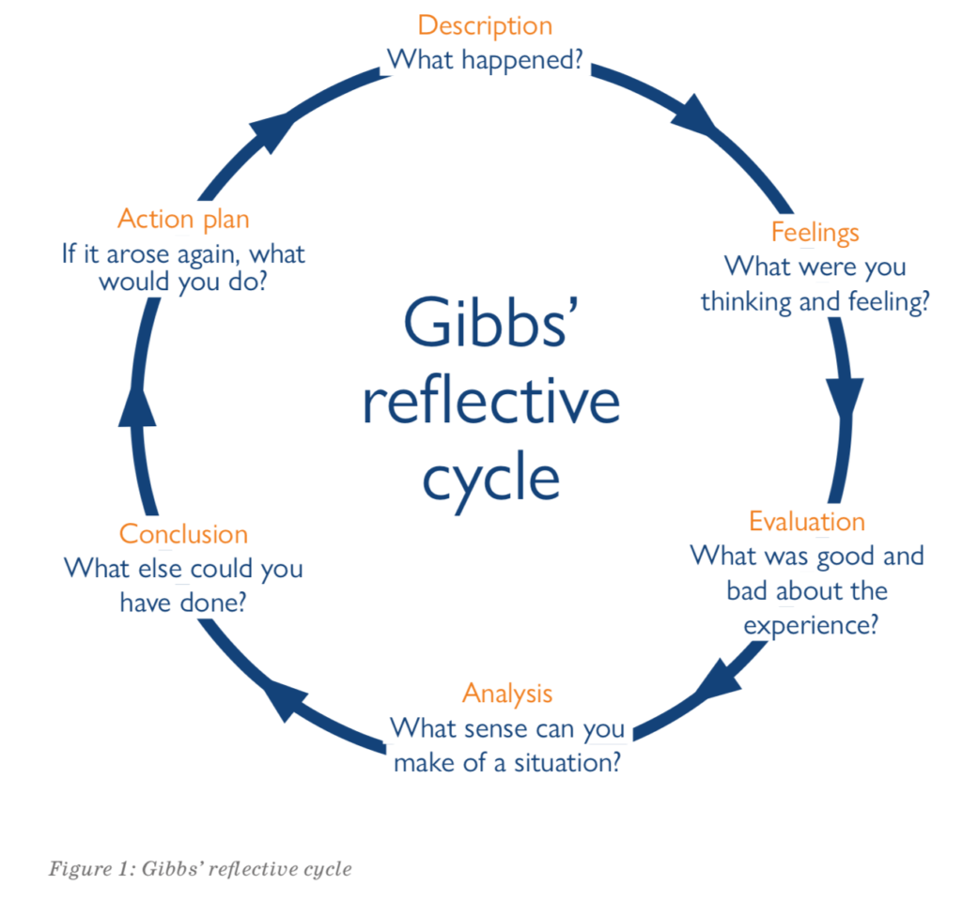
Figure 5: Gibbs Reflective Cycle (drroopesh, 2025)
Description
Netflix UK was chosen as it has a high level of competitive, technological and regulatory pressures as well as being market leader. I reviewed its external context, internal strengths, the priorities it places on CSR and its performance indicators to make recommendations for improving differentiation. The Gibbs' cycle was found to be a useful structure for the following reasons: reflection and description led to evaluation, analysis and future action. Recent studies also show the positive impact that structured reflective writing can have on learning to apply what is learnt to practice (Ezezika and Johnston, 2023).
Feelings
At first I thought that as Netflix was so dominant, that their market position was fairly safe and that their figures were still going to increase on subscribers. But as the analysis progressed, I began to lose my faith on these assumptions as the UK market seemed to be a mature market and competition was not just from traditional streaming services. This was a reminder to me that sometimes first impressions can be misleading when not backed up by evidence to challenge it.
Evaluation
One element of my work which was very effective was to use the external and internal analysis in tandem with each other, rather than separate PESTEL, VRIO and SWOT. In understanding this I realised why it is important to have an opportunity when the organisation has resources to take advantage of the opportunity. The most challenging part was sifting through information to determine what was strategically important and to not provide too much description. I also realised that it was possible to make the ‘realities' of a matter easier to handle through the use of frameworks. Elbanna, Thanos and Jansen (2020) illustrate that strategic decision processes are very context-dependent and that results in this field are sometimes mixed or inconclusive..
Analysis
Most salient learning was about the need to synthesize rather than complete the framework in the process of strategy. Beyond Netflix's scale, content and technology, external factors such as the maturity, affordability and regulations of the market were also a factor. I thus learnt how to relate external opportunities and threats with internal strengths and weaknesses and then make suggestions.
Also, grew more critical of strategic models. They arrange the facts but don't eliminate uncertainty or make sure the right strategic choice. However, the environmental, organisational and decision factors can affect the strategic decision making and the same set of analysis may yield different results in different scenarios (Elbanna, Thanos and Jansen, 2020). A strategic approach to thinking has also been described as having a systems perspective, focused intent, intelligent opportunism and hypothesis driven analysis, and rational and intuitive decision making by Sinnaiah, Adam and Mahadi (2023). This helped me to reinforce my thinking that evidence should be used for judgement and not to supplant it.
Cost leadership, focus and differentiation were other strategies that showed the importance of strategic fit. Availability of an option may look like it is desirable, but actually be unsuitable because of lack of resources, expectations of the stakeholders or implementation requirements. The implementation analysis thus caused me to take a new look at strategy from the choice of an option to the coordination of capabilities, systems, people and performance measures.
Conclusion
In a general way, I had a change of perception about strategic management from a set of analytical tools to an integrated decision making process. I saw that there need to be evidence-based and synthesized, as well as comparing the alternatives and feasibility of implementation for credible recommendations. It also revealed the effect of my own preconceptions in my understanding of the material. Reflective writing that is structured can enhance critical thinking skills as it can help learners to review their preconceptions and relate academic knowledge to practical situations (Ezezika and Johnston, 2023).
Action Plan
Future strategic analyses will involve stating the core strategic issue, then choosing analysis frameworks. I will select and give priority to the latest, most reliable evidence; compare conflicting evidence and be clear about when evidence is missing. I will differentiate between the description of findings and the implications of the findings for strategic choice and analyse alternatives in terms of their suitability, the consequences for those affected by them and the resources needed and implementation requirements. I will also be incorporating the capability gaps, responsibilities, performance measures and risks upfront in the process as well. Lastly, instead of reflecting at the end of the research process, I will reflect during the research process as structured reflection can enhance critical thinking and further action (Trimasse, 2025).

7. Conclusion
Netflix has a strong strategic position overall to the streaming market in the UK, driven by its brand, scale and ability to offer content and to personalise their offering for viewers. But the ease with which it can be achieved diminishes in a maturing market, as seen with the increased competition, affordability concerns and regulatory developments. The analysis suggests that a more differentiated strategy, which is unique to the UK market, has the best potential to meet the needs of young audiences. Today's unique criteria will shape the market of tomorrow, and this analysis highlights the importance of adapting to the needs of young audiences through the implementation of enhanced differentiation and a range of other UK-specific measures. To be considered a success, these must be synchronized in terms of skills, systems and capabilities of the organisation without compromising the customer experience. For Netflix, however, their long term advantage in the UK will depend on their ability to innovate continuously, invest strategically and execute their plans well, as they seek to implement an integrated, differentiation strategy.

8. References
Bajaria, B. (2023) ‘Making progress: Our latest film & series diversity study and Netflix Fund for Creative Equity updates’, About Netflix, 27 April. Available at: https://about.netflix.com/news/making-progress-our-latest-film-and-series-diversity-study-and-netflix-fund (Accessed: 10 August 2026).
Barb (2025) ‘Barb releases Q3 2025 SVOD subscriptions data’, Barb, 11 November. Available at: https://www.barb.co.uk/news/barb-releases-q3-2025-svod-subscriptions-data/ (Accessed: 11 August 2026).
Bitesize (2024). How to do a SWOT analysis [with examples & templates]. [online] BiteSize Learning. Available at: https://www.bitesizelearning.co.uk/resources/swot-analysis-explained-examples-templates (Accessed 10 August 2026).
British Film Institute (BFI) (2025) ‘Official BFI statistics for 2024 reveal £5.6 billion film and high-end television production spend in the UK’, BFI, 6 February. Available at: https://www.bfi.org.uk/news/official-bfi-statistics-2024 (Accessed: 11 August 2026).
Budzinski, O., Gaenssle, S. and Lindstädt-Dreusicke, N. (2021) ‘The battle of YouTube, TV and Netflix: an empirical analysis of competition in audiovisual media markets’, SN Business & Economics, 1, article 116.
Department for Culture, Media and Sport (2025) ‘£380 million boost for creative industries to help drive innovation, regional growth and investment’, GOV.UK, 23 June. Available at: https://www.gov.uk/government/news/380-million-boost-for-creative-industries-to-help-drive-innovation-regional-growth-and-investment (Accessed: 11 August 2026).
drroopesh (2025). Reflection: A basic guide. [online] communitymedicine4all. Available at: https://communitymedicine4asses.wordpress.com/2025/01/10/reflection-a-basic-guide/ (Accessed 10 August 2026).
Elbanna, S., Thanos, I.C. and Jansen, R.J.G. (2020) ‘A literature review of the strategic decision-making context: A synthesis of previous mixed findings and an agenda for the way forward’, M@n@gement, 23(2), pp. 42–60.
Ezezika, O. and Johnston, N. (2023) ‘Development and implementation of a reflective writing assignment for undergraduate students in a large public health biology course’, Pedagogy in Health Promotion, 9(2).
GOV.UK (2024) Media Act 2024. London: UK Parliament. Available at: https://www.legislation.gov.uk/ukpga/2024/15/contents (Accessed: 11 August 2026).
Grant, R.M. (2021) Contemporary Strategy Analysis. 11th edn. Hoboken, NJ: Wiley.
Hsiao, K.J., Feng, Y. and Lamkhede, S. (2025) ‘Foundation model for personalized recommendation’, Netflix Technology Blog, 21 March. Available at: https://netflixtechblog.com/foundation-model-for-personalized-recommendation-1a0bd8e02d39 (Accessed: 11 August 2026).
Knudsen, E.S., Lien, L.B., Timmermans, B., Belik, I. and Pandey, S. (2021) ‘Stability in turbulent times? The effect of digitalization on the sustainability of competitive advantage’, Journal of Business Research, 128, pp. 360–369. doi:10.1016/j.jbusres.2021.02.008.
Kumar, S., Lim, W.M., Sureka, R., Jabbour, C.J.C. and Bamel, U. (2024) ‘Balanced scorecard: trends, developments, and future directions’, Review of Managerial Science, 18(8), pp. 2397–2439.
Malik, P. (2024). The McKinsey 7-S model framework, explained (2022) - whatfix. [online] The Whatfix Blog | Drive Digital Adoption. Available at: https://whatfix.com/blog/mckinsey-7s-model/ (Accessed 10 August 2026).
Myers, V. (2023) ‘2022 Inclusion Report Update’, About Netflix, 28 April. Available at: https://about.netflix.com/news/2022-inclusion-report-update (Accessed: 11 August 2026).
Netflix (2024) ‘Mayor of West Midlands visits set of “Peaky Blinders,” highlighting Netflix’s significant investment in the UK creative industries’, About Netflix, 15 November. Available at: https://about.netflix.com/news/mayor-of-west-midlands-visits-set-of-peaky-blinders-highlighting-netflix-investment-in-uk (Accessed: 8 August 2026).
Netflix (2025) ‘What We Watched: The First Half of 2025’, About Netflix, 17 September. Available at: https://about.netflix.com/en/news/what-we-watched-the-first-half-of-2025 (Accessed: 3 August 2026).
Netflix (2025) Q4 2024 shareholder letter. 21 January. Available at: https://ir.netflix.net/files/doc_financials/2024/q4/FINAL-Q4-24-Shareholder-Letter.pdf (Accessed: 8 August 2026).
Ofcom (2025) ‘Further findings from our latest look at the UK’s media habits’, Ofcom, 30 July. Available at: https://www.ofcom.org.uk/media-use-and-attitudes/media-habits-adults/further-findings-from-our-latest-look-at-the-uks-media-habits (Accessed: 11 August 2026).
Ofcom (2025) ‘Tuning into YouTube: UK’s media habits revealed’, Ofcom, 30 July. Available at: https://www.ofcom.org.uk/media-use-and-attitudes/media-habits-adults/tuning-into-youtube-uks-media-habits-revealed (Accessed: 6 August 2026).
Ofcom (2025) Media Nations 2025: UK report. London: Office of Communications. Available at: https://www.ofcom.org.uk/siteassets/resources/documents/research-and-data/multi-sector/media-nations/2025/media-nations-2025-uk-report.pdf?v=401287 (Accessed: 11 August 2026).
Office for National Statistics (ONS) (2025) Household Costs Indices for UK household groups: July to September 2025. 28 November. Available at: https://www.ons.gov.uk/economy/inflationandpriceindices/bulletins/householdcostsindicesforukhouseholdgroups/julytoseptember2025 (Accessed: 11 August 2026).
Plekhanov, D., Franke, H. and Netland, T.H. (2023) ‘Digital transformation: A review and research agenda’, European Management Journal, 41(6), pp. 821–844.
Sarandos, T. (2023) ‘Netflix DVD – The Final Season’, About Netflix, 18 April. Available at: https://about.netflix.com/news/netflix-dvd-the-final-season (Accessed: 11 August 2026).
Satiya, K. (2025) ‘Behind the scenes: Building a robust ads event processing pipeline’, Netflix Technology Blog, 9 May. Available at: https://netflixtechblog.com/behind-the-scenes-building-a-robust-ads-event-processing-pipeline-e4e86caf9249 (Accessed: 11 August 2026).
Sinnaiah, T., Adam, S. and Mahadi, B. (2023) ‘A strategic management process: The role of decision-making style and organisational performance’, Journal of Work-Applied Management, 15(1), pp. 37–50.
Speaking Nerd (2021). Investigative study of PESTLE Analysis Model. [online] SpeakingNerd. Available at: https://speakingnerd.com/strategy/strategy-models/pestel-analysis (Accessed 10 August 2026).
Stewart, E. (2023) ‘Our Progress on Sustainability: Two Years In’, About Netflix, 27 March. Available at: https://about.netflix.com/news/our-progress-on-sustainability-two-years-in (Accessed: 11 August 2026).
Tawse, A. and Tabesh, P. (2021) ‘Strategy implementation: A review and an introductory framework’, European Management Journal, 39(1), pp. 22–33.
Trimasse, N. (2025) ‘The use of reflective reports in higher education’, Reflective Practice, 26(1), pp. 154–171.
Tryczak, J., Lis, A. and Czyżewicz, J. (2024) ‘Towards a universal model of engineering change management’, Journal of the Knowledge Economy, 15(3), pp. 12439–12471.
Whittington, R., Regnér, P., Angwin, D., Johnson, G. and Scholes, K. (2023) Exploring Strategy: Text and Cases. 13th edn. Harlow: Pearson.

