

Assessment 2

Module Name : Marketing Management
Module Code : LCMB7024_LON
Student Name: Kush Jani
Student Number: 2504341
Lecturer’s Name: Dr Jaya Gopalkrishnan
Word Count: 2507

Table of Contents
Element 1: Segmentation, Targeting, Differentiation and Positioning Analysis 3
Introduction to the business 3
New Brand Concept 3
Trends and Changing Consumer Behaviour 4
Key Market Segments and Target Audience 5
Differentiation 6
Reference For Element 1 7
Element 2: Marketing Mix 9
Product 9
Price 9
Place 10
Promotion 10
People 11
Process 11
Physical Evidence 11
Reference For Element 2 13
Element 4: Reflection 15
Experience developing the VI Wave brand concept 15
Experience in preparing and delivering the marketing strategy pitch 15
Key Skills and Insights 15
Improving approach and performance 16
Conclusion 16
Reference For Element 4 17
Appendix 18
Element 3: Marketing Strategy Pitch 18

Element 1: Segmentation, Targeting, Differentiation and Positioning Analysis
Introduction to the business
VodafoneIdea (VI) Limited is the third-largest telecom operator in India. Due to growing competition pressure from other telecom brands like Airtel and Jio, the business is struggling to record positive financial performance and retain market share (refer-to-figure-1) (Grover, 2025). This report aims to propose a new brand for VI Limited to improve the business outcomes and financial returns. The report will evaluate the rationale behind new brand concepts, trends of consumer behaviour and will finally define the new targeted consumer segment.
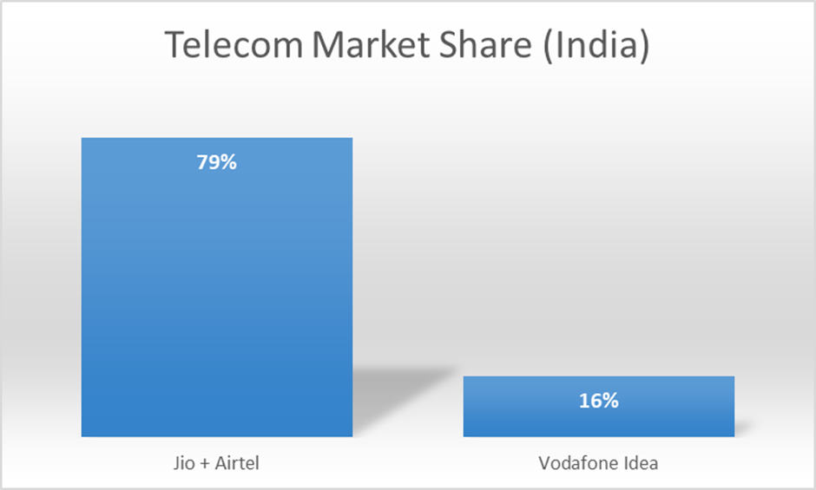
Figure 1: Indian Telecom Industry Market Share (Source: Dubey, 2025)
New Brand Concept
Brand development is an ongoing process of building and strengthening a brand's perception, identity and connection with consumers. Kotler's brand development strategy identifies various ways of creating a new brand, such as brand extension, line extension, multibrands and new brands. Brand Extension is the most commonly used approach where a new brand within a well-known company is established to cater for a new market segment with a new product/service (Liao, 2024). For VI Limited, this brand extension strategy is followed to introduce a new brand named "VI Wave". VI Wave will be a new OTT platform for the Indian consumers. The brand's USP is high-quality entertainment content for adults and young people at a lower subscription price than existing market competitors. The brand slogan will be "Spend Less, Stream More".
Trends and Changing Consumer Behaviour
In 2024, the Indian OTT market size was estimated at £2.94 billion. Market practitioners are expecting a CAGR of 15.62% in the OTT market in the next 10 years of operation (Market Research Future, 2025). At present, the Indian OTT market competition is relatively high with large existing brands like Discovery+, ZEE5, Netflix, Amazon Prime Video and Disney + Hotstar (Hamdulay and Ponde, 2024) (refer-to-figure-2). However, Indian consumers are still struggling to manage their preferences across these platforms. More than 66% of the Indian consumers want to pay a lower subscription price in-exchange for ads, while on the other hand, more than 50% of the Indian consumers experience difficulties in cancelling their subscriptions (refer-to-figure-3) (Economics Times, 2024; Localcircles, n.d.). As a result, unwanted subscription charges are levied on the people.
The "Theory of Planned Behaviour" defines that beliefs arising from attitudes and subjective norms directly or indirectly influence the behaviour (Sander et al., 2024). By experiencing unwanted subscription charges, Indian consumers have now developed the consciousness that unclear policies related to subscription are a trap to deceive them financially (Localcircles, n.d.). Hence, they prefer to pay-less in-exchange for ads. VI Wave is going to exploit this consumer difficulty as an opportunity to introduce the new OTT platform. The platform will be structured in a user-centric way where transparent subscription policy, easy one-time cancellation option and low-cost subscription will be prioritised and marketed for building consumer awareness. The primary revenue stream of the platform will be advertisement-revenue, which is being sought by the Indian people. In this way, the VI Wave will create value for the consumers to improve market share and financial performance.

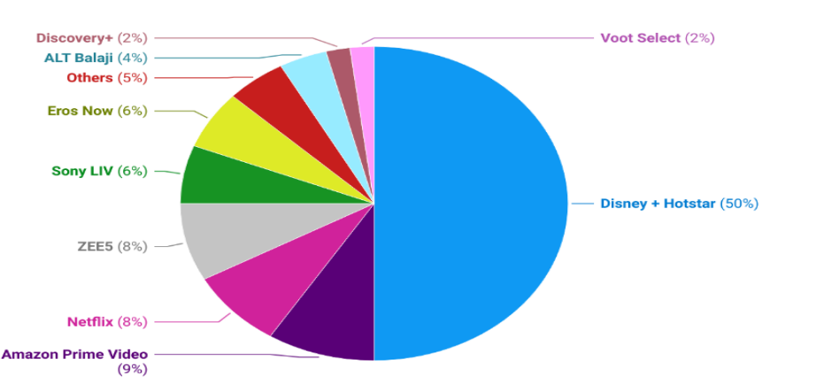
Figure 2: Market Share of Indian OTT platforms (Source: Hamdulay and Ponde, 2024)
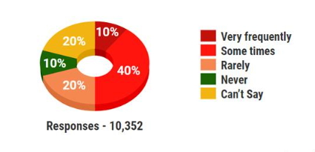
Figure 3: Percentage of Indian consumers who experience difficulty with cancellation (Source: Localcircles, n.d.)

Key Market Segments and Target Audience
Segmentation:
The demographic and behavioural segmentation approach will be applied to refine the target audience for VI Wave. Demographic segmentation involves dividing the target market based on age, gender, occupation and other demographic factors, while behavioural segmentation emphasises behaviour-based segmentation like purchase frequency and others (Akinrinoye et al., 2020). According to the reports, OTT platforms are more popular among the young consumer group of India, specifically those who are from tier-2 cities across both genders (Cyrill, 2023). Therefore, demographic segmentation needs to be applied to different target consumers based on age groups. At the same time, the growth of any OTT platform in India is driven by affordable subscription plans (Cyrill, 2023). Thus, a price-sensitive behaviour is detected, which ensures that behavioural segmentation needs to be applied to refine target consumers among these young people groups.
Targeting:
Young Indian people in the age group of 16-24 years are the primary consumers of OTT platform content (Cyrill, 2023). They want affordable subscription plans with high-quality original content like web-series. Hence, VI Wave will target the price-sensitive young people of India by advertising the platform's affordability and the originality.
Positioning:
VI Wave will be positioned as the most affordable OTT platform with a series of original content available for young Indian people.
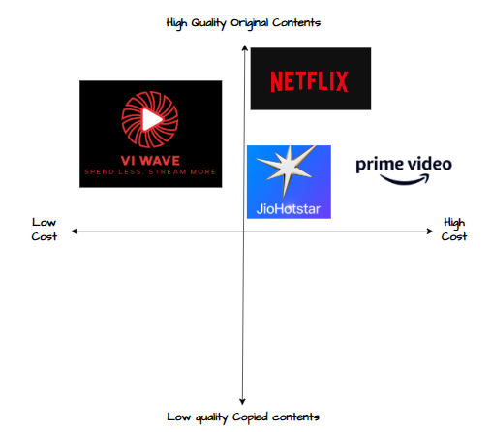
Fugure 3: Perceptual Map of VI Wave (Source: Self-Created)
Differentiation
Porter's Generic Strategy framework provides an array of strategies to improve brand differentiation and competitive positioning. The cost leadership strategy emphasises becoming the lowest cost producer, while the focus strategy prioritises serving a targeted niche market (Ali and Anwar, 2021). VI Wave will combine the cost leadership and focus strategy to differentiate itself from the competitors. While competitors like Disney-Hotstar+ have a base subscription fee of £1.22/month, VI Wave will offer the subscription at <£1/month (Hamdulay and Ponde, 2024). At the same time, only the young Indian consumers will be targeted because they are the primary consumers of OTT content. In this way, VI Wave will appeal differentially to the young Indian people by offering them original content at the lowest cost.

Reference For Element 1
Akinrinoye, O.V. Kufile, O.T. Otokiti, B.O. Ejike, O.G. Umezurike, S.A. and Onifade, A.Y. (2020) ‘Customer segmentation strategies in emerging markets: a review of tools, models, and applications’, International Journal of Scientific Research in Computer Science, Engineering and Information Technology, 6(1), pp.194-217. https://www.researchgate.net/profile/Omolola-Kufile/publication/394014688_Customer_Segmentation_Strategies_in_Emerging_Markets_A_Review_of_Tools_Models_and_Applications/links/688428c800a2407910a43f9a/Customer-Segmentation-Strategies-in-Emerging-Markets-A-Review-of-Tools-Models-and-Applications.pdf
Ali, B.J. and Anwar, G. (2021) ‘Porter’s Generic Competitive Strategies and its influence on the Competitive Advantage’, International Journal of Advanced Engineering, Management and Science, 7(6), pp.42-51. https://www.academia.edu/download/67574092/g28.pdf
Cyrill, M. (2023) Exploring India’s Thriving OTT Video Segment: Trends, Growth, and Investor Interest. Available at: https://www.india-briefing.com/news/india-ott-video-segment-growth-trends-investments-27681.html/ (Accessed: 17 December 2025).
Economics Times, (2024) 66% of Indian consumers prefer to pay less in exchange for watching ads: Survey. Available at: https://economictimes.indiatimes.com/industry/media/entertainment/media/66-of-indian-consumers-prefer-to-pay-less-in-exchange-for-watching-ads-survey/articleshow/111335541.cms?from=mdr (Accessed: 17 December 2025).
Grover, J. (2025) Vodafone Idea narrows loss in Q2, survival hinges on government relief. Available at: https://www.livemint.com/companies/company-results/vodafone-idea-q2-results-company-loss-financial-performance-agr-relief-11762745939942.html (Accessed: 17 December 2025).
Hamdulay, N.A. and Ponde, S.J. (2024) ‘TREND OF OTT PLATFORMS IN INDIA’, Journal of Visual and Performing Arts, 5(1), pp. 1815-1827. https://www.researchgate.net/publication/384021304_TREND_OF_OTT_PLATFORMS_IN_INDIA
Liao, Y.H. (2024) ‘Study on the Impact of Multi-brand Strategy on Perceived Value and Consumption Intention: A Case of the Chain Restaurant Industry’, Advances in Management and Applied Economics, 14(6), pp.1-6. http://www.scienpress.com/Upload/AMAE/Vol%2014_6_6.pdf
Localcircles, (n.d.) Users in India report 6 dark patterns common on OTT platforms; Over 1 in 2 upset over introduction of additional rental charges, advertisements post. Available at: https://www.localcircles.com/a/press/page/ott-subscription-trap (Accessed: 17 December 2025).
Sander, A. Ghazoul, J. Finger, R. and Schaub, S. (2024) ‘Participation in individual and collective agri-environmental schemes: a synthesis using the theory of planned behaviour’, Journal of Rural Studies, 107, p.103255. https://www.sciencedirect.com/science/article/pii/S0743016724000597

Element 2: Marketing Mix
Product
Product in the marketing framework defines every component of the service or product that adds value for the targeted consumers (Jain, Jain and Jain, 2022). VI Wave particularly targeted the young and price-sensitive Indian consumers in the age group of 16-24 belonging to urban areas because almost 70% of the OTT content is consumed by them (Dang, 2020). Hence, following the behavioural trend of affordable subscription plans and original content, VI Wave will ensure that its subscription price remains low-cost and affordable for these young people.
At the same time, the platform will establish connections with large production and media houses in India, such as Yash Raj Films (YRF) and Red Chillies, to create original and user-preferred content like crime thriller web-series because Indian users demand fresh content in various regional languages (Cyrill, 2023). In this way, user-centric content will be created and integrated into the platform to create value for them and enhance their engagement to improve the market share.
Price
Price in the marketing mix framework not only includes the item's price but also the price adjustments, payment options and others to maintain competitiveness in the market. News articles have mentioned that improving the consumer subscription rate in India for OTT platforms needs to showcase affordability (MET, 2025). This behaviour trend indicates that Indian consumers need to offer affordable subscription prices to enhance the user penetration rate. Following this behavioural trend, VI Wave will ensure that the Ad-revenue stream remains the primary source of revenue to reduce subscription price pressure on consumers. In particular, VI Wave will aim for a <£1/month subscription price for consumers to meet their need for affordability. However, payment options and price adjustments are also a crucial part of the price aspect in the marketing mix. A comparative study on Indian consumers has found that Generation Z (born after 1997) values personalisation and authenticity to remain loyal to a specific brand. At the same time, they prefer to experiment with new brands but are strictly influenced by discounted offers across the digital web (Singh and Singh, 2025). Following these personality factors, VI Wave will provide multiple and personalised payment options such as credit-cards, digital-wallet and UPIs through the mobile application. On the other hand, a consumer loyalty programme will be created to offer 10-15% discounts on subscription price for repeat purchases. In this way, the price-sensitive and personalised behaviour trend of Indian users will be managed to enhance VI Wave applicability among the Generation Z (age 18-24) Indian consumers.
Place
Place in the marketing mix framework refers to the distribution routes of how the service will reach potential consumers. There are two distribution channels identified: physical and electronic distribution. Generation Z people of India are considered truly digital native, people where more than 63% prefers online shopping and 69% believes that advanced technologies like virtual reality are the future of social connection and entertainment (Mintel, 2023). The service of VI Wave is also a digital media-based service. Hence, aligning with the digital native behaviour and preference for personalisation, VI Wave will distribute the content through a mobile application and a separate brand website. While the mobile application will act as the primary source of payment and content consumption in a personalised way, the website will serve as the main medium to receive insights on future content, discounts, sales deals and others. In this way, the digital-native behaviour and personalisation needs of the target Generation Z consumers will be displayed and maintained by VI Wave.
Promotion
Promotion in the marketing mix framework is the brand's ability to connect with consumers. Indian Generation Z consumers have a strong preference for social media channels. More than 91% of the Indian Generation Z people consume social media platforms like Instagram, Facebook and others for news and awareness of new brands (Storyboard18, 2025). Additionally, 28% of the Urban Indian Generation Z access Instagram more than 10 times a day (YouGov, 2023). Hence, this higher rate of social media activity among the consumers will be considered as an opportunity for social media promotion of VI Wave’s new OTT platform. In the opinion of Jacobson, Gruzd and Hernández-García (2020), social media promotions allow brands to reach consumers quickly in a cost-efficient manner, while social listening improves brand value by better understanding public interest. Following this theoretical value and consumer behaviour trend, VI Wave will purely use the social media platforms for improving brand awareness. Specifically, unique and attractive content highlighting low cost and content originality will be circulated to improve consumer awareness and interest in the brand. Further, by applying a social media sentiment analysis strategy, the attitudes, pain points, and needs of the targeted people will be evaluated by VI Wave (Singh, Tomar and Sangaiah, 2020). Based on such understanding, explicit improvements in service features will be made and communicated to the consumers for engagement.
People
People are the human element who support brand communication with consumers. Following the value of personalisation by Indian Generation Z, VI Wave will create a separate consumer support team. The team will work on a rotation shift to provide personalised communication related to services and features 24*7 of a day. Additionally, the business website will be supported with AI chatbot technology to allow people to get instant and personalised responses to their queries at any time.
Process
Process refers to the system and workflow that allows brands to save money and time with improved process efficiency. VI Wave will create dedicated mobile applications supported with advanced cloud-native technologies and AI functionality. For example, an AI recommendation system to provide suggested content based on past consumption patterns for improving user engagement (Srivastava and Singh, 2025). The mobile application will be the primary process for users to pay for a subscription, scroll the content catalogue, consume content and see the business policy. In this way, a transparent and user-friendly process will be created to improve user experience and engagement.
Physical Evidence
Physical evidence represents the tangible cues of a brand. The mobile web application, social media platforms and brand logo will be the primary physical evidence. Additionally, the website will feature social proof by listing user reviews. These measures will act as the tangible cues for building trust with the Indian Generation Z people.

Reference For Element 2
Cyrill, M. (2023) Exploring India’s Thriving OTT Video Segment: Trends, Growth, and Investor Interest. Available at: https://www.india-briefing.com/news/india-ott-video-segment-growth-trends-investments-27681.html/ (Accessed: 17 December 2025).
Dang, S. (2020) ‘Patterns of over the top (OTT) content consumption among student population in India across genre and language’, International Journal of Advances in Engineering and Management, 9(2), pp. 166-171. https://ijaem.net/issue_dcp/Patterns%20of%20over%20the%20top%20(OTT)%20content%20consumption%20among%20student%20population%20in%20India%20across%20genre%20and%20language.pdf
Jacobson, J. Gruzd, A. and Hernández-García, Á. (2020) ‘Social media marketing: Who is watching the watchers’? Journal of retailing and consumer services, 53(1), p.101774. https://www.sciencedirect.com/science/article/pii/S0969698918307744
Jain, R. Jain, S. and Jain, S. (2022) ‘Analyzing and exploring the effectiveness of each element of 7Ps of marketing mix’, International Journal of All Research Education and Scientific Methods (IJARESM), 10(1), pp. 2455-6211. https://www.researchgate.net/profile/Riddhisha-Jain/publication/357657009_Analyzing_and_Exploring_the_Effectiveness_of_Each_Element_of_7Ps_of_Marketing_Mix/links/61d84cdfb6b5667157d148c7/Analyzing-and-Exploring-the-Effectiveness-of-Each-Element-of-7Ps-of-Marketing-Mix.pdf
MET, (2025) NO CHILL: A Deep Dive into the Commercial Watching Habits on OTT Platforms. Available at: https://www.met.edu/knowledge_at_met/no_chill_a_deep_dive_into_the_commercial_watching_habits_on_ott_platforms#:~:text=IV.,IBEF%2C%202020 (Accessed: 17 December 2025).
Mintel, (2023) Indian Gen Z: Financially savvy, socially conscious and ready to travel. Available at: https://www.mintel.com/press-centre/indian-gen-z-financially-savvy-socially-conscious-and-ready-to-travel/ (Accessed: 17 December 2025).
Singh, M.N. and Singh, S.N. (2025) ‘A Comparative Study on the Buying Behaviour of Generation Z and Millennials’, International Journal of Current Science Research and Review, 8(10), pp. 5174-5180. https://ijcsrr.org/wp-content/uploads/2025/10/29-1710-2025.pdf
Singh, N.K. Tomar, D.S. and Sangaiah, A.K. (2020) ‘Sentiment analysis: a review and comparative analysis over social media’, Journal of Ambient Intelligence and Humanized Computing, 11(1), pp.97-117. https://www.academia.edu/download/107767710/s12652-018-0862-820231124-1-vm31ri.pdf
Srivastava, S. and Singh, R.P. (2025) ‘The Role of Artificial Intelligence in Enhancing Content Recommendation Systems and Consumer Engagement on OTT Platforms in Lucknow’, International Journal of Advanced Research in Commerce, Management & Social Science, 8(2), pp. 239-246. https://www.researchgate.net/profile/Ms-Srivastava/publication/392710932_The_Role_of_Artificial_Intelligence_in_Enhancing_Content_Recommendation_Systems_and_Consumer_Engagement_on_OTT_Platforms_in_Lucknow/links/6852c2fc26f43051a5816cba/The-Role-of-Artificial-Intelligence-in-Enhancing-Content-Recommendation-Systems-and-Consumer-Engagement-on-OTT-Platforms-in-Lucknow.pdf
Storyboard18, (2025) 91% of Gen Z in India turn to social media for news: Google-Kantar study. Available at: https://www.storyboard18.com/digital/91-of-gen-z-in-india-turn-to-social-media-for-news-google-kantar-study-78577.htm (Accessed: 17 December 2025).
YouGov, (2023) India’s Gen Z, who love the ‘GRAM. Available at: https://yougov.com/reports/46637-profile-peek-india-gen-z-who-love-the-gram (Accessed: 17 December 2025).

Element 4: Reflection
Experience developing the VI Wave brand concept
At the time when I was assigned this task of developing a new brand and preparing marketing, I was tense and feared failure because I believed that identifying a market opportunity for an existing brand was challenging. However, as I progressed with the work, I found it very interesting because at the same time, I was performing market research, detecting opportunities and preparing strategies. Although I faced a challenge in identifying the market opportunity, consistency with the assignment has helped me cope with the challenge effectively. Overall, I have a great experience working on the task because I have actually found an original and unique brand concept. After completing this task, I believe that the task was an opportunity to improve my knowledge base and practical skills to allow me to become competent in the future employment process. Hence, I conclude this experience as an opportunity to improve my employability efficiency.
Experience in preparing and delivering the marketing strategy pitch
There is a mixed feeling related to the marketing strategy pitch. The positive experience in the marketing pitch was that I performed detailed market research in completing this task. This allowed me to justify my brand concept and positioning adequately. However, I also knew that I failed to maintain a persuasive communication and tone during the presentation. In the opinion of Meade (2021), persuasion in marketing pitches improves the communication of the message in a user-centric way and influences targeted actors' decisions. Being a non-native English speaker, I failed to maintain persuasion during the pitch. However, my detailed research has supported me in overcoming this weakness. Hence, in future, I need to improve my communication skills to excel in future marketing roles.
Key Skills and Insights
By working on this assignment, I built some critical skills and gained insights into the Indian OTT market trends and strategies. One of the most critical insights I received is that the Indian OTT market's primary consumers are Generation Z people from urban areas (Cyrill, 2023). They want affordable and original content (Singh and Singh, 2025). I also learnt about their digital native behaviour trend and social media usage (Storyboard18, 2025; YouGov, 2023). Such insights will allow me to design bespoke marketing strategies for this market in future roles.
The skills I developed from this task are analytical writing, market research and critical thinking. Through identifying a range of Indian OTT market insights, I built the market research skills and then writing about the two elements of brand segmentation and marketing mix, I built the analytical writing skill. Critical thinking ability is developed by evaluating the market opportunity for VI Wave from the set of market research reports. These skills will be crucial to transform my future professional career as a performance marketing manager.
Improving approach and performance
To improve performance in future similar projects, I would like to improve my verbal communication skills. I will prioritise and learn the techniques for integrating persuasion in communication. Additionally, I will learn storytelling skills from Ted-Talks of industry leaders. In this way, I believe that I can improve my presentation and marketing pitch effectiveness to build trust with audiences.
Conclusion
In conclusion, the assignment provides an opportunity to improve my employability skills. I am currently lacking an effective communication approach during marketing pitches. I will promise to build this skill in future to deliver a more engaging marketing pitch. Additionally, I also need to build storytelling competency to position myself as a competent performance marketing expert in future.s
Reference For Element 4
Cyrill, M. (2023) Exploring India’s Thriving OTT Video Segment: Trends, Growth, and Investor Interest. Available at: https://www.india-briefing.com/news/india-ott-video-segment-growth-trends-investments-27681.html/ (Accessed: 17 December 2025).
Meade, L., 2021. Persuasive Speechmaking: Pitching Your Idea and Making it Stick. Available at: https://uark.pressbooks.pub/speaking/chapter/persuasive-speechmaking/ (Accessed: 17 December 2025).
Singh, M.N. and Singh, S.N. (2025) ‘A Comparative Study on the Buying Behaviour of Generation Z and Millennials’, International Journal of Current Science Research and Review, 8(10), pp. 5174-5180. https://ijcsrr.org/wp-content/uploads/2025/10/29-1710-2025.pdf
Storyboard18, (2025) 91% of Gen Z in India turn to social media for news: Google-Kantar study. Available at: https://www.storyboard18.com/digital/91-of-gen-z-in-india-turn-to-social-media-for-news-google-kantar-study-78577.htm (Accessed: 17 December 2025).
YouGov, (2023) India’s Gen Z, who love the ‘GRAM. Available at: https://yougov.com/reports/46637-profile-peek-india-gen-z-who-love-the-gram (Accessed: 17 December 2025).

Appendix
Element 3: Marketing Strategy Pitch


