 |  | Charles Hadley  DE&S OME Degree Student  +44 7919977349  Charles.Hadley104@mod.gov.uk  UWTSD IQ Campus,  Waterfront,  University of Wales Trinity,  Swansea  SA1 8EW
Charles Hadley | 15-Oct-25 Our Reference: ACLAB_01

LAB REPORT ON THE IDENTIFICATION OF UNKOWN MATERIALS USING FT-IR ANALYSIS

References. See footnotes and embedded documents section at end of document.

Abstract
This report details the process and results from the FT-IR experiment conducted by the student on 10th October 2025. The experiment was to identify 4 unknown materials provided by the lecturer using spectroscopic analysis.

This experiment will use a PerkinElmer Spectrum 2 with diamond ATR module to scan and test the unknown materials. Although the main tasks involved will me the measuring of the sample absorption using the FT-IR this report will detail the appropriate method used to achieve the results and staps taken in processing and determination of the materials.

Table of Contents

Abstract 1
Table of Contents 2
1. Introduction and Background 3
1.1. Experiment Purpose 4
1.2. Hypothesis 4
1.3. Variables 4
2. Materials and Setup 5
3. Procedure 5
4. Observations and Data 7
4.1. Sample A 7
4.2. Sample B 7
4.3. Sample C 8
4.4. Sample D 8
5. Calculations and Processing 9
5.1. Sample A 9
6. Results & Discussions 9
6.1. Library Identification 9
7. Conclusions 10
8. References 10
9. Annex 1 – Experimental Notes Digital and Physical 11
10. Annex – 2 Raw Results 16
10.1. Sample A 16
10.2. Sample B 18
10.3. Sample C 20
10.4. Sample D 22

Introduction and Background

Fourier Transfer Infra-Red (FTIR) is a type of Spectro analysis that uses a beam of infra-red light to ascertain what a sample of a material might be. As the light is bounced through the sample certain wavelengths of the light are absorbed by some molecules and bonds within the sample. The FTIR then observes the light that’s coming out of the sample and can plot a graph knowing what is missing from the light. This is the absorption spectrum of a sample. The below absorption spectrum for TNT shows major peaks in the form of wavelength (µm) this can be converted into wave number cm⁻¹ using Equation 1.

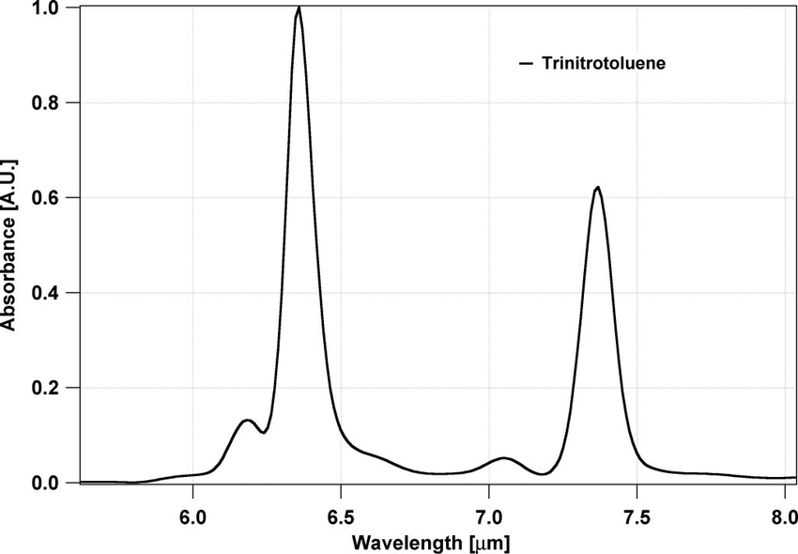
Figure 1 - Absorption Spectrum of TNT [1]

Equation 1 - $Wavenumber \left({cm}^{-1}\right)=\frac{{10}^{4}}{Wavelength (µm) }$

From Equation 1 we can take the 2 major peaks and 2 minor peaks and convert them into wavenumbers in the table below. From this data the functional groups can be identified. [2] [3] [4]

Wavelength estimate (µm) | Wavenumber approximation (${cm}^{-1}$) | Peak Shape | Functional Group
6.3 | 1587 | Strong / Sharp | C=C stretching and or asymmetric NO₂ stretching
7.3 | 1370 | Medium / Sharp | Symmetric NO₂ stretching confirming first peak at 6.3 is Asymmetric NO₂ stretching.
6.2 | 1613 | Weak/ Broad | C–H Bending
7.1 | 1408 | Weak / Broad | C–N Stretching
Table 1 - TNT absorption peaks Processing

As Table 1 demonstrates the reading of absorption data can be difficult and heavily specialised. This is the reason that most FTIR experiments use a library of known results to compare against. This provides the user with a quick and accurate method of achieving a result without having to use the basic principles of functional groups to determine the chemical composition.

FTIR is regularly used in Ordnance Munitions and Explosives (OME) as a method of energetics identification, residue analysis and thermal stability analysis. FTIR analysis is used as it has key advantages being non-destructive, highly sensitive, versatile and can be made portable. [5]

Mainly FTIR is used in the identification of materials post incident. For example when an Improvised Explosive Device (IED) has been either recovered, made safe or initiated the identification of the energetic used can support the investigation and help prevent future incidents [6]

Experiment Purpose

The aim of this experiment is to identify the 4 unknown samples using the FT-IR machine to prove the process and identify the materials. The scenario provided by the lecturer is detailed below.

“Following a site inspection at a small materials-testing facility, inspectors recovered a series of labelled reference powders that were reportedly being used in the evaluation of new energetic formulations. The materials are common industrial or laboratory chemicals, but each represents a different class of functional group frequently encountered in the design, manufacture, or degradation of energetic compounds. Before the samples can be cleared for safe disposal, confirmation of their identity and chemical functionality is required.” [7]

Hypothesis

The hypothesis is that the 4 materials will be identified using the FTIR machine and associated material library with a confidence level of above 95%.

Variables

The below table details the variables identified in this experiment, their type and how they relate to the experiment

Variable Type | Variable | Effect/ example
C | FTIR Technique | The equipment available and therefore the technique used can affect the results KBr Plates vs ATR Crystal.
C | Instrument Calibration | Is the machine calibrated, when and is the experiment using reference materials.
C | Instrument Settings | Settings like the apodization function will alter how much smoothing or background noise is removes from the result.
C | Spectral Resolution | This resolution setting determines how many ‘bounces’ through the sample the laser does and therefore will impact the readings
D | Absorbance / Transmittance | This is the primary measurement.
D | Baseline Characteristics | How much noise exists on the result, this directly reflects how contaminated the sample is. The less noise the purer the sample.
D | Peak Intensity | This corelates to how concentrated the sample is and the strength of certain bonds.
D | Peak Position | This correlates to Bond vibration frequencies.
I | Sample | Which sample is being tested.
I | Sample Composition | What the sample is.
I | Sample Phase | what phase the sample is, S,L or G
I | Sample Thickness | The thickness of the sample can affect.
Table 2 - Experimental Variables

Materials and Setup

PPE
Safety Goggles
Nitrile Gloves

Materials
Isopropyl alcohol
Blue Roll
Powdered Sample Materials
Equipment
1 x Sample Container Per sample.
1 x Metal Spatula Per Sample
1 x Perkin Elmer Spectrum 2 with Diamond ATR and associated equipment

Setup
Other than the gathering of appropriate materials no setup is specifically required for this experiment outside of the procedure. If the FTIR is new the manufactures instructions should be followed for initialisation and first use. [8]

Procedure
The procedure outlined below details what was performed in the experiment but does not include specifics related to the equipment being used.

  - Prepare Sample
    - Place a small amount of the sample in a labelled disposable container.
  - Prepare FTIR Machine
    - Start Up Machine
    - Retract foot from sample plate
    - Remove Protective covers from foot and sample plate
  - Clean Sample Plate and Foot
    - Rotate foot to clear plate to enable cleaning.
    - Remove foot by pulling down gently.
    - Clean sample plate and foot using IPA and Blue Roll.
    - Re attached foot gently be pushing it back on.
  - Perform Background Scan.
    - Rotate Foot to over the sensor
    - Tighten the foot till the ratchet clicks
    - Initiate the background scan on the software.
    - Observe the results for any irregularities to the ‘normal’ scan. ‘If anything makes sense clean and test again’.
    - Once successful test is achieved loosen the foot and rotate the foot out of the way of the sample plate to finish preparation for the sample.
  - Load Sample
    - Using the metal spatula add a sufficient pile of the material to the sensor until the sensor is covered. The quantity does not matter if the sensor is covered. “This is bucket chemistry” [9]
    - Rotate the arm and foot over the sample.
    - Tighten foot until the ratchet clicks
  - Scan Sample
    - Select Scan
    - Wait for Initial Scan
    - Confirm reading is logical for expected material
    - Select Scan
    - Await Final Scan to complete.
  - Initial Processing
    - Change Sample results graph line colour to something ‘sensible’
    - Compare result to available Library
    - Observe and note Initial Result
    - Save Files in file format Name: YYYYMMDDHHMM-SAMPLENAME-OPERATOR.csv
    - Repeat from Step 3 for each new sample.
  - Initial Results from Library Lookup
    - Sample A Vit C Powder
    - Sample B Guanidine Nitrate
    - Sample C Methyl 3-nitrobenxoate
    - Sample D Acetaminophen (Paracetamol)
  - Tidy Up
    - After the final sample has been tested, repeat Steps 3 and 4 till clean.
    - Replace Foot and Plate covers
    - Tighten foot till click.
    - Power down equipment.

Observations and Data

The full results achieved for each sample can be seen in Annex 2 separated by sample, this also details the library search results for each sample. The below section reports the individual spectra for each sample with the associated absorption peaks.

Sample A

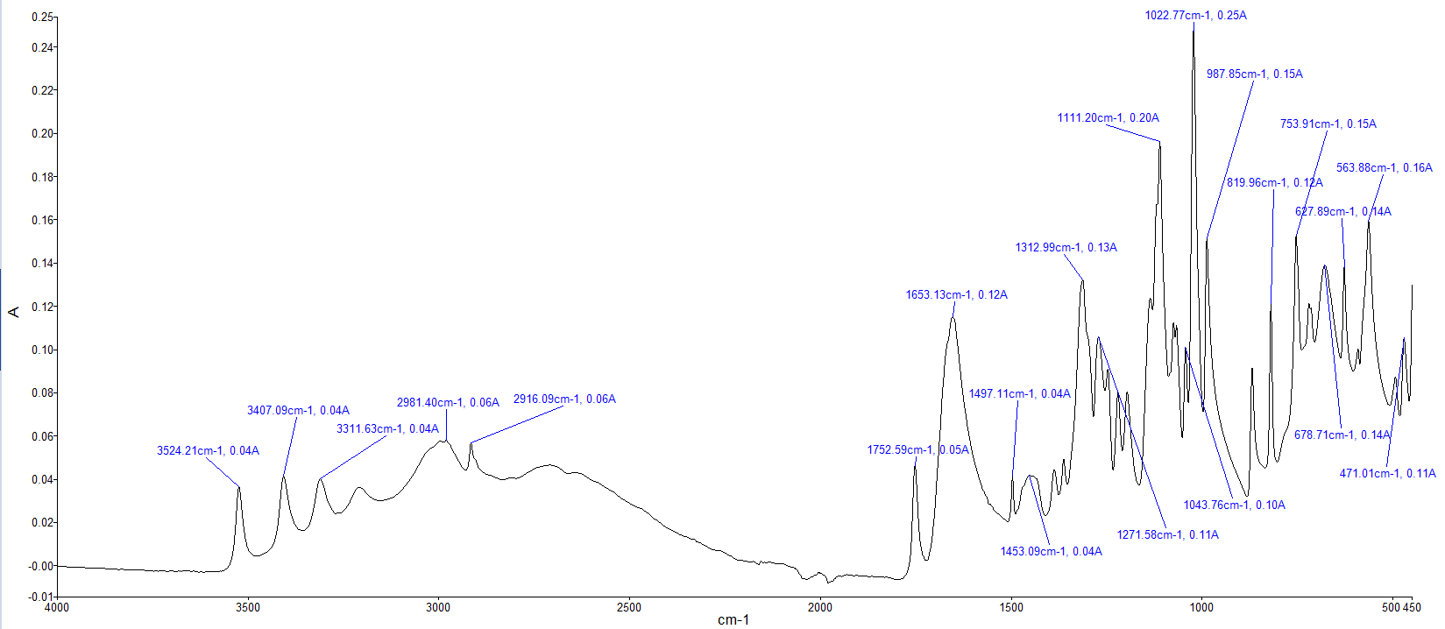
Figure 2- Sample A Spectra

Sample B
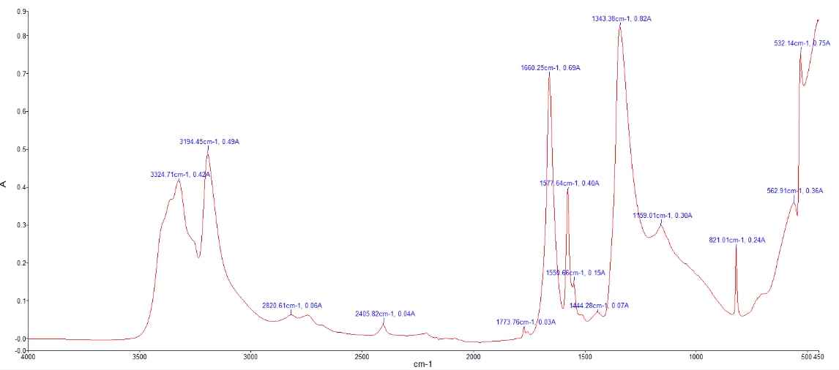
Figure 3 - Sample B Spectra

Sample C

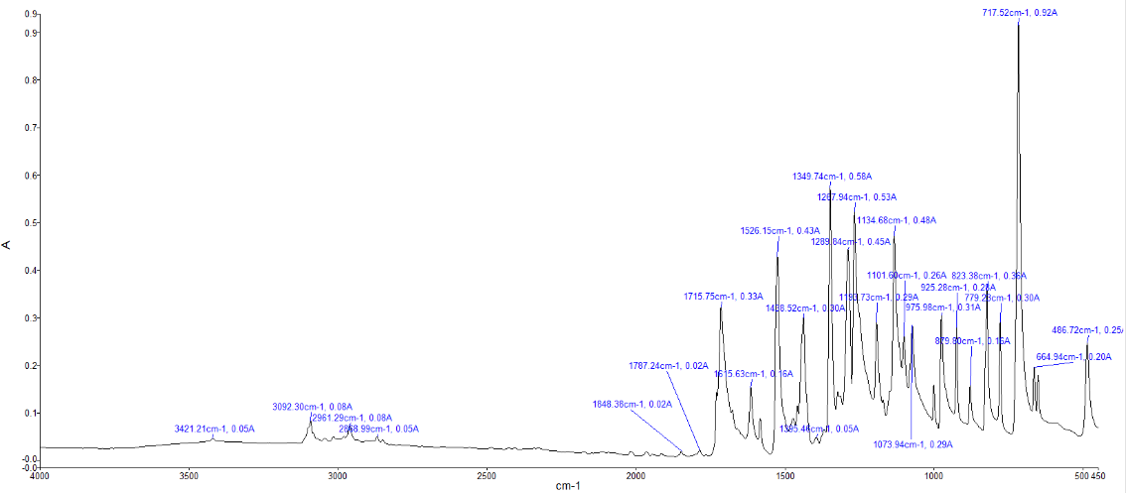
Figure 4 - Sample C Spectra

Sample D
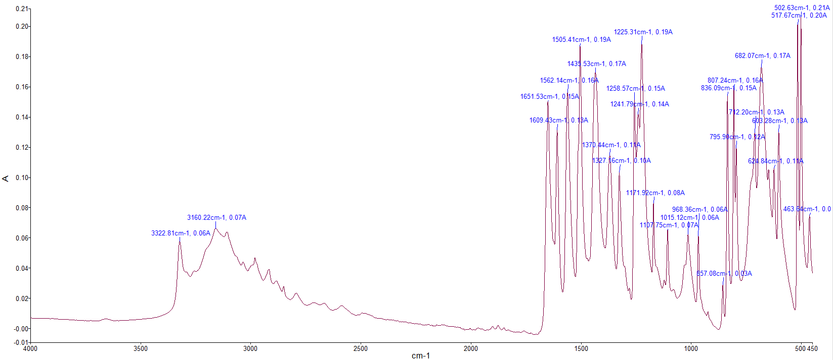
Figure 5 - Sample D Spectra

Calculations and Processing

The common method to process and evaluate FTIR spectra is to compare the resultant absorption spectra to a library of known spectra. This is the fastest and most effective way of accurately determining the chemical in a spectrum. Prior to these libraries being available, the reading of spectra results was a valued skill. The sections below detail the major functional groups that can be identified from the sample spectra as this is what would be done when a there is no result from a library or chemical is unknown.

Due to the constraints of this report only sample A will be evaluated manually as detailed in the introduction using a list of available functional groups with wave numbers [10].

Sample A

Wavenumber approximation (${cm}^{-1}$) | Peak Shape | Functional Group
3524, 3407,3311 | Sharp | O-H Stretch
2981, 2916 | Broad, Medium | C-H Strech
1732, 1653 | Strong, Sharp | C=O Stretch
1497,1453 | Medium | C-H Bending
1271, 1111, 1043 | Strong, Sharp | C-O Stretch
987,819,753 | Strong, Sharp | C-H Bending

From the above functional groups, it can be determined that the sample has a at least a hydroxyl Group, a Benzene Ring and a Carbonyl Group but without more detailed evaluation it is not simple to determine the compound from this information.

Results & Discussions

Library Identification

Using the available library matching the below results can be concluded.

Sample Name | Determined compound | % Confidence From Library Search | Comments
A | Vitamin C Powder | 99.4 | High confidence in results
B | Guanidine Nitrate | 95.3 | Slightly lower confidence than expected. Could re-run.
C | Methyl 3-Nitrobenzoate | 52.8 | Compound not in library, identified Ethyl 4-nitrobenzoate instead
D | Paracetamol (acetaminophen) | 99.3 | Hi confidence in results
Table 3 - Library Search Results

The results in Table 3 provide high confidence in the identification of samples A,B and D. With confidence matches all above 95% there is little likelihood of misidentification. Sample 3 came back with a incorrect match with a low confidence. On further investigation it was determined that the correct spectra is not available in the library hence the incorrect result. In addition, as this sample was locally synthesised quality and contamination of the sample are concerns.

Conclusions
In conclusion the 4 unknown materials where able to be correctly identified using the FTIR despite sample C not being available in the library. The basic evaluation of the major functional groups within the samples further assured the correct results. FTIR spectrometry is a critical method in the identification of unknown materials within OME and is often used in both lab and field conditions. As a whole the experiment was a success, enabling the safe disposal of the materials from the given scenario.

References

[1] | I. G. D. M. P. A. G. T. R. G. Michael B. Pushkarsky*†, “High-sensitivity detection of TNT,” PNAS, vol. 103, no. 52, pp. 19630-19634, 2007.
[2] | LibreTextx, “Infrared Spectroscopy Absorption Table,” LibreTextx Chemistry, [Online]. Available: https://chem.libretexts.org/Ancillary_Materials/Reference/Reference_Tables/Spectroscopic_Reference_Tables/Infrared_Spectroscopy_Absorption_Table. [Accessed 12 10 2025].
[3] | R. O. R. R. Asep Bayu Dani Nandiyanto∗, “How to Read and Interpret FTIR Spectroscope of Organic,” Indonesian Journal of Science & Technology, vol. 4, no. 1, pp. 97 - 118, 2019.
[4] | Thermo Fisher Scientific, “basic organic functional group,” 27 02 2015. [Online]. Available: https://documents.thermofisher.com/TFS-Assets/CAD/posters/XX51346-E-0215M-OrganicFunctionalChart.pdf. [Accessed 14 10 2025].
[5] | C. Langford, “Explosives Identification Using FTIR Technology,” ThermoFisher Scientific, 14 12 2017. [Online]. Available: https://www.thermofisher.com/blog/identifying-threats/explosives-identification-using-ftir-technology/#:~:text=FTIR%20spectrometers%20are%20exceptionally%20useful,and%20then%20together%20(right):. [Accessed 12 10 2025].
[6] | 1. P. a. J. W. R. P. Yongyan Mou, “Detection and identification of explosive particles in fingerprints using attenuated total reflection-Fourier transform infrared spectromicroscopy,” Forensic Science, vol. 54, no. 4, pp. 739-973, 2009.
[7] | E. Kazimierska, “ACDA6020 LAB #1 FT-IR Analysis and Identification of Organic Materials,” 09 10 2025. [Online]. Available: https://moodle.uwtsd.ac.uk/course/view.php?id=11711. [Accessed 12 10 2025].
[8] | PerkinElmer, “L1050228-Spectrum-Two-Users-Guide,” 04 2015. [Online]. Available: https://www.s4science.at/wordpress/wp-content/uploads/2019/04/L1050228-Spectrum-Two-Users-Guide-en-US.pdf. [Accessed 12 10 2025].
[9] | D. M. Broadhead, Interviewee, Experimental Introduction. [Interview]. 10 10 2025.
[10] | InstaNANO, “FTIR Functional Group Database Table with Search,” Instanano, [Online]. Available: https://instanano.com/all/characterization/ftir/ftir-functional-group-search/. [Accessed 2025 10 13].

Annex 1 – Experimental Notes Digital and Physical

The below annex details the data and information captured through both digital and written means during the experiment.

Fillable FT-IR Method Template
(complete every field. Where asked to justify a choice, give a short reason,1–2 sentences.)
1. Safety & sample handling (tick / fill)
PPE required: [ ] Lab coat [x] Nitrile gloves [x] Safety glasses [ ] Fume hood if dusty
Hazard notes (brief): No Specific Notes in relation to the Task but unknown chemicals should be treated with sufficient caution
Waste route (how samples / wipes will be disposed):
Most samples present no hazard and therefore contaminated supplies can be disposed of through general waste. Methyl 3-nitrobenzoate contaminated items will be disposed centrally through contaminated waste.
2. Equipment & consumables (list model where applicable)
Item | Make / model (if known) | Qty / Notes
ATR-FTIR spectrometer | Perkins Elmer Spectrum 2 | ___1___
ATR crystal (type) | X Diamond ☐ ZnSe ☐ Other: | ___1___
Cleaning solvent | (IPA / EtOH / other) | ___500ml___
Micro-spatula / tissue | Blue Tissue and Metal Spatulas | 1 Roll + 1 Spatula per sample
PC / software | Spectrum IR | ______
Reference spectra files | Stored in local Library | ______
3. Acquisition parameters (fill and justify)
Spectral range: 4000 – 250 cm⁻¹ - This is the capability of the machine.
Resolution: __________________ cm⁻¹ - Justification: this refers to how many ‘bounces’ the laser does along the sample
Background scans: 15 scans - Justification: this is considered a statistically relevant number of scans to allow for a more relevant average reading of the sample.
Sample scans: 15 scans - Justification: Same as background.
Apodization function: __________________ - Justification: TBC
Pressure/force guidance: (how you will ensure consistent contact)
The ATR has an inbuilt max torque wrench
File naming convention: YYYYMMDDHHMM-SAMPLENAME-OPERATOR.csv
Files to be saved: [ ] native format [X] .csv [ ] .png/.pdf annotated
4. Step-by-step measurement procedure (numbered)
(Be explicit so another trained student could reproduce your work.)
- Prepare Sample
  - Place a small amount of the sample in a labelled disposable container.
- Prepare FTIR Machine
  - Start Up Machine
  - Retract foot from sample plate
  - Remove Protective covers from foot and sample plate
- Clean Sample Plate and Food
  - Rotate foot to clear plate to enable cleaning.
  - Remove foot by pulling down gently.
  - Clean sample plate and foot using IPA and Blue Roll.
  - Re attached foot gently be pushing it back on.
- Perform Background Scan.
  - Rotate Foot to over the sensor
  - Tighten the foot till the ratchet clicks
  - Initiate the background scan on the software.
  - Observe the results for any irregularities to the ‘normal’ scan. ‘If anything makes sense clean and test again’.
  - Once successful test is achieved loosen the foot and rotate the foot out of the way of the sample plate to finish preparation for the sample.
- Load Sample
  - Using the metal spatula add a sufficient pile of the material to the sensor until the sensor is covered. The quantity does not matter if the sensor is covered. “This is bucket chemistry” [9]
  - Rotate the arm and foot over the sample.
  - Tighten foot until the ratchet clicks
- Scan Sample
  - Select Scan
  - Await for Initial Scan
  - Confirm reading is logical for expected material
  - Select Scan
  - Await Final Scan to complete.
- Initial Processing
  - Change Sample results graph line colour to something ‘sensible’
  - Compare result to available Library
  - Observe and note Initial Result
  - Save Files in file format Name: YYYYMMDDHHMM-SAMPLENAME-OPERATOR.csv
  - Repeat from Step 3 for each new sample.
- Initial Results from Library Lookup
  - Sample A Vit C Powder
  - Sample B Guanidine Nitrate
  - Sample C Methyl 3-nitrobenxoate
  - Sample D Acetaminophen (Paracetamol)
- Tidy Up
  - After the final sample has been tested, repeat Steps 3 and 4 till clean.
  - Replace Foot and Plate covers
  - Tighten foot till click.
  - Power down equipment.
5. Data processing & interpretation policy (state what you will do)
ATR correction: [ ] Apply [X] Do not apply - Reason: Not Needed
Baseline correction: [ ] Yes [X] No - Method / settings: None
Smoothing: [X] None [ ] Savitzky-Golay (window = ___, poly = ___) - Reason: Smoothing from 15 scans and Average
Peak-picking rules: (e.g., pick top 5 peaks > X% absorbance, tolerance ± Y cm⁻¹)
Manual____________________________________________________________________
Library search use: [X] Will run library search - acceptance threshold: 95 %
Manual justification requirement: (state how many diagnostic peaks you will cite) ___
6. Quality control / validation checks (tick and comment)
Background collected at start - time: ______ - comment: ____________________
Blank collected after each sample - comment: Yes per notes and Procedure.
Replicate acquisition performed on sample: [ ] A [ ] B [ ] C [ ] D - results OK? [ ] Yes [ ] No - notes:
ATR crystal cleaned between samples - method: Clean after Test, Re background test, and then next sample
S/N check - main peaks S/N ≥ ______ - measured at _____ cm⁻¹ - value: _____
If any check fails, describe corrective action: Reclean, Background Scan, and Retest
7. Troubleshooting (two likely problems and mitigation)
Problem 1: Contamination
Action: Reclean, Background Test and Retest
Problem 2: Poor Sample Contact
Action: Retighten till torque drive clicks, retest.

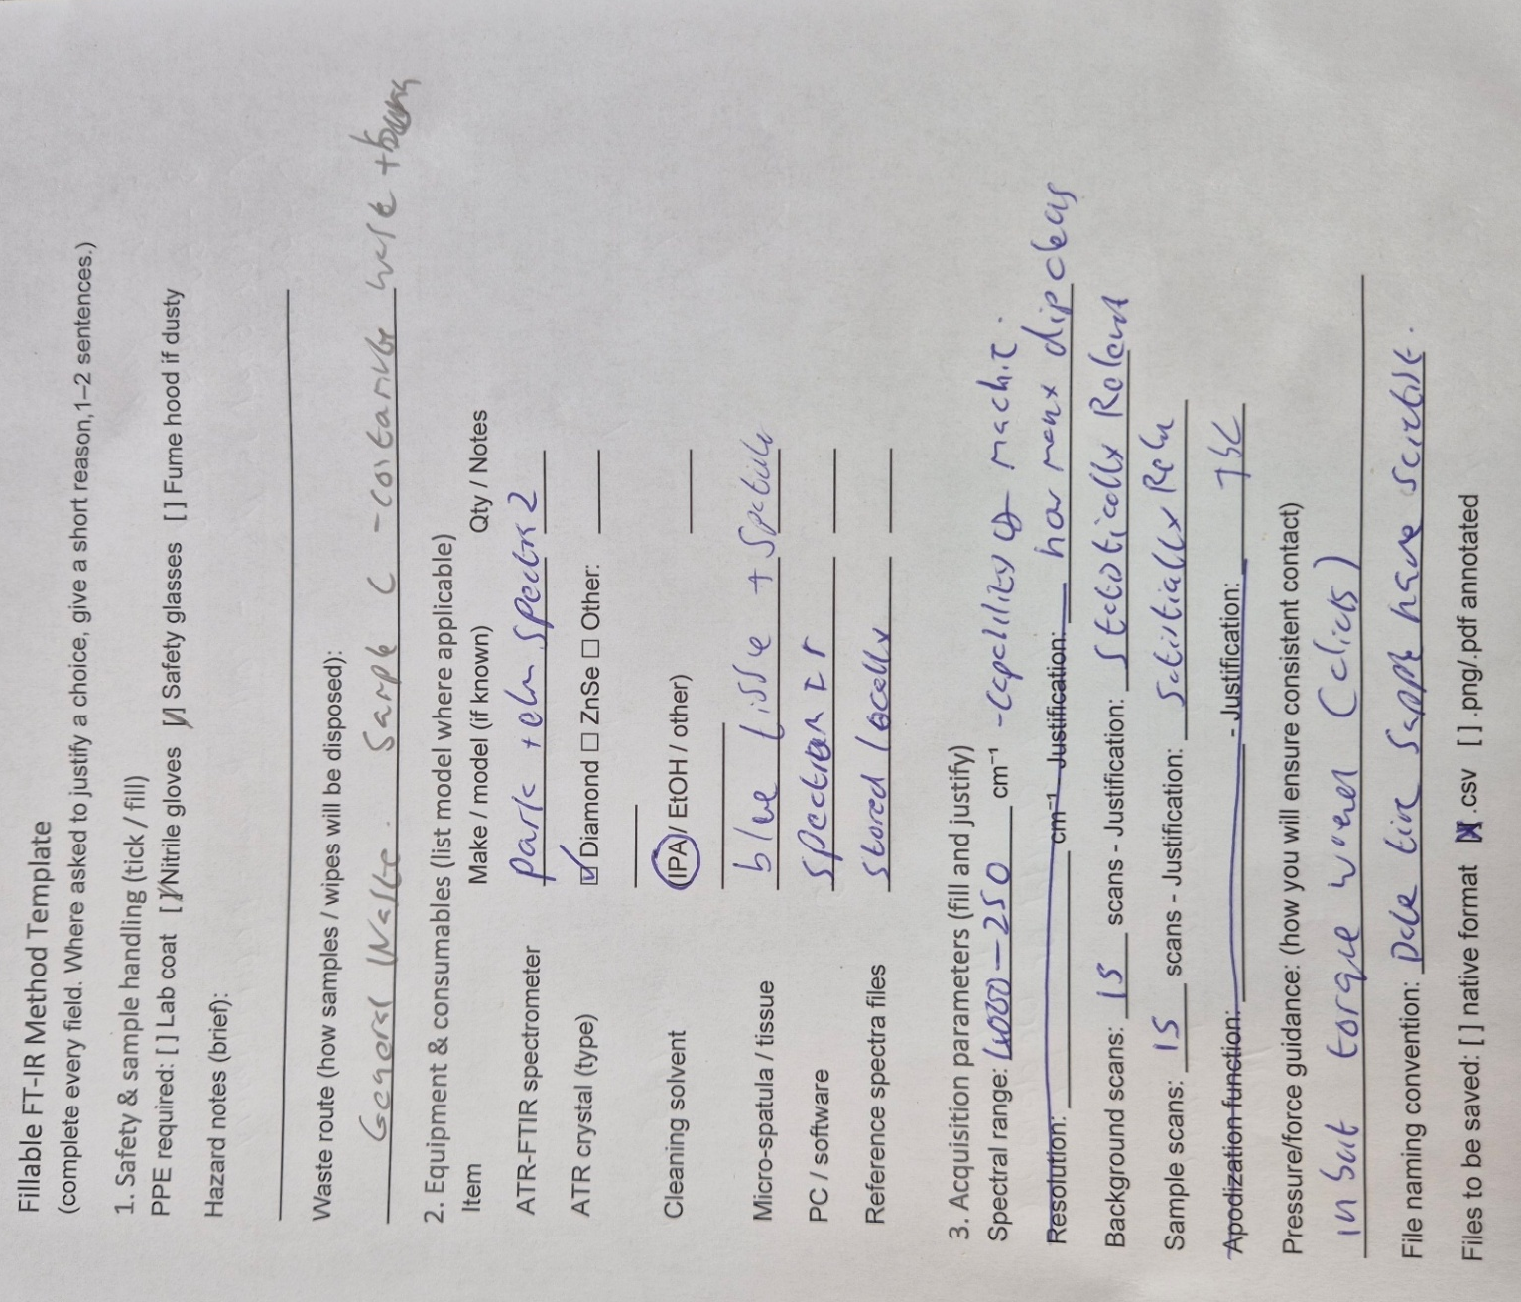
Figure 6 - Written Experiment Notes Page 1
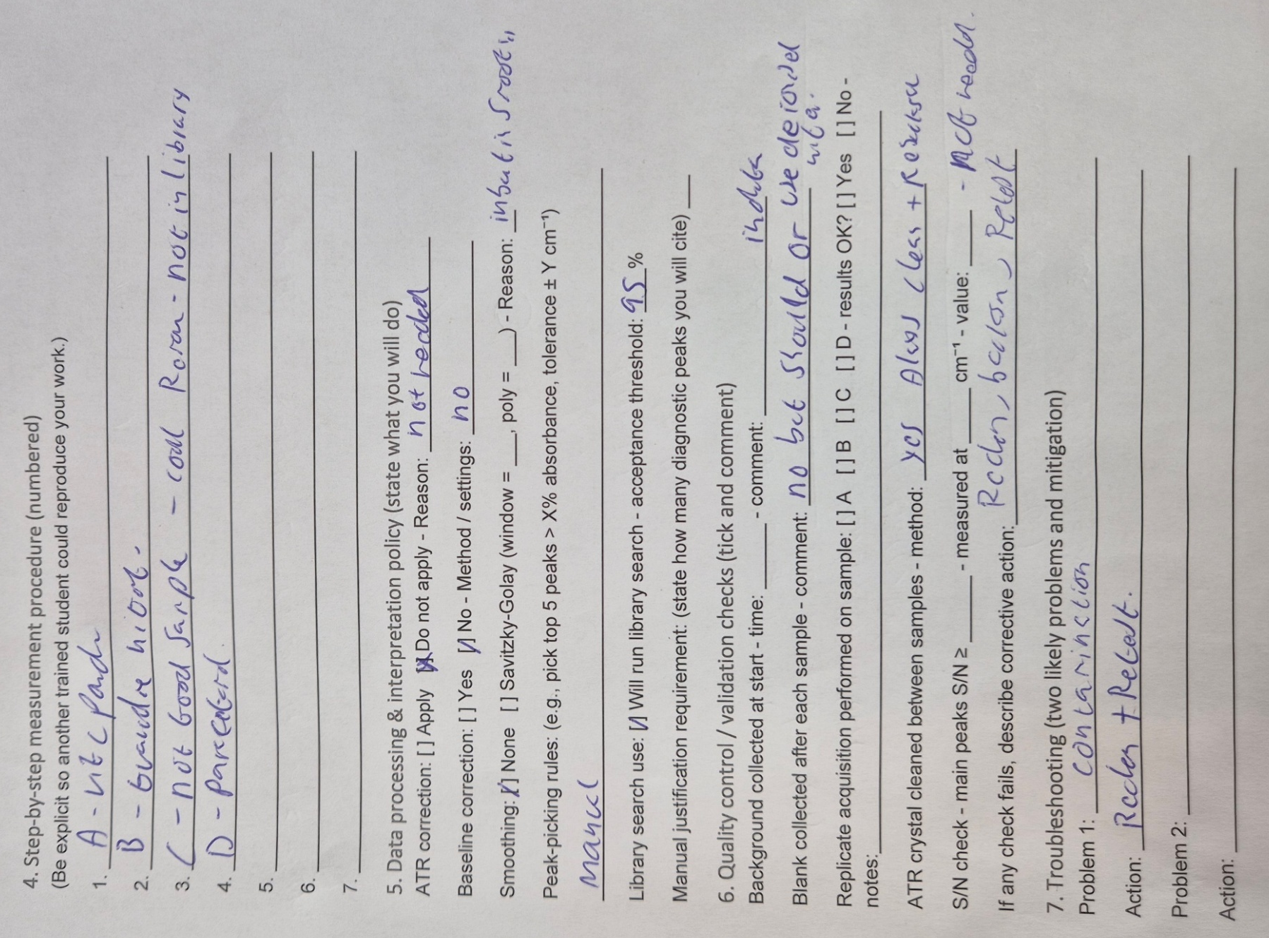
Figure 7 - Written Experiment Notes Page 2

Annex – 2 Raw Results

Sample A

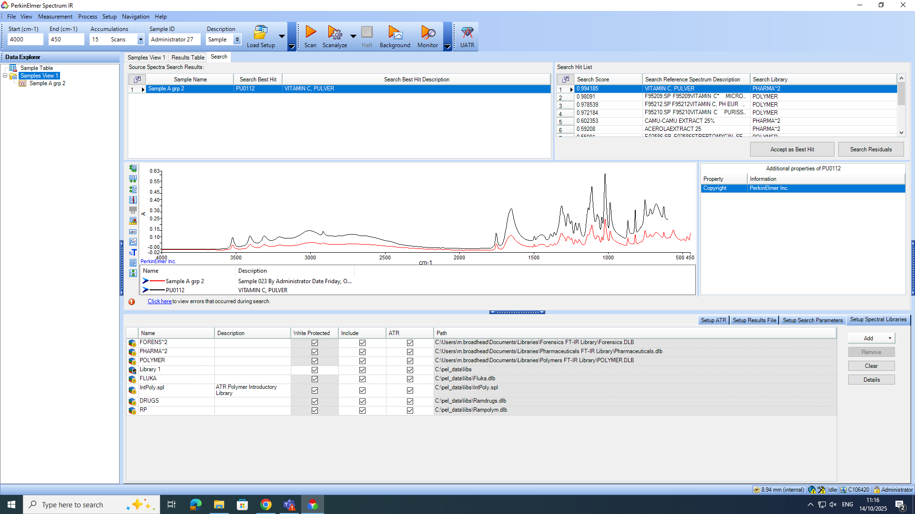
Figure 8 - Sample A Screen Shot

Figure 9 - Sample A Spectra

Sample B

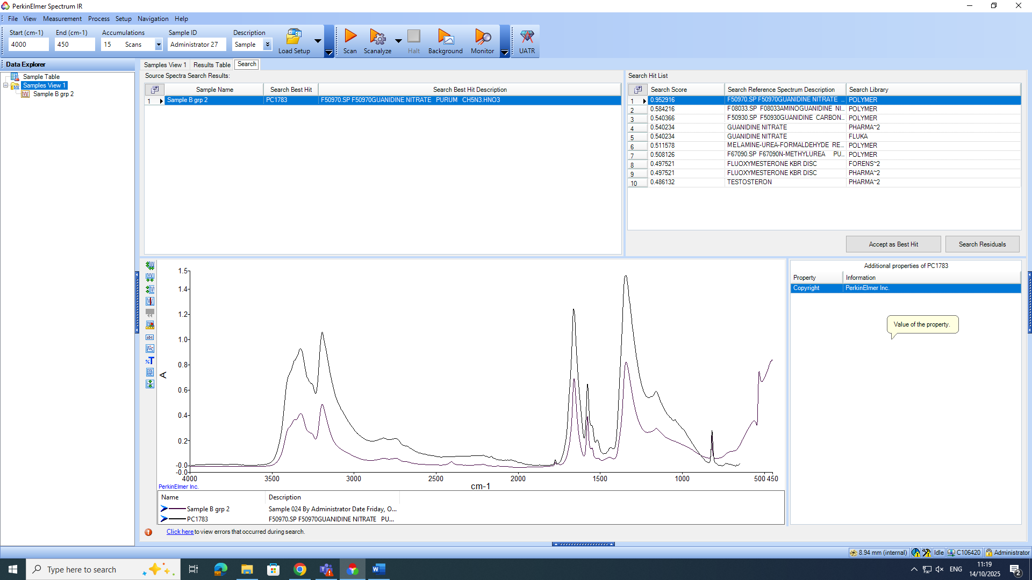
Figure 10 - Sample B Screen Shot

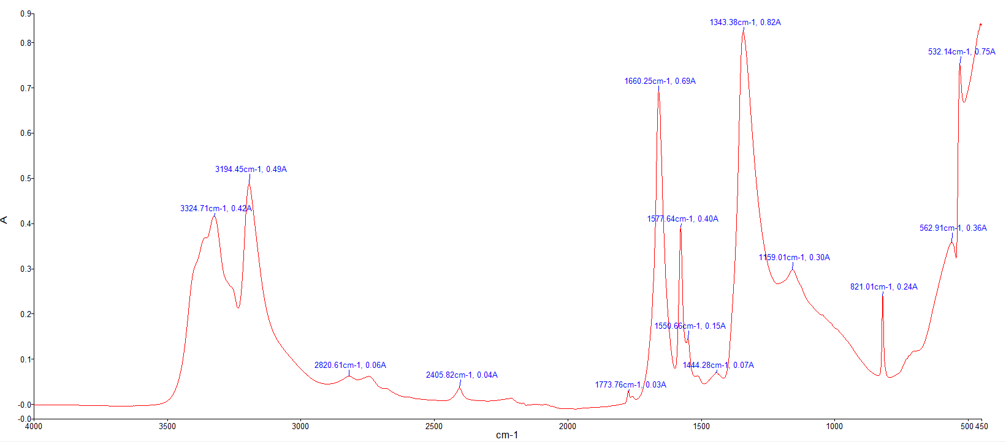

Figure 11 - Sample B Spectra

Sample C
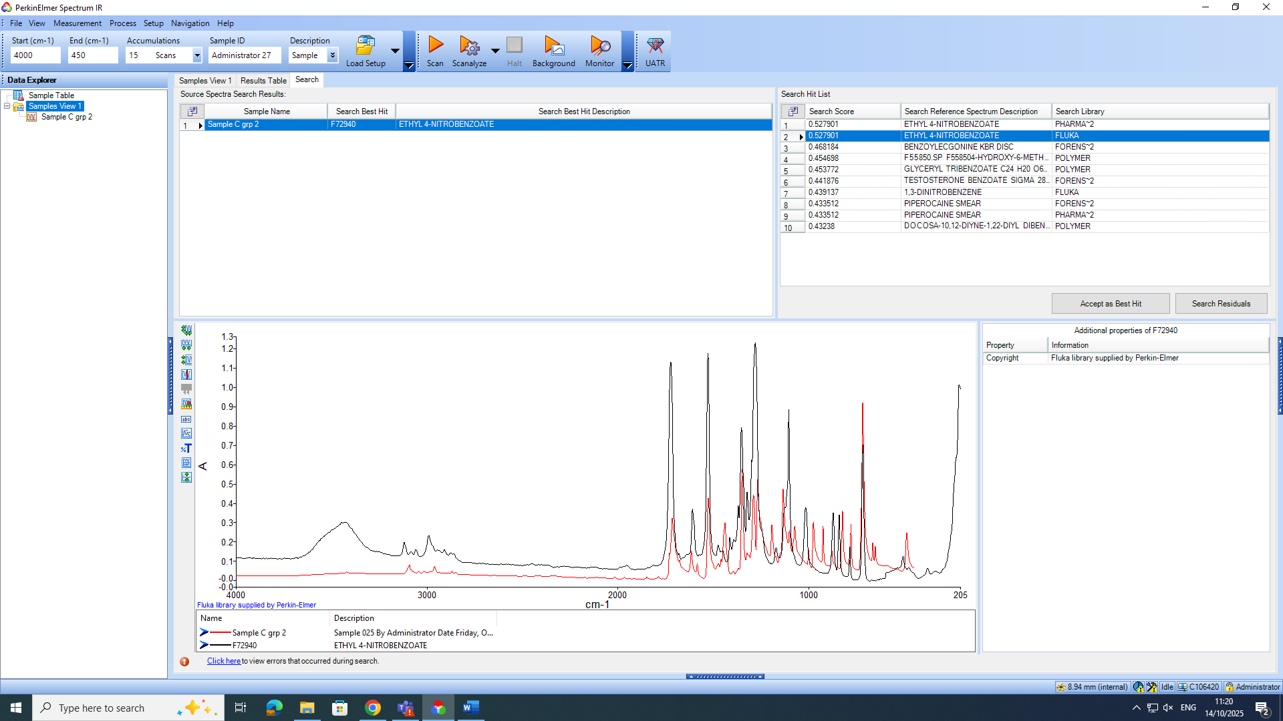
Figure 12 - Sample C Screen Shot

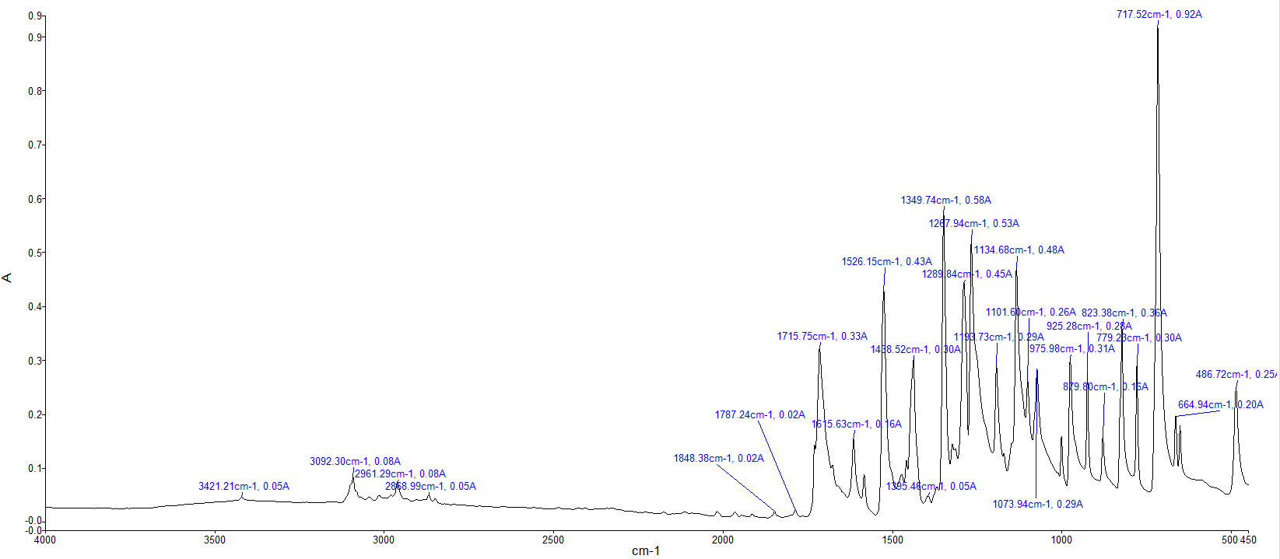
Figure 13 - Sample C Spectra

Sample D
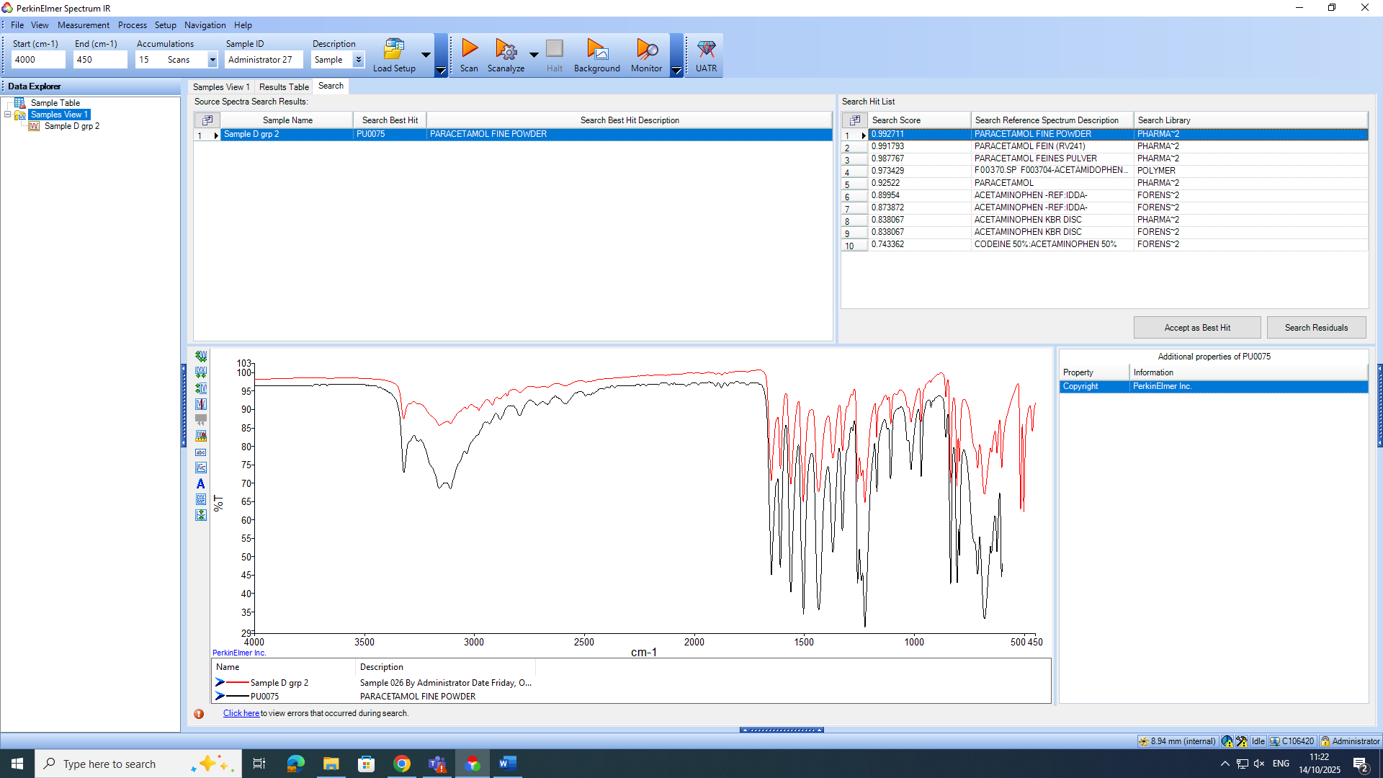Figure 14 - Sample D Screen Shot
Figure 15 - Sample D Spectra

I = Independent, D = Dependent, C = Controlled

