Module Title: Digital Skills and Research Methods

Table of Contents
Introduction 3
Rationale 3
Objectives 3
Literature review 4
Concept of Virtual Learning Environments 4
Positive and negative impacts of VLEs 4
Improvement in virtual Learning environment 5
Methodology 6
Research Approach 6
Data Collection Method 6
Sample and Sampling Technique 6
Survey Questionnaires 7
Primary Data Analysis 8
Secondary Data Analysis 9
Conclusion/Recommendation 13
References 14

List of Figures:
Figure 1: Managed Virtual Earning 10
Figure 2: Market share of VLE 10
Figure 3: Staggering VLE 11
Figure 4: Opportunities For VIE 12

List of Pie Charts:
Pie chart 1 8
Pie chart 2 8
Pie chart 3 9

Introduction
The research is based on the study of the Impact of Virtual Learning Environment (VLE) on the learning experience of students at the University of Wales Trinity Saint David London Campus. The focus is paid on the experience of students and the use of Virtual learning environment (VLE) in present times. The research has obtained information to understand the impact of VLE on the learning experience of students by assessing their performance. Virtual Learning Environment (VLE) is similar to an online classroom system where the e-learning courses can be hosted for students to participate in. the impact of virtual learning environment, its concept and effects have been mentioned in the study.

Rationale
The emergence of VLE in recent times have become an important focus for imparting knowledge and education to students. So, it is important to understand the learning style and maintain an environment to enable students to get the best out of it. If they are not catering to the needs of the students then there are rendered useless as it has no impact on the learning experience. The VLE must be such that it gives enough information to allow students to keep engaging in their learning experience and broaden their understanding of the study.

Objectives
- To understand the concept and knowledge of virtual learning environment
- To provide recommendation for better learning experience by collaborating with technology and virtual learning environment
- To evaluate the positive and negative impacts of Virtual Learning Environment on students

Literature review

Concept of Virtual Learning Environments
Virtual Learning Environments (VLE) had been introduced to assist in formal learning in educational institutions. This is considered to be a dynamic concept since it has kept on evolving with changes in technology. These systems are being used by a number of educational institutions- universities, schools- teachers and students. The system of virtual learning environment has been useful in gathering valuable data and analysing its contents as per the need of the course of study. These are similar to mediators in the process of learning that use technology for the activities related to it (Grivokostopoulou, et al.,2020). Virtual learning environment are helpful in facilitating continuous and uninterrupted interaction within the learning process. Thus, it is helpful in enhancing the framework and constructing the educational process. The educational environment are multidimensional concept that are dynamic and keep emerging with evolutions in the society and technology.
The main disposition of the VLE is to provide ways to assist in the production and dissemination of contents, communicating and assessing in the process of learning. The virtual learning environment provides these features in various dimensions such as time, strategies, virtual space and resources (Herrera, 2017). These help in the assimilation, management and distribution of information for the members associated in the process in a simple and qualified manner. Virtual learning environment enable to conduct the process of learning in assistance with the components of such an environment.

Positive and negative impacts of VLEs
A virtual learning environment is beneficial for a student since it provides them to learn at their own pace and bestows them with the opportunity of learning and adhering to new skills without having to go anywhere. It beneficial in supporting the progression of the students in their particular courses, while fulfilling educational needs in the areas of personalised, out of schools learning, and immediate in-class as well as assessment out of school (Dung, 2020). These provide educators with the benefit to set course and lessons without any interruption regardless of the distance and are also providing the facility to work remotely if required.
There are various challenges in Virtual learning environment as well. Unrealistic and virtual experiences are created which are not imperative in relevance to the everyday environment of life. These can lead to having boring and irrelevant experiences which have been created with such hard work. At times, the modules or course are not in sync with the culture and structure of the institution. The feedback received is also limited; the learners can access the teachings modules, contents at any time as per their requirements but they are not always able to ask their queries and get instant answers (O’Connor and Larkin, 2019). This delays their understanding of the content and might create deviation in their learning process. Thus, rendering them with limited knowledge of the subject. This system of learning often isolates from the engaging environment where every individual participates in real-time question-answer activities. This at times leads to disengagement from the end of learners leaving them feel completely left-out and having limited understanding of the course. Issues of improper network connectivity, security problems, and other technical glitches. These problems are likely to arise in virtual platforms and can have damaging effects on the virtual learning environment.

Improvement in virtual Learning environment
- To increase engagement between teacher and students
It is required to improve the interaction between the teachers and learners for improving the experience of virtual learning for both. In order to improve engagement between student and educators, it is required to allot time frames accordingly. In one time frame the educators shall present the study and in the next the students must be allowed to put forward their queries and issues related to the course of study (Beňo and Ölvecký, 2019). This improve the interaction and does not let any student feel left out in the experience of virtual learning environments. This might also require increasing the time duration for the courses.
- Development in infrastructure of virtual learning environments
The infrastructure in the learning process of virtual environment must be improved. these includes development in network availability, internet speed, connectivity, and availability of proper technology and equipment for accessing the virtual learning need to be developed so that every student is able to connect and engage in this environment. The technologies must be developed in such a manner to make virtual learning environments accessible to students from every stratum of the society.

Methodology

Research Approach
The research method is primarily segmented into two major block of research that is data collection and data analysing. For data collection quantitative data is used and for data analysing the data, deductive approach is used. The deductive approach is mainly focused on every segment of research and apply knowledge and learning to extract accurate result of the research.

Data Collection Method
The data collection methods applied in this research are survey and secondary data. The research uses both type of data to analyse the impact of virtual learning environment on the learning capacity and ability of students of University of Wales Trinity Saint David London Campus that is primary and secondary data. To collect primary data, survey is used with 8 different questionnaires (that includes on demographic, behaviour, psychology and many more) and secondary data from journals and articles.

Sample and Sampling Technique
The sample size for primary data collection is 60 and the all the 60 participants are from the same university mentioned in the research. The sampling method used for this research is random sampling technique, as it provides higher chance of collecting right information.

Survey Questionnaires
Q1. What is your age?
Strongly Agree | Agree | Neutral | Disagree | Strongly Disagree

Q2. How do you feel virtual learning environment is being used as primary tool in educational institute?
Strongly Agree | Agree | Neutral | Disagree | Strongly Disagree

Q3. Does learning with virtual environment has higher impact on the student?
Strongly Agree | Agree | Neutral | Disagree | Strongly Disagree

Q4 How do you feel about the lack of infrastructure for virtual environment has made significant disturbance for students?
Strongly Agree | Agree | Neutral | Disagree | Strongly Disagree

Q5. Are you satisfied with the process of online learning classes over offline classes?
Strongly Agree | Agree | Neutral | Disagree | Strongly Disagree

Q6. Do students adapt with the virtual learning environment quickly over offline learning environment?
Strongly Agree | Agree | Neutral | Disagree | Strongly Disagree

Q7. Do you think teacher need to adapt and learn more of technology use and learning assistance?
Strongly Agree | Agree | Neutral | Disagree | Strongly Disagree

Q8. Do you think virtual environment has better impact on the learning process of students than classroom process?
Strongly Agree | Agree | Neutral | Disagree | Strongly Disagree

Primary Data Analysis
The data analysis of all the questionnaire answered by all the 60 participants are analysed with the uses of graphical representation.

Pie chart 1
In the first question, the number of participants it highest number of populations belongs to 23-26 years of age. This age group has 30% of the total sample size.

Pie chart 2

The next question focused on the virtual learning environment being right for educational institute and around 75% of the participants has strongly agreed with the question. Therefore, it signifies that majority students have shown high interest toward the virtual learning environment.

Pie chart 3
The next question was emphasized on the lack of infrastructure that provides virtual learning environment and more than 80% of the students have agreed to the question. This showcase that students do suffer from poor infrastructure to process virtual environment.

Secondary Data Analysis
The virtual learning environment is basically web-based platform under which education technology is surfaced keeping in configuration the entire digital requirement. The virtual learning environment platform helps to present audio and video availability between parties to present their instructions and other content in the virtual platform. In other words, it can be said as sharing of information with real-time communication facilities with live audio and video conferencing. The main advantage of the virtual learning platform includes specific resource system and mechanism of detailed interaction between students and related parties. The virtual learning platform helps in increasing the overall academic performance of the students with accelerated learners and real-time progress tracking of the students and managing other words related to industry and operations of the organisation. The secondary data analysis has been taken into consideration for the real-time explanation of the virtual learning environment platform.
The virtual learning environment has a very feasible and accessible learning platform and also addresses the social economic issues of certain individuals. The whole process of virtual learning environment is very much feasible and accessible to the disabled people and is very much reliable under unforeseen circumstances and challenging situations. It helps to treat several diseases and creating a personal communication among individuals. The whole process proves to be very fruitful and helpful for the blind and visually impaired individuals and is very much helpful for mental health problem and is reliable in giving medications and treatment of certain diseases like dyslexia.
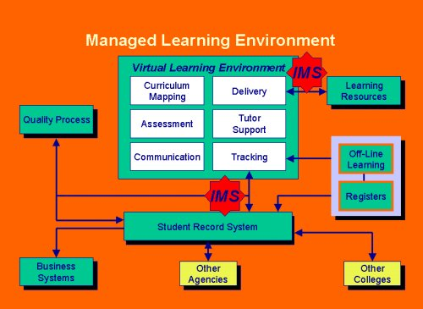
Figure 1: Managed Virtual Earning
(Sources: Al-Azawei, 2020)
The unforeseen circumstances including the covid-19 pandemic has realise the unexpected benefits of virtual learning and self-discipline to learn digitally capturing a wide range of individual which are geographical dispersed (Annansingh, 2019).
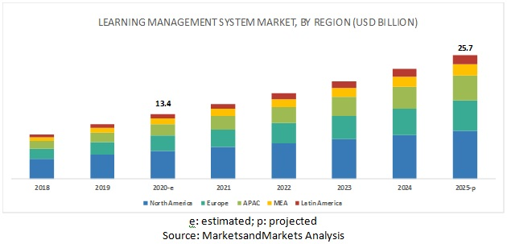
Figure 2: Market share of VLE
(Sources: Al-Azawei, 2020)

It is very important and specific to mention that as per the telecommunications report around 81% of the individuals interacted globally at least once during the time of pandemic and more than 54 % outside a traditional office at least half of the week. It is also worth mentioning that more than and 81% of 250 US business leaders offered working from home to their employees and among them 100% telecommuted
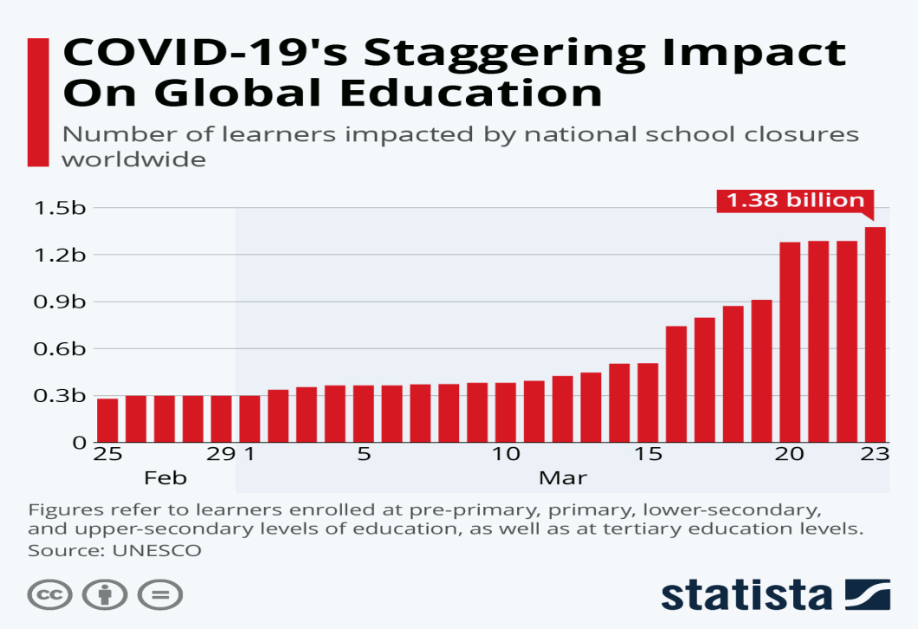
Figure 3: Staggering VLE
(Sources: Annansingh, 2019)
The virtual learning environment has also enhanced the overall learning process and is very helpful to train the employees in the best possible and efficient way (Al-Azawei and Al-Masoudy, 2020). There has been several and Rapid development in the virtual learning environment to solve several technical issues and made the overall environment satisfactory as per the needs and demands of the current situation.
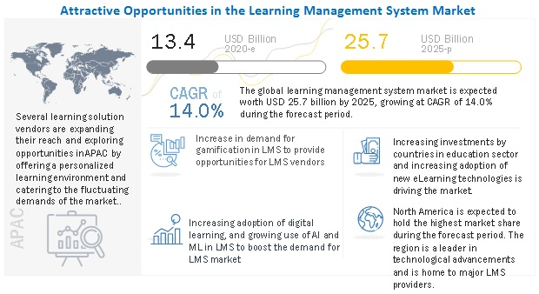
Figure 4: Opportunities For VIE
(Sources: Al-Masoudy, 2020)

There has been five segmented regions including North America Europe Asia Pacific Latin America which has seen a drastic hike in the use of virtual learning environment platforms for the students as well as the industrial and operational use as per the market and market analysis there has been smart learning market development for implementation in North America and South America with the effective collaboration of the Government and the regulations for the use of virtual learning environment platform and is also seen more than 81 % hike in the overall use of the platform

Conclusion/Recommendation
The research topic of virtual learning environment being used for student’s learning over the classroom environment in University of Wales Trinity Saint David London is being evaluated. The research is aimed to analysed research objective and it provide analysis of both primary and secondary data collected from survey and journals. The study showcases the lack of infrastructure provided to every student has made gap in learning and hence it is seen in the grading system of students.

References
Al-Azawei, A. and Al-Masoudy, M., 2020. Predicting Learners' Performance in Virtual Learning Environment (VLE) based on Demographic, Behavioral and Engagement Antecedents. International Journal of Emerging Technologies in Learning (iJET), 15(9), pp.60-75.
Annansingh, F., 2019. Mind the gap: Cognitive active learning in virtual learning environment perception of instructors and students. Education and Information Technologies, 24(6), pp.3669-3688.
Beňo, M. and Ölvecký, M., 2019, November. The impact of virtual learning tools on the student’s remembering knowledge. In 2019 17th International Conference on Emerging eLearning Technologies and Applications (ICETA) (pp. 64-68). IEEE.
Dung, D.T., 2020. The advantages and disadvantages of virtual learning. IOSR Journal of Research & Method in Education, 10(3), pp.45-48.
Grivokostopoulou, F., Kovas, K. and Perikos, I., 2020. The Effectiveness of Embodied Pedagogical Agents and Their Impact on Students Learning in Virtual Worlds. Applied Sciences, 10(5), p.1739.
Herrera Mosquera, L., 2017. Impact of implementing a virtual learning environment (VLE) in the EFL classroom. Íkala, Revista de Lenguaje y Cultura, 22(3), pp.479-498.
O’Connor, K. and Larkin, L., 2019. Making a Better Student Learning Experience for Virtual Learning Environment Users.

