Name: Noah John________________________________

Student Number: 2502346________________________
__________________________________________________________

WORKSHEET 2 – TESTING (Tiles)

- Original code:

[Copy and paste your original code from Moodle into this box. Do not change it.]

import math

tileHeightLength = 20
wallHeight = float(input("Enter the height of your wall (cm):").strip())
wallWidth = float(input("Enter the width of your wall (cm):").strip())

while wallHeight <= 0:
wallHeight = float(input("Please enter a valid height:").strip())

while wallWidth <= 0:
wallWidth = float(input("Please enter a valid width:").strip())

heightAmount = math.ceil(wallWidth / tileHeightLength)
widthAmount = math.ceil(wallHeight / tileHeightLength)

totalTiles = heightAmount * widthAmount

print("You need {} tiles".format(totalTiles))

- Code Testing

For each test below (i – vii), run your code and enter the values provided. Present a screenshot of the of what happened when the programme ran. Did the programme behave correctly or did it do something unexpected, and if so, why?

Input:

- Enter dimensions of wall: Width 40 Length 45
- Enter dimensions of wall: Width 100000 Length 200000
- Enter dimensions of wall: Width -16 Length -20

Logic:
- Enter dimensions of wall: Width 80 Length 80. The result should be 16 tiles
- Enter dimension of wall: Width 40 Length 45. The result should be 6 tiles
- Enter dimensions of wall: Width 85 Length 90. The result should be 25 tiles.
- Enter dimensions of wall: Width 15 Length 15. The result should be 1 tile.

Note: If you decided to include logic within your program to allow a tile to be cut such that 2 pieces can be used from the same tile where possible (therefore reducing the total number of tiles required), your results may differ from the above. In this case, explain your logic as part of your answer. If you did not, consider adding this logic to your final code.

Fill in a box for each test above. You should present 7 separate boxes, 1 for each test. (Note: the first box is provided as a template)

Test i:
Input i. - Enter dimensions: Width 40 Length 45
Screenshot(s) of output:
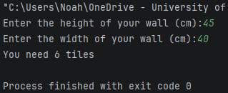
Result: Did the programme behave as expected ie syntactically and logically correct?
YES
If NO, what went wrong?
If YES, comment on what happened

The program ran the user inputs through the calculation and outputted the results with no problems.

Continue the rest of the tests below. (Copy and paste a box for each one)

Test:
Input ii – Enter dimensions: Width 100000 Length 200000
Screenshot(s) of output:
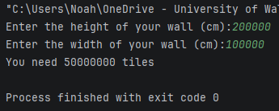
Result: Did the programme behave as expected ie syntactically and logically correct?
NO
If NO, what went wrong?
If YES, comment on what happened

Although the program ran the user inputs through the calculation and outputted the results with no problems. It would be unrealistic to assume any house owner would need 50000000 tiles. A validation rule should be put in place to prohibit a user from entering unrealistic values.

Test:
Input iii – Enter the dimensions: Width -16 Length -20
Screenshot(s) of output:
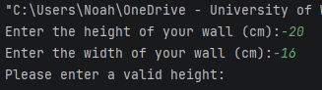
Result: Did the programme behave as expected ie syntactically and logically correct?
YES
If NO, what went wrong?
If YES, comment on what happened

Upon entering unrealistic (negative) values, the user inputs enter validation while loops that ask the user to enter valid inputs. The while loop(s) in question:

while wallHeight <= 0:
wallHeight = float(input("Please enter a valid height:").strip())

while wallWidth <= 0:
wallWidth = float(input("Please enter a valid width:").strip())

Test:
Logic iv - Enter dimensions of wall: Width 80 Length 80. The result should be 16 tiles
Screenshot(s) of output:
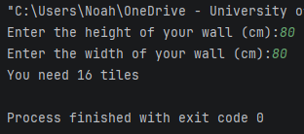
Result: Did the programme behave as expected ie syntactically and logically correct?
YES
If NO, what went wrong?
If YES, comment on what happened

The program ran the user inputs through the calculation and outputted the results with no problems.

Test:
Logic v - Enter dimension of wall: Width 40 Length 45. The result should be 6 tiles
Screenshot(s) of output:
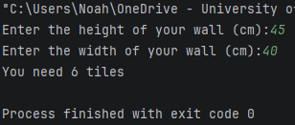
Result: Did the programme behave as expected ie syntactically and logically correct?
YES
If NO, what went wrong?
If YES, comment on what happened

The program ran the user inputs through the calculation and outputted the results with no problems.

Test:
Logic vi - Enter dimension of wall: Width 85 Length 90. The result should be 25 tiles
Screenshot(s) of output:
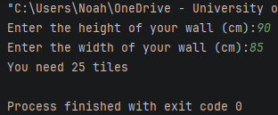
Result: Did the programme behave as expected ie syntactically and logically correct?
YES
If NO, what went wrong?
If YES, comment on what happened

The program ran the user inputs through the calculation and outputted the results with no problems.

Test:
Logic vii - Enter dimension of wall: Width 15 Length 15. The result should be 1 tile
Screenshot(s) of output:
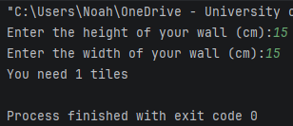
Result: Did the programme behave as expected ie syntactically and logically correct?
YES
If NO, what went wrong?
If YES, comment on what happened

The program ran the user inputs through the calculation and outputted the results with no problems.

- Consider the results of the above tests and revisit your code in order to solve any problems discovered at the testing phase. (Note: you may not be able to solve all of them, but solve as many as you can.)

Paste your revised code here:

[Copy and paste your revised code here – note, do not use a screenshot]
import math

tileHeightLength = 20
wallHeight = float(input("Enter the height of your wall (cm):").strip())
wallWidth = float(input("Enter the width of your wall (cm):").strip())

while wallHeight <= 0:
wallHeight = float(input("Please enter a valid height:").strip())

while wallHeight > 1250:
wallHeight = float(input("Please enter a realistic height:").strip())

while wallWidth <= 0:
wallWidth = float(input("Please enter a valid width:").strip())

while wallWidth > 1250:
wallWidth = float(input("Please enter a realistic width:").strip())

heightAmount = math.ceil(wallWidth / tileHeightLength)
widthAmount = math.ceil(wallHeight / tileHeightLength)

totalTiles = heightAmount * widthAmount

print("You need {} tiles".format(totalTiles))

