

Design of human-computer interaction software based on optical fiber sensing technology

by
Zong Chen
200673

Supervisor: Stephen Hole

Project submitted as part of the requirements for the award of
MSc Applied Computing

November 2021

DECLARATION

I Zong Chen declare that I am the sole author of this Project; that all references cited have been consulted; that I have conducted all work of which this is a record, and that the finished work lies within the prescribed word limits.

This work has not previously been accepted as part of any other degree submission.

Signed : ............... ..............................

Date : ....2021/11/11...........................................

FORM OF CONSENT

I Zong Chen hereby consent that my Project, submitted in candidature for the M.Sc. Applied Computing degree, if successful, may be made available for inter-library loan or photocopying (subject to the law of copyright), and that the title and abstract may be made available to outside organisations.
Signed : ....... ......................................

Date : ....2021/11/11...........................................
目录
Design of human-computer interaction software based on optical fiber sensing technology 1
Abstract 3
1 introduction 4
1.1 Overview of human-computer interaction interface 4
1.2 Development of human-computer interaction interface 5
1.3 Overview of optical fiber sensing and demodulation technology 7
1.4 Main research significance and content of this paper 9
2. Fiber Bragg grating sensing and demodulation principle 9
2.1 Classification of fiber gratings 9
2.2 Fiber Bragg grating sensing principle 10
2.2.1 Principle of FIBER Bragg grating strain sensing 12
2.2.2 Principle of FBG temperature sensing 13
2.2.3 Acceleration sensing principle of FIBER Bragg grating 14
2.3 Fiber Grating wavelength demodulation method 15
2.3.1 Spectral detection method 16
2.3.2 Matching grating method 17
2.3.3 Edge filtering method 18
2.2.4 Tunable scanning laser demodulation method 20
2.2.5 Tunable filter demodulation method 21
2.4 Comparative analysis of demodulation schemes 23
3. Design of human-computer interaction interface 24
3.1 The importance of human-computer interaction 24
3.2 Three elements of human-computer interaction 24
3.3 Content of interaction design 25
3.3.1 The four basic activities of interaction design 25
3.3.2 Three key characteristics of the interaction design process 25
3.3.3 Human-computer interaction model 26
3.4 HMI design rules and organization principles 26
3.4.1 Design rules of man-machine interface 26
3.4.2 Organization principles of HMI 27
3.5 Interface design process 28
3.5.1 Relevant models of interface design 28
3.5.2 Task analysis and modeling 29
3.5.3 Additional problems in human-machine interface design 30
4. Wavelength demodulation system of fiber grating based on tunable laser 30
4.1 Composition of fiber Grating demodulation system 31
4.2 Fiber Grating demodulation scheme design 31
4.3 Peak seeking algorithm of sensor signal 32
4.3.1 This qualitative method to 33
4.3.2 General polynomial fitting 33
4.3.3 Fitting method of Gaussian formula 34
4.3.4 Cubic spline fitting method 36
4.3.5 Smoothing filtering fitting method 36
5. Realization of human-computer interface based on tunable laser demodulator 37
5.1 Software development Platform 37
5.1.1 Graphical user interface based on QT 37
5.1.2 Signal and slot mechanism 38
5.1.2 Implementation of UDP protocol in QT 39
5.2 Implementation of human-computer interaction software 40
5.2.1 Analysis of human-computer interaction software requirements 40
5.2.2 Introduction to human-computer interaction software 40
5.2.2 Data transmission and processing design 41
5.2.3 Start and Stop module design 47
5.2.4 Spectrogram design 48
5.2.5 Setting System Parameters and Temperature Parameters 50
5.2.6 Software testing 52
6 summarizes 54
7. Looking forward to 55
reference 56

Abstract
Due to its characteristics of broad detection range, cheap laying cost, strong anti-interference ability, reaction speed, and high sensitivity, optical fibre sensing has been extensively deployed in many key national engineering projects like a novel optical sensing technology. Long-distance unmanned inspection of oil pipelines in the petrochemical sector, for example, or 24-hour dynamic data collecting of major bridge health monitoring in civil engineering infrastructure. It may also be utilised for earthquake, tsunami, and military objectives of effective all-weather early warning detection, as well as the identification of marine natural resources, among other things.

The sensor system's key technology is signal demodulation; the performance of the sensing demodulation system is directly related to the design and application of the sensing test system. As an information conversion and transmission unit (energy), it can accurately and quickly determine the size of the role of information quantity, and the simulation can accurately determine the changing process of information over time. Numerous demodulation strategies for FBG sensing signals have been described, including intensity demodulation, phase demodulation, frequency demodulation, polarisation demodulation, and wavelength demodulation. Each of these approaches has distinct benefits and is well-suited to certain sensing system needs. Wavelength demodulation technology is one of them, and it offers several benefits, including wavelength encoding of sensor information, narrow band reflection at the centre wavelength, and no correction for fibre connection and coupler loss, as well as light source output power variation. As a result, leveraging the superior properties of fibre Bragg grating to replace the costly and bulky spectrum analyzer in the laboratory is a significant approach to designing a novel sensing demodulation system with high sensitivity, low signal loss, and good stability. It may also be used to measure and monitor a broad variety of technical systems.

This article initially explains the evolution of cross-platform technology before going into some fundamental ideas and the current state of the human-computer interaction interface, and points out the background, content and significance of this study. Then introduces the design method and design process of the human-computer interaction interface, combined with the characteristics and actual requirements of cross-platform human-computer interaction interface, analyzes the design rules and organization principles that the system should follow in the development process. Then introduces the QT development environment and library and its characteristics. At the same time, this paper focuses on the principle, classification and research status of fiber grating sensors. Several common demodulation algorithms of fiber grating are also described and the important position of modulation in the field of fiber sensing is introduced. Finally, combined with the above methods and principles and the existing 16-channel high-speed optical performance monitoring module in the laboratory, the optimal peak seeking algorithm is selected by Matlab QT created the software for the top computer so that it can connect with the lower computer in real-time, receive data and convert it into the corresponding grating center wavelength and its spectral map.

1 Introduction

1.1 Overview of the human-computer interaction interface
In the late 1980s, the American Computer Society (ACM) and the Institute of Electrical and Electronics Engineers (IEEE) recommended: "user interface design" as a formal curriculum of computer science, which indicates that people have begun to attach great importance to the "usability" of systems and the "user experience" in the process of use. After more than 20 years of development, the field of human-computer interaction (HCI) has evolved into an emerging discipline -- interaction design.

The process of direct or indirect communication between individuals and devices, systems, interfaces, and other objects is referred to as interaction. On the application side, the current research direction is moving from feature-following to user-centric design. The so-called "interaction design" is described by Winograd(1997) as "the design of human communication and interaction space", which is about finding support methods. Jennifer Preece(2002) defined it as "interactive products designed to support People's Daily work and life".Interaction design is an interdisciplinary field, involved in software engineering, artificial intelligence, man-machine engineering, computational linguistics, cognitive psychology, social psychology and so on the multi-discipline comprehensive knowledge, the continuous development puts forward a new proposition for interaction designers: create a new user experience, improve and expand people's communication style.

Human-machine interfaces designed according to human capabilities and cognitive characteristics should not only support users to complete tasks but also enable users to work happily and efficiently. Mark Weiser first proposed the idea of pervasive computing in 1991, when the starting point was that "good tools and mature technologies should be used without distracting users".According to Moore's Law, one of the three laws of computing, computers double in speed and decrease in price every 18 months. In the 21st century, when the global information superhighway is popularized, computer hardware is developing at a very fast speed, and the improvement of cost performance attracts more and more users [L]. Apple's marketing slogan was "A computer for everyone." This makes the study of the human-computer interaction interface become an important topic.

1.2 Development of human-computer interaction interface
During the two World Wars, engineers and designers focused on the human-machine relationship in new weapons and equipment from the aspects of human physiological, psychological and cognitive characteristics and behavioural habits, so as to adapt machines to human beings and improve the safety, efficiency and comfort of equipment. Human factors in design were paid more and more attention. In the middle of the 20th century, ergonomics was gradually formed and developed, mainly studying the interaction between people, machines and their working environment.

The birth of "ENIAC" in 1946 marked the beginning of the computer age. The combination of computer and mechanical products created a new era of electronic digital program control, large aircraft, cars, small household appliances, kitchen and other products to automation. The operation and control of the product are integrated on the electronic screen, and the "screen" has gradually become the most important carrier of the product use method, which causes difficulties and complexity in users' understanding and use. Designers and engineers must face the problem of making the interface easier to understand and use. In 1959, Shackel published his first human-machine interface paper "Ergonomics for a Computer".In 1960, Licklider put forward the concept of man-machine symbiosis in his paper and pointed out that man-machine symbiosis was an expected development direction of the cooperative interaction between human and electronic computers. The study of computer man-machine interface has become one of the important fields of ergonomics.

Engineers actively explore new input and output methods for batch processing and command-line interfaces that are difficult to use by ordinary users. In 1970, the graphical user interface (GUI) developed by PARC (Palo Alto Research Center) was introduced. In the 1970s and 1980s, companies like Apple, IBM, and Commodore introduced their own personal computers, which helped popularize computing. Graphical user interface, computer and other software and hardware developed rapidly. In the 1980s, the concept of "human-computer interaction" replaced "human-computer interface", and put more emphasis on the feedback interaction between computer and human. It became a new discipline branch independent of ergonomics. An international conference on human-computer interaction (ACM CHI Conference on Human-Computer Interaction) defined human-computer interaction in 1992 as the design, development and implementation of human-computer interaction systems and the study of important phenomena surrounding them.

Driven by computer and information technology, product design breaks through single physical form design and becomes a combination of hardware products and software. The design of the software interface and its operation mode in products is more critical. The design not only focuses on the appearance but also pays more attention to the use process of people. Bill Moggridge recognized this change early and first proposed the term "soft surface design" at a design conference in 1984, then changed it to "interaction design" to describe this "hardware + software" paradigm shift in design. Since then, interaction design has developed as a design discipline.

The complexity of computer hardware and software is beyond the understanding and cognitive ability of ordinary people, and most software development and design were completed by programmers at that time, so users' product cognition is quite different from that of programmers during software development, which makes it difficult for users to understand. Users are forced to adapt to software programs, and the lack of humanized software design makes people feel frustrated. Therefore, designing an interface that is easy to understand, efficient and pleasant to use has become A key factor in interface design, namely "usability" proposed by Jakob Nielsen and "user experience" proposed by Donald A. Norman, which has become the goal of interaction design.

After the 1990s, personal computers and the Internet became increasingly popular. People can get all kinds of information through computers and networks, and the demand for user-friendly interface interaction is more and more urgent. Easy-to-use software and web interface design have become the main content of interaction design. In addition, fast advancements in software and hardware technology such as sensors, microprocessors, virtual reality, augmented reality, artificial intelligence and operating systems, wearable products, gaming equipment, VR, smart home and other hardware products are rapidly becoming intelligent. Such as the desktop computer mouse, keyboard, such as a relatively single, fixed, accurate interaction can not meet the needs of people, multi-channel, natural information acquisition and interaction has become the mainstream appeal of users. For example, the multi-touch interaction of the iPhone and the voice interaction of the Echo smart speaker have greatly expanded the field of interaction design. The current and future directions of interaction design development are centred on natural interaction based on sophisticated and diverse human-computer interaction technologies.

The following conclusions can be drawn from the above:

- An ergonomics-based approach to understanding human-computer interaction is the primary source of research material for human-computer interaction, interaction design, and user experience.
- Human-computer interaction formally originated from the rise and popularity of computers, and gradually become an important branch of ergonomics, and used to refer to the interaction between people and computers.
- Interaction design formally originated from human-computer interface design. With the popularization of graphical user interfaces and personal computers, user-friendly and attractive interactive interface design is paid more and more attention, hence the concept of "interaction design" is put forward.
- Usability and a good user experience become the goals of interaction design. Figure 2 depicts the link between interface design, user experience, and human-computer interaction. Usability is the basic requirement of interaction design, and a better user experience is the top-level goal of interaction design.

1.3 Overview of optical fiber sensing and demodulation technology
The development of fibre optic communication technology to light wave as the carrier, fibre as the medium, sensing and transmission of external measured signals has sped up the development of fibre optic sensing technology, which dates back to the 1970s. Optical fibre sensors may be classified into two categories based on the role of optical fibre in the sensing system: non-functional and functional. Optical fibre is solely utilised as a transmission channel for optical signals in non-functional optical fibre sensors. Optical fibre serves as both the optical transmission channel and the sensitive element in a functioning optical fibre sensor. According to the wave equation of light, the parameters describing light wave mainly include light intensity, wavelength, phase, polarization state, etc., which may be changed by external influences (such as temperature, humidity, concentration, voltage, current, displacement, strain, vibration, acceleration and other physical and chemical influences) during optical fiber transmission. An optical fibre sensor is a kind of sensor that detects measured parameters using the distinctive properties of light waves. Some specific optical devices may be created employing this property because of the photosensitivity of specially doped optical fibre materials. Photosensitivity of materials refers to changes in the physical or chemical characteristics of materials caused by exposure to external light, which might be transient or permanent. The photosensitivity of optical fibre material relates to variations in refractive index, spectrum absorption capacity, material density, and other optical fibre parameters (such as the interaction between an external incident photon and germanium ion in the core causes permanent changes in refractive index). Fiber Bragg gratings use the photosensitivity of optical fibre material to produce periodic changes in the refractive index of the fibre core along its axial length. They can be used as a transmission or reflection type filter, and the wavelength of the transmitted or reflected light varies with strain and temperature variations, allowing them to be used as a sensor. Fiber Bragg grating sensors are functional fiber sensors with good electromagnetic insulation, and the sensing signals are encoded by intrinsic wavelengths, which can avoid light intensity fluctuations and electromagnetic radiation interference, especially suitable for remote monitoring in strong electromagnetic fields, inflammable and explosive dangerous environments. In addition, the optical fiber grating sensor structure is compact and easy to integrate, can also be used time and wavelength division multiplexing technology for a variety of parameters (stress, temperature, acceleration, etc.) of the distributed network measurement, making it in construction engineering, electric power, aviation, petrochemical, the nuclear industry in areas such as safety monitoring has a broad application prospect, In the realm of contemporary sensing, it has become a significant study direction.

The fibre Bragg grating (FBG) is a wavelength modulation sensor with wavelength coded sensing information. The main challenge of the FBG sensor demodulation system is to detect minor shifts in the FBG's centre wavelength. We can use spectrometers to demodulate the wavelength of FBG sensors in the laboratory. It is a practical requirement to develop a demodulation scheme with high sensitivity, fast scanning speed, good stability and high-cost performance to replace the spectrometer. A lot of research has been done on the wavelength demodulation of FBG sensors at home and abroad, and a variety of effective wavelength shift demodulation methods have been proposed, Methods include non-equilibrium Mach-Zehnder interferometers, edge filtering, F-P tunable optical filters, Fourier transform spectroscopy, and CCD spectrometers, among others.

Fiber grating sensing demodulator with great speed and accuracy has arisen in international nations. MOI (Micron Optics Inc.) has announced the release of a line of FIBER grating demodulation devices based on THE F-P cavity. The SM130, for example, is a multi-sensor measuring system with high power, high speed, and a proprietary Micron Optics wavelength scanning laser. The SM130 is a full system with a scanning light source and four detectors that measure the optical signal reflected back from each fibre concurrently. It has high power and quick scanning (up to 2KHZ). Multiple sensors may be linked to a single optical fibre, the resolution is less than 1pm, and repeatability is up to 2pm, making it ideal for strain, temperature, acceleration, and other measurements.

FIBERPRO is also a world leader in FBG demodulation technology, including the IS7000, which has a scanning frequency of 200Hz. Eight fibre channels can simultaneously measure up to 480 grating sensors with a measurement resolution of 5pm.

The 80DL fiber grating sensor demodulation instrument developed by Beijing Xuntiyu Photoelectric Technology Co., Ltd. is a kind of fiber grating sensor demodulation instrument based on the CCD spectrometer method. Considering the difference of different measurement precision, two kinds of CCD pixel sensor demodulation systems are designed. The measurement rate is up to 34kHz with a repeatability of 1pm and an accuracy of 5pm. The company's low-speed multi-channel synchronous FIBER Grating demodulation instrument can simultaneously measure 32-channel fiber grating sensors. The wavelength resolution is up to 0.1pm, the accuracy is up to 1pm, and the low-speed scanning speed is 1-100Hz.

Each demodulation method has its own advantages and disadvantages. Among them, edge filter has low cost, fast response, but poor portability; Fourier transform spectroscopy has high wavelength resolution and is easy to wavelength division multiplexing, but the system optical path structure is more complex.CCD spectrometer has a fast response speed and strong anti-interference ability, but there are many factors affecting wavelength resolution. Tunable F-P filter method is widely used, which can be tuned in a large range. Single-channel can be connected in series with a large number of FBG, with high accuracy, but poor repeatability. A tunable F-P filter is easy to be affected by external temperature so that the wavelength of output light is unstable.

1.4 Main research significance and content of this paper
Since Morey et al. applied fiber Bragg grating to the sensing field for the first time in 1989, Fiber Bragg grating sensing has gotten a lot of attention and study, and fibre Bragg grating technology has advanced quickly. Strain, pressure, temperature, vibration, refractive index, acceleration, and other physical characteristics, as well as the concentration of chemical components in liquid and air, have all been detected using fibre Bragg grating technology. Fiber Bragg grating sensing system has also been widely used in practical life. For example: in aerospace, medicine, civil engineering, electricity and other aspects are playing a great role. FBG is a wavelength modulation sensor, and the sensing information of FBG is wavelength coded. The core problem of FBG sensor demodulation is to detect the tiny shift of the center wavelength of FBG. We can use spectrometers to demodulate the wavelength of FBG sensors in the laboratory, but the high precision spectrometers are expensive and not suitable for practical sensor applications. It is of great practical value to develop a demodulation scheme with high sensitivity, good stability and high-cost performance. At the same time, human-computer interaction technology so that people can intuitively view the data of optical fiber sensors, plays an indispensable role in the field of optical fiber.

The application status of fibre Bragg grating sensor technology is examined in this work, as well as the fundamental theory of fibre Bragg grating sensor and the concept of fibre Bragg grating sensor. Among them, the peak searching algorithm is primarily investigated, with the goal of determining the offset of the Bragg grating's centre wavelength and obtaining measurement data by finding the wave peak in a huge quantity of data. At the same time, when integrated with human-computer interaction theory, on the QT platform to make the upper computer software, set up communication with the demodulation system, so that you can intuitively view the data, spectrum and storage data.

2. Fiber Bragg grating sensing and demodulation principle

2.1 Classification of fiber gratings
According to its spatial period and refractive index distribution characteristics, fiber gratings may be loosely classified into the six categories listed below:

- Fiber Bragg grating, also known as uniform short-period dispersed grating or uniform short-period distributed grating (^<1um), is characterized by periodic refractive index distribution, which can reflect the light of a specific wavelength. It is the earliest discovered and the most widely used one at present. It is mainly used in fiber laser, fiber sensing and wavelength division multiplexing in optical communication.

- Chirped fiber gratings are obtained by changing the grating period, average refractive index or grating length. Chirped fiber gratings are widely used in EDFA gain flattening and dispersion compensation in WDM systems, as well as in sensing fields.

- Phase-shifted fiber gratings, which are mainly obtained by introducing phase-shifted grating during fabrication, can be regarded as the discontinuous connection of two gratings. In dense wavelength division multiplexing, it is commonly employed as a demultiplexer, (DWDM) due to its high wavelength selectivity.

- The main characteristic of flamed fiber gratings (tilted gratings) is that the writing plane of the gratings with respect to the fibre axis, has a particular angle. Glinted fiber gratings are mainly used as gain flat filters of erbium-doped fiber amplifiers due to their unique spectral characteristics.

- Superstructure and overlapping fiber gratings are mainly used to modulate the frequency of the written ULTRAVIOLET light source in the process of writing the grating, or to superimpose multiple gratings with different central wavelengths in the same position of the fiber. These two gratings have a certain application value in multi-wavelength fiber lasers.

- Long-period fiber gratings, that is, fiber gratings with grating period >1lum, differ from Bragg gratings in that they couple light of a particular wavelength into the fiber cladding rather than reflecting it back. It has important application value in high sensitivity optical fiber sensors and gains flattening of broadband EDFA.

2.2 Fiber Bragg grating sensing principle
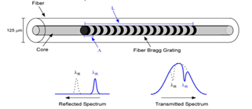
Figure 2-1 Structure diagram of fiber Bragg grating
Figure 2-1 The construction of a fibre Bragg grating is shown. The FIBER Bragg grating is formed by irradiating the fibre with ultraviolet light along its axis, causing the refractive index of the fibre core to vary regularly. When incident light passes through the fibre grating and fulfils the Bragg reflection condition, the incident light is reflected back by the fibre grating, which is equivalent to creating a mirror or narrow band filter within the fibre core.

Fiber Bragg grating is a wavelength modulation sensor. The principle of using fiber Bragg grating as a sensing unit is to obtain the sensing information by modulating the Bragg grating center wavelength with the change of external environmental parameters.$λ_{B}$The mathematical expression of grating Bragg center wavelength is as follows:$λ_{B} λ_{B}=2n_{eff}Λ$

Where: denotes the fibre core's effective refractive index.;$n_{eff}Λ$Represents the grating period.

The total of the FBG will vary when it is changed by external temperature and strain, resulting in a shift in Bragg wavelength.$n_{eff}Λ$The derivative of Equation (1-1) can be obtained as follows:$∆λ_{B}=2Λ{∆n}_{eff}+2n_{eff}∆Λ$
Where does the effective refractive index vary, and where does the grating period change.${∆n}_{eff}∆Λ$By dividing equation (1-2) by equation (1-1), we can get:+ (1-3)$\frac{∆λ_{B}}{λ_{B}}={∆n}_{eff}/n_{eff}∆Λ/Λ$
Equation (1-3) shows that the centre wavelength of a fibre Bragg grating is determined by the effective refractive index of the fibre core and the grating period, and that any physical action that changes these two parameters causes the centre wavelength to move.$n_{eff}Λ$Through the change of measuring center to realize the sensing detection of physical quantity.

Figure 2-2 depicts a typical FBG sensor demodulation setup. The 3dB coupler transmits the wideband light generated by the wideband light source to the FIBER Bragg grating, and the light fulfilling the reflected light requirement is reflected back by the grating and returned to the photoelectric detecting device for wavelength demodulation. The wavelength of the reflected light of the FIBER Bragg grating is modulated when the ambient physical quantity varies, and the corresponding connection between the wavelength change and the physical quantity is employed to achieve sensor demodulation of the environmental physical quantity. Varied physical characteristics have different effects on the FIBER Bragg grating's principles. The following is a theoretical derivation of the fibre Bragg grating demodulation principles in terms of temperature, strain, and acceleration.
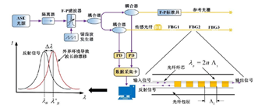
Figure 2-2 Optical fiber sensing principle
Fiber Bragg grating sensors have very obvious advantages:

- Strong ability to resist electromagnetic interference.
- The sensor package is simple in structure and small in size.
- To create a number of different optical fibre sensor networks.
- Measurement repeatability is excellent.
- The absolute measurement of environmental factors may be performed after the fibre grating has been calibrated.
- Grating writing technology is mature.

2.2.1 Principle of FIBER Bragg grating strain sensing
The stretching and photoelastic effects of axial strain on the centre wavelength of a fibre grating are reflected in the stretching effect. When only axial tension affects the FBG and the temperature stays constant. Then, the change of grating period λ caused by axial strain can be
Expressed as:
$∆Λ$= (1-4)$Λ·∆ε$

Where is the strain at the sensing point.$∆ε$

The effective refractive index change of fiber grating core caused by photoelastic effect is expressed by Formula (1-5) :
$∆n_{eff}=-∆εn_{eff}^{3}[p_{12}-v(p_{11}+p_{12})]/2$ (1-5)

The form of Equation (1-6) can be obtained by deformation of Equation (1-5) :
$∆n_{eff}/n_{eff}=-∆εn_{eff}^{3}[p_{12}-v(p_{11}+p_{12})]/2$ (1-6)

Where, v represents the Poisson's ratio of the core material;$p_{ij}(j=1,2)$Represents the photoelastic coefficient. The effective photoelastic coefficient Pe is defined as:
$p_{e}=-∆εn_{eff}^{3}[p_{12}-v(p_{11}+p_{12})]/2$ (1-7)

Substituting Equation (1-7) into Equation (1-6), we can get:
$\frac{∆n_{eff}}{n_{eff}}=-p_{e}∆ε$ (1-8)
Substituting Equations (1-8) and (1-4) into (1-3), it can be obtained that the change of grating wavelength generated by strain is:
$\frac{∆λ_{B}}{λ_{B}}=(1-p_{e}) ∆ε$ (1-9)
It can be seen from Equation (1-9) that the wavelength change of the fiber grating is linear with the strain. The strain sensitivity coefficient of fiber Bragg grating can be obtained as:
$K_{ε}=\frac{∆λ_{B}}{λ_{B}·∆ε}=1-p_{e}$ (1-10)
For example, for germanium doped quartz fiber, Pe is 0.22/. According to Equation (1-10), the strain sensitivity of FIBER Bragg grating can be roughly calculated as 0.78/.$μεμε$The allowable tension applied to the fiber grating is usually about 1%. When the error caused by the second-order strain is ignored, the Bragg wavelength of the fiber grating has a good linear relationship with the strain.

2.2.2 Principle of FBG temperature sensing
Temperature's influence on fibre Thermal expansion and thermo-optic effects both contribute to the Bragg wavelength. According to the fiber Bragg equation.$λ_{B}=2n_{eff}Λ$The central wavelength shifts with the grating period and effective refractive index.$Λn_{eff}$When the external temperature changes, the refractive index of the fiber core will change with the thermo-optical effect of the fiber itself.Under the action of thermal expansion effect, the grating period will change, so the central wavelength of the fiber grating will change.$Λλ_{B}$

The grating period change caused by thermal expansion effect can be expressed as:$∆Λ=α·Λ·∆T$

Where, is the thermal expansion coefficient of the optical fiber, and represents the temperature change.$α=∆Λ/(Λ·∆T)∆T$

The change of effective refractive index of fiber core caused by thermal-optical effect is as follows:$∆n_{eff}=ξ·n_{eff}·∆T$

Where, is the thermal-optical coefficient of the optical fiber, that is, the change rate of refractive index with temperature.$ξ=∆n_{eff}/(n_{eff}·∆T)$Equation (1-11) and
Substitute the formula (1-12) into the formula to get (1-13).$\frac{∆λ_{B}}{λ_{B}}=\frac{∆n_{eff}}{n_{eff}}+\frac{∆Λ}{Λ}=\left(ξ+a\right)·∆T$
The temperature sensitivity coefficient of fiber Bragg grating can be defined as:$K_{T}=\frac{∆λ_{B}}{∆T·∆λ_{B}}=ξ+a$
For germanium doped quartz fiber at room temperature, it can be estimated that the temperature sensitivity of fiber Bragg grating at room temperature is =7.5×.$a=0.5×{10}^{-6} ,ξ=7.0×{10}^{-6}ξ{10}^{-6}/℃$When the temperature range is very small, it is generally considered to be constant, so there is a good linear relationship between the Bragg wavelength change and temperature.$ξ$But in practical application, the temperature may vary in a wide range, so the nonlinear effect of temperature should be considered.

2.2.3 Acceleration sensing principle of FIBER Bragg grating
The schematic design of the fibre Bragg grating acceleration sensor is shown in Figure 3-3. The fibre grating acceleration sensor consists of a cantilever beam with a length of L, a mass block with a mass of M, and associated components. The cantilever beam is made of manganese steel with good resilience and elasticity. The free end of the cantilever beam is subjected to a vertical force, which bends the beam. At this moment, the cantilever beam will exhibit an elastic restoring force parallel to the vertical acting force. Therefore, the acceleration sensor shown in Figure 2-3 is analyzed in combination with the undamped mass-spring system, and the elastic coefficient K is determined by the characteristics of the cantilever beam.

The fibre grating is attached to the surface near the cantilever beam's fixed end. The acceleration sensor is completely coupled to the item under test. When the component of the acceleration of the measured object in the Y direction is A, the magnitude of the force on the mass m is F=ma. Because of the force, the cantilever beam will bend to a certain extent, so that the sensing fiber grating will stretch or compress. Similar to the strain sensing model, additionally, the central wavelength of FBG moves. The acceleration A is computed by sensing the drift of its centre wavelength.

A cantilever beam of identical strength is employed to guarantee a linear connection between wavelength drift and acceleration. The slide bar constrains the mass's movement in the Y direction. The cantilever beam is flexibly connected with the mass block by ball bearings to ensure that the cantilever beam is only affected by force in the Y direction.

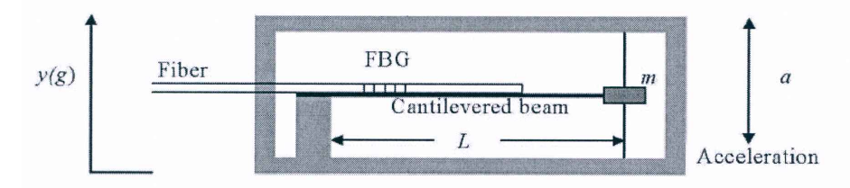
Figure 2-3 Structure of the FBG acceleration sensor
As seen in Figure 2-4, the equal strength cantilever beam is bent by vertical force. When the deflection Y is not large, the curvature radius ρ of the equal strength cantilever beam can be regarded as constant. According to material mechanics theory, the strain at each point on an equal-strength cantilever beam is determined by the load, the nature, and the size of the beam:

$ε=\left(\frac{6L}{Ebh^{2}}\right)|P|$ (1-15)

Where b, L, and h denote the width of the beam's fixed end, the beam's length, and the beam's thickness, respectively.
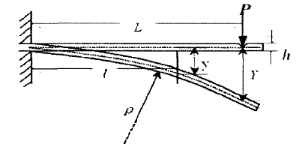
Figure 2-4 Analysis diagram of equal-strength beam
For the fiber grating pasted on the beam, its wavelength drift is:$\frac{∆λ}{∆λ_{B}}=ղ(1-p_{e}) ε$
Where, is the grating elastic-optical coefficient, which is generally 0.22.$p_{e}ղ$Is the bonding coefficient between the fibre optic and the cantilever beam, which is affected by the characteristics of the adhesive and the bonding effect.

There are: (1-17)$\frac{∆λ}{∆λ_{B}}=6ղ\left(1-p_{e}\right)L\left|P\right|/(Ebh^{2})$
When measuring acceleration, a fibre Bragg grating acceleration sensor is attached to the item being measured. If the acceleration of the item being measured in the sensor's y direction is A, then the inertial force on the mass block is: F= Ma (1-18)

The force F is in the same direction as the acceleration A. At this point, it is similar to delivering a load of F to a cantilever beam of identical strength, causing the beam to bend. Equation (1-18) as a substitute for Equation (1-17), it can be obtained:

$\frac{∆λ}{∆λ_{B}}=6ղ\left(1-p_{e}\right)ma/(Ebh^{2})$ (1-19)
The fibre Bragg grating acceleration sensor's fundamental formula is (1-19). We may deduce from Formula (1-19) that the wavelength drift of the sensing fibre Bragg grating is proportional to the detected object's acceleration A when the beam parameters and bonding coefficient are constant.$∆λ$

2.3 Fiber Grating wavelength demodulation method
The wavelength, intensity, phase, frequency, and polarisation of the light wave inside the fibre Bragg grating sensor may be employed as transmission parameters to detect changes in external physical values. The quality of FBG sensing and measuring ability is affected by FBG fabrication technology, light source parameters, demodulation method stability, precision and so on. Among these, the demodulation method based on fibre grating wavelength does not need consideration of the light source's power fluctuation or the loss fluctuation induced by other devices, making it the most extensively used fibre grating demodulation technology. The fibre grating wavelength demodulation technique can detect the shift in the centre wavelength of the fibre grating reflection spectrum in order to determine the change in external parameters. At the moment, demodulation techniques based on the wavelength of a fibre grating include spectral detection, matched grating, edge filtering, tunable filtering, and tunable laser.

2.3.1 Spectral detection method
Spectrometer is a precision instrument dedicated to measuring and detecting the spectral characteristics of light beams. It is the most intuitive wavelength demodulation method to measure the drift of the central wavelength of FBG reflection spectrum based on spectral detection method. The wavelength measurement of spectrometers is based on lens, volume phase grating (VPG) or dispersive prism, coupled arsenic photoelectric detection array and other devices. A broadband light source (BBS) generates light waves within a specified wavelength range, while light waves of various wavelengths have varying diffraction angles. The volume phase grating (VPG) delivers light waves of various wavelengths to the photoelectric detection array's various detection units. The photoelectric detection array obtains the reflection spectrum of the fiber grating according to the light intensity and amplitude information of different detection units. The spectrometer may be used to determine the location of the reflected spectrum's peak. Figure 2-5 illustrates a wavelength demodulation system based on the spectral detection approach.
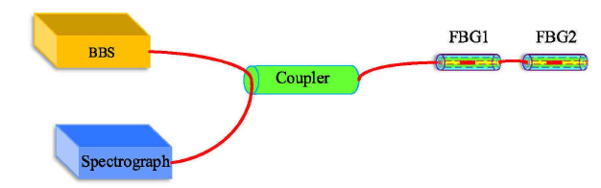
Figure 2-5 Schematic diagram of fiber grating wavelength demodulation system based on spectral detection method

The wavelength demodulation technique is straightforward in structure and operation, but on the one hand, the spectrometer cannot realize the real-time demodulation function because of its low scanning speed, low wavelength resolution, and no real-time peak searching and real-time storage functions. On the other hand, the application scope of the FBG wavelength demodulation technique based on spectral detection is severely constrained owing to the enormous volume and high cost of spectrometers, and is often confined to labs and other locations.

2.3.2 Matching grating method
The fibre Bragg grating sensing system is introduced into a fibre Bragg grating whose central wavelength is similar to that of the fibre Bragg grating and whose parameters are exactly the same as that of the fibre Bragg grating, that is, matching fibre Bragg grating, by matching fibre Bragg grating tracking the fibre Bragg grating's centre wavelength drift quantity circle. The demodulation system based on the matched grating approach may be split into transmission and reflection types depending on the varied placements of matched fibre gratings in the demodulation system. Figure 2-6 shows a schematic representation of the demodulation system.
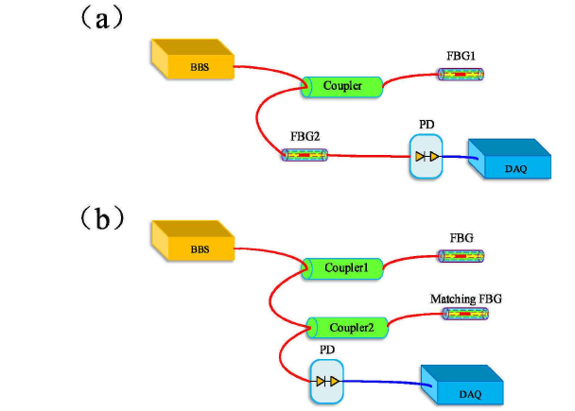
Figure 2-6 Wavelength demodulation system of fiber grating based on matched grating method (a) transmission type (b) reflection type

For example, in a wavelength demodulation system based on the reflective matched grating approach, the broadband light source outputs an optical signal of a certain wavelength range, which then travels through the sensing fibre grating and matched fibre grating twice before reaching the photodetector. By changing voltage to drive the piezoelectric ceramics (PZT) matching the center of the fiber Bragg grating wavelength, when matching FBG center wavelength and the sensing fiber Bragg grating wavelength at the same time, the incident light intensity in photoelectric detector in corresponding extremal, photoelectric detector light intensity information can be converted to voltage signal data processing obtains the sensing fiber Bragg grating wavelength.

The fibre grating's reflection spectrum may be approximated by a Gaussian function, which is defined as the sensing fibre grating's reflection spectrum:$S(λ)$

$S\left(λ\right)=I_{0}R_{S}exp⁡[-4ln2\frac{λ-λ_{S}}{∆λ_{s}^{2}}]$ (1-20)
Where represents the incidence intensity of the broadband light source, represents the sensing fibre grating's reflectivity, represents the sensing fibre grating's Bragg reflection wavelength, and represents the sensing fibre grating's 3dB bandwidth.$I_{0}R_{S}λ_{S}{∆λ}_{s}$

Defined as the reflection spectrum of matching fiber gratings:$R(λ)$
$R\left(λ\right)=R_{B}exp⁡[-4ln2\frac{λ-λ_{S}}{∆λ_{s}^{2}}]$ (1-21)
Where, represents matched fiber grating reflectivity, represents matched Bragg reflection wavelength of fiber grating, and represents matched 3dB bandwidth of fiber grating.$R_{B}λ_{B}{∆λ}_{B}$

Therefore, the spectrum acquired by the photodetector in a wavelength demodulation system based on the reflective matched grating approach may be represented as:$I\left(λ\right)$
$I\left(λ\right)=αS\left(λ\right)*R\left(λ\right)=α\int_{-∞}^{+∞}{S(λ^{'})R(λ-λ^{'})}$d() (1-22)$λ$

Where, the optical power accepted by the photodetector may be represented as: $α$ indicates the total light intensity loss coefficient in the optical channel.

$P_{D}\left(λ\right)=\int_{-∞}^{+∞}{I\left(λ\right)dλ}$ (1-23)
According to formulas (1-22) and (1-23), is a function of λ. The peak wavelength of the sensing fibre grating is the wavelength value of the matched grating corresponding to the maximum point of the voltage curve of the detected output signal after photoelectric conversion of the photoelectric detector.$P_{D}\left(λ\right)λ_{B1}$Sensing fiber Bragg grating is affected by the external environment, leading to the Bragg wavelength drift, by changing voltage to drive the PZT matching grating reflection spectrum tracking sensing fiber Bragg grating spectrum, until and matching grating and the Bragg reflection wavelength of sensing grating to overlap, to achieve the maximum voltage curve, the corresponding matching FBG wavelength at this time, The variation of parameters to be measured can be obtained.$λ_{B2}∆λ_{B}=|λ_{B2}-λ_{B1}|$

By sensing the highest light intensity and voltage, the wavelength demodulation system based on matched grating technique calculates the Bragg reflection wavelength, and the demodulation result is less impacted by optical channel loss and light intensity noise. The system is easy to use, has a good resolution, and is inexpensive. However, since the sensitivity characteristics of the matching grating and the sensor grating are not totally constant, the system's measurement accuracy is limited. Furthermore, the measuring range of the system is limited by the wavelength harmonic range of the matched fibre grating, and the multiplexing rate is low.

2.3.3 Edge filtering method
The primary premise of the edge filtering technique is that the variation of the edge filter's output optical power and the drift of the incoming wavelength have a linear connection throughout the C-band region. Figure 2-7 shows a schematic representation of a fibre grating complementary wavelength demodulation system using the edge filtering approach.
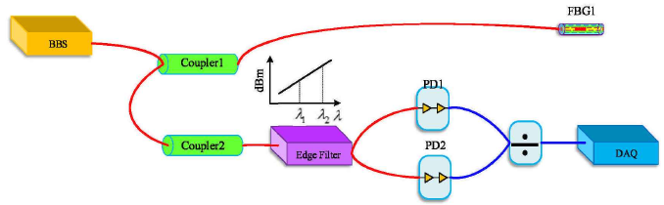
Figure 2-7 Edge filter Linear filtering principle

Assuming that the edge filter satisfies a linear relationship between wavelength and, its wavelength conversion coefficient can be expressed as:$λ_{1}λ_{2}$
$T\left(λ\right)=\left\{\begin{aligned}1-\frac{λ-λ_{1}}{λ-λ_{2}} λ_{1}<λ<λ_{2} \\ 0 其他\end{aligned}\right.$ (1-24)

The light intensity detected by photodetector PD1 and PD2 can be expressed as:$I_{1}、I_{2}$
$I_{1}=α_{1}\int_{-∞}^{+∞}{S\left(λ\right)dλ}$ (1-25)
$I_{2}=α_{2}\int_{-∞}^{+∞}{T(λ)S\left(λ\right)dλ}$ (1-26)

Where, and respectively represent the total loss coefficient of the optical path, the reflection spectrum function of the fiber grating sensor, and the wavelength conversion coefficient of the edge filter.$α_{1}α_{2}S\left(λ\right)T(λ)$Formulas (1-25) and (1-26) represent both functions of the reflected wavelength of the fiber grating center, and the wavelength modulation function is defined ղ(λ):$I_{1}、I_{2}λ_{B}$

$ղ\left(λ\right)=\frac{I_{1}}{I_{2}}$ (1-27)

Evaluate the relationship between fiber grating wavelength and edge filter, and substitute formulas (1-25) and (1-26) into wavelength modulation function to obtain:

$ղ=KT(λ_{B})$ (1-28)

The parameter is connected to the fibre Bragg grating's core wavelength and has nothing to do with optical route loss or other variables, and the ratio of the two signals can remove the impact of light source power fluctuations.$ղλ_{B}$But the wavelength demodulation system based on edge filter is simple in structure, easy to process, quick in response and low in cost. However, the edge filtering method based on the intensity type of light intensity filtering characteristics and the approximate linear characteristics of the filter greatly restricts the precision of the understanding modulation system, The parameter is connected to the fibre Bragg grating's core wavelength and has nothing to do with optical route loss or other variables, and the ratio of the two signals can remove the impact of light source power fluctuations.

2.2.4 Tunable scanning laser demodulation method
Tunable semiconductor is an important active device in the next generation of dynamic optical communication network and optical fiber sensor network. Using tunable laser technology to collect and analyze the fiber grating spectrum is also an important wavelength demodulation scheme of fiber grating. Tunable laser is equivalent to broadband light source and tunable F-P filter in function, but the cost is lower than that of broadband light source and tunable F-P filter. The distributed feedback (DFB) tunable laser has excellent dynamic single-mode characteristics, stable and reliable performance, but the TUNING speed of DFB laser is' diffuse, the tuning range is limited circle; The plasma effect is used to modify the refractive index of the material in the distributed Bragg reflection (DBR) tunable laser, which has a broader harmonic range. In 1993, L. A. Coldren et al. proposed A four-stage sampling grating distributed Bragg reflection (SGDBR) tunable laser composed of A front grating segment, A gain segment, A phase segment and A rear grating segment, which realized A wide range of wavelength tuning by using the verner effect of the front and rear sampling gratings through injection current.

With the further research of tunable semiconductor, SCDBR laser not only has the advantages of small size, wide tuning range, fast wavelength switching speed, high output spectral quality, high signal-to-noise ratio, high tunable repeatability, and can achieve a wide range of mode-hopping wavelength locking. It's also simple to combine with SOA, EA, MZI, and other semiconductor functional devices, all of which have a high prospective engineering application value in the future in the fields of fibre communication and fibre sensing. Figure 3-8 depicts a wavelength demodulation system based on an SGDBR tunable laser (a). Wavelength reference modules are often used in the wavelength demodulation system of fibre gratings based on tunable lasers in order to increase wavelength demodulation accuracy and stability. Figure 3-8(b) shows a schematic design of the demodulation system with wavelength reference modules.

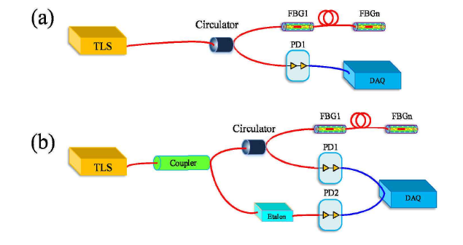
Figure 2-8 (a) Wavelength demodulation system based on SGDBR tunable laser (b) Tunable laser demodulation system with wavelength reference module

The SGDBR tunable laser carries frame synchronization trigger signal and point synchronization trigger signal, and outputs extremely narrow line width light pulses in a certain scanning step within the C-band range, as shown in Figure 2-9. The optical pulses of different wavelengths reach the photodetector through the optical path, and the fibre Bragg grating's reflection spectrum may be drawn based on the optical power received by the photodetector. In the scanning cycle of tunable laser, the corresponding wavelength information can be obtained according to the starting wavelength, the stopping wavelength and the scanning step.

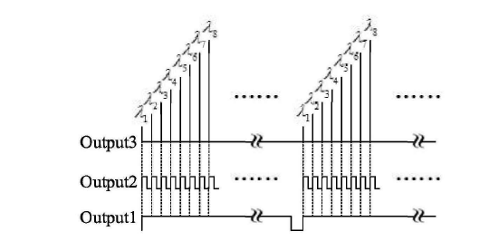
Figure 2-9 Schematic diagram of output wavelength of tunable laser

2.2.5 Tunable filter demodulation method
One of the most extensively used fibre grating demodulation techniques is wavelength demodulation using an adjustable Fabry-Perper (F-P) filter. F-p filter consists of f-P cavity composed of two mobile mirrors, which has wavelength selectivity. When the transmission spectrum of broadband light passing through F-P filter matches the reflection spectrum of fiber Bragg grating, the output optical power reaches the maximum, and the photoelectric detector outputs the maximum voltage at this time. Tunable F-P filter also uses triangle wave voltage to drive PZT to realize wavelength tuning. The matching connection between filter scanning voltage and filter transmission wavelength may be used to monitor the wavelength of a fibre grating in real time. Figure 2-10 depicts the principle diagram of a wavelength demodulation system based on a tunable F-P filter.

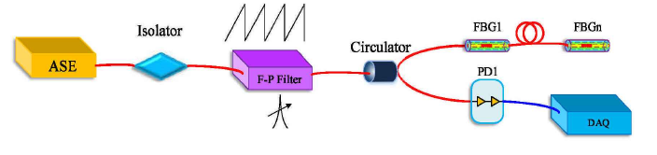
Figure 2-10 Schematic diagram of wavelength demodulation system according to tunable F-P filter

The fibre grating's reflection spectrum may be estimated as a compound Gaussian distribution, and its reflection spectrum is assumed to be rectangular:
$G\left(λ\right)=I_{0}exp⁡[-4ln2{(\frac{λ-λ_{B}}{∆λ_{B}})}^{2}]$ (1-29)

Where is the broadband light source's incoming light intensity, is the fibre grating's Bragg reflection wavelength, and is the fibre grating's 3dB bandwidth.$I_{0}λ_{B}∆λ_{B}$According to Fresnel formula, the transmission spectral function of f-P filter is:

$T\left(λ\right)=\frac{1}{1+\frac{4R}{{\left(1-R\right)}^{2}}\sin^{2}(\frac{2nπcosφ.L}{λ})}$ (1-30)

Where R is the reflectivity of the reflector on the F-P cavity's surface, n is the refractive index of the medium in the F-P cavity, and is the transmitted wave's incidence angle on the F-P cavity's surface, L is the length of the F-P cavity, λ is the wavelength of the incident light wave.$φ$

The cross-correlation integral value of the fibre grating's reflection spectrum and the F-P filter's transmission spectrum is the optical power received by the photodetector. The optical power received by the photodetector is defined as,$P_{D}\left(λ\right)$
$P_{D}\left(λ\right)=\int_{0}^{+∞}{G\left(λ\right)}T\left(λ\right)dλ$= (1-31)$\int_{0}^{+∞}{I^{i}\frac{{(1-R)}^{2}}{{(1-R)}^{2}+4R\sin^{2}(\frac{2nπcos∅.L}{λ})}exp⁡[-4ln2\frac{λ-λ_{B}}{λ_{B}^{2}}]}dλ$

The transmission maximum condition of the tunable F-P filter is presumed to be met when the fibre grating's centre reflection wavelength reaches the transmission maximum criterion of the tunable F-P filter at t0:$λ_{B}$
2 (L+) =K (1-32)$∆Lλ_{B}$

Where k is the interference series and is the variable of tunable F-P filter cavity length. ∆L The nearly linear connection between the length variation of the tunable F-P filter cavity and the driving voltage of the triangle wave may be used to compute the Bragg reflection wavelength of the fibre Bragg grating.$λ_{B}$

The resolution of a wavelength demodulation system based on a tunable F-P filter is impacted by the bandwidth of the F-P filter and the SNR of the reflected spectrum of the fibre grating, and the system has numerous benefits such as a broad adjustable range and high fineness. With a 3dB bandwidth of 0.22mm, a maximum tunable range of 100nm and a maximum tunable rate of 800HZ, Micron Optics' ffp-tf2 series of special tunable filters can meet the demodulation accuracy requirements of most low and medium speed engineering applications. However, PZT has hysteresis and creep, and is easily affected by the environment, resulting in poor linearity and repeatability between the scanning voltage and the transmission wavelength of the filter. As a result, a wavelength reference correction module is often used in demodulation systems to increase accuracy and stability. Figure 2-11 depicts the system's architecture. During the scanning phase of a triangle wave, the wavelength reference correction module can calibrate and correct the scanning voltage and transmission wavelength of the filter in real time, and then perform wavelength demodulation with high precision and stability. However, the local nonlinear characteristics of tunable filter are more obvious when the scanning frequency of triangle wave is high and the ambient temperature fluctuates greatly. The demodulation method based on tunable filter can not effectively meet the real-time demodulation of high frequency dynamic signal.
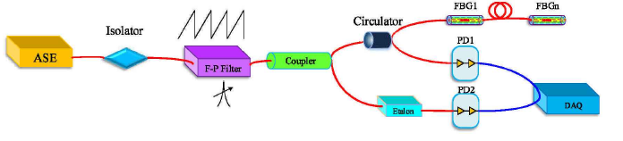
Figure 2-11 Tunable filter demodulation system with wavelength reference module

2.4 Comparative analysis of demodulation schemes
The speed and accuracy of detecting the centre wavelength of the reflected light of the fibre grating are significant features of the demodulation device in industrial demodulation monitoring products. Demodulation speed is an important parameter in the measurement of physical quantity with high changing frequency. The demodulation precision determines the minimum physical quantity change that can be measured by the modulation instrument. Interference demodulation and filtering demodulation are the two types of demodulation systems.

Interference demodulation methods include unbalanced Michelson interference demodulation method, unbalanced Mach-Zehnder interference demodulation method, Zagnaik interference demodulation method, composite interference demodulation method, etc. Different interference demodulation has different optical interference structures. The fibre Bragg grating sensor turns a change in an external physical quantity into a change in wavelength, which is then converted into a change in phase through the interference structure. The change in centre wavelength of fibre Bragg grating reflected light may be determined by detecting the change in phase of the interference output light, and eventually wavelength demodulation can be achieved.

The demodulation method using interference structure has good sensitivity and the demodulation scheme is easy to build. The measuring range of this approach, on the other hand, is restricted owing to the narrow range of phase change. The change of external environment easily interferes with demodulation result, which is often used in dynamic demodulation.

Filtering methods mainly include tunable F-P filter demodulation method, matched grating demodulation method, edge filter demodulation method, adjustable laser light source method and so on. Filtering demodulation method of demodulation principle is: the use of appropriate design, adopt different reflected light of sensing grating filter device, from all the different wavelengths of light intensity, based on the maximum output light intensity and wavelength filter values of corresponding relation, the wavelength demodulation is eventually realised when the centre of the fibre Bragg grating wavelength values are used. The demodulation approach based on an adjustable F-P filter is the most developed of these methods and has a broad variety of applications in practise.

3. Design of human-computer interaction interface

3.1 The importance of human-computer interaction
The challenge of man-machine communication will be a major issue in the information area in the twenty-first century. The basic technology of computer applications is man-machine interface technology. The man-machine interface, as a means of man-machine communication, has a direct impact on the function of software, end-user use, computer advertising, and even people's job and lives. It has had a far-reaching effect on society to have computers and computer user interface evolve at the quick pace that they have in the 1980s. This has had a significant effect on many parts of society including business and transportation as well as the military and education. The amount of software in a computer is steadily expanding as the technology improves. More than 40% to 80% of the time spent on software development is spent designing and developing the human-machine interfaces. In addition, the human-machine interface is the most complex component of computer creation since various individuals have varied expectations for the interface. As a result, software developers all around the globe are concentrating their efforts on human-machine interface (HMI) technology.

3.2 Three elements of human-computer interaction
Interactive computer systems must address three factors in order to accomplish excellent human-computer interaction: human component, interactive equipment and software implementation of human-computer discourse. There are three basic aspects in all types of interactive systems, although the content of each of these parts varies. The majority of them are included：

1) Graphics, picture input and output equipment, sound, posture, tactile equipment, three-dimensional interactive equipment, and so on are examples of interactive equipment.

2) Interactive software is the heart and soul of every interactive computer.

3) Human factor refers to the user operation model and is associated with a variety of user attributes. Tasks combine the actions of the user and the machine.

3.3 Content of interaction design

3.3.1 The four basic activities of interaction design
1) Identify customer wants and requirements: Understanding who the target users are and what assistance the interactive product should give is critical to designing goods that can help people. These specifications serve as the foundation for product specifications, which in turn serve as the foundation for further design and development.

2) Design candidate: This is the essence of design, i.e., proposing a solution to a problem.

3) Build an interactive version of design: Interaction design is the process of creating an interactive product, and the best method to assess design is to have consumers engage with it. This necessitates the creation of an interactive version of the design, but it does not have to be a fully functional piece of software.

4) Design assessment is the process of determining a product's or design's usability and acceptance. A variety of actions linked to quality assurance and testing are included in most designs to verify that the final product achieves its objectives. Assessment is supposed to complement and strengthen these activities, not to replace them.

3.3.2 Three key characteristics of the interaction design process
User-centricity, particular usability requirements, and iteration are three fundamental elements of the interface design process.

User-centric This is a fundamental concept in interaction design, because integrating the user in the design and assessment of the whole process allows for more immediate feedback. Specific usability and user experience objectives should be defined and clearly articulated at the start of the project, as well as requirements, which can be reviewed at any moment throughout product development and assist designers pick alternative candidates. Iterating allows designers to utilise feedback to enhance their designs, which is unavoidable since they can't always discover the best answer the first time.

3.3.3 Human-computer interaction model
During the design and development of a human-computer interaction system, people put forward many kinds of human-computer interaction models from different angles, such as behavior model, structure model and implementation model. Among them, the typical behavior model is LOTOS model, the typical structure model is Seeheim model, and the typical implementation model is E-O and MVC model.

3.4 HMI design rules and organization principles

3.4.1 Design rules of man-machine interface
Users control the application system via the man-machine interface: on the one hand, users must monitor a significant number of system feedback information; on the other hand, users must monitor a huge quantity of system feedback information. on the other hand, users need to analyze and judge various information to make decisions. Not only is the user the system's controller, but he or she is also the system's monitor. Its actions will have a direct impact on the system's usual functioning. The system's efficiency and safety are mostly determined by people's working circumstances. Therefore, designers should be required to have a clear understanding of users, that is, to understand the rules of user cognitive behavior. To know how people's senses receive external information, how information memory and reasoning are carried out, and ultimately how to make timely and accurate decisions about events. A good user interface design is to meet the needs of users, taking into account the health and psychological status of users.

Software interface design includes the following design rules:

Rule 1: color matching rules
The use of color is a very important aspect of interface design. Good use of color can attract users' attention, affect the way users work, and give users a beautiful feeling.

According to the requirements of color matching and the characteristics of manufacturing science, the main colors of software interface are positioned in black, white and gray. The proper use of color can accentuate the logic of the screen, facilitate the recognition of various parts of the screen, highlight differences, and make the display more interesting.

Rule 2: Information organization rule
Discrete stimuli in the visual field can be organized together to form a whole vision due to some relationship between them, and this phenomenon becomes the organizational characteristic of vision. The organization principles of vision mainly include proximity principle, similarity principle and closure principle.

Rule 3: Visual search rule
Visual search is to search for a stimulus among many visual stimuli, the stimulus being searched is called the target stimulus, and the other stimuli are called the interference stimulus. Visual search has two ways: serial search and parallel search.

3.4.2 Organization principles of HMI
In the early application system interface design, man-machine combination is not a big problem, because the computer performance at that time is relatively poor, and mostly text interface, single expression, structural layout, etc., are subject to certain restrictions, as long as the prompt is clear, the user is not difficult to adapt to the shortcomings of the design. With the improving of the computer performance, the advent of multimedia technology, as well as the fast growth of information processing technology, the diversification of express way, expressing the abstraction of the content, diversity, man-machine interface more weak link will appear highlighted, should through the reasonable design of man-machine interface, the application system to meet the requirements of people. Therefore, in the design of man-machine interface system, it is necessary to follow the following principles: habitual principle, artistic principle, practical principle and intuitive principle.

- The principle of habituation: People tend to have certain stereotypes about how interfaces are expressed. Violation of this stereotype will lead to prolonged reaction time, higher error rate, easy fatigue and prolonged learning time.

- Principle of art: if a design is aesthetic or pleasing to the eye, it will attract the attention of the subconscious mind and convey information quickly and accurately.

- Principle of usability: The main purpose of the interface of an application system is to achieve the functional requirements of the system, so another requirement of interface design is usability.

- Intuitionistic principle: Intuitionistic interface is a basic requirement of ergonomics research, mainly depends on the functional mode of the system, formatted output/input and random dialogue requirements.

3.5 Interface design process

3.5.1 Relevant models of interface design
The process of building user interfaces should begin with an analysis of system function, i.e., the function of the system should be defined first, since it is the cornerstone of software systems and the goal of software design. The goal of creating a human-computer interaction interface is to provide users with a comfortable environment in which to control software. Users may operate certain basic and straightforward interface components to control the processing process of the whole system in order to fulfil the defined tasks. The system's heart and soul is its function.

Because a system is created for users, and for a system to accomplish specific activities, user input is required, the study of system functions is divided into tasks. That is, determine what has to be done when, which tasks are performed by the user, which tasks are performed by the computer, which tasks are performed by both, what is the connection between them, and what are the essential conditions for the job to be completed, and so on. Some design issues in the man-machine interface may be resolved, and the system's core structure and interface style can be chosen, thanks to this job division. Four models should be considered when creating a human-computer interaction interface: Software engineers create a design model, which includes software data structure, system structure, data transfer between people and computers (human-computer interface), and process representation, in the early stages of system design, in accordance with the schedule to complete the system function. The software engineer incorporates the man-machine interface, defines the system's interface form, produces an effective user interface, and implements the system model based on the system and user design models. Users have their own needs and expectations for the system's interface and operation. The user model is the system they envision (including functionalities and interface forms). Software engineers begin system design based on these models, which includes the computer system's interface form as well as the information needed to explain the system's syntax and semantics. These models must be incorporated in the system design; the design model must contain some information in the system model; the user model must be understood; the needs and features of the user must be correctly grasped; and they must be clearly reflected in the system design. If these four models are too far away, the interface design will fail; on the other hand, if these four models are too close together, the system will succeed in reflecting user requirements and needs. The interface designer's job is to fill in the gaps and provide a uniform interface.

These models are abstractions of what users do or envisage doing while using an interactive technology. In essence, these models follow a key interface design principle: "Know the user, know the job."

3.5.2 Task analysis and modeling
We should start building the design model and the system model when we've identified the system's functionality. Task analysis and modelling should be the first step in creating design and system models. Task analysis and modelling aid in the understanding of people's activities and the mapping of those tasks to a comparable set of tasks that can be executed in a human-computer interaction environment.

Regardless of the job analysis approach used, the software engineer must first describe and categorise the task, as well as decide data transmission in the man-machine interface and specify the interface form. These duties should be accomplished by the interface design model in a way that is compatible with the system and user models.

The interface design process starts once each job or activity has been specified. The following are the first phases in the interface design process:

1) Define the task's goals and objectives.

2) Determine what information and actions the user will need to accomplish the planned job, as well as when the user will need to intervene.

3) For each aim or purpose, create a unique action sequence.

4) Identifies the interface element responsible for carrying out the desired action sequence.

5) The actions are defined in the order they are performed on the interface.

6) Indicates the system's current state, i.e. the interface's representation at the time the action is executed.

7) Define control mechanisms, or devices and activities that users may employ to alter the state of the system.

8) Describes how control methods impact the state of the system.

9) Indicates how the system status should be explained using the information on the interface.

The action is usually allocated to the computer, the user, or both within each task. In general, the user performs tasks such as invention, judgement, and exploration, while the computer does tasks such as repetitive inspection, computation, and data processing. Data input and data recovery are intertwined operations that need both human and machine involvement. As a result, more work is needed to establish the exact duties that people and computers must do. Tasks should be structured to fit people's talents, neither too difficult or too easy, and should allow users to utilise their abilities to the best of their ability. To avoid short-term memory overload, the user's mental strain should be addressed while designing activities.

3.5.3 Additional problems in human-machine interface design
There are usually always four types of issues to consider when developing user interfaces: system response time, user aid facilities, error message handling, and command interaction. Many designers, on the other hand, fail to identify these issues until it is too late, resulting in extra iterations, project delays, and so on. As a result, it's important to think about them as design challenges early in the design process, when adjustments are simpler to make.

Although computer hardware performance has greatly improved, software system design is no longer as efficient as it was in the past. However, because some systems are relatively large and require more system resources, the design should consider whether the hardware equipment used by users can meet the requirements. Furthermore, the system's reaction time should not be very lengthy; otherwise, users may lose faith in the system and stop using it. As a result, the system operating platform should be selected early in the design process to guarantee that the system responds normally.

Users of interactive systems need assistance on a regular basis, and in most situations, software offers online assistance that enables users to address difficulties without leaving the interface.

4. Wavelength demodulation system of fiber grating based on tunable laser
The wavelength demodulation system based on tunable laser fibre grating has a large tunable range and a high harmonic speed, according to the second chapter's study, which is more suitable for the wavelength demodulation system of high frequency dynamic signal. In this paper, the principle and system composition of wavelength demodulation of fiber Bragg grating for tunable laser are described in detail. Meanwhile, three peak-seeking algorithms are simulated in MATLAB and compared. The signal conversion acquisition and demodulation processing of the light grating sensor demodulation system determine the overall demodulation accuracy of the system. Based on the above analysis, aiming at the field of temperature monitoring, this paper selects a demodulation scheme based on scanning laser, which has high demodulation accuracy, good stability and a large wavelength measurement range. It has an important application prospect in the field of engineering and other quasi-distributed measurement where single point and multi-point sensing are needed.

4.1 Composition of fiber Grating demodulation system
The FBG demodulation system is mainly composed of FBG sensor array, transmission optical path, A/D conversion, hardware acquisition and upper computer processing and display. As shown, the FBG sensor array is composed of multi-channel, through WDM combined with air separation reuse, demodulation system output signal light into multiple, every all the series number of FBG sensors, each A sensing signal by A/D conversion and the acquisition of hardware circuit, and then the real-time data from USB transmission first machine, The upper computer software processes the data and demodulates the wavelength information of each sensor, then calculates the variation of the corresponding physical parameters, and finally displays the correlation curve. Figure 5-1 shows the demodulation system structure diagram.
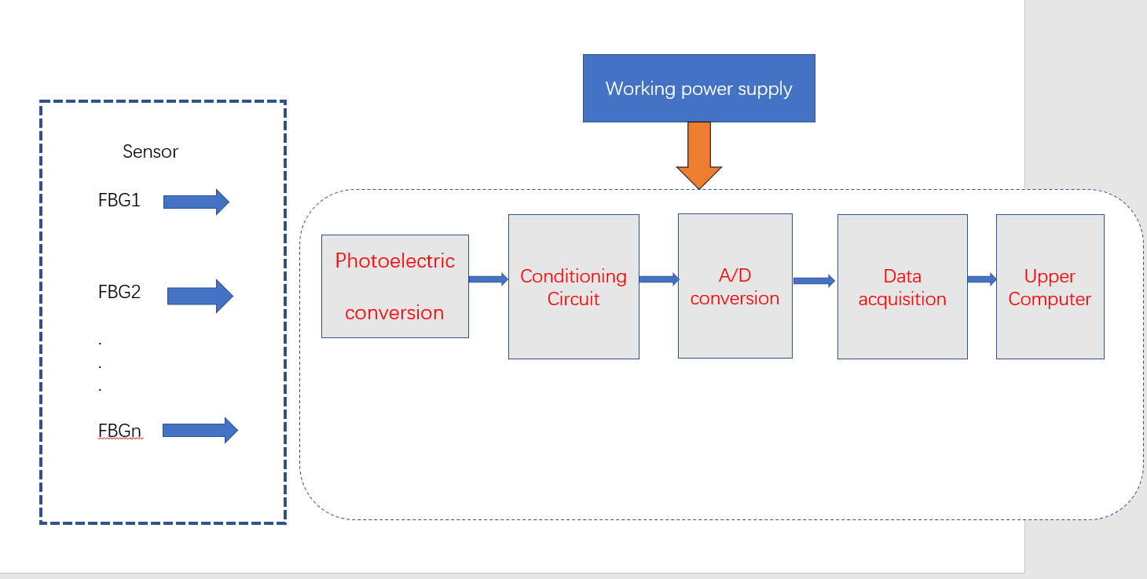
Figure 5-1 Demodulation system structure diagram

4.2 Fiber Grating demodulation scheme design
Temperature detection belongs to static detection, comprehensive consideration of the system demodulation range, capacity, accuracy, stability and cost and other factors, this program chose the scanning semiconductor laser demodulation method to study. Figure 5-2 shows the principle of single-channel FIBER grating demodulation system based on scanning semiconductor laser
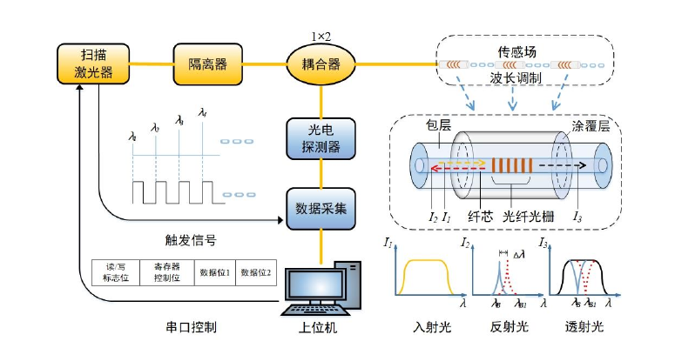
Figure 5-2 Schematic diagram of single-channel demodulation system
The system mainly includes the light source part, transmission light path part, sensor array part, signal conversion and acquisition part and upper computer control part. At the beginning of system operation, the working mode and parameters of laser are controlled by upper computer. The system light source outputs a certain wavelength of light first through the isolator and then into the first end of the 1X2 coupling. One of the remaining two paths of the coupler is used to transmit light to the FBG array in the latter one, and the spectrum reflected back from each FBG sensor enters the photoelectric detector to realize photoelectric conversion through the remaining one of the coupler. The signal from the sensor grating is then captured by the synchronous data acquisition card after A/D conversion. Simultaneously, the laser's trigger signal is recorded, and the data is then communicated to the top computer via USB for additional software demodulation, display, and other operations.

Theoretically, when the external environmental parameters remain unchanged, the reflection center wavelength obtained by demodulation of each FBG sensor will not change. When the temperature of the surrounding environment changes, the reflection centre wavelength of the related FBG temperature sensor shifts. The demodulation software calculates the wavelength variation of each sensor. Then according to the corresponding temperature calculation formula to get the final physical parameter value.

4.3 Peak seeking algorithm of sensor signal
In data processing, detecting the properties of data peak value is a typical necessity. The easiest solution is to use the fact that the first derivative of the data peak value has a downward zero crossing at the greatest value to solve the issue. During the demodulation process, Data acquisition device according to certain sampling rate collection and get the corresponding reflection spectra of FBG sensor sampling in sensor network voltage value, on the basis of the external environment, because of the existence of the noise in the process of collecting data will have a lot of mistakes in passing zero, secondly, the discrete data itself will continue to have change, There will be a large demodulation error when these data are directly searched, which seriously affects the demodulation precision of the demodulation system. Therefore, in order to reduce or eliminate noise effects, need reflection spectrum of FBG sensors sampling data using curve fitting method to estimate the position of the peak and other parameters, using the relevant mathematical algorithm to fit after looking for smooth, undistorted peak curve coordinates, the peak corresponding wavelength signals that the desires of the center wavelength of FBG sensors. The precision and stability of FBG demodulation system can be improved significantly by these methods. Center of mass technique, generic polynomial fitting method, Gaussian fitting method, cubic spline fitting method, smoothing filtering fitting method, and more peak fitting methods are now available.

4.3.1 This qualitative method to
The sensor reflection spectrum intensity data collected by the FIBER Bragg grating demodulation system is normally closer to the wave peak, while the point with smaller value is further away from the wave peak. For asymmetrically distributed data, the abscissa of sampling point of centroid detection method is used as the weight size, so the abscissa of weight center can be expressed as:

$x_{0}=\frac{\sum{x_{i}y_{i}}}{\sum{y_{i}}}$ (5-1)

When this method is applied to the reflection spectrum of FBG sensor, it can be concluded that:

$λ_{B}=\frac{\sum{λ_{i}I_{i}}}{\sum{I_{i}}}$ (5-2)
Where, is the amplitude of sampling point, is the corresponding wavelength, and is the Bragg wavelength of FBG.$I_{i}λ_{i}λ_{B}$

When the sampling rate of this method is small, the accuracy of peak search will be greatly affected, and the calculation results under different data conditions are not stable in practice.

4.3.2 General polynomial fitting
After the reflection spectral signal of THE FBG sensor is converted and collected, the discrete data sampled by the FBG sensor is approximated to a polynomial curve, and the discrete data is divided into peak truncation and further approximated to the function. The function curve with the best fitting degree to the original data is then determined using the least square approach, and the peak value is obtained.

The general formula of the least square method is:

$P_{n}\left(x\right)=p_{n}x^{n}+p_{n-1}x^{n-1}+….+p_{1}x+p_{0}$ (5-3)

Based on the reflected waveform of FBG sensor, binomial polynomial is selected, that is, n=2. The above formula can be expressed as:

$P\left(λ\right)=P_{2}λ^{2}+P_{1}λ+P_{0}$ (5-4)

Assume that the number of sample points () in the reflection spectrum is n, i.e. (I =1,2......N), then the sum of the squares of the deviation of the above formula is:

S= (5-5)$\sum_{i=1}^{n}{{(I_{i}-P(λ_{i}))}^{2}}$

When S takes the minimum value, the values of the coefficients P0,P1 and P2 can be determined. After substituting into the formula (), the analytical formula of the first-order differential can be obtained:

$P_{2}^{'}\left(λ\right)=2P_{2}λ+P_{1}$ (5-6)

If the above formula is equal to 0, Bragg wavelength can be obtained as:

$λ_{B}=\frac{-P1}{2P2}$ (5-7)

In the results obtained by the above method, the polynomial fitting effect of order 8 was obtained. In the research process, the corresponding data fitting implementation was carried out based on the multiple similarity of order 1 to 8 respectively, but the fitting effect was relatively poor. A normal fit cannot be achieved. Therefore, there is no selection in the subsequent processing.

4.3.3 Fitting method of Gaussian formula
The spectral shape of the reflection spectrum of the FBG sensor is approximately gaussian distribution, so the data spectral shape is here It can be approximated by gaussian function as:

$I\left(λ\right)=I_{0}exp⁡{[-4ln2(\frac{λ-λ_{B}}{∆λ_{B}})}^{2}]$ (5-8)

Where, is the reflection spectrum amplitude, is the reflection center wavelength of the FBG sensor, and is the reflection spectrum bandwidth.$I_{0}λ_{B}∆λ_{B}$

Let the number of sampling points () of reflection spectrum be n, where (I =1,2...$λ_{i}，I_{i}$,n), and the sum of the calculated deviation squares S is$I\left(λ\right)$

$S=\sum_{i=1}^{n}{{(I_{i}-I(λ_{i}))}^{2}}$ (5-9)

The fitting curve of FBG reflection spectrum has the best effect at the minimum value of S-selection group, and the Bragg wavelength of FBG can be obtained by solving the curve.$I\left(λ\right)$

In addition to the above method of directly fitting by gaussian formula, it can also be combined with general polynomial fitting to fit the spectrum of FBG sensor, such that the location of the sensor grating's reflection peak may be determined. Take the logarithm of both sides of the above equation to get:

$lnI\left(λ\right)=-\left(4ln2\frac{λ_{B}^{2}}{∆λ_{B}^{2}}-lnI_{0}\right)+8ln2\frac{λ_{B}^{2}}{∆λ_{B}^{2}}λ-4ln2\frac{1}{∆λ_{B}^{2}}λ^{2}$ (5-10)

To: p (lambda) = ln (5-11)$I(λ)$

$P_{0}=-(4ln2\frac{λ_{B}^{2}}{∆λ_{B}^{2}}-lnI_{0})$ (5-12)
$P_{1}=8ln2\frac{∆λ_{B}}{∆λ_{B}^{2}}$ (5-13)
$P_{2}=-4ln2\frac{1}{∆λ_{B}^{2}}$ (5-14)

Then Formula 5-10 can be changed into:

$P\left(λ\right)=P_{2}λ^{2}+P_{1}λ+P_{0}$ (5-15)

Formula 5-15 is in the form of quadratic polynomial fitting, so the least square method is used to discriminate and perform data fitting, and the values of P0, P1 and P2 are calculated.

$λ_{B}=\frac{-P1}{2P2}$ (5-16)

The Bragg wavelength of FBG sensor can be obtained.

In addition to the above methods, the Gaussian formula nonlinear fitting method is also a wavelength fitting method. After the demodulation system samples the FBG reflection spectrum data, the N sampling points are firstly processed by Gaussian fitting, as shown in the Gaussian formula.$（λ_{i},In(λ_{i})）$Then, the minimum value of the following formula can be obtained according to the nonlinear least square method:

$E={(\frac{1}{N}\sum_{i=1}^{N}{|I\left(λ_{i}\right)-I_{n}(λ_{i})|})}^{\frac{1}{2}}$ (5-17)

The root mean square error of the original data and the fitted data is E in the calculation above. The partial derivative is computed according to 5-10, and the required fitting coefficient is achieved by simplification, followed by the data peak value calculation. Figure 3-15 shows the gaussian fitting effect. This fitting method basically restores the peak shape of the collected data. Due to the uncertainty in the grating production process, the original spectral signal may not be completely symmetric. However, the results obtained by the gaussian fitting method are generally symmetric curves, so the actual spectral shape can not be completely restored.

4.3.4 Cubic spline fitting method
In the process of numerical analysis, interpolation method is one of the common methods, but this method can not completely reflect the convex and concave curves in the connection curve in the realization process, and will cause unnecessary "spike" phenomenon. Compared with linear interpolation, the effect of cubic spline interpolation algorithm is more in line with the actual demand. The interval [a, B] is divided with Xi as sample points, assuming that there are n+1 sample points (a=x0<x1<...<xn=b), there exists a function f(x) on the interval [a,b], which satisfies f(xi)=fi (I =0,1....n), if S(X) satisfies S(xi)=fi(I =0,1...,n), and its second derivative is continuous on [a,b] and in each sub-interval [xi-1,xi](I =1,2....,n) is a cubic polynomial function, then s(x) is called f(x) at node xi (I =0,1..N) cubic spline interpolation on.S(x) constructs the function expression based on the first and second derivatives of sample points based on known N +1 interpolations, 3n-3 continuous conditions and certain boundary constraints. In the step of determining the function, we should first estimate the cubic polynomial and determine the spline function form. The zero of the differential is the peak position we require. This method can completely restore the spectral state, but it is not conducive to the stable selection of peak value due to more spikes.

4.3.5 Smoothing filtering fitting method
According to the collected spectral signal to noise, adopt a smooth filtering fitting method can get smooth fitting a curve to the data processing, the algorithm through some data smoothing algorithm in data smoothing processing within the fixed window width, by setting different smoothing method and window width can get fitting curve of different smoothing effect, This method also has a good fitting effect on the peak data without good symmetry, which can avoid the over-correction of data by other fitting methods. Besides, it can achieve a good fitting of noise and ensure no distortion compared with the original data. The available smoothing data algorithms mainly include local regression algorithm (weighted linear least squares algorithm and a polynomial model, weighted linear least squares algorithm and a quadratic polynomial model), moving average method (linear average model, weighted linear least squares algorithm and a polynomial model of specified degree).The fitting method can completely restore the corresponding peak state, and its fitting curve has a good smoothing effect, and the fitting state has a good stability in the actual demodulation. Based on this effect, the realization effect is further studied in the subsequent system design.

5. Realization of human-computer interface based on tunable laser demodulator

5.1 Software development Platform

5.1.1 Graphical user interface based on QT
It is a collection of GUI component library built using object-oriented GRAPHICAL user interface GUI programming principles. Qt via multiple operating system GUI encapsulation, users may use Qt programming by directly using Qt class library to perform the functionality. Easy to use, drag-and-drop component library for visual operations. The user interface is clean and simple to utilise. Additional functions provided by Qt include signals and slots particular to Qt that map between different functions and GUI interface components.

The Qt GUI development approach is based on the traditional GUI programming paradigm. The following are some of the benefits of using Qt to design desktop applications for Windows:

- Simple to use: The Qt class library package is excellent, providing basic to comprehend procedures that may be used to create a simple application.

- A lot of Qt-related knowledge, so the learning process may be more referenced.

- Concise interface: Use Qt for GUI interface programming for visual operation; buttons, text boxes, picture display, and other interface components can be constructed by dragging and dropping; they may function according to the user's demands, making MFC comparatively easy and obvious.

- Cross-platform: Qt-based cross-platform development may minimise the time it takes to modify code and the amount of time it takes to do so.

Because much of the demodulator's upper computer software has previously been developed in MFC, the following explains the differences between QT and MFC, as well as the benefits of QT in comparison:

- MFC can only be used on Windows systems, but Qt may be used on any platform by using platform-specific libraries.

- Qt has contained the underlying details, making it simpler to get started; MFC just wraps the Windows API in a layer of packaging. MFC requires knowledge of the Windows API in order to create GUI applications, which makes it tough to learn.

- Common GUI libraries for Linux include Qt, GTK+, wxWidgets, and AWT and Swing, which are all based on C++. Qt and GTK+ are the most well-known of these: Qt is already the default GUI library in the KDE desktop system, while GTK+ is the default GUI library in the Gnome desktop system.

5.1.2 Signal and slot mechanism
The signal and slot mechanism is Qt's one-of-a-kind data transport system. Signals link two objects to the slot mechanism, leaving them undisturbed, making Qt more appropriate for GUI development. Signals and slots are message handlers in programmes that are created by the operating system. Signals and slots are two types of connections that link two things. When a key is pressed in the Qt interface, for example, the application sends a message to the object associated with the key, which is the key's related event generating function.

A slot is a class member function with any kind of parameters. It may be virtual or overloaded, much like other c++ member functions; it can be public, protected, private, or call other c++ member functions. When the signal associated to the slot is emitted, the slot is connected to the signal, which differs from c++.
This slot will be called if that occurs.

The Qobject:: connect() method is used to implement the signal and slot; the code is as follows:

QObject::connect (sender, SIGNAL(SIGNAL()), receiver, SLOT(SLOT()));

The name of the item that transmits the signal is called the sender, and the name of the signal is called the signal (). The object that receives the signal is called Receiver, and the slot function is called Slot ()..

5.1.2 Implementation of UDP protocol in QT
Introduce the UDP protocol, which is used by the host computer programme for human-computer interaction.

UDP, a connectionless transport protocol supported by the Internet protocol family, may transfer encapsulated IP datagrams without establishing a connection.

As indicated in the image, the UDP datagram is separated into header and user data, with the IP datagram enclosed in the user data UDP data packet structure:
16-bit source port number | 16-bit destination port number
16-bit UDP length | 16-bit UDP checksum
Data (if available)

The UDP header has eight bytes and consists of four fields, each of which is two bytes.
- Source port: Indicates the source port number. Set this parameter to 0 if no reply is required
.
- Destination port: indicates the destination port number, which is used when the destination delivers packets.

- Length: Indicates the length (including header and data) of a UDP datagram.

- Checksum: Checks whether the UDP datagram has errors during transmission and discards any errors.

When the transport layer gets a UDP packet from the IP layer, it transfers it to the application process through the matching port, which is determined by the target port in the header. Furthermore, UDP is incapable of subcontracting or combining massive volumes of data. Therefore, data needs to be packaged and grouped when UDP is used for data transmission.

To transmit and receive datagrams in QT, use the QUdpSocket class. The most typical application is to bind addresses and port numbers with bind(), and to transmit data with writeDatagram () and readDatagram(). Every time a packet is sent to the network, the socket object generates a bytesWritten() signal. You don't need to use bind() if you only wish to transmit a packet over a QUdpSocket; the packet will be readyRead() when it comes, and hasPendingDatagrams() will return true. To retrieve the message's length, use the pendingDatagramSize() function. Finally, readDatagram() is used to read the datagram.

5.2 Implementation of human-computer interaction software

5.2.1 Analysis of human-computer interaction software requirements
Data collection, curve fitting, peak finding algorithm, analysis and storage of the gathered data, and real-time display of the fibre Bragg grating central wavelength signal and measured physical quantity signal are all required for the fibre Bragg grating demodulation system. As a result, the PC software for the FBG demodulation system should have easy operation, an intuitive interface, a large number of functions, and a high level of practicability. In this paper, based on QT and MATLAB demodulation system upper computer part, to achieve the required functions of fiber grating demodulation system. The demodulated FBG centre wavelength curve and measured external physical quantity curve are shown using the QT front panel and multithreading technology, and the interface layout is finished using the TAB function. Create storage programmes to preserve, playback, and analyse the signals you've gathered. To increase the demodulation system peak seeking accuracy, MATLAB is used to determine the right method, data signal filtering, and curve fitting processing.

The functions achieved by the higher computer programme should comprise the following, according to the actual needs and visualisation requirements of the FBG demodulation system:

- Parameter setting and software startup;
- Data acquisition and signal processing;
- The collected data will be stored;
- The central wavelength and measured external physical quantity of fiber grating are displayed.

5.2.2 Introduction to human-computer interaction software
The demodulator human-computer interaction software, namely the upper computer software (hereinafter collectively referred to as the upper computer), adopts the client communication mode to design. The demodulator hardware sends the data signal to the upper computer in real time for display, and the data sent by the upper computer hardware is preprocessed and analyzed, and the real-time image is presented. At the same time, the upper computer can also set the hardware parameters of the demodulator, such as the setting of temperature parameters and the selection of demodulator channel, as shown in Figure 6-1.
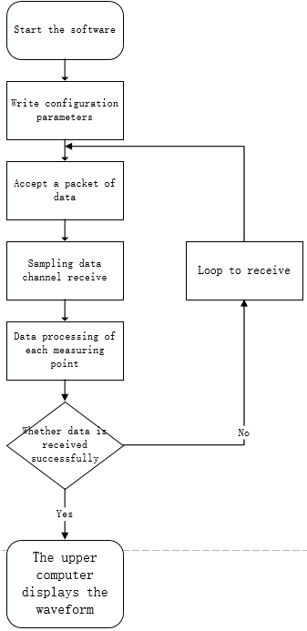
Figure 6-1

The interface development of demodulation machine is mainly realized based on QT development platform, and the data image display is realized based on QT5 template library, tool classes and various controls. The hardware acquisition of the demodulator needs to communicate with the upper computer online. The software is written in C++ language and based on QT Creator platform. The design is shown in figure 6-2.
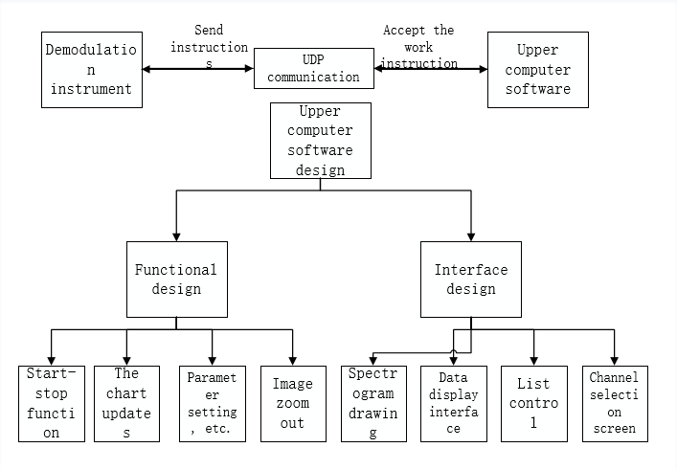
Figure 6-2 Software design diagram

5.2.2 Data transmission and processing design
Use UDP communication To communicate with the demodulator through the RJ45 network port of the demodulator. Set the LOCAL IP address to "192.168.0.120" and the DEMOdulator IP address to "192.168.0.119". Write monitoring thread code: create SOCKET packets to receive instructions from the demodulator, and then respond to the corresponding instruction information. Create mlistBuffers buffers to store the received data. MlistBuffers is an object of type QByteArray. QByteArray is the default array for processing hexadecimal characters defined in QT. Wavelength data are sent actively; Each packet sends 1024 bytes of data, more than the other packets. After receiving the data, I put it into my own class XDataProcess, which is the class that decodes the spectrometer data. All data decoding is done here.
After receiving data, the UDP service on the main interface enters this interface to complete data splicing and data decomposition. After receiving the data, determine whether the length is sufficient. And determine which channel the data comes from, and convert the data according to different channels. The core algorithm for the spectrometer data is also done here. The packet format is 01 0x datA1 data2...... Data1024.This class defines methods such as processing spectral data, processing wavelength, processing wavelength density and so on. The packet format is 01 0x datA1 data2...... Data1024.The demodulator and PC communicate with each other in question and answer mode. By sending instructions to the demodulator, the signal of fiber Bragg grating sensor is displayed and processed.

This protocol supports 30 gratings per channel. The following table is the instruction set.
category | Instruction (HEX) |  | function
The user instructions | 01 | 02 | Read parameters (device model, serial number, software and hardware version, local IP address, port number, MAC address, destination IP address, port number, device temperature, start-stop flag, channel number, subnet mask, default gateway)
The user instructions | 01 | 04 | Write local IP address, port number, MAC address, subnet mask, and default gateway
The user instructions | 01 | 06 | Write a time
The user instructions | 01 | 07 | Read the time
The user instructions | 01 | 08 | Read continuous transmission status, spectrum/wavelength/intensity continuous transmission frame number
The user instructions | 01 | 0A | Rev. Stop
The user instructions | 01 | 0C | Grating wavelength data in channels 0-15 (panel channel no. 1-16)
The user instructions | 01 | 14 | Call the police
The user instructions | 01 | 16 | Read the spectral data of a certain channel (panel numbers 1 to 32)
The user instructions | 01 | 17 | Start value of read wavelength, wavelength interval, data points, number of channels, number of returned data frames

Instructions:
- Instructions: 0 x0102
Function: Read parameters (device model, serial number, software and hardware version number, local IP address, port number, MAC address, destination IP address, port number, device temperature, start and stop flag, channel number, subnet mask, default gateway)
The host sends data: 01 02
Device return number data:
Parameters that | Length (Byte) | Data (HEX)
Baotou 01. | 2 | D0, D1
Device Model (ASCII code) | 16 | D2~D17
Serial number (ASCII code) | 16 | D18~D33
Software and hardware version (ASCII code), | 16 | D34~D49
Local IP address | 4 | D50~D53
Local port number | 2 | D54, D55
Local MAC address | 6 | D56~D61
Destination IP address | 4 | D62~D65
Destination port number | 2 | D66, distinguished district
Temperature of the equipment | 2 | D68, D69
Rev. Stop sign | 2 | The D70, D71
The channel number | 1 | D72
Subnet mask | 4 | D73~D76
The default gateway | 4 | D77~D80

- Instructions: 0 x0104
Run the following command to write the local IP address, port number, MAC address, subnet mask, and default gateway
Host sends data:
Parameters that | Length (Byte) | Data (HEX)
Baotou 01 04 | 2 | D0, D1
The IP address | 4 | D2~D5
The port number | 2 | D6, D7
The MAC address | 6 | D8~D13
Subnet mask | 4 | D14~D17
The default gateway | 4 | D18~D21
Default value:
IP address: 192.168.0.119
Port number: 4010
MAC address (HEX) : 7A 53 AD 28 FD 23
The subnet mask is 255.255.255.0
Default gateway: 192.168.0.1

- Instructions: 0 x0106
Function: Write time
Host sends data:
Parameters that | Length (Byte) | Data (HEX)
Baotou 01 06 | 2 | D0, D1
years | 2 | D2~D3
month | 1 | D4
day | 1 | D5
when | 1 | D6
points | 1 | D7

- Instructions: 0 x0107
Function: Read time
Host sends data:
Parameters that | Length (Byte) | Data (HEX)
Baotou 07 01 | 2 | D0, D1
The device returns data:
Parameters that | Length (Byte) | Data (HEX)
Baotou 07 01 | 2 | D0, D1
years | 2 | D2~D3
month | 1 | D4
day | 1 | D5
when | 1 | D6
points | 1 | D7

- Instructions: 0 x0108
Function: read continuous transmission state, spectrum/wavelength/intensity continuous transmission frame number
Host sends data:
Parameters that | Length (Byte) | Data (HEX)
Baotou 01 08 | 2 | D0, D1
The device returns data:
Parameters that | Length (Byte) | Data (HEX)
Baotou 01 08 | 2 | D0, D1
spectrum | 1 | D2
The wavelength | 1 | D3
The intensity of | 1 | D4
D2: number of frames of spectral data. 0 indicates that there is no spectral data
D3: number of wavelength data frames, 0 indicates that there is no wavelength data
D4: Number of intensity data frames. If the value is 0, there is no intensity data

- Instructions: 0 x010a
Function: start and stop control
Host sends data:
Parameters that | Length (Byte) | Data (HEX)
Baotou 0 a 01 | 2 | D0, D1
Rev. Stop sign | 1 | D2
D2=0x55, start sending wavelength data, D2=0x00, stop sending
Note: Modules in active send mode only respond to stop commands.

- Instructions: 0 x010c
Function: 0-15 channels (panel channel no. 1-16) grating wavelength data
The device sends data:
Parameters that | Length (Byte) | Data (HEX)
Baotou 01 0 c | 2 | D0, D1
0 Channel data: indicates the channel number | 1 | D2
0 channel data: number of raster | 1 | D3
0 channel data: wavelength data | n
...
15 channel grating wavelength data | n
Format of grating wavelength data for each channel: 1 byte channel number, 1 byte grating number, n byte wavelength data, n= grating number *2
Each wavelength value contains 2 bytes of wavelength data, with the lower byte being the first. The actual wavelength value is (DataL +DataH*256) /1000+1520
Channel numbers: 0-15

- Instructions: 0 x0114
Function: Alarm
The host sends data: 01 14
The device returns data:
Parameters that | Length (Byte) | Data (HEX)
Baotou 01 14 | 2 | D0, D1
Alarm type | 1 | D2
Overtemperature alarm time | 6 | D3~D8
D2, 0x01: Overtemperature alarm.

- Instructions: 0 x0116
Run the following command to read the spectral data of a channel (0 to 31, panel 1 to 32)
Host sends data:
Parameters that | Length (Byte) | Data (HEX)
Baotou 01 16 | 2 | D0, D1
Channel number | 1 | D2
D2: channel number. The value ranges from 0 to 31
The device returns data:
Parameters that | Length (Byte) | Data (HEX)
Baotou 01 16 | 2 | D0, D1
Channel number | 1 | D2
Package no. | 1 | D3
Spectral data 1 | 2 | D4, D5,
 | ... | ...
Spectral data N | 2
Spectral data (iN dBm) : low bytes first
Calculation method:
Dus = (D4+D5*256); Dus: D is an unsigned short int
Ds = (short int)Dus; Ds means D is a short int
Df = (float)Ds; Df indicates that D is a float
Spectral data 1 = Df /10;
The last frame is wavelength and intensity data, and the data format is as follows:
Parameters that | Length (Byte) | Data (HEX)
Baotou 01 16 | 2 | D0, D1
Channel number | 1 | D2
Package no. | 1 | D3
Number of grating | 1 | D4
Wavelength data 1 | 2 | D5, D6
 | ... | ...
Wavelength data 30 | 2
Intensity data 1 | 2
 | ... | ...
The intensity of the data | 30
Each wavelength value contains 2 bytes of wavelength data, with the lower byte being the first. The actual wavelength value is (DataL +DataH*256) /1000+1520
Intensity data (iN dBm) : low bytes first
Calculation method:
Dus = (DataL+DataH*256); Dus: D is an unsigned short int
Ds = (short int)Dus; Ds means D is a short int
Df = (float)Ds; Df indicates that D is a float
Spectral data 1 = Df /10;

- Instructions: 0 x0117
Function: read wavelength start value, wavelength interval, data points, channel number, return data frame number
Host sends data:
Parameters that | Length (Byte) | Data (HEX)
Baotou 01 17 | 2 | D0, D1
The device returns data:
Parameters that | Length (Byte) | Data (HEX)
Baotou 01 17 | 2 | D0, D1
Initial wavelength value | 2 | D2, D3,
Wavelength interval | 2 | D4, D5,
The data points | 2 | D6, D7
The channel number | 2 | The D8, D9
Returns the number of data frames | 2 | D10, D11
Wavelength start value: low bytes first, (D2 +D3*256) /1000+1520, unit: nm
Wavelength interval: the first byte is (D4 +D5*256), in the unit of PM
Data points: low bytes first, is (D6 +D7*256)
Number of channels: low bytes first, is (D8 +D*256)
Number of data frames returned: low bytes first, is (D10+D11*256)

6.2.3.4

5.2.3 Start and Stop module design
(1) Parameter setting
Setting parameters before beginning the top computer software can help ensure that data is collected and stored efficiently. The performance of the data collection card is used to set the parameters, and the data collection card's operating efficiency should be improved as much as feasible in order to fulfil the demodulation accuracy. Sampling frequency, reading length, data storage path, and peak number are all parameters of the FBG demodulation system's top computer. The sample rate determines the accuracy of the data obtained and the FBG demodulation system's resolution. The broadband light source in the demodulation system has a spectral range of 1525-1565nm. 40*1000 sampling points are required to attain a resolution of 1pm. According to Nyquist's law, a sampling rate of more than three times the number of sampling points is required to achieve a resolution of one PM. The data collection card utilised in the FBG demodulation system has a maximum sampling rate of 400KHz, which meets the requirement of 1 PM resolution. The length of data read by the data acquisition card each time is referred to as read length. Because the data capture card's precision is 14 bits, the maximum read length is 16,384. The address of data storage is the storage path. The data storage capacity of the FBG demodulation system is significant because the central wavelength signal and measured physical quantity signal must be stored in real time, thus the proper storage path should be chosen for data storage. To ensure the accuracy and stability of the FBG demodulation system's peak search, the number of peak searches is chosen according to the number of FBG sensors in each channel.

(2) Start and stop the module
The start and stop control module is used to operate the host computer software of the fibre grating demodulation system, primarily through the internal link control program's start and stop module. Two state keys are included in the start and stop module. When the "Start" button is pushed, the program's modules begin to run; The application will no longer run and the higher computer software will stop when the "stop" button is hit. Exit the higher computer software by pressing the "X" button in the upper right corner. To set the start and stop function, first check whether the host software is running. If it is not running, the start and stop button is "Play"; if it is running, the start and stop button is "Stop". Figure 6-3 shows the start and stop function.
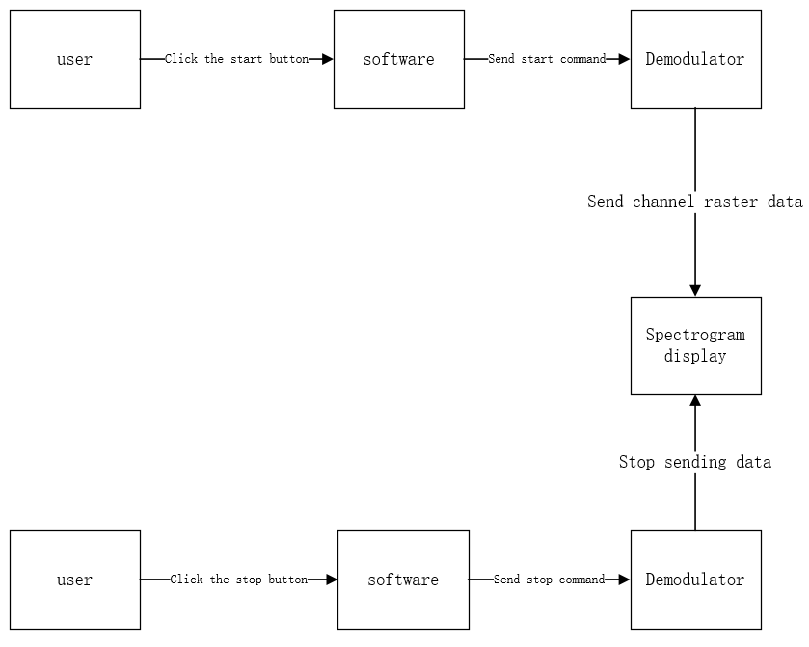
Figure 5-3 Starting and stopping functions

Functions As long as the QAction function is used, the RunOrStop button pointer is defined, and the signal and slot function is used. When the button is pressed, the software sends the instruction to the demodulator to stop sending data, as shown in Figure 5-4.
Figure 5-4 Shows part of the code

5.2.4 Spectrogram design
When users enter the software, they can intuitively view the spectrum through the main interface of the software, and also operate the spectrum by enlarging, shrinking and resetting the three buttons. When the user clicks the reset button in the upper computer software, the spectrum display range, spectrum graph, wave peak wavelength data and temperature data can be reset and refreshed. The zoom in, zoom out and reset function of spectrograph is mainly through button_zoomIn, button_zoomOut and button_zoomReset objects (pointer types) defined in QPushButton class, which are displayed as mouse scroll in the interface, and zoom in and out with the current mouse position as the center point.First, determine whether customPlot (qcustomplot is a Qt C++ control for drawing and data visualization, and customPlot is an object of this kind) is empty. If not, enter the function theme and use the scaleRange function to scroll the mouse outward to zoom out and inward to zoom out.See Figure 5-5(a) and (b).
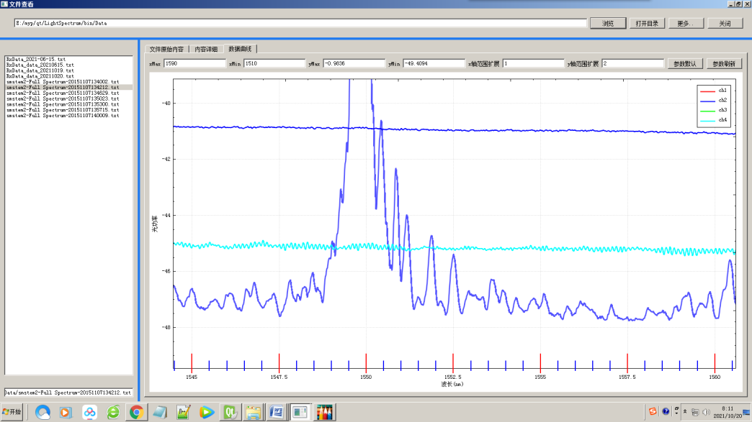
Figure 5-5 (a) Zoom in
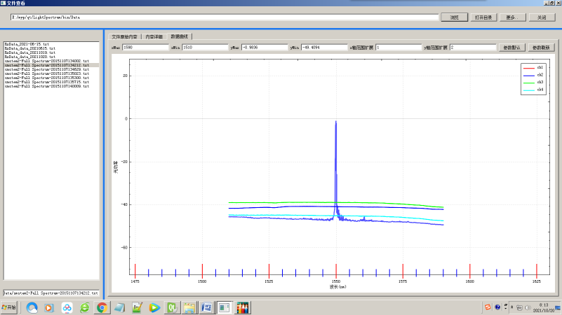
Figure 5-5 (b) Zoom out
To reset a curve, you simply use your own pushButton_zoomReset_Slot() function, which is triggered when the reset button is clicked to reset and clear data in each channel.

Qcustomplot control is directly used to reference QT internal written Qcustomplot support. After creating QT project, add Qcustomplo source code to the project file and create a filter. Finally, add the referenced header file path to the mainwindow. CPP file, then add controls, initialize the display range of the coordinate axis, and create the coordinate axis, initialize the display area size, initialize the drawing window, Then add the timer, initialize the display buffer buff, and add the display function and timer.Through the received data, the central wavelength is X-axis, the spectral intensity is Y-axis, and the spectral curve is summarized.As shown in Figure 5-6, perform spectrum mapping on the test data.

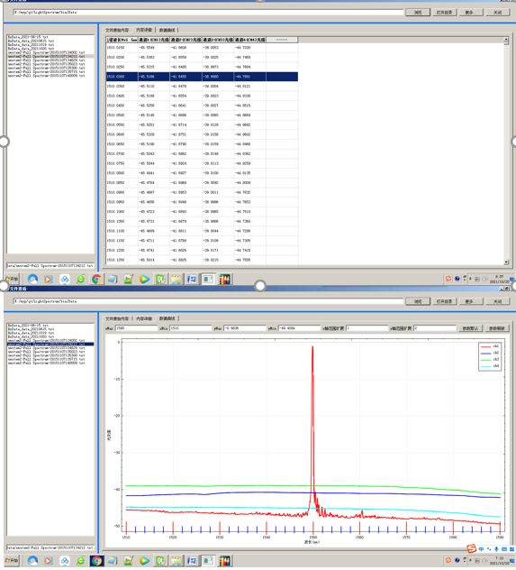
Figure 5-6 Spectrum drawing of the test data

5.2.5 Setting System Parameters and Temperature Parameters
(1) Temperature parameter setting
Set temperature parameter dialog box, configure the temperature parameter correlation coefficient in this file.Ini to modify the temperat ure parameters directly, or to obtain the default temperature parameters by setting the temperature coefficient in the temperature channel dialog box in the software. The OnBnClicledOk method is called to input and modify the temperature coefficient.

Edit the first function coefficient of temperature and peak wavelength data and the offset of the first function of temperature and peak wavelength data.If the input format is incorrect, the system prompts you to enter the correct format, as shown in Figure 5-7. If the input format is correct, you can edit the temperature parameters, as shown in Figure 5-8.

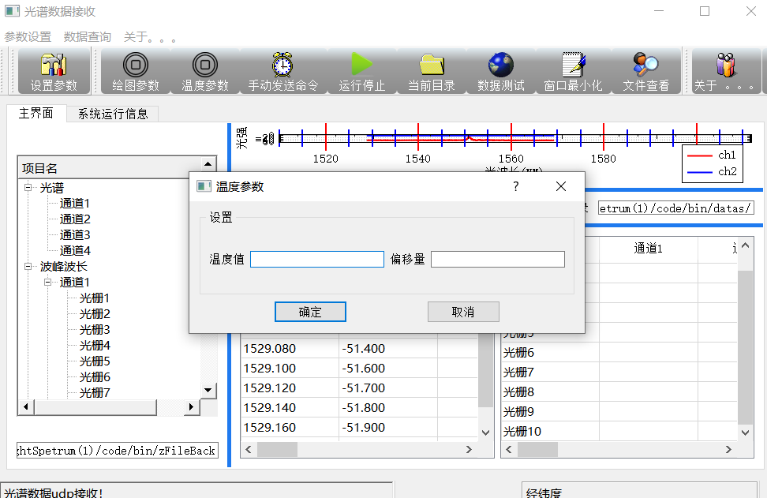
Figure 5-7 Temperature parameter design page
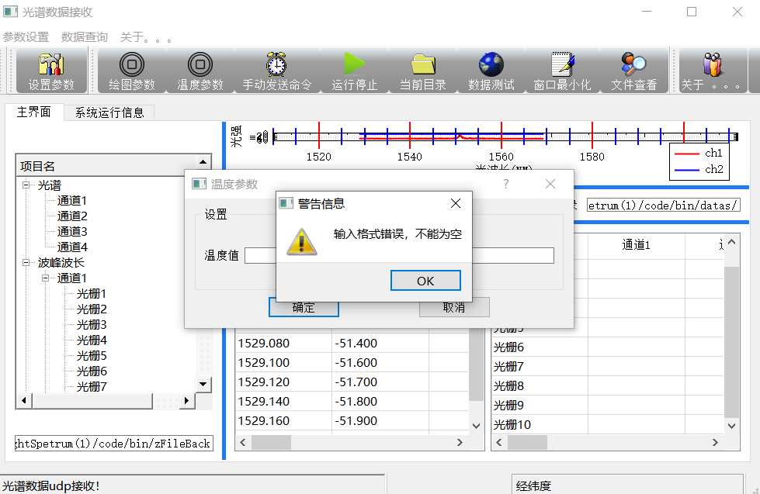
Figure 5-8 Input format error

(2) System parameter design
System parameter design includes system title, local address IP, local UDP port number, and demodulation device IP address and port number, at the same time marked when the file is large, select part of the line display, you can input the range of line display. After the test Settings can be linked to the device, once the device is linked, you can send instructions to the device, interact with the device, receive data for data decoding, curve display and file storage. As shown in Figure 5-9.At the same time, the system parameter design also includes curve drawing parameter Settings, which can set the corresponding X axis and Y axis respectively
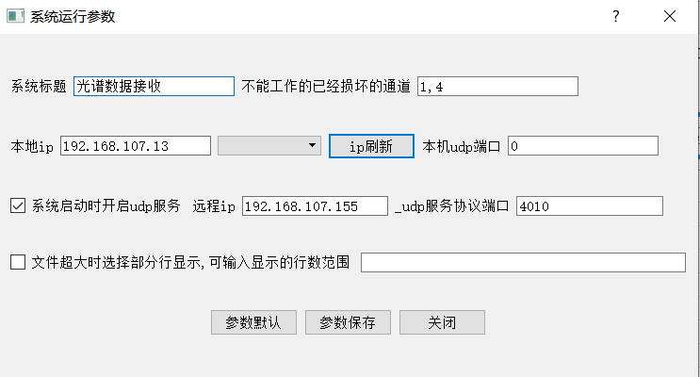
Figure 5-9 Setting system parameters

(3) Spectrum curve drawing parameter setting
Curve drawing parameter setting, as shown in FIG. 5-10, corresponding physical quantities of X axis and Y axis can be set respectively (different demodulators can be used to photograph the human-computer interaction software, and not all demodulators are light intensity).At the same time, the value range of X axis and Y axis, the minimum scale value and the name of the spectrum are specified.

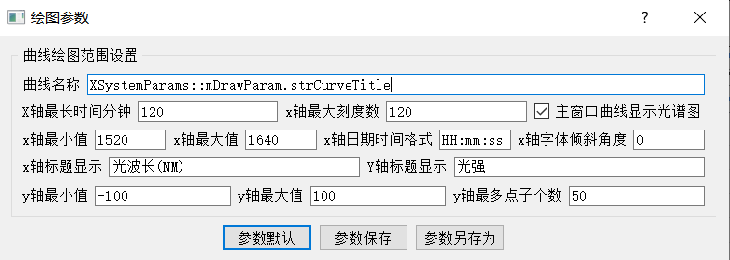
Figure 5-10 Setting curve drawing parameters

5.2.6 Software testing
The upper computer software is tested as shown in Table 3-2. The test environment is to configure the demodulator in advance, start the upper computer, connect the prepared fiber Bragg grating, and the Ethernet address of the upper computer must be 192.168.0.120.
Table 3-2 Test case table of the upper computer
The test number | 101
Test purposes | Check whether the upper computer software can run normally and the spectrum is displayed normally
Test scenarios | The desired effect | The actual effect
Click the start button when the user starts the software | Spectrum interface displays spectrum, and the table below shows the specific value of wave peak wavelength | Spectrum interface displays spectrum, and the table below shows the specific value of wave peak wavelength
When the user clicks the stop button | The spectrogram returns to its default state and the table clears | The spectrogram returns to its default state and the table clears
The specific test of the upper computer is shown in Figure 5-11. When the user clicks the start button, the upper computer software runs successfully and the spectrogram successfully displays all the fiber Bragg grating spectra and data. The upper computer software is tested successfully this time, which verifies the feasibility of the upper computer software development, spectrogram and data display.
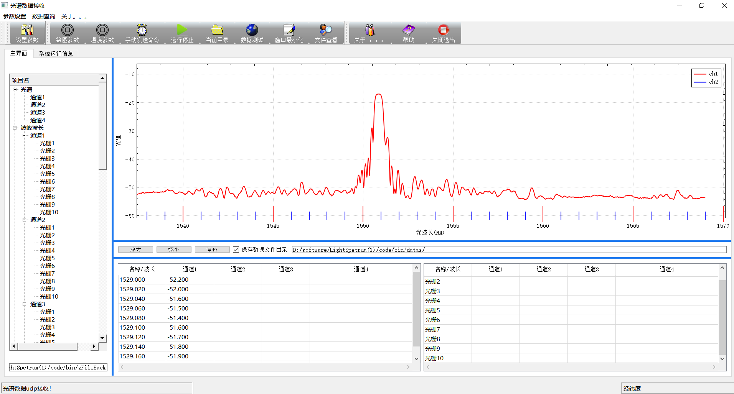
Figure 5 to 11
At the same time verify the file storage function, can read the central wavelength values are successfully stored in the specified folder, for later research.As shown in Figure 5-12.
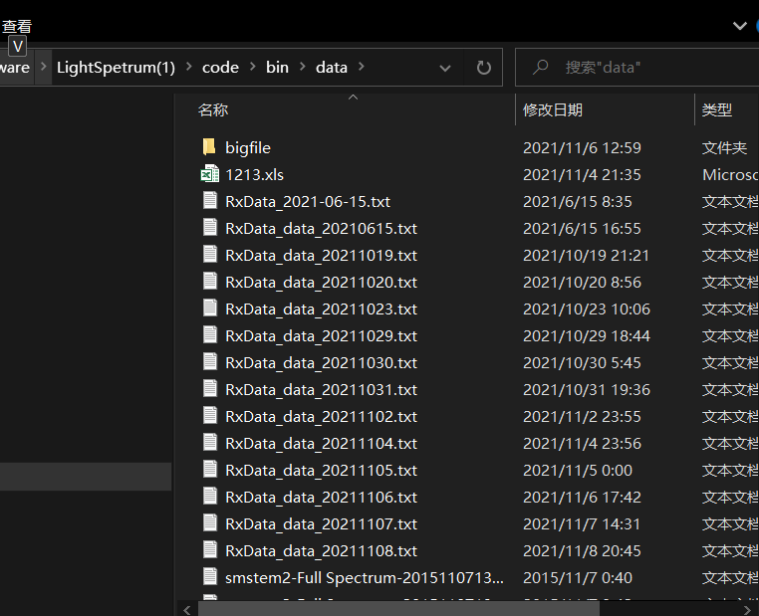
Figure 5-12

6 Summarizes
With the development and engineering application of FBG sensing technology, people have higher requirements on the demodulation speed, demodulation precision, sensing capacity and user experience of FBG sensing system. In this paper, tunable laser demodulation system and scheme are studied. At the same time, aiming at scanning laser wavelength demodulation system of high speed and high precision fiber grating, based on human-computer interaction interface design theory, human-computer interaction software is developed to communicate with the demodulation instrument.

The main work of this paper is as follows:

1. This paper mainly introduces the background and significance of the subject research, summarizes the development history of human-computer interaction interface, and also introduces the general situation of FBG sensing and demodulation technology, main application fields and development situation.

2. The temperature and strain sensing theoretical model of the fibre Bragg grating is presented, and the temperature and strain sensing formula of the fibre Bragg grating is inferred using the coupling theoretical model. According to the sensing principle of fibre Bragg grating, five typical wavelength demodulation algorithms are outlined, laying a theoretical framework for the study and construction of high-speed fibre Bragg grating demodulation systems.

3. Introduces the relevant theories and design ideas of human-computer interaction interface design, respectively expounds the three elements of human-computer interaction interface design, design content, rules and organization principles and interface design process. It lays a good foundation for the design of human-computer interaction software based on optical demodulation.

4. Based on the theory of fiber grating demodulation, the wavelength demodulation system and scheme of fiber grating based on tunable laser are introduced. Among them, peak-seeking algorithm plays an indispensable role in fiber grating demodulation, and five most commonly used peak-seeking algorithms are introduced.

5. A kind of human-computer interaction software is developed based on QT platform and written in C++ language combining the scanning laser fiber grating demodulation instrument and human-computer interaction interface design theory. The whole human-computer interaction software mainly includes parameters setting (temperature coefficient, system parameters, curve setting parameters), spectrum drawing, data acquisition, storage and central wavelength display four functions.

Looking forward to
This paper develops human-computer interaction software based on scanning laser fiber grating demodulation system, so that users can easily and intuitively watch the change of fiber grating wavelength and spectrum, but there are many problems.

1. Serial communication can be added to control the laser scanning frequency of demodulator in real time, so as to facilitate future research.

2. There is no corresponding database. With the increase of data volume, the search and query speed of data will decrease, so database and a corresponding optimization search algorithm are needed to improve the data access rate

3. In the process of drawing the original data, when the data amount reaches millions, in order to improve the drawing efficiency, the method of selecting points is adopted in the paper. The method of selecting points can be further optimized to highlight the data features.

Reference
[1] Yang Jing. Research and Application of Human-machine Interface and User Model [D]. Tianjin;Hebei University of Technology, 2002
[2] Guo Yajun, Jin Xianzhan. Human-computer Interaction [M] Huazhong University of Science and Technology Press, 2005
[3] Sun Q, Feng H ,Yan X Y, et al. Recognition of a phase-sensitivity OTDR sensing system based on morphologic feature extraction[J] Sensors, 2015, (7) : 15179-15197
[4] Culshaw ,B.Optical Fiber Sensor Technologies:Opportunities and -Perhaps-Pitfalls[J]. Journal of Lightwave Technology, 2004 ,22(1) :39-50
[5] Ma Chunyu. Distributed fiber disturbance sensor Based on Asymmetric Dual Mach-Zehnder Structure [D], Tianjin University, 2017
[6] CAI Linjun. Design and Implementation of High speed Fiber Grating Sensing demodulation System [D]. Wuhan University of Technology, 2013
[7] Zhou Guangli, E Shulin, Deng Wenyuan. Study and application of optical fiber temperature sensor [J]. Optical communication technology, 2007,31 (06) : 54-57
[8] Di Sante R. Fiber Optic Sensors for Structural Health Monitoring of Aircraft Composite Structures : Recent Advances and Applications[J]. Sensors . 2015, 15(8): 1866-18713
[9] Loutas T H, Panopoulou A, Roulias D,et al,Intelligent health monitoring of aerospace composite structures based on dynamic strain measurements[J]. Expert Systems with Applications, 2012,39(9): 8412-8422
[10] He Meng. Study on high speed Fiber Grating demodulation instrument based on CPLD [D]. Tianjin University, 2009
[11] Wada.A.Tanaka.S,Takahashi. N. Optical Fiber Vibration Sensor Using FBG Fabry -Perot Interferometer with Wavelength Scanning and Fourier Analysis[J] IEEE Sensors Journal,2012,12(1): 225-229
[12] Ma Yongjie. Research on Demodulation Technology of Fiber Grating Sensor [D] Beijing University of Posts and Telecommunications 2007
[13] Zhou Guangli, E Shulin, Deng Wenyuan. Optical communication technology, 2007,31 (06):54-57. (in Chinese
[14] Xu Yingbin. Research on scanning semiconductor laser technology and its application in fiber sensing [D]. Shandong University, 2016
[15] Chen Zhijun, Bai Jian, WU Zutang, et al. Acta photonica sinica, 2015,44 (11) : 77-82. (in Chinese)
[16] research and application of C++ programming platform [J]. Computer science and technology, 2005
[17] Li Wenqiang, Zhu Wencai. Cross-platform Scheme of MFC Framework Application Software [J]. Computer Engineering and Application.2005
[18] Fine.V.E Cross-platform QT-based implementation of low level GUI layer of ROOT[J] Nuclear Instruments and Methods in Physics Research ,Section A: Accelerators,
[19] Brun, R Cross-platform approach to create the interactive applications based on ROOT and QT GUI libraries[J] Accelerators, Spectrometers, Detectors and Associated Equipment, v534, nl, Nov21, 2004, Proceeding of the IXth International Workshop, P94-97
[20] Wu Jian-lei, TIAN Da-qing, MAO Zhi-hong, A new technology of e-government message transmission based on UDP [J]. Information Technology, 2014(1):124-127.
[21] Linsong Ding, Liqin Huang, Qt4 Graphic Design and Embedded Development (M). Beijing: Posts and Telecommunications Press, 2009:1-12
[22] Yin Lifeng. Qt C++ cross-platform graphical interface programming foundation [M]. Beijing: tsinghua university press, 2014:1-23
[23] He Runan. Design and implementation of Reliable Transmission System for Large-scale Data Transmission based on UDP [D]. Shandong University, 2015
[24] Kong Zhiming. Design and Implementation of distributed video Management System based on TCP and UDP [D]. Anhui University, 2019
[25] Li Shujun, Chen Xin, JI Baojie. Application of UDP protocol in Field Real-time Communication [J]. Automation & Instrumentation, 2004(04):37-40
[26] Tobias J. Weismuller,Taotao Zhou,Sandra Kalthoff,Henrike Lenzen,Michael P.Manns,Christian P.Strassburg.Genetic Variants of UDP-glucuronosy Itransferase 1A genes are associated with disease presentation and outcome in primary Sclerosing cholangitis [J]. Journal of Liver International, 2020, 40 (7) : 38-40
[27] Wu Jing, Wu Hanping, HUANG Junbin, et al., Research progress of fiber Grating sensor signal demodulation technology [J]. Chinese Optics, 2014, 4:519-531
[28] QIAO Xuegang, DING Feng, Jia Zhenan, et al. Research on edge filtering demodulation technology based on ASE light source [J]. Journal of Optoelectronics · Laser, 2009(9):1170-1173.
[29] Li Lanlan, "Research on Optical Performance Monitoring Technology", [doctoral thesis], Beijing University of Posts and Telecommunications, 2012, P11, P18
[30] optical fiber communication technology development strategy, HTTP: / / http://blog.163.com/m_ypeng/blog/static/1195990062/01023155119608
[31] Liao Yanbiao, Principle and Application of Optical Fiber Optics [M], Tsinghua University Press,2010:290-300
[32] GOU D D, Yang S G, Yin F F, et al.1 micron band broadband tunable mode-locked fiber laser [J]. Acta Optica Sinica, 2013, 33(7):71-75.
[33] Liu Quan, CAI Linjun, LI Zhengying, et al. Research on peak seeking algorithm of high speed and high precision FIBER Bragg Grating demodulation. Journal of Optoelectronics · Laser, 2012(7):1233-1239.
[34] WANG PENG-zhi, LIU Chun-tong, LI Hong-cai, WU Rong-jing, design of a quasi-distributed fiber grating sensor demodulation system based on LabVIEW [J]. Laser & optoelectronics progress, 2016,53(2):206-213.
[35] QT5 Development and Examples (4th Edition)[M] Publishing House of Electronics Industry

APPENDICES
MainWindow::MainWindow(QWidget *parent) :
QMainWindow(parent),
ui(new Ui::MainWindow)
{
ui->setupUi(this);

udpSocket_receiver=NULL;//udp服务的指针变量置空；

// 状态描述
is_running = 0;
is_grabbing = 0;
spectrum_sending_enableded = true;

//窗口的最大化最小化按钮的设置。不用这些代码，
Qt::WindowFlags flags=Qt::Window;
flags |=Qt::WindowMinimizeButtonHint;
flags |=Qt::WindowMaximizeButtonHint;
flags |=Qt::WindowCloseButtonHint;
flags |=Qt::MaximizeUsingFullscreenGeometryHint;//设置窗口按钮，最大最小关闭；
setWindowFlags(flags);//标志设置完成；

createAction();//创建各种菜单和工具栏的按钮事件
createMenu();//具体创建菜单
createToolBar();//创建工具栏
createStatusBars();//创建状态栏
listWidget_showRightMenu();//设置显示系统运行信息界面的右键菜单；

XSystemParams::LoadParam();//加载系统定义的默认参数；
initControls();//初始化曲线控件
initTree();//初始化左边的数形状的视图；
// 下面是这种按钮事件的绑定；
QObject::connect(tableWidget2,SIGNAL(itemClicked(QTableWidgetItem*)),this,SLOT(tableWidget2_itemClicked(QTableWidgetItem*)));
QObject::connect(tableWidget1,SIGNAL(itemClicked(QTableWidgetItem*)),this,SLOT(tableWidget_itemClicked(QTableWidgetItem*)));
QObject::connect(button_zoomOut, SIGNAL(clicked(bool)),this, SLOT(pushButton_zoomOut_Slot()));
QObject::connect(button_zoomIn, SIGNAL(clicked(bool)),this, SLOT(pushButton_zoomIn_Slot()));
QObject::connect(button_zoomReset, SIGNAL(clicked(bool)),this, SLOT(pushButton_zoomReset_Slot()));
QObject::connect(mainSplitter, SIGNAL(splitterMoved(int , int )),this, SLOT(mainSplitter_splitterMoved_Slot()));
QObject::connect(rightSplitter, SIGNAL(splitterMoved(int , int )),this, SLOT(rightSplitter_splitterMoved_Slot()));

XSystemParams::mXBaseParam.bOpenSaveProcessDetail=true;//设置保存处理文件的标志；

this->setWindowTitle(XSystemParams::mXBaseParam.strTitleMain);//主界面的标题信息显示，对话框最上面的；

//接受运行信息的槽函数和发送消息的绑定；
QObject::connect(&XGlobals::mZZSendMsg,SIGNAL(showRunMessage(const QString)),this,SLOT(mShowRunInfo(const QString)));

// ui->splitter->setSizes(widgetSizes);
// ui->splitter->setStretchFactor(2, 1);
init_udp_Listener();//udp数据服务开始监听，
// on_btnListen_clicked();

