Student Name: Ashleigh Steel
Assignment: Case Study – Health Informatics
Course: Applied Computing
Modula: Geographical Information Systems
Submission Date: 28/01/2019

Table of Contents
Introduction 3
Geovisualization 3
SDSS / Meningitis 3
MapInfo 4
Health Data 4
Analysis 5
Bibliography 8
Appendix 9

Introduction
I have been task to produce a research paper to document my findings using the [1]NHS wales site “Healthmapswales.uk” with its geographic referencing to provide a visual analysis to the meningitis situation. Using a software like [2]MapInfo I will be showing why providing data with geographical referencing to visually see results would be extremely useful, especially those working in healthcare.
Below Il be explain why but also showing examples of how GIS will/has change the way we look at data, by allowing us to more accurately see results and act more effectively to the situation. Using MapInfo I’ll be creating maps of Swansea area and using the meningitis jab of infants at age 1 and 2 I’ll be able to forecast areas of that will require effect otherwise meningitis for teens in those area could become a problem in the upcoming years.

Geovisualization
[3]Geovisualization is a visualization that deals with displaying information with geographic information tide to it. So while performing my case study to find out about meningitis in Swansea, I’ll be doing Geovisualization to pinpoint areas using geo code tide with the Uk councils “Health maps wales” to provided geographical accuracy with my findings. For example see images below “Analysis”.

SDSS / Meningitis
[4]SDSS or Spatial decision support system is a computer system made to help in decision making while also solving a spatial problems. It helps spatial planner by guiding land use decisions. It’s used to make the most effective decision. At times it’s referred to in our case as a GIS geographic information system.
[5]Meningitis or also known as meningococcal is very deadly and jabs at a young age is required to prevent the chance of getting the infection. This is because it’s more common to effect babies, young children and teenagers. It can cause blood poisoning and result in damage to the brain or nerves, that’s why vaccinations are required early to protect against it.
[6]Looking for Meningitis case studies, I stumbled upon one made by Rita A Krueger discussing how a three month old infant was brought to a clinic with meningitis showing how deadly this can be and she states that 15 to 20% of the cases were due to enterovirus infection which are common, especially in infants and children. The Symptoms being fever headache nuchal stiffness, lethargy, vomiting and sensitivity to light. Infants tend to include irritability and fever. [7] Meningitis affects the meninges, it’s what surrounds the brain and spinal cord to protect nervous system, meningitis cause these areas to swell, most likely casing damage to the areas it effects. So awareness for Meningitis jabs is extremely important for youngsters to ensure this doesn’t happen to them.
So using GIS to gather geographic information of say meningitis jabs, we can use this and perhaps act more directly to the problem at hand, for example if we see high increase of manful in England, using geo code and jab percentages provided we can see what areas in England had low infant jab rates so we can prevent this from happening again by ensure that these areas get better awareness of the problem at hand. I’ll be doing the same below with wales, Swansea area.

MapInfo
[2] MapInfo is used to show spatial relationships within data, it has been used since 1986 and is still being widely used. For example it can generate a map showing the area covered by specific post codes or data from one map could be used to enhance another. MapInfo is extremely useful to large companies as it allows them to geographically see results and pinpoint areas of improvement or changes needed to increase profit and so on. Later versions now allow for spreadsheets and databases which I’ll be taking advantage off to import NHS data on Meningitis with geographical code to pin point areas using a map and the data given.

Health Data
Health Maps Wales by the NHS wales informatics service allows us to use their previous data records with detail and with geographical information (with consent of each patient). Using this with MapInfo I am able to diagnose my analysis and perhaps forecast a possible feature with geographic accuracy.
I have gathered data from 2015 to 2018, this is due to jabs only being available to infants age 1 to 2 during 2015, while before this, this was ministered to teens of the age 10 – 12 before this time period, of course this is still read available but as infants are now beginning to receive this jab (unless there’s changes), I feel the results for teens will be irrelevant due to low numbers needing their jabs. Also depending on your symptoms and situations, on average, 2 jabs are needed to take full effect of eliminating the possibility of meningitis with a space of 4 weeks, but for infants, a year gap is recommended especially for age 1 infants.
First of [8]MSOA meaning Middle later super output area is designed to improve the reporting of small area statistics, while USOA is similar but is less accurate with less areas, USOA will say 4 areas in Swansea while MSOA will separate it for each smaller sections. When choosing to gather data on Meningitis jabs, I chosen to use MSOA over USOA because I need Area/region based results not very precise location for my analysis, I need to find out what areas are not keeping up with their jabs, not exactly who.
(See Appendix 1, 2 and 3 for heath data) Shown in “Appendix” is the data extracted and imported into Map info GIS system. They have provided all of wales Vaccination locations, but I have normalized it and limited this to only Swansea while using the Geo codes provided. So with this I’ll be able to analyse the data shown below.

Analysis
I have gathered information from 2015 to 2018 to analysis and forecast a possible feature to show why GIS is essential by showing its usefulness to even those in health care, preventing meningitis from happening in certain areas in Swansea (using % of those taken the jab).

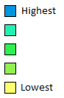
Year 2015
Age 1 Age 2
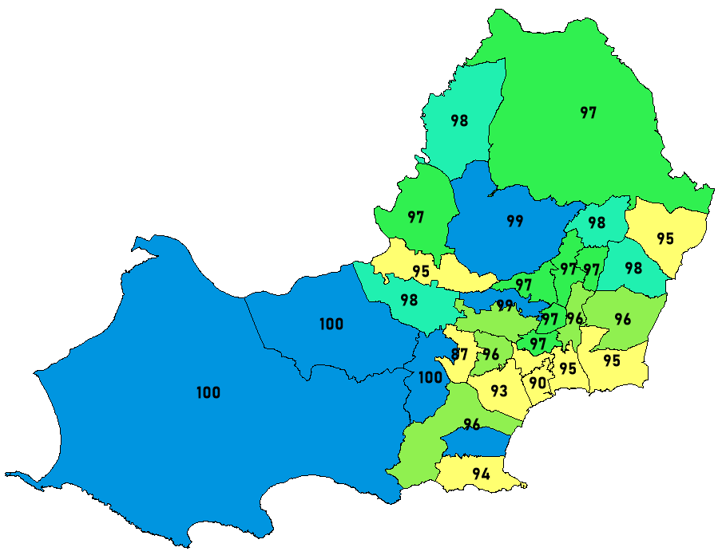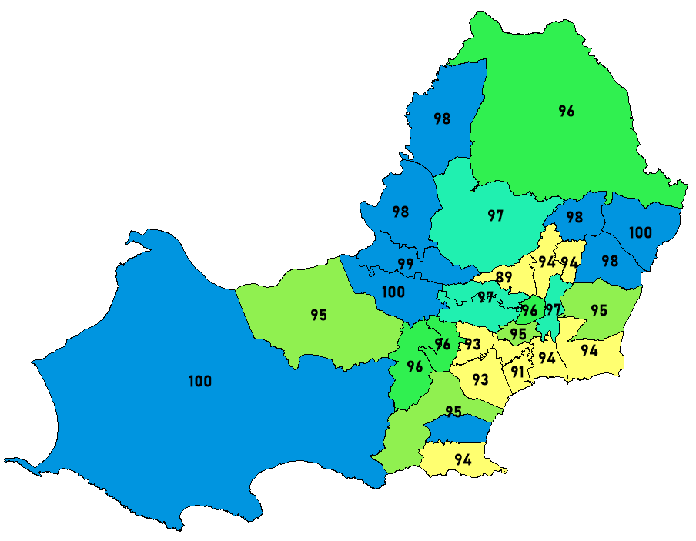
First starting with age 1 infants in 2015, we can see the majority of the low percentages are actually in Swansea’s centre (south east side). While north and west are majority high numbers, shown by the numbers and colours, being less likely of meningitis incidents. For age 2 infants we can see a similar recurring theme with majority of the low percentages are Swansea’s central so in the years to come, a cause for action involving more awareness of meningitis to parents around these areas could be made to prevent such catastrophe in the years to come as its more and more likely for their child that haven’t had the jab, to have a chance of getting meningitis.

Year 2016
Age 1 Age 2
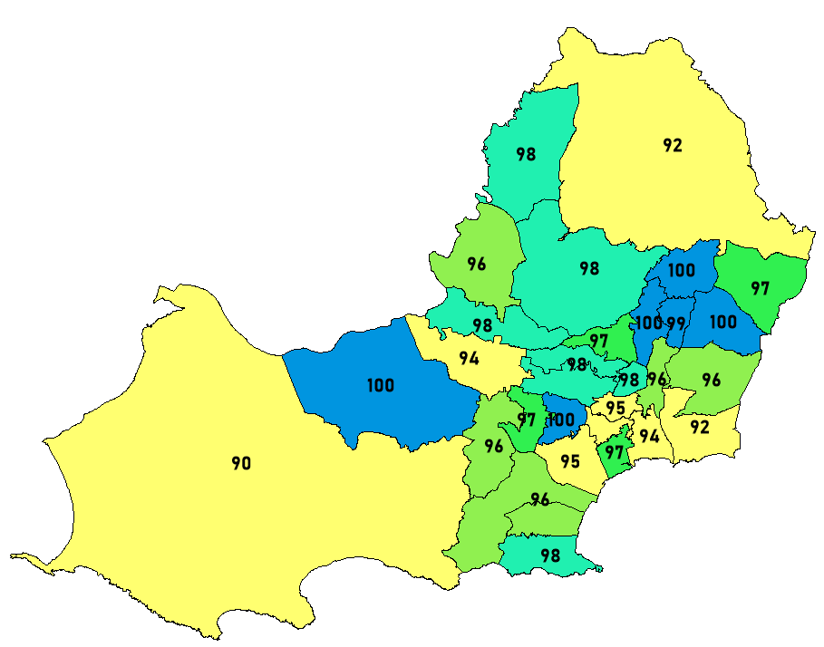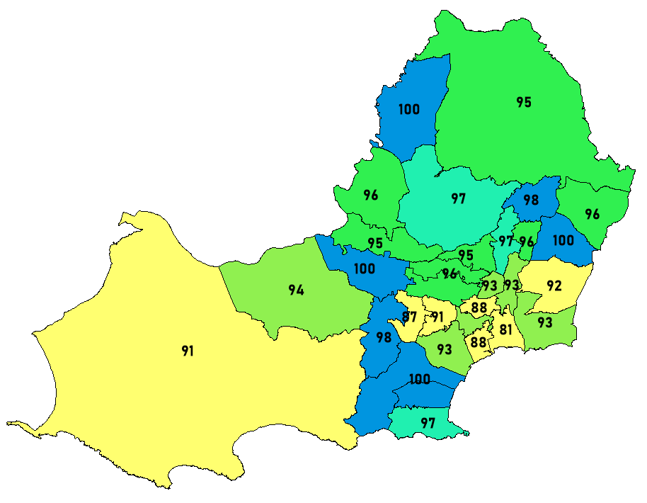
Looking at 2016 age 1 and 2 data we can see a huge change, with only small number of areas having 98 - 100% jab rates, meaning from 2016 to at least 2032 the younger population born in 2016 are going to have a much higher threat of getting meningitis if actions aren’t taken, especially areas such as west Swansea, like Llangennith and north like Pontardawe.

Year 2017
Age 1 Age 2
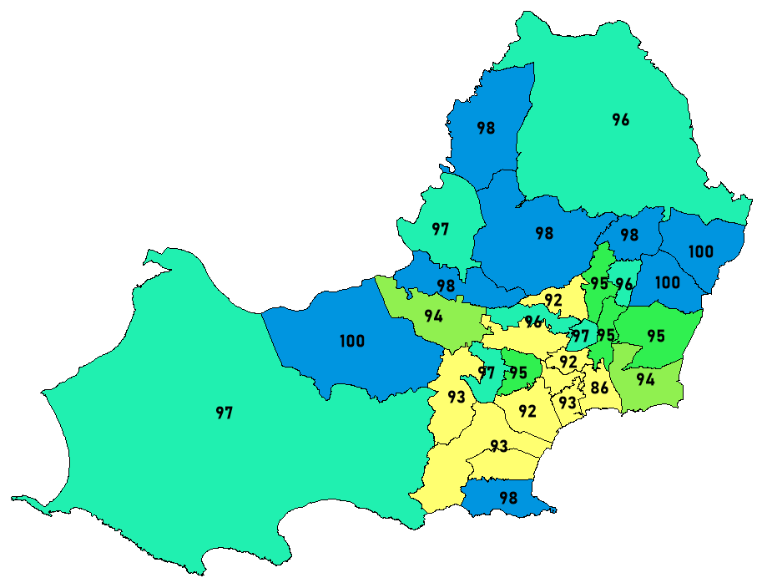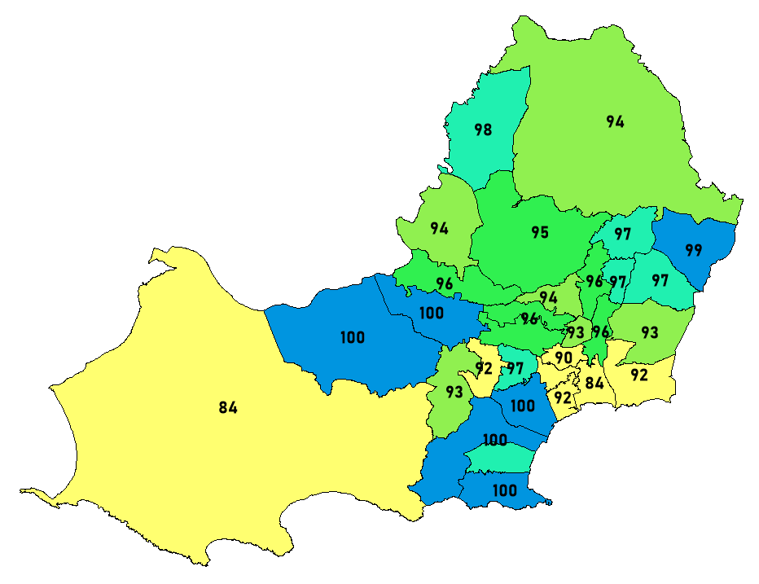
GIS shown in 2017 can be shown to be extremely useful, as we can see for age 1 population, all around is a lot higher than the past years part from a few areas are central Swansea, especially with 86% around Port Tennant (Swansea Centre), so immediate action should be taken before a wide spread of meningitis could accrue around Swansea centre in the upcoming years. But then for Age 2 we can see areas like Llangennith could still be still be at danger as the majority of them still haven’t had their second required jab, same with Port Tennant. GIS has shown which areas need to be focused on to prevent epidemic of meningitis.

Year 2018
Age 1 Age 2
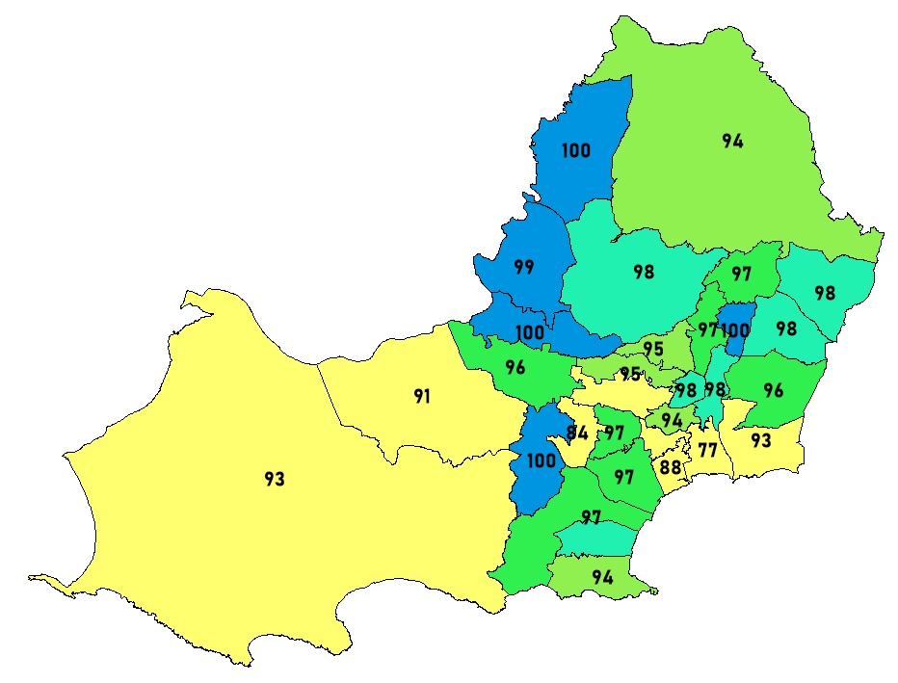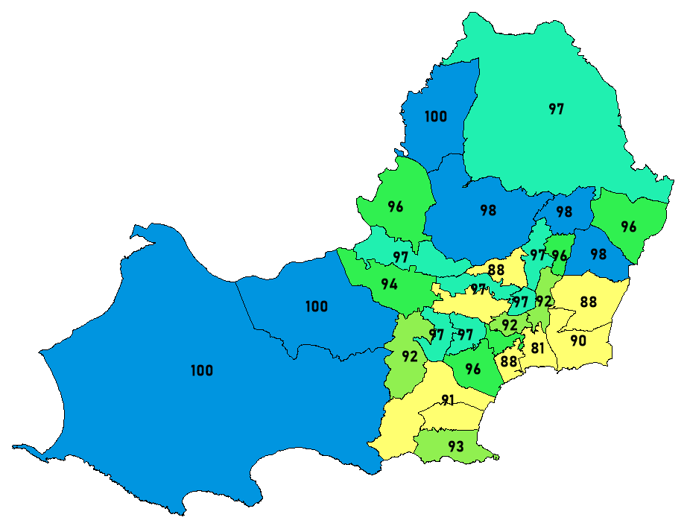
So during 2018 we can see age 1 infant’s particularly in areas such as 77% Port Tennant and surrounding areas, parents need to be aware of the important of these jabs, as of each year, these jabs don’t just contain meningitis vaccinations, [5]they continue to improve and prevent even more illnesses, new or old to help stop or prevent their children getting these horrible and sometimes left threatening infections. For age 2 we can see an improvement across the board from last year age 1 infants, part from areas in central Swansea.

Forecast
So from using the GIS information gathered above, I am able to forecast a possible meningitis increase in certain areas of Swansea, for example if Swansea centre doesn’t perhaps increase awareness of the dangers of meningitis, in 10-16 years from 2015 a highly increase chance of those who haven’t taken their jabs yet, are at higher risks during their teenager ages. Same with areas like Llangennith and Pontardawe in 2016 and particularly in Swansea centre, Port Tennant from 2016 to 2018 is lower than 90% worse than most of the other areas in Swansea and so on.
Looking at this data gathered with GIS software (elements) not just cause of percentages of the population we can see a possible meningitis problem but also what areas we need to tackle to prevent this. Especially Around Port Tennant as they seem to be the only area that consistently under 90% from 2016, so from the year 2026 onwards, teens at least 10% of them are at high risk of getting a very serious and deadly meningitis and need to be seen to before this could cause a terrifying epidemic around Swansea for all teens leaving around these times.
GIS has allowed me to pin point areas of problems and allow for more accuracy to be shown with data, this could be useful more effective with other general health issues. So I insist the use of GIS for anything that has geographical data tide to it and want as much accuracy shown as possible to allow those to tackle the situation effectively.

GIS Awareness
For Health informatics, the use of GIS for their data is extremely useful. Shown above it can prevent those likely to get meningitis but this wouldn’t be its only use, it could be used to gather general health and see why certain areas get more sicknesses than others, and so on, above is a small scale example of how powerful GIS could be to any business or organisation, or in this case the health board.
[9]Lastly here are a few other using of GIS and how it has ended changing things for the better. First of a few agriculture GIS applications has allowed farmers to harvest more per acre while spending less fertilizer using the precision farming GIS software, Disease control is much better but identifying critical intervention areas and targeting them. Raise the awareness of global hunger in places with hunger maps and many more. A few astronomy or planetary GIS applications like using it to map mars, Show water flow on mars, show satellite in orbits, and mapping out international space station in real time locations and so on. This list is endless, in fact this resources speaks about 1000 uses generically but GIS is also used a lot in businesses to help identify more accurately certain things like for example how well something is selling in key areas of the UK and so on.

Bibliography

[1] | NHS Wales, “Health maps wales,” NHS, ?? ?? ????. [Online]. Available: https://www.healthmapswales.wales.nhs.uk/IAS/home/. [Accessed 22 01 2019].
[2] | Pitney bowes, “Mapinfo Pro,” Pitney bowes, ?? ?? ????. [Online]. Available: https://www.pitneybowes.com/us/location-intelligence/geographic-information-systems/mapinfo-pro.html. [Accessed 22 01 2019].
[3] | D. Gloag, “Geovisualization: definition and examples,” Study, ?? ?? ????. [Online]. Available: https://study.com/academy/lesson/geovisualization-definition-examples.html. [Accessed 22 01 2019].
[4] | Wiki, “Spartial decision support system,” Wikipedia, 17 08 2018. [Online]. Available: https://en.wikipedia.org/wiki/Spatial_decision_support_system. [Accessed 22 01 2019].
[5] | NHS, “Meningitis,” NHS Wales, 12 04 2016. [Online]. Available: https://www.nhs.uk/conditions/meningitis/. [Accessed 22 01 2018].
[6] | R. A. Krueger, “Meningitis case study,” Academic, 10 10 1987. [Online]. Available: https://academic.oup.com/labmed/article-abstract/18/10/677/2642456?redirectedFrom=PDF. [Accessed 22 01 2019].
[7] | C. nordqvist, “All about bacterial meningitis,” Medical News Today, 30 11 2017. [Online]. Available: https://www.medicalnewstoday.com/articles/9276.php. [Accessed 22 01 2019].
[8] | NHS, “MSOA,” NHS, ?? ?? ????. [Online]. Available: https://www.datadictionary.nhs.uk/data_dictionary/nhs_business_definitions/m/middle_layer_super_output_area_de.asp?shownav=1. [Accessed 24 01 2019].
[9] | GISGeography, “1000 GIS Applications & Uses – How GIS Is Changing the World,” GISGeography, ?? ?? 2016. [Online]. Available: https://gisgeography.com/gis-applications-uses/. [Accessed 24 01 2019].

Appendix

- Codes and names
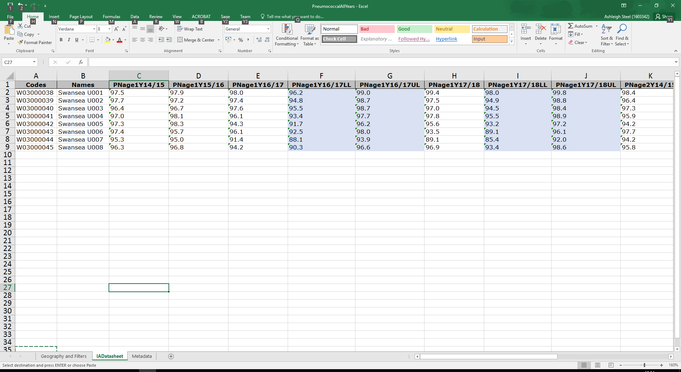
- Age 1 Jabs
- Age 2 jabs


