
Lecturer Name: Christine Joy

Word count: 4309

Module Name: Principles and Concepts of Finance
Module Code: BMSW5012
Student Name & Number: Andreea Lilea (2126939)
Contents
Executive Summary 1
1. Introduction 2
3. Preparation of Budgets 3
3.1 Stock Budget 3
Figure 1 4
3.2 Cash Budget 4
Figure 2 5
3.3 Budgeted Profit and Loss 6
Figure 3 6
SECTION B – ANALYSIS AND MANAGEMENT RESPONSE 7
4. Financial Problems and Management Actions 7
SECTION C – BUDGETING AND BEHAVIOURAL FACTORS 9
5. Conditions for Successful Budgeting 9
6. Behavioural Issues in Budgetary Control 11
SECTION D – CRITICAL EVALUATION OF TRADITIONAL BUDGETING 12
7. Critique of Traditional Budgeting in Fast-Changing Environments 12
8. Conclusion 14
References 15

Executive Summary
This report examines the budgeting process and projected financial performance of Silver Stitch Ltd for the period ending 31 December. Its purpose is to prepare and interpret forecast budgets, assess the main financial implications for the business, and critically evaluate the role of budgeting and budgetary control in a business environment that is becoming increasingly volatile and demanding.
The stock budget shows that inventory is expected to rise steadily across the period, moving from an opening level of £100,000 in July to a closing level of £388,000 in December. This suggests that the business is purchasing stock faster than it is converting that stock into sales. Although a high stock level may support product availability, it also ties up cash and places pressure on working capital. The cash budget shows that the business is expected to maintain positive balances by the end of the period, but the monthly position remains relatively tight in places. This indicates that the company’s main financial problem is not a lack of profit, but pressure on liquidity and cash flow.
The budgeted profit and loss account shows that Silver Stitch Ltd is profitable overall, with a forecast profit of £368,140 for the six months. However, the report argues that profit should not be viewed in isolation. The key finding is that the company faces tension between profitability and liquidity, mainly because inventory growth and fixed financial commitments restrict cash flexibility.
The report recommends tighter stock control, improved demand forecasting, more careful timing of expenditure, closer management of working capital and consideration of more flexible planning tools such as rolling forecasts. It also concludes that traditional budgeting still has value for planning and control, but on its own it can be too rigid, too historical and too slow to respond to rapid changes in the operating environment.

1. Introduction
Budgeting is one of the most important activities within management accounting because it provides a structured financial plan for future operations and helps managers control the use of organisational resources. In simple terms, a budget is a quantified plan for a future period, normally expressed in monetary terms, while budgetary control is the process of comparing actual results with the budget and taking action where differences arise (Drury, 2018; Seal et al., 2018). Budgeting therefore supports both planning and control, which are central functions of management.
In practice, budgets are used to translate strategic aims into operational targets. They help managers think ahead, coordinate departments, allocate scarce resources and evaluate performance (Bhimani et al., 2019; Atrill and McLaney, 2022). In retail organisations, this is especially important because managers must balance stock availability, customer demand, pricing decisions and cash flow pressures. Budgets also support decision making by providing financial information that can be used to assess the likely consequences of different courses of action (Arnold, 2019; Ryan, 2018). A manager deciding whether to increase purchases, reduce discretionary spending or delay refurbishment work will normally rely on budget information to understand the likely effect on liquidity, profitability and operational continuity.
The importance of budgeting becomes even clearer when a business is under financial pressure. Silver Stitch Ltd, a chain of twelve stores selling premium casual clothing, began June with an overdraft of £30,000, and the bank requested that this overdraft be cleared by the end of December. This requirement makes cash planning particularly significant. The business is not only expected to remain profitable, but also to generate enough cash to maintain operations and satisfy external financial expectations.
At the same time, budgeting is not free from criticism. Traditional budgeting has often been criticised for encouraging incremental thinking, relying too heavily on past data and responding too slowly to fast-moving market conditions (Hope and Fraser, 2003; Otley, 2016). These criticisms are highly relevant in sectors such as clothing retail, where customer preferences, sales volumes and stock risks can change quickly.
This report prepares forecast budgets for Silver Stitch Ltd, evaluates the financial implications, and critically assesses the role of budgeting systems in dynamic environments.

SECTION A – FINANCIAL ANALYSIS

3. Preparation of Budgets

3.1 Stock Budget
The stock budget shown in Figure 1 is an important part of the wider master budget because it links expected sales activity to purchasing requirements and inventory control. A master budget brings together the main functional budgets of a business, so that operational plans and financial consequences can be understood as one integrated system (Horngren et al., 2017; Burns et al., 2013). In this case, the stock budget supports planning by showing how much inventory must be available in order to support forecast sales while also respecting the business’s policy of maintaining a minimum stock level.
The opening stock on 1 July is £100,000. Cost of sales is calculated by applying the gross profit margin information. Since the gross profit margin is 40 per cent of sales, the cost of goods sold must represent 60 per cent of sales. This means that for July, when sales are £210,000, the cost of goods sold is £126,000. The same method is applied for each following month. Purchases are then added to opening stock and cost of sales is deducted to calculate closing stock. The resulting stock budget is shown below.
Figure 1 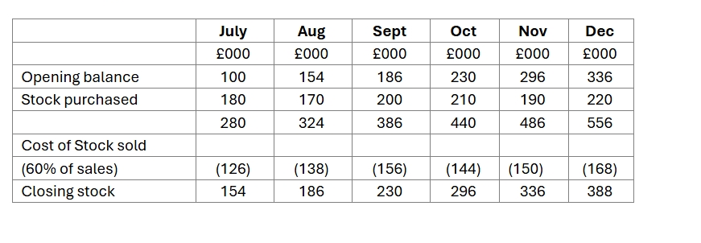
As shown in Figure 1 and in the table above, stock levels rise every month. On one level, this can be viewed positively because it suggests that the business is unlikely to suffer stock shortages. In a premium retail environment, management may deliberately prefer high availability to protect customer experience and brand perception (Kotler and Keller, 2020). However, the financial logic is less positive. Stock is increasing much faster than might be expected from the minimum stock requirement of £50,000. This suggests that purchases may be too high relative to the level of sales.
This matters because stock control is closely connected to liquidity. Inventory is part of working capital, and when too much money is tied up in stock, less cash is available to meet day-to-day obligations (Brigham and Ehrhardt, 2020; Brealey et al., 2020). In fashion retail, this is even more sensitive because stock can lose value quickly through style changes, seasonality or markdown pressure (Heizer et al., 2020). The stock budget therefore supports planning, but it also reveals a possible weakness. It suggests that Silver Stitch Ltd may be prioritising availability more than efficiency. That may be strategically understandable, but it has a cost. The stock growth identified here is directly linked to the cash pressure discussed later in the cash budget, showing that inventory policy cannot be separated from financial control.

3.2 Cash Budget
The cash budget shown in Figure 2 is particularly important because Silver Stitch Ltd entered the broader planning period with an overdraft of £30,000, and the bank required this to be eliminated by the end of December. A cash budget forecasts cash receipts and cash payments over time and is therefore a core tool for liquidity management (Drury, 2018; Dyson, 2019). Unlike the profit and loss account, which is based on accrual principles, the cash budget focuses only on actual cash movements.
The business receives sales proceeds in the month of sale, but 35 per cent of customers pay by credit card and the card provider charges 2.5 per cent of the relevant sales value. This means that cash receipts are slightly lower than sales income. The business also receives one month’s credit from suppliers, so stock purchases are paid one month after the purchases are made. Selling expenses are also paid one month in arrears. Administration expenses are paid when incurred, but because they include depreciation of £7,000 per month, that non-cash amount must be removed for cash budget purposes. Cash outflows also include taxation, interest, loan repayments and store refurbishment costs.
The six-month cash budget is presented below.
Figure 2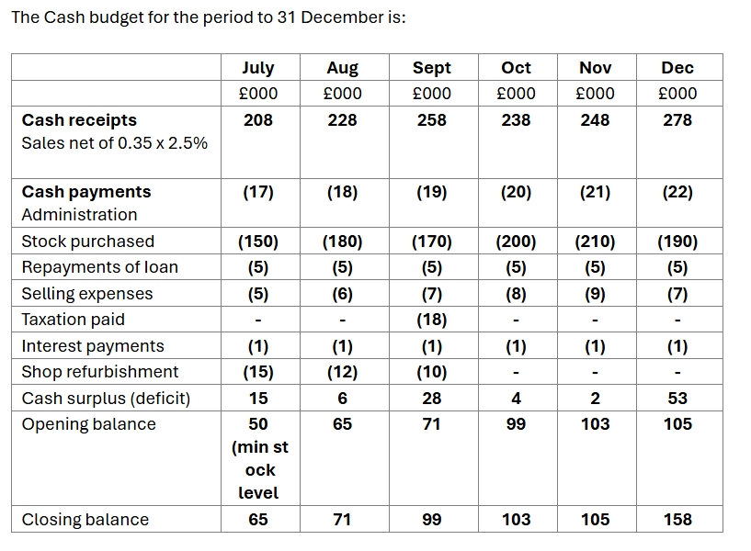
As shown in Figure 2, the business improves its cash position across the period and ends December with a positive balance. At first sight, this appears reassuring, but the monthly surpluses are relatively modest in several months, especially August, October and November. This suggests that the company’s cash position is more fragile than the final December figure might imply. Liquidity is about the ability of a business to meet short-term obligations as they fall due, and the cash budget suggests that Silver Stitch Ltd has limited room for error (Atrill and McLaney, 2022). Even without calculating formal liquidity ratios such as the current ratio or quick ratio, the pattern of receipts and payments indicates working capital pressure.
The budget also demonstrates the practical difference between profit and cash. Some expenses reduce profit but not cash, such as depreciation, while other cash commitments such as loan capital repayments affect cash but not profit in the same way (Libby et al., 2020; Needles and Powers, 2013; Weygandt et al., 2019). This is why a profitable business may still experience cash stress. In Silver Stitch Ltd’s case, stock growth, refurbishment spending and fixed financing commitments all place pressure on liquidity.
At the same time, there is a limitation to this analysis. The cash budget is built on forecast assumptions, especially sales levels. If demand turns out to be lower than expected, the business could face a more difficult position than the budget currently suggests. This means the cash budget is useful, but it should not be treated as certain. It would be more effective if management reviewed and updated it regularly rather than relying on a fixed static forecast.

3.3 Budgeted Profit and Loss
The budgeted profit and loss account shown in Figure 3 summarises the expected financial performance of Silver Stitch Ltd over the six months to 31 December. It provides an accrual-based view of performance and therefore complements the cash budget rather than replacing it. The projected statement is as follows.
Figure 3 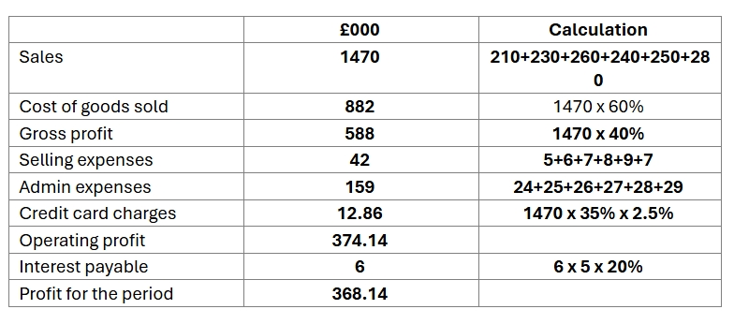
The statement shows that the business is profitable overall. A gross profit margin of 40 per cent suggests that the company has a reasonably strong pricing position and is able to generate value from its sales base (Kotler and Keller, 2020; Mankiw, 2021). Even after administration expenses, selling costs, credit card fees and finance charges, the forecast profit remains positive and substantial.
However, the most important point is not simply that the business is profitable, but that profitability and liquidity are not moving with equal strength. The company can report a profit of £368,140 while still experiencing cash pressure in individual months. This tension is central to management accounting analysis because strong reported profit does not automatically mean that a business is financially comfortable (Kaplan and Atkinson, 2015; Horngren et al., 2017). In Silver Stitch Ltd’s case, the profit figure is encouraging, but the cash budget suggests that the business remains exposed to working capital strain. The forecast therefore indicates that the company’s problem is not viability in a broad accounting sense, but the practical challenge of turning trading success into a stable cash position.

SECTION B – ANALYSIS AND MANAGEMENT RESPONSE

4. Financial Problems and Management Actions
The budgets suggest that Silver Stitch Ltd is not facing a profitability crisis, but rather a liquidity management problem. The most significant issue is the pressure created by working capital, particularly through the steady growth in inventory. Stock levels increase consistently over the period, which may support product availability and sales but also ties up cash within the business. As a result, even if sales remain strong, the company may still struggle to maintain comfortable liquidity levels (Arnold, 2019; Brigham and Ehrhardt, 2020).
A second concern is the pattern of cash flow across individual months. Although the business ends December with a positive closing balance, the monthly surpluses are relatively small in several periods. This creates vulnerability, as any shortfall in sales, delay in customer payments or unexpected expense could quickly weaken the cash position. The fact that the business initially operated with an overdraft reinforces that this is not simply a theoretical issue, but an existing financial pressure that requires careful management.
A further issue relates to the burden of fixed and committed cash outflows. From a cost behaviour perspective, the business carries a number of costs that remain relatively fixed in the short term, including administration expenses, loan repayments and interest (Garrison et al., 2018; Bhimani et al., 2019). Fixed costs are significant because they do not reduce when sales decline, which limits the company’s flexibility in adverse conditions. Cost-volume-profit analysis highlights this risk, as profitability depends on the relationship between sales volume, costs and margins (Hilton and Platt, 2020; Shapiro, 2014). Where fixed costs are high, even a modest reduction in sales can have a disproportionate impact on both profit and cash flow.
This issue is closely linked to the assumptions underlying the budget. The forecasts assume that sales will be achieved at the planned levels and that the gross profit margin will remain stable. While these assumptions may be reasonable, they are not guaranteed. In clothing retail, demand can be influenced by factors such as trends, weather conditions and consumer behaviour. This means the budget should be viewed as a planning tool rather than a precise prediction. Recognising this limitation is important, as it highlights the uncertainty inherent in financial forecasting.
Inventory management represents a particularly significant area of concern. The business aims to maintain a minimum stock level of £50,000, yet closing stock reaches £388,000 by December. This suggests that stock purchases may exceed what is required for operational needs. While high stock levels can be justified in a premium retail context to ensure availability and protect customer experience, they also increase holding costs and reduce financial flexibility. In this case, the strategy may be commercially understandable, but financially inefficient.
Several management actions could be considered to address these issues. One of the most important is improving inventory turnover. This could be achieved through better demand forecasting, more selective purchasing and closer monitoring of slow-moving items (Heizer et al., 2020). Reducing excess stock would release cash and ease pressure on working capital. Another possible action is to renegotiate supplier credit terms. Extending payment periods could improve short-term liquidity, although this may not always be feasible and could affect supplier relationships.
A further option is to reduce or delay refurbishment expenditure. While store refurbishment may support long-term competitiveness, its timing should be carefully considered when cash is constrained. Postponing non-essential investment could provide immediate relief, although it may have implications for customer experience and future costs.
Pricing and sales strategies could also be reviewed. If demand for certain products is relatively inelastic, there may be opportunities to increase margins without significantly reducing sales volume (Mankiw, 2021; Kotler and Keller, 2020). However, such decisions must be made carefully, as pricing changes can affect competitiveness and customer perception.
Short-term financing may provide another solution by smoothing cash flow fluctuations. However, this would increase financial dependence and potentially raise costs. Given that the bank has already expressed concern about the overdraft, additional borrowing may not be a sustainable long-term solution.
Finally, tighter cost control is necessary. Management should focus on distinguishing between essential and non-essential expenditure, ensuring that resources are allocated efficiently (Kaplan and Atkinson, 2015; Johnson and Kaplan, 1987). Overall, the most effective approach for Silver Stitch Ltd would involve a combination of improved stock management, careful cash planning and selective cost control. The company’s financial position is manageable, but only if management responds proactively rather than relying solely on reported profitability.

SECTION C – BUDGETING AND BEHAVIOURAL FACTORS

5. Conditions for Successful Budgeting

For budgeting to work successfully, an organisation needs much more than technical calculations. A budget can be numerically accurate and still fail in practice if the organisation does not have the right conditions to support it. Budgeting is most effective when it operates within a wider system of planning, communication, accountability and strategic control (Drury, 2018; Seal et al., 2018). This means that success depends not only on accounting techniques, but also on how the organisation manages people and decisions.
One essential condition is the presence of clear objectives. Budgets should not be prepared simply as a routine exercise. They should reflect what the organisation is trying to achieve, whether this is growth, tighter liquidity control, stronger cost management or improved market position. If these goals are not visible within the budget, managers may focus only on meeting financial targets rather than creating value for the business (Kaplan and Norton, 2001). In Silver Stitch Ltd, the main short-term priority is to eliminate the overdraft and protect liquidity. If the budget does not emphasise this clearly, it may fail to address the company’s most immediate problem.
A second important condition is top management support. Budgeting requires leadership because it often involves negotiation, discipline and difficult decisions. Senior managers should not treat budgets as documents produced only by the finance function. They need to use them actively, communicate their importance and link budget targets to wider organisational priorities (Bhimani et al., 2019; Burns et al., 2013). In Silver Stitch Ltd, strong management support is especially important because decisions about purchasing, refurbishment and cost control may directly affect the company’s cash position.
Participation is also a major factor in successful budgeting. A system is usually more effective when those responsible for delivering results are involved in budget preparation. Participation can improve motivation, realism and commitment because operational managers often have a better understanding of day-to-day conditions (Merchant and Van der Stede, 2017). However, participation also has limitations. If it is not managed carefully, it can encourage budgetary slack or defensive negotiation. This means that involvement should be balanced with challenge and review.
Communication is equally important. Budgets act as coordination tools, so their meaning must be clearly understood across the organisation. Departments need to understand not only their own budget figures, but also how their decisions affect other functions. Poor communication can create conflict between sales targets, purchasing decisions and cash constraints. In Silver Stitch Ltd, the increase in stock levels suggests that operational and financial priorities may not be fully aligned. Better communication would help ensure that stock planning is understood not just as a sales issue, but also as a liquidity issue (Atrill and McLaney, 2022).
Another condition is realism. Budget targets should be demanding enough to improve performance, but realistic enough to remain credible. Targets that are too easy will not encourage improvement, while targets that are too difficult may demotivate staff or encourage manipulation (Zimmerman, 2017). This is relevant to Silver Stitch Ltd because the forecast assumes strong sales while inventory levels continue to rise. If these sales assumptions are too optimistic, both the stock position and the cash position could become more problematic.
Finally, budgeting must be integrated with strategy and wider control systems. Budgets should not exist separately from performance measurement, operational decision making and management review. They need to support long-term organisational aims, not only short-term compliance (Emmanuel et al., 2013; Merchant and Van der Stede, 2017). In a premium clothing retailer such as Silver Stitch Ltd, this means supporting stock availability, customer experience and financial resilience together.
If these conditions are missing, budgeting can become ineffective or even harmful. Weak objectives, poor leadership, limited communication, unrealistic targets and lack of strategic integration can all reduce the value of the system. For this reason, budgeting should be viewed as an organisational process rather than simply a numerical document. In Silver Stitch Ltd, the financial issues identified earlier suggest that budgeting must be more closely linked to strategic priorities and operational discipline if it is to support both performance and stability.

6. Behavioural Issues in Budgetary Control
Budgetary control is often presented as a rational process of setting targets and analysing variances, but in reality it has important behavioural implications. Once budgets are linked to performance evaluation and accountability, they begin to influence how managers act, communicate and make decisions (Zimmerman, 2017; Parker, 2012). This means that behavioural issues are central to the effectiveness of budgeting systems rather than a secondary concern.
One key issue is budgetary slack. This occurs when managers deliberately underestimate revenues or overestimate costs in order to make targets easier to achieve. While this may reduce personal pressure, it weakens the accuracy of budgets and reduces their usefulness for planning and control (Merchant and Van der Stede, 2017). In Silver Stitch Ltd, this could be particularly problematic, as the business is already facing liquidity pressure. Any distortion in budget figures would make it more difficult to manage working capital effectively.
Resistance to change is another common issue. Budgeting systems often require managers to adjust behaviour, improve forecasting or accept tighter cost control. Employees may resist if they see these changes as unfair or imposed without consultation (Otley, 2016). This resistance can appear as low engagement or passive non-cooperation, reducing the effectiveness of the system. For this reason, management must support budgeting with clear communication and involvement.
A further issue concerns the balance between motivation and demotivation. Budgets can motivate by providing clear targets, but unrealistic expectations may have the opposite effect. Excessive pressure can create stress, reduce morale and encourage unethical behaviour (Emmanuel et al., 2013). In Silver Stitch Ltd, the pressure to improve cash flow could lead to overly demanding targets, which may ultimately harm performance rather than improve it.
Short-termism is also a significant behavioural risk. Managers may focus on achieving short-term budget targets at the expense of long-term performance. This can include delaying necessary expenditure, increasing stock unnecessarily or manipulating timing to improve reported results (Kaplan and Norton, 2001; Parker, 2012). In Silver Stitch Ltd, such behaviour could worsen liquidity problems or damage long-term strategic positioning.
Overall, these issues show that budgeting is not purely a technical process. It must be designed and managed carefully to align targets with strategy, encourage realistic planning and avoid unintended consequences. Behavioural understanding is therefore essential for ensuring that budgeting supports, rather than undermines, organisational performance.

SECTION D – CRITICAL EVALUATION OF TRADITIONAL BUDGETING

7. Critique of Traditional Budgeting in Fast-Changing Environments
Traditional budgeting has long been a central tool in management accounting, particularly in organisations that require structured planning and control. It provides a formal framework for setting targets, allocating resources and evaluating performance. However, despite its widespread use, it has been increasingly criticised, especially in business environments characterised by rapid change, uncertainty and the need for strategic flexibility (Hope and Fraser, 2003; Seal et al., 2018).
One of the main weaknesses of traditional budgeting is that it is time consuming. The preparation of annual budgets often involves a lengthy process of forecasting, negotiation and revision, which can absorb significant managerial time (Bhimani et al., 2019). In fast-moving industries, such as clothing retail, this is problematic because conditions may change during the budgeting process itself. By the time the budget is finalised, some of its assumptions may already be outdated, reducing its usefulness as a planning tool.
Another important limitation is inflexibility. Traditional budgets are usually fixed for a specific period and used as a benchmark for control. This can create rigidity, as managers may feel constrained by initial assumptions even when external conditions change (Drury, 2018). In the case of Silver Stitch Ltd, the budget provides a clear financial plan, but it does not appear highly responsive to potential changes in demand or cost structures. This lack of flexibility may limit the company’s ability to react quickly to emerging risks or opportunities.
A further criticism is that traditional budgeting relies heavily on past data. Many organisations use incremental budgeting, where previous figures are adjusted rather than fundamentally reassessed. This approach can encourage incremental thinking and allow inefficiencies to continue (Kaplan and Atkinson, 2015). In Silver Stitch Ltd, the steady increase in inventory levels suggests that purchasing decisions may not have been sufficiently challenged, highlighting the risk of continuing existing practices without critical evaluation.
Traditional budgeting is also less effective in volatile environments. Static annual budgets assume relatively stable conditions, but in reality many markets are unpredictable and subject to frequent change. In such situations, managers require more flexible and forward-looking information (Hansen, Otley and Van der Stede, 2003). If actual conditions differ significantly from the budget, it may lose relevance for decision making, even if it remains useful for performance control.
In addition, traditional budgeting can encourage short-term thinking. When managers are evaluated based on fixed targets, they may prioritise achieving those targets over long-term strategic goals (Merchant and Van der Stede, 2017). This can reduce innovation and lead to decisions that improve short-term results at the expense of long-term value. In Silver Stitch Ltd, this risk could appear in decisions such as maintaining high stock levels to support sales targets, even if this weakens liquidity.
These limitations have led to the development of alternative approaches to budgeting. The Beyond Budgeting model promotes more flexible and decentralised systems, allowing decisions to be based on real-time information rather than fixed annual plans (Hope and Fraser, 2003). Rolling forecasts enable organisations to update financial expectations regularly, improving responsiveness. Zero-based budgeting requires all costs to be justified from the beginning, which can strengthen cost control (Soin and Collier, 2013). Activity-based budgeting focuses on the activities that drive costs, improving the allocation of resources (Horngren et al., 2017).
However, it would be unrealistic to conclude that traditional budgeting is no longer useful. It continues to provide discipline, coordination and a clear structure for planning and control. For Silver Stitch Ltd, budgeting remains essential for managing cash flow, controlling costs and monitoring inventory levels.
A balanced approach is therefore necessary. Traditional budgeting should be retained for its strengths, but complemented by more flexible tools that allow organisations to respond to change. For Silver Stitch Ltd, this means maintaining financial discipline while improving responsiveness to fluctuations in sales, stock and liquidity. Traditional budgeting is not obsolete, but it must evolve in order to remain effective in a dynamic business environment.

8. Conclusion
This report has examined the forecast budgets of Silver Stitch Ltd and evaluated the wider role of budgeting and budgetary control in supporting financial management. The budget analysis shows that the business is profitable overall, with a forecast profit of £368,140 over the six months to 31 December. However, the report also demonstrates that profitability does not remove the need for careful cash management. The most significant financial finding is that stock levels rise steadily across the period, creating pressure on working capital and contributing to a liquidity position that remains tighter than the profit figure alone might suggest.
The main organisational risks are therefore connected to cash flow pressure, inventory growth, fixed financial commitments and the possibility that forecast assumptions may not be fully achieved in practice. The analysis has shown that if sales weaken or costs rise unexpectedly, the current budget position could become less comfortable quite quickly. It has also shown that operational decisions, such as stock purchasing, cannot be separated from financial consequences. Profit, liquidity, cost behaviour and strategic control are all closely linked.
The report has also argued that effective budgeting depends not only on accurate numbers, but on organisational conditions such as clear objectives, communication, management support and realistic targets. Behavioural issues, including budgetary slack, resistance to change, demotivation and short-termism, can weaken budgetary control if not managed carefully. This means budgeting should be viewed as both a financial and a managerial process.
Finally, the report has critically evaluated traditional budgeting and concluded that it remains valuable for formal planning and control, but is less effective when used in isolation in fast-changing environments. For Silver Stitch Ltd, a more adaptive approach would be beneficial. Better stock discipline, closer cash monitoring, selective cost control and more flexible planning methods would improve resilience. The overall conclusion is that budgeting remains essential, but its real value depends on how intelligently and flexibly it is applied.

References
Arnold, G. (2019) Corporate Financial Management. 6th edn. Harlow: Pearson.
Atrill, P. and McLaney, E. (2022) Management Accounting for Decision Makers. 10th edn. Harlow: Pearson.
Bhimani, A., Horngren, C.T., Datar, S.M. and Rajan, M.V. (2019) Management and Cost Accounting. 7th edn. Harlow: Pearson.
Brealey, R.A., Myers, S.C. and Allen, F. (2020) Principles of Corporate Finance. 13th edn. New York: McGraw-Hill.
Brigham, E.F. and Ehrhardt, M.C. (2020) Financial Management: Theory and Practice. 16th edn. Boston: Cengage Learning.
Burns, J., Quinn, M., Warren, L. and Oliveira, J. (2013) Management Accounting. Maidenhead: McGraw-Hill.
Drury, C. (2018) Management and Cost Accounting. 10th edn. Andover: Cengage Learning.
Dyson, J.R. (2019) Accounting for Non-Accounting Students. 10th edn. Harlow: Pearson.
Emmanuel, C., Otley, D. and Merchant, K. (2013) Accounting for Management Control. 2nd edn. London: Springer.
Garrison, R.H., Noreen, E.W. and Brewer, P.C. (2018) Managerial Accounting. 16th edn. New York: McGraw-Hill.
Hansen, S.C., Otley, D.T. and Van der Stede, W.A. (2003) ‘Practice developments in budgeting: an overview and research perspective’, Journal of Management Accounting Research, 15(1), pp. 95–116.
Heizer, J., Render, B. and Munson, C. (2020) Operations Management. 13th edn. Harlow: Pearson.
Hilton, R.W. and Platt, D.E. (2020) Managerial Accounting: Creating Value in a Dynamic Business Environment. 12th edn. New York: McGraw-Hill.
Hope, J. and Fraser, R. (2003) Beyond Budgeting: How Managers Can Break Free from the Annual Performance Trap. Boston: Harvard Business School Press.
Horngren, C.T., Datar, S.M. and Rajan, M.V. (2017) Cost Accounting: A Managerial Emphasis. 16th edn. Harlow: Pearson.
Johnson, H.T. and Kaplan, R.S. (1987) Relevance Lost: The Rise and Fall of Management Accounting. Boston: Harvard Business School Press.
Kaplan, R.S. and Atkinson, A.A. (2015) Advanced Management Accounting. 3rd edn. Harlow: Pearson.
Kaplan, R.S. and Norton, D.P. (2001) The Strategy-Focused Organization. Boston: Harvard Business School Press.
Kotler, P. and Keller, K.L. (2020) Marketing Management. 16th edn. Harlow: Pearson.
Libby, R., Libby, P.A. and Hodge, F.D. (2020) Financial Accounting. 10th edn. New York: McGraw-Hill.
Mankiw, N.G. (2021) Principles of Economics. 9th edn. Boston: Cengage Learning.
Merchant, K.A. and Van der Stede, W.A. (2017) Management Control Systems: Performance Measurement, Evaluation and Incentives. 4th edn. Harlow: Pearson.
Needles, B.E. and Powers, M. (2013) Financial Accounting. 11th edn. Boston: Cengage Learning.
Otley, D. (2016) ‘The contingency theory of management accounting and control: 1980–2014’, Management Accounting Research, 31, pp. 45–62.
Parker, L.D. (2012) ‘Qualitative management accounting research: assessing deliverables and relevance’, Critical Perspectives on Accounting, 23(1), pp. 54–70.
Ryan, B. (2018) Introduction to Financial and Management Accounting. 3rd edn. London: Cengage Learning.
Seal, W., Garrison, R. and Noreen, E. (2018) Management Accounting. 6th edn. London: McGraw-Hill Education.
Shapiro, A.C. (2014) Capital Budgeting and Investment Analysis. Harlow: Pearson.
Soin, K. and Collier, P. (2013) Risk and Management Accounting: Best Practice Guidelines for Enterprise-wide Internal Control Procedures. London: CIMA Publishing.
Weygandt, J.J., Kimmel, P.D. and Kieso, D.E. (2019) Financial Accounting. 11th edn. Hoboken: Wiley.
Zimmerman, J.L. (2017) Accounting for Decision Making and Control. 9th edn. New York: McGraw-Hill Education.

