Assessment Form

Module: Preparing for Professional Policing
Student Name: Matthew Daniel
Module Tutor (s): Kelly Andrews
Question | 1  Situation | 2  Task | 3.  Action | 4.  Result |  | Total Mark
1 | 3/5 | 4/5 | 11/15 | 3/5 |  | 21/30
2 | 2/5 | 2/5 | 14/15 | 2/5 |  | 20/30
3 | 4/5 | 3/5 | 10/15 | 1/5 |  | 16/30
 |  |  |  |  |  | Total Mark 57/90
Key
No Reference | Minimum | Satisfactory | Exceptional
0 | 0-4 | 5-10 | 11-15

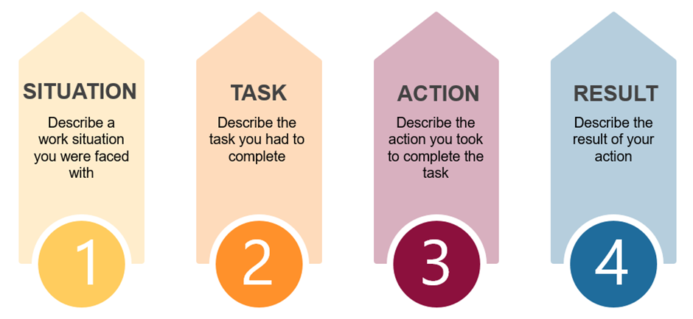

Question | Comments
1 | Q2  College example  Cambodia trip example. Working in a group setting  Task to teach children English. I took it upon myself to lead the group, planning lessons. I knew we couldn’t just go into the lessons unplanned; it wouldn’t be fair on us or the children.  Got some bad feedback at the start, they didn’t like that I took control, but I knew it was something that needed to be done. Over time the group did engage, and it was a lot easier the next day.  We could be flexible which made things easier.  Result: the children found it engaging, over time the group understood the importance of planning the lesson.  Actions detailed.  Ensure you use STAR in full.
2 | Q3  Used the same situation but in a different context.  The children had mixed abilities. We separated the children into groups. The two children I worked with had different needs so I needed to change communication skills for each child.  Provided tasks for one but needed to support the other more.  Evaluated how it worked, which was good. Explaining decision making.  Needed a prompt for result –  Remember to include task for each example.  Actions very detailed.
3 | Q7:  Family example:  Situation: Nan has older generation views. When grandad passed away everyone felt bad when stepdad passed away, I had to speak to her to discuss how she was treating my mother.  Needed to.  Explain in more detail why you made the decision to speak to her.  Why did you think her view was inappropriate.  Needed a prompt for why it was inappropriate – remember to provide detail.  Result:  .

.

.

