

UNIVERSITY OF WALES TRINITY SAINT DAVID

Master of Business Administration
Module: International Business Concepts
Module Code: LCMB7034
Lecturer: Akshay Narayanan
Student Name: Merlin Lawrence
Student ID: 2437597

Netflix in the United Kingdom: An International Business Analysis

Table of contents
Sn. No | Contents
1 | Introduction
2 | Industry and Country Overview
3 | Porter's Diamond Model
4 | Critical Evaluation of Netflix's Operations in the United Kingdom
5 | Conclusion
6 | Reflection
7 | References

Section 1: International Industry and Business Report

1. Introduction

The United Kingdom has been identified as one of the most competitive digital media markets in Europe, with its subscription video-on-demand market size estimated at around £3.4 billion in 2023 (Badr et al., 2024)

Rapid technological advancement, changing consumer behaviour in post-pandemic situations, and changing regulatory frameworks have created both opportunities and challenges for international streaming services in the United Kingdom. Netflix, Inc., being the market leader in this market segment with around 17 million subscribers in the United Kingdom in 2023, is identified as a significant subject for international business analysis.

This report undertakes a structured critical analysis of the UK streaming industry, including the role of Netflix. An industry and country overview establishes the competitive environment. Porter's Diamond Model (Porter, 1990) is used as a framework to evaluate competitive advantage at the national level. A critical analysis of Netflix's operations in the UK, from a political, economic, legal, and cultural perspective, using PESTLE analysis (Johnson et al., 2017) and Hofstede's Cultural Dimensions (Hofstede et al., 2010), precedes a synthesis, which provides a conclusion on the attractiveness of the UK market.

2. Industry and Country Overview

2a. The UK Streaming Industry: Context and Definition

The United Kingdom has developed into one of the most advanced and competitive markets for digital media in Europe. The video on demand (VOD) and subscription video on demand (SVOD) industry comprises companies that provide filmed entertainment over the internet on a subscription or ad-supported basis. This ranges from pure play global players like Netflix and Amazon Prime Video to hybrid broadcasting companies like ITVx and BBC iPlayer. This industry can be divided into various segments like SVOD, AVOD, and TVOD, depending on the various monetization strategies.

The UK, with its well-developed digital infrastructure, high penetration rates of broadband, and the English language, has been a strategically important market for the streaming industry. Ofcom (2024) reports that approximately 69 per cent of the UK's adult population were subscribers to at least one streaming service in 2023. Viewing habits formed during the pandemic have largely endured, reinforcing the structural position of SVOD over linear TV (Statista, 2024).

2b. Size, Scope, and Economic Importance

The streaming market in the UK was recorded at £3.4 billion in 2023 and is forecasted to rise at a compound annual growth rate (CAGR) of around 6.5 per cent between 2023 and 2028, fueled by rising smartphone penetration rates, rising broadband speeds, and the government's £5 billion project gigabit plan to deliver 85 per cent full-fibre coverage by 2025 (Badr et al., 2024). Consumer behaviours developed during the pandemic has been found to be largely sticky, continuing to support SVOD services in the face of economic challenges.
The economic importance of the industry goes beyond mere revenue generated from subscriptions. The British Film Institute (Shangguan, 2026) reports that the UK's content production, largely driven by the commissioning of content by streaming services, added over £6 billion to the national economy, supporting employment in areas including screenwriting, directing, acting, post-production, and digital marketing. In fact, Netflix alone spent over £1 billion on content production in the UK between 2020 and 2023, according to Netflix Investor Relations (2023), signifying the amount of foreign direct investment contributed by large SVOD services to the UK's creative industry.
The UK’s streaming content is reaching wider international audiences, with productions such as The Crown, Top Boy, and Sex Education further enhancing the UK’s reputation as a world-class origination market, thus increasing the cultural export value of the UK, as well as reinforcing the symbiotic relationship between investment in global platforms and growth in the UK’s creative industries (Shangguan, 2026).

2c. Major Domestic and Multinational Firms: Competitive Positioning

The streaming market in the UK is marked by stiff competition between US-based global streaming services and home-grown broadcasting services, each employing unique competitive strategies.

Netflix, Inc. dominates the UK’s SVoD market with an estimated subscriber count of around 17 million in 2023 (Chalaby, 2024)

. Netflix stands out for its extensive library of global content, continued investment in UK originals, and sophisticated data-driven personalization technology. The addition of its ad-based plan at £4.99/month in late 2022 helped increase market accessibility and reduce subscriber churn in the context of the cost-of-living crisis.

Amazon Prime Video is the second-largest SVOD platform, and it benefits from being bundled together with Amazon Prime membership. The bundling effect provides a strong competitive advantage as the incremental cost to the consumer is low. Amazon’s investment in acquiring rights to live sports programming, like Premier League football, has helped Amazon improve its strategic positioning beyond the entertainment genre.

Disney+ has recorded rapid growth in market share after its entry into the UK market in March 2020, relying on its powerful intellectual property portfolios from Disney, Pixar, Marvel Cinematic Universe, and Star Wars, with specific strengths in content genres such as families and superhero content. Apple TV+, despite being a smaller player, has recorded growth through its strategy of premium content with high ratings, integrating well with the Apple ecosystem.

Domestic competitors like BBC iPlayer and ITVX have free-to-access streaming services funded by the licence fee and ad revenue respectively, and have a strong reputation and audience loyalty. BritBox, a joint venture between the BBC and ITV, has established a niche SVOD service targeting British drama enthusiasts worldwide and domestically.

The competitive landscape, therefore, can be said to be multi-dimensional, as the monetization strategy as well as the content strategy are heterogeneous. The sustained investment of Netflix in the production of content originating from the UK remains the key strategic difference, as it helps the company achieve higher cultural embedding in the market, where the preference for home content remains high.

3. Porter's Diamond Model: Global Competitiveness of the UK Streaming Industry

Porter's Diamond Model of National Advantage (Porter, 1990) proposes four key components for national competitive advantage: Factor Conditions, Demand Conditions, Related and Supporting Industries, and Firm Strategy, Structure, and Rivalry. However, two external factors, namely Government and Chance, also play their part in this regard. In this context, it is possible to understand both the structural foundation for international competitiveness in the UK streaming market and its ability to provide opportunities for companies in this market.
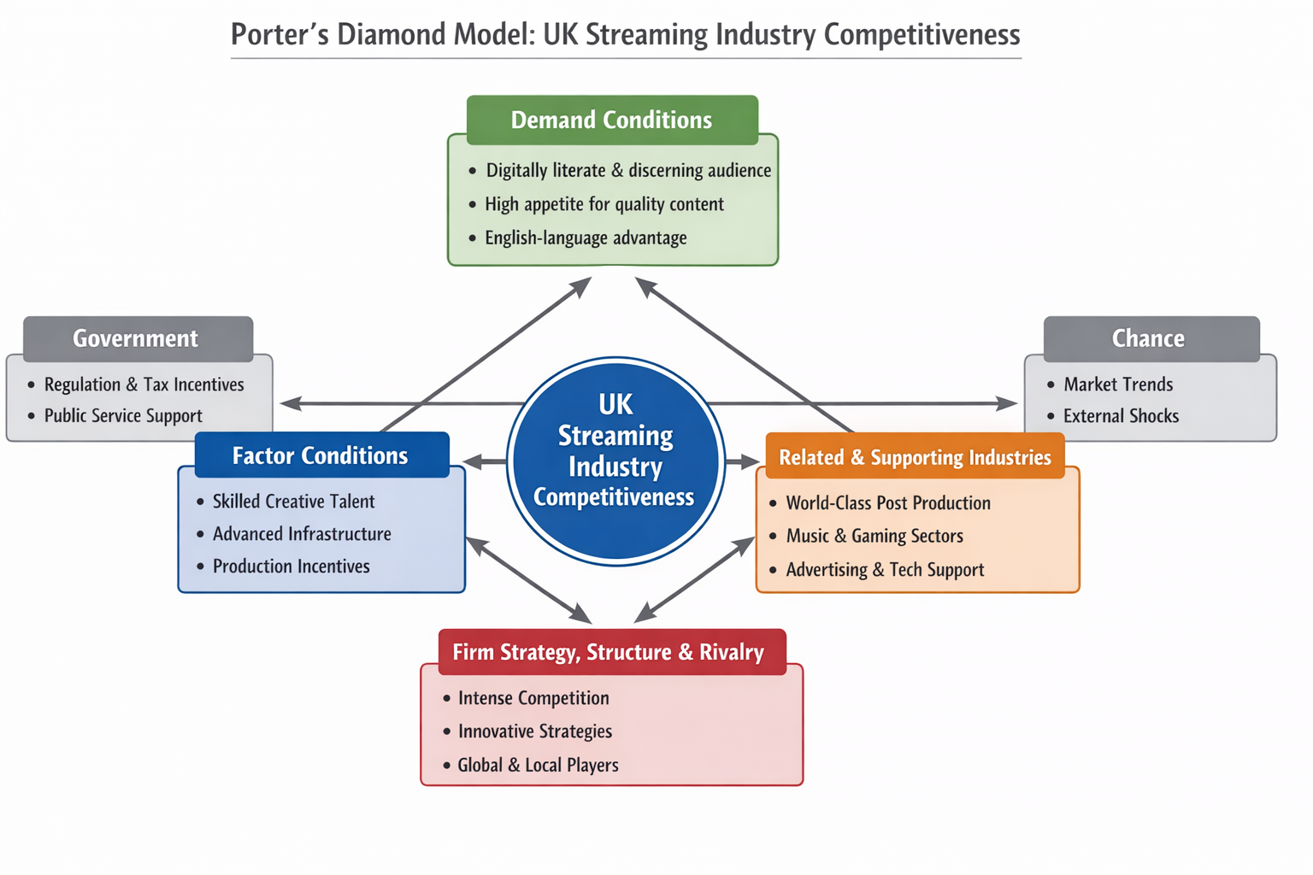

3a. Factor Conditions

Factor conditions involve the necessary inputs to compete within the industry. Human resources, physical infrastructure, knowledge capital, and financial capital are included. The UK has extremely high scores in many areas that are vital to streaming competitiveness.

The UK boasts one of the world's largest reservoirs of creative talent, which has been developed through such esteemed institutions as the National Film and Television School, Goldsmiths University of London, and the London Film School. A century of public service broadcasting through the BBC, ITV, and Channel 4 has sustained high standards of production and developed a technically competent workforce in every area of content creation (Petrie, 2025).

.
The digital infrastructure is generally favourable, with Ofcom (2024) stating that around 80 per cent of premises in the UK have access to super-fast broadband, with the government's 'Project Gigabit' aiming to achieve 85 percent coverage for full-fibre by 2025 (Poon et al., 2026).

The Audio-Visual Expenditure Credit, which provides up to 25 percent tax relief for qualifying productions, is an important government-created factor advantage for the UK in relation to other production markets (HMRC, 2024).

However, one of the important limitations is that the cost of skilled creative and technology labour is relatively high compared to the emerging production hubs of Eastern Europe and Southeast Asia. The increase in production costs has encouraged some of the platform operators to divert their production expenditure internationally; this is a structural pressure on the UK's cost of factors of production and can have important implications for its competitiveness over time.

3b. Demand Conditions
UK citizens are digitally literate, culturally discerning, and have a strong appetite for high-quality content in genres like drama, documentary, comedy, and sports. The data indicates that the average consumption of content per week among UK subscribers is 5.7 hours, which is a reflection of their in-depth engagement in SVOD services (Ofcom, 2024).
The complexity of this demand landscape forces all market players to continually invest in high-quality, locally relevant content, creating higher levels of competition within the market. The UK has a long tradition of high-quality public broadcasting, which has naturally inured consumers to expect content that is engaging with society, creating differentiation in content investment quality.

Critically, the language advantage of the UK serves to translate domestic demand conditions into global commercial opportunities, with content developed to meet the exacting demands of the British market having the potential to translate into international commercial success and thus provide a mechanism for cross-subsidising the cost of supporting local content with revenue generated from international markets.

3c. Related and Supporting Industries
The UK's streaming landscape is helped by having an unusually developed supporting industry. The world-class post-production industry, which includes companies such as Framestore, Double Negative (DNEG), and Cinesite, ensures that UK content is of world-class production standards. The UK's advertising industry is one of the most innovative in the world and supports the data-driven model of advertising that is used in AVOD services.

The UK video games industry, which contributes more than £7 billion each year to the country, and its world-leading music industry offer synergistic content IP, talent, and storytelling assets that enhance streaming content through cross-industry creative spillovers (UKIE, 2023). Telecommunications infrastructure, delivered through BT, Virgin Media O2, and Sky, underpins strong content delivery, and the country’s world-leading data analytics sector delivers critical support to personalization and recommendation engines on which streaming services' competitive position is partly based.

3d. Firm Strategy, Structure, and Rivalry
The UK’s streaming market is marked by incredibly high levels of rivalry, which is a major factor in Porter’s (1990) model of rivalry driving innovation and efficiency. The presence of global SVOD leaders like Netflix, Amazon, Disney+, and Apple TV+ alongside strong native SVOD brands like BBC iPlayer, ITVX, and BritBox ensures a competitive dynamic in the market.
This competition has encouraged constant and dynamic strategic innovations such as the development of ad-based models, sports programming inclusion, interactive content types, and AI-based recommendation systems. The implementation of password sharing restrictions in 2023 by Netflix is another instance of how competition in the UK market is influencing global-level decisions of the organization, as this was partly prompted by stagnating subscriber growth in the UK (B. Rajesh Kumar, 2024).
Government influence is carried out through Ofcom’s framework, content investment standards, and support for public service broadcasting, which influence competition by ensuring high-quality free-to-view content is available. The UK Film Tax Credit system is a government determinant that makes the industry stronger by enhancing content investment incentives.

On the basis of the above Synthesised Position of the Diamond analysis, it can be noted that the UK streaming industry is found to be in a position of competitive advantage, driven by superior factor conditions, sophisticated consumer demand, a supportive ecosystem, and a highly competitive environment. This is the reason behind the UK acting as a key content creation market and a high-value subscriber base for the SVOD operators.

4. Critical Evaluation of Netflix's Operations in the United Kingdom

4a. Overview of Netflix in the UK
Netflix ventured into the UK in January 2012, which is one of the earliest European markets for Netflix (B. Rajesh Kumar, 2024). Over a decade, Netflix transformed from a challenger brand to a dominant player in the UK SVOD market, with an estimated 17 million+ subscribers by the end of 2023 and revenues estimated to be over £1.5 billion every year (Chalaby, 2024). The story of Netflix in the UK is a classic case of a blend of leverage and adaptation.

This analysis is based on the PESTLE analysis tool (Johnson et al., 2017), and the theoretical perspectives of institutional theory (North, 1990) and the liability of foreignness theory that argue that MNEs have inherent competitive disadvantages in the host country’s market due to their unfamiliarity with the local institutions and the costs of transaction and cultural differences. Critical analysis of the PESTLE component of the UK market environment in relation to how Netflix has overcome the inherent competitive disadvantages is as follows:

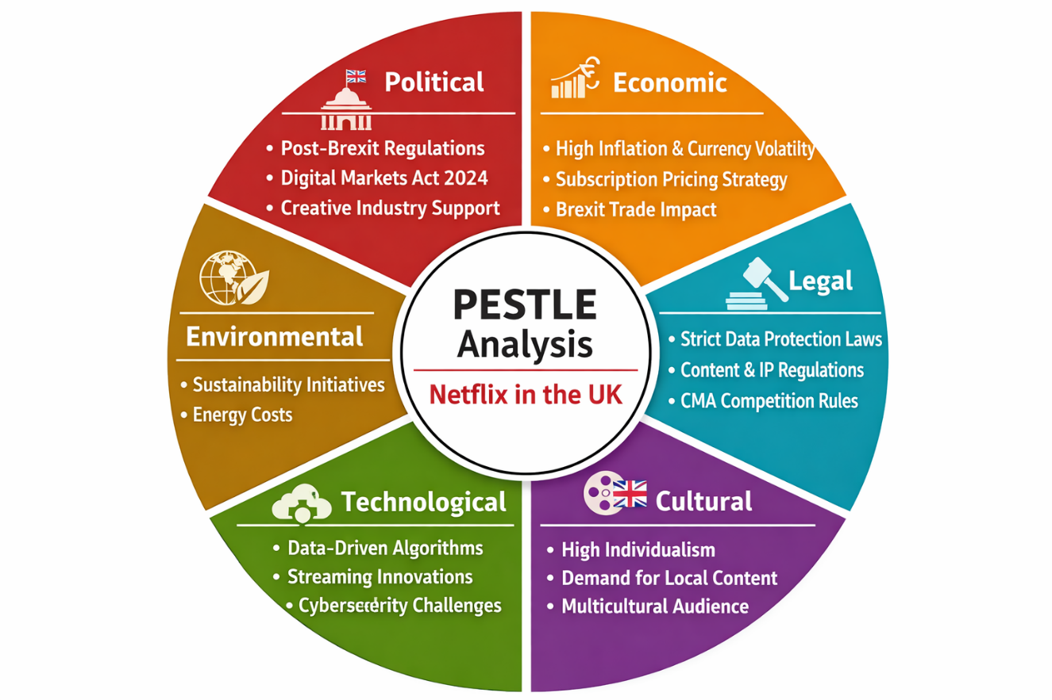

4b. Political Factors
The UK's political environment provides enabling conditions and upcoming regulatory challenges for Netflix's business. Brexit, which occurred in January 2020 and saw the UK leave the EU, created significant regulatory changes. Before Brexit, UK-based video-on-demand services were subject to the EU's Audiovisual Media Services Directive (AVMSD), which mandated a 30 percent minimum requirement of European content for major video-on-demand services. Since Brexit, the UK has implemented its own regulatory framework, with Ofcom having jurisdiction over video-on-demand services under the Audiovisual Media Services Regulations 2020, which for the first time applied broadcasting regulations to video-on-demand services (Ofcom, 2023).
The passing of the Digital Markets, Competition, and Consumers (DMCC) Act 2024 signals an escalation in the UK government's regulatory ambitions. The legislation provides the Competition and Markets Authority (CMA) with new powers to assign "strategic market status" to digital platforms, which could require them to comply with various rules, such as fair dealing, interoperability, and data access (Yati Nurhayati, 2023).
The overall direction of digital regulations in the UK signals a significant shift in regulatory approach from a relatively hands-off approach to one that could be more interventionist, potentially imposing operational limitations and costs for Netflix's data-intensive business model, creating a risk for Netflix that requires strategic engagement rather than reactive compliance.
Simultaneously, there exists political opportunity with the UK government's Creative Industries Sector Vision policy framework, as developed by the DCMS in 2023. This policy framework demonstrates sustained investment in the UK creative economy, as well as in Audio-Visual Expenditure Credit, which will continue to be supported by the UK government. This places Netflix in a position as a net beneficiary and contributor to the UK creative economy, thus creating political goodwill, which will temper UK regulatory environments. The UK has a democratic system of government, rule of law, and an independent judiciary, which reduces political risk in comparison to other markets (Heritage Foundation, 2024).

On the whole, the UK’s political environment is enabling for Netflix’s operations; however, it is becoming more interventionist in the digital sphere and thus requires continued proactive regulatory engagement to address increasing complexity and strategic risk.

4c. Economic Factors
The economic background for Netflix in the UK is complex and multifaceted. The country boasts the second-largest European economy in terms of GDP, reaching $3.1 trillion in nominal value in 2023 (World Bank, 2024). The country also boasts high discretionary spend, developed financial services markets, and high levels of e-commerce penetration – all factors that are generally conducive to growth in the SVOD market.
Yet, in the period between 2022 and 2024, the economic background was dominated by strong economic headwinds. The combined effect of post-pandemic supply chain issues and rising energy and labor costs propelled UK inflation to a 41-year high in October 2022, reaching 11.1% (ONS, 2023). Research found that in 2022, 6.5 million UK households cancelled at least one streaming service, marking the first period of subscriber decline for the industry (Kantar, 2023).
A significant aspect of the strategic response of Netflix was the company’s quickness in reacting to changing circumstances. The company’s decision to launch the new version of Netflix at a price of £4.99 per month, thus making the product more accessible and enabling the company to retain subscribers who might have otherwise cancelled their subscription, is a remarkable aspect of the company’s sensitivity towards the local market conditions (B. Rajesh Kumar, 2024).
The company’s decision, though successful in the short term, may have an adverse effect of commoditizing the company’s premium brand and may impact the average revenue per user in the long term, which is a strategic constraint in itself.
Exchange rate dynamics can be viewed as an important structural economic factor. Being a US-based corporation with reporting currency as USD, Netflix is exposed to currency fluctuations in Sterling/USD exchange rates. For instance, if Sterling depreciates, as was experienced in the UK during the "mini-budget crisis" in 2022, this will increase the cost of production expenditure in the UK, thus eroding profitability for content investments in this market. The new trade environment, particularly after Brexit, has introduced further complexity in content licensing, particularly with regard to digital trade agreements in place for the UK and EU, which are still in a state of evolution (Gluer, 2025).

In all, the economic conditions of the UK, though favorable in terms of structural opportunities in terms of the large and digitally connected consumer base, also carry significant risks in terms of currency volatility, inflation, and Brexit-related complexities.

4d. Legal Factors
Netflix operates within an increasingly sophisticated and proactive UK legal framework spanning content regulation, data protection, intellectual property, and competition law.
Regulation of content is an area of increasing importance. Ofcom is responsible for video-on-demand services in the UK since 2021, according to the Audiovisual Media Services Regulations 2020. It includes regulations on harmful content, accessibility, and promoting UK public service content. The regulations on Netflix are operationally significant. It is required to provide subtitles for at least 80 percent of content, according to Ofcom's regulations on accessibility. It is a significant technical and financial undertaking for Netflix (Ofcom, 2023).
Data protection law is particularly significant for Netflix's business model. The UK GDPR and Data Protection Act 2018 are particularly stringent in their requirements for data collection, processing, and cross-border data transfers. Netflix's competitive advantage is largely based on its data-driven personalization algorithm. However, the relationship between a data-intensive business model and data protection principles such as data minimization and data limitation is inherently complex and may demand a change in Netflix's business model as the ICO develops in enforcing data protection regulations (ICO, 2023). This is a potential structural legal risk to Netflix's most commercially significant business advantage.
Furthermore, intellectual property laws afford Netflix significant protection for its content assets in accordance with the Copyright, Designs and Patents Act 1988. The UK has robust laws in place to protect IP, with specialist courts and close cooperation between IP owners and internet service providers, thus ensuring the commercial value of Netflix's investment in premium content is protected from digital piracy, which is not always the case in emerging markets.
From a competition perspective, the more aggressive approach being taken by the CMA, as reflected in the DMCC Act 2024, signals a changing legal risk for Netflix. The provisions for platform-based strategic market status could, in theory, impose ex-ante behavioural obligations on Netflix in the future, such as access to view data or interoperability with competitors, which would significantly limit its freedom to compete (CMA, 2024).

In this case, the overall UK legal framework provides critical protection, especially with regard to IP, although it is becoming increasingly demanding, posing a risk to Netflix, which requires continued investment in compliance infrastructure.

4e. Cultural Factors
Cultural compatibility is another key determinant for Netflix's success in the UK market. Cultural Dimensions theory is used to examine cultural compatibility in the context of the UK market (Hofstede et al., 2010).
The Hofstede score for individualism in the UK market is high at 89. This reflects the cultural emphasis on self-expression and autonomy. Netflix's value proposition is based on self-expression and autonomy, and this is intrinsically related to individualism. The recommendation engine at Netflix is therefore an embodiment of British cultural individualism as a market strategy. The low uncertainty avoidance score in the UK market at 35 makes it easier for new and novel services and features, such as the ad-based service, to gain traction in the market. The low power distance score in the UK market at 35 makes it easier for Netflix to position itself as a democratizing influence in the market, while the high indulgence score at 69 makes it easier for consumers to spend on streaming services as a value.
The moderate score for long-term orientation in the UK (51) indicates that tradition and pragmatic adaptation are equally valued, and therefore, it is significant for strategic decision-making to recognize the importance of honoring cultural heritage in storytelling while at the same time incorporating new formats. Netflix investing in originals in the UK, such as "The Crown," "Top Boy," and "Sex Education," reflects their sophisticated understanding of cultural identity in the UK, thus illustrating the concept of "glocalization" as proposed by Robertson(1995), where global companies respond to local cultural contexts while enjoying the economic benefits of going global.
It is, however, essential to recognize that Hofstede's data on cultural variables, based on data from the 1960s and 1970s, may not sufficiently represent the current diversity and dynamism of British cultural identity, thus limiting analysis. From an institutional theory viewpoint, this is also a liability of foreignness for Netflix, in that, unlike domestic competitors, Netflix may have a blind spot in terms of understanding multicultural British audiences, which a domestic MNC would not. Netflix's increasing investment in productions that represent multicultural British experiences, such as *I May Destroy You* and *Dreaming Whilst Black*, is a positive indication of a learning process.

Overall, it may be noted that the cultural fit between Netflix’s value proposition and cultural characteristics in the UK market is exceptionally high, although the cultural diversity in the UK market necessitates that Netflix should further enhance its multicultural content investment in order to remain relevant in the market.

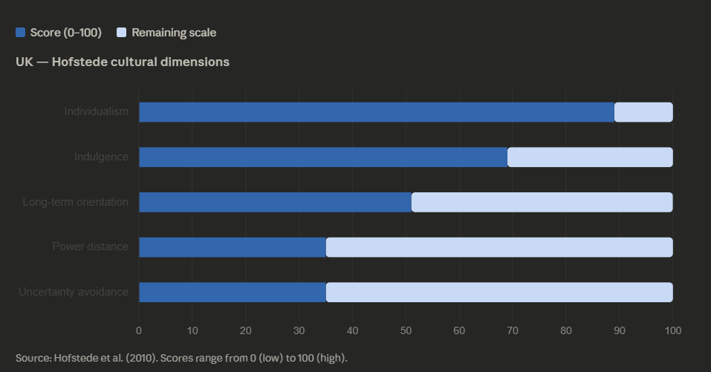

4f. Synthesis: Overall Market Attractiveness
By integrating all the political, economic, legal, and cultural aspects of the above analysis, it can be concluded that the UK represents a highly attractive operational market for Netflix, with structural strengths far outnumbering the relative weaknesses. The presence of a highly developed consumer base, a world-class content production infrastructure, a highly sophisticated consumer culture, and a largely stable, rule of law-based environment all combine to make the UK an extremely attractive market.

Nevertheless, challenges emerge that are significant and require strategic management. Competition is intensifying, thus limiting subscriber growth opportunities. Price sensitivity is also heightened by economic volatility, thus necessitating continuous price innovation. The more active regulatory environment, including content, data, and competition issues, also brings rising compliance costs. How these challenges are addressed while maintaining cultural relevance and content quality, which are essential for subscriber loyalty, is the strategic challenge for Netflix in the UK market.

5. Conclusion
This report has undertaken a systematic analysis of the UK streaming industry and critically examined Netflix's business success in the UK, employing Porter's Diamond Model, PESTLE Analysis, and Hofstede's Cultural Dimensions to provide a multi-layered assessment of the country-industry context (Volkov et al., 2025).
Applying Porter's Diamond Model to analyse the UK streaming industry, we can observe that the UK streaming industry is built on strong competitive foundations, including a world-class creative talent pool, sophisticated and culturally demanding consumer demand, a rich supporting industry, and a high level of multi-directional competition.
The success of Netflix in operations is therefore seen as a result of strategic alignment in relation to its global platform strength and the unique features of the UK environment. The continued investment in content in the UK, flexible price strategy, and personalization capabilities are some of the factors that have created a strong and sustainable competitive position for Netflix in the country. However, at the same time, this analysis also reveals some challenges in relation to an increasingly interventionist political and regulatory environment, economic conditions, rising complexity in legal compliance, and changing diversity in relation to cultural identity in Britain.
The overarching judgment of this analysis is that the UK is a market that is extremely attractive to Netflix and that its advantages far outweigh its areas of concern. However, to remain in the position of market leader in this market requires enhanced cultural intelligence and investment in regulatory engagement and price and content strategy. The above judgment is entirely consistent with the key insight of the theory of international business: that size is no substitute for a sophisticated and adaptive understanding of the host country's politics, economics, law, and culture.

Section 2: Reflection
Gibbs' Reflective Cycle (Gibbs, 1988) offers a structured, iterative framework for experiential learning, comprising six stages: Description, Feelings, Evaluation, Analysis, Conclusion, and Action Plan. Applying this model to the process of researching, analysing, and preparing the preceding section enables systematic self-assessment and informs continuing professional development.
The task involved the research, analysis, and presentation of an extensive international industry and business report, with the focus being on the international industry and business of the UK, with particular reference to the operations of Netflix. The task was multidimensional, including the identification of a suitable country-industry pair with adequate publicly available data, literature and industry research, the identification and application of suitable theoretical frameworks (Porter’s Diamond Model, PESTLE, Hofstede’s Cultural Dimensions).

The research process was started through the execution of a structured literature search, conducted via academic databases such as Scopus, Business Source Complete, Research Gate, Google Scholar, using the following search terms: "Netflix UK strategy," "UK streaming industry competitiveness," "Porter's Diamond model of the media industry," and "SVOD market UK." Additionally, industry reports were obtained from Ofcom, BFI, PricewaterhouseCoopers, Statista, Digital TV Research, as well as Netflix's investor relations documents, as well as CMA and ICO regulatory documents.
At the beginning of the assignment, there were certain levels of uncertainty as far as the scope of the analysis was concerned. The breadth of the assignment, as it covered competitiveness at the industry level, the business environment at the national level, strategy at the firm level, as well as cultural analysis, seemed at the beginning to be somewhat overwhelming. Additionally, there were certain levels of uncertainty as far as the applicability of the Porter Diamond Model, which had been introduced at the theoretical level, was concerned, specifically as far as the contemporary digital industry was concerned.

As the investigation progressed, these initial ambiguities soon made way for greater intellectual engagement. The investigation into the UK streaming market proved to be a stimulating experience, especially in light of the significant structural evolution that the industry has witnessed. The application of Hofstede's Cultural Dimensions in the context of the UK proved to be particularly rewarding, especially in light of the fact that it necessitated a direct translation of theoretical concepts into their implications for Netflix's business strategy.
On the whole, the research and writing process has proved to be effective. The availability of rich secondary data sources on the UK streaming market as well as the operations of Netflix in the UK has been a major enabler, as it has offered a strong empirical base from which the analytical arguments could be derived. The approach of using multiple frameworks as opposed to a single lens of analysis has helped present a more textured and richer evaluation.
A significant drawback in this process was the lack of readily available recent, peer-reviewed, and academic literature available that focused specifically on Netflix’s UK strategy in detail. This was particularly significant, given the fast-evolving nature of this market, with much recent analysis available in reports, official publications, and journalism as opposed to peer-reviewed journals. This was, in effect, a conflict between academic integrity, which demands peer-reviewed sources, and currency, which demands recent market developments. In retrospect, it would have been beneficial to have spent more time initially in assessing this gap in the available literature, as opposed to being surprised by it mid-process, which is a flaw in my initial planning that would be rectified in subsequent projects by conducting an initial ‘source landscape’ review.

Moreover, the scope of the analytical tools applied — Porter's Diamond model, PESTLE analysis, and Hofstede's framework — was lofty considering the word count constraints. In hindsight, it might have been more worthwhile to delve deeper into one or two of the models to achieve critical analysis as opposed to the scope achieved at the expense of some level of analysis. This is a key methodological choice that I would have taken differently.
Reflecting upon this process analytically, we find that several significant learning points emerge. First and foremost, this process reinforced the critical nature of framework selection in relation to structuring complex analytical tasks. While Porter's Diamond and PESTLE offer complementary frameworks, they are conceptually distinct: whereas Diamond sheds light upon structural sources of national competitive advantages at the industry level, PESTLE allows for systematic scanning at the firm-operational level. The successful and cohesive application of both frameworks in a single report, while eliminating redundancy and maximizing analytical scope, was a function of structural planning and disciplined writing.
Secondly, the process highlighted the importance of source triangulation in the construction of analytical argument. Comparing Netflix's own investor relations data, which, as a form of corporate communication, will necessarily prioritize narratives of positive performance, with regulatory, consumer research, and academic sources enabled a more balanced and critically aware evaluation. The ability to think reflexively about the interests represented by different types of sources is a skill that can be transferred to a very wide range of research contexts.
Thirdly, the use of Hofstede's Cultural Dimensions served to illustrate the advantages and disadvantages of quantitative models of cultural analysis. Whilst Hofstede's models are a useful starting point for analysis due to their structured nature and international applicability, they are potentially overly simplistic in their approach to understanding the rich internal diversity and evolution of national cultural identities. In recognizing this potential drawback and working to alleviate it through qualitative cultural observations, particularly in terms of multicultural aspects of British identity, a more sophisticated and academically acceptable form of cultural analysis was achieved. The process of actively evaluating and critiquing a theoretical framework is, I believe, a major step forward in terms of my own analytical maturity.

Fourth, this exercise helped me understand the interaction between macro-environmental factors and firm-level strategic decisions. The strategic decisions made by Netflix in the UK, ranging from its pricing structure to its localized content investments, do not occur in a vacuum; they occur in direct response to the particular characteristics of the UK’s political, economic, legal, and cultural environments. This, of course, is the fundamental lesson taught by the field of international business.
In completing the assignment, there have been a number of specific learning outcomes. Notably, the ability to apply established theoretical frameworks to real-world business contexts has been greatly enhanced, particularly with respect to Porter's Diamond Model, PESTLE analysis, and Hofstede's Cultural Dimensions. In addition, the critical research skills, particularly the ability to synthesise evidence from a wide range of source types, has been greatly enhanced.

The process of working through the tension between academic currency and analytical rigor has served to underscore the methodological difficulties involved in applied business studies. Most importantly, the assignment has helped me develop my critical evaluation skills, the ability not simply to apply, describe, and deploy theoretical frameworks, but also to question these, recognize the limitations of these, and incorporate multiple analytical approaches into a cohesive argument, a skill set with direct relevance to a wide range of academic and professional fields.
In order to build upon the learning that has been created as a result of this assignment, a series of developmental actions will be undertaken. Firstly, a focus will be maintained on the further development of critical evaluation skills within academic work, which will be undertaken by ensuring that theoretical frameworks are subject to critical evaluation rather than mechanistic application. Secondly, a focus will be maintained on the further development of engagement with academic journals on the subject of international business, which will include the ‘Journal of International Business Studies,’ ‘International Business Review,’ and ‘Journal of World Business’.

References
Shangguan, S. (2026). Navigating the Storm: Assessing UK Government and British Film Institute Efforts to Support the Film Industry during the COVID-19 Pandemic. Journal of British Cinema and Television, 23(1), pp.90–116. doi:https://doi.org/10.3366/jbctv.2026.0802.
Yati Nurhayati (2023). Regulatory Analysis Digital Markets Act (Dma) European Union In Business Competition. International Journal of Law, Environment and Natural Resources, 3(1), pp.107–174. doi:https://doi.org/10.51749/injurlens.v3i1.46.
Poon, S., Salili-James, A., Addis, C., Leong, A., van Schalkwyk, H., Zhang, N. and Hartley, B. (2026). Scaling AI Across the UK Culture and Heritage Sector: The NHM-DCMS AI Pilot Programme. Biodiversity Information Science and Standards, 10. doi:https://doi.org/10.3897/biss.10.182096.
Gluer, E.E. (2025). The Level Playing Field and Determining Trade Impact under Trade Agreements: Implications from the EU–UK Trade and Cooperation Agreement. World Trade Review, pp.1–26. doi:https://doi.org/10.1017/s1474745625100979.
Chalaby, J.K. (2024). Streaming giants and the global shift: building value chains and remapping trade flows. Journal of Communication, [online] 75(2). doi:https://doi.org/10.1093/joc/jqae040.
Petrie, D. (2025). Between economic development and social inclusion. Global Film Policies, pp.110–129. doi:https://doi.org/10.4324/9781003171287-7.
Gibbs, G. (1988) Learning by Doing: A Guide to Teaching and Learning Methods. Oxford: Further Education Unit, Oxford Polytechnic.
Heritage Foundation (2024). Index of Economic Freedom 2024. Washington, D.C.: Heritage Foundation.
HMRC (2024) Audio-Visual Expenditure Credit: Guidance Notes. London: HM Revenue and Customs. Available at: https://www.gov.uk/guidance/audio-visual-expenditure-credit (Accessed: 10 March 2026).
Volkov, A., Averyanov, A. and Roslyakova, N. (2025). Comparison of Hofstede and Minkov methods for measuring socio-cultural characteristics. Vestnik instituta sotziologii, 16(2), pp.108–134. doi:https://doi.org/10.19181/vis.2025.16.2.6.
House, R.J., Hanges, P.J., Javidan, M., Dorfman, P.W. and Gupta, V. (eds) (2004) Culture, Leadership, and Organizations: The GLOBE Study of 62 Societies. Thousand Oaks, CA: Sage.
Day, D.V. and Antonakis, J. (2017). The nature of leadership. Thousand Oaks, Calif: Sage.

Hymer, S.H. (1976). The International Operations of National Firms: A Study of Direct Foreign Investment. Cambridge, MA: MIT Press.
ico (2023). UK GDPR guidance and resources. [online] ico.org.uk. Available at: https://ico.org.uk/for-organisations/uk-gdpr-guidance-and-resources.
Johnson, G., Whittington, R., Scholes, K., Angwin, D. and Regnér, P. (2017). Exploring Strategy: Text and Cases. 11th edn. Harlow: Pearson Education.
Katz, N. (2023). Book Review: Streaming Culture: Subscription Platforms and the Unending Consumption of Culture. New Media & Society, p.146144482311731. doi:https://doi.org/10.1177/14614448231173134.
B. Rajesh Kumar (2024). Case 40 Netflix. Management for professionals, pp.299–304. doi:https://doi.org/10.1007/978-3-031-50032-9_40.
North, D.C. (1990). Institutions, Institutional Change and Economic Performance. Cambridge: Cambridge University Press.
Ofcom (2023) Media Nations: UK 2023. London: Office of Communications.
Ofcom (2024) Communications Market Report 2024. London: Office of Communications.
ONS (2023) Consumer Price Inflation, UK: October 2022. Newport: Office for National Statistics.
Porter, M.E. (1990). The Competitive Advantage of Nations. New York: Free Press.
PricewaterhouseCoopers (2023) Global Entertainment and Media Outlook 2023–2027. London: PwC.
Robertson, R. (1995) 'Glocalisation: Time–Space and Homogeneity–Heterogeneity', in Featherstone, M., Lash, S. and Robertson, R. (eds) Global Modernities. London: Sage, pp. 25–44.
Statista (2024) Video Streaming in the United Kingdom: Market Data Report 2024. Hamburg: Statista.
Trompenaars, F. and Hampden-Turner, C. (1997) Riding the Waves of Culture: Understanding Cultural Diversity in Business. 2nd edn. London: Nicholas Brealey.
UKIE (2023) UK Video Games Industry Statistics 2023. London: Association for UK Interactive Entertainment.
World Bank (2024) United Kingdom GDP Data 2023. Washington, D.C.: World Bank. Available at: https://data.worldbank.org/indicator/NY.GDP.MKTP.CD?locations=GB (Accessed: 10 March 2026).
Zaheer, S. (1995) 'Overcoming the Liability of Foreignness', Academy of Management Journal, 38(2), pp. 341–363.

