Introduction

This submission will critically reflect on three images representing what society calls black people and how this group of African heritage is portrayed and misinterpreted in society. The submission will define what social representation is, highlight power and control. Explore implication for quality and fairness—a conclusion of the challenges and what needs to be done and a complete reference list. Furthermore, I will focus mainly on the United States of America because, in America (USA), discrimination is in your face and not undercover like in the United Kingdom (UK). Moreover, whatever America does, the rest of the world follows.

Body of Submission

As stated in ‘Theory and methods of social representation’ social representation theory is a social psychological framework of concepts and ideas to study psychosocial phenomena in modern societies. It maintains that social psychological phenomena and processes can only be adequately understood if seen as embedded in historical, cultural, and macro-social conditions. Doing so attempts to overcome the shortcomings of those currently general theories and approaches in social psychology based on methodological individualism and epistemology, which functionally separates the subject from the object (Furr 1996).

Image1
‘Don’t remove the kinks from your hair! Remove it from your brain’. Marcus Garvey
This image represents a black woman with her natural hairstyle that expresses her beauty, historically social oppression, abuse, and racial discrimination, which have forced many black women to hide their hair. Many black women in the industrial workforce felt forced to adopt a more anglicized practice for hairstyles such as straightened, processed, and altered from their natural state because they want to blend in with everyone. American courts are still divided about African American’s right to wear their natural hair in the workplace. According to society, this image represents unprofessional, not decent, agly ……. In the 1700s enslaved women who worked in the fields usually covered their hair in head-rags due to their work's harsh environment. Light-skinned enslaved Africans who worked in the big house sometimes mimicked the hairstyles of their masters, either by wearing a wig that had become popular during that era or shaping their kinky hair to emulate them. Free creole women of colour in cities like New Orleans donned elaborate hairstyles that displayed their kinks and coils with an air of legality, and the city implemented laws- the Tignon Laws that required these women to wear a tignon (scarf or handkerchief over their hair to signify that they were members of the slave class, regardless of whether they were free or enslaved. At the end of the 19th-century sow, the hair straightening comb's invention, by 1920s straight hair, had become the preferred texture to signal middle-class status. The first wave of the natural hair movement emerged in the 1960s (Black is Beautiful) movement which assured black women and men that their skin, facial features, and natural hair were admirable. Wearing an afro became a weapon in the fight for racial equality and a public declaration of self-love and solidarity within the black community. Whether rocking afros or pressed hair, black protesters demanded the signing of the Civil Rights Act of 1964, which ended segregation. The Act created the Equal Employment Opportunity Commission, which operates as the lead enforcement agency in workplace discrimination. Black people were granted access to public workplaces but did not foresee black hair needing equal access. In the 1980s-1990s, adverts on television and in magazines encouraged black women to alter their hair's texture by spotting pressed and permed hair. This period also witnessed the popularization of braids and cornrows styles. In 2000s, A documentary film by Chris Rock (Good Hair) focused on the economics of black women buying weaves and perming their hair influenced the movement by raising social consciousness, prompting many black women to abandon their perms and pressing combs. In 2006 the EEOC issued its Compliance Manual on Race and Colour Discrimination, which details what constitutes discrimination based on physical characteristics in the workplace, associated with race, such as a person’s color, hair, facial features, height, and weight.
Image 1: Title
There’s a Petition to Include the word Afro-Latina in the Dictionary
Image
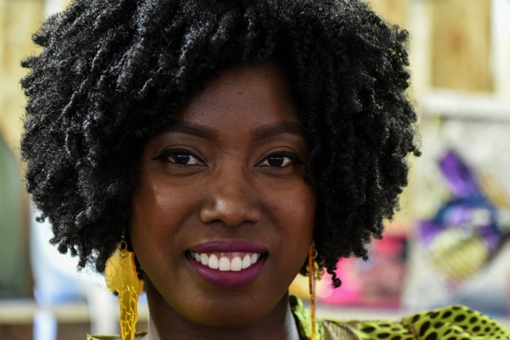

(Rebels, 2018).

Image2
‘When you are in an elevator or walking behind somebody and you feel like you have to perform to make them feel safe, it is like apologising for your existence’ Paul Butler.
It is not a secret that society is often afraid of black boys and men; black boys and men always need to prove themselves because society classes them as thugs, drug dealers, buglers, and dangerous. Society is often nervous around them and assumes that they are a threat to society because they are black. The article ‘What defines a man states that manhood is more than a compilation of traits but a reflection of who they are at a deeper level. These ideas are rooted in an amalgamation of gendered ideals, cultural norms, religious doctrine and beliefs, and age-related priorities. Threat stereotypes are more significant for black men who face more discrimination from police officers and elicit stranger judgments of threat. Height is intrinsically beneficial for white men and not for black men. In terms of salaries and success, white men are seen as competent. Manhood is often seen as an innate quality that is the natural result of being a biological male, but manhood is an identity that is constructed through intrapersonal and interpersonal relationships. Many men are marginalised by race, ethnicity, and class. Racism, segregation, economic discrimination, and other structural forces in the US have limited ways black men can define themselves concerning hegemonic masculine norms, for example: fulfilling the role of economic provider, moving their families into desirable housing and neighborhood conditions, and accumulating wealth to pass on to their children and grandchildren. Manhood is constantly precarious and can produce fear that other men will see them as weak, timid, or frightened. Many men value their reputation and how other men perceive them in many areas of life. The idea of proving one’s manhood has been driven by social, cultural, and structural changes in the context of family, political, and work aspects of life, and the consequences of these changes have been both social and psychological. Manhood is linked to economic success and is often defined by physical and sexual virility, the consumption and collection of consumer goods, and leisure time activities. The Big Man Little Man Complex argues that men attempt to achieve a level of respectability through economic success, educational attainment, and social class status, while simultaneously demonstrating prowess along the social and cultural dimensions of traditional masculinity; virility, sexual expertise, risk-taking, physical strength, and hardiness. These factors highlight that masculinity may lead to stress and coping that results from achieving success in areas of respectability: engagement in risky behaviors that may represent traditional aspects of masculinity, for example; eating large portions, alcohol abuse, substance use, speeding while driving, risky type of physical activities, high numbers of sexual partners and inconsistent safe sex practice.

Image 2: Title
Fear Of Black Men

Image
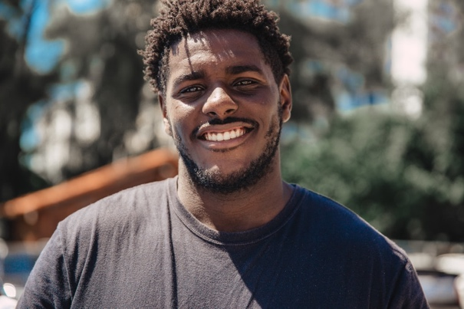

(, no date).

Image3

‘The greatest enemy of the truth is very often not the lie- deliberate, contrived and dishonest- but the myth, persistent, persuasive and unrealistic’ (J.F. Kennedy).
The African continent's social representation in society is that the Africans are; dying of poverty and Aids, unable to speak and support themselves, and waiting to be saved by a kind white foreigner mainly represented as the (white Jesus). The Democratic of the Congo (DRC) in Eastern Africa has the most prominent Colten mining sector, which plays an essential role in the technological revolution. However, the DRC often linked to violent conflict for over two decades, yet less attention has been paid to DRC people. Returns on investment in Africa have been the highest in the world for the past 20 years. 12 of the 20 fastest-growing economies over the next five years will be in Africa. An American-based law firm AlixPatners and Dentons, confirms evidence that suggests that despite the progress achieved in Africa in the past two decades, the continent continues to be plagued by negative perception and a limited understanding of its investment prospects. However, there are concerns related to corruption and transparency in African businesses.
Image 3: Title
Mapped: Visualizing the true size of Africa
Image
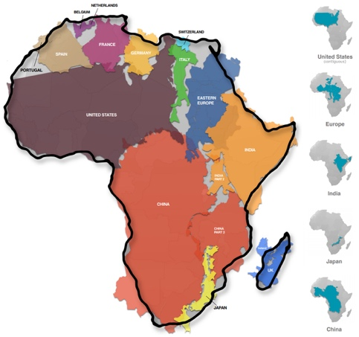
(Desjardins, J, 2021).

Compare and Contrast and draw conclusions

It does not matter whether male or female the fact that one is a child of mama Africa with the African heritage society perceive the African heritage at the bottom of the scale in all aspects of society, no matter how educated and knowledgeable an individual is. The fact that their skin colour is darker than anyone else is enough to put them at the bottom of society's scale. However that been said, the holy bible states that as humans, we are made in the image of the only living God- humans are in the image of God, their morals, spiritual and intellectual nature (Genesis 1:270 the creator of all things in heaven, earth and under the earth (Psalm146:6). It further argues that we can do all things through Christ who strengthens us (Philippians 4:13).

Conclusion

To conclude, as highlighted in the black panther movie, the children of mama Africa are still fighting brother against brother and sister against sister for vibranium from saving Wakanda. As so-called black people, they need to focus on who they indeed are and not on the colour of their skin to living life abundantly in all aspects of their life’s. That being said, others need to educate themselves on deception, and the history courses division between humanity and the so-called blacks and the rest of the world need to talk constructively about the past, present, and future. Accept accountability, for example, the whole world depends on coltan for the technology, yet the children of the DRC experience abused in all aspects of their life’s, and yet the world is silent about it does the United Nations Convention on the right of the child not apply to them? Who owns these technical companies? Furthermore, what are individuals doing about it- having the latest phone every year? Forgiveness and making the world a better place for the near future generations need to be done.

Reference List:
Anon, (1970). Holy bible authorized King James version., Oxford UP.

Ankomah, Baffour, (2018). Black Panther: I beg to differ: Although the film Black Panther has been hailed as overturning the usual negative perception of Africa, is it not in the same tradition as 'the single African story' of black people fighting senseless wars? New African (London. 1978), (585), p.14.

Boateng, Osei, (2013). In business, Africa still suffers from negative perceptions. New African (London. 1978), (529), pp.56–58.

Desjardins, J (2020) Mapped: Visualizing the true size of Africa available at:https://www.visualcapitalist.com/map-true-size-of-africa/ [Accessed 24th March 2021].

Griffin, C (2019) Politics and Government available at: https://daily.jstor.org/how-natural-black-hair-at-work-became-a-civil-rights-issue/ [Accessed 23rd March 2021].

Griffith, D. M., Cornish, E. K. (2018). “What defines a man?”: Perspectives of African American men on the components and consequences of manhood. Available at: https://psycnet.apa.org/record/2016-53580-001 [Accessed 23rd March 2021].

Griffith, D., Brinkley- Rubinstein, L., A Bruse, M., J Thorpe, R., Metzel, J (2015) Available at: https://www.ncbi.nlm.nih.gov/pmc/articles/PMC4547385/ [Accessed 23rd March 2021].

Hester, N., Gray, K (2017) For Black men, being tall increases threat stereotyping and police stops Available at:https://www.pnas.org/content/115/11/2711 [Accessed 23rd March 2021].

Kabukanyi, Julie & Aron, Pat, (2017). Protecting the children of Congo: Boston WILPF impels action on Congo conflict minerals.(Women's International League for Peace and Freedom). Peace and freedom (1978), 77(1), p.2.

Martin, M (2015) Fear Of Black Men: How Society Sees Black Men And How They See Themselves available at:https://www.npr.org/2015/03/31/396415737/societys-fear-of-black-men-and-its-consequences?t=1616625326265 [Accessed 23rd March 2021].

Njoh, Ambe J, (2009). Urban planning as a tool of power and social control in colonial Africa. Planning perspectives, 24(3), pp.301–317.Rebels L (2018) There’s a Petition to Include the word Afro-Latina in the Dictionary. Available at:https://www.latinorebels.com/2018/10/30/afrolatinapetition/ [Accessed 23rd March 2021].

Price Cohen, Cynthia & Naimark, Hedwin, (1991). United Nations Convention on the Rights of the Child. The American psychologist, 46(1), pp.60–65.

Unsplash (no date) Photos for everyone available at:https://unsplash.com/photos/2EGNqazbAMk [Accessed 23rd March 2021].

Vogel, Christoph & Musamba, Josaphat, (2017). Brokers of crisis: the everyday uncertainty of Eastern Congo's mineral négociants. The Journal of modern African studies, 55(4), pp.567–592.

Wagner, Wolfgang et al., (1999). Theory and Method of Social Representations. Asian journal of social psychology, 2(1), pp.95–125.

