University of Wales Trinity Saint David
Wales Institute of Science and Art



Electronic Circuits Testing and Applications

ACHA4031 Vehicle Electronics

Pablo Model Rodrigues
2503092
13/04/2026
Contents
1.1 Scope Time Division Calculations 3
1.2 Function Generator output square wave 4
1.3 Capacitor charge and discharge wave marked at correct points 5
1.4 Basic Capacitor Calculations 6
1.5 Capacitor discharge table 7
1.6 Plot log(V) Gradient 8
1.7 Gradient Calculations and Compare 9
1.7.1 Gradient Calculations 9
1.7.2 Comparison table 10
1.8 Capacitor Uses 10
1.9 Inaccuracies Question 12
1.10 Risk Question 13
2 Reference List 14

1.1 Scope Time Division Calculations

To display one full waveform lasting τ(40) on the oscilloscope, first the time constant of the RC circuit was calculated using:
$$τ=RC$$
For this experiment, a 1 kΩ resistor and a 1 µF capacitor was used.
$$τ=1000×1×{10}^{-6} \\ τ=0.001 =1 ms$$
Then the total time for 40τ was calculated:
$$40τ=40×0.001=0.04 s$$
Since the oscilloscope screen has 10 divisions, the time per division was worked out as:
$$\text{Time/div}=\frac{40τ}{10}=\frac{0.04}{10}=\frac{ 0.004 s}{div} \\ \text{Time/div}=\frac{ 4 ms}{div}$$
This setting was used so that the full waveform could be seen clearly across the screen. If the time division was different it would not show the full signal properly.

1.2 Function Generator output square wave

The function generator was set to produce a square wave and this was used as the input signal for the RC circuit. On the oscilloscope the signal was around 4.5 kHz and the voltage was about 5 V. This was useful because the square wave makes it easier to see how the capacitor charge and discharge over time.
The input signal changes very fast between high and low, but the capacitor voltage changes more gradually. This helps show the effect of the RC circuit more clearly on the oscilloscope.

Figure 1: Function generator output square wave.
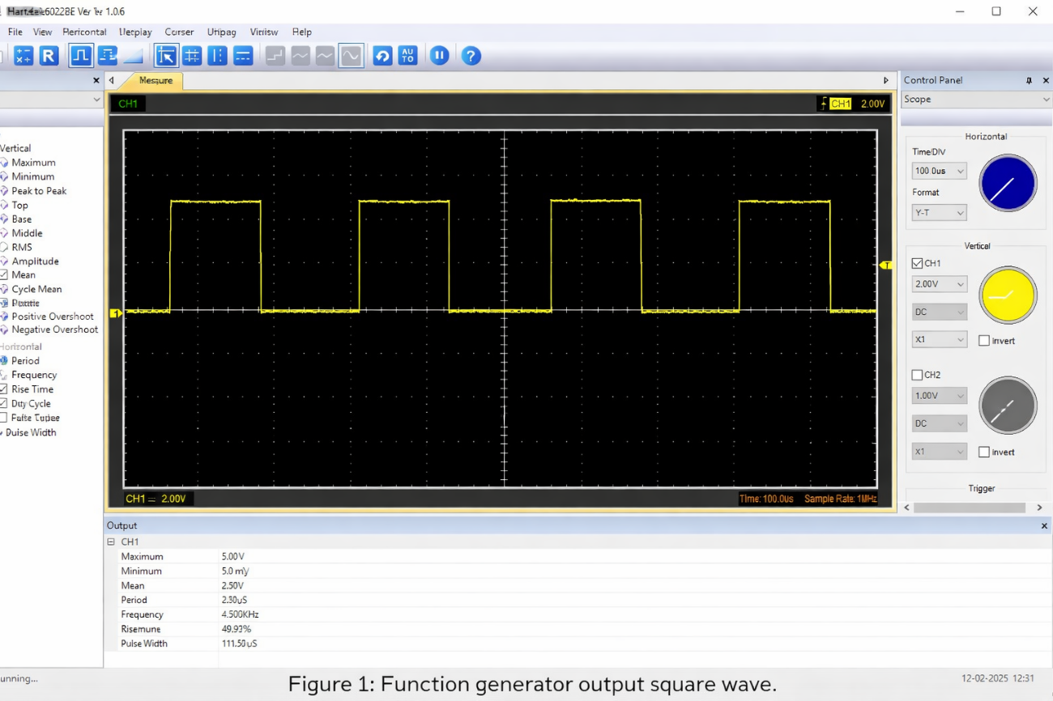

1.3 Capacitor charge and discharge wave marked at correct points

The waveform across the capacitor shows the charging and discharging behaviour of the RC circuit. Instead of following the square wave input exactly, the voltage across the capacitor increases and decreases gradually over time.
This happens because the capacitor stores energy when charging and releases it when discharging, so the voltage does not change instantly. The shape of the waveform is therefore curved rather than sharp like the input signal.
From the oscilloscope, it can be seen that the capacitor does not fully charge or discharge before the signal changes again. This is because the time constant of the circuit is larger than the signal period, so the capacitor does not have enough time to reach the maximum or minimum voltage.
The charging part of the waveform corresponds to when the voltage is increasing, and the discharging part corresponds to when the voltage is decreasing. These regions should be clearly marked on the oscilloscope output.

Figure 2: Capacitor charge and discharge waveform.
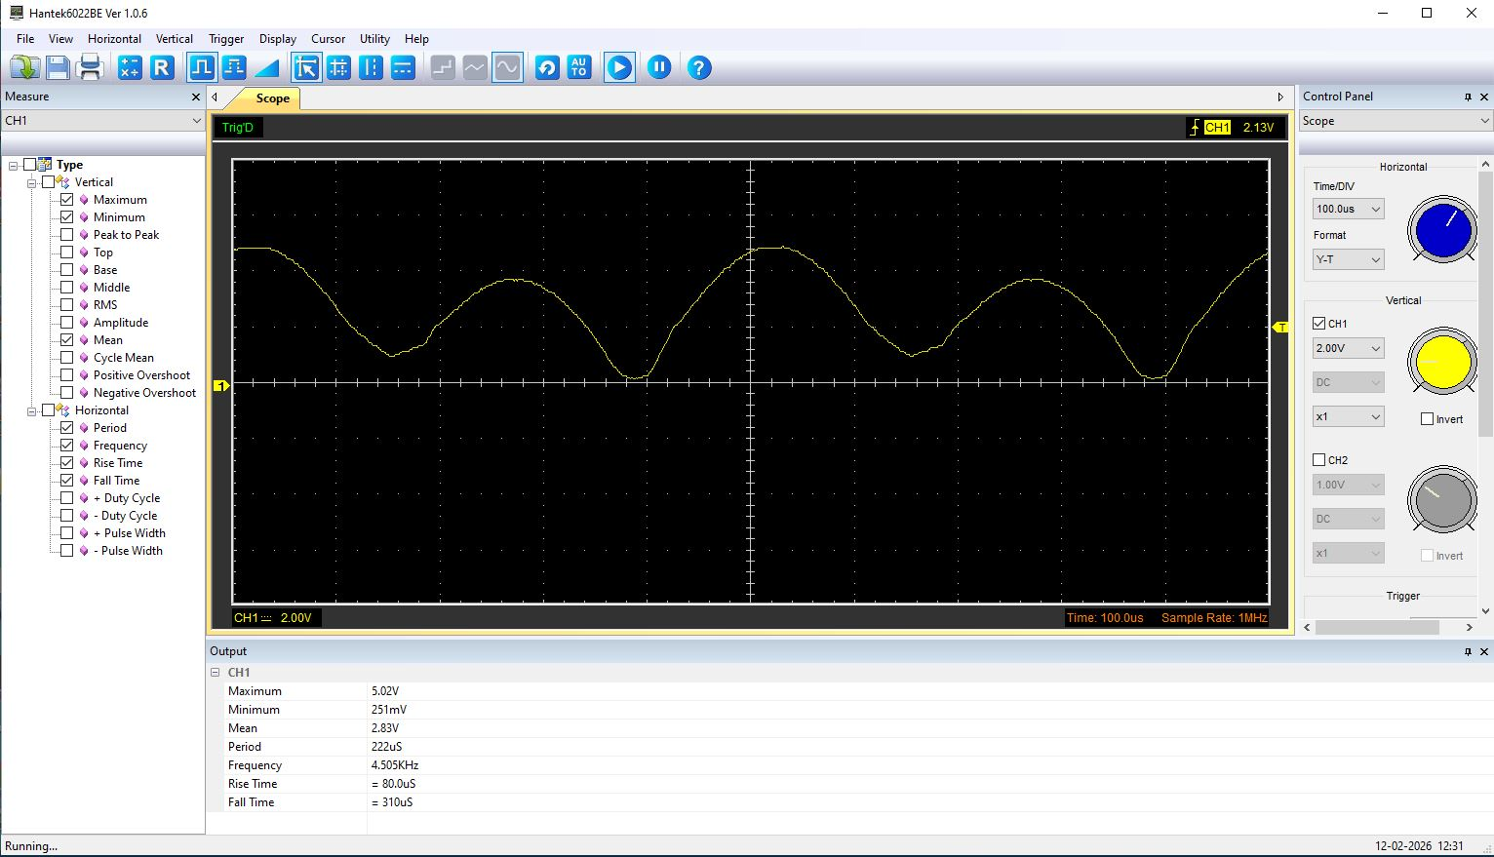

1.4 Basic Capacitor Calculations

The capacitance was calculated using the formula:
$$t=RC$$
This can be rearranged to:
$C=\frac{t}{R}$
For the circuit, the resistor used was 1 kΩ, which is:
$R=1000 Ω$
The time constant from the earlier calculation was:
$t=0.001 s$
So the capacitance was worked out as:
$C=\frac{0.001}{1000}$
$$C=1×{10}^{-6} F \\ C =1 μF$$
So the value of the capacitor was calculated as 1 µF. This is the same as the expected capacitor value, so the result looks reasonable.

1.5 Capacitor discharge table

The discharge part of the waveform was split into 10 points from the oscilloscope graph. These values are approximate because they were taken from the screen and not measured exactly. The natural log of the voltage was then worked out for each point so it could be used to calculate the gradient.
Time (s) | Voltage (V) | ln(V) | dy | dx | dy/dx
0 | 5.02 | 1.613 | – | – | –
0.00003 | 4.6 | 1.526 | -0.087 | 0.00003 | -2900
0.00006 | 4.05 | 1.399 | -0.127 | 0.00003 | -4233
0.00009 | 3.45 | 1.238 | -0.161 | 0.00003 | -5367
0.00012 | 2.85 | 1.047 | -0.191 | 0.00003 | -6367
0.00015 | 2.25 | 0.811 | -0.236 | 0.00003 | -7867
0.00018 | 1.7 | 0.531 | -0.28 | 0.00003 | -9333
0.00021 | 1.15 | 0.14 | -0.391 | 0.00003 | -13033
0.00024 | 0.72 | -0.329 | -0.469 | 0.00003 | -15633
0.00027 | 0.3 | -1.204 | -0.875 | 0.00003 | -29167

These values was used for the log(V) against time graph in the next section,the differences in ln(V) (dy) and time (dx) were calculated between each point to estimate the gradient of the discharge curve.

1.6 Plot log(V) Gradient
The values from the discharge table was used to plot ln(V) against time. The graph gives an almost straight line, which is what would be expected for a capacitor discharge.
This happens because the discharge curve is exponential, but when ln(V) is plotted against time it becomes more linear. This makes the gradient easier to calculate for the next part.

Figure 3: Plot of ln(V) against time for the capacitor discharge curve.

1.7 Gradient Calculations and Compare

1.7.1 Gradient Calculations
The gradient was calculated from the values of dy/dx in the capacitor discharge table. Because the discharge points were taken approximately from the oscilloscope trace, the gradient is only an estimated value.
From the table, the values of dy/dx were:
-2900, -4233, -5367, -6367, -7867, -9333, -13033, -15633, -29167
The average gradient was calculated as:
$$\text{Average gradient}=\frac{-2900+(-4233)+(-5367)+(-6367)+(-7867)+(-9333)+(-13033)+(-15633)+(-29167)}{9} \\ \text{Average gradient}=\frac{-93800}{9} \\ \text{Average gradient}≈-10422.22 s^{-1}$$
For a capacitor discharge curve:
$$\text{Gradient}=-\frac{1}{RC}$$
Rearranging to make capacitance the subject:
$$C=-\frac{1}{R⋅\text{Gradient}}$$
Using:
$$R=1 kΩ=1000 Ω \\ C=-\frac{1}{1000×(-10422.22)} \\ C=\frac{1}{10422220} \\ C≈9.59×{10}^{-8} F \\ C≈0.096 μF$$
So, the capacitance calculated from the gradient method was approximately 0.096 µF.

1.7.2 Comparison table
Capacitance | Delta | Percentage difference
Actual | 1 µF | x
Marker Calculation | 1 µF | 0 %
Gradient Calculation | 0.096 µF | 90.4%

The marker calculation gave a value of 1 µF, while the gradient calculation gave about 0.096 µF. This is quite a big difference. This probably happened because the values was taken by eye from the oscilloscope, so even small errors can affect the gradient a lot. Also the graph was not perfectly straight, which makes the result less accurate.

1.8 Capacitor Uses

Capacitors are widely used in electrical and automotive systems because they can store and release energy, filter signals and stabilise voltage (Sarjeant, Zirnheld and MacDougall, 1998; Simon and Gogotsi, 2020). They play an important role in ensuring stable operation of electronic circuits by reducing voltage fluctuations and improving signal quality. In automotive systems, capacitors are also used in control units, sensors and power systems to support reliable performance.

Some common uses include:
1 . Voltage smoothing in power supplies
2 . Noise filtering in electronic circuits
3 . Signal coupling between amplifier stages
4 . Power factor correction in electrical systems
5 . Energy storage in flash cameras
6 . Bypass capacitors in microcontrollers
7 . Timing circuits (RC circuits)
8 . Audio filtering systems
9 . Automotive ignition systems (spark suppression)
10 . Radio tuning circuits

1.9 Inaccuracies Question

The capacitance value that was calculated ended up being quite different from the expected 1 µF. There are a few reasons that could explain this.
One of the main issues is probably measurement error. The voltage and time values were taken from the oscilloscope screen, so they were only approximate and not exact values. Because of that, even small mistakes when reading the graph can affect the gradient quite a lot, especially since logarithmic values were used. Measurement systems themselves can also introduce some error in the voltage readings, which then affects the final result (Le et al., 2018). Also, depending on the scale used on the oscilloscope and its resolution, it can be quite hard to read accurate values, mainly when the signal is changing quickly.
Another reason could be the tolerance of the components. In real circuits, resistors and capacitors are not exactly the value written on them. For example, a 1 µF capacitor might actually be slightly higher or lower, sometimes by around ±10% or even more (Bolton, 2021). The resistor value can also vary a bit, and since both R and C affect the time constant, this will have an impact on the calculation.
There are also some environmental factors that could have influenced the results. Temperature, for example, can change how components behave, especially capacitors. On top of that, electrical noise or interference from other equipment nearby could have affected the readings shown on the oscilloscope.
Another thing to consider is that the ln(V) vs time graph was not perfectly straight. Ideally it should be more linear, but in this case it had some variation. Because of that, it becomes harder to find an accurate gradient. Also, the points taken from the graph were estimated, so they might not represent the exact shape of the curve.
Overall, the difference between the calculated and expected values is most likely due to a combination of these factors, including measurement errors, component tolerances and general limitations of the equipment used.

1.10 Risk Question
Modern vehicles use multiple electronic control units (ECUs) that are connected through communication networks like the Controller Area Network (CAN Bus). This setup helps improve performance, safety and overall comfort, but at the same time it also introduces some cybersecurity risks. Research has shown that attackers can take advantage of weaknesses in vehicle systems, either through physical access or wireless connections (Petit and Shladover, 2015).
One of the main risks is message injection into the CAN Bus. Because the CAN protocol does not have built-in security features such as encryption or authentication, if someone gains access to the network they can send false messages to control important vehicle functions. This could affect things like braking, steering or engine behaviour, which makes it a serious safety issue (Plappert et al., 2021). Also, access points such as the OBD-II port, Bluetooth or telematics systems can increase the chances of an attack happening (Yang et al., 2022).
To reduce these risks, different cybersecurity measures can be used. One of the main ones is message authentication, which makes sure that only trusted ECUs can send valid signals. Encryption can also be used to protect data from being intercepted. Another important method is intrusion detection systems (IDS), which monitor the network and help detect unusual behaviour in real time.
Another approach is using secure gateways to separate critical systems and limit communication between different parts of the vehicle network. Regular software updates, including over-the-air (OTA) updates, are also important because they allow vulnerabilities to be fixed when they are found. These methods help reduce the chances of a successful cyberattack.
The ISO/SAE 21434 standard gives a structured way of managing cybersecurity risks during the whole vehicle lifecycle, from the design stage all the way to maintenance (ISO/SAE, 2021). It focuses on risk management, continuous monitoring and secure development. In a similar way, UNECE Regulation No. 155 requires manufacturers to have proper cybersecurity systems in place and show that risks are being controlled (UNECE, 2021).
Overall, protecting CAN Bus systems requires a mix of good design, monitoring and regular updates. It’s not possible to remove all risks completely, but these measures can make modern vehicles much more secure against cyberattacks.

2 Reference List

Sarjeant, W.J., Zirnheld, J. and MacDougall, F.W. (1998) “Capacitors,” IEEE transactions on plasma science, 26(5), pp. 1368–1392. Available at: https://doi.org/10.1109/27.736020.

Simon, P. and Gogotsi, Y. (2020) “Perspectives for electrochemical capacitors and related devices,” Nature materials, 19(11), pp. 1151–1163. Available at: https://doi.org/10.1038/s41563-020-0747-z.

Le, J. et al. (2018) ‘Harmonic voltage measurement error of the capacitor voltage transformer’, PLOS ONE, 13(11), p. e0205231. Available at: https://doi.org/10.1371/journal.pone.0205231.

Bolton, W. (2021) Engineering science. Seventh edition. Abingdon, Oxon ; Routledge.

ISO/SAE (2021) Road vehicles – Cybersecurity engineering (ISO/SAE 21434).

UNECE (2021) UN Regulation No. 155 – Cyber security and cyber security management system.

Petit, J. and Shladover, S.E. (2015) ‘Potential Cyberattacks on Automated Vehicles’, IEEE Transactions on Intelligent Transportation Systems, 16(2), pp. 546–556. Available at: https://doi.org/10.1109/TITS.2014.2342271.

Plappert, C. et al. (2021) ‘Attack Surface Assessment for Cybersecurity Engineering in the Automotive Domain’, in Proceedings - Euromicro Workshop on Parallel and Distributed Processing. IEEE, pp. 266–275. Available at: https://doi.org/10.1109/PDP52278.2021.00050.

Yang, C. et al. (2022) ‘Intelligent Connected Vehicles Cybersecurity Vulnerability Rating Methodology Based on Multiple Factors’, in Proceedings of the 4th International Conference on Advanced Information Science and System. New York, NY, USA: ACM, pp. 1–6. Available at: https://doi.org/10.1145/3573834.3574528

