
COMTEMPORY ISSUES in management
Module Code BMBM6003 / Lecturer: Rubyn Griffiths
Cyrille Tounoudjou

Ethical assessment of Management Theory in Nexus Tech Global Leadership Practices
Executive Summary
This report focuses on the ethical and managerial issues of Nexus Tech Global which is a fast-growing AI analytics company. Although the company has embraced an agile by design philosophy, the firm has a control-oriented bureaucratic culture that is characterised by micromanagement, overwork and a lack of trust even amongst its employees- demonstrated by a decline in employee confidence by 38%. The analysis with reference to Mainstream theories (Taylor, Fayol, Weber, Contingency) and Critical perspectives (Post-bureaucratic, Feminist, Foucauldian, Systems) identifies burnout, loss of autonomy and inconsistent diversity practices as the underlying ethical concerns. The report summarises that the Nexus Tech management has not adhered to ethics of duty, care and fairness. Some of the recommendations are trust-based management, decentralised decision-making process, ethical leadership training, standardised diversity policies, and open communication to restore trust and sustain ethical performance.

Contents
1.0 Introduction 3
2.0 Main Finding 4
2.1 Ethical Context and Organisational Background 4
2.2 Evidence of Complaints and Issues 4
3.0 Mainstream Management Theories and Nexus Tech 5
3.1 Scientific Management (Taylor) 5
3.2 Administrative Theory (Fayol) 5
3.3 Bureaucracy (Weber) 6
3.4 Contingency Theory 6
4.0 Critical Management Theories and Nexus Tech 7
4.1 Post-Bureaucratic Theory 7
4.2 Feminist Theory 8
4.3 Foucauldian Perspective 8
4.4 Systems Theory 8
5.0 Ethical Evaluation of Management Practices 8
6.0 Conclusion 9
7.0 Recommendations 9
8.0 Reference List 10
9.0 Appendices 12

1.0 Introduction
Nexus Tech Global is a fast-growing and AI-based analytics company in the UK, experiencing ethical and managerial problems that are caused by control-based leadership, excessive workload, and deteriorating transparency. Although it has encouraged an Agile by design philosophy, the organisation is managed in a bureaucratic and performance-dominated manner, thus resulting in employee dissatisfaction and burnout. This report analyses the management problems in Nexus Tech based on the Mainstream and Critical theories and finds ethical implications regarding the issues of autonomy, inclusivity, and trust. The analysis will help evaluate the theoretical explanation of these challenges as well as present some practical and ethically based recommendations to balance the performance efficiency and employee well-being.

2.0 Main Finding

2.1 Ethical Context and Organisational Background
Nexus Tech Global is a fast-growing UK company that specialises in analytics based on artificial intelligence in the context of healthcare and retail. After 18 months of huge investments and an expanding workforce, the organisation encountered serious ethical and managerial problems (Koay and Lim, 2021). Despite the Agile by design philosophy with the support of flexibility, collaboration, and innovation, Nexus Tech is characterised by a bureaucratic and control-oriented culture in its internal operations. Middle managers have embraced the practices that focus more on performance, which value output and compliance rather than employee well-being and independence (Pandey, 2018).This discrepancy between stated values and behavioural patterns has brought ethical strains in the organisation. The staff members complain that they are overworked, not heard, and there is a lack of openness in the decision-making process, which has led to a decrease in trust towards top management by 38% (Wesemann Lekkas et al., 2025). The existing management strategy of the organisation is in breach of some of the fundamental ethical guidelines, such as autonomy, fairness, and honesty (Nexus Tech, 2025). Nexus Tech leaders have failed in their ethical duty to consider performance targets as an end to employees instead of a duty to an end, according to the duty-based ethics perspective (Huang et al., 2021). Equally, according to the ethics of care, when wellbeing and inclusivity are not prioritised, a failure in relational responsibility is evident. Such unethical practices are not only a threat to employee morale but also long-term sustainability of the organisation.

2.2 Evidence of Complaints and Issues
According to recent internal feedback and employee surveys within Nexus Tech Global, there is an increasing number of complaints regarding toxic and unsustainable work culture. Employees report about micromanagement, too many workloads, and a lack of opportunity to raise concerns, as well as discuss ideas, which means that there was a definite lack of employee voice. These problems demonstrate the contradiction between the professed values of Agile by design at Nexus Tech and the reality of the bureaucratic and approval-based management practices (Nexus Tech, 2025). Decision-making is centralised rather than encouraging autonomy and collaboration, hampering innovation and destroying trust.
Moreover, diversity and inclusion programs have been applied unevenly in the international locations, which has posed inequities and exposed the company to ethical and reputational threats. This contradicts the reputation of the company as a socially responsible and inclusive employer. The net impact of this management failure can be seen in terms of employee burnout, high turnover and decrease in psychological safety, which are all risky to the overall organisational performance (Ullah et al., 2021). Ethically, these problems are a failure to support key values of dignity, respect, and inclusion. The disregard of employee well-being not only breaches the ethics of care, as it focuses on empathy and responsibility, but also the more general principles of organisational justice, which points to a wide morality and management lapse at Nexus Tech.

3.0 Mainstream Management Theories and Nexus Tech

3.1 Scientific Management (Taylor)
Scientific Management by Frederick Taylor stresses on control, efficiency and performance measurement. The use of performance measurements and output surveillance in Nexus Tech indicates this Taylorism rationale, as the productivity of employees is valued more than their well-being (Grosse et al., 2023). The middle managers are highly supervised, and performance is done based on time and which causes overwork, stress and burnout. Although this control can enhance short-term performance, it reduces creativity and autonomy, which is against the Agile by design philosophy of the organisation. Taylorism is ethically wrong because it considers workers as body parts instead of moral persons with personal dignity (Arnold et al., 2019). This instrumental perspective fails to consider the moral obligation of the company towards the psychological safety and meaningful work.
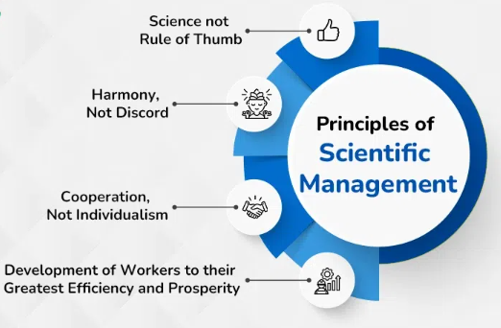
Figure 1: Scientific Management Theory
(Source: Grosse et al., 2023).

3.2 Administrative Theory (Fayol)
The Administrative Theory of Henri Fayol lays stress on control, discipline, and command line. This hierarchy can also be traced in Nexus Tech, where the flow of authority is vertical and the decisions are strictly supervised by senior managers. This rigidity strengthens order but constrains the involvement of employees and flexibility. The high reliance on managerial consent goes against the decentralised and cooperative culture demanded by current technology companies (Sukmana and Maryanti, 2023). The moral issue is that the voice and creativity of workers are repressed, thereby degrading fairness and respect, which are the central ideas of contemporary organisational ethics.
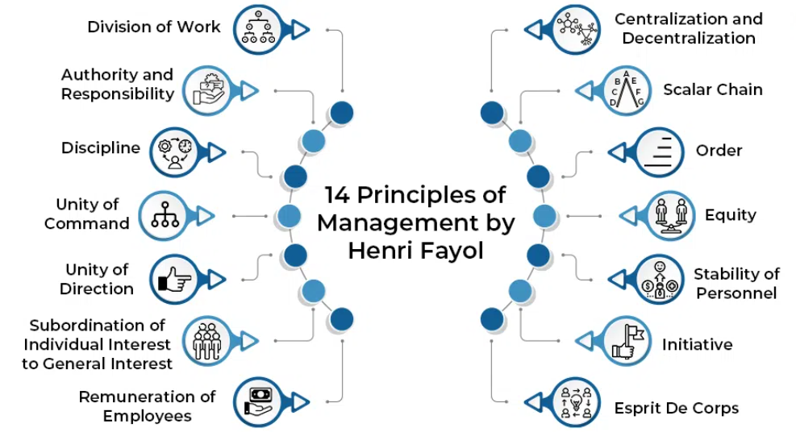
Figure 2: Administrative Theory
(Source: Sukmana and Maryanti, 2023).

3.3 Bureaucracy (Weber)
The Bureaucratic Theory by Max Weber lays emphasis on structure, formal rules and impersonality as means of attaining efficiency and predictability. This model is manifested in the bureaucratic systems of Nexus Tech, such as long chains of approval, standardised procedures, and over-reporting. As much as these controls are meant to guarantee accountability, they only lead to rigidity, loss of innovation, and a psychological distance between the leaders and employees (Yilmaz and Telsac, 2021). The Weberian bureaucracy, morally speaking, results in depersonalisation and alienation, as people feel underrated and disinterested in organisational mission. This leads to a loss of trust and morale, as evidenced by a 38% decline in employee confidence in senior leadership [Referred to Appendix 2].

3.4 Contingency Theory
The Contingency Theory states that management efficient theories rely on the suitability of organisational structure in relation to the requirements of the environment. Nexus Tech is a company in a fast-paced, innovative sector that needs a flexible environment and quick adjustment (Abedin, 2021). The lack of flexible, control-intensive practices, though, means a lack of fit. Nexus Tech also compromises the agility and the ethical responsiveness by not adjusting its management approach to the unstable technology environment.
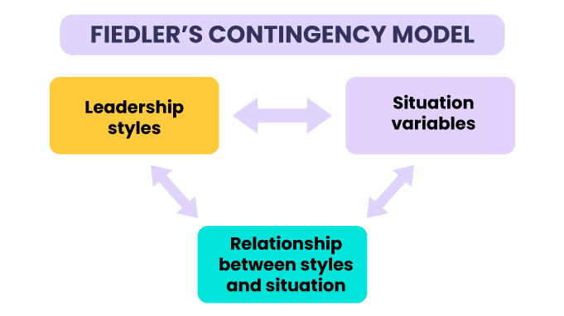
Figure 3: Contingency Theory
(Source: Abedin, 2021)

4.0 Critical Management Theories and Nexus Tech

4.1 Post-Bureaucratic Theory
Post-bureaucracy theory is an alternative to conventional hierarchical models which propagates flexibility, cooperation, and coordination based on trust. On the contrary, the established management strategy at Nexus Tech assumes strict approval procedures and micromanagement that limit the freedom of the teams and postpone innovation. A post bureaucratic structure would enable employees to make decisions and be involved in resolving problems without being under thorough supervision (Ciardi and Scalzo, 2022). This change has been consistent with the company proclaimed Agile by design vision, which focuses on adaptive team and decentralised power (Clegg, 2019). Post-bureaucratic practices are morally sound and promote respect to autonomy, psychological safety, and participative justice which are nowadays compromised by the culture of control in Nexus Tech.
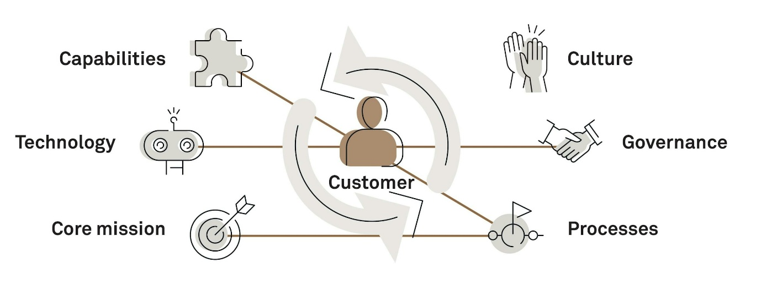
Figure 4: Post-Bureaucratic Theory
(Source: Ciardi and Scalzo, 2022)

4.2 Feminist Theory
The ethics of care, relational leadership and inclusivity are presented in the feminist organisational theory, as the main ethical management principles (Arar and Saiti, 2022). The inconsistency of diversity programs at Nexus Tech indicates a lack of sensitivity to gender and cultural equality, which is an indicator of an empathetic, people-based management philosophy. According to the feminist theory, emotional labour, shared responsibility and fair voice should be appreciated in ethical organisations (Brantley, 2023). This is the view that would promote more inclusive dialogue frameworks in which employees feel listened to and valued at Nexus Tech. Outside compliance, these reforms develop a culture of empathy and fairness, and these are vital in restoring trust and to make sure ethical considerations go beyond productivity measures.

4.3 Foucauldian Perspective
A Foucauldian lens is a prism of analysing power and its activity in the fields of surveillance and the unseen manipulation. The aspect of tracking performance at Nexus Tech by pervasive application of KPI and analytics tools can be viewed as the Foucault concept of discipline power whereby employees internalize the power of control and govern themselves to meet the expectations of the managers. This fosters an environment of self-policing and panic and reduces freedom and welfare (Phillips, 2023). Such a system, in terms of ethics, turns employees into objects of observation as opposed to subjects involved in organisational development. The understanding of this dynamic enables the management to develop systems, which foster accountability based on trust and empowerment instead of fear and control.

4.4 Systems Theory
Systems theory perceives organisations as interrelated subsystems, including leadership, HR, operations and communication, which must work together. In Nexus Tech, there has been misalignment among these subsystems, which has created inefficiencies and ethical dissonance. As an illustration, the well-being programs of the HR are at odds with the pressure of the leadership to always ensure high performance, which leads to a systemic lack of harmony (Markovsky and Dörfler, 2021). The lack of proper feedback systems implies that the issue of employee engagement is not met properly, which results in frustration and disengagement. Ethically, this absence of systemic integration is a debilitating factor in terms of fairness and mutual responsibility and compromises the organisational social contract [Referred to Appendix 1].

5.0 Ethical Evaluation of Management Practices
The modern business model practised by Edgestitch can be considered highly unethical according to the most prominent ethical frameworks. In the Deontological Ethics approach, the management has violated its obligation of handling employees as an end in themselves as opposed to a means of productivity. Micromanagement, over-control, and lack of respect to the fact that employees are human beings show that they lack the ability to respect their inherent dignity and autonomy (Hegde, 2024). These practices go against the Kantian principle of moral duty and in this case ethical action is motivated by respect towards the individual as rational moral agents.
Nexus Tech fails to pass the long-term ethical justification test based on Utilitarian Ethics where the greater good is the ultimate result of efficiency through control-heavy practices. Although it might result in increased productivity in the short run, burnout, turnover, and lack of trust are more harmful than beneficial in the long run and reduce the welfare of employees and organisational performance (Saha et al., 2024). According to Virtue Ethics, the actions of the Nexus Tech leaders lack integrity, empathy, and transparency, which are virtues required in ethical leadership. The decisions made seem to be influenced by performance metrics as opposed to morality and organisational values, which undermine credibility and ethical integrity (Nexus Tech, 2025). Lastly, Ethics of Care emphasises the fact that Nexus Tech does not practice its relational and moral duty in relation to the well-being of its employees. An authentic culture of care demands thoughtfulness, concern and sensitivity to personal needs-which is lacking in the managerial behaviour of the firm.

6.0 Conclusion
In Conclusion. The management systems at Nexus Tech are more of the archaic, control-based systems that are focused on productivity rather than ethical responsibility. Although the Mainstream theories explain the structural efficiency of the firm, the theories do not take the moral and human implications of excessive control. Critical theories show the additional concerns of power, communication and inclusiveness that erode trust and morale. Duty, care, and integrity - Ethical analysis points to breaches of duty, care, and integrity. Sustainable reform should thus be a combination of performance management and values of ethical leadership and a focus on the employees. Through instilling fairness, transparency and respect, Nexus Tech will be able to regain organisational trust, increase participation and practice to support long-term organisational ethical and strategic success.

7.0 Recommendations
Nexus Tech needs to embrace various reforms to restore confidence and to have the operations running in line with ethical standards. First, change the control-based to the trust-based management through empowering and decentralising the decision making through the post bureaucratic and systems thinking. Second, introduce training in ethical leadership and emotional intelligence so that empathy, integrity and moral awareness can be encouraged among managers (Sharif and Ghodoosi, 2022). Third, global diversity and inclusion policies should be standardised so that there are fairness and adherence to the corporate social responsibility principles. Fourth, strengthen the ethos of Agile by design with the help of adaptable structures that are collaborative. Lastly, develop wellbeing surveillance and ethical audits to hold oneself accountable and safe psychologically. These reforms should be accompanied with open communication forums that enhance the dialogue, inclusiveness, and resilience of ethical performance.

8.0 Reference List
Abedin, B. (2021). Managing the tension between opposing effects of explainability of artificial intelligence: a contingency theory perspective. Internet Research, ahead-of-print(ahead-of-print). doi: https://doi.org/10.1108/intr-05-2020-0300.
Arar, K. and Saiti, A. (2022). Ethical leadership, Ethical Dilemmas and Decision Making among School Administrators. Equity in Education & Society, [online] 1(1), pp.126–141. Available at: https://journals.sagepub.com/doi/full/10.1177/27526461211070828.
Arnold, G, A, Beauchamp, T, L, Bowie, E, N, (2019), Ethical Theory and Business, 10th Edition, Cambridge University Press, Cambridge https://books.google.com/books?hl=en&lr=&id=FHG9DwAAQBAJ&oi=fnd&pg=PR15&dq=Arnold,+G,+A,+Beauchamp,+T,+L,+Bowie,+E,+N,+(2019),+Ethical+Theory+and+Business,+10th+Edition,+Cambridge+University+Press,+Cambridge+&ots=FhcFbOvvHu&sig=NixvEEKTZxp68klZm37WMqMPVvM
Brantley, M. (2023). Black feminist theory in maternal health research: A review of concepts and future directions. Sociology Compass, 17(5). doi: https://doi.org/10.1111/soc4.13083.
Ciardi, L. and Scalzo, G. (2022). Power, Authority, and Leadership: A Proposal for Organizational Theory in the Post-Bureaucratic Era. Philosophy and Business Ethics, pp.569–596. doi: https://doi.org/10.1007/978-3-030-97106-9_22.
Clegg, S, (2019), Management, Organisation and Contemporary Social Theory, Routledge, Oxford The Conversation https://opus.lib.uts.edu.au/handle/10453/134883
Grosse, E.H., Sgarbossa, F., Berlin, C. and Neumann, P. (2023). Human-centric production and logistics system design and management: transitioning from Industry 4.0 to Industry 5.0. International Journal of Production Research, 61(22), pp.7749–7759. doi: https://doi.org/10.1080/00207543.2023.2246783.
Hegde, D.M. (2024). Integrating Western Management Theories with Indigenous Knowledge Systems: Ethical Conduct and Development... ResearchGate. doi: https://doi.org/10.52783/eel.v14i2.1553..
Huang, N., Qiu, S., Yang, S. and Deng, R. (2021). Ethical leadership and organizational citizenship behavior: Mediation of trust and psychological well-being. Psychology Research and Behavior Management, 14(1), pp.655–664. doi: https://doi.org/10.2147/prbm.s311856.
Koay, K.Y. and Lim, P.K. (2021). Ethical leadership and knowledge hiding: testing the mediating and moderating mechanisms. Journal of Knowledge Management, ahead-of-print(ahead-of-print). doi: https://doi.org/10.1108/jkm-02-2021-0091.
Markovsky, I. and Dörfler, F. (2021). Behavioral systems theory in data-driven analysis, signal processing, and control. Annual Reviews in Control, 52, pp.42–64. doi: https://doi.org/10.1016/j.arcontrol.2021.09.005.
Nexus Tech (2025). Nexus Tech Global - AI-Driven Technology Solutions. Nexus Tech Global. Available at: https://nexustechglobal.com/ [Accessed 3 Nov. 2025].
Pandey, B, K, (2018), Contemporary Issues in Strategic Management, Routledge, Oxford https://books.google.com/books?hl=en&lr=&id=1vdqDwAAQBAJ&oi=fnd&pg=PR3&dq=Cole,+K.,+2018.+Leadership+and+management:+Theory+and+practice.+Cengage+AU.&ots=M_rvgzpBla&sig=jQBJSsdpdbXBVNDg28N0iw5MX8c
Phillips, M.J. (2023). Towards a social constructionist, criticalist, Foucauldian-informed qualitative research approach: Opportunities and challenges. SN Social Sciences, 3(10), pp.1–25. Available at: https://link.springer.com/article/10.1007/s43545-023-00774-9.
Saha, S., Rizvan Hasan, A., Mahmud, A., Ahmed, N., Parvin, N. and Hemal Karmakar (2024). Cryptocurrency and financial crimes: A bibliometric analysis and future research agenda. Multidisciplinary Reviews, 7(8), pp.2024168–2024168. doi: https://doi.org/10.31893/multirev.2024168.
Sharif, M.M. and Ghodoosi, F. (2022). The Ethics of Blockchain in Organizations. Journal of Business Ethics, 178(4). Available at: https://link.springer.com/article/10.1007/s10551-022-05058-5.
Sukmana, F.H. and Maryanti, S. (2023). TEORI ADMINISTRASI HENRI FAYOL: GAGASAN, KONTRIBUSI, DAN BATASANNYA. Politea : Jurnal Politik Islam, 6(2), pp.44–66. doi: https://doi.org/10.20414/politea.v6i2.8544.
Ullah, I., Mirza, B. and Jamil, A. (2021). The influence of ethical leadership on innovative performance: modeling the mediating role of intellectual capital. Journal of Management Development, ahead-of-print(ahead-of-print). doi: https://doi.org/10.1108/jmd-08-2020-0277.
Wesemann Lekkas, H., Antretter, T., Souitaris, V., Shepherd, D. and Wincent, J. (2025). Appearing Authentic: How Dress Formality Influences Perceived Authenticity in Investment Evaluations. Journal of Management. doi: https://doi.org/10.1177/01492063251366209.
Yilmaz, V. and Telsac, C. (2021). AUTHORITY AND BUREAUCRACY FROM WEBER’S PERSPECTIVE. Mehmet Akif Ersoy Üniversitesi Sosyal Bilimler Enstitüsü Dergisi, 34(34). doi: https://doi.org/10.20875/makusobed.903546.

9.0 Appendices
Appendix 1: Systems Theory
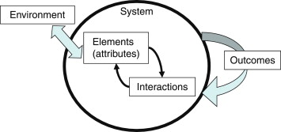
(Source: Markovsky and Dörfler, 2021)

Appendix 2: Bureaucratic Theory
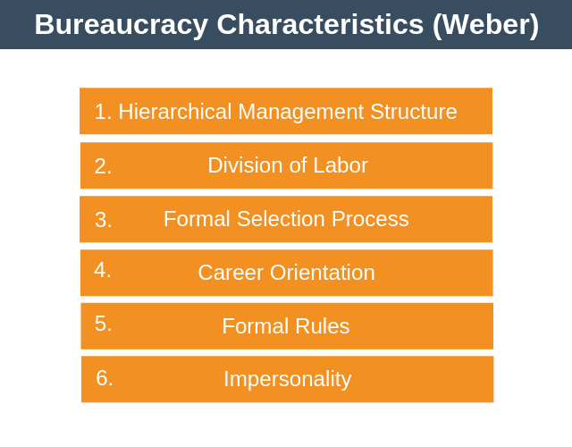
(Source: Yilmaz and Telsac, 2021).

