

[Place Image Here]

Image [1]

Assignment 1
Name: Zaeem
Student No.: 1902036
Course: Applied Computing (Web Development)
Module: Changemakers: Creativity and Value Creation
Date: 07/10/2020

Table Of Contents
Content Page Number
Introduction 3
e-Portfolio 4
Task 1 – Mind Map 5
Task 2 – Image-based Video Presentation 6
Task 3 – Video Presentation 7
Task 4 – Academic Poster 9
References 10

Introduction
For this assignment, the user will need to complete four different tasks and place those four different on a web-based e-Portfolio in order to complete the assignment.
The first task is to complete a Mind Map to brainstorm the development of the user project.
The second task is to create an Image Based Video Presentation about the development of the user project.
The third task is to create a Video Presentation towards the progress of the user project. The video can also be used to promote the user project.
The fourth task is to produce an Academic Poster to show the user progression towards the project. The poster can also be used to promote the user project.
Even more, the user will also have to participate and engage feedback in the module forum, blogs and padlet.

e-Portfolio
The e-Portfolio will contain a total of six webpages and they are called Home, Mindmap, Image Based, Video Presentation, Poster and References.

To view the e-Portfolio, please visit this link:
https://1902036.wixsite.com/z1ep

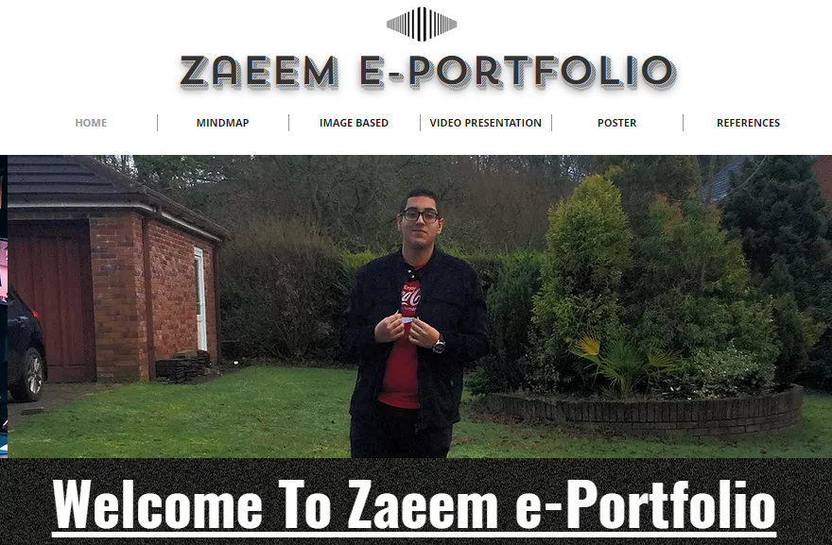
Image of e-Portfolio

Task 1 – Mind Map
The first task is to complete a Mind Map to brainstorm the development of the user project.
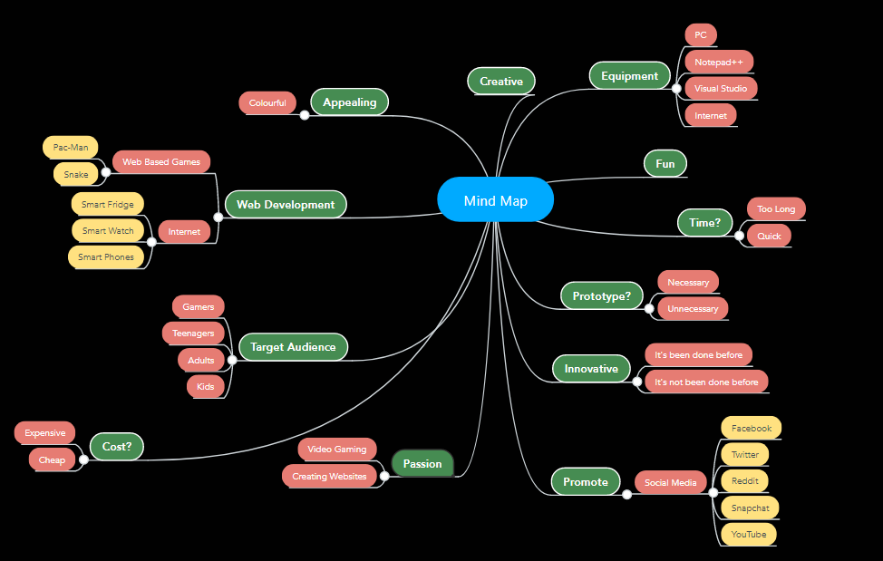

Link = https://1902036.wixsite.com/z1ep/mindmap
Mind Map Link = https://mm.tt/1640490375?t=JCzqew1bg8

Image of Task 1 on e-Portfolio
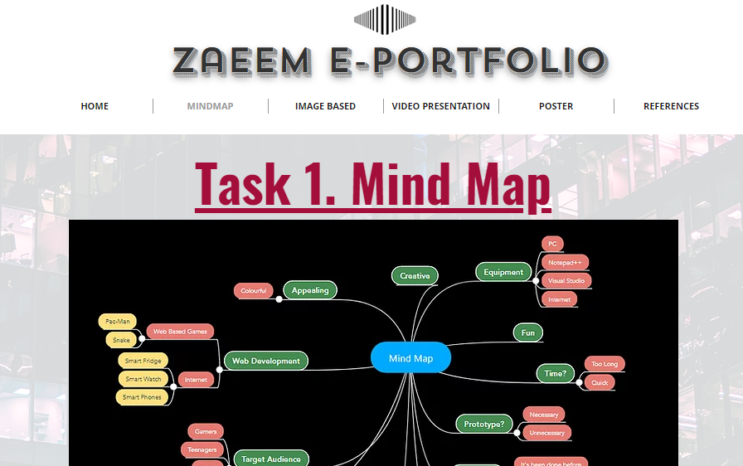
Task 2 – Image-based Video Presentation
The second task is to create an Image Based Video Presentation about the development of the user project.
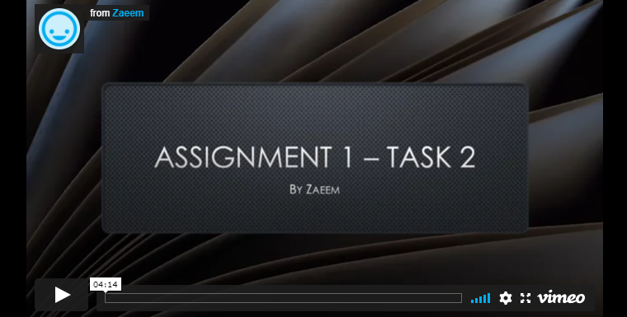

Link = https://1902036.wixsite.com/z1ep/image-based-1
Video Link = https://vimeo.com/479524231

Image of Task 2 on e-Portfolio
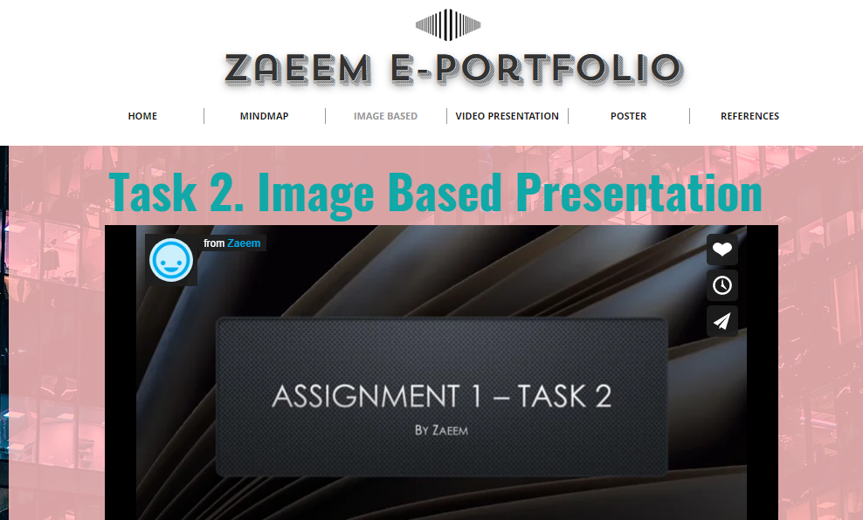

Task 3 – Video Presentation
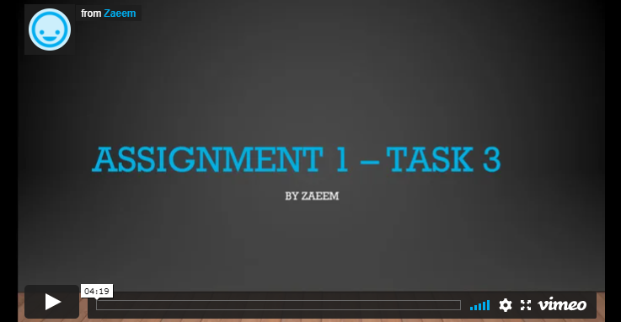
The third task is to create a Video Presentation towards the progress of the user project. The video can also be used to promote the user project.

Link = https://1902036.wixsite.com/z1ep/video-presentation-1
Video Link = https://vimeo.com/482406534
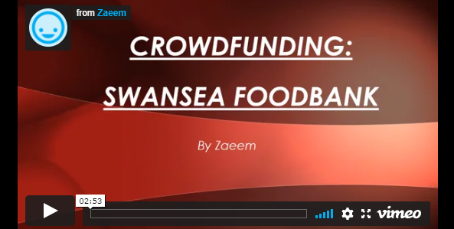

Crowdfunding Video Link = https://vimeo.com/478737696

Image of Task 3 on e-Portfolio
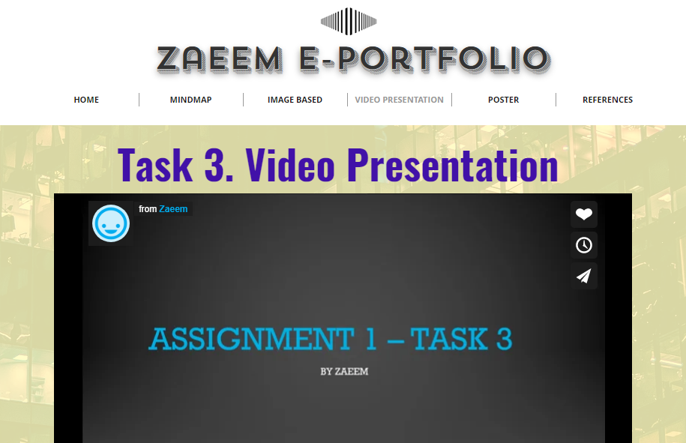

Task 4 – Academic Poster
The fourth task is to produce an Academic Poster to show the user progression towards the project. The poster can also be used to promote the user project.
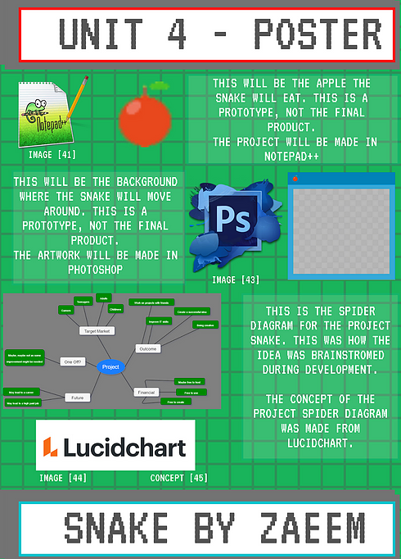

Link = https://1902036.wixsite.com/z1ep/poster-1
Poster Link = https://www.canva.com/design/DAEOhEBcQpo/QJcOmaORlmssBitepweavQ/view?utm_content=DAEOhEBcQpo&utm_campaign=designshare&utm_medium=link&utm_source=homepage_design_menu

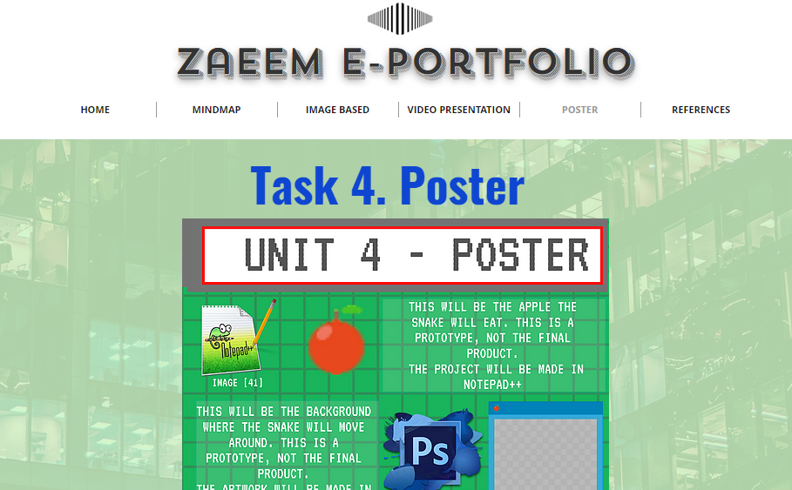
Image of Task 4 on e-Portfolio

References

References

[1] | D. SULLIVAN, "Why Entrepreneurs Are The Greatest Change-Makers In The World," N/A N/A N/A. [Online]. Available: https://resources.strategiccoach.com/the-multiplier-mindset-blog/why-entrepreneurs-are-the-greatest-change-makers-in-the-world-3. [Accessed 7 October 2020].
[2] | D. K. Hudson, "WHAT IS THE BEST DEFINITION OF INNOVATION?," 13 March 2014. [Online]. Available: https://drkenhudson.com/best-way-define-innovation/#:~:text=%E2%80%9CInnovation%20is%20the%20creation%2C%20development,%2C%20effectiveness%20or%20competitive%20advantage.%E2%80%9D&text=%E2%80%9CInnovation%20is%20the%20successful%20implementation,creative%. [Accessed 7 October 2020].
[3] | L. Onibalusi, "How Innovation Is Impacting Society," 13 September 2019. [Online]. Available: https://datafloq.com/read/how-innovation-is-impacting-society/6898#:~:text=In%20terms%20of%20businesses%2C%20innovation,problems%2C%20especially%20in%20developing%20countries.. [Accessed 7 October 2020].
[4] | R. Ough, "THE IMPORTANCE OF CREATIVE WEB DESIGN," 20 August 2018. [Online]. Available: https://www.elementarydigital.co.uk/the-importance-of-creative-web-design/. [Accessed 7 October 2020].
[5] | N. Butt, "Planning Snake," 13 October 2017. [Online]. Available: https://n86-64.github.io/low%20level%20programming/c++/games%20programming/software%20design/developer%20dairy/snake/Planning-Snake. [Accessed 7 October 2020].
[6] | T. Jones, "THE HISTORY OF PAC-MAN," 16 August 2013. [Online]. Available: http://www.todayifoundout.com/index.php/2013/08/the-history-of-pac-man/. [Accessed 7 October 2020].
[7] | N/A, "Chrome Logo," 28 August 2020. [Online]. Available: https://logos-world.net/chrome-logo/. [Accessed 7 October 2020].
[8] | N/A, "Introducing the new Microsoft Edge," N/A N/A N/A. [Online]. Available: https://www.microsoft.com/en-us/edge. [Accessed 7 October 2020].
[9] | A. Inc., "File:Safari browser logo.svg," 3 April 2018. [Online]. Available: https://commons.wikimedia.org/wiki/File:Safari_browser_logo.svg. [Accessed 7 October 2020].
[10] | N/A, "SEC Says That It’s Not Easy Determining Whether Teva Whistleblowers Are Deserving Of A Bounty," 15 July 2019. [Online]. Available: https://fcpaprofessor.com/sec-says-not-easy-determining-whether-teva-whistleblowers-deserving-bounty/. [Accessed 2 November 2020].
[11] | N/A, "Steve Jobs, HD Png Download - 1240x1580(#3468486) - PngFind," N/A N/A N/A. [Online]. Available: https://www.pngfind.com/mpng/iomioxT_steve-jobs-hd-png-download/. [Accessed 2 November 2020].
[12] | B. Lovejoy, "PSA: Apple’s renewal of its trademark for the rainbow Apple logo doesn’t mean anything," 20 February 2018. [Online]. Available: https://9to5mac.com/2018/02/20/apple-rainbow-apple-logo/. [Accessed 2 November 2020].
[13] | J. Clover, "36 Years Ago Today, Steve Jobs Unveiled the First Macintosh," 24 January 2020. [Online]. Available: https://www.macrumors.com/2020/01/24/macintosh-36th-anniversary/. [Accessed 2 November 2020].
[14] | N/A, "Welcome to iPod Repair Clinic - iPod, iPhone and iPad repair specialist!," N/A N/A N/A. [Online]. Available: http://www.ipodrepairclinic.com/. [Accessed 2 November 2020].
[15] | N/A, "Davis Business Consultants," N/A N/A N/A. [Online]. Available: https://www.davisbusinessconsultants.com/10-must-haves-for-a-successful-entrepreneur/. [Accessed 4 November 2020].
[16] | A. HAYES, "Entrepreneur," 1 July 2020. [Online]. Available: https://www.investopedia.com/terms/e/entrepreneur.asp. [Accessed 4 November 2020].
[17] | N/A, "Apple Logo Png Transparent Svg Vector Freebie Supply - Apple Logo White Svg, Png Download - 2400x2944(#317703) - PngFind," N/A N/A N/A. [Online]. Available: https://www.pngfind.com/mpng/hRxJRJ_apple-logo-png-transparent-svg-vector-freebie-supply/. [Accessed 4 November 2020].
[18] | Robin.Christopherson, "VoiceOver on the iPhone turns 10 - and turns blind access up to 11," 20 June 2019. [Online]. Available: https://abilitynet.org.uk/news-blogs/voiceover-iphone-turns-10-and-turns-blind-access-11. [Accessed 4 November 2020].
[19] | T. REDIGOLO, "Walking: Can I go for a walk in the countryside," 28 March 2020. [Online]. Available: https://www.express.co.uk/life-style/life/1259128/Uk-lockdown-can-i-go-for-walk-in-countryside-coronavirus-uk-covid-19. [Accessed 5 November 2020].
[20] | Company, "Apple reports Q4 results with record quarter revenue but shares tumble," 30 October 2020. [Online]. Available: https://news.cgtn.com/news/2020-10-30/Apple-reports-Q4-results-with-record-quarter-revenue-but-shares-tumble-V08auDEXyE/index.html. [Accessed 5 November 2020].
[21] | F. ADMINS, "Inspections: Analysing and presenting the evidence," 22 March 2016. [Online]. Available: https://attendancemattersmagonline.co.uk/inspections-analysing-and-presenting-the-evidence/#prettyPhoto. [Accessed 5 November 2020].
[22] | P. ECONOMY, "7 Powerful Secrets of Thinking Like an Entrepreneur," 2014 December 2014. [Online]. Available: https://www.inc.com/peter-economy/7-powerful-secrets-of-thinking-like-an-entrepreneur.html. [Accessed 5 November 2020].
[23] | Anonymous_Society, "Dont Rush!," 16 March 2012. [Online]. Available: https://www.planetminecraft.com/blog/dont-rush/. [Accessed 5 November 2020].
[24] | Christina Newberry, Evan LePage, "How to Create a Social Media Strategy in 8 Easy Steps (Free Template)," 27 May 2020. [Online]. Available: https://blog.hootsuite.com/how-to-create-a-social-media-marketing-plan/. [Accessed 9 November 2020].
[25] | R. Kehoe, "A secret of science: Mistakes boost understanding," 10 September 2020. [Online]. Available: https://www.sciencenewsforstudents.org/article/secret-science-mistakes-boost-understanding. [Accessed 9 November 2020].
[26] | A. Atkinson, "5 ways to improve your recruitment strategy in 2019," 8 February 2019. [Online]. Available: https://www.atkinsonmoss.co.uk/5-ways-to-improve-your-recruitment-strategy-in-2019/. [Accessed 9 November 2020].
[27] | S. Satpute, "Analyse to turn social data into action," 30 October 2017. [Online]. Available: https://www.wecaredigital.in/analyse-to-turn-social-data-into-action/. [Accessed 30 November 2020].
[28] | N/A, "All Strength Comes From Repetition," N/A N/A N/A. [Online]. Available: https://dariusforoux.com/repetition/. [Accessed 9 November 2020].
[29] | D. Thorwaldson, "Q3 Project — Idea Sharing and Group Formation," 30 November 2017. [Online]. Available: https://medium.com/the-road-to-code/q3-project-idea-sharing-and-group-formation-bf63759a8817. [Accessed 9 November 2020].
[30] | A. Phan, "The State of the Web Browser in 2020," 5 October 2020. [Online]. Available: https://www.currentware.com/the-state-of-the-web-browser-in-2020/. [Accessed 9 November 2020].
[31] | G. Bronte, "Boston Tea Party becomes first coffee chain to ban use of disposable cups," 25 April 2018. [Online]. Available: https://www.bighospitality.co.uk/Article/2018/04/25/Boston-Tea-Party-becomes-first-coffee-chain-to-ban-use-of-disposable-cups#. [Accessed 13 November 2020].
[32] | M. Stockley, "Matrix under the microscope: what a niche ransomware can teach us," 30 January 2019. [Online]. Available: https://nakedsecurity.sophos.com/2019/01/30/matrix-under-the-microscope-what-a-niche-ransomware-can-teach-us/. [Accessed 17 November 2020].
[33] | S. Morris, "TECH 101: WHAT IS THE DIFFERENCE BETWEEN A WEB DESIGNER AND WEB DEVELOPER?," N/A N/A N/A. [Online]. Available: https://skillcrush.com/blog/difference-between-web-designer-and-web-developer/. [Accessed 17 November 2020].
[34] | M. Roussel, "Webinar on solar digital strategies," 24 June 2020. [Online]. Available: http://solarheateurope.eu/2020/06/24/webinar-on-solar-digital-strategies/. [Accessed 17 November 2020].
[35] | N. Shaxon, "Corporate bailout demands – scamming the taxpayer," 30 March 2020. [Online]. Available: https://truepublica.org.uk/united-kingdom/corporate-bailout-demands-scamming-the-taxpayer/. [Accessed 17 November 2020].
[36] | Jason Drysdale, Ed.D, "The Real You: Design as an Act of Authenticity," 12 November 2019. [Online]. Available: https://onlinelearningconsortium.org/the-real-you-design-as-an-act-of-authenticity/. [Accessed 18 November 2020].
[37] | N/A, "Download Snapchat Logo transparent PNG," N/A N/A N/A. [Online]. Available: https://www.stickpng.com/img/icons-logos-emojis/tech-companies/snapchat-logo. [Accessed 18 November 2020].
[38] | N/A, "WhatsApp Logo," 16 November 2020. [Online]. Available: https://logos-world.net/whatsapp-logo/. [Accessed 18 November 2020].
[39] | Stefan, "yt-logo," 17 August 2016. [Online]. Available: https://stefan-van-essen.nl/2016/08/things-to-watch-when-no-ones-watching/yt-logo/. [Accessed 18 November 2020].
[40] | JosephMcMullan, "Discord Logo," 25 January 2019. [Online]. Available: https://imgur.com/t/discord/btgYslb. [Accessed 18 November 2020].
[41] | J. S. Cook, "How to Use Notepad++ Advanced Text Editor for Windows," 29 June 2020. [Online]. Available: https://www.arrow.com/en/research-and-events/articles/how-to-use-notepad-advanced-text-editor-for-windows. [Accessed 29 November 2020].
[42] | A. Poovanna, "Tic-Tac-Toe Learner AI," 3 August 2019. [Online]. Available: https://towardsdatascience.com/tic-tac-toe-learner-ai-208813b5261. [Accessed 22 November 2020].
[43] | N/A, "Photoshop Logo PNG Transparent Images #2388737," N/A N/A N/A. [Online]. Available: http://clipart-library.com/clipart/Photoshop-Logo-PNG-HD.htm. [Accessed 25 November 2020].
[44] | J. Duffy, "Lucidchart," 21 February 2020. [Online]. Available: https://uk.pcmag.com/productivity-2/86093/lucidchart. [Accessed 25 November 2020].
[45] | L. McNeely, "Weaving Ideas with Spider Diagrams," N/A N/A N/A. [Online]. Available: https://www.lucidchart.com/blog/weaving-ideas-with-spider-diagrams. [Accessed 25 November 2020].

[1] = Changemakers Pic
[2] = The Definition of Innovation
[3] = Innovation impacting and affecting society
[4] = Why creativity is important in web development?
[5] = Snake Pic
[6] = Pac-Man Pic
[7] = Chrome Logo
[8] = Microsoft Edge Logo
[9] = Safari Logo
[10] = Not So Easy Pic
[11] = Steve Jobs Pic
[12] = Apple Logo
[13] = Macintosh Pic
[14] = Apple Devices Pic
[15] = Entrepreneur Pic
[16] = Entrepreneur Definition
[17] = Apple Logo 2
[18] = iPhones Pic
[19] = Walk Pic
[20] = People Looking Pic
[21] = Analysing Pic
[22] = Ideas Pic
[23] = Slow Down Pic
[24] = Create Pic
[25] = Mistakes Pic
[26] = Improve Pic
[27] = Analyse Pic
[28] = Repeat Pic
[29] = Idea Pic
[30] = Web Browsers Pic
[31] = Disposable Cups Pic
[32] = Matrix Pic
[33] = Web Code Pic
[34] = Media Pic
[35] = Tax Payer Pic
[36] = Authenticity Pic
[37] = Snapchat Logo
[38] = WhatsApp Logo
[39] = YouTube Logo
[40] = Discord Logo
[41] = Notepad++ Logo
[42] =Tic Tac Toe Pic
[43] = Photoshop Logo
[44] = Lucidchart Logo
[45] = Project Spider Diagram Concept

