Assessment 1: Online portfolio of set exercises (e-portfolio)

Student Name: Harriet Erhere Akpojotor
Student Number: 2020979
Lecturer Name: Diola Bijhout
Module Code: BMHP5014
Module Title: Changemaker Creativity and Value Creation

Introduction
The purpose of this document is to present a portfolio of set exercises. This e-portfolio contains a blog and an elevator style pitch. The two artefact tasks are based on an advocacy for an existing project called CoFarm Cambridge. The program aims to address the supply gap that exists in the UK with regards to accessible and affordable food items. Examination of the food industry in the UK shows that most citizens are constantly exposed to ultra-processed diets, which raises their risk of becoming overweight and obese. The issue is exacerbated by the fact that the country is capable of producing sufficient organic food products for its population and there are enough rural farmers, landowners and entrepreneurs to meet demand. However, structural barriers have resulted in the country’s heavy reliance on global supply chains. Moreover, the concentration of the local food retail sector by major corporations means that fragmented rural farmers are unable to effectively compete. Therefore, the blog entry will provide a more comprehensive illustration of the food system in the UK and will highlight the challenges that CoFarm Cambridge attempts to address. Thereafter, the elevator style pitch will illustrate a presentation for an audience that convinces them to rally their support for CoFarm Cambridge.

ARTEFACT TASK 2: Blog Addressing Obesity through food improvement: The support for CoFarm Cambridge

In my assessment of the food system in the UK, I established that it is composed of a unique mix of local, national and global supply chains. According to Hasnain, Ingram and Zurek (2020), 53% of the food consumed in the UK is produced by local farmers. Therefore, the country is mostly self-sufficient in the production of grains as it manages to supply 90% of wheat and 100% of oats and barley demanded locally. In addition, the UK produces 80% of its total eggs, meat and milk and more than 50% of all vegetables locally consumed (Hasnain, Ingram and Zurek, 2020). Despite the fact that local farmers play a significant role in the food industry of the country, there still lies a heavy reliance on imports according to the Department for Environment, Food and Rural Affairs (2021) from major EU countries like Germany, Netherlands, France and the Republic of Ireland. This means that the country still imports food that can be grown locally, which creates net deficits in almost all the food categories (Scheelbeek et al., 2020). Moreover, researchers like Mozaffarian, Angell, Lang and Rivera (2018) found that approximately 45% of British citizens perceived imported foods more affordable than locally produced options. The existence of large retailers like Tesco also increases the accessibility of imported foods regardless of ecological seasons at affordable prices. 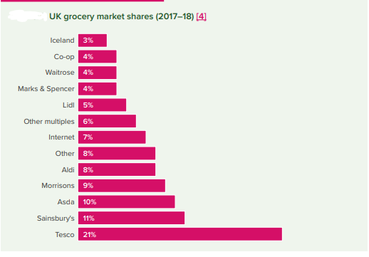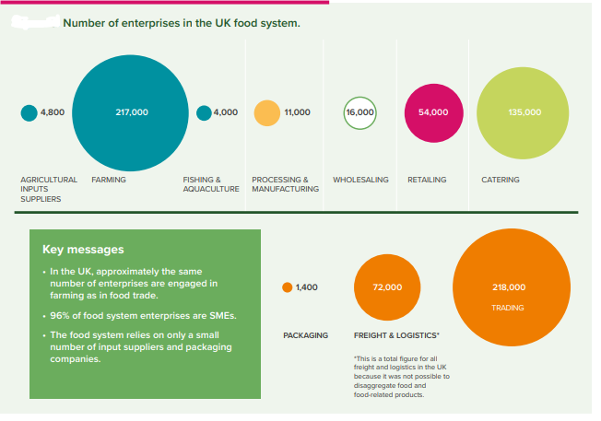
The problem lies in the fact that the UK possesses a high consumption rate of ultra-processed foods. Hasnain, Ingram and Zurek (2020) demonstrated that the UK ranks third in largest sales volumes of ultra-processed foods per capita and that UK citizens rely on the most processed diet across all of Europe. This has resulted in 63% of the UK population becoming overweight and obese, which creates a huge burden to the community and the state according to Public Health England (2016). The social and healthcare costs of dealing with this epidemic in the UK costs the government approximately £47 billion each year (Public Health England, 2016). The issue is exacerbated by the fact that more people are eating out-of-home meals that are readily available and cheap but possess high degrees of saturated fats, sugar and salt. This means that there is a huge gap in the UK’s food industry for healthier, affordable and accessible food items.
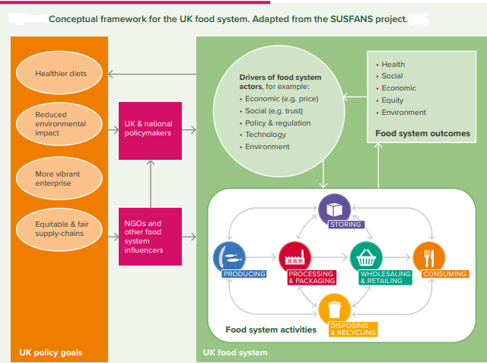
It is as a result of this observation that I champion my support for the Co-Farm foundation, which is a registered charity in England and Wales that was launched in 2019 (ERASMUS+, 2021). The charity operates two wholly owned trading subsidiaries: CoFarm Cambridge and CoFarm Estate Limited. The former was launched in 2019 and aims to provide rural entrepreneurs, rural landowners and farmers with appropriate skills and knowledge to implement cooperative initiatives among themselves (ERASMUS+, 2021). The purpose of the project is to provide these individuals with an opportunity to address some of the challenges they face in the sector and therefore enhance the future of family-owned farms in the UK. The charity acknowledges that in order to realize these aims, proper training must be provided to rural farmers and entrepreneurs on the principles of cooperation between different ventures. Therefore, the project intends to develop and implement a dynamic training program that should teach reliable knowledge and skills to rural farmers and entrepreneurs. 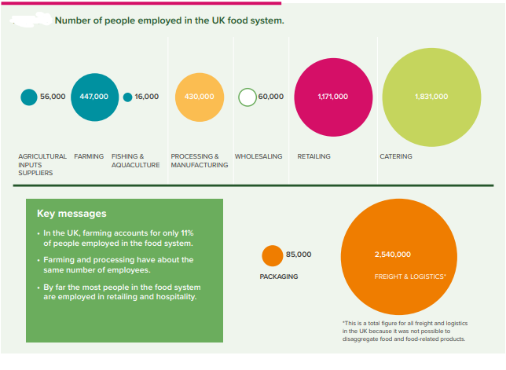

ARTEFACT TASK 3: Elevated Pitch

Introduction
Salutations to everyone. My name is […….] and work as the [………] for [……..]. It is an honour to engage with all of you and to present my support pitch for CoFarm Cambridge based in the UK.

Problem
In my capacity as the [………..] for [……….], I realized that the UK suffers from the high consumption rate of ultra-processed foods. Scholars like Hasnain, Ingram and Zurek (2020) conducted studies and found that the UK ranks third in larges sales volumes of ultra-processed foods per capita and that UK citizens rely the most on processed food items when compared to other countries across Europe. This has exacerbated existing health commodities and Public Health England (2016) published that approximately 63% of the population in the UK is overweight and obese. This phenomenon creates an enabling environment for the development of other life-threatening conditions like diabetes and cardio-vascular disease.
Existing efforts by the government to mitigate the rise in obesity mean that the state incurs approximately £47 billion annually to meet the rising healthcare and social costs (Public Health England, 2016). The prevalence of unhealthy dietary habits is exacerbated by the existence of large food vendors like Tesco that provide readily available and cheap out-of-home meals that are composed high levels of saturated fats, salt and sugar. Moreover, it is clear that the UK’s local farmers are more than capable of meeting the dietary needs of the population, albeit the country’s heavy reliance on global supply chains undermines their ability to provide accessible and affordable healthy food items.

Solution
CoFarm Cambridge is a non-profit program that aims to empower local farmers by providing them with training in order to impart appropriate skills and knowledge to them that would enable them to create cooperative initiatives among themselves (Rowbury 2022). This means that the rural farmers, entrepreneurs and landowners would be able to fetch a competitive price for their products and services and the consumers would acquire healthier and more affordable food alternatives.

Value Proposition
CoFarm Cambridge acknowledged the rising need for rural farmers to cooperate and collaborate more closely amongst themselves as a result of the evolving structural changes within the rural economy (Rowbury, 2022). Such activities should consequently diminish the costs of labour, training and capital. As the leading organization in this field, CoFarm Cambridge aims to enhance the access to sustainably-gown local food in the country via the development of a network of agroecological community farms spread out across various regions of the UK. It intends to achieve its quantified goal of realizing a distributed estate of about 250,000 acres of community farming land by 2030 (Rowbury, 2022).

Audience Engagement
I have a strong conviction that the solutions proposed by CoFarm Cambridge could prove sustainable and reliable. Active efforts to empower local farmers should present positive possibilities for economic gain and supplement the government’s efforts towards a healthier nation. I will be available for further clarification regarding the organization and the issue of poor diet at large.

Conclusion
This document presented a blog entry and an elevated pitch to rally for the support of CoFarm Cambridge. The non-profit organization that is based in the UK intends to develop and implement training programs for rural farmers, entrepreneurs and landowners that should provide them with the necessary skills and knowledge to form cooperative alliances. Such alliances should help them develop unique competitive advantages that should result in significant cost reductions for labour, training and capital. Thereafter, the collaborating groups should be at a better position to penetrate the concentrated market and compete with large retailers like Tesco. The activities conducted by CoFarm Cambridge should go a long way in solving the healthy food problem in the UK, which is currently exacerbated by robust structural rigidities that have seen the country rely extensively on global supply chains. This reliance has resulted in limited food options for UK citizens and has led to their inadvertent reliance on ultra-processed foods. This has resulted in adverse health outcomes as more than half of the UK population is considered overweight and obese. Therefore, CoFarm Cambridge’s solution should positively contribute to the government’s efforts to reduce the cost of burden of disease, which is estimated at £47 billion annually.

References
Department for Environment, Food and Rural Affairs, 2021. Department for Environment, Food & Rural Affairs. [online] GOV.UK. Available at: <https://www.gov.uk/government/organisations/department-for-environment-food-rural-affairs> [Accessed 08 April 2022].
ERASMUS+, 2021. CO-FARM. [ebook] European Commission, pp.1-35. Available at: <https://www.foodsecurity.ac.uk/activities/future-food-system-scenarios/> [Accessed 08 April 2022].
Hasnain, S., Ingram, J. and Zurek, M., 2020. Mapping the UK Food System – a report for the UKRI Transforming UK Food Systems Programme. [online] Oxford: University of Oxford, pp.4-68. Available at: <https://www.eci.ox.ac.uk/research/food/downloads/Mapping-the-UK-food-system-digital.pdf> [Accessed 8 April 2022].
Mozaffarian, D., Angell, S., Lang, T. and Rivera, J., 2018. Role of government policy in nutrition—barriers to and opportunities for healthier eating. BMJ, p.k2426.
Public Health England, 2016. Health matters: obesity and the food environment. [online] GOV.UK. Available at: <https://www.gov.uk/government/publications/health-matters-obesity-and-the-food-environment/health-matters-obesity-and-the-food-environment--2> [Accessed 08 April 2022].
Rowbury, J., 2022. News. [online] COFARM. Available at: <https://www.cofarm.co/news> [Accessed 08 April 2022].
Scheelbeek, P., Moss, C., Kastner, T., Alae-Carew, C., Jarmul, S., Green, R., Taylor, A., Haines, A. and Dangour, A., 2020. United Kingdom’s fruit and vegetable supply is increasingly dependent on imports from climate-vulnerable producing countries. Nature Food, 1(11), pp.705-712.

