Is there a need for the UK Construction Industry to move away from lowest cost procurement at the expense of quality?

Created For:
Steve Tindall

Created By:
Tomos Williams

Contents
1.0 Introduction 2
2.0 Procurement 2
3.0 Tendering Process 3
4.0 Senedd (Welsh Parliament Building) 4
4.1 Review of the project 4
5.0 Holyrood (Scottish Parliament Building) 5
5.1 Review of the project 5
6.0 Conclusion 6
References 7

Introduction

This report will give an outline of procurement and tendering, highlighting the different actions that can be selected during these processes. It will look at how these different actions compare and their effectiveness of completion of a project. It will also look at the procurement method and tendering process of the Welsh parliament building (Senedd) and the Scottish parliament building (Holyrood) to see if the methods used were good or whether a different method would have been more appropriate.

2.0 Procurement

The process of creating, managing, and carrying out contracts is known as procurement.
Therefore, the delivery and maintenance of building works are broken down into three stages of the procurement process, notably:

- The stage of planning when choices are made on the types, quantities, locations, and timing of the contracts that will be needed, as well as the products and services that will be needed.
- An acquisition stage in which contracts are signed after a selection process has been completed
- A stage defined as contract management (or contract administration), when project risks that arise throughout the execution of the contracts are handled along with requirements compliance and requirement revisions.

Once a requirement for purchase is determined, procurement operations begin and terminate with the transaction. The procurement process consists of six main actions, including:

- Decide what needs to be purchased.
- Choose the packaging, contracting, targeting, and selection methods for procurement strategies.
- Seek bids for the tender.
- Assess tender proposals.
- Grant the contract.
- Manage contracts and ensure that requirements are fulfilled.

It involves methods, processes, and operational policies to carry out these main functions. The numerous procurement subprocesses each have a limited range of different methods and procedures that may be standardised based on a combination of system goals (Standards, 2020).

3.0 Tendering Process

A prospective supplier's answer to a request for proposals is known as a tender. It presents a proposal for the provision of products or services. The primary tendering procedure in construction is often used to choose the contractors who will build the project. The works are built including a number of different contractors, each of whom is contracted to the client, and contractors could undertake additional functions like design and management as procurement roles have grown more complex. Tenders could well be required for a wide variety of products and services, an example of this would be a construction management contract. Integrated supply teams for public projects may comprise of the primary contractor, designers, subcontractors, suppliers, facilities managers, among others. There is also a growing trend for suppliers to be combined under one contract.

Regardless of the type of products or services being sought, the procedure for obtaining bids may take one of many distinct fundamental forms:

- Open Tendering - Anyone may offer to provide the needed goods or services through open tendering. Typically, a notice will be posted stating that the contract is out for tender, and this will enable any organisation the chance to make a bid.
- Selective Tendering - Suppliers may only submit offers in response to invitations under selective tendering. A pre-selected group of potential suppliers is created that is known to be appropriate towards a contract of the requisite size, complexity, and type based on their prior performance. Lists of potential suppliers that have been "approved" by consultants or seasoned clients may be kept, and suppliers' performance may then be periodically reviewed to see if they should be kept on the list.
- Negotiated Tendering - It may be suitable to negotiate with only a single supplier for highly specialised contracts or to expand the parameters within an existing contract. It can save tendering costs and enable early contractor engagement, but the competitive aspect is diminished, and unless the negotiation structure is clearly outlined, there is a risk of an adversarial environment arising prior to the contract being granted.
- Serial Tendering - Entails the creation of bids dependent on a typical or hypothetical schedule of work or bill of goods. The rates offered can then be applied to evaluate the work throughout a number of related projects, frequently for a set amount of time, after which the tendering process may be repeated.
- Framework Tendering - By employing framework agreements, clients that often commission work may be able to decrease timeframes, learning curves, and other hazards. Such agreements enable the customer to request proposals from vendors for the provision of products and services on a call-off approach over an extended period of time as needed. Requests for schedules of rates as well as time charges, in addition to a summary of the resources and overheads that will be used, are likely to be included in framework tender papers.
- Single Stage Tendering - When all the data required to determine a reasonable price is provided at the start of the bidding process, single stage tendering is employed. The tender invitation is sent to potential suppliers, followed by the preparation and return of tenders, the selection of a preferred tenderer, and, perhaps, their appointment after negotiations.
- Two Stage Tendering - Is employed to enable early supplier appointment before all the information needed to enable them to quote a fixed price has been completed. A temporary appointment is agreed upon in the first step to enable the start of work, and the contract's fixed fee is negotiated in the second stage (Anon, 2021).

4.0 Senedd (Welsh Parliament Building)
The structure features a glass facade that wraps completely around it, a steel roof, and a wood ceiling that dominate it. It looks southwest over Cardiff Bay. The first and second floors are open to the public, but the ground floor is a private space for officials. The structure was created to be as transparent and open as possible. The structure was not supposed to be a secluded, closed structure. Instead, it would comprise a transparent enclosure that could be seen from Cardiff Bay and beyond, allowing the people to see the Assembly's inner workings and promoting democratic engagement. The Siambr, a debate chamber with a public viewing gallery, is the focal point of the structure. The main welcome hall, the Neuadd, is located on the first level, while the Oriel is located on the second story. On the ground level, there are three committee rooms and the Cwrt (Anon, 2021).

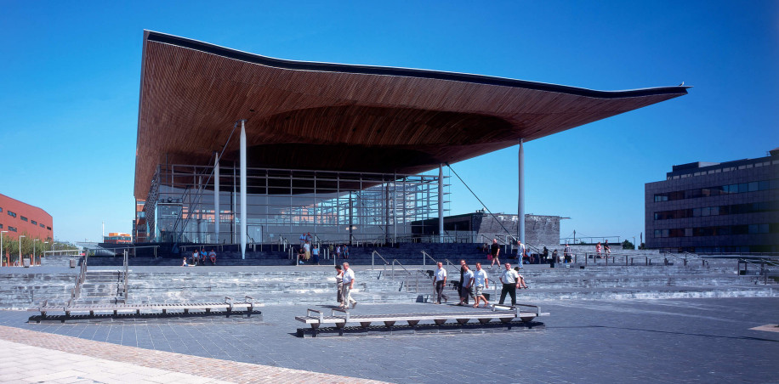
(anon, 2021)

4.1 Review of the project

The Senedd is a landmark construction with good environmental credentials. Although the Senedd was far more expensive than expected, the Welsh Assembly Government and collaborators made every effort to keep costs to a minimum. Despite the challenges, the overall procurement process was well-managed, although ICT had concerns with the delayed acquisition of Merlin. The formation of a dependable and effective team that cooperated with a clear and unified goal was critical to the project's success. The Senedd's initial cost estimate was £12 million in 1997. By the time the project was cancelled in 2001, the estimated costs had risen to more than £40 million. When a fixed price design and construction contract was signed in 2003, the estimated total cost had risen to £66 million, and the building was eventually built for close to £70 million. This significant cost increase was caused by a number of factors, including a lack of reliability in earlier estimates, a portion of which were based on an inexact building design, and unanticipated changes in specification, particularly in relation to the requirement for increased security in the aftermath of the 2001 attacks in New York City. Costs for various parts increased between the time estimates and the finished design and build contract price, which also included a contingency to accommodate for probable cost overruns encountered by the private sector contractor. Despite the cost increases encountered by the project, the audit committee is convinced that adequate cost control mechanisms were in place when the project was restarted. Testing against the open market, open book accounting, value engineering, utilisation of the contractor's established supply chain, whole life costing, and cost validation by the project's independent quantity surveyor and project manager were all part of this. They point out that, unlike many previous large scale public sector building projects, the project was completed on time and on budget, despite the obstacles posed by its iconic, one of a kind characteristic (Anon., 2008).

5.0 Holyrood (Scottish Parliament Building)

Scotland's Parliament is situated in front of the magnificent Salisbury Crags and Holyrood Park at the base of Edinburgh's Royal Mile. The complicated edifice, which was built from a combination of steel, wood, and granite, was acclaimed upon opening to be among the most avant-garde designs in Britain at the time. Enric Miralles, a renowned world top architect, created a structure that is meant to resemble a building that is sprouting out of the ground by taking inspiration from the local landscape, Charles Rennie Mackintosh's flower paintings, and the upside-down boats near the sea (Anon, 2021).

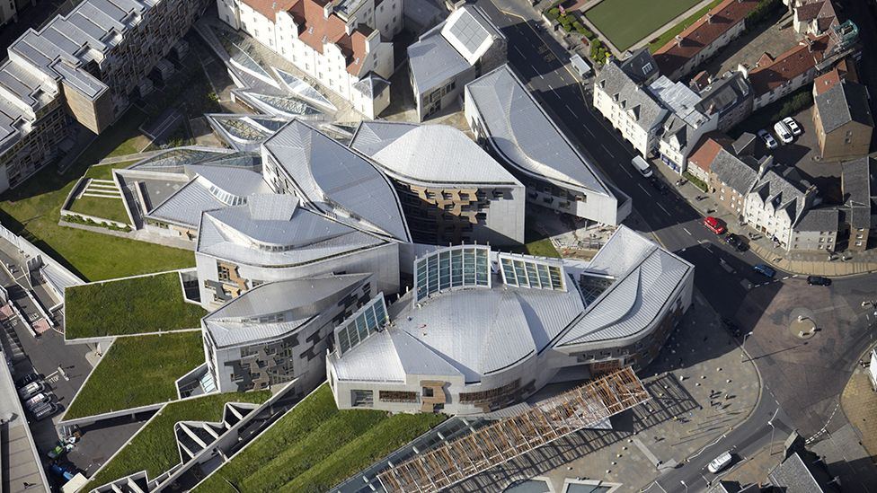
(anon, 2021)

5.1 Review of the project

Following a study of numerous sites, Holyrood was chosen as the location for the Parliament in 1997. With the selection of the design team later in 1998, design issues and the risk of increased expenditures emerged. As of March 1999, the client had not been able to freeze the project's design or construct an adequate cost control strategy. In June 1999, the Corporate Body became the client, and it directed that several alterations be made to the chamber's design. In August 1999, serious problems with the project were discovered. A new demand for extra space in the fall of 1999 increased uncertainty and raised the prospect of further costs and delays.
By February 2000, a technique to add extra space had been discovered, but issues about the cost and programme remained. The investigation highlighted both delays and expense increases that occurred from the start of the project and the publishing of the report in September 2000. In April 2000, Parliament agreed that the overall cost will be increased from £90 million up to £195 million. Estimated cost of construction had climbed from £50 million up to £108 million, while other costs had risen from £40 million up to £87 million within the £195 million target. It was also anticipated that £14 million will be required for road building and landscaping. The biggest source of the increase in construction expenses was the 47% increase in building size. The remaining percentage of the increase was caused by a variety of factors, including the intricacies of the authorised design, developments in the structure's quality, the need for security, and the expense of Queensberry House. Consultant fees might exceed £26 million, and the research did offer recommendations on how to properly control spending at the time. In September 2000, according to the Auditor General, a significant percentage of the expenses remained to be expended nevertheless, if the building was to be completed on time and on budget, risks and uncertainties would need to be carefully controlled. The Auditor General criticised the project management cost reporting practises. Prior to June 1999, it was noted that reports simply showed the basic construction expenditures and made no systematic or frequent mention of the financing requirements for contingencies, fees, furnishings and fittings, and VAT. Another key error was that the construction expenditure presentation had not included a separate allowance for risk throughout the bulk of the project's life. The report argued that an examination into the use of incentive structures to stimulate extra value during the design and construction phase was required. Financial incentives for on time completion and fines for lateness were regularly utilised in large construction projects with severe deadlines. The study concluded that the project's handover of the Scottish Executive to the Corporate Body of the Scottish Parliament in June 1999 needed to be managed more efficiently. The Auditor General expressed dissatisfaction that no independent review had been undertaken because the design was currently being worked on at the time, and the cost consultants revealed substantially higher than expected construction costs. The persons in charge of managing and executing the project were also highlighted. Even though project management offered advantages, the study queried if they consistently held the optimal blend of skills for this difficult task. According to the report, the project's completion was delayed from July 2001 to December 2002 due to a number of factors, including the architects' inability to meet the original brief's extremely strict deadline and unexpected modifications requested by the Corporate Body to accommodate the new Parliament's evolving needs during its initial year of operation (Anon., 2004).

6.0 Conclusion

To conclude there was little information to be found on the initial phase of construction of the Senedd, so in respect of this we can conclude that amending to something similar to a fixed price Design and Build contract was a lot better in outcome than the Management Procurement contract they were previously using. This report also shows that the Management Procurement Method used for both the Senedd Parliament Building and Holyrood Parliament building, is tricky to get right but can work as long as the correct team is in place. The acquired team must possess the necessary skills to manage difficult projects such as these. These projects may have been better run and came in closer to the strict time deadlines, with better cost control and overall quality by using a Traditional Two Stage Tender Process. By using the Traditional Two Stage Tender process, this would have allowed early supplier appointment before all the information needed to enable them to quote a fixed price has been completed. A temporary appointment could have been agreed upon in the first step to enable the start of work, and then the contract's fixed fee would have been negotiated in the second stage.

References
Anon., 2000. An examination of the management of the Holyrood Project, Edinburgh: Auditor General.
Anon., 2004. Management of the Holyrood Buildin Project, Edinburgh: Audit Scotland.
Anon., 2008. The Senedd, Cardiff: Audit Comitee.
anon, 2021. [Online]
Available at: https://www.bbc.co.uk
Anon, 2021. [Online]
Available at: https://www.designingbuildings.co.uk/
Standards, B., 2020. [Online]
Available at: http://www.ihsmarkit.com

