
APPENDIX GA36c

LEVEL 6 ASSESSMENT SPECIFICATION

Student name: | Sian Werner | Student ID number: | 1904813
Programme: | Physical Education and Outdoor Adventure Education
Module: | Curriculum Adventure
Module code: | BMOE6002 | Contribution to Overall Module Assessment (%): | 50%
Lecturer: | Dr Nalda Wainwright | Internal Verifier:
Assignment Title: | Problem Based learning assignment | Word count (or equivalent): | 2500
Submission deadline: |  | Return date of provisional marks & written feedback:
Submission method: | All written assessments, where practical and possible, must be submitted via Turnitin unless otherwise instructed by the Lecturer. (Please DO NOT put this assessment specification into Turnitin or it will match many similarities with other students’ submissions.)  Alternative submission method (if applicable):  Late submission of the assessment will result in a late penalty mark. Penalties for late submission: Up to one week late, maximum mark of 40%. Over one week late, 0%. Only the Extenuating Circumstances Panel may approve a change to submission dates.
Academic honesty / referencing: | Academic honesty is required. In the main body of your submission you must give credit to authors on whose research and ideas your work is based. Append to your submission a reference list that indicates the books, articles, etc. that you have used, cited or quoted in order to complete this assessment.
Module Learning Outcomes
(from module syllabus)
- critically evaluate the importance of adventure to individual learning, personal development, society and work;

- critically analyse a range of different teaching and learning strategies appropriate to adventurous learning;

- negotiate a range of learning opportunities to underpin adventure in the whole curriculum;

- critically analyse the role of adventure and the outdoors in the development of children’s physical literacy

This assignment will critically look at the benefits that children will obtain by introducing different affordances and areas for outdoor adventure within school grounds and further community settings. Focusing on the individual learning outcomes with supporting the curriculum by using teaching and learning strategies, which will mature and underpin how outdoor adventure can improve children and adolescents’ physical literacy.

There is growing concern across the globe with people’s disengagement with nature and outdoor spaces, leading to a lack of opportunities for children of all ages to experience and engage in adventurous activities, within school setting and in leisure time (Louv, 2005, waite, 2011, waller, 2007, Fjortoft, 2004). If children continue to miss these opportunities, it could impact their development in physical, mental, personal, and social areas. Children who are not connected with nature, will not value or respect it in the future. Therefore, as they grow into adults will be less likely to connect and preserve it (Bragg et al, 2013, Wainwright and Williams, 2019). Research by Barton et al., (2016) says that regular physical exercise and nature independently enhances health, as it offers a broad range of challenging, with varied and intense affordances. Natural settings can be a positive distraction from daily pressures, by promoting positive affect in ways of conjuring pleasantness, calm, thereby, reducing stress (Niklasson & Sandberg, 2003). Pretty et al., (2005) coined the phrase “Green exercise” to proclaim the health benefits embedded through being active in green and natural settings.
This could be one of the reasons contributing to the rise of new health and wellbeing challenges and non-communicable illnesses. Also, due to the modern change in lifestyles, linked to social pressures of, parents working longer hours, rise in traffic, stranger danger leading to parents’ anxiety of allowing children’s outdoor play in leisure time (Palmer, 2015). Furthermore, natural environments are under constant pressure of developments and with population growth and demands for housing increasing (Barton et al., 2009), taking away green belt, which could be accessed by the public. Sedentary time is increasing and connected to this is the increase of health and well-being illnesses, with links to diabetes, cardiovascular disease, and hypertension (Lindsay et al, 2017, Kirk, 2009, whitehead, 2013, Wainwright & Williams). Similarly, the Covid -19 pandemic has highlighted, working, and playing in the outdoors lessens the spread of dieses and how during the time of isolation people valued their one daily exercise period, with an increase in physical activity with walking, jogging, cycling in the outdoors, many craved to be near and submerged in green and blue spaces such as woodlands, beaches, lakes, fields, which helped improve mood and overall mental health at a difficult and stressful time. Caputo and Reichert (2020), reported a 33 percent of participants in their study who were inactive became active during the pandemic, and 44 percent who were already active increased their activity levels.
The world health organisation definition of health and well-being is “health is a state of complete physical, mental and social well-being, and not merely the absence of disease and or infirmity”. (World Health Organisation, 2019). The new Welsh government has put health and wellbeing into the heart of the new curriculum, by allocating health and wellbeing a new area of learning and experience (Welsh Government, 2020). The four purposes surrounding the new curriculum, states that students will learn to understand and appreciate the delicately interconnected layers of emotions that will allow them to recognise, what good health and wellbeing is and its importance to enable successful learning. By developing confident, healthy individuals, that will be ready to lead fulfilling lives as valued members of society. Through expanding their skills and experiences in motivation, resilience, the ability to make decisions and be empathic towards others, empowering students to have the ability to become ambitious, capable learners, that shall be ethically informed citizens of Wales and the world. By incorporating how to show respect, listen to others, maintaining healthy relationships, alongside expanding enterprising, creative contributors for life and work (WG, 2018).
The what matter statements have been designed to help guide educators to build lessons and units of work to enable students to develop physical health and wellbeing, which has lifelong benefits, including health promoting welfare, factors that include effects of healthy behaviours, including physical activity alongside, diet, personal care, hygiene, sleep, and prevention for infection. Enveloping support in respect for themselves and others with a sense of self-worth and understanding health harming behaviours. Whilst developing competence in confidence, motivation, physical ability. Which will promote good health and wellbeing. How students respond to experiences will impact their mental health and wellbeing, through learning that emotions are not fixed and are changeable, with skill on how to be empathetic, knowing where to seek help and support. How social influences shape who we are by identifying our values, and self-identity. Which will underpin, positive attributes that contribute to healthy relationships (WG, 2018).
However, there are some concerns with the new curriculum, with possible need for more teacher training, with the emphasis on schools to build their own curriculum around the four purposes, what matter statements and cross curricular links. Depending on the structure and models that the whole school engage with, this could leave teachers focusing on reaching aims and targets rather than the learning which is taking place and needs to take place. Therefore, schools and managements teams will have to engage teachers to revaluate their teaching strategies and teaching styles to include powerful pedagogies and practices, to ensure all students can thrive and grow in a holistic environment, engaging in a positive school culture (Newton, 2018).
Transition from primary to secondary school can be daunting for many students. A negative transition can have extreme impact on wellbeing, through separation from peers, anonymity, new physical, emotional, and educational environment with less support. Which can bring increased anxiety and decrease self-esteem. However, Dismore and Bailey (2009) state that some children have feelings of excitement and maturity. Hughes et al., (2019) found that students involved in their study, strongly associated wellbeing with fresh air, open spaces with equipment they can be physically active with, and generally have fun and spend time with friends. Hughes et al., (2019) also highlights, there is substantial research for early years and primary age children, with regards to learning within the outdoors and school environment. However, very little research has been done with secondary schools. In those earlier years of secondary school children still wanted some opportunity to have active play.
Dyment and Bell, (2007), suggest, how playground aesthetics can influence how children interact within such space, and how versatile their play can become. Many schools’ playgrounds consist of large open green space, which is mostly use for competitive sports, a large blank grey playground. This can be inclusive and leave children watching on the outskirts. For schools to release the full potential of child engagement, in not only active play, also creativity and inclusivity, then they need address this. Some schools are turning to greening projects by introducing bushes, trees, rocks, and gardens into play areas (Hyndman, Benson, & Telford, 2016).
The introduction of loose parts, and affordances can dramatically encourage and promote naturally occurring active play during school hours (Luchs & Fikus, 2013). Hughes et al., (2016) found that children had suggested a wide range of different types of moveable and more structured equipment, as depending on the weather, who they were with, the time of year, would all influence where they were active and how. This could lead to greater affordances, which are known to help with building gross motor skills and fundamental movement skills (Waite, 2011). Fiskum and Jacob (2099) state that different size and height in physical equipment and natural surroundings, can deliver more social affordances, for smaller groups to collaborate and large groups to play games. Furthermore, outdoor education can help to reduce the demand for action regulation during the school day, which can help to reduce stress and stimulate calmer behaviour, especially for ALN students.
Most school classes are held within four walls and children are confined to desks, outdoor classrooms could provide a safe dry area, which would encourage cross curricular links, Largo-Wight et al., (2018), argues that outdoor classrooms can provide a ‘large dose’ of outdoor exposure without disrupting academic timetables, with links to subjects which are taught in a more traditional classroom setting, such as maths and science. Some of the benefits include, enhancing reading comprehension, behaviour and discipline, creativity through drawing, peer learning and support, better engagement of reluctant learners. Similarly, more child centred teaching styles and delivery were established by educators. Better social interaction which links to the new Welsh curriculum (WG,2018), and promising health intervention. In Largo-Wight et al., (2018) study, children were found to be more on task, with less disruptive behaviour, and showed positive wellbeing.
Different sizes of outdoor classrooms (Appendix 1) could provide for different uses, smaller more personal and quieter lessons, and larger classrooms for sport, as schools tend to take gymnasiums for other uses, such as examination areas. Leaving no space for Physical education lessons in bad weather (Boyle, Jones, & Walters, 2008). Other subjects like drams and music could utilise this space, especially if tiered seating (Appendix 2) was included as performances could be delivered and spectators could watch sports matches such as netball, basketball, as well as productions and concerts. This area could also provide a space for students to eat lunch and engage in active play during breaks.
Due to the nature of the weather in Wales, a fixed roof and one permanently fixed wall, taking into consideration the prevailing wind direction, this would provide more shelter. Therefore, greater purpose of use. The fixed wall could have multiple uses within it, maybe a climbing wall of different difficulties (Appendix 3), with the more difficult parts being instructor lead. This can provide students the opportunity to improve and build, body management through body weight and control, core strength and balance, coordination, proprioception which stabilises the body, spatial and body awareness. These skills can enhance a child’s physical literacy, combining fundamental and locomotor movement skills (whitehead, 2011, Goodway, 2017), with cross curricular links, thus, will open more opportunity for these skills to be embedded.
A plain graffiti wall (Appendix 4) which would allow for self-expression, creativity, and curricular art projects, other ways for students to express themselves and communicate, inside the outdoor classroom (Bangayan-Manera, 2019). This wall could be painted plain white at the end of each term, photos could be taken, and books made creating a memory book. Showing student voice, which over years could highlight, student perceptions of culture, current news topics, trends, influences, thoughts, and emotions (WG,2018). Furthermore, combing of cross curricular links.
Arguably, outdoor learning and active play can create noise through more boisterous movements and louder voices, which could disrupt other learning environments (Waite, 2011). Therefore, mindfulness of location should be considered. Other barriers to consider are teacher confidence, student health and safety, assessment for learning is more difficult to assess, time constraints of timetabled lessons. Hopefully, once the new curriculum is underway some of these barriers can be lifted (Dyment, 2005). Furthermore, traditional school uniform which presents girls wearing skirts, clumpy leather shoes, blazors, shirts and ties, have been noted as a barrier towards childrens participation in active risky play. It is restrictive for movements and some uniforms are expensive. Therefore, a reform for more accommodating robust school uniform which can encourage and promote more active healthy behaviours.

The Berlin Story (2011), grounds for learning project recognises, the introduction of more varied natural structures of different levels and textures reduced the amount of unruly behaviour and fighting with in school. This could be implemented as a nature trial around school grounds, with interchanging terrain, combining plants and herbs, which are known for calming, different textures in shrubbery and foliage, and changing levels in height with large boulder type shapes for climbing and hiding, opens spaces with seating areas, steppingstones and balancing beams (Fjortoft, 2004). Other uses for this trail depending on the surfaces used, could be cycle track, pump track for any wheeled type of equipment, which could encourage use within leisure time. This could bring links to the community, which could strengthen application for grants from local authorities. Also, familiarisation of secondary school grounds for younger children, which could make transition more accommodating (Appendix 5&6).
If the school grounds were open to more community links, then allotments and growing areas could be utilised, school projects for extracurricular and leisure time (Appendix 7), combining some land for citizens of the community to rent or have the space, if they were willing to help with upkeep of such areas (Sadegholvad, 2017). Knowing the pressures and constraints already on teachers and schools. This could provide a two-way project of sharing of experience, gaining physical activity, healthy nutrition, connection with nature, combating loneliness. Funds could be raised and produce sold. Skills of planning, communication, cooperation, food, hygiene which all link back to the what matter statements (WG, 2018).
There is risk in almost every activity we take part in, children are very curious and have the urge to explore. There are tasks that can not be undertaken without an element of risk, such as learning to ride a bike (Gill, 2010). Adults underestimate how well children can gauge risk, Mullarkey, (cited in Gill, 2010) writes, the terminology used for talking about risk should be changed to ‘risk/benefit assessment’. Often minor accidents can occur especially in challenging and adventurous play. However, children can learn from these experiences, by overcoming and adapting, and approaching the risk differently. Gill, (2010) argues, Uneven ground, unsteady equipment, heights, swinging objects all contribute to developing, body weight management, equilibrium, attributing to physical literacy, curiosity, which builds intuitive risk management, and knowing limitations (Appendix 8). Whilst building trust in others, all which underpins courage and determination instilling confidence and intrinsic motivation (Deci and Ryan, 2012).
The benefits out way the negatives of risky play, and if children can be confronted with risk and challenges in a safe and learning environment, it will instil skills which can be transferred to everyday life. Tom Mullarkey (cited in, Gill, 2010) states “It is rare indeed that a well-planned exercise leads to accident. It will instead be most likely to bring a sense of enterprise, fun, and accomplishment, Vital for maturity, judgement and well-being”. Gray, (2020) recognises that through risky play children develop awareness in anger and fear, the example given, during rough and tumble play between peers, one must be able to control such emotion and fear, and not lash out, to enable the play to continue, this is called emotion regulation theory.
Conclusion.
Research has shown the importance and impact that outdoor learning has on childrens physical, emotional, cognitive and social domains (Bragg et al, 2013, Wainwright and Williams, 2019), which also promotes good health and wellbeing. Whilst incorporating an abundance of physical, body aware, fundamental and locomotor skills, which all contribute to a childs physical literacy journey (Whitehead, 2011). There will always be an element of risk in all areas of teaching. However, with careful planning and risk assessments activities will be made exciting and challenging. The benefits to a childs overall development through risky adventurous play greatly out ways the possible dangers that are perceived by many. The new curriculum opens opportunities for schools to create their own curriculum. Therefore, management teams can create spaces within their outdoor spaces, that will excite and encourage children and educators to teach, learn and interact within nature, during timetabled lessons and free time. Which can improve behaviour, increase creativity, and build healthy confident students, who can become ambitious capable learners. By integrating links to the wider community, which can benefit the school and enhance a whole school approach to learning.

Word Count 2615.

Reference list
Bangayan-Manera, A. (2019). Textual Analysis of School Graffiti. The Asian EFL Journal, 17381460(21), 2-3.
Boyle, S. E., Jones, G. L., & Walters, S. J. (2008). Physical activity among adolescents and barriers to delivering physical education in Cornwall and Lancashire, UK: A qualitative study of heads of PE and heads of schools. BMC public health, 8(1), 1-9.
Bragg, R., Wood, C., Barton, J., & Pretty, J. (2013). Measuring connection to nature in children aged 8-12: A robust methodology for the RSPB. University of Essex.
Caputo, E. L., & Reichert, F. F. (2020). Studies of physical activity and COVID-19 during the pandemic: a scoping review. Journal of Physical Activity and Health, 17(12), 1275-1284.
Deci, E. L., & Ryan, R. M. (2012). Self-determination theory.
Dismore, H., & Bailey, R. (2010). ‘It's been a bit of a rocky start’: attitudes toward physical education following transition. Physical Education and Sport Pedagogy, 15(2), 175-191.
Dyment, J. E., & Bell, A. C. (2008). Grounds for movement: green school grounds as sites for promoting physical activity. Health education research, 23(6), 952-962.
Dyment, J. E. (2005). Green school grounds as sites for outdoor learning: Barriers and opportunities. International Research in Geographical & Environmental Education, 14(1), 28-45.
Fjørtoft, I. (2004) The Natural Environment as a Playground for Children: The Impact of Outdoor Play Activities in Pre-Primary School Children. Available at: (PDF) The Natural Environment as a Playground for Children: The Impact of Outdoor Play Activities in Pre-Primary School Children (researchgate.net) (Accessed 16 December 2021)
Fjørtoft, I. (2004). Landscape as playscape: The effects of natural environments on children's play and motor development. Children Youth and Environments, 14(2), 21-44.
Gill, T. (2010). Nothing Ventured... Balancing Risks and Benefits in the Outdoors. UK: English Outdoor Council.
Goodway, J. D., Ozmun, J. C., & Gallahue, D. L. (2019). Understanding motor development: Infants, children, adolescents, adults. Jones & Bartlett Learning.
Gray, P. (2020). Risky Play: Why Children Love and Need It. In The Routledge Handbook of Designing Public Spaces for Young People (pp. 39-51). Routledge.
Hughes, H., Franz, J., Willis, J., Bland, D., & Rolfe, A. (2019). High school spaces and student transitioning: Designing for student wellbeing. In School Spaces for Student Wellbeing and Learning (pp. 97-119). Springer, Singapore.
Hyndman, B., Benson, A., & Telford, A. (2016). Active Play: Exploring the Influences on Children's School Playground Activities. American Journal of Play, 8(3), 325-344.
Kirk, D. (2009). Physical education futures. Routledge.
Lindsay, A. C., Greaney, M. L., Wallington, S. F., Mesa, T., & Salas, C. F. (2017). A review of early influences on physical activity and sedentary behaviors of preschool‐age children in high‐income countries. Journal for Specialists in Pediatric Nursing, 22(3), e12182.
Luchs, A., & Fikus, M. (2013). A comparative study of active play on differently designed playgrounds. Journal of Adventure Education & Outdoor Learning, 13(3), 206-222.
Newton, N. (2018) The why, what & how of Successful Futures. Available at: The_why__what___how_of_Successful_Futures_-_a_discussion_paper_on_curriculum_reform_and_development20190719-93494-lkvwpx-with-cover-page-v2.pdf (d1wqtxts1xzle7.cloudfront.net) (Accessed on: 14 December 2021).
Niklasson, L., & Sandberg, A. (2010). Children and the outdoor environment. European Early Childhood Education Research Journal, 18(4), 485-496.
Palmer, S. (2015). Toxic childhood: How the modern world is damaging our children and what we can do about it. Orion.
Pretty, J., Peacock, J., Sellens, M., & Griffin, M. (2005). The mental and physical health outcomes of green exercise. International journal of environmental health research, 15(5), 319-337.
Sadegholvad, S., Yeatman, H., Parrish, A. M., & Worsley, A. (2017). What should be taught in secondary schools’ nutrition and food systems education? Views from prominent food-related professionals in Australia. Nutrients, 9(11), 1207.
Seaman, A., (2011) The Berlin story, Grounds for learning, [video]. Available at: 6a The Berlin Story - YouTube (Accessed on: 16 December 2021).
Wainwright., N and Williams, A. (2021) Outdoor and Adventurous Activities in The Handbook of Primary Physical Education, Grigg, G and Randall, V. (eds) 2 edition. In press.
Simmons, C., Graham, A., & Thomas, N. (2015). Imagining an ideal school for wellbeing: Locating student voice. Journal of Educational Change, 16(2), 129-144.
Waite, S. (2011) children learning outside the classroom birth to eleven. London: SAGE Publications.
Waller, T. (2007). ‘The Trampoline Tree and the Swamp Monster with 18 heads’: outdoor play in the Foundation Stage and Foundation Phase. Education 3–13, 35(4), 393-407.

Welsh Government (WG). (2020). Statement of what matters. Available At: Health and Well-being: Statements of what matters - Hwb (gov.wales) (Accessed: 16 December 2021).

Welsh Government (WG). (2020b). Curriculum for Wales. Available At: Health and Well-being: Introduction - Hwb (gov.wales). (Accessed: 16 December2021).

Whitehead, M. (2013). What is physical literacy and how does it impact on physical education. Debates in physical education, 37-52.
World Health Oragainsation (2019). Health and Wellbeing. Available at: Health and Well-Being (who.int) (Accessed on: 16 December 2021).

Apendix 1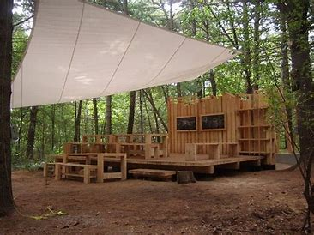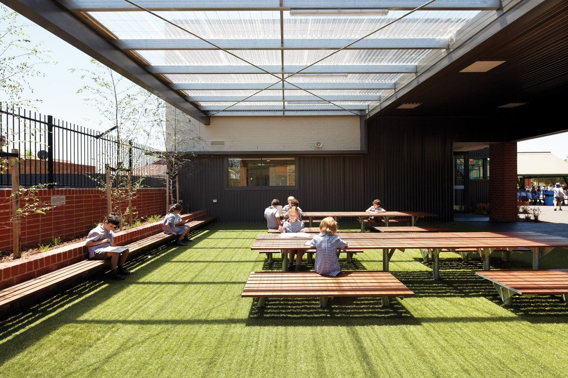

Appendix 2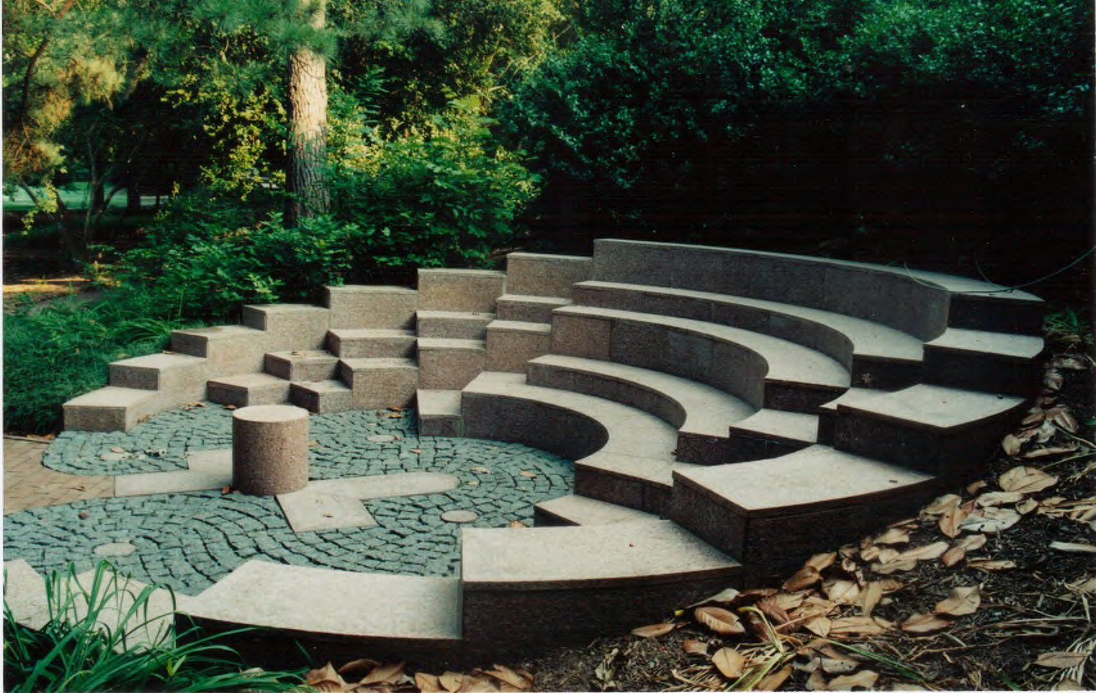
Appendix 3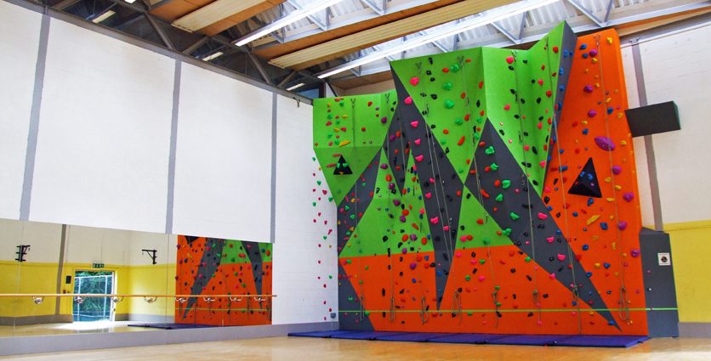
Appendix 4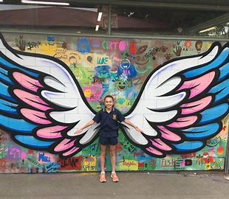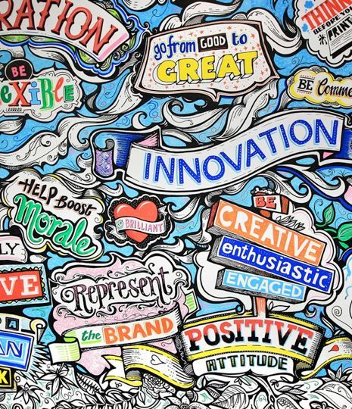

Appendix 5
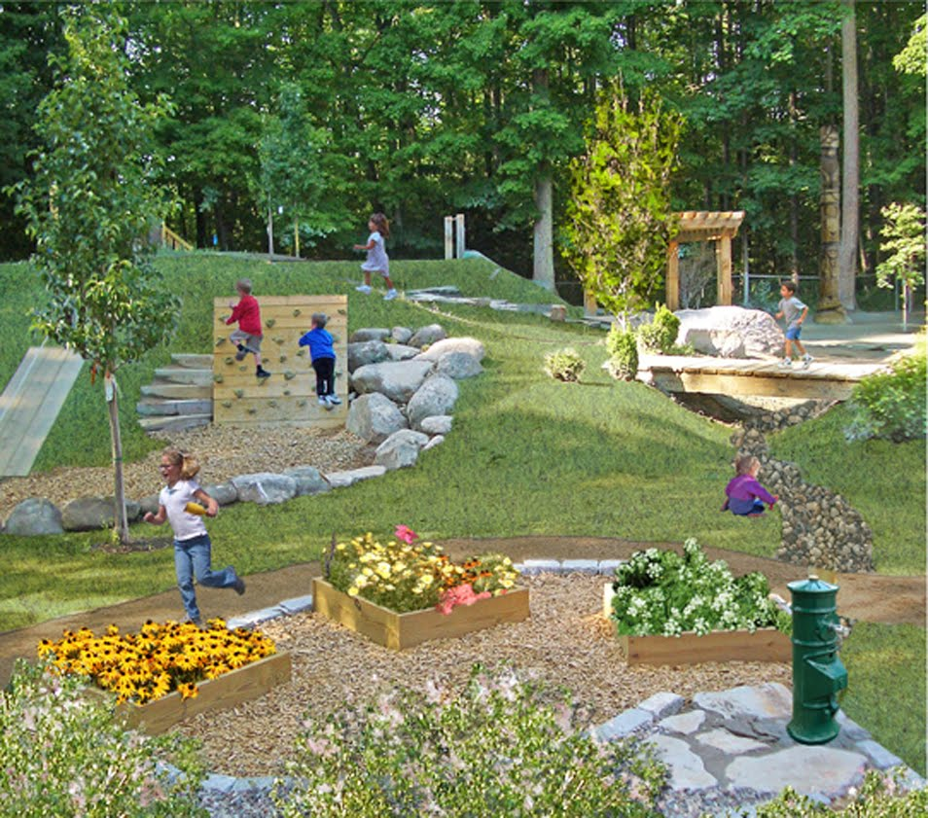

Appendix 6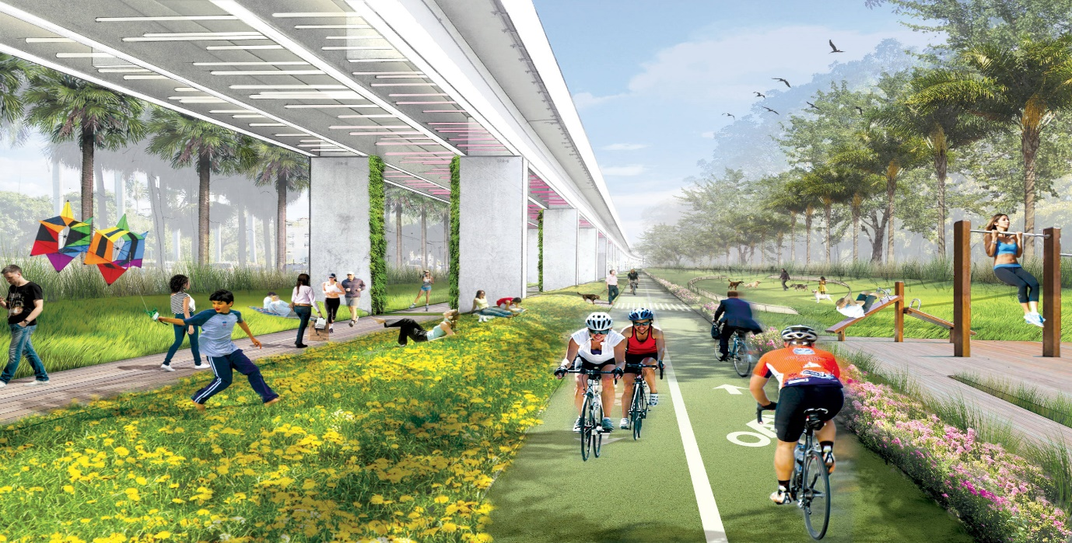
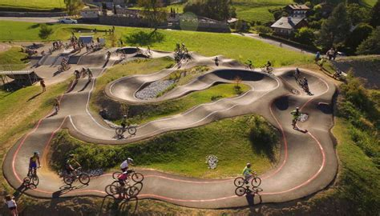

Appendix 7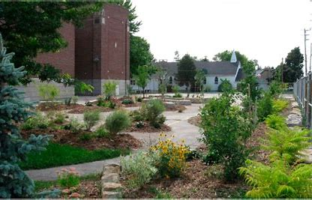
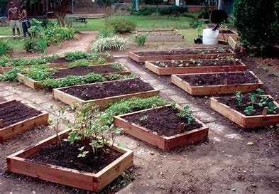

Appendix 8


