

Assessment 1

Student Name: Cătălin Tăbăraș
Student ID: 2247295
Module code: LCBB4003
Lecturer: Dr. Hoang Dang Nguyen

Table of contents
Introduction 3
Organisation structure 3
Organisation culture. 4
Impact on the performances 5
Motivating the employees in Sainsbury’s 6
Conclusion 8
References 9

Introduction
Structure and culture both are quite substantial elements in the perspective of any organization. Structure is a particular format by which all the people of an organization are formatted. On the other hand, culture is the norms, beliefs or values of the organization which are practised by the employees there. A combination of proper organizational structure and a strong culture is quite significant for any organization to be successful (Janićijević, 2023). This is also applicable in terms of Sainsbury’s, which is one of the most popular companies in the UK. Sainsbury's is a global retail giant which is performing its business in several segmentations. Since its establishment in 1869, this company has been performing beautifully throughout the UK. Currently, this company has more than 1400 shops all over the United Kingdom. Nearly 171,000 people are working for Sainsbury's across all its branches (Wood, and Pierson, 2020). Argos, Habitat, Nectar and TU are the sub-brands owned by this company. This essay defines its organizational structure and culture, along with its impact on the employees. Besides, the way this company motivates its employees is also depicted in this essay.

Organization Structure
An organizational structure is known as the blueprint that depicts the way an organization is operated. Reporting relationships, communication channels, decision-making procedures, and people with particular responsibilities are included in an organizational structure. It is a framework by which one can get an idea of the whole organization. It holds everything together. It helps the organization achieve its goals by allocating responsibilities to particular people within the organization (Yazici, 2021). An organizational structure includes some key materials. Organizational hierarchy, Departments, teams, roles, responsibilities, and communication channels are the most significant ingredients of an organizational structure. Different types of organizational structures can be used by business organizations worldwide. It includes hierarchical, functional, flat metrics and so on. The choice of a particular organizational structure can have a significant impact on the success of an organization. A well-designed structure is quite significant in improving communication, employee morale and decision-making within the organization.
As it is old and popular, company Sainsbury's always tries to ensure the use of the best combination of its organizational structure. It helps the company define the responsibilities of all the associates in the best possible way (Dragun, 2019). It also helps the company ensure the accountability of all employees. Figure 1 depicts the organizational structure of this company which is topped by Simon Roberts, who is playing his responsibility as the Chief Executive Officer of this company.
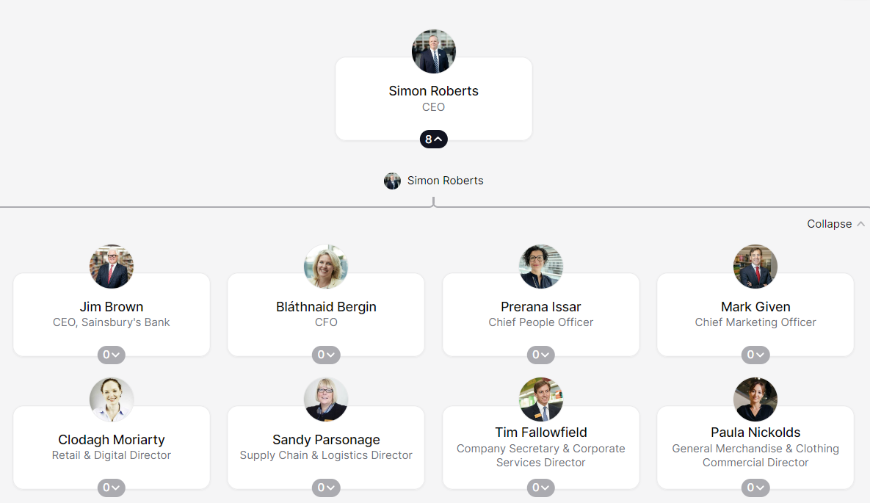
Figure 1: Organizational Structure of Sainsbury's (Ormerod, 2020)
Apart from the top CEO, there is the CEO of Sainsbury's Bank, the chief financial officer, the chief people officer, the chief marketing officer, the retail and digital director, the supply chain and logistics director, the Company secretary and corporate service director, the general merchandising and clothing commercial director in Sainsbury’s (Leigh, and Waddock, 2018). All these directors and managers have different responsibilities to perform in this company. They are also to ensure mutual collaboration so that they can make the best possible decision and accurately implement that.

Organization Culture
The organizational structure is another significant element of sensibilities that has helped this company achieve its landmarks. Organizational culture cannot be defined by only words and official statements of an organization. It's about the understanding of the organization, about the shared values, attitudes and behaviours that premiere the company (Tamzid, and Parves, 2019). All these elements also shape how the employees of a particular company interact and work together towards achieving their goals. Some key aspects of the organizational culture include values, behaviours, overfilling, visualization of the culture, and so on. These elements can also be defined from the perspective of Sainsbury’s.
In terms of values, this company always prefers serving customers first above all. This is a value possessed by this company prioritizing customer satisfaction and providing excellent service. Its commitment to fresh food, comparative pricing and the welcoming shopping experience are evidence that this company has taken the initiative to ensure maximum customer satisfaction (Pioch, and Gerhard, 2018). On the other hand, it always tries to make a difference by emphasizing its role in the community. It's also committed to ethical sourcing, sustainability and supporting local causes. On the other hand, another significant value of this company is to respect everyone. It fosters a diverse and inclusive workforce. It is also known as the central to the culture of this company to value their employee’s well-being.
On the other hand, behaviour is another core element of culture. Sainsbury’s culture possesses a behaviour of collaboration and teamwork. In this collaborative culture, colleagues work together to achieve the common goals of the organization. Besides this, culture also focuses on ensuring continuous improvement (Akter, 2021). Sainsbury's provides training and development facilities to its employees so that they can improve themselves and contribute more. This company also tends to provide testimonials to its employees to motivate them. The community involvement, branding of sensibilities, rewarding and fulfilling and fast-paced and dynamic working environment of this company are some common elements of its culture.

Impact on the performances
The workplace culture of science beauties, as mentioned earlier, possesses some major positive impacts on its employees. This working culture is beneficial in providing motivation and ensuring the engagement of the employees. They can feel aligned with the company's values and purposes. For example, this company focuses on serving customers and making a difference. To achieve this goal, this company needs a motivated and energetic workforce. The organizational culture helps this company ensure so (Ogbonna, and Harris, 2022). Besides, the organizational culture of science theories promotes collaboration and teamwork. Helps in getting improved performance in terms of collaboration and teamwork. Emphasizing working together and sharing knowledge since varies can lead to better communication, decision making and improved performance. Improved performance of the employees laid towards enhancing customer service. By feeling respected and valued within the organization, employees become motivated to work to the best of their abilities to provide the best services to the organization (Akter, 2021). It helps this company provide better services to its customers. On the other hand, increased innovation and adaptability can also be ensured by maintaining a suitable working culture within the organization.
Apart from the organizational culture, organizational structure also plays a crucial role in shaping the overall performance of an organization which is also applicable in the organizational context of Sainsbury’s. Clear lines of roles and responsibilities help all the employees in this organization understand their duties properly and perform accordingly. It resulted in increased accountability and performance of the employees. The managers of this company also get the chance to make better decisions because of these clear lines of roles and responsibilities (Pioch, and Gerhard, 2018). Escalation of making complex decisions is quite easy while having defined levels of authority throughout the whole organization. In this type of context, it is easier for the employees to work properly without having the headache of making decisions. Employees also get their career development opportunities in organizations with a hierarchical structure. They get to know the way by which they can get promoted to higher levels. By doing this, they also get the opportunity to gain new responsibilities and leadership experience (Imam, 2019). On the other hand, a core limitation of having a decent organizational structure in Sainsbury's is limited autonomy and decision-making along with communication bottlenecks. However, in a nutshell, the organizational structure of this company is beneficial for Sainsbury’s in making the best decisions and implementing these properly to be more successful.

Motivating the Employees in Sainsbury’s
A combination of extrinsic and intrinsic motivators are used by Sainsbury's to keep their employees engaged. By implementing this combination of motivators, this company ensures the best performance of their employees. It can relate to Hertzberg's two-factor theory of motivation. This company motivates its employees by following two particular structures.
In terms of extrinsic motivation, this company provides proper compensation and benefits to its employees. It offers a competitive salary along with bonus schemes and a comprehensive benefits package. This benefit package of sensibilities includes pension plans, healthcare, and discounts on their products (Newaz, 2023). These can be regarded as tangible rewards that meet the basic needs of the employees. Apart from this, performance recognition is another significant extrinsic motivation of Sainsbury's. “Star of the Month” and “Team of the Quarter” awards are the performance recognition initiatives taken by this company. By performing these activities, Sainsbury’s publicly acknowledges the achievements of its employees which also boosts their morale of them. On another aspect, career development opportunities are also provided to the employees. This company invests in training and development programs. These programs provide employees with opportunities to gain new skills and advance their careers (Miah, and Hossan, 2020). This is a reflection that this company is committed to the growth and well-being of its employees. Finally, discounts and perks are also provided to the employees to ensure the maximum satisfaction of them. The generous discounts on the products and employee perks are quite attractive for all the employees in this organization.
Apart from the extrinsic motivators, the intrinsic motivators of Sainsbury’s are also quite substantial. This company focuses on its commitment to ethical sourcing, sustainability, and community involvement. These emphasizing activities of this company help employees connect their work to a larger purpose beyond individual profit (Imam, 2019). It is a major intrinsic motivation and job satisfaction for the employees. Employees are also provided with empowerment and autonomy to perform their jobs in the ways they want. Thus, employees get the opportunity to take ownership of their tasks and make decisions within their area of expertise. Another major intrinsic motivation for the employees provided by Sainsbury’s is a positive work environment. This company always promotes a friendly and collaborative work environment with open communication and teamwork (Imam, 2019). It helps create a suitable working environment with belonging and community. Employees in any type of organization always prefer working in this type of environment where they can show their worthiness and credibility.

Conclusion
Sainsbury's has been successful since it began working in the British market. There are several factors which worked as drivers behind achieving this level of success in this company. Organizational structure, culture, and employees played the most significant roles in achieving these objectives. Initially, in terms of organizational structure, the structure of Sainsbury's is quite transparent. That ensures accountability of the managers and employees. This is why all the employees of this organization always know what their responsibilities are and what to do. Besides, the working culture of this company always promotes ethical working procedures and the best efforts. This is how this company is always getting the best possible performance from its employees. Finally, by providing employee motivation, this company always keeps its employees energetic.

References
Akter, S., 2021. Employee Satisfaction of SAINSBURY’s An Exploratory Study. International Journal of Academic Research in Business and Social Sciences, 2(8), p.316.
Dragun, D., 2019. Financial management at Sainsbury's. In Retail Strategy (pp. 298-308). Routledge.
Imam, M.T., 2019. An investigation of the role of Transformational Leadership Behaviours: a case study of Sainsbury’s (Doctoral dissertation, University of the West of Scotland).
Janićijević, N., 2023. The mutual impact of organizational culture and structure. Economic Annals, 58(198), pp.35-60.
Leigh, J. and Waddock, S., 2018. The emergence of total responsibility management systems: J. Sainsbury's (plc) voluntary responsibility management systems for global food retail supply chains. Business and Society Review, 111(4), pp.409-426.
Miah, M.K. and Hossan, C.G., 2020. Performance management system in UK retail industry: a case study. Far East Journal of Psychology and Business, 7(3), pp.13-25.
Newaz, M.T., 2023. The role of performance management system in shaping psychological contract: A case study approach. International Journal of Business and Management Tomorrow, 2(3), pp.1-10.
Ogbonna, E. and Harris, L.C., 2022. Organizational culture: a ten year, two‐phase study of change in the UK food retailing sector. Journal of Management studies, 39(5), pp.673-706.
Ormerod, R.J., 2020. Information systems strategy development at Sainsbury's supermarkets using “soft” OR. Interfaces, 26(1), pp.102-130.
Pioch, E.A. and Gerhard, U., 2018. Organizational culture as differentiator in international retailing. The Service Industries Journal, 34(8), pp.729-749.
Tamzid, M. and Parves, M.T., 2019. Human Resource Management Policies and Diversity Management (A Case Study on Sainsbury’s). Human Resource Management, 8(4).
Wood, L.M. and Pierson, B.J., 2020. The brand description of Sainsbury's and Aldi: price and quality positioning. International Journal of Retail & Distribution Management, 34(12), pp.904-917.
Yazici, H.J., 2021. Significance of organizational culture in perceived project and business performance. Engineering Management Journal, 23(2), pp.20-29.

