
Module: Academic Skills Study.
Module Code: ECGE4002P
Name: Ebony Tuckwood
Student Number: 1900477
Date: 07/11/19


Component 1: A portfolio of tasks reflecting the skills, knowledge and dispositions needed for higher education study.
Contents
Developing your skills: Vision of Success as a Student-teacher. 2
My Vision for Success. 4
Developing Critical Thinking. 4
What I Think About Education in Wales. 5
References. 6

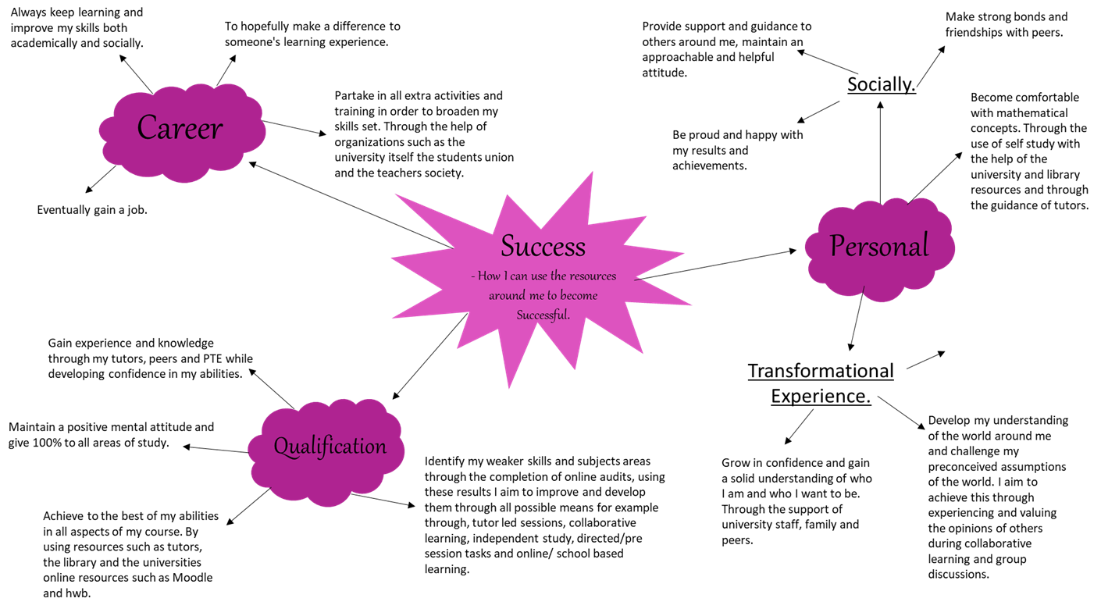
Developing your skills: Vision of Success as a Student-teacher.
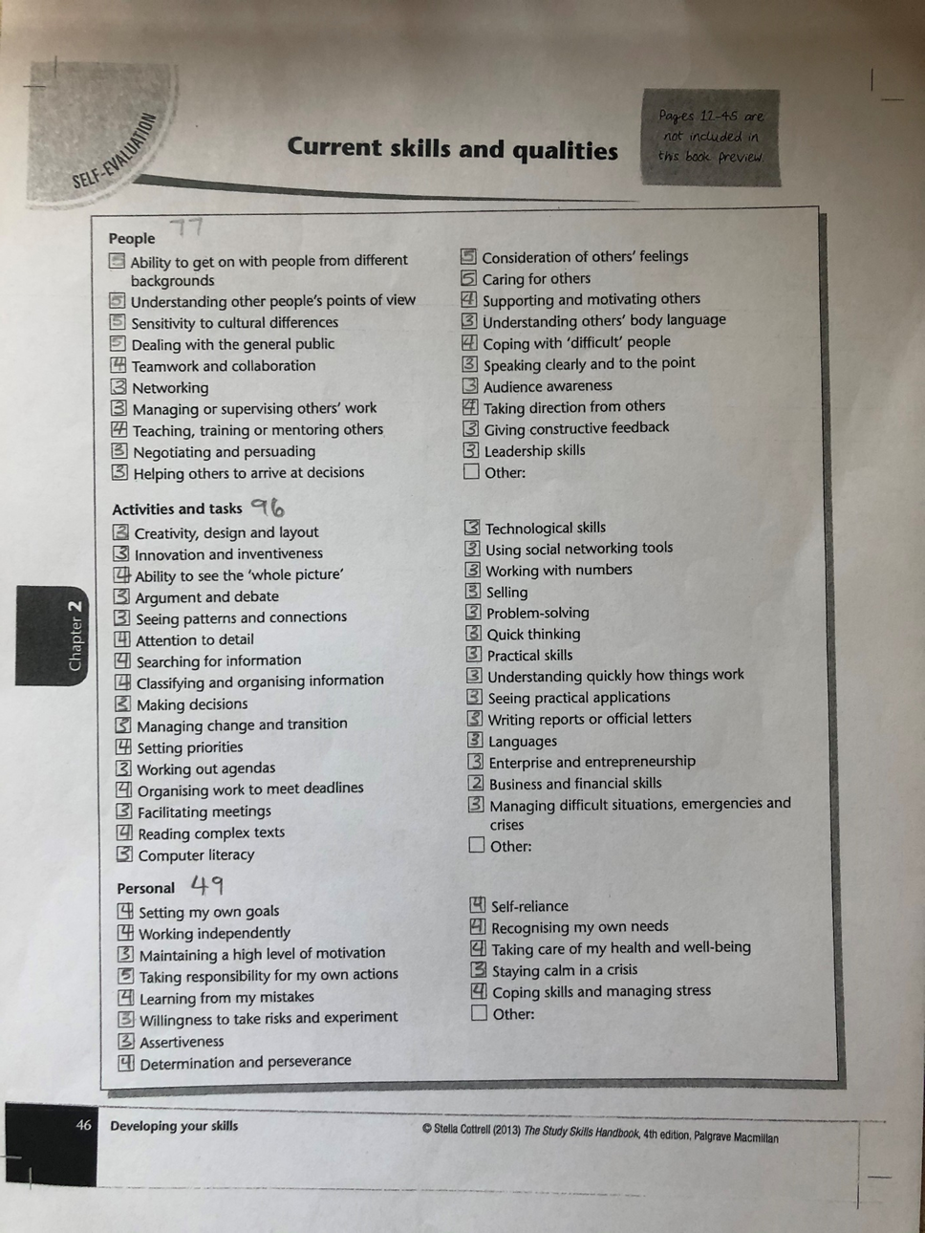

My Vision for Success.
Success for me ‘like most people’ includes many factors. Ultimately, I aim to work to the best of my abilities in all areas possible hopefully leading me to be successful in the completion of my degree allowing me to embark on an accomplishing career. However, for me personally success isn’t measured entirely in an academic sense. Success also encompasses personal and social development and growth, I also aim within my vision to be successful in the creation of strong bonds and friendships with all those around me. Alongside these points, I intend to retain a positive mental attitude while gaining as much confidence in my abilities as possible. My vision for success is as a transformational experience; to become and remain successful I intend to continuously develop and change for the better in all areas of both my professional and personal life.

Developing Critical Thinking.
It is suggested by (Cottrell, 2005) that thinking critically allows readers to analyze the information before them while providing them with the resources to constructively criticize and doubt what they are reading. The majority of people are able to improve and develop their skills in this area through practice, correct understandings and the effective management of barriers such as a misunderstanding of criticism; not all people are naturally effective in their critical thinking this can be due to the assumption that criticism equals negativity. Critical thinking is associated with the mind and is a cognitive activity which requires judgment, selection, attention, categorization and evaluation (Cottrell, 2005). Effective critical thinking uses and improves a great variety of qualities and skills although, the development of these requires patience there are great rewards in the form of improved skills and abilities such as spotting flawed reasoning with ease and being in a more informed position to make decisions and choices, this can also further widen your influence upon others.
Thinking effectively in a critical way involves precision, perseverance, accuracy and a certain degree of dedication to finding the right answers. To be effective readers must learn to consider all perspectives and pay attention to all details however small they may first appear, it is also important for individuals to ensure they remain as impartial as possible to gain the most accurate outcome (Cottrell,2005). Critical thinking requires a skeptical reflection and the rational thinking of both the positive and negative elements, this requires the aspect of a polite doubting allowing and encouraging readers to see the full and wider picture of what they are considering or already believe and helps them to consider the possibility of bias and the use of incorrect information (Ennis, 1987). In order to develop critical thinking individuals, need to identify and recognize their barriers and become aware of the blocks on their effective thinking (Cottrell, 2005), once identified these aspects and gaps in a reader’s skills set can be elaborated to increase their abilities as a critical thinker.
In order to make accurate judgements readers must become self-aware (Cottrell, 2005). Becoming self-aware encompasses the identification of the influences and barriers on our own judgement, this includes identifying the gaps within our own knowledge and realizing we need to question our points of view and also back them up suffiently. It’s stated in Critical Thinking Skills (Cottrell, 2005) that self-reflection in areas such as emotional self-management, the influences upon your thinking and challenging opinions, along with the completion of self-evaluative audits can aid individuals in the
identification of their strengths and weaknesses with regards to their critical thinking abilities. Discovering more about your personal qualities is essential in the development as a critical thinker, once realized these areas can be prioritized in order of importance to a specific person’s development.

What I Think About Education in Wales.
Education in Wales has been inconsistent in the past due to the lack of determined ideas about the nature in which things should be taught by the government, despite their somewhat direction welsh schools weren’t unified in their delivery of education (Alexander, Rose and Woodhead, 1992). The welsh education system became too outdated, bland and boring, it was fast becoming too test based and stress filled with children being viewed as statistics rather than important and different individual learners (Donaldson, 2017). Education as a whole was failing to meet the new needs of the children of today and needed a revamp that would save the old principles of learning while embracing change for the better. These observations of education in wales lead to the devolution of education to the welsh assembly in 1999, with the intention of providing fresh aspirations for education the devolution aimed to remove the coldness from schools and planned to bring back the spark to an unloved system (Jones,2016). The devolution involved the removal of SAT’s tests and league tables and later the introduction of the foundation phase and the welsh baccalaureate. The focus’ for the remodeling of education from this point seemed heavily weighted at the beginning and end of compulsory education with little thought for the in-between stages of learning(Jones,2016). Following these changes education is still full of problems however the issue has become how and what to teach specifically, the results of the foundation phase remain unclear although, it’s thought the policy was not entirely successful in achieving its core aims an overall decision cannot be made until the children who began education with the foundation phase in 2008 complete their GCSE’s in 2020 (Jones,2016). This data will come to light just years before the expected arrival of the new curriculum meaning the new system will lack the guidance these results could provide education (Jones,2016).
In my opinion education in wales needs an overhaul and it seems it is going to receive one in the form of the new curriculum which promises wide-ranging radical proposals with a coherent and manageable vision for the future (Donaldson,2015). Donaldson aims to build on the strengths of the current education system but also proposes significant change through the implementation of his 4 purposes, it is perceived that it will provide secure support to guide future decisions across wales and is expected to underpin all teaching and learning in wales as a whole (Donaldson,2015). If the new curriculum is as promised then I feel it will provide exactly what education needs in the form of enrichment, enjoyment and stimulation. It’s hoped it will broaden horizons, stimulate imaginations and promote enjoyment in learning; containing the main competences and skills such as literacy, numeracy and digital competency which are foundations for almost all learning within the modern world (Donaldson,2015). From my perspective education has lost its spark and purpose, for many it has become something to endure rather than to appreciate and continue throughout their lives, I believe if a love for learning is instilled within children it will be carried with them throughout their lives and this will thus improve education in wales altogether (Donaldson,2015).

References.
1.Alexander, R. J., Rose, J., and Woodhead, C. (1992). Curriculum Organization and Classroom Practice in Primary Schools: A Discussion Paper. London: DES.
2.Cottrell, S. (2005) Critical Thinking Skills; Developing Effective Analysis and Argument.
3.Ennis, R. H. (1987) 'A Taxonomy of Critical Thinking Dispositions and Abilities'. In J. Baron and R. Sternberg (eds), Teaching Thirzkirzg Skills: Theory and Practice (New York: W. H. Freeman).
4.Donaldson, G CB (2015) Successful Futures; Independent Review of Curriculum and Assessment Arrangements in Wales. Available:https://moodle.uwtsd.ac.uk/pluginfile.php/315883/mod_resource/content/1/Successful-futures.pdf.
5.Donaldson, G. (2017) ‘A SystemaMc Approach to Curriculum Reform in Wales’, Wales Journal of EducaMon, 19(1), pp. 7-20.
6.Jones, A. (2016) How Wales Works: Changes to Welsh schools post devolution, BBC Wales political correspondent. Available: https://www.bbc.co.uk/news/uk-wales-35323992

