

University of Wales Trinity Saint David
School of Engineering

Engine Control Systems
Electronic Ignition & Fuel Injection Systems
Module code: M4X02197
Bradley Burton
1803066
HNC Motorsport Engineering
27th April 2020
Contents

Figure List 3
1. Introduction 6
2. Research and Literature Review 7
3. Methodology 12
4. Results 18
5. Analysis 23
6. Discussion 25
7. Conclusion 27
8. Further Work 30
9. References 31
10. Appendix 32

Figure List

Table 1. Cold cranking injection on time (Jetronic)
Table 2. Dynamic test results (Jetronic)
Table 3 Cold cranking injection on time (Motronic)
Table 4 Dynamic test results (Motronic)
Table 5 Throttle potentiometer resistance data (Jetronic)
Table 6 Coolant temperature sensor resistance data (Jetronic)
Table 7 MAF sensor resistance data (Jetronic)
Table 8 Injector solenoid resistance data (Jetronic)
Table 9 Ignition coil resistance data (Jetronic)
Table 10 High temperature lead resistance data (Jetronic)
Table 11 Battery voltage (Jetronic)
Table 12 Fuel control unit voltage (Jetronic)
Table 13 Ignition control unit voltage (Jetronic)
Table 14 Throttle potentiometer resistance data (Motronic)
Table 15 Coolant temperature sensor resistance data (Motronic)
Table 16 MAF sensor resistance data (Motronic)
Table 17 Air temperature resistance data (Motronic) (Engine - 54°C / Air - 20°C)
Table 18 Idle control valve resistance data (Motronic)
Table 19 Injector valve resistance data (Motronic)
Table 20 Ignition coil resistance data (Motronic)
Table 21 Ignition lead resistance data (Motronic)
Table 22 Battery voltage (Motronic)
Table 23 Engine control unit voltage (Motronic)

Graph 1 Engine temperature vs Injection on time (Jetronic)
Graph 2 Engine temperature vs NTC 2 Resistance (Jetronic)
Graph 3 NTC 2 – Voltage vs Resistance (Jetronic)
Graph 4 Engine temperature vs Injection on time (Motronic)
Graph 5 Engine temperature vs NTC 2 resistance (Motronic)
Graph 6 Engine temperature vs NTC 2 resistance (Motronic)

Figure 1 Idle injection signal (Jetronic)
Figure 2 Acceleration injection signal (Jetronic)
Figure 3 Deceleration signal (Jetronic)
Figure 4 Idle injection signal (Motronic)
Figure 5 Acceleration injection signal (Motronic)
Figure 6 Deceleration injection signal (Motronic)
Figure 7 Crank sensor signal (Jetronic)
Figure 8 Ignition amplifier spark advance and primary signals (Jetronic)
Figure 9 Ignition amplifier primary signal (Jetronic)
Figure 10 Secondary coil voltage signal (Jetronic)
Figure 11 Ignition amplifier supply and earth signals (Jetronic)
Figure 12 Control unit engine speed output (Jetronic)
Figure 13 Crank sensor signal (Motronic)
Figure 14 Ignition primary signal (Motronic)
Figure 15 Ignition secondary signal (Motronic)
Figure 16 Ignition supply and earth signals (Motronic)
Figure 17 Injector bank 1 and 2 signals (Motronic)
Figure 18 Lambda sensor signal (Motronic)
Figure 19 Rotary idol valve signal 80°C (Motronic)
Figure 20 MAF sensor & Throttle potentiometer signals (Motronic)

Introduction

This report is the investigation into electronic engine control systems and how they function. It will describe the operation of adjustments made to the system to manage engine performance under any driving condition. The constantly changing state of an engine while driving requires sensory signals, read by the Electronic Control Unit (ECU), to initiate adjustments in ignition timing and fuel delivery in order to maintain a level of emission control.
Control systems provide performance and emission reduction by enabling adaptive control to satisfy emission laws for the year of production. Due to ever tightening regulations, manufactures are required to constantly innovate these systems to ensure efficiency and saleability of their vehicles. Modern fuel delivery and ignitions system have become more complex, however, the positives achieved through controllability and accuracy far outweigh the negatives.
The initial aim of the report is to provide an understanding of the many sensors, actuators and control devices used in conjunction with the control unit. It will describe how sensors communicate with the ECU and investigate the actions taken to control both ignition timing and injector operation dependant on the requirement.
The report also describes the process of testing two electronic control units, namely the LE3 Jetronic and later Motronic control units. The test will include dynamic procedures, investigating how increasing temperature, acceleration and deceleration effect fuel delivery. It will also describe the static testing procedures, looking at the resistive values of individual components to assess their condition and test the voltage value of each control unit pin with ignition on and off. With the data taken during testing, injection scope patterns and graphs have been produced and evaluated to enable understanding of ECU control procedures.

Research and Literature Review

An engine’s electrical control unit operates and monitors both fuel injection and ignition systems through sensory inputs to the ECU at each stage of the combustion cycle. Hillier describes that all sensors send signals to provide the ECU with information that relates to a “specific mechanical action or thermal effect” (Hillier, 1996, p84). Ultimately, these signals enable the ECU to time the spark correctly and add the optimum air fuel mixture despite changes in load, engine speed or temperature.
The ignition system enables combustion by providing a spark to the cylinder on its compression stroke five degrees before top dead centre. This ignites the pressurised stochiometric air-fuel mixture to enable the power stroke, forcing the piston down, thus, converting heat energy from rapidly expanding gasses into rotational energy at the crank.
Ignition systems consist of a battery positive connected through an ignition switch to the primary windings of an ignition coil, controlled by a rotary switch that makes connection in its dwell period between each spark. Once the connection breaks at the end of the compression stroke, the collapse in electromagnetic field causes a back EMF (Electromotive Force). This powers the coils secondary windings which connect to the pulse generator and provide a high voltage spark with enough power to ignite the mixture in a turbulent pressurised cylinder.
Dwell time or angle is a three to five millisecond period in which the primary is grounded allowing the coil to build charge. Denton states that “for an ignition system to produce constant energy the dwell angle must increase as engine speed increases” (Denton, 1995, P189). Systems that control primary switch timing are knows as ‘Variable Dwell’ units. Early ignition systems used inlet vacuum or centrifugal force from weights to adjust dwell cam timing, whereas later systems use a signal from an electromagnet to gauge speed and adjust the primary switch opening time accordingly. These ignition systems are referred to as ‘Constant Energy’ as the voltage remains constant through all operating conditions, therefore, rising resistance must increases the voltage in the circuit.
The back EMF caused by the collapse in electromagnetic field sends a pulse through the circuit that requires dissipation in order to protect semiconductors from high voltage (Hillier, 1989, p207). Early points ignition units utilised a condenser for this purpose, however due to the minimal lifespan, contemporary systems now employ an amplifier containing transistors that can absorb up to 16 Amps, known as ‘Darlington pairs’ used for switching the primary to earth (Hillier, 1989, P206), and ‘Zener Diodes’ to limit the reverse breakdown voltage (Bosch, 2007, p177).
Early points and condenser and hall effect ignitions rely on a pulse generator (distributor) to correctly time each cylinder’s spark with the end of the compression stroke. In most cases the distributor is powered by the rotation of the camshaft revolving at half engine speed, whereby the rotor arm completes the connection initiating the spark. Also, engine speed can be monitored through the distributor’s negative terminal through pulsed signals. Modern reluctance type units use a ‘reluctance sensor’ device that utilises a permanent magnet to read a break in connection per crank revolution. This sends an analogue signal to the electronic control unit, whereby it converts to digital to enable a speed and crankshaft position reference.
Hall effect ignitions use a single coil capable of producing large voltage when the primary is switched. They incorporate an amplifier that is constantly powered by signal voltage of three to eight volts and contains ‘Darlington’ transistors as a primary switch and ‘Zener’ diodes to absorb back current. Variable dwell is controlled using an interrupter ring with numerous air gaps, relating to the number of cylinders. This break in connection sends a signal from the ‘Hall sensor’ to the ‘DFI’ (digital fire injection) module control unit which adjusts primary switch timing accordingly ensuring a reliable spark (Stackpoole, Morrison & Gregory, 1993, p220).
Wasted spark distributor less ignitions use a coil for every two spark plugs which ignite simultaneously, twice every rotation, and incorporate a larger spark gap to enhance the initial burn. As per the name, wasted spark units waste energy. Later direct ignition system incorporates a ‘coil on plug’ for each cylinder which ignite sequentially once every crank revolution. In these systems dwell is controlled by Darlington transistors within the ECU, which uses a crank sensor for speed reference and adjusts timing as necessary.
The fuel and air mixture, once delivered through a carburettor, known as mechanical single point injection, has now been replaced by injectors controlled by the ECU to allow constant adjustment. Although adjustments can be made to alter the fuel and air mixture, carburettor settings do not vary, therefore, condition changes such as load or air density greatly effect efficiency and emittance of hydrocarbons. Modern injection systems include digital sensors which provide signals to the ECU, whereby calculated actuator outputs meter both injector on time and airflow in the case of ‘Idol control’ systems.
Before the development of electronic fuel injection (EFI) systems, manufactures utilised ‘continuous injection’, whereby fuel metering is governed by an airflow sensor connected to the fuel distributor. Due to emission regulation, mechanical injection systems have been replaced by EFI units due to their ability to quickly assess and manage a variety of sensory data (Probst, 1991, p11).
Fuel is supplied to the injectors from a vented fuel tank using a mechanical or electric pump to ensure pressures of 1 - 1.5 Bar is reached. This enables correct atomisation of the fuel as it meets with the airstream to provide the engine with a homogenous mixture. Air flow is controlled through driver throttle input which operates a butterfly before the inlet. The inlets are shaped and finished to encourage flow of air and the vacuum from the piston returning after combustion forces the flow to the correct cylinder. In the case of ‘Multi-Point injection’ the atomised fuel is delivered into the airstream before the inlet valve, whereby is compressed and ignited before the power stroke. However, ‘Direct injection’ delivers atomised fuel to the cylinder itself (Probst, 1991, p1.4).
Each injector houses a solenoid to build pressure when closed and to deliver fuel when necessary. The solenoid consists of wire coils wrapped around a hollow tube, that when energised, magnetically attracts the armature and opens the injector, releasing and atomising the fuel due to inherent high pressure. Injector opening period ranges from 1.5 to 10 ms dependant on condition. (Denton, 2000, p47)
Fuel injection systems deliver fuel either, simultaneously to all injectors which supply half the required amount every 360 degrees of crank rotation, or sequentially with the firing pattern that provide the whole amount every 720° rotation. The fuelling is controlled by actuators in the injectors that open for the specified time to produce the correct ratio under all conditions. Injector on time is specified and controlled by the ECU which varies the period due to load, engine temperature, throttle position and deceleration.
As fuel expands with heat, containment tanks require ventilation to prevent leaks. Many fuel systems direct the ventilated hydrocarbons into a canister containing porous charcoal, whereby they are stored and vented into the inlet manifold with the fuel air mixture to prevent unnecessary emission. To avoid rough running when cold or idling, the control valve should only feed the intake with hydrocarbons once the engine is up to temperature and as speed is increased.
Mellard states that advancement in integrated control systems has led to the emergence of “total management systems”, that can combine fuel injection, ignition, automatic transmission and other functions controlled by a single engine control unit. The control unit reads pulsating voltage signals from various sensors which incur calculated ECU outputs that control ignition, injector on-time, additional air at idol and hydrocarbon reuse (Mellard, 1988, p117).
The ECU’s knowledge of temperature is a vital variable in the control of injector opening period. The most common sensor used for both air and coolant temperature is a thermistor which has a negative temperature coefficient (NTC), therefore, as their temperature rises resistance and voltage values fall. The air temperature senor, often referred to as NTC 1, either utilises a ‘Nickle thick-film thermistor’ in the air stream or a thermocouple that measures the inside wall of the inlet manifold. The coolant sensor operates in a similar manner, however, is situated in the engine’s water jacket (Mellard, 1988, p14).
To enable control of the homogenous mixture, constant air load information is required to allow the control unit to adjust injector pulse time as necessary. This information is gathered by a sensor located in the intake’s air stream before the manifold. Early systems incorporate a vane type sensor, attached to a potentiometer that gains resistance under increased air flow, and cooperates with a fuel pump switch which operates after approximately five degrees of vane rotation. This function helps to alleviate the risk of fire upon possible collision. (Bonnick, 1998, p67). Most modern systems use hot wire air mass (MAF) meters that contain a thin resistance wire. The wire is heated via electric current of 500-1200 mA, dependant on the heat transfer from the wire to intake air stream. Mellard states, that MAF sensors determine air mass by measuring the wires resistance (Mellard,1988, p19). As the wire’s heat is reduced with airflow, its resistive value increases which incurs a rise in voltage to signal the ECU. From the air mass data, pressure can be calculated by the control unit using engine speed. Absolute manifold pressure (MAP) sensors can also be used, in place of a flow meter. MAP sensors utilise a strain gauge that increases resistance as manifold pressure builds due to load, therefore, as the throttle is released, manifold vacuum will decrease resistance and voltage signal to the ‘Electronic control module’ (Stackpoole, Morrison & Gregory, 1993, p299).
Data collection from driver input, is collected through a ‘throttle potentiometer’, which is a device that houses a variable resistor on a carbon track. As the throttle is opened, the element moves along the track increasing resistance, which varies voltage signal from 325 mV (closed) to 4.8 V (open). Denton informs that this rate of change specifies the intensity of both deceleration and acceleration that is used to increase fuelling or initiate “over-run cut off” as necessary (Denton, 1995, p151).
Vehicle circuitry can de defined as either, ‘open loop’ or ‘closed loop’ which describes the system’s ability, or inability, to feedback further information to the ECU for it to carry out punitive measures as necessary. The headlight system is an example of an open loop circuit, that has only inputs from battery and switch. Although the output voltage will be higher due to resistance, no feedback is required for operation (Denton, 1995, p46). Many modern systems incorporate closed loop systems to ascertain information that influences fuelling and ignition timing. To obtain the most effective burn, spark is advanced as far as possible before incurring detonation. This is enabled by a Knock sensor located in the block with its control unit installed between the coil and distributor (Stackpoole, Morrison & Gregory, 1993, p266). The sensor detects detonation through sound waves using a ‘Piezoelectric crystal’ that outputs data before and after TDC (top dead centre), this signals the ECU to retard timing as necessary to complete the closed loop ignition circuit.
Closed loop fuel injection control is carried out by a ‘Lambda sensor’ located within the exhaust gas stream that detects quantity of oxygen. A voltage signal is sent to the ECU when no oxygen is found, which occurs when the ratio is fuel heavy or rich. With this information the control unit calculates that injector on time must decrease, therefore, causing the sensors voltage to reduce as the mixture becomes progressively oxygenated. Hillier states that the mixture oscillates between rich and lean to allow time for the controller to adjust between the limits, also sensors with a greater sensitivity allow minimal fluctuation between rich and lean, therefore, minimising emissions (Stackpoole, Morrison & Gregory, 1993, p266) (Figure 19).
Modern fuel injection units also include an idol control valve that operates by increasing the inlets air flow at tick over to prevent fluctuation when required. The control valve increases airflow upon both cold start and increased engine load due to the use of onboard electrical components, in order to keep idol speed within parameters preventing excessive emissions. Small idle-stabilisation adjustments are made by changing ignition timing utilising data from the engines speed sensor. If engine speed decreases during operation the ECU advances timing to increase rmp and retards timing to reduce speed (Probst, 1991, p3.34).
Ever increasing environmental concerns have fuelled innovation in engine control, as manufactures are required to inject finances and develop systems that meet stringent, constantly evolving emission regulations. A petrol engine mainly emits CO₂ (carbon dioxide) and water vapor which are non-toxic, however, excessive CO₂ contributes to the ‘greenhouse effect’. The components of exhaust gas, although minimal, include CO (carbon monoxide), NOx (oxides of nitrogen, NO & NO₂), HC (hydrocarbons) and particulate matter (Bosch, 2000, p518).
Emission regulations in most countries require manufactures to produce their vehicles with ‘Catalytic converters’ which attempt to reduce the harmful gasses produced in the combustion process. This task is carried out by the three to four grams of precious metals contained, including Platinum to reduce HC and CO, and Rhodium to diminish NOx. For this unit to be effective the air and fuel mixture must be near or close to stoichiometry (approximately 14.7:1) to ensure the correct ingredients are produced for the catalytic converter to operate. Although effective in their operational period catalytic converters deteriorate, therefore, later systems include a ‘downstream oxygen sensor’ that reads oxygen levels after to detect faults with the system (Denton, 2000, p223-224).

Methodology

This methodology describes the processes of testing two electronic control systems, manufactured at different stages in control system evolution, for the purpose of data acquisition and comparison. This will enable the understanding of actions taken by the fuel injection and ignition systems in order to keep emissions low and efficiency high.
Prior to testing, advice from the ‘Health and Safety Executive’ should be read, understood and adhered to, to ensure safety of all persons in the vicinity:
Engine Emission Safety
“Engines may need to be run for diagnostic purposes, but exhaust fumes irritate the eyes and respiratory tract, and are a risk to health if you breathe them in. Carbon-fuelled engine fumes contain carbon monoxide, a poisonous gas. Prolonged exposure to diesel fumes, especially blue or black smoke, may lead to coughing and breathlessness. Long-term repeated exposure to diesel fumes over a period of about 20 years may increase the risk of lung cancer. Exhaust fumes can quickly reach harmful concentrations, particularly from cold or intermittently run engines (when run indoors without exhaust ventilation). Provide extraction or exhaust equipment, preferably by direct coupling to the vehicle exhaust. It should ventilate to a safe place in the open air – where fume will not be drawn back into the workshop or affect other premises or people nearby. This is particularly important when working in a vehicle inspection pit. Maintain couplings and flexible connections in good condition to prevent leaks. Don’t rely on catalytic converters to run engines safely indoors. They are less effective when exhaust gases are relatively cool, e.g. from vehicles idling for long periods or used intermittently for short periods. Catalytic converters do not remove toxic oxides of nitrogen” (HSE, 2011, p8).
Vehicle Electrical Safety
“The electrical systems on vehicles can be a source of electric shock, burn, fire and explosion. In addition to the normal electrical battery ignition circuits, some vehicles are equipped with high-intensity lighting systems and/or are powered as an electric/hybrid vehicle. Each of these systems present additional sources of electrical risk. For high-intensity discharge (‘xenon’) lighting systems the start-up voltage can be over 20 000 volts, with an operating voltage of around 80 to 90 volts and a frequency of several hundred Hertz. Electric/hybrid vehicles can have parts of the electrical system operating at 650 volts dc with batteries operating at around 280 volts. Most of these parts of the vehicle will tend not to be serviceable (replaced rather than repaired). Special precautions may be required for road rescue/recovery and electric/hybrid vehicle manufacturers have produced information for non-dealership personnel and have dealt directly with the emergency services to discuss different rescue scenarios. Inadvertent contact with the electrical parts of these systems is usually prevented by design (e.g. by placement, insulation and use of distinct colours). International standards exist for fuel cell vehicles and electric road vehicles to protect people against electric hazards. However, repairs following an accident, fault finding or work on the electrical system may involve access to potentially dangerous electrical systems. As with all electrical work, the person undertaking the work must be competent to do so. The vehicle manufacturer’s guidance should be followed. Where possible, no work should be carried out on or near live conductors that may cause danger. For example, safely disconnect the battery before working on high-intensity discharge circuits (‘memory keepers’ can be used to retain radio codes and other electronic settings)” (HSE, 2011, p77).

Testing Equipment Personal Protection Equipment
- Test rig mounted engine - Steel toe capped boots
- Digital multimeter - Laboratory coat
- Bosch universal oscilloscope (ms scale)
- Data collection tables
- Carbon monoxide detector
- Paperclip
For the purpose of the test, engine rigs should be assembled, serviced and test run prior, to prevent unnecessary failures while carrying out the process. Before commencing, it is advised that a door or window is opened to promote airflow and that a carbon monoxide (CO) detector is switched on and monitored throughout testing. Kidde Fire Safety suggests that CO levels under 50 ppm (parts per million) is the “maximum allowable concentration for continuous exposure for healthy adults in an eighty-hour period”. Whereas, 1900 ppm can cause headaches dizziness and nausea in twenty minutes, and death in an hour (Kidde, 2019). To begin, initiate the extractor units and attach to the test engines exhaust outlet. Then set up the scope by turning on, attaching the positive and negative leads to battery and placing the temperature probe into the dipstick tunnel, after adjusting its length to that of the dipstick removed. Attach negative probe to a metal point whereby a good connection can be made in an area to prevent disruption during the test, which can cause inaccurate results, and attach a paperclip to the positive probe to enable ECU testing. For all tests following, the scope should be set to the correct function within the correct parameters for each test. Finally, record each result in data tables as per the results section.
Jetronic (LE3) Test:
Dynamic Testing
To check injection on time upon cold cranking, firstly check engine temperature, then attach positive probe to pin 3 (injector earth) on fuel injection ECU, crank engine until it begins to fire then freeze the scope and terminate engine.
Next, ensure scopes engine temperature reading is close to 20°C (after test run), then using the multimeter set to Ohms (Ω), remove plug at NTC 2 (coolant temperature sensor) then test resistance between both sensor pins. Ensure to replace and secure sensor plug once data is gathered.
Attach the positive probe to pin 8 (NTC 2). Turn the ignition on to obtain voltage value for the coolant temperature sensor.
After, attach probe to pin 3 (Injector negative) to test injector on time. Start the test engine, allow to settle momentarily and pause scope. Using the controller adjust parameters of the scope to measure and record injector on time.
Allow engine temperature to rise close to 30°C. Once at the desired temperature stop engine and carry out the three tests described above. Repeat this procedure ensuring to warming the engine between tests in increments of ten degrees, up to and including 60°C. Once at 60°C the thermostat will open, initiating the fan, causing a slight drop in engine temperature.
Once complete, connect the probe to pin 3 and start engine to obtain a scope pattern for injection on time as the engine reaches its idol operating temperature. Collect a scope pattern during snap acceleration using the throttle control at the inlet. Also, obtain a declaration scope print, by opening the throttle near to revolution limit and closing, allowing engine speed to drop and overrun to initiate, then stop engine.
Attach probe to pin 12 (crank sensor) on the injection ECU, to acquire crank sensor scope pattern.
To obtain a scope pattern comparing primary and secondary signal, connect probe to ignition amplifier pin 1 (primary). Also, connect secondary probe negative terminal to ground and positive to amplifier pin 4.
Attach primary probe to amplifier pin 2 (earth return) and secondary probe to pin 3 (supply) to compare scope pattern signals while running.
After, attach primary scope to ignition ECU pin 5 to obtain a scope print of engine idle speed signal.
Attach scope pick up sensor to secondary coil lead to ascertain voltage values and record pattern throughout operation. Once complete terminate engine.
Finally, disconnect fan to prevent operation while testing and check temperature to ascertain engine’s max operating temperature. Repeat first three tests for NTC 2 resistance, voltage (pin 8 – ignition on) and injector on time (pin 3 – engine running) as per three tests previously mentioned, stopping engine once recorded.

Static Testing
With the negative probe still grounded, use positive to check voltage at each pin on both injection and ignition ECU with ignition off, then repeat process with ignition on.
Continue by testing following components, ensuring data is collected and plugs are re secured to prevent future failure.
Remove the throttle potentiometer plug. Using the multimeter set to Ohms, resistance test sensor terminals 2 & 18 with throttle closed and repeat test between terminals 3 & 18.
Remove plug for the mass air flow sensor and carry out resistance test between both terminals.
Test resistance value between both terminals on injector one once plug removed. Repeat process for all injectors.
Test resistance between positive and negative coil terminals (primary windings). Then remove coils secondary HT lead to test between positive terminal and lead attachment (secondary coil).
Resistance test each ignition leads sequentially to enable comparison, ensuring to replace correctly once complete.
Finally, connect the multimeter negative and positive probes to ascertain the leads resistive value to enable subtraction from the values recorded.

Motronic Test:
Dynamic Testing
Check engine temperature and test injection on time while cold cranking by attaching positive probe to pin 16. Crank engine until it begins to fire, pause scope to record data and turn engine off.
Start engine and allow temperature to rise close to 20°C. Once at temperature turn of engine, remove NTC 2 (coolant temp sensor) plug and using the multimeter set to Ohms to resistance test sensor between terminals.
Attach positive probe to ECU’s pin 45 (NCT 2 – coolant temp sensor) and turn ignition on to obtain the voltage value. Repeat test for pin 44 (NTC 1 – air temp sensor) and record both (only test pin 44 at 20 & 80°C).
Secure positive probe to pin 16 to test injector on time. Start engine and let settle before freezing scope, then using the controller, adjust parameters of the scope to measure and record.
Then connect probe to pin 4 (rotary idol valve) while running to test percentage on time. Pause scope and measure time to convert to percentage (10 ms = 100 %).
Test pin 5 (tank vent valve) and blip throttle to asses the temperature at which the solenoid is activated (once activated, note temperature parameters and cease to test).
Stop engine and move probe to pin 28 to access temperature that the lambda sensor initiates (repeat test until reading received and as per previous test, note temperature parameters at which it occurs).
Start engine and allow temperature to rise just below 30°C. Repeat this procedure ensuring to warming the engine between tests in increments of ten degrees, up to and including 60°C. Once at 60°C the thermostat will open, causing a slight drop in engine temperature. Also manually operate the fan while running engine above 60°C to prevent overheating (ensure to disable fan while testing components with engine off to avoid false readings).
Repeat test sequence for both 70 and 80°C and record data, ensuring to recheck pin 44 voltage once engine temperature is 80°C.
Connect probe to pin 1 (negative side of coil), start engine and let settle to obtain scope pattern illustrating dwell time.
Then attach probe to pin 4 to secure a scope pattern of the rotary idol valves keying ratio.
Attach primary probe to pin 27 (ignition supply) ensuring to ground correctly, connect secondary positive probe to pin 2 (earth return) to enable scope comparison.
Connect primary probe to pin 7 (Air flow meter) and secondary to pin 53 (throttle potentiometer) to compare signals at idol.
Secure primary probe to pin 16 (injectors x2) and secondary to pin 17 (injectors x2) to obtain a scope pattern comparing injector signals.
Remove secondary probe and obtain singular scope patterns for injector signal at idol, snap acceleration and deceleration.
Attach positive probe pin 28 and allow engine to idol. Freeze scope to obtain idle lambda signal pattern.
Next, connect probe to pin 49 to collect scope pattern for speed sensor at idle.
Attach scope pick up sensor to secondary coil lead to record pattern throughout operation and terminate engine once complete.

Static Testing
Keeping negative probe attached to ground, measure and record voltage at each pin on ECU with ignition off, then repeat process with ignition on.
Continue by testing following components, ensuring data is collected and plugs are re secured to prevent future failure as previously stated.
Remove throttle potentiometer plug and resistance test sensor pins 1 & 2, with throttle closed using a multimeter set to Ohms. After, repeat test between pins 1 & 3 with throttle open.
Disconnect mass air flow sensor and test resistance between terminals 2 & 4, then repeat test between pins 3 & 4.
Resistance test NTC 1 using ECU pin 44 (air temperature sensor) and 26 (earth). Ensure to note engine temperature as reference to assess parameters.
Next, remove plug for idle control valve and check resistance between terminals.
Test injector one resistance value between both terminals once plug removed. Repeat process for all injectors.
Test resistance between positive and negative coil terminals (primary windings). Remove secondary HT lead to test between positive terminal and lead attachment (secondary coil).
Lastly, check the ignition lead’s resistance individually, ensuring to replace correctly once complete.

Results

Jetronic (LE3) Test Results:
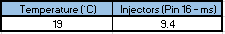
Table 1 Cold cranking injection on time (Jetronic)

Table 2 Dynamic test results (Jetronic)
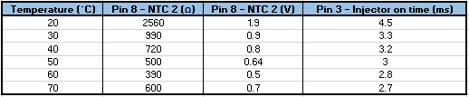

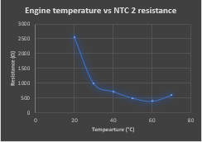
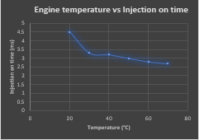
Graph 1 Engine temperature vs Injection on time (Jetronic)

Graph 2 Engine temperature vs NTC 2 Resistance (Jetronic)
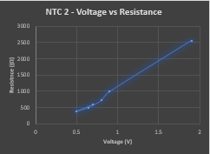

Graph 3 NTC 2 – Voltage vs Resistance (Jetronic)

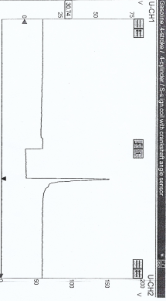

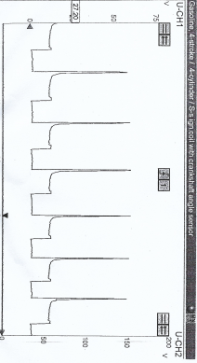

Figure 1 Idle injection signal (Jetronic)

Figure 2 Acceleration injection signal (Jetronic)

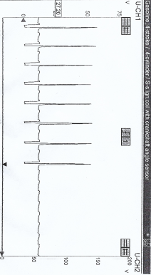
(

Figure 3 Deceleration signal (Jetronic)

Motronic Test Results
Table 3 Cold cranking injection on time (Motronic)

Table 4 Dynamic test results (Motronic)
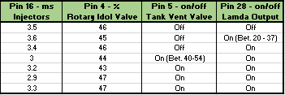
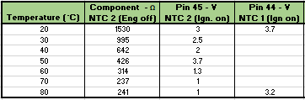

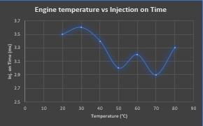

Graph 4 Engine temperature vs Injection on time (Motronic)

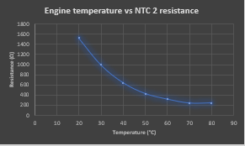

Graph 5 Engine temperature vs NTC 2 resistance (Motronic)
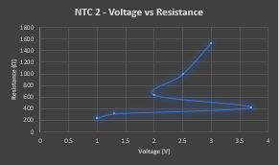

Graph 6 Engine temperature vs NTC 2 resistance (Motronic)

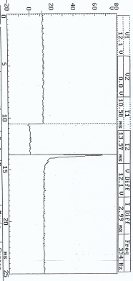

Figure 4 Idle injection signal (Motronic)

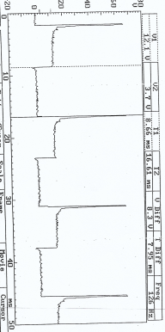

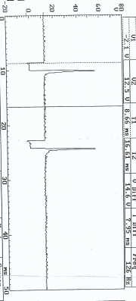

Figure 5 Acceleration injection signal (Motronic)

Figure 6 Deceleration injection signal (Motronic)

Analysis

Jetronic LE3
Tables 1 and 2 show data gathered in testing the Jetronic (LE3) systems idol injector on time. To assess how rising engine temperature effects injector on time, resistance and voltage data is collected from NTC 2 (coolant temp sensor), to enable understanding of sensor operation and signal output.
Graph 1 illustrates engine temperature against injection on time. At 20°C injectors are open for 4.5 ms, which reduces rapidly to 3.3 as the engine reaches 30°C. As temperature climbs further, injector on time decreases by 0.1 - 0.2 ms per 10°C. As the data states, injector on time decreases as engine temperature rises. Graph 2 illustrates how rising engine temperature affects NTC 2 resistance. The resistance is greatest at 20°C, with a value of 2560 ohms, which falls rapidly to under 1000 as temperature rises to 20°C. As temperature increases further the resistive value falls in a linear manner until it reaches 60°C, whereby the thermostat opens, inducing fresh coolant into the water jacket. This cools the surface of NTC 2 increasing the resistive value. Graph 3 shows NTC 2 resistance against voltage. As shown, resistance is proportional to voltage, therefore, as engine temperature continues to rise, the sensor’s resistance and voltage signal to the electronic control unit reduce.
Figure 1 scope pattern is the injector pulse at idol. As shown at the beginning of the pattern, a voltage of approximately 13.5 V is supplied to the injector. Voltage briefly rises due to small resistance increase as all injectors use a common supply. Due to the low circuit resistance, when the injector closes, a collapse in magnetic field produces a voltage spike caused by back electromotive force (EMF). The magnitude of this spike indicates the condition of the injector windings. After this, current limiting or ‘hold time’ begins, reducing solenoid output voltage until it reaches the 13.5 V to enable the procedure to repeat. As recorded in the results table, idol injector on time at operating temperature is 2.7 ms. Figure 2 illustrates injector operation upon snap acceleration. This shows an increasing frequency and decreasing injector on time as engine speed increases. Figure 3 show injector characteristics upon deceleration. Upon closing the throttle at high engine speed injector on time diminishes greatly until the injectors close due to the overrun cut-off switch incorporated in the throttle potentiometer. (Waveforms, 1995, p11)

Motronic
Tables 2 and 3 show the results of the Motronic dynamic testing to enable the understanding of the components that affect injector on time. As per previous test, NTC 2 resistance value, voltage signal and injector on time are recorded with an addition of NTC 1. Rotary idol control valve opening percentage is also deduced from the period it is open (100 % = 10 ms). Also, Lambda signal shows that the closed loop system becomes operational at an engine temperature between 20 – 37°C. And finally, assessment of the tank vent valve signal shows that it begins to operate between 40 - 54°C.
Graph 4 illustrates injection on time against engine temperature. As temperature rises form 20°C to 30°C injector on time rises slightly and then drops in a linear manner as it continues to rise to 50°C. Injector on time then increases due to a loose contact at NTC2 which increases the voltage signal at the ECU as there is greater resistance. This drops back down upon testing at 70°C as the issue was diagnosed and plug re-secured for next measurement. Between 70 and 80°C, injector on time increases due to thermostat opening and fan being induced which increased load, actioning the rotary idol valve to open for a longer period. Graph 5 shows engine temperature against resistance which clearly states that the resistance value decreases as engine temperature increases. Graph 6 illustrates NTC 2 voltage against resistance. As it is a constant energy system, voltage will increase to overcome resistance, therefore, as resistance reduces, the voltage signal will also drop proportionally. The large voltage spike, as described previously, is due to NTC 2 plug not secured.
Figure 4 illustrates the Motronic idle injection signal at operating temperature. As previously described, voltage is supplied to the injector which drops when the solenoid opens inducing injector on period. Once closed voltage spikes due to back EMF caused by a break in electromagnetic field which is then brough back down to approximately 13.5 V as the system is current limiting. Figure 4 shows injector operation upon acceleration. As the throttle is depressed the MAF sensor and throttle potentiometer work in conjunction to signal the ECU to increase frequency and injector on time as engine speed increases. Figure 6 illustrates injector pulse upon deceleration which shows a reduction in injector on time before the injectors shut as over-run begins, caused by the cut-off switch incorporated in the potentiometer.

Discussion

Both systems are very similar in their operation, however, the Motronic system is superior due to increased adaptive control provided by the closed loop injection system. A lambda sensor’s ability to assess exhaust gas oxygenation is advised as it enables the ECU to adjust injection on time to provide the correct homogeneous fuel and air mixture in all conditions. The systems similarities include adaptive idol control, coolant temperature monitoring, engine speed and position defined by a crank sensor and finally simultaneous multipoint injection. Both systems include throttle potentiometers and air flow monitoring to measure driver input and load. The Jetronic system uses a mass air pressure system, whereby a vane in the airstream is actioned to enable volume calculation. Although this unit successfully monitors air flow, the vane restricts air flow and many moving parts inhibit durability and cost effectiveness. The Motronic system uses a MAF sensor, whereby the wire’s temperature is affected by induction airflow and current is increased to sustain its constant temperature, therefore current is proportional to air flow. As MAF sensor output can fluctuate if the wire becomes dirty, the system prevents this by increasing the current for 1s after the engine is terminated, causing the wire to burn off any contaminates (Denton, 2000, p42). The Motronic system also includes an air temperature sensor (NTC 1) located in the inlet air stream, that decreases in resistance as air temperature increases. This sensor provides the control unit with air density information to extend or reduce injector on time, as the air-fuel ratio relates to the weight of both, so greater air density requires more fuel for an effective burn (Probst, 1991, p3.16). The Jetronic system incorporates two control units, one to control fuel distribution and other for ignition. Although the system receives and deciphers voltage signals in a matter of milliseconds, having two control units increases this time, as signals such as engine speed must be passed from fuel control unit to ignition ECU. The Motronic system also includes a charcoal cannister to absorb the hydrocarbons from the tank and a vent valve to introduce such to the homogeneous mixture when up to temperature. Lastly, the Jectronic system powers all injectors with the same power and supply whereas the Motronic incorporates two supplies that both operate a pair of injectors.
Jetronic and Motronic systems both incorporate a hall effect pulse generator to control ignition timing. These systems successfully provide a well-timed high voltage spark but rely on high temperature leads, that can disrupt sensory signals, and correct operation of wear components such as the rotor arm and distributor cap. To improve the operational effectiveness, these systems can be updated with coil on plug units that require less maintenance as there are no moving parts and do not require HT leads. Coil on plug systems are directly controlled by the ECU where timing is calculated with information from the crank sensor, also, cam sensors can be incorporated to add additional engine position data. A knock sensor can also be applied to help maintain the most effective burn by advancing the timing close to detonation. Addition of this sensor would complete a closed loop ignition system as the knock sensor provides the control unit with continuous post combustion information, therefore, power output and efficiency can be increased without the risk of damaging the engine. Although unlikely, knock sensors can be disrupted by vibrations from loose components. If the vehicle has a vibration that occurs in the sensor’s frequency of operation, the ECU can be tricked into adjusting the timing without requirement (Probst, 1991, p3.37).
Both Jetronic and Motronic systems incorporate simultaneous multipoint injection that adds half of the required fuel needed for combustion to each cylinder, every 360 degrees of rotation. In the case of simultaneous injection, all injectors fire at once while the cylinders are at different stages of combustion, therefore, losses occur, and efficiency is limited. To improve fuel efficiency and controllability, a sequential injection system can be utilised. Sequential injection supplies the full amount of fuel required, every 720 degrees of crank rotation, upon the induction stroke of each cylinder following the firing order (Denton, 1995, 157). For sequential injection to operate, each injector requires a separate live and earth connection to enable individual control. Due to the increased complexity, a greater number of components and increased computing power are required. Although detrimental to cost effectiveness, the benefits of sequential injection outweigh the negatives. As each cylinder has individual injection, pulse time can be longer to facilitate a lower idle speed. Also, idol operation is smoother with reduced emissions due to diminished mixture fluctuation between cylinders. Due to single injector operation, fuel pressure is greater and acceleration response time increases as the operation begins at the next cylinder, while simultaneous systems are delayed until the following crank rotation (Probst, 1991, p3.34). To further improve both systems oxygen sensors can be added to the exhaust gas flow to asses mixture post combustion and complete the closed loop fuel injection system (Hillier, 1989, p260). Modern systems include two sensors, one just after the exhaust manifold (upstream) and another situated after the catalytic converter (downstream). The upstream sensor assesses the oxygen level in the gas and through resistive changes, signals the control unit to fluctuate mixture from rich to lean within set limits. The downstream oxygen sensor monitors the gas after the catalytic convertor. If damaged or worn, the downstream sensor will signal the ECU to illuminate the fault warning light.

Conclusion

To conclude, Injector frequency and operational period are defined by the control unit, once sensory voltage data is gathered and analysed. As the test results prove, injector on time is increased or reduced to meet the operational need of any driving condition to ensure efficiency. The main contributors required for fuel quantity calculations are load and engine speed, however, accuracy and performance are enabled with data provided by further sensory inputs (Stackpoole, Morrison & Gregory, 1993, p245).
Due to the complexity of the system and the many components required, faults can occur due to wear. If a sensor breaks down in operation it can result in greatly reduced efficiency, however, the difference in voltage signal powers the fault warning indicator and supplies a diagnostic code to the control unit. If a load detection or engine speed indication fault occurs, the ECU will reduce and limit load to prevent engine damage.
Upon switching ignition before starting, the Jectronic systems singular injector connection showed no voltage signal, whereas the Motronic system powered both injector banks with 12.31 V before cranking. When cold cranking, at an engine temperature of 19°C, the Jetronic unit showed an injector opening period of 9.4 ms, due to the high voltage signal of NTC 2. Whereas, the Motronic system produced an injector opening time of 11.9 ms at 18.1°C. The period is greater due to instantaneous operation of the idol control valve, providing larger quantity of air, therefore, more fuel is required to obtain an efficient initial flame front. Both systems have a very large initial injector operation period due to their ‘after-start enrichment’ characteristics, to build initial heat with increased pulse width, which reduces rapidly post start-up.
Once started, both engines rising temperature effects the resistance of NTC 2. At an engine temperature of 20°C, the Jectronic system’s coolant temperature sensor has a high resistance value of 2560 ohms, which incurs a voltage signal of 1.9 V, therefore, an injection on time of 4.5 ms. Once the temperature rises to 30°C, NTC 2 voltage drops to .9 and injectors open for 3.3 ms. This great difference could be signs of a wearing temperature sensor decreasing the fuel efficiency when cold. The Motronic system has a more efficient injection on time at 20°C of 3.5 ms and idol control operation of 46 %. As engine temperature rises to 30°C, injection on time rises to 3.6 ms, due to initiation of the lambda sensor reading a lean mixture. Injection on time then reduces in a linear manner until thermostat opens and fan initiates. The Jetronic’s NTC 2 resistance rises at 70°C due to the influx of fresh coolant as the thermostat opens, however, injection on time continues to reduce until operating temperature is reached. As the Motronic system reaches 70°C, the electronic idol control increases to 47% and injection on time increases to address additional load.
Upon acceleration, the control unit detects a rapid increase in voltage from the throttle potentiometer and responds by increasing pulse width to enable efficient combustion under additional load. Denton states, that if the sudden rush of additional air from rapid throttle opening is not met with additional fuel, the inherent weak mixture will cause flat spots (Denton, 1995, p152). As engine speed increases, crank sensor pulses increase injection frequency, however, as speed rises injection on time reduces as less fuel is required for efficient combustion. Upon deceleration, both system’s injector opening periods greatly reduce due to decrease in voltage from the throttle potentiometer, while frequency remains high until over-run cut-off begins. Over-run cut-off is an emission reduction state, whereby the injectors do not operate at all. This condition will only occur once the throttle is closed and engine is warm. Upon cut off Injection signal returns to a constant of approximately 13.5 V which fluctuates slightly due to electronic interference. Fuel cut-off can also occur due to overspeed which helps to prevent engine damage. Overspeed cut-off causes the ECU to stop injector operation until engine speed reduces bellow its set threshold (Denton, 1995, p152).
Upon idling the Jetronic system reaches its maximum operating temperature of 70°C, as back pressure is minimal, and an injection on time of 2.7 ms. The Motronic system reaches an operating temperature of 80°C, due to the addition of a catalytic converter (greater back pressure) and has an injector on time of 3.3 ms. This figure will fluctuate due mixture changes caused by lambda sensor.
Both systems use ‘magnetic reluctance position’ crank sensors to define engine speed although show different signal wave patterns. The Jetronic system (figure 7), shows a voltage fluctuation in a four signal per rotation pattern. These signal changes occur due to the four rotating tabs meeting the magnetic field of the reluctance sensor, which supplies the control unit with accurate data regarding engine position and speed. The Motronic system (figure 13) utilises a gearwheel connected to the crankshaft, whereby a fluctuating signal, caused by gearwheel teeth, is disrupted by a gap which defines TDC. Speed sensors provide the control unit with an analogue voltage signal which requires conversion. This occurs at the ‘analogue-to-digital converter’ (ADC) and transforms the voltage signal into a numerical digital output (figure 12) that the microcomputer can interpret (Ribbens, 1998, p129).
Upon ignition both systems show similar primary and secondary idol wave forms. Initially, primary is supplied with 3 – 8 V. As the rotational vane meets the hall sensor, dwell time is initiated causing a slight coil oscillation and drop in voltage. As the vane leaves the sensor, the collapse in electromagnetic field causes a voltage spike of over 129.2 V in the case of the Jetronic system (figure 9). The spike represents spark initiation which falls instantly to approximately 50 V and reduces slightly when firing until the secondary is switched off, causing a more apparent coil oscillation. The secondary wave mimics the primary pattern, however, does not have a supply voltage and once primary connection is broken back EMF voltage reaches approximately 7 kV with a spark duration voltage of 1.5 – 2 kV.
Figure 20 shows the relationship between the Motronic unit’s MAF sensor and throttle potentiometer. Both sensors provide engine load data from driver input. Both scope signals follow a similar pattern and are proportional to one another throughout operation.

Further Work

To improve data and understanding of control unit operation, testing can be repeated in different conditions, such as a range of ambient temperatures to assess how variations such as increased or decreased air density affect operation. A further improvement to testing could be the use of individuals with test experience and specific operational tasks. As the results of the Motronic system illustrate, minor issues such as the misplacement of the coolant sensor plug can greatly alter data, therefore, a competent test team with experience in the task will record data with greater accuracy.

References

Bonnick, A. (1998) Vehicle Electronic Systems & Fault Diagnosis. London: Arnold Publishers
Bosch (2000) Automotive Handbook. Massachusetts: Bentley Publishers
Bosch, R. (2007) Automotive Electrics Automotive Electronics. 5th Ed. Germany: Imprime en Allemagne
Denton, T. (1995) Automobile Electrical and Electronic Systems. Arnold Publishers
Denton, T. (2000) Automobile Eletrical and Electronic Systems. 2nd Ed. London: Arnold Publishers
Health and Safety Executive. (2009) Health and safety in motor vehicle repair and associated industries. Available at: https://www.hse.gov.uk/pUbns/priced/hsg261.pdf. (Accessed: 1st April 2020)
Hillier, V.A.W. (1996) Fundamentals of Automotive Electronics. 2nd Ed. Cheltenham: Stanley Thornes Ltd
Kiddle Fire Safety (2019) Carbon Monoxide levels and their symptoms. Available at: https://www.kidde.com/home-safety/en/us/support/help-center/browse-articles/articles/what_are_the_carbon_monoxide_levels_that_will_sound_the_alarm_.html (Accessed: 2nd April 2020)
Mellard, T. (1988) Automotive Electronic Systems. Oxford: Heinemann Professional
Probst, C. O. (1991) Bosch Fuel Injection & Engine Management. Massachusetts: Robert Bentley, Inc
Ribbens, W.B. (1998) Understanding Automotive Electronics. 5th Ed. Woburn: Butterworth-Heinemann
Stackpoole, L. Morrision, M. & Gregory, A. (1993) Electronics for Motor Mechanics. Australia: Longman Cheshire Pty Limited

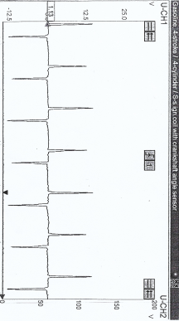
Appendix

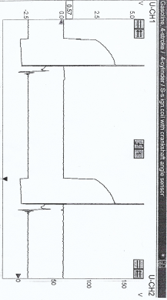

Figure 7 Crank sensor signal (Jetronic)

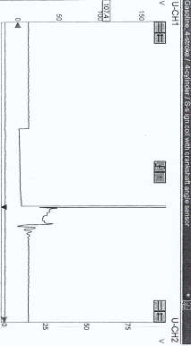
Figure 8 Ignition amplifier spark advance and primary signals (Jetronic)

Figure 9 Ignition amplifier primary signal (Jetronic)

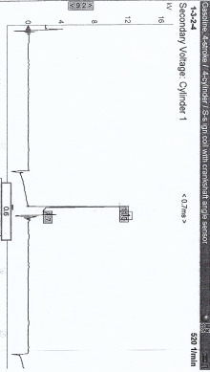

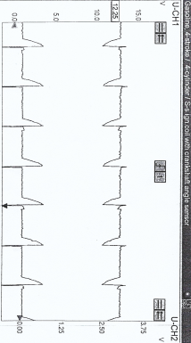

Figure 10 Secondary coil voltage signal (Jetronic)

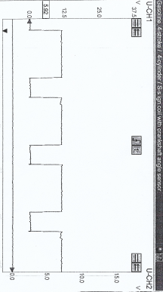

Figure 11 Ignition amplifier supply and earth signals (Jetronic)

Figure 12 Control unit engine speed output (Jetronic)

Table 5 Throttle potentiometer resistance data (Jetronic)
Table 6 Coolant temperature sensor resistance data (Jetronic)
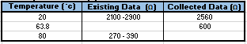

Table 7 MAF sensor resistance data (Jetronic)

Table 8 Injector solenoid resistance data (Jetronic)


Table 9 Ignition coil resistance data (Jetronic)

Table 10 High temperature lead resistance data (Jetronic)


Table 11 Battery voltage (Jetronic)
Table 12 Fuel control unit voltage (Jetronic)
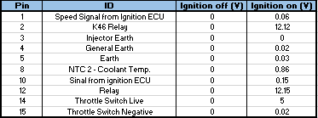

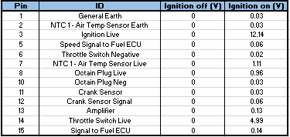
Table 13 Ignition control unit voltage (Jetronic)

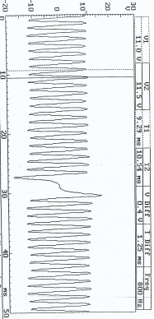

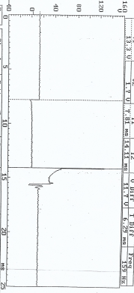
Figure 14 Ignition primary signal (Motronic)

Figure 13 Crank sensor signal (Motronic)

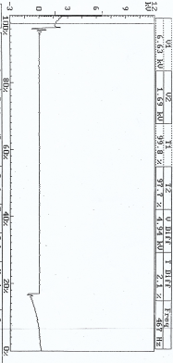

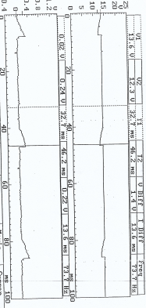
Figure 15 Ignition secondary signal (Motronic)

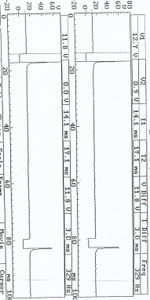
Figure 16 Ignition supply and earth signals (Motronic)

Figure 17 Injector bank 1 and 2 signals (Motronic)

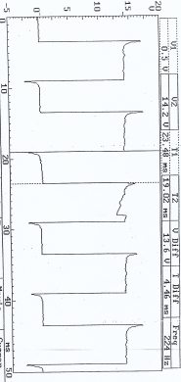
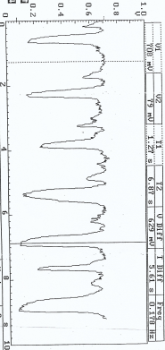
Figure 18 Lambda sensor signal (Motronic)

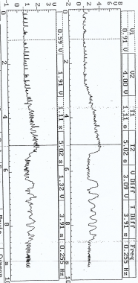

Figure 19 Rotary idol valve signal 80°C (Motronic)

Figure 20 MAF sensor & Throttle potentiometer signals (Motronic)

Table 14 Throttle potentiometer resistance data (Motronic)

Table 15 Coolant temperature sensor resistance data (Motronic)


Table 16 MAF sensor resistance data (Motronic)


Table 17 Air temperature resistance data (Motronic) (Engine - 54°C / Air - 20°C)

Table 19 Injector valve resistance data (Motronic)
Table 18 Idle control valve resistance data (Motronic)



Table 20 Ignition coil resistance data (Motronic)

Table 21 Ignition lead resistance data (Motronic)


Table 22 Battery voltage (Motronic)

Table 23 Engine control unit voltage (Motronic)


