

BA International Hotel Management

Hotel Placement Research Project

BMIH6008

Topic: Food and Beverage

Research Title: A Case Study of Food and Beverage Operations at Ibis Birmingham New Street Station Hotel
Student Name: Daniela Gabriela Vartolomeu
Student ID:2130495
Supervisor Name: Ben Chong

AI Acknowledgement
I confirm that I have not used any AI tools in the research and creation of this assignment. I confirm that I have not presented any AI-generated materials as my own work. I confirm I have copies of my drafts, notes, and other resources I used, which I may be asked to provide in evidence

Abstract
This study aimed to evaluate food and beverage service efficiency and customer satisfaction at Ibis Birmingham New Street Station. Secondary qualitative data on customer satisfaction, operational efficiency, and progress comes from journals and websites. Examine how hotel food and beverages enhance guest satisfaction and efficiency. Customers like food quality, service quickness, and staff interactions. Poor service and food may annoy guests. Poor kitchen, workforce, and peak-hour demand management reduce service quality. Customer satisfaction and service speed drop, resulting in bad reviews.
This research also offers recommendations for the hotel. Good staff training increases customer service and experience. Optimising operating models and culinary methods speeds service. Third, online booking and ordering could reduce wait times and boost guest satisfaction. Fourth, departmental communication helps visitors. Finally, sustainable food sourcing and waste management save money and meet customers' growing sustainability expectations. This research exposes operational issues and offers methods Ibis Birmingham New Street Station can improve food and beverage, customer satisfaction, and efficiency. Addressing these concerns will help the hotel succeed.

Table of Contents
Abstract 2
Introduction 5
Background to the Research Project 5
Aims, Objectives and Questions 5
Overview of the Case Study 6
Key Topic to Be Explored 6
Literature Review 7
Food and Beverage Operations in Hotels 7
The relationship between food and beverage service efficiency and customer satisfaction 7
Operational challenges in food and beverage management 8
Strategies to enhance food and beverage service efficiency 9
Research Gap 11
Methods 12
Case Study Hotel 15
Descriptive Information 15
SWOT Analysis 17
PEST Analysis 19
Competitor Analysis (Price vs Quality) 21
Netnography 22
Reflection 24
Discussion 26
Customer Preferences and Satisfaction Levels Regarding Food and Beverage Services of Ibis Birmingham New Street Station 26
Impact of Food and Beverage Operations on Customer Satisfaction 27
Assessing Operational Challenges and Efficiency in Food and Beverage Management 28
Strategies to Enhance Food and Beverage Service Efficiency 30
Exploring Implications of This Study 31
Acknowledging Limitations of This Study 32
Valuable areas critical to Ibis Birmingham New Street Station’s operation 32
Conclusion and Recommendations 34
Conclusion 34
Recommendations and Practical Strategies 35
References 38

Introduction

Background to the Research Project
Food and beverage is one of the most important aspects of a hotel which determines whether a hotel will have success or not. It makes up 30% of hotel income (Statista, 2024). Good food and drink boosts guest satisfaction, retention, and reviews. According to UK Hospitality (2023), 72% of hotel guests value food and drink and 65% said poor service will deter them. Good food and beverage operations make dining easier, increasing sales and loyalty. Hotel food production, presentation, and service must improve to compete. Ibis Birmingham New Street Station, an Accor Group hotel, is affordable for business and leisure tourists (Balloo, 2024). Mid-sized hotel food and beverage managers like Ibis Birmingham New Street Station must combine efficiency, customer preferences, and operational restrictions. These elements help implement strategic improvements. This study investigates hotel food and beverage operations utilising these traits.

Aims, Objectives and Questions
Aim
- The research aims to evaluate food and beverage service efficiency and customer satisfaction at the hotel.
Objectives
- To conduct an extant literature review of food and beverage management in the hospitality sector.
- To analyse customer preferences and satisfaction levels regarding food and beverage services at the hotel.
- To assess operational challenges and efficiency in food and beverage management at the hotel.
- To make recommendations for improving food and beverage service quality and operational efficiency.
Questions
- How do food and beverage operations at Ibis Birmingham New Street Station impact customer satisfaction?
- What strategies can enhance food and beverage service efficiency at Ibis Birmingham New Street Station?

Overview of the Case Study
In over 70 countries, Accor Group Subsidiary Ibis Hotels is a popular cheap hotel. The hotel is conveniently accessible at 21 Ladywell Walk, Birmingham B5 4ST, UK, near Birmingham New Street Station (Accor.com, 2025). This Ibis, one of Accor's 1,200 hotels, fulfils service standards. Food and beverage offerings shape the guest experience, resulting in 7.8/10 online guest satisfaction in 2023 due to its prominent location (Tripadvisor, 2025). With reasonable lodging and great service, the brand prioritises convenience. Ibis Birmingham New Street Station's accessibility to transit, shopping, and business districts draws foreign and domestic tourists. The hotel serves breakfast, all-day dining and a bar. These services must be efficient to ensure a smooth dining experience. Food and beverage operations in budget hotels must balance cost and quality (McComb, 2024). Consumer expectations, service performance, and operational changes are examined in Ibis Birmingham New Street Station's food and beverage operations. The findings can assist mid-sized hospitality businesses improve service.

Key Topic to Be Explored
Food and beverage companies should study service efficiency, customer happiness, and operations. The study concluded that these elements impact Ibis Birmingham New Street Station's business and customer experience (Cousins et al., 2022). Customer engagement and service quality will be evaluated in food and beverage management. Hotel food and beverage staff will receive efficiency and customer satisfaction suggestions. Food and beverage management research improves cheap hotel service.

Literature Review

Food and Beverage Operations in Hotels
Hotel food and beverage operations affect guest satisfaction and performance. According to Boussard (2021), hotel food and beverage operations encompass menu planning, food preparation, service delivery, and quality control. These firms need effective management to boost output, customer satisfaction, and cost control. Cousins et al. (2019) report that mid-scale hotel restaurants generate 30-40% of hotel revenue when handled well. Food and service promote guest satisfaction and repeat business. Good food hygiene, presentation, and service improve consumer perceptions.
Budget hotels have trouble managing food and drink. Mun, Woo and Seo (2020) list labour constraints, food price fluctuations, and customer preferences as operating challenges. Computerised ordering and staff training may overcome these issues and improve service efficiency. Improving food and beverage operations requires technology integration. Molina et al. (2021) claim self-service kiosks, smartphone ordering apps, and AI-driven kitchen management systems have slashed hotel dining wait times by 20-30%. The study found that tech-driven solutions boost efficiency and customer satisfaction. Food and beverage operations must balance quality, efficiency, and industry changes. Management must be effective for guest satisfaction and economic success.

The relationship between food and beverage service efficiency and customer satisfaction
Hotel visitors want to enjoy great food and beverages. Goh et al. (2022) define hotel food and beverage service efficiency as timely, high-quality, and cheap meals and drinks. Service efficiency reduces wait times, fulfils orders, and maintains food quality, increasing visitor experiences. Tan and Despotis (2021) found that 78% of hotel guests like fast food and drinks. Long wait periods and poor service reduce customer satisfaction. The study also found 30% higher guest satisfaction in hotels with automated ordering and kitchens. Eating habits and technology have transformed food and beverage service. Mun, Park and Woo (2022) found that urban hotel business guests want personalised service, flexible eating, and speedy order processing. Hotel guests and revenue may suffer without these criteria. Chawla, Lugosi and Hawkins (2021) prioritised food quality and quickness over personalisation. Hotels with good service satisfy customers without modification.
The food and beverage operations of a hotel need skilled workers and fast service. Based on Mahafzah et al. (2020), hotels with structured staff training reduced service issues by 25% and improved customer satisfaction. Okumus et al. (2020) claim that well-trained workers can handle meal delivery, client complaints, and high service demand. Poorly trained staff lose orders, delay service, and disappoint customers. Service efficiency improves with tech. According to Jeaheng, Al-Ansi and Han (2020), hotels using self-service kiosks and mobile ordering apps reduced order processing times by 40%, improving customer satisfaction. Ivanov and Webster (2022) observed that digital solutions speed up operations and reduce the need for large service teams, reducing human costs without affecting quality. Overusing technology without adequate human interaction may lead to impersonal service, which guests may detest. Food and beverage efficiency impacts hotel visitors' enjoyment. Service efficiency improves brand image, customer satisfaction, and retention. Hotel guests’ value trained staff, technology, and consistency.

Operational challenges in food and beverage management
Hospitality food and beverage management impacts service, profitability, and satisfaction. Inventory management, staff training, supply chain disruptions, and shifting customer expectations plague food and beverage companies, according to Davis et al. (2018). Organisational efficiency and service quality require strategic planning and process improvement.
Tan and Despotis (2021) discovered that inventory management inefficiencies squander 15-20% of hotel food, costing money and harming the environment. Due to poor demand forecasting, stock control, and storage, excess inventory or stock shortages damage food quality and customer service. Hayes, Ninemeier and Miller (2017) found that automated inventory systems cut hotel food waste by 25% and improved cost control. Automation cannot eliminate errors due to system breakdowns and human oversight.
Food and beverage management staff training and retention concerns. Serafim, Stangarlin‐Fiori and Hecktheuer (2018) claim high hospitality employee turnover affects service quality, raises training costs, and disrupts business. Dopson and Hayes (2020) found structured training enhanced employee performance and customer satisfaction by 30%. Workplace stress, long hours, and competitive job markets make talent retention hard. The authors claimed that strong remuneration and career opportunities stabilise work and reduce turnover.
Disruptions affect food and beverage supply systems. Walker (2020) states that global supply chain instability, rising food prices, and inconsistent delivery periods reduce menu uniformity and service reliability. Hotels adjust procurement and locate new suppliers to reduce risk due to disruptions. Yacoub and ElHajjar (2021) found local sourcing improved hotel supply reliability and cost. Rural restaurants may charge more and offer fewer alternatives.

Figure 1: Operational challenges
Source: (Tan and Despotis, 2021)
Food and beverage management is complicated by customer tastes. Hotels must offer healthier, sustainable, and personalised meals, according to Chan and Hon (2020). Hotel guests with plant-based and sustainable food were 20% happier. These changes raise operational costs and supplier constraints. As customer expectations shift, Koseoglu et al. (2019) found that service quality and food presentation are key to visitor enjoyment. Hospitality food and beverage enterprises face efficiency, cost, and visitor satisfaction issues. Successful operations require inventory efficiency, labour retention, supply chain risk minimisation, and consumer expectations. Service is improved via strategic technology, training, and sustainable sourcing initiatives.

Strategies to enhance food and beverage service efficiency
Hotel profitability, customer satisfaction, and competitiveness depend on food and beverage efficiency. Technological integration, staff training, menu optimisation, and process homogeneity boost service. Hotels with structured service efficiency retain and attract consumers, argues Narendratama and Wijoyo (2025). According to Limna (2023), technological integration minimises wait times and speeds up order processing, enhancing service efficiency. Mobile payments, self-service kiosks, and digital ordering reduce errors and accelerate transactions. The hotel with automated kitchen display systems reduced order processing time by 40% and increased kitchen-service coordination. Technology may alienate traditional customers.
Food and beverage service efficiency depends on worker training. Vitsentzatou, Tsoulfas and Mihiotis (2022) found that staff training boosts hotel service speed and accuracy by 25%. Staff training improves product understanding, customer engagement, and high-demand scenario management. Truong et al. (2020) found that extensive time management, multitasking, and conflict resolution training improved service delivery. Employee motivation and organisational culture affect service efficacy more than technical abilities. Training helps.
Menu optimisation also improves food and beverage operations. Cheong et al. (2021) believe well-curated, simplified meals save money and time by simplifying labour and ingredients. Camilleri (2021) found that dynamic pricing and seasonal menu changes boosted hotel efficiency by 15%. Regular menu changes can disrupt kitchen workflow and need staff training. Process standardisation boosts service efficiency. Teng, Hu and Chang (2019) found that hotels with fixed table layouts and workflow systems improve service efficiency by 30%. Duty allocation and clear communication reduce service delays and improve teamwork. Amicarelli et al. (2021) claim standardised methods eliminate operational bottlenecks and increase worker efficiency.
Service management efficiency improves with data analytics. Wang and Teng (2019) found that consumer data and predictive analytics improve hotel staff, inventory, and demand estimations, reducing waste and enhancing service. Bharwani and Mathews (2021) believe data-driven decision-making helps hotels predict busy hours, modify menus, and speed service. Budget hotels may struggle with data analytics since it requires software and expertise. Sustainable food and beverage services boost efficiency. Gim et al. (2025) found that eco-friendly packaging, trash minimisation, and energy-efficient kitchen appliances cut hotel costs by 20%. Buhalis and Moldavska (2021) found sustainable sourcing and portion control boost inventory and service efficiency. Small businesses may struggle with sustainability project start-up costs.

Research Gap
Hotel food and beverage service efficiency literature addresses customer happiness, operational concerns, and strategic changes. Service efficiency at budget hotels like Ibis Birmingham New Street Station is uncertain (Tsui and Chen, 2020). Previous studies researched service efficiency in luxury and mid-range hotels, while budget hotels with limited resources and high client turnover have received less attention. Mid-scale hotel food and beverage service efficiency and customer satisfaction are also poorly studied. Most studies have addressed service efficiency trends but not budget hotel operational issues including staff management, menu optimisation, and technology adoption. To remedy these gaps, secondary qualitative research examined budget hotel food and beverage management literature, industry reports, and case studies (Spanaki, Papatheodorou and Pappas, 2021). This method evaluates Ibis Birmingham New Street Station's efficiency, customer satisfaction, and service improvements.

Methods
A case study was used as the methodological approach to assess food and beverage operations at Ibis Birmingham New Street Station. A company's service, operations, and customer satisfaction are studied. Quinlan et al. (2019) claim case studies provide contextual insights that broader research cannot. Mid-scale hospitality food and beverage management dynamics were best understood through case studies. Conclusions are organization-specific and may not apply to the industry, limiting generalizability. Mid-scale hospitality case studies demonstrate service, efficiency, and customer experience best practices.
Positive thinking supported the study. Positivism promotes objective knowledge through facts and analysis. This study employed business reports, historical case studies, and academic literature, therefore positivism worked. Positivism ensures credible and replicable research through order and rigour (Zikmund, Babin and Griffin, 2017). Positivism restricts consumer satisfaction studies. Positivism ensures factual and reliable research despite this restriction.
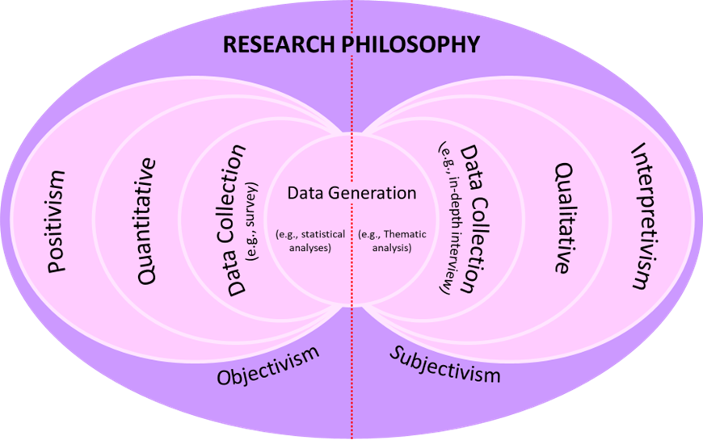
Figure 2: Research Philosophy
Source: (Bell, Bryman, and Harley, 2022)
Deductive reasoning evaluated hotel food and beverage and client happiness. Deductive reasoning applies theories to specific settings to justify knowledge (Schindler, 2022). Using food and beverage management, Ibis Birmingham New Street Station is studied. Research comparisons are easier using deduction. It does not develop new theories or notions outside of literature. The rational technique measured hospitality service efficiency and client experience despite this flaw.
This study employed solely secondary qualitative data from academic journals, industry reports, hotel performance reviews, customer satisfaction studies, and government or hospitality sector publications. Secondary data on food and beverage management trends, operations, and customer expectations is cheap and fast (Collis and Hussey, 2021). Full Ibis Birmingham New Street Station service efficiency review data was validated by many sources. Secondary data collection has downsides. This investigation disregarded Ibis Birmingham New Street Station's food and beverage operations, which may be missing. The accuracy and usefulness of secondary data affect trustworthiness. Validating the findings needed current, credible articles. Despite constraints, secondary data analysis reveals hospitality food and beverage service efficiency.
The study analysed secondary qualitative data by applying thematic analysis. Thematic analysis finds themes in qualitative data (Bell, Bryman, and Harley, 2022). This strategy showed operational concerns, client preferences, and food and beverage efficiency. The steps of thematic analysis:
Steps | Analysis
Data Familiarisation | Studying academic literature, industry reports, and consumer input to understand hotel food and beverage service efficiency.
Theme Identification | Ibis Birmingham New Street Station satisfaction, service, and operational trends.
Interpretation and Discussion | How food and beverage efficiency influences consumer satisfaction.
Table 1: Thematic analysis
Saunders, Lewis and Thornhill (2019) suggest thematic analysis helps qualitative researchers discover nuance in complex datasets. Thematic analysis' subjective theme selection may prejudice researchers. Multiple secondary sources were used to pick themes for fair and impartial data analysis. Using secondary sources and academic integrity ensured ethical research. Ethical research requires reliable sources, unbiased analysis, and no bias. Marshall and Rossman (2016) claim that removing people from secondary research prevents informed consent and data protection. Ethics can arise while reporting sources and assessing results impartially. Scholarly data and findings were properly cited to avoid plagiarism and provide openness. Reliable hospitality research requires ethics.

Case Study Hotel
This section includes the placement hotel's brand, location, SWOT, PEST, Competitor Analysis, and Netnography. The case study examines Accor Group's Ibis Birmingham New Street Station. Studying hotel operations, food and beverage, and visitor experience.

Descriptive Information
Ibis Birmingham New Street Station, 21 Ladywell Walk, Birmingham B5 4ST, UK, is owned by Accor. Guest rooms at Ibis budget hotels globally are affordable and high-quality. The city centre position and walking distance from Birmingham New Street Station make it perfect for business and leisure tourists (Joshi, 2024). The motel has 120 cheap rooms. These rooms offer air conditioning, flat-screen TVs, and free Wi-Fi. The hotel's bar and restaurant provide many cuisines. Service, satisfaction, and value are hotel priorities.
Turnover and Financial Performance: The varied Accor portfolio increases brand profitability, including Ibis Birmingham New Street Station. Competitive pricing and affordability boost occupancy at UK Ibis hotels, although turnover data is unavailable. Ibis targets budget-conscious customers with efficiency and Accor's brand awareness. Accor, which owns Ibis, generated €13.6 billion in 2021 from 5,100 hotels in 100 countries under different brands (Cambon, 2024). Budget-friendly Ibis brings Accor money.
Staffing and Operations: Budget hotel Ibis Birmingham New Street Station is good. Hotel reception, housekeeping, food and beverage, and maintenance employ 50-60 individuals (Booking.com, 2025). Tourists expect affordable, comfortable lodgings, so personnel are trained to provide basic service. Hotels offer fast check-in, check-out, room cleaning, and maintenance to boost customer satisfaction and minimise costs. High occupancy rates require extra staff during peak hours to handle guests. To help guests, all employees receive customer service training.
Number of Branches and Locations: Ibis has hotels in major cities worldwide. London, Manchester, Edinburgh, and Glasgow have Ibis hotels. Market share grows for Midlands hotel Ibis Birmingham New Street Station. In Birmingham, a UK business and tourism hub, Ibis thrives. Over 1,200 Ibis hotels offer affordable accommodation globally (Birmingham, 2024). For site-wide comfort and quality, Ibis standardises services and amenities. This global network lets Ibis service several markets and improve Accor Group revenue.
Geographical and Cultural Context: Second-largest British city is Birmingham, West Midlands. A diverse population, industrial background, and lively arts scene make the city a cultural and economic hub. A vibrant 2.7 million-person city, Birmingham attracts millions (WPR, 2024). Birmingham museums, galleries, Symphony Hall, and Bullring shopping centre draw visitors. The city's diverse cuisine, strong retail sector, and active nightlife draw tourists and businesspeople. Birmingham's New Street train station is among the UK's busiest. Birmingham's modern comforts and historical significance draw UK and foreign visitors, affecting hospitality demand (Birmingham.gov.uk, 2024). Its bustling atmosphere draws business travellers, international visitors, and domestic passengers to Ibis Birmingham New Street Station.
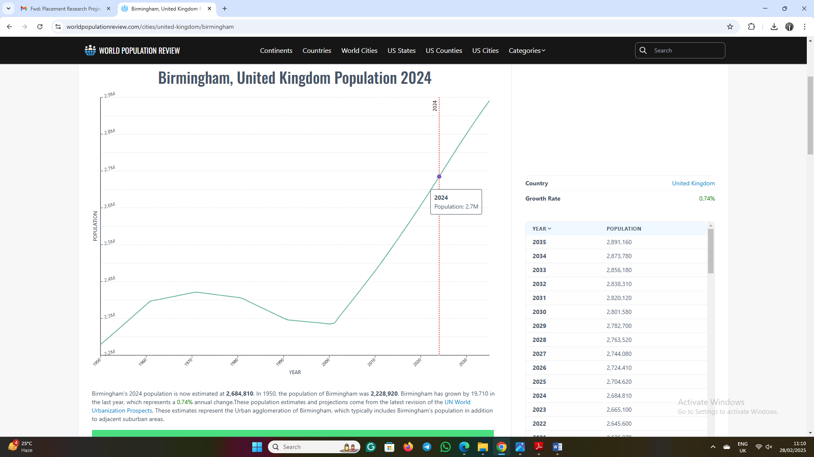
Figure 3: Birmingham's Population
Source: (WPR, 2024)
Location Context: Hotels near Birmingham New Street Station are close to attractions and transit. Birmingham New Street Station, the UK's busiest railway station outside London, handles regional, national, and international trains (Britannica, 2024). City and hotel exploration is convenient from Ibis Birmingham New Street Station. Near the city's business and shopping districts, the hotel benefits culturally and geographically. Short-term stays, conferences, and leisure travel are available due to its proximity to landmarks, cultural institutions, and corporate hubs.
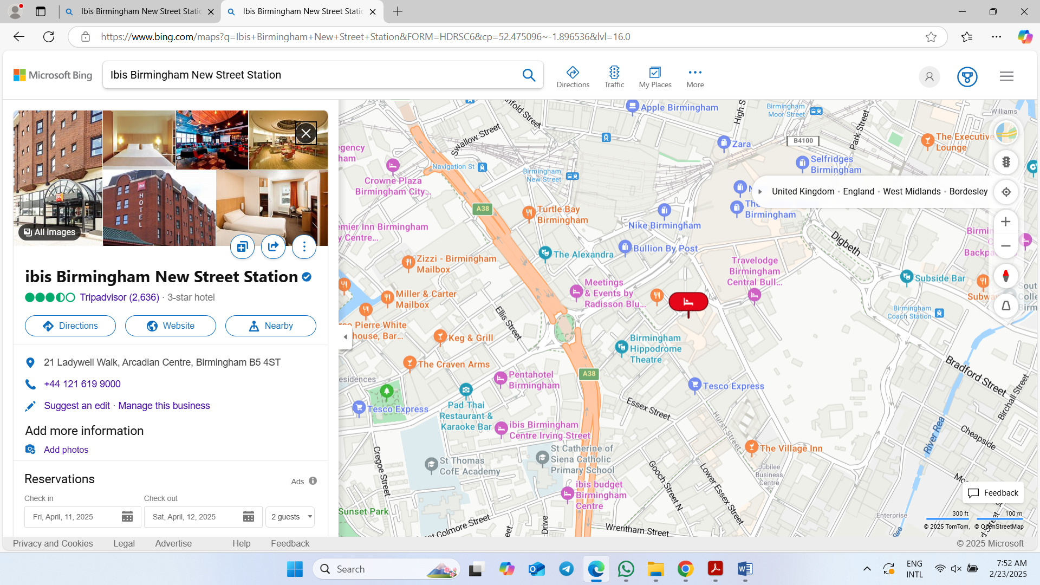
Figure 5: Birmingham New Street Station
Source: (Google Maps, 2024)

SWOT Analysis
SWOT analysis is an effective tool to assess where the hotel is doing well and the areas in which needs improvement. A detailed SWOT analysis of the business is given below:
Strengths: One of the UK's busiest train stations is near Ibis Birmingham New Street Station. This method boosts occupancy and revenue by attracting business and leisure tourists. Desirable location near major shopping, entertainment, and corporate headquarters (Agoda.com, 2025). Accor-owned Ibis is well-known and trusted. Global presence ensures service standards and access to a big client base through loyalty programs like Accor Live Limitless. Accor's central booking, marketing, and service guidelines help operations. Budget hotels prioritise efficiency and service. Regular room layouts, basic design, and effective cleaning lower operational costs. Automatic check-in and digital key access save time and money (Miranda, 2022). All Ibis hotels provide the same service. A 24-hour front desk, complimentary Wi-Fi, and on-site dining reassure guests and encourage repeat bookings. This stability appeals to budget tourists who trust their hotels. Food & beverage, conference room rents, and local company collaborations provide revenue beyond hotel bookings.
Weaknesses: The budget Ibis Birmingham New Street Station lacks a spa, gymnasium, and concierge. Not having these amenities makes it less appealing to luxury travellers and less competitive with mid-range and posh hotels. Space-saving rooms maximise occupancy. This may not suit families or business travellers. Comfort-seeking guests may select competition with larger rooms and more amenities (Cambon, 2024). Hotel visitors are mostly budget and business travellers. Business travel and recessions affect occupancy. Conferences increase peak occupancy but vary in demand. Overcrowding may occur due to the popularity of affordable, convenient accommodations. The lobby, restaurant, and bar may be packed, hurting the stay. Peak-hour restaurants with limited seating may disappoint.
Opportunities: More Birmingham visitors desire cheap lodging. Ibis Birmingham New Street Station can capitalise on cheap stays with better customer involvement and marketing. AI-driven customer service, smartphone check-ins, and tailored bookings boost productivity and satisfaction (Ali, 2023). Automation of smart rooms and customer service could improve the experience. Eco-friendly hygiene, energy-efficient lighting, and plastic reduction can be implemented as environmental awareness rises. Green hotels attract guests and improve their reputation. Themed dining, local products, and extended hours may improve restaurant and bar traffic. Meal delivery platform deals improve non-resident revenue (Wu, Li and Liu, 2024). Attract corporate clients with business traveller packages, loyalty programs, and long-term contracts. Networking, small business events, and corporate training may increase reservations.
Threats: Birmingham has various inexpensive and mid-range hotels in the city centre, making hospitality competitive. Threatening competitors have gyms or larger rooms at the same price. Consumer expenditure, inflation, and recessions affect travel (Hotels.com, 2025). Airbnb may draw cheap tourists during financial crises, reducing hotel revenue. Telecommuting and digital nomadism may require hotels to upgrade their in-room workplaces and internet speeds. Not meeting changing expectations may harm client reservations. It's hard to find and keep good hosts. Employee turnover, wage increases, and workforce shortages can impair service efficiency and customer satisfaction (Easyhotel.com, 2024). Hotel operations and service might suffer from staff turnover. Operating costs might rise due to government regulations, taxes, and safety. Corporations need post-pandemic health and safety procedures.
Strengths | Weaknesses | Opportunities | Threats
Prime city-centre location | Limited luxury amenities | Growth in the budget travel market | Intense market competition
Strong brand reputation (Accor Group) | Small room sizes | Technology integration for efficiency | Economic uncertainty
Cost-effective operations (IBIS, 2025). | High dependency on budget travellers | Sustainability initiatives | Changing customer expectations (Wu, Li and Liu, 2024).
Consistent customer experience | Potential overcrowding | Enhanced food and beverage services | Staffing and labour shortages
Diverse revenue streams | Seasonal demand fluctuations | Corporate client engagement | Regulatory and legal changes
Table 2: SWOT Analysis

PEST Analysis
Political Factors: UK hoteliers must follow safety, employment, and data protection laws. This law raises prices at inexpensive hotels like Ibis Birmingham New Street Station. Brexit may cut EU hospitality workers, worsening staffing shortages (Tourky et al., 2020). Immigration laws hinder hiring. VisitBritain eases visas and promotes tourism. Budget hotels profit from price-conscious tourists. Higher VAT on hospitality services may affect pricing and profitability.
Economic Factors: Inflation and living costs affect hotel bookings and spending. Cheap visitors keep Ibis Birmingham New Street Station going. Cost-cutting or price changes may be needed to maintain profitability if utilities, salaries, and supply chain delays rise. Economic downturns, currency rate changes, and global financial volatility affect tourism (Abdullah, Sufi and Kumar, 2023). A weak pound can boost UK hotel tourism by attracting foreigners. Economic uncertainty reduces business travel and hotel occupancy since businesspeople are budget travellers. Hospitality demands adaptable workers. Budget hotels suffer from growing minimum wages and worker shortages. Brexit recruitment concerns may affect service quality and efficiency.
Social Factors: Digital ease, sustainability, and customisation are rising. Budget hotels are popular, but contactless check-ins, eco-friendliness, and better in-room tech are shifting expectations. Budget hotels must follow these trends to compete. COVID-19 boosted domestic tourism and city escapes (Panzone, Larcom and She, 2021). This helps Ibis Birmingham New Street Station attract locals seeking affordable city centre lodging. Regional tourism promotion in the UK keeps demand. The diverse UK city of Birmingham draws travellers. Multilingual staff, culturally inclusive services, and diverse food boost guest happiness (Hamid, Azhar and Sujood, 2022). International travellers must be accommodated; especially as inbound travel trends change.
Technological Factors: AI-powered customer service, mobile check-ins, and digital keys modify visitor expectations. Budget hotels' productivity and customer satisfaction increase. Affordable technology helps Ibis Birmingham New Street Station compete. Commission costs lower profit margins, therefore OTA dominance affects pricing (Forlani, Dini and Pencarelli, 2022). Budget hotels may boost direct bookings and lessen third-party dependence with a better website and loyalty program. Hotels handling visitor data must follow UK data protection rules, including GDPR. Transaction and consumer data are protected by cybersecurity for confidence and compliance.
Factor | Impact on Ibis Birmingham New Street Station
Political | - Compliance with regulations increases costs  - Brexit affects labour availability  - Tourism policies influence occupancy rates.
Economic | - Inflation impacts consumer spending  - Fluctuating travel demand affects occupancy  - Rising wages create financial pressures (Lu and Tabari, 2019).
Social | - Changing guest preferences drive demand for digital services  - Domestic tourism boosts budget hotel stays.
Technological | - Digital innovations enhance efficiency  - Reliance on OTAs affects pricing  - Cybersecurity investments ensure data protection.

Competitor Analysis (Price vs Quality)
Budget hotels like Ibis Birmingham New Street Station compete on pricing and service. The hotel competes with Premier Inn Birmingham City Centre (New Street Station), Holiday Inn Express Birmingham - Snow Hill, Travelodge Birmingham Central, and Hampton by Hilton Birmingham Broad Street in the city centre (Leonardohotels.co.uk, 2025). Each competitor offers business and leisure tourists varied prices, amenities, and services.
The pricing strategy used by the hotel put it into the mid-range budget hotel category. The rooms cost £60–£90 per night, cheaper than Premier Inn and Holiday Inn Express but more than Travelodge (Skyscanner.net, 2025). Premier Inn Birmingham City Centre (New Street Station) charges £70–100 per night for larger rooms, Hypnos beds, and a superb restaurant. For £75 to £110 per night, Holiday Inn Express Birmingham - Snow Hill provides corporate guests free breakfast and sophisticated business conference facilities. Travelodge Birmingham Central, with few amenities, is the cheapest at £35–£80 per night (Trivago.co.uk, 2025). For £85 to £130 per night, Hampton by Hilton Birmingham Broad Street offers business travellers and high-end budget visitors’ free breakfast, a fitness centre, and excellent linen.
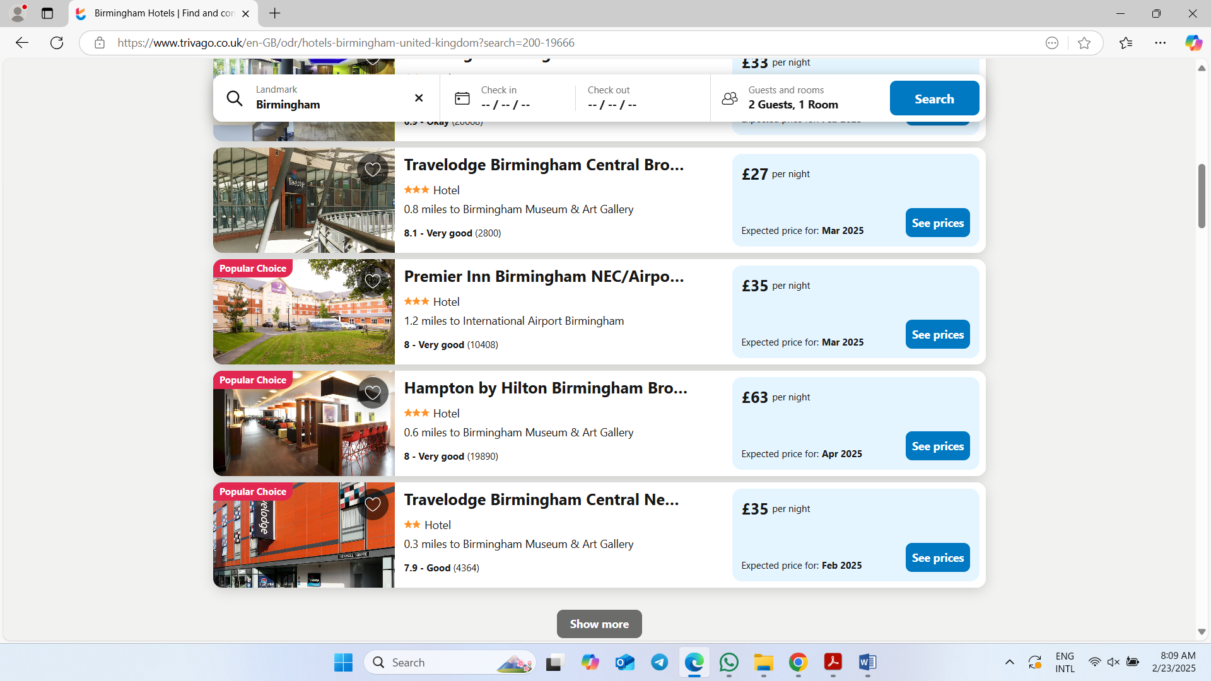
Figure 6: Price
Source: (Trivago.co.uk, 2025)
Ibis provides wonderful amenities and service. Both short-term and long-term guests can enjoy free Wi-Fi, 24-hour reception, and a restaurant and bar. Premier Inn and Holiday Inn Express have free breakfast, larger rooms, and superior bedding (Attar, Amidi and Hajli, 2022). Hampton by Hilton's gym and business centre draws long-term business travellers. Budget travellers like Travelodge, are the cheapest but least served. Consumer perception drives competition. Ibis Birmingham New Street Station offers value, convenience, and service. Smaller accommodations and a lack of premium services may irritate guests seeking a better experience. Budget-conscious travellers seeking comfort choose Premier Inn's strong brand and great service (Massidda, Piras and Seetaram, 2022). The modern decor and free amenities of Holiday Inn Express attract business travellers seeking convenience. The low-cost Travelodge earns average reviews for its minimal features. Hampton by Hilton is a luxurious budget hotel with exceptional service.
Brand competition exists for Ibis Birmingham New Street Station. Premier Inn and Holiday Inn Express led with customer loyalty and strong marketing. Travelodge's low costs attract budget tourists, strengthening economy category competition. To compete, Ibis may offer better rooms, more breakfast options, and personalised loyalty awards (Yacoub and ElHajjar, 2021). Ibis Birmingham New Street Station thrives in budget hotels with affordability and amenities. The competition from Premier Inn, Holiday Inn Express, and Hampton by Hilton necessitates constant guest experience and service enhancements. Strategic customer interaction, pricing flexibility, and service uniqueness could help the hotel compete in Birmingham's evolving hospitality market and attract more customers.

Netnography
Quality netnography of online consumer activity and interactions illuminates Ibis Birmingham New Street Station customer impressions. Online reviews, social media, and travel forums expose guest experiences, service expectations, and competitive positioning. Google Reviews, Booking.com, TripAdvisor, and social media show user changes (Tripadvisor.com, 2025). Hotel visitors like its proximity to Birmingham New Street Station and attractions. People value convenience over shopping, transportation, and leisure. Though cheaper than Premier Inn and Holiday Inn Express, the motel is popular. Regular cleaning and service improve hotel efficiency.
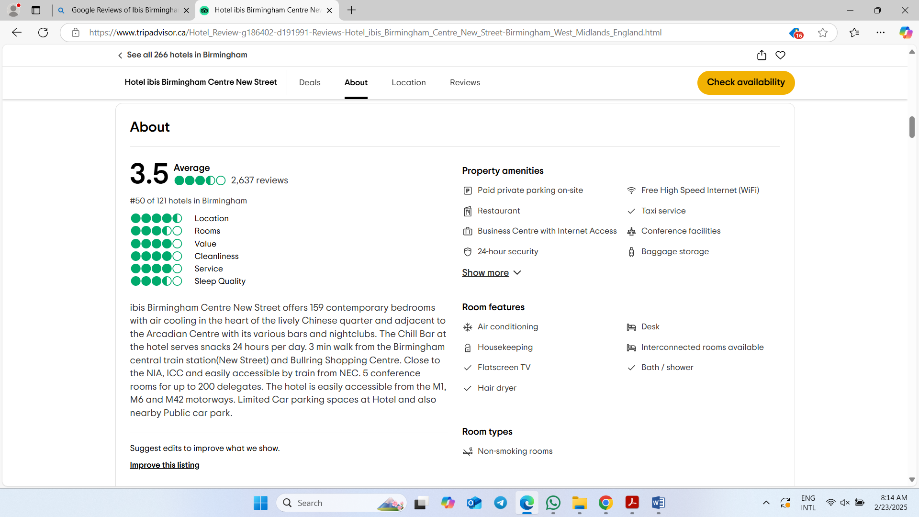
Figure 7: Reviews
Source: (Tripadvisor.com, 2025)
Small rooms, noise, and amenities are big issues. Guests worry about small rooms and luggage storage. Night-time and street noise disturb light sleepers. Free Wi-Fi and a restaurant are appreciated, although breakfast and soundproofing are needed. Premier Inn and Hampton by Hilton get better scores for larger rooms and amenities (Wu, Li and Liu, 2024). Social media indicates customer service expectations and preferences. Customers praise the hotel's fast resolution of concerns on Twitter and Facebook, driving brand engagement. Instagram photographs of the hotel's trendy design and good location attract youthful and corporate guests. Comparing luxury inexpensive hotels means longer stays with better rooms.
Booking platforms influence tastes. Comfort and facilities attract guests to better-rated competitors at comparable pricing. Promotions, loyalty, and flexible bookings keep customers. In travel forums, visitors compare Ibis Birmingham New Street Station to Travelodge and Holiday Inn Express (Booking.com, 2024). The hotel has great brand awareness and price, but service and facility improvements could improve satisfaction. It might improve its Birmingham hospitality market position by fixing netnographic research issues.
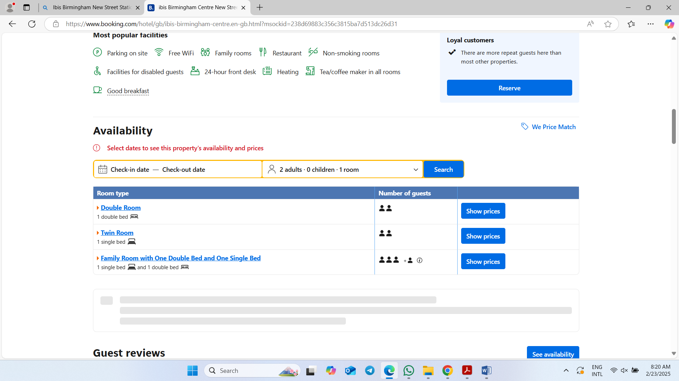
Figure 8: Booking Process
Source: (Booking.com, 2024)

Reflection
My time at Ibis Birmingham New Street Station showed me the hotel's strengths and weaknesses. Strategically near Birmingham New Street Station, hotel occupancy rose. I saw how the hotel's public transport attracted business and leisure tourists as a staff member. Easy city centre travel improved tourists' experience. The hotel was convenient, but I noted flaws that could prevent customers. Compact rooms were fine for budget travellers but scared visitors seeking larger accommodations (Wang and Teng, 2019). Many complained about room size, especially at peak hours. Hotel service coordination improved efficiency. However, its lack of luxurious amenities may dissuade purchasers. I considered Birmingham's competitive hotel industry, where guests have several options at similar prices with superb amenities.
I learnt to provide great service at busy hotels like Ibis Birmingham New Street Station. Speedy digital keys and automatic check-ins were great. I learnt technology can improve visitor experiences, which I hope to continue. Client behaviour let me discover evolving traveller demands. My interest in sustainability and eco-friendly behaviour grew from meeting new individuals. Younger hotel guests enjoyed its environmental efforts (Walker, 2020). I discovered sustainable hospitality can increase customer loyalty. Finally, Ibis Birmingham New Street Station taught me operations and hospitality. Price, central location, and service consistency were strengths. Ibis studied ways to better serve a diverse customer because of room and amenity constraints.

Discussion

Customer Preferences and Satisfaction Levels Regarding Food and Beverage Services of Ibis Birmingham New Street Station
Hotel food and drink dramatically affect client satisfaction. Ibis Birmingham New Street (BNS) Station's customer satisfaction studies reveal food and drink affect tourist experiences.
Customer Preferences: At Ibis Birmingham New Street Station, clients prioritise pricing, convenience, and simplicity. Budget hotels serve decent meals, but breakfast is cheap and convenient. Vegan, gluten-free, and healthful are popular (Vitsentzatou, Tsoulfas and Mihiotis, 2022). This follows industry trends of guests seeking special diet meals. Data promotes local, healthy, diverse options. Research suggests cheap hotels should serve better dietary-specific meals. Ibis Birmingham New Street Station guests desired healthier food. Gluten-free and vegan food may boost sales. Ibis Birmingham New Street Station's limited selections fail to meet customer expectations (UK Hospitality, 2023). Data reveals some customers prefer local or regional foods. Industry trends show guests prefer local food. Local features may enhance Ibis BNS's guest experience. Guest satisfaction and a unique hotel dining experience would result.
Satisfaction Levels: Ibis Birmingham New Street Station offers mixed meals and drinks. Customers like fast and efficient meal service, supporting industry claims that efficiency is key to customer pleasure (Tsui and Chen, 2020). Fast food delivery and pleasant service boost visitor happiness. Many critiqued meal variety and quality. Visitors expect better food even at cheap hotels, hence this let-down. Despite its good food, Ibis BNS cannot meet the growing demand for variety and quality. Diners felt diet-specific dishes lacked flavour, variety, and innovation. According to the literature, Ibis BNS's food demonstrates a hospitality sector shift towards variety and skill (Truong et al., 2020). Insufficient dining space was a guest issue. The space is efficient but lacks hotel cosiness. Industry study reveals that dining settings increase guest happiness, therefore Ibis BNS may improve dining rooms.
Comparison with Competitors: Premier Inn, Holiday Inn Express, and Ibis Birmingham New Street Station compete. These rivals offer healthier food. Breakfast at Premier Inn includes fruit and muesli to suit healthy eating demands. Food at Holiday Inn Express is gluten-free and vegan. The Ibis BNS menu is limited. Diet-friendly food outperforms hotel breakfast. Lack of variety and quality may reduce guest satisfaction compared to modern-diet competitors (Tourky et al., 2020). Not as elegant as its competitors, the Ibis BNS dining room. At Premier Inn and Holiday Inn Express, cosier dining rooms improve dining. To gratify customers and be nicer, Ibis BNS may renovate its eating space.

Impact of Food and Beverage Operations on Customer Satisfaction
Hotels like Ibis Birmingham New Street Station need food and drink. These services impact brand loyalty, satisfaction, and image. Data from customers and studies illustrate how this hotel's practices affect satisfaction compared to hospitality literature.
Customer Preferences and Satisfaction Levels: Quality, efficiency, and variety of hotel food and drinks affect guest satisfaction. Fast and convenient service is standard at Ibis Birmingham New Street Station. Business travellers commended the service's efficiency. Research reveals that efficiency is crucial to meeting guest expectations, and the hotel's rapid service meets the growing need for fast and convenient meals (Teng, Hu and Chang, 2019). The limited menu scared vegetarians and gluten-frees. This restriction follows consumer demand for healthier, inclusive menus. Although cultural and culinary diversity was limited, the meal was well-received. According to comprehensive hospitality research, modern hotel guests prefer meal variety and customising. More dietary options at Ibis Birmingham may improve customer satisfaction and connect the hotel with industry trends.
Quality of Food and Beverages: Food and drink quality greatly impacts satisfaction. While some Ibis Birmingham visitors appreciated the food, others found it generic. Research shows that tourist satisfaction depends on food quality (Tan and Despotis, 2021). Premier Inn and Holiday Inn Express in Birmingham had more inventive food than Ibis BNS. Many hotel dining surveys revealed consumers preferred fresher, tastier food. Ibis BNS might improve customer satisfaction by increasing its menu and employing local ingredients.
Atmosphere and Dining Experience: The atmosphere at Ibis Birmingham affects customer satisfaction. Studies showed that the dining area was efficient but lacked the warmth and ambience of high-end hotel dining rooms. Compared to competitors, Ibis BNS's dining room was plain. The literature shows that comfortable eating rooms satisfy guests (Spanaki, Papatheodorou and Pappas, 2021). Enjoyable seating, ambient lighting, and smart décor enhance food and beverage selections and guest enjoyment. Comfortable dining may also extend hotel restaurant stays.
Operational Efficiency: Efficiency in food and beverage operations boosts guest pleasure. Service at Ibis Birmingham is swift during peak hours. This supports evidence suggesting hotel dining service efficiency boosts satisfaction (Serafim, Stangarlin‐Fiori and Hecktheuer, 2018). Service speed boosts visitor satisfaction, especially for busy customers who prefer quick meals. Peak-time service speed complaints suggested staff training or capacity management difficulties. Premier Inn's policies and staff training may assist Ibis Birmingham.

Figure 9: Impacts
Source: (Teng, Hu and Chang, 2019)

Assessing Operational Challenges and Efficiency in Food and Beverage Management
Ibis Birmingham New Street Station's food and beverage management efficiency and operational issues affect customer satisfaction. The study addresses these issues and matches hotel operational efficiency research.
Staffing: Operations success depends on efficient staff. Visitors slow hotel service. Hotel operations literature emphasises staffing and training. Panzone, Larcom and She (2021) found that, understaffed or undertrained workers lower service quality. Peak-hour Ibis Birmingham wait times lower customer satisfaction. Good scheduling, cross-training, and peak-hour workers could improve service.
Inventory management: For the hotel, it is hard to control inventory. The survey found menu items sometimes run out. Okumus et al. (2020) discovered that poor hotel food and beverage inventory control upsets guests. Due to operational inefficiency, customers cannot order their desired dishes, affecting their experience. Modern inventory tracking and forecasting could reduce menu item stock-outs.
Variety and quality of menu: Food quality and selection are difficulties at Ibis Birmingham. Guests’ desire gluten-free and vegan options. According to Narendratama and Wijoyo (2025), modern clients expect menu diversity, and not offering it can cost the hotel business. Limited food may decrease hotel appeal. More inclusive and healthy food may increase customer loyalty.
Efficiency in service delivery: Optimise service delivery. Hotel food and beverage operations are efficient except during peak demand. Operations efficiency is crucial to timely guest service, argue Mun, Woo and Seo (2020). Ibis Birmingham visitors may detest meal delivery delays and waits. A more efficient kitchen and front-of-house staff could speed up service.
Layout of the dining area: The dining room layout impacts efficiency. Although functional, the design does not optimise service flow. Molina et al. (2021) say effective layout increases productivity and customer happiness. Remodelling the dining space to optimise worker and customer flow could save wait times and improve the meal.
Food and beverage operations literature examines Ibis Birmingham New Street Station's staff, inventory, menu variety, service efficiency, and layout. Staffing, inventory management, menu diversity, and operational processes could improve the hotel's food and beverage services, enhancing customer satisfaction and efficiency.

Strategies to Enhance Food and Beverage Service Efficiency
To improve food and beverage service, Ibis Birmingham New Street Station must address operational inefficiencies that affect customer satisfaction and staff performance. Several research and literature-based initiatives can improve service delivery and operations.
Implementation of advanced technology: Advanced technology is essential for the hotel's success. Technology improves hospitality efficiency, Miranda (2022) discovered. POS systems that communicate with Ibis Birmingham's kitchen may reduce errors, speed up order processing, and improve front-to-back communication. It enhances meal ordering and service speed. Guest mobile ordering could boost speed and satisfaction.
Staff training and development: Staff development matters as it will determine service quality. The research demonstrates that inexperienced staff provide inconsistent service. McComb (2024) advocates staff training to meet consumer expectations. A knowledgeable staff answers enquiries, serves meals swiftly, and provides great service. Training food and beverage personnel in several professions can help them manage busy hours and enhance efficiency.
Inventory management improvements: Massidda, Piras and Seetaram (2022) noted inventory control problems create stock-outs, delays, and customer dissatisfaction. Improved inventory management can use predictive analytics to forecast demand based on prior data to maintain supply at Ibis Birmingham. Preventing shortages and overstocking boosts efficiency. Food waste may decrease with just-in-time inventory, enhancing efficiency and profitability.
Streamlining kitchen workflows: Kitchens benefit from workflow optimisation. Kitchen efficiency is important for timely food delivery Mahafzah et al. (2020). To speed up service at Ibis Birmingham, the kitchen layout should optimise people flow and reduce food preparation time. Reorganising the kitchen staff's work distribution and division of labour could help them focus, reduce errors, and speed up service. Lean management optimises tasks and processes to reduce waste and boost efficiency.
Enhancing menu design: Design menus to improve service. Well-designed menus improve speed and consumer happiness, argue Lu and Tabari (2019). A brief menu speeds up kitchen staff, especially during busy periods. Few popular recipes may cook faster and better. Vegan and gluten-free choices may simplify the menu and satisfy customers.
Optimising service layout and flow: Enhancing dining room service flow is another option. Limna (2023) highlights efficient service layouts that allow personnel to move throughout the dining area and reduce wait times. Drink stations and food deliveries at Ibis Birmingham could be repositioned to improve worker movement and customer wait times. Changing seating could enhance dining room flow and accommodate more guests without sacrificing comfort.
Customer feedback systems: Customer feedback systems can recommend improvements. Hotel guests can submit real-time food and beverage feedback via surveys or digital systems. Studies show client tastes evolve, thus a good feedback system keeps guests happy. Koseoglu et al. (2019) found that business decisions based on consumer insights improve customer experience and goals.

Figure 10: Strategies
Source: (Mahafzah et al., 2020)

Exploring Implications of This Study
Ibis Birmingham New Street Station's operational improvements, customer satisfaction, competitive positioning, and sustainability depend on this study. Food and beverage efficiency analysis aids hotel strategy and decision-making. Impacts include operational efficiency. Inefficient order processing, culinary operations, and staff coordination need technology and training (Joshi, 2024). Professionals’ advice lowering wait times, enhancing service, and minimising expenditures. Also important: is consumer satisfaction. The study highlights consistent service, menu diversity, and customer preference in service quality and guest satisfaction. Better online reviews and brand reputation boost occupancy and repeat business.
Competition counts. Premier Inn and Holiday Inn, Birmingham rivals, serve good food and drink, research shows. Budget travellers seeking excellent food and service may visit Ibis Birmingham. This study's operational changes may boost income and save money (Jeaheng, Al-Ansi and Han, 2020). Food waste reduction, inventory management, and table rotation increase earnings and service. Also crucial is long-term sustainability. Food and beverage ethical sourcing and waste reduction can improve the hotel's CSR and satisfy customers. The study recommends food and beverage service efficiency to position Ibis Birmingham New Street Station for guest satisfaction, operational success, and long-term expansion in the competitive hospitality market.

Acknowledging Limitations of This Study
Secondary qualitative data for this study is scarce. Poor online and journal data reliability. Previous research may be biased or obsolete. Comparing study techniques and sample sizes may alter results. Not having Ibis Birmingham New Street Station operating data is another issue. Industry trends replace hotel performance, consumer input, and staff interviews. Research is limited by literature (Marshall and Rossman, 2016). Prioritising reliable sources may limit real-time consumer experience or managerial plan success study. Economic, customer, and regulatory changes affect food and beverage service efficiency but may not be fully represented in secondary statistics. Consumer and staff interviews or surveys can assist researchers in understanding hotel food and beverage management operational issues and service improvements.

Valuable areas critical to Ibis Birmingham New Street Station’s operation
Management of food and beverage makes Ibis Birmingham New Street Station successful. Menu selection, hygiene, safety, and service efficiency effect customer satisfaction and competition. Operation success depends on service efficiency. Reduce wait times, expedite order processing, and encourage worker cooperation to improve service (Ivanov and Webster, 2022). Digital ordering and self-service kiosks improve client satisfaction and reduce delays. Menu optimisation improves customer happiness. A wide range of economical, high-quality meals that fulfil customer needs increases the company's reputation. Customer reviews and online feedback improve menu composition and freshness.
Safe food builds customer trust. Food handling best practices and UK Food Standards Agency compliance training prevent health risks and increase brand reputation. Another major concern is supply chain efficiency. Supplier confidence affects ingredient quality and cost. Strategic sourcing and inventory control reduce waste and increase earnings (Hayes, Ninemeier and Miller, 2017). Green strategies like waste reduction and eco-friendly packaging satisfy customers and increase company accountability. Responsible sourcing and energy-efficient cooking promote sustainability. Improve operations and service by training staff. Employee training boosts accuracy, efficiency, and customer service. Career advancement improves service and retains knowledge.

Conclusion and Recommendations

Conclusion
This study investigates Ibis Birmingham New Street Station's food and beverage operations' customer satisfaction, efficiency, operational issues, and improvement initiatives. The hotel's food and beverage services were evaluated using secondary qualitative data from journals and online sources on service quality, customer expectations, and operational efficiency. Food quality, menu variety, pricing, and service speed affect consumer satisfaction. Studies suggest standardised meal preparation and presentation improves consumer satisfaction. Visitors expect fresh, high-quality ingredients and a wide, dietary-friendly menu. Cost and quality affect hotel guests' enjoyment because they respect value. Online reviews and social media effect brand reputation and customer expectations.
Food and beverage management challenges with workforce, supply chain, and delivery. Employee turnover and shortages lower service quality and efficiency, generating wait times and dissatisfaction. Inexperienced or temporary staff may disrupt service. Stock fluctuations from supply chain instability limit menu options and food quality. Improve service delivery using personnel management, supplier reliability, and automation. Research shows that scheduling and people planning improve peak service hours’ staff deployment and efficiency. Customer satisfaction and operational efficiency depend on food and beverage efficiency. Reduce service delays by streamlining order-taking and kitchen workflows. Research shows that mobile ordering, self-service kiosks, and computerised inventory management reduce restaurant and hotel errors. Technology increases productivity and lowers labour expenses. Customer data analytics allows demand forecasting, menu improvement, and food waste reduction. Strategic improvements improve customer satisfaction and service. Sustainable packaging, waste reduction, and energy-efficient cooking equipment please consumers. Food hygiene laws increase consumer trust and minimise foodborne illness. Service and client satisfaction improve with staff training. Research reveals that well-trained staff enhances service and guest satisfaction.
The study has secondary data restrictions. Without user surveys and real-time operational data, analytics are limited. Literature covers industry trends, consumer expectations, and operational best practices, but primary data can uncover hotel difficulties and customer experiences. Study seasonal demand and local competition to set improvement goals. Ibis Birmingham New Street Station can increase food and beverage services by improving efficiency, employing technology, and being sustainable. Long-term success in the competitive hospitality sector depends on the hotel's adaptability to market and operational changes.

Recommendations and Practical Strategies
To improve customer satisfaction, efficiency, and profitability, Ibis Birmingham New Street Station must optimise food and beverage operations. Strategic hotel service improvement is needed in the competitive hospitality industry. Five sound recommendations are based on secondary research, industry best practices, and food and beverage operational difficulties. Every solution addresses major issues and encourages sustainable hotel food and beverage growth.
Enhancing Workforce Training and Development: Staff qualifications are needed for high service standards and efficiency. Excellent customer service requires training for frontline food and beverage personnel (Hamid, Azhar and Sujood, 2022). Training in customer service, food handling, and hospitality management improves worker skills. Continuous training reduces service faults, strengthens client relationships, and enhances eating experiences, according to research. Interactive complaint resolution, menu knowledge, and table service etiquette seminars improve service. Food and beverage cross-training increases staff adaptability. Staff multitasking lowers peak-hour service issues. This reduces dependency on individuals and ensures service delivery during labour shortages. Performance bonuses promote excellent service. Rewarding good service encourages it (Goh et al., 2022). Recognition, bonuses, and job advancement improve employee satisfaction and retention.
Leveraging Digital Technology for Order and Inventory Management: Food and beverage operations need technology to speed up, eliminate delays, and reduce errors. Digital solutions improve productivity and enjoyment (Gim et al., 2025). Order Management Systems Digital options including table-side payment, self-service kiosks, and smartphone ordering reduce wait times and enhance accuracy. Studies demonstrate digital ordering speeds up service and enhances customer convenience. Mobile apps that pre-order meals and tailor dining improve guest experiences. Menu consistency and food waste reduction necessitate inventory management. With real-time stock monitoring, automated inventory management systems optimise procurement (Forlani, Dini and Pencarelli, 2022). Research shows predictive analytics increases demand estimates, lowering supply shortages and inventory costs. Real-time QR code surveys and digital ratings boost service. Management analyses user feedback to improve service.
Strengthening Supply Chain and Sustainable Sourcing Practices: Supply chains must be resilient and sustainable for menu consistency, food quality, and environmental responsibility. Over time, sustainable sourcing and supplier collaborations boost efficiency. Supplier longevity reduces procurement risks and ensures product consistency (Dopson and Hayes, 2020). Clear vendor contracts improve supply chain efficiency and cost. Responsible sourcing meets green dining. Research shows hotels that promote local products and sustainable supply chains gain more clients. Local seasonal food is more sustainable and tasty. Donating food and portion control help the environment. Research shows waste control saves hotels money and boosts brand reputation.
Menu Optimisation and Customer-Centric Offerings: Menu design substantially affects customer satisfaction and efficiency. Menus improve kitchen operations and consumer satisfaction. Customer comments and sales determine menu success. Locating popular meals lets menu modifications keep winners and remove failures (Davis et al., 2018). Vegetarian, vegan, gluten-free, and allergen-free options boost hotel business. Inclusive menus increase brand appeal and customer satisfaction, research finds. Menu specials boost sales and interest. Lunch deals and happy hour attract customers.
Implementing Proactive Customer Engagement and Personalisation Strategies: Customer engagement increases brand loyalty and repeat business. Personal service pleases customers and distinguishes the resort. Free lunches, discounts, and other incentives encourage repeat visits (Cousins et al., 2019). Structured pay schemes improve client retention and long-term revenue, study finds. Digital customer engagement increases brand recognition and participation. Social media ads, interactive content, and real-time customer interactions boost brand engagement. Mobile app reservations and personalised cuisine recommendations improve client satisfaction. Post-visit surveys, automated reservation confirmations, and targeted email campaigns increase guest relations. Research suggests personalised communication boosts guest satisfaction and brand perception.
Enhancing Service Speed and Table Turnover Efficiency: Service speed affects customer satisfaction and money. Delays in food and drink affect customer satisfaction and repeat business. Service speed and quality increase efficiency (Chawla, Lugosi and Hawkins, 2021). Improve kitchen staff communication and workstations for efficiency. Brigade kitchen workflow models improve order accuracy and speed, claim researchers. Schedule cooking and service workers during peak hours to deliver meals on time. Avoid line-ups by pre-ordering breakfast and lunch. Digital reservation systems that quickly assign tables improve dining. Research suggests that lowering delays and improving table turnover improves customer happiness (Chan and Hon, 2020). Fast or takeaway lunches are available for busy customers. Service lanes boost revenue and convenience for business travellers and guests. These adjustments may increase service, table turnover, and food and beverage efficiency at Ibis Birmingham New Street Station.
Implementing these ideas requires strategic planning and resource allocation. Supply chain improvements demand vendor cooperation, while workforce training and digital technology adoption necessitate upfront costs (Camilleri, 2021). Sustainable sourcing may require financial planning and supplier interactions. Ibis Birmingham New Street Station may increase operational efficiency, client satisfaction, and hospitality sector competitiveness by addressing these challenges gradually and analysing results. These recommendations boost revenue, earnings, and customer loyalty. Technology, sustainable sourcing, menu optimisation, and customer engagement set the hotel up for longevity (Cambon, 2024). Continuous improvement and best practises can assist Ibis Birmingham New Street Station improve service, operational efficiency, and its Birmingham hospitality market position.

References
Abdullah, O., Sufi, T. and Kumar, S. (2023). Impact of Food and Beverage Quality and Service Quality Towards Customer Satisfaction and Customer Retention, A Study of Five-Star Hotels. International Journal of Professional Business Review: Int. J. Prof.Bus. Rev., [online] 8(5), p.98. Available at: https://dialnet.unirioja.es/servlet/articulo?codigo=8957031.
Accor.com (2025). Ibis Birmingham New Street | Central Hotel in Birmingham - ALL. [online] all.accor.com. Available at: https://all.accor.com/hotel/1459/index.en.shtml [Accessed 12 Feb. 2025].
Agoda.com (2025). ibis Birmingham New Street Station. [online] Agoda.com. Available at: https://www.agoda.com/en-sg/ibis-birmingham-new-street-station/hotel/birmingham-gb.html?cid=1844104 [Accessed 23 Feb. 2025].
Ali, B. (2023). Corporate social responsibility practices within the scope of sustainable tourism: A research at Accor Hotels - Publikációtár. Uni-bge.hu. [online] doi:https://publikaciotar.uni-bge.hu/id/eprint/1913/1/2022-0022%202023-10-1-3%20230314.pdf.
Amicarelli, V., Aluculesei, A.-C., Lagioia, G., Pamfilie, R. and Bux, C. (2021). How to manage and minimize food waste in the hotel industry: an exploratory research. International Journal of Culture, Tourism and Hospitality Research, 16(1), pp.152–167. doi:https://doi.org/10.1108/ijcthr-01-2021-0019.
Attar, R.W., Amidi, A. and Hajli, N. (2022). The role of social presence and trust on customer loyalty. British Food Journal, 125(1). doi:https://doi.org/10.1108/bfj-11-2021-1218.
Balloo, S. (2024). Birmingham New Street LIVE as city centre shops evacuated near Britannia Hotel in emergency incident. [online] Birmingham Live. Available at: https://www.birminghammail.co.uk/news/midlands-news/birmingham-new-street-live-city-29019878 [Accessed 20 Feb. 2025].
Bell, E., Bryman, A. and Harley, B. (2019). Business Research Methods. 5th ed. Oxford: Oxford University Press.
Bharwani, S. and Mathews, D. (2021). Post-pandemic pressures to pivot: tech transformations in luxury hotels. Worldwide Hospitality and Tourism Themes, 13(5). doi:https://doi.org/10.1108/whatt-05-2021-0072.
Birmingham (2024). ibis Birmingham Centre New Street Station Hotel | WEBSITE ✅ | Birmingham | West Midlands | England. [online] Uk-hotel.info. Available at: https://ibisbirminghamcentrenewstreetstation.uk-hotel.info/ [Accessed 19 Feb. 2025].
Birmingham.gov.uk (2024). Origins of Birmingham. [online] www.birmingham.gov.uk. Available at: https://www.birmingham.gov.uk/info/50050/culture_arts_and_heritage/1258/origins_of_birmingham [Accessed 22 Feb. 2025].
Booking.com (2024). ibis Birmingham Centre New Street Station Hotel. [online] Booking.com. Available at: https://www.booking.com/hotel/gb/ibis-birmingham-centre.en-gb.html?msockid=238d69883c356c3815ba7d513dc26d31 [Accessed 21 Feb. 2025].
Booking.com (2025). ibis Birmingham Centre New Street Station Hotel. [online] Booking.com. Available at: https://www.booking.com/hotel/gb/ibis-birmingham-centre.en-gb.html [Accessed 21 Feb. 2025].
Boussard, S. (2021). Food and beverage management in the luxury hotel industry. New York, New York (222 East 46th Street, New York, NY 10017): Business Expert Press.
Britannica (2024). Birmingham | History, Population, Map, & Facts. In: Encyclopædia Britannica. [online] Available at: https://www.britannica.com/place/Birmingham-England [Accessed 23 Feb. 2025].
Buhalis, D. and Moldavska, I. (2021). Voice assistants in hospitality: using artificial intelligence for customer service. Journal of Hospitality and Tourism Technology, 13(3), pp.386–403.
Cambon, A. (2024). Full-Year 2023 Results: Record EBITDA of more than €1 billion - Accor – Newsroom. [online] Accor – Newsroom. Available at: https://press.accor.com/full-year-2023-results-record-ebitda-of-more-than-eur1-billion/?lang=eng [Accessed 21 Feb. 2025].
Camilleri, M.A. (2021). Sustainable Production and Consumption of Food. Mise-en-Place Circular Economy Policies and Waste Management Practices in Tourism Cities. Sustainability, [online] 13(17), p.9986. doi:https://doi.org/10.3390/su13179986.
Chan, E.S.W. and Hon, A.H.Y. (2020). Application of extended theory of planned behavior model to ecological behavior intentions in the food and beverage service industry. Journal of Foodservice Business Research, 23(2), pp.169–191. doi:https://doi.org/10.1080/15378020.2020.1718402.
Chawla, G., Lugosi, P. and Hawkins, R. (2021). Food Waste Drivers in Corporate Luxury Hotels: Competing Perceptions and Priorities across the Service Cycle. Tourism and Hospitality, 2(3), pp.302–318. doi:https://doi.org/10.3390/tourhosp2030019.
Cheong, Y.S., Seah, C.S., Loh, Y.X. and Loh, L.H. (2021). Artificial Intelligence (Ai) In The Food And Beverage Industry: Improves The Customer Experience. [online] IEEE Xplore. doi:https://doi.org/10.1109/AiDAS53897.2021.9574261.
Collis, J. and Hussey, R. (2021). Business Research. Bloomsbury Publishing.
Cousins, J., Foskett, D., Graham, D. and Hollier, A. (2022). Food and Beverage Management. Goodfellow Publishers Ltd.
Cousins, J.A., Foskett, D., Graham, D. and Hollier, A. (2019). Food and beverage management : for the hospitality, tourism and event industries. Wolvercote, Oxford: Goodfellow Publishers Ltd.
Davis, B., Lockwood, A., Alcott, P. and Pantelidis, I.S. (2018). Food and beverage management. 6th ed. London: Routledge.
Dopson, L.R. and Hayes, D.K. (2020). Food and Beverage Cost Control. 7th ed. Hoboken, New Jersey: John Wiley & Sons, Inc.
Easyhotel.com (2024). easyHotel Birmingham City Centre. [online] easyHotel. Available at: https://www.easyhotel.com/hotels/united-kingdom/birmingham/birmingham-city-centre?gad_source=1&gclid=CjwKCAiAiOa9BhBqEiwABCdG87zP3ceFL8K02SXvp3sRrnSQhbCU17Zy73KubnIjlt8zqHhFu1ssmxoCa1QQAvD_BwE&gclsrc=aw.ds [Accessed 18 Feb. 2025].
Forlani, F., Dini, M. and Pencarelli, T. (2022). The importance of food and beverages in wellness experiences: a cross-continental analysis of tourists’ perceptions. British Food Journal, 124(13), pp.520–540. doi:https://doi.org/10.1108/bfj-05-2022-0430.
Gim, J., Chan, J., Woo, L. and Mun, S.G. (2025). Navigating cost-cutting practices to cope with crisis: Insights from the hotel industry during COVID-19. Tourism Economics. doi:https://doi.org/10.1177/13548166251323296.
Goh, E., Okumus, B., Jie, F., Djajadikerta, H.G. and Lemy, D.M. (2022). Managing food wastage in hotels: discrepancies between injunctive and descriptive norms amongst hotel food and beverage managers. British Food Journal, ahead-of-print(ahead-of-print). doi:https://doi.org/10.1108/bfj-05-2021-0513.
Google Maps (2024). Google Maps. [online] Google Maps. Available at: https://www.google.com/maps/place/ibis+Birmingham+New+Street+Station/@52.4750931 [Accessed 20 Feb. 2025].
Hamid, S., Azhar, M. and Sujood (2022). Behavioral intention to order food and beverage items using e-commerce during COVID-19: an integration of theory of planned behavior (TPB) with trust. British Food Journal, ahead-of-print(ahead-of-print). doi:https://doi.org/10.1108/bfj-03-2021-0338.
Hayes, D.K., Ninemeier, J.D. and Miller, A.A. (2017). Hotel operations management. 3rd ed. Boston: Pearson.
Hotels.com (2025). Ibis Birmingham New Street Station Hotel, Birmingham: Info, Photos, Reviews | Book at Hotels.com. [online] Hotels.com. Available at: https://uk.hotels.com/ho128521/ibis-birmingham-new-street-station-hotel-birmingham-united-kingdom/ [Accessed 16 Feb. 2025].
IBIS (2025). The best cheap hotels in Birmingham | ibis Hotels. [online] Accor.com. Available at: https://ibis.accor.com/en/destination/city/hotels-birmingham-v0444.html [Accessed 22 Feb. 2025].
Ivanov, S. and Webster, C. (2022). Restaurants and robots: public preferences for robot food and beverage services. Journal of Tourism Futures, 9(2). doi:https://doi.org/10.1108/jtf-12-2021-0264.
Jeaheng, Y., Al-Ansi, A. and Han, H. (2020). Impacts of Halal-friendly services, facilities, and food and Beverages on Muslim travelers’ perceptions of service quality attributes, perceived price, satisfaction, trust, and loyalty. Journal of Hospitality Marketing & Management, 29(7), pp.1–25. doi:https://doi.org/10.1080/19368623.2020.1715317.
Joshi, A. (2024). The Ultimate Itinerary: 10 Must-Visit Places to Visit in Birmingham. [online] Airtel. Available at: https://www.airtel.in/blog/ir/the-ultimate-itinerary-10-must-visit-places-to-visit-in-birmingham/ [Accessed 19 Feb. 2025].
Koseoglu, M.A., Chan, E.S.W., Okumus, F. and Altin, M. (2019). How do hotels operationalize their competitive intelligence efforts into their management processes? Proposing a holistic model. International Journal of Hospitality Management, 83, pp.283–292. doi:https://doi.org/10.1016/j.ijhm.2018.11.007.
Leonardohotels.co.uk (2025). Leonardo Royal Hotel Birmingham | UK | Leonardo Hotels. [online] Leonardohotels.co.uk. Available at: https://www.leonardohotels.co.uk/birmingham/leonardo-royal-hotel-birmingham?gad_source=1&gclid=CjwKCAiAiOa9BhBqEiwABCdG84LJwAAOb4CmUgEvJJRIiD9R0BMacL_-bqJl1ez7iNE5lUWXkzYuhBoC_b0QAvD_BwE&gclsrc=aw.ds [Accessed 23 Feb. 2025].
Limna, P. (2023). Artificial Intelligence (AI) in the Hospitality Industry: A Review Article. International Journal of Computing Sciences Research, [online] 7, pp.1306–1317. Available at: http://stepacademic.net/ijcsr/article/view/337 [Accessed 21 Feb. 2025].
Lu, L. and Tabari, S. (2019). Impact of Airbnb on Customers’ Behavior In the UK Hotel Industry. Tourism Analysis, 24(1), pp.13–26.
Mahafzah, A., Mohammad Aljawarneh, N., Abdel Kader Alomari, K., Altahat, S. and Saleh Alomari, Z. (2020). THE ROLE OF CUSTOMER RELATIONSHIP MANAGEMENT ON FOOD AND BEVERAGE SERVICES QUALITY: THE MEDIATING ROLE OF EMPLOYEES SATISFACTION. Humanities & Social Sciences Reviews, 8(2), pp.222–230. doi:https://doi.org/10.18510/hssr.2020.8226.
Marshall, C. and Rossman, G.B. (2016). Designing Qualitative Research. 6th ed. Thousand Oaks (Cal.) Etc.: Sage.
Massidda, C., Piras, R. and Seetaram, N. (2022). Analysing the drivers of itemised tourism expenditure from the UK using survey data. Annals of Tourism Research Empirical Insights, 3(1), p.100037. doi:https://doi.org/10.1016/j.annale.2022.100037.
McComb, R. (2024). ibis Styles Birmingham Centre (Birmingham). [online] The Telegraph. Available at: https://www.telegraph.co.uk/travel/destinations/europe/united-kingdom/england/birmingham/hotels/ibis-styles-birmingham-centre-hotel/ [Accessed 18 Feb. 2025].
Miranda, C.A. (2022). Multinational firms in the tourism sector: Accor Hotels. dspace.uib.es. [online] Available at: https://dspace.uib.es/xmlui/handle/11201/158933.
Molina, M.E., Belda-Miquel, S., Hytti, A. and Gil-Saura, I. (2021). Addressing sustainable food management in hotels: proposing a framework and examining hotel groups. British Food Journal, ahead-of-print(ahead-of-print). doi:https://doi.org/10.1108/bfj-12-2020-1171.
Mun, S.G., Park, E.O. and Woo, L. (2022). Strategic target customers of food and beverage offerings in full-service hotels: Outside-hotel customers. International Journal of Hospitality Management, 102, p.103159. doi:https://doi.org/10.1016/j.ijhm.2022.103159.
Mun, S.G., Woo, L. and Seo, K. (2020). Importance of F&B operation in luxury hotels: the case of Asia versus the US. International Journal of Contemporary Hospitality Management, 33(1), pp.125–144. doi:https://doi.org/10.1108/ijchm-06-2020-0546.
Narendratama, R.P. and Wijoyo, T.A. (2025). Enhancing Guest Satisfaction through Human Resource Quality and Hotel Facilities: A Strategic Approach. International Journal of Management and Business Intelligence, [online] 3(1), pp.1–14. doi:https://doi.org/10.59890/ijmbi.v3i1.285.
Okumus, B., Taheri, B., Giritlioglu, I. and Gannon, M.J. (2020). Tackling food waste in all-inclusive resort hotels. International Journal of Hospitality Management, 88, p.102543. doi:https://doi.org/10.1016/j.ijhm.2020.102543.
Panzone, L.A., Larcom, S. and She, P.-W. (2021). Estimating the impact of the first COVID-19 lockdown on UK food retailers and the restaurant sector. Global Food Security, [online] 28(100495), p.100495. doi:https://doi.org/10.1016/j.gfs.2021.100495.
Quinlan, C., Babin, B., Carr, J., Griffin, M. and Zikmund, W. (2019). Business Research Methods. 2nd ed. [online] Hampshire: Cengage Learning Emea. Available at: https://r1.vlereader.com/Reader?ean=9781473758919.
Saunders, M., Lewis, P. and Thornhill, A. (2019). Research Methods for Business Students. 9th ed. Pearson.
Schindler, P.S. (2022). Business research methods. 14th ed. New York, Ny: Mcgraw-Hill Education.
Serafim, A.L., Stangarlin‐Fiori, L. and Hecktheuer, L.H.R. (2018). Good handling practices in food and beverage areas of hotels: Evaluation of improvements achieved versus financial investments. Journal of Food Safety, 38(6). doi:https://doi.org/10.1111/jfs.12543.
Skyscanner.net (2025). Trusted Birmingham hotel providers. [online] Skyscanner.net. Available at: https://www.skyscanner.net/hotels/united-kingdom/birmingham-hotels/ci-27538786 [Accessed 23 Feb. 2025].
Spanaki, M.Z., Papatheodorou, A. and Pappas, N. (2021). Tourism in the post COVID-19 era: evidence from the hotel sector in the North East of England. Worldwide Hospitality and Tourism Themes, ahead-of-print(ahead-of-print). doi:https://doi.org/10.1108/whatt-01-2021-0013.
Statista (2024). Food & Drink - Worldwide | Statista Market Forecast. [online] Statista. Available at: https://www.statista.com/outlook/amo/app/food-drink/worldwide [Accessed 20 Feb. 2025].
Tan, Y. and Despotis, D. (2021). Investigation of efficiency in the UK hotel industry: a network data envelopment analysis approach. International Journal of Contemporary Hospitality Management, 33(3), pp.1080–1104.
Teng, C., Hu, C. and Chang, J. (2019). Triggering Creative Self‐Efficacy to Increase Employee Innovation Behavior in the Hospitality Workplace. The Journal of Creative Behavior. doi:https://doi.org/10.1002/jocb.419.
Tourky, M., Alwi, S.F.S., Kitchen, P., Melewar, T.C. and Shaalan, A. (2020). New conceptualization and measurement of corporate identity: Evidence from UK food and beverage industry. Journal of Business Research, 109. doi:https://doi.org/10.1016/j.jbusres.2019.03.056.
Tripadvisor (2025). Tripadvisor. [online] Tripadvisor. Available at: https://www.tripadvisor.com/Hotel_Review-g186402-d191991-Reviews-Hotel_ibis_Birmingham_Centre_New_Street-Birmingham_West_Midlands_England.html [Accessed 23 Feb. 2025].
Trivago.co.uk (2025). Birmingham Hotels | Find and compare great deals on trivago. [online] trivago. Available at: https://www.trivago.co.uk/en-GB/odr/hotels-birmingham-united-kingdom?search=200-19666 [Accessed 23 Feb. 2025].
Truong, N., Dang-Pham, D., McClelland, R. and Nkhoma, M. (2020). Exploring the Impact of Innovativeness of Hospitality Service Operation on Customer Satisfaction. Operations and Supply Chain Management: An International Journal, 13(3), pp.307–319. doi:https://doi.org/10.31387/oscm0420272.
Tsui, P.-L. and Chen, Y.-C. (2020). Sustainable Development of Hotel Food and Beverage Service Training: Learning Satisfaction with the Situated Cognitive Apprenticeship Approach. Sustainability, [online] 12(5), p.1951. doi:https://doi.org/10.3390/su12051951.
UK Hospitality (2023). Economic contribution of hospitality. [online] UKHospitality. Available at: https://www.ukhospitality.org.uk/insight/economic-contribution-of-hospitality/ [Accessed 23 Feb. 2025].
Vitsentzatou, E., Tsoulfas, G.T. and Mihiotis, A.N. (2022). The Digital Transformation of the Marketing Mix in the Food and Beverage Service Supply Chain: A Grey DEMATEL Approach. Sustainability, [online] 14(22), p.15228. doi:https://doi.org/10.3390/su142215228.
Walker, J.R. (2020). Introduction to hospitality management. Boston: Pearson.
Wang, Y.-F. and Teng, C.-C. (2019). A transformative sustainability learning model for inculcating passion for learning about green food and beverage in hospitality college students. Journal of Teaching in Travel & Tourism, 19(4), pp.302–325. doi:https://doi.org/10.1080/15313220.2019.1592060.
WPR (2024). Birmingham, United Kingdom Population 2024. [online] Worldpopulationreview.com. Available at: https://worldpopulationreview.com/cities/united-kingdom/birmingham [Accessed 21 Feb. 2025].
Wu, Y., Li, J. and Liu, J. (2024). Trends in Digitalized Hospitality Services: Accor Hotels Group’s Digital Transformation. Journal of Design Service and Social Innovation, 2(3), pp.65–86. doi:https://doi.org/10.59528/ms.jdssi2024.1031a23.
Yacoub, L. and ElHajjar, S. (2021). How do hotels in developing countries manage the impact of COVID-19? The case of Lebanese hotels. International Journal of Contemporary Hospitality Management, 33(3), pp.929–948. doi:https://doi.org/10.1108/ijchm-08-2020-0814.
Zikmund, W., Babin, B. and Griffin, M. (2017). Business Research Methods. 9th ed. Mason, Ohio: South-Western.

