Managing Projects in the Organisation
STUDENT NAME: SHELIMA B MIAH
STUDENT ID: 1707655
LECTURE: DR REXON NTING
MODULE CODE: BMSK5006
WORD COUNT: 4002

Table of Content
Title | Page Number
“Introduction” | 2
“1) Critical assessment of the usefulness of project management tools and techniques” | 2
“2) Prepare a plan for the implementation of the project and specify the relevant steps that must be followed and how the plan is going to be implemented. Communicate the project plans with appropriate colleagues and stakeholders.” | 5
“3) Critically evaluating the ability to manage a project by using feedback from others to evaluate one’s own ability to plan and implement a project, identifying strengths and weaknesses and creating a self-development plan to improve performance in managing projects.” | 18
“Conclusion” | 20
“References” | 21

“Introduction”
Using project management tools helps manager to manage a project in most effective way. Project management techniques ensure the success of a project by securing productivity and the highest level of performance within the pre-determined time and schedule (Charvat, 2003). So risk assessment is also very important managerial tools which need certain techniques to find it out. Before implementing any of the project plan, it is the duty of the manager to define all the material and potential; risks of that project (Harper et al, 2012). In this technique manager can easily estimate the risk associated with each activities and can also get the solution to overcome the uncertain situation. Manager can fix the proper time to start and to finish the work and also be able to monitor the whole management process (Lock, 2013). This bar chart is called the Gantt charts which is used as project time scale to correlate time with work. But it is also stated that this Gantt chart will only be applicable for small projects. In case of performing lengthy project this chart might not be effective as it is for the small project.

“1. Critical assessment of the usefulness of project management tools and techniques”
1.1 Project Initials
It is the essential to project a plan before doing anything. A complete project can be a great solution for upcoming problems that might face at the time of final projection (Frigenti and Comninos, 2012). Thus project manager uses the initial tools of project management to make and use strategies and also to finish the project work within the required time period (Charvat, 2003). They determined a certain goal with some objectives and uses the techniques to execute all the plans that was pre-determined.
1.2 Work Breakdown Structure (WBS)
Work breakdown structure is one of the important tools of project management which is very important. WBS makes the whole project work easier by dividing them according to the nature of the working classes (Harper et al, 2012). In this process manager can efficiently categorize the work class and can ensure the performance within the time period. Work breakdown structure covers all the essential work strategies like resource planning, time maintenance, work responsibilities and all other things (Frigenti and Comninos, 2012). Through the work breakdown structure, manager can easily identify the upcoming risks and opportunities. So it is must to do the work breakdown structure before starting any project (Lock, 2013).
1.3 Gantt Charts
Time management is one of the greatest challenge in any project work. It has been always a concern that whether the project can reach the finishing line successfully within the pre-planned time schedule or not. To solve this problem Kodukula in early 2014 established a horizontal chart which helps in making, developing and scheduling project activities. This bar chart is called the Gantt charts which is used as project time scale to correlate time with work. But it is also stated that this Gantt chart will only be applicable for small projects. In case of performing lengthy project this chart might not be effective as it is for the small project.
1.4 Critical path analysis
We use to draw the critical path for a project to estimate the probable time period. It is the easiest and most effective way to calculate project duration (Charvat, 2003). Like Gantt chart, it also helps in resource planning along with time management. According to this technique project activities are interrelated to each other and after finishing one activities completely the other activities can be started which is showing the inter dependent relationship of project activities (Harper et al, 2012).
1.5 Project Evaluation and Review Technique (PERT)
PERT is popularly known as project evaluation and review technique which gives manager a full description about the overall project planning and completion. It also determines completion and projection time of the project activities (Frigenti and Comninos, 2012). This will help the activities to correlate with each other with proper timing. In project management, allocating time with activities is very essential. PERT helps a manager to do so along with a complete evaluating view of the project (Harper et al, 2012). In this technique manager can easily estimate the risk associated with each activities and can also get the solution to overcome the uncertain situation. Manager can fix the proper time to start and to finish the work and also be able to monitor the whole management process (Lock, 2013).

1.6 Resources
Arranging resources may be difficult but planning and using them properly is lot more challenging when it comes for accomplishing a project. No project can be done completely without financial support. Thus resource planning is crucially important part of project planning. From the beginning to the ending, resource allocation and maintenance is must. Allocating resources requires a lot more strategies (Charvat, 2003). The more a manager’s resource plan is strategically developed, the chances of over lapping is lesser. Thus it is essential to correlate the loop of the time, activities and resources.
1.7 Milestone
It is probably the initial work of project planning. Setting milestone is more like setting objectives with a certain goal or it might be explain couple of goals. Milestone determines the starting to end point of a whole project plan (Frigenti and Comninos, 2012). As we know by the help of work breakdown structure, a project gone through so many stages. Milestone helps to encourage completing each stage of activities ultimately for achieving the desired goal (Harper et al, 2012). But it is also true that, milestone does not help a project in work diversification.
1.8 Project Planning Document (PID)
Detailing project planning helps in evaluating and justifying the reason to select a project. PID is known as the project planning document helps in justification and detailing. Though it mainly focuses on the financial activities, but I also helps in calculating the probable constraints like time risk, resource allocation, plan execution, costing and market situation etc.
1.9 Risk Assessment
As we all know the phase and that is if there is no risk, there will be no gain at all. So it is very common to face unexpected situation sometimes (Lock, 2013). This uncertain situation is called risk. Though risks are common but a manager have to be clever enough to assess the risk that might appear in future while executing project work (Charvat, 2003). So risk assessment is also very important managerial tools which need certain techniques to find it out. Before implementing any of the project plan, it is the duty of the manager to define all the material and potential; risks of that project (Harper et al, 2012).

“2) Prepare a plan for the implementation of the project and specify the relevant steps that must be followed and how the plan is going to be implemented. Communicate the project plans with appropriate colleagues and stakeholders.”
Project’s goals:
Primary goals of this project is introducing new pastry shop for the company in Richmond so that it can achieve some extra business opportunity.
Project objectives
With a view to fulfill the primary goals of opening new Pastry shop for Chitchat Music Cafe there are some others secondary objectives related to this. These objectives are described below:
- Finding out a suitable location near to Richmond station within 31st December of 2019.
- Developing all distribution channel to smooth distribution of products among consumers within 30th November 2019
- Enhancing the awareness of local consumers regarding quality and characteristics of products and services of the company within 31st December 2019
Reason for Project
Recently Chitchat Music Cafe Ltd has increased their business sales which is the reason of its better performance in the market and increasing profit ratio than other companies under the same industry. Though, for last few years the grocery industry is growing fast in United Kingdom, Chitchat Music Cafe Limited is not interested in opening their first Pastry shop inside East London rather than outside of this area.
Roles and Responsibilities
The project manager will be engaged as a director of department of marketing. Other are project Information Technology manager, Human Resource manager, manager of distribution of products and services, manager of research and development department etc. their main functions are as:
- Technological facilities conducted by Information Technology manager.
- Information Technology manager will conduct administrative function also.
- Marketing activities of product and service marketing will be conducted by marketing manager.
- Products will be provided to Pastry shop by the distribution manager to meet the domestic needs and also to ensure proper distribution services.
- Information regarding customers’ needs and demands will be gathered and analyzed by the manager research and development department.
Work Breakdown Structure (WBS)
According to two great researchers Alam and Guhl a proper work distribution structure helps the successful completion of project and proper achievement of goals and objectives. Work breakdown structure of this project is provided below:
Chitchat Music Cafe

1.1 Project Closer
1.1 Project Initials
2.1 Project Resources
3.1 Develop Marketing
1.1 Distribution

3.1.1 Develop store interior
3.1.2 Find out customers’ needs
3.1.3 Plan marketing
3.1.4 Implement marketing strategy

1.1.1 Select suitable location for café
1.1.2 Rent location

2.1.1 Recruit employees
2.1.2 Provide training
2.1.3 Set IT tools

4.1.1 Communicate with suppliers
4.1.2 Develop product distribution

5.1.1 Monitor and control
5.1.2 Make necessary changes

Figure 02: Work breakdown Structure of Chitchat Music Cafe Ltd

Gantt chart
Gantt chart is introduces as kind of bar chart that can explain the schedule of projects full functions from start to end. On the vertical axis of this chart functions are illustrated and on the horizontal axis time needs of that function are illustrated. Besides this, width of each horizontal bars can illustrate the duration of activity.
This chart is defined as the most effective process to design all functions of a projects within a specific time schedule so that it can be ensured that all function can be performed within time which is set by the management. Gantt chart of Chitchat Music Cafe limited is given below:
Project Activities | 2019
Project Activities | Jan |  | Feb |  | Mar |  | Apr |  | May |  | Jun |  | Jul |  | Aug |  | Sep |  | Oct |  | Nov |  | Dec
Select suitable location for café
Rent location
Recruit employees
Provide training
Set IT tools
Develop store interior
Find out customers’ needs
Plan marketing
Implement marketing strategy
Communicate with suppliers
Develop product distribution
Monitor and control
Make necessary changes
Figure 03: Gantt chart
The largest time of total project period is taken by the conduction of marketing activities which is basically for communication with the potential consumers to gathering information related to their needs and demands and analyzing this information to produce products and services as per information. Time related to raising awareness level among consumers also included here. The project planning has been developed for 12 months of duration so that it works effectively for the profit making of Chitchat Music Cafe Ltd. After developing of time frame for all functions, a strong team should be developed by the Human Resource Department.
Network Diagram
 | Task | Days/Weeks | Proceeding
A | Select suitable location for café | 15/2
B | Rent location | 45/6 | A
C | Recruit employees | 15/2 | B
D | Provide training | 15/2 | C
E | Set IT tools | 15/2 | D
F | Develop store interior | 15/2 | E
G | Find out customers’ needs | 30/4 | F
H | Plan marketing | 30/4 | G
I | Implement marketing strategy | 15/2 | G
J | Communicate with suppliers | 60/8 | I
K | Develop product distribution | 105/14 | J
L | Monitor and control | 15/2 | K
M | Make necessary changes | 15/2 | L

Critical Path
G
4
F
22
E
2
D
2
C
2
A
2
B
6

J
8
I
2
M
2
L
2
K
14
H
4

Critical Path
A+B+C+D+E+F+G+I+J+K+L+M = 2+6+2+2+2+2+4+2+8+14+2+2 = 48 WEEKS

Resources:
It is probably the initial work of project planning. Setting milestone is more like setting objectives with a certain goal or it might be explain couple of goals. Milestone determines the starting to end point of a whole project plan (Frigenti and Comninos, 2012). As we know by the help of work breakdown structure, a project gone through so many stages.
Milestone:
Milestone helps to encourage completing each stage of activities ultimately for achieving the desired goal (Harper et al, 2012). But it is also true that, milestone does not help a project in work diversification (Lock, 2013).

 | Project Activities |  |  |  | 2020
 |  |  |  |  | Jan |  | Feb |  | Mar |  | Apr |  | May |  | Jun |  | Jul |  |  | Aug |  |  | Sep |  |  | Oct |  |  | Nov |  |  | Dec
A | location for café | 01/01/2020 | 15/01/2020 | 2
B | Rent location | 16/01/2020 | 28/02/2020 | 6
C | Recruit employees | 01/03/2020 | 15/03/2020 | 2
D | Provide training | 16/03/2020 | 31/03/2020 | 2
E | Set IT tools | 01/04/2020 | 15/04/2020 | 2
F | Develop store interior | 16/04/2020 | 30/04/2020 | 2
G | customers’ needs | 01/05/2020 | 15/05/2020 | 4
H | Plan marketing | 16/05/2020 | 31/05/2020 | 4
I | Implement marketing strategy | 06/05/2020 | 15/06/2020 | 2
J | Communicate with suppliers | 16/06/2020 | 31/06/2020 | 8
K | Develop product distribution | 01/07/2020 | 15/08/2020 | 14
L | Monitor and control | 01/09/2020 | 15/12/2020 | 2
M | Make necessary changes | 16/12/2020 | 31/12/2020 | 2
“Project Planning Document (PID)”
“Project Initiation Document (PID)” | Tick when complete
“Section 1 – What is the project all about?”

“Project Title”
New Pastry shop Opening in Richmond
“Background”
Detailing project planning helps in evaluating and justifying the reason to select a project. PID is known as the project planning document helps in justification and detailing. Though it mainly focuses on the financial activities, but I also helps in calculating the probable constraints like time risk, resource allocation, plan execution, costing and market situation etc.

“Purpose”
The aim of the project is to introduce new Pastry shop of Chitchat Music Cafe Ltd in Richmond for new business opportunity

“Objectives “
- Find out a Pastry shop location near the Richmond train station
- Enhance the local customers awareness about the product and service
- Develop product distribution channels

“Project scope”
Arranging resources may be difficult but planning and using them properly is lot more challenging when it comes for accomplishing a project. No project can be done completely without financial support.

“Exclusions from scope”
Thus resource planning is crucially important part of project planning. From the beginning to the ending, resource allocation and maintenance is must. Allocating resources requires a lot more strategies.

“Deliverables”
The more a manager’s resource plan is strategically developed, the chances of over lapping is lesser. Thus it is essential to correlate the loop of the time, activities and resources.

“Constraints”
Work breakdown structure is one of the important tools of project management which is very important. WBS makes the whole project work easier by dividing them according to the nature of the working classes.

“Assumptions”
In this process manager can efficiently categorize the work class and can ensure the performance within the time period. Work breakdown structure covers all the essential work strategies like resource planning, time maintenance, work responsibilities and all other things.

“Section 2: Why should this project go ahead?”
“Business case: Project Benefits”
Through the work breakdown structure, manager can easily identify the upcoming risks and opportunities. So it is must to do the work breakdown structure before starting any project
“Options”

Cost and Timescale
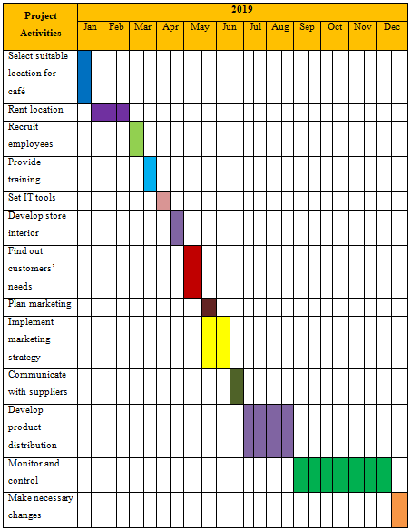
Cost/Benefit Analysis
Description | Month 1
Sales Revenue | 70,000
Cost of Sales / supplies | 42000
Gross Profit | 28,000
Exepnses | Month 1
Office rent | 10,000
Depreciation of Furniture and fixture | 2,000
Machinery | 3,000
Interest of Bank loan | 500
Employee cost (Salary cost) | 5,000
Advertising promotion | 3,500
Utility bill (electricity, gas etc) | 2,000
Total cost | 26,000
Net Profit | 2,000
Percentage of net profit to revenue | 3%

“Risk Analysis: Risk Identification”
It is the essential to project a plan before doing anything.
“Risk prevention”
A complete project can be a great solution for upcoming problems that might face at the time of final projection.

“Risk Management”
Thus project manager uses the initial tools of project management to make and use strategies and also to finish the project work within the required time period.
“Risk Monitoring”
They determined a certain goal with some objectives and use the techniques to execute all the plans that was pre-determined.

Section 3: Who will work on the project?
“Roles and Responsibilities”
In order to make the companies prevent from the loss different kinds of important financial decisions are taken for the companies. It prevents companies from loss and make various profits and developments.

Task Association Diagram plan

“Titles: Task Promoter”
Senior Management Team
“Task Administrator”
Chief of Advertising
Unit:
The time and the procedure of the task transfer

“Primary Task Strategy”
From 01/01/2018 the task will be in progress and thorough inside 31/12/2018. During the years, the upright execution of the task would appraisal.

“Social Source Desires”
Certain perpetual and freelance staffs required for HRM branch for the original stock process.

“Upkeep Supervise”
N/A
“Supplementary Run”
N/A
“Observing appliances”
By the brace from IT supervisor, HRM supervisor, Merchandise dissemination supervisor, investigation and progress supervisor the administrators of advertising regulator the overall task.

“Announcement programs”
Initially at 2018, the enactment of the staffs would be evaluated and fresh approaches will first-rate for refining the enactment of the staffs.
“Value Resistor”
The periodic presentation of the task study after six months of phase.

“Threat Valuation”
In order to accomplish all actions properly it is essential to involve Specialists for foundational firsthand provisions and offer teaching to the staffs for aggregate supply deals and clienteles appointment.
“Superiority Mechanism”
In order to guarantee the proper governor of the task with guaranteeing the value of all task accomplishments accomplished with superiority necessities.
Task Appraisal Method
As said by Clerk (2009), the economic supposition of the corporation taken in relations of the administrative proceeds, assessment of the administrative skill and provisional upon its charge. In order to make the companies prevent from the loss different kinds of important financial decisions are taken for the companies. It prevents companies from loss and make various profits and developments.
“Internal rate of return”
The method use for IRR is along these lines:
“Categorize the economic equivalent of the task”
The economic concerns of the supply significantly influence on the sustainability and accomplish economical benefit inside the commerce atmosphere, according to Biafore (2017). There are numerous economic matters that must be appropriately directors
- The supply desires to progress in a manner that the supplies are more lighthearted and desires to usage crystal in most of the zones with the intention of the desires of the liveliness would lessen
- The supply dimension desires to hang onto less significant with the intention of a smaller amount of worker would needs to activate and the additional charge of the supply would also lessen
- Want to endorse personal variety significantly with the intention of the corporation would capable of lessen the merchandise charge and please the clienteles.
- Want to assemble conference by way of the contractors to make them capable of accomplish of artifact stock timely
“Estimate widespread non-financial investments”
There are numerous economic matters that must be appropriately directors,
- The staffs need to be known for their enhanced enactment in supply which would create their performance superior and distribute from top to bottom excellence provision to the clients.
- Want to place conference by means of the contractors and confer by way of the matters for emerging merchandise value.

Connect the scheme strategies by means of suitable generations and investors will make the task more cost-effective and developed.
Communication of the Project with Stakeholder’s and Colleagues
Develop presentation using power point tools to communicate with colleagues and stakeholders of the company.
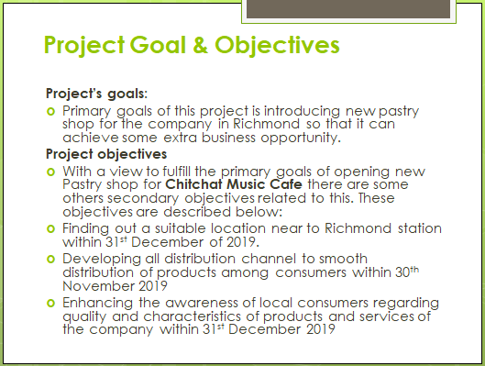
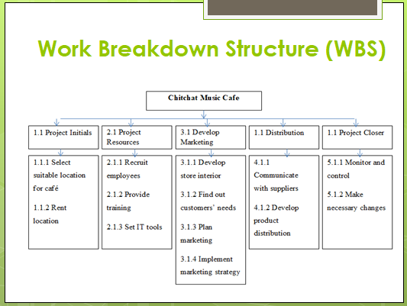
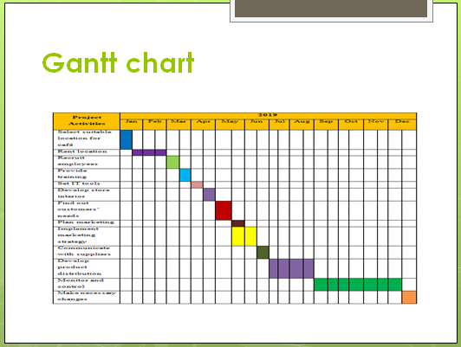
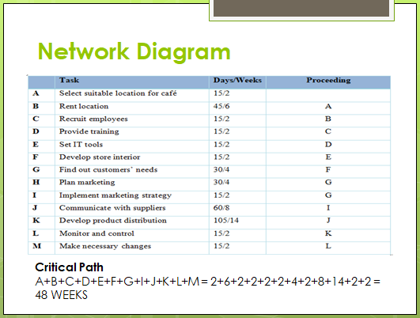
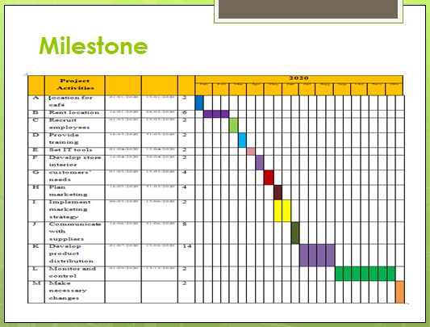
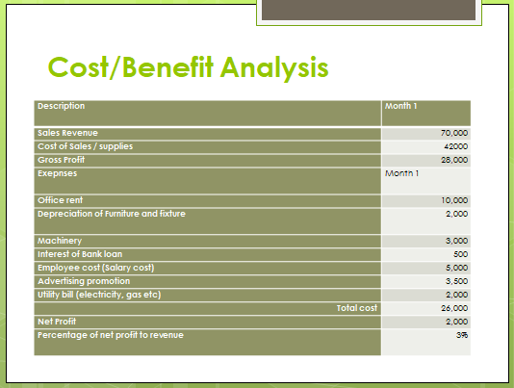

“3. Critically evaluating the ability to manage a project by using feedback from others to evaluate one’s own ability to plan and implement a project, identifying strengths and weaknesses and creating a self-development plan to improve performance in managing projects.”
Ability of managing a project:
For me, I have the ability to communicate, to motivate people. Importantly I know how to make decision on the situational demand. I have flexibility in thought which helps me making decision at the adverse time. And I believe that it is important to learn from every situation, this will help me to risk assessment and will enhance my ability to judge and evaluate in most effective way. I still have a lot more things to learn. I have to upgrade my communication skills and have be more focused on detailing.
Apart from technical collaboration and knowledge, it is also very important to have strong ethical power. Without honesty nothing will last long.
Strength and weaknesses of the project implementation
It is common practice for the manager to analysis the strengths and weaknesses before implementing any plan. It is the internal environmental analysis which helps a manager to determine how effectively the plan will work. Evaluating and receiving feedback from the sub-ordinates will help to calculate the strengths and will help to give solution for overcoming weaknesses. Some strengths and weakness been founded and presented below:
Strength-
- It is important to determined priorities of the activities which denotes which activities should done before and which should be done later.
- Having good communication skill ensure the higher understanding power which will reduce the probability of miscommunication.
- Respecting others thought and decisions is also important. It will help to get diversified project idea and will encourage the people in making innovative decisions.
- Power of forecasting and the power to thing big is a qualitative characteristics that a manager should have. Ability to think about the big picture will help a project to be successful in the long run.
I have all those abilities and also I am able to asses risk and have the ability to analyze those risk factors to overcome them. I am also quite good in resource planning and time management. I can correlate time and cost properly.
Weaknesses:
Apart from those strengths, I have some weaknesses in my personality trait and working style. I am still a noob in managing complex and lengthy project. I have the shortage of knowledge of work ethics and different working culture. And most importantly I have to increase my abilty to solve problem in different situation.
Personal Development Plan
Personal development plan helps a person to determine one’s own strengths and weaknesses. After identifying them, a person will take initiatives to overcome their weakness and enhance strengths. In the following I have developed a personal development plan of mine which have been shown below-
Development  Objectives | Priority | Activities should consider in achieving objectives? | Sources to achieve objectives | Target date for achieving my objectives | Actual date of achieving my objectives
Technological development | Moderate | Professional training and practicing | Self-support and support from organization | 06-05-2019 to 30-06-2019 | 06-05-2019 to 30-06-2019
Critical reasoning power | High | Know to solve case studies | Various books and uses of internet | 06-05-2019 to 20-05-2019 | 06-05-2019 to 20-05-2019
Ethical knowledge about work environment | Moderate | Learn about ethics in work place | Gain the ethical knowledge from experienced person and from books | 06-05-2019 to 30-05-2019 | 06-05-2019 to 25-05-2019
Flexibility in decision making | High | Enhance the ability to be firm and keep calm in complex situation | Experience and training | 06-05-2019 to 20-05-2019 | 06-05-2019 to 20-05-2019

Conclusion
Being a manager might sound an easy task but managing something successfully according to planned way is harder than is seems. Being a manager needs some sort of certain qualities like leading power, forecasting ability, high communication skills, motivating skills and most importantly the power of making right decision at the right time. It is also important to have the power of evaluation and judging a plan according to its current and future situation. Being flexible is one of the important factor that a manager should have because situation can change any time, it can be complex any time. So it is also very important for a manager to be firm in any type of unfavorable situation. Flexibility helps in making proper decision at adverse situation. As we all know the phase and that is if there is no risk, there will be no gain at all. So it is very common to face unexpected situation sometimes (Lock, 2013). This uncertain situation is called risk. Though risks are common but a manager have to be clever enough to assess the risk that might appear in future while executing project work (Charvat, 2003).

References
- Charvat, J., (2003). Project Management Methodologies: Selecting, Implementing, and Supporting Methodologies and Processes for Projects, London: John Wiley & Sons
- Frigenti, E., Comninos, D., (2012). The Practice of Project Management: A Guide to the Business-focused Approach, New York: Kogan Page Publishers
- Harper-Smith, P., Derry, S., (2012). Project Management: Fast Track to Success, London: FT Press
- Lock, D., (2013). Project Management, London: Gower Publishing, Ltd.
- Kloppenborg, T., (2014). Contemporary Project Management, New York: Cengage Learning
- Milosevic, D. Z. (2003). Project Management ToolBox: Tools and Techniques for the Practicing Project Manager, London: John Wiley & Sons
- Nicholas, J, M., Steyn, H., (2008) Project Management for Business, Engineering, and Technology: Principles and Practice, London: Elsevier
- Portny, S. E., (2011). Project Management For Dummies, London: John Wiley & Sons
- Roberts, P., (2011). Effective Project Management: Identify and Manage Risks Plan and Budget Keep Projects Under Control, New York: Kogan Page Publishers
- Schwalbe, K., (2015). Information Technology Project Management, London: Cengage Learning

