
APPENDIX GA36a
LEVEL 4 ASSESSMENT SPECIFICATION

Student name: | Abdullah Karakan | Student ID number: | 2514523
Programme: | CertHE Computing Skills for Workplace
Module: | Introduction to Web and Database Concepts
Module code: | ACCA4023 | Contribution to  Overall Module Assessment (%): | 50%
Lecturer: | Dr. Fahad Ahmed | Internal Verifier: | Abida Perveen
Assignment Title: | Design and Implementation of a Relational Database System | Word count (or equivalent): | 2000
Submission deadline: | Week 7  24 March 2026, 2.00 pm | Return date of provisional marks & written feedback: | 20 April, 2026, 2:00PM
Submission method: | All written assessments, where practical and possible, must be submitted via Turnitin unless otherwise instructed by the Lecturer. (Please DO NOT put this assessment specification into Turnitin or it will match many similarities with other students’ submissions.)  Alternative submission method (if applicable):  Late submission of the assessment will result in a late penalty mark:  Work which is submitted up to 1 week late will be capped at 40% for the first attempt and will be awarded a mark of 0% for re-assessment. Late submission penalties may be lifted only if there is an approved extenuating circumstances claim.  Work submitted more than 1 week late will be considered as a non-submission and will not be marked. The work may be considered as a submission for reassessment if offered by an Examining Board or if there is an approved extenuating circumstances claim.
Academic honesty / referencing: | Academic honesty is required. In the main body of your submission you must give credit to authors on whose research and ideas your work is based. Append to your submission a reference list that indicates the books, articles, etc. that you have used, cited or quoted in order to complete this assessment.

Table of Contents
List of Figures 3
1. Introduction 4
2. Scenario Analysis 4
2.1 Identification of Entities and Attributes 4
2.2 Relationships Between Entities 7
2.3 Summary of Design Approach 7
3. Entity Relationship Diagram (ERD) 8
4. Data Structure Development 9
5. Normalization 12
5.1 First Normal Form (1NF) 13
5.2 Second Normal Form (2NF) 13
5.3 Third Normal Form (3NF) 13
6. Implementation and Sample Data Population 13
7. Query Development 17
7.1 Low Stock Medicines Query 17
7.2 Total Sales per Customer 18
7.3 Sales Transactions Query 18
7.4 Medicines Sold Query 19
7.5 Prescriptions Query 20
7.6 Total Revenue Query 20
8. Validation and Testing 21
8.1 Validation Techniques 21
8.2 Testing Procedures 28
8.3 Evaluation 28
8.4 Limitations and Improvements 28
9. Conclusion 29
References 30

List of Figures
Figure 1: ER diagram 9
Figure 2: Table Creation 10
Figure 3: Relationship of Tables 14
Figure 4: Table 1 14
Figure 5: Table 2 15
Figure 6: Table 3 15
Figure 7: Table 4 16
Figure 8: Table 5 16
Figure 9: Table 6 17
Figure 10: Query 1 18
Figure 11: Query 2 18
Figure 12: Query 3 19
Figure 13: Query 4 19
Figure 14: Query 5 20
Figure 15: Query 6 21
Figure 16: data type validation 1 22
Figure 17: data type validation 2 23
Figure 18: data type validation 3 24
Figure 19: data type validation 4 25
Figure 20: data type validation 5 26
Figure 21: data type validation 6 27
Figure 22: Data value validation 28

1. Introduction
The report is based on the development and design of the relational database system of the pharmacy named as Medi link. It is situated in a community, and the interests include activity revival and performance. Since up to now the company has handled all the operations manually, from handling processes to sales dealing and client database handling. This might cause errors in the management due to inefficiency.
The strategy of database implementation discussed would help in structuring and designing a more automated database design, which would help simplify the processes and management to eliminate the expected errors. This type of system structure will enable it to store and process the operational data, the medicine and suppliers’ data, customer data, prescription data, and sales data.
The database design concepts, such as the entity-relationship modelling and the third normal form (3NF) normalization of the data, and the structured query language (SQL), will all be skewed towards the benefit of the data integrity and the quality of the decision making [4].

2. Scenario Analysis
Medi Link Pharmacy is a developing pharmacy community that currently uses manual systems in the management of medicinal data, prescribed documents, prescriptions, suppliers, sales and client data. The use of a paper-based system leads to inefficiencies, redundant data, and increased risks of mistakes. Therefore, the need to possess a structured database solution that will allow assessing the accuracy of data, enhancing the efficiency of its operations, and assisting in decision-making is present [10].
In developing a useful database system, there should be a specification of the key entities and their attributes, along with their relationship with the key entities.

2.1 Identification of Entities and Attributes
Following the details of the situation, the following fundamental entities are identified:
1. Medicines
This organisation maintains records of all the single medicines in the pharmacy.
Attributes:
- Medicine ID (Primary Key)
- Medicine Name
- Category
- Unit Price
- StockQuantity
- Expiry Date
- SupplierID (Foreign Key)
Justification:
Pharmacy is linked with the use of medicines, and keeping track of inventory levels and expiry dates is crucial in regard to the control of inventory and compliance [9].
2. Suppliers
This is the body that gives the information on the drug suppliers.
Attributes:
- SupplierID (Primary Key)
- SupplierName
- ContactNumber
- Email
- Address
Justification:
To purchase and communicate, there have to be supplier records, which are supplied by a supplier of all medicines.
3. Customers
This maintains the databases of the consumers who buy drugs.
Attributes:
- CustomerID (Primary Key)
- Customer Name
- Phone Number
- Address
- DateOfBirth
Justification:
The customer information is needed to place the orders for the prescriptions and monitor the purchase history.
4. Prescriptions
Prescriptions which are made by the customers are monitored in this entity.
Attributes:
- Prescription ID (Primary Key)
- CustomerID (Foreign Key)
- Doctor Name
- Prescription Date
Justification:
The pharmacy systems should have the prescriptions to release the controlled medicines appropriately and as required by law.
5. Sales
The data concerning the purchases of medicine transactions are the ones that are recorded by.
Attributes:
- SaleID (Primary Key)
- CustomerID (Foreign Key)
- Sale Date
- TotalAmount
Justification:
Financial tracking, reporting and business analysis require sales records.
6. Sale Details
It is a collaborative body that keeps the record of the contents of medicines per sale.
Attributes:
- Sale Detail ID (Primary Key)
- SaleID (Foreign Key)
- Medicine ID (Foreign Key)
- Quantity
- Subtotal
Justification:
Every Sale can include many medicines, which implies that Sales and Medicines are many-to-many. This is what this entity divests itself of.

2.2 Relationships Between Entities
The identified entities are related in the following way:
1. Supplier → Medicines (One-to-Many)
2. Customer → Prescriptions (One-to-Many)
3. Customer → Sales (One-to-Many)
4. Sales → Sale Details (One-to-Many)
5. Medicines → Sale Details (One-to-Many)

2.3 Summary of Design Approach
The proposed entities and relationships constitute a relational database design that is organised, and which:
- Eradication of duplication by the due separation of organisations.
- Assures that data is non-corrupted with primary and foreign keys.
- Meets the corporate needs, including inventory management, prescription management and sales management [11].
With the database design principles, the form of the data in well-identified entities and relations can result in further efficiency of the system and the minimisation of the occurrences of anomalies [2]. Moreover, relational modelling is involved so as to ensure that the database can be easily expanded and maintained afterwards.

3. Entity Relationship Diagram (ERD)
The ERD will also be created in the form of a depiction of a relational platform in which each object represents a certain component of the pharmacy system. The records are uniquely identified with the help of primary keys and provide a relationship between the entities to ensure referential integrity by providing a foreign key.
Multiplicity between Sales and Medicines is eliminated by the addition of the Sale Details entity, as it enables a single transaction to be linked with several medicines. It is a design process which makes the system of the database more flexible and scalable [2].
Also, the separation into such objects as Customers, Suppliers, and Prescriptions also eliminates the duplication and makes data easy to retrieve. The case in the database design theory is that ER diagrams give a graphical representation, which enhances transparency of the design as well as makes the errors in design implementation lower.
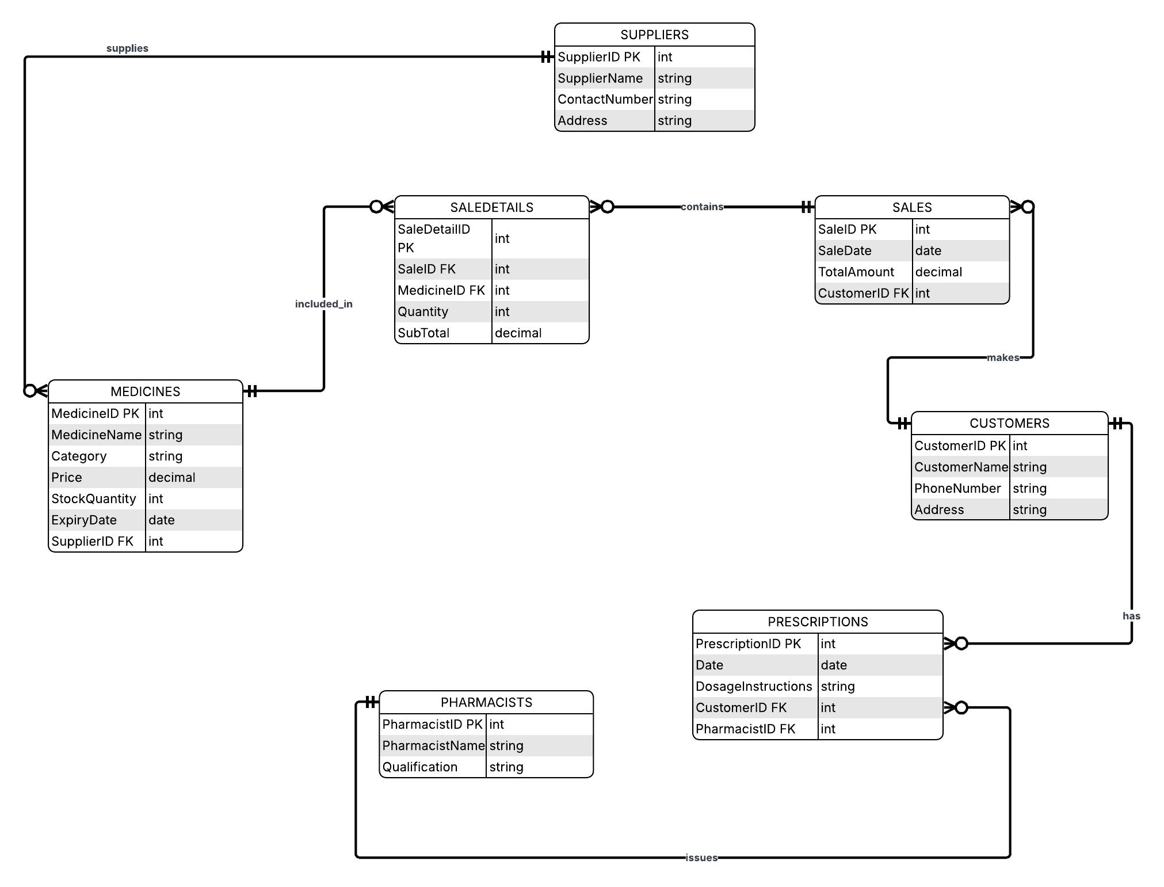
Figure 1: ER diagram

4. Data Structure Development
The implementation of the database was done on Microsoft Access by developing tables that match all the entities.
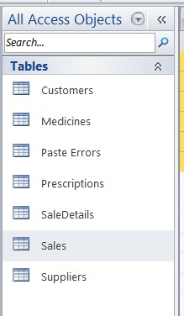
Figure 2: Table Creation
Suppliers Table
Field Name | Data Type
SupplierID | AutoNumber
SupplierName | Short Text
ContactNumber | Short Text
Email | Short Text
Address | Short Text

Medicines Table
Field Name | Data Type
Medicine ID | AutoNumber
Medicine Name | Short Text
Category | Short Text
Unit Price | Currency
StockQuantity | Number
Expiry Date | Date/Time
SupplierID | Number

Customers Table
Field Name | Data Type
CustomerID | AutoNumber
Customer Name | Short Text
Phone Number | Short Text
Address | Short Text
DateOfBirth | Date/Time

Prescriptions Table
Field Name | Data Type
Prescription ID | AutoNumber
Prescription Date | Date/Time
Doctor Name | Short Text
CustomerID | Number

Sales Table
Field Name | Data Type
SaleID | AutoNumber
Sale Date | Date/Time
TotalAmount | Currency
CustomerID | Number

Sale Details Table
Field Name | Data Type
Sale Detail ID | AutoNumber
Quantity | Number
Subtotal | Currency
SaleID | Number
Medicine ID | Number
Each table has suitable types of data and primary keys.
Record identifiers were based on primary keys. Tables had relationships that were enforced using foreign keys [6].
Referential integrity was also embraced, which in the database guarantees that the associated records are also consistent.

5. Normalization
Medi link Pharmacy database is normalised to the extent that redundancy issues are reduced, data consistency is enhanced, and the efficiency of the whole system is simplified. This has been maintained by structuring the database into different related tables, and the tables have a particular purpose to play.

5.1 First Normal Form (1NF)
The tables were created in such a manner that would meet the First Normal Form, which refers to the elimination of repeating groups and the fact that there was no single field having more than one atomic (individual) value [3]. This implies that every attribute can only assume one value, and no multi-valued column exists in any table.

5.2 Second Normal Form (2NF)
This was attained by eliminating partial dependencies to obtain the Second Normal Form. The presence of all the non-key attributes was totally identified as the primary keys, especially in the tables with composite keys, including the sale details, and this guarantees the proper and consistent matching of the data [3].

5.3 Third Normal Form (3NF)
The third normal form was suggested by eradicating the transitive dependencies. An example of one such is that the supplier information was not duplicated in the Medicines table, but rather stored in the Suppliers table; this could have been improved to form a DB and was quite logical as well [3].

6. Implementation and Sample Data Population
All the tables contained the sample data to recreate the actual pharmacy functioning to ensure that the database system is working well [1]. The data that was given was the different medicines like Paracetamol and Amoxicillin, their prices, stocks and expiration dates. The relevant information, such as names, contact numbers and addresses, was also updated in the customer records. The totals were also included in sales deals and were attached and linked to the individual customers and drugs on the Sale Details table. The structure of such data population was well tested in the system, as were the relationships, validation rules, and results of queries.
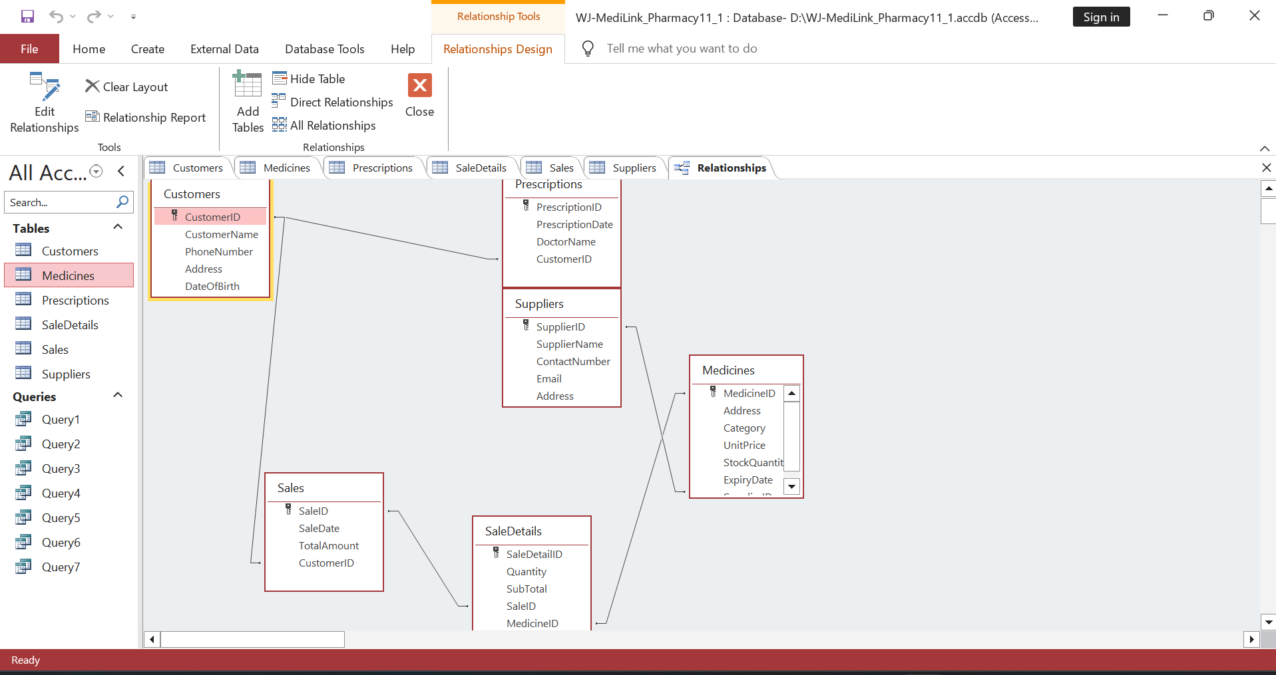
Figure 3: Relationship of Tables
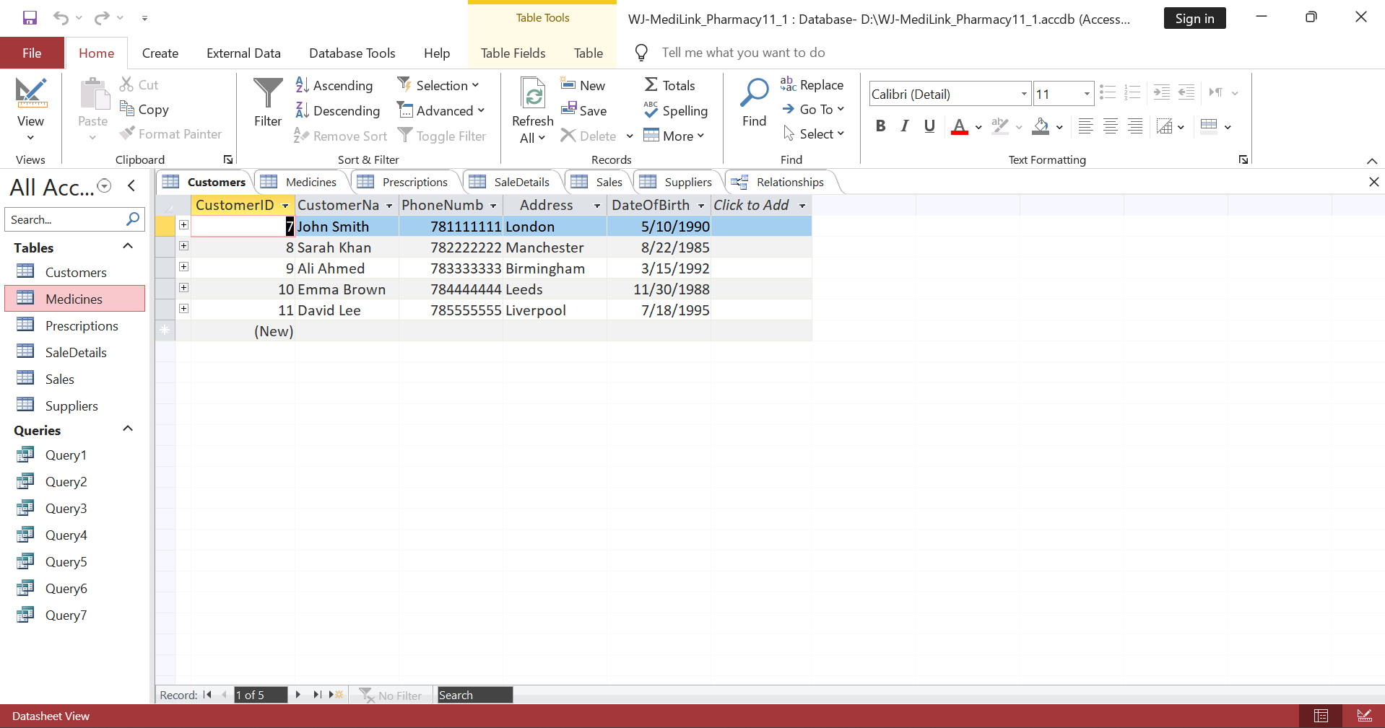
Figure 4: Table 1
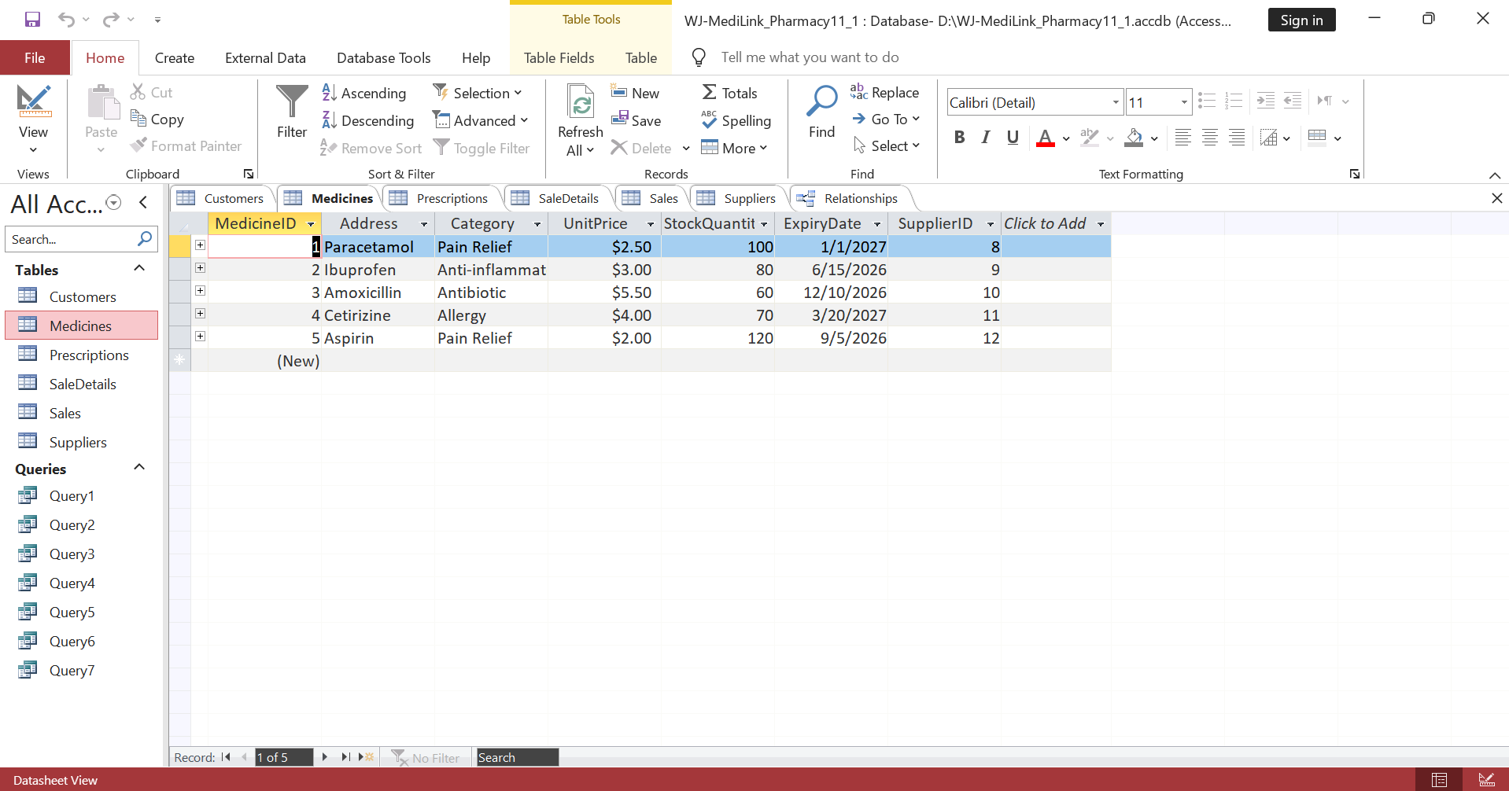
Figure 5: Table 2
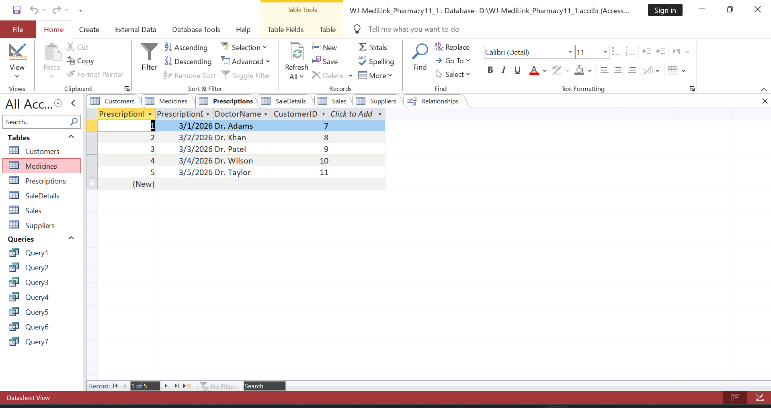
Figure 6: Table 3
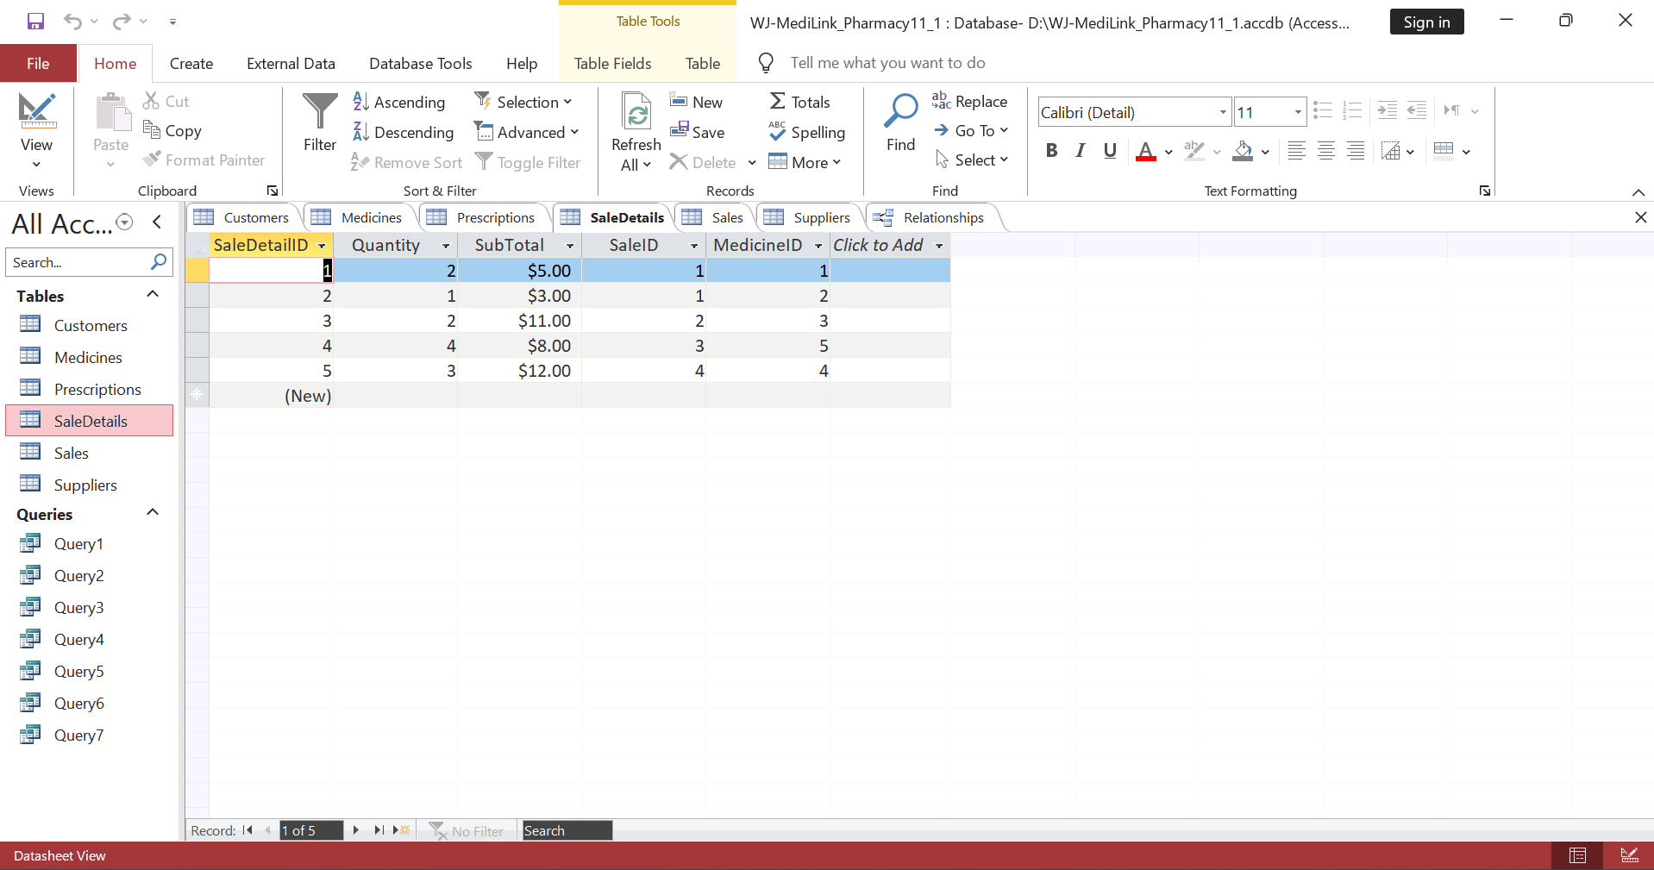
Figure 7: Table 4
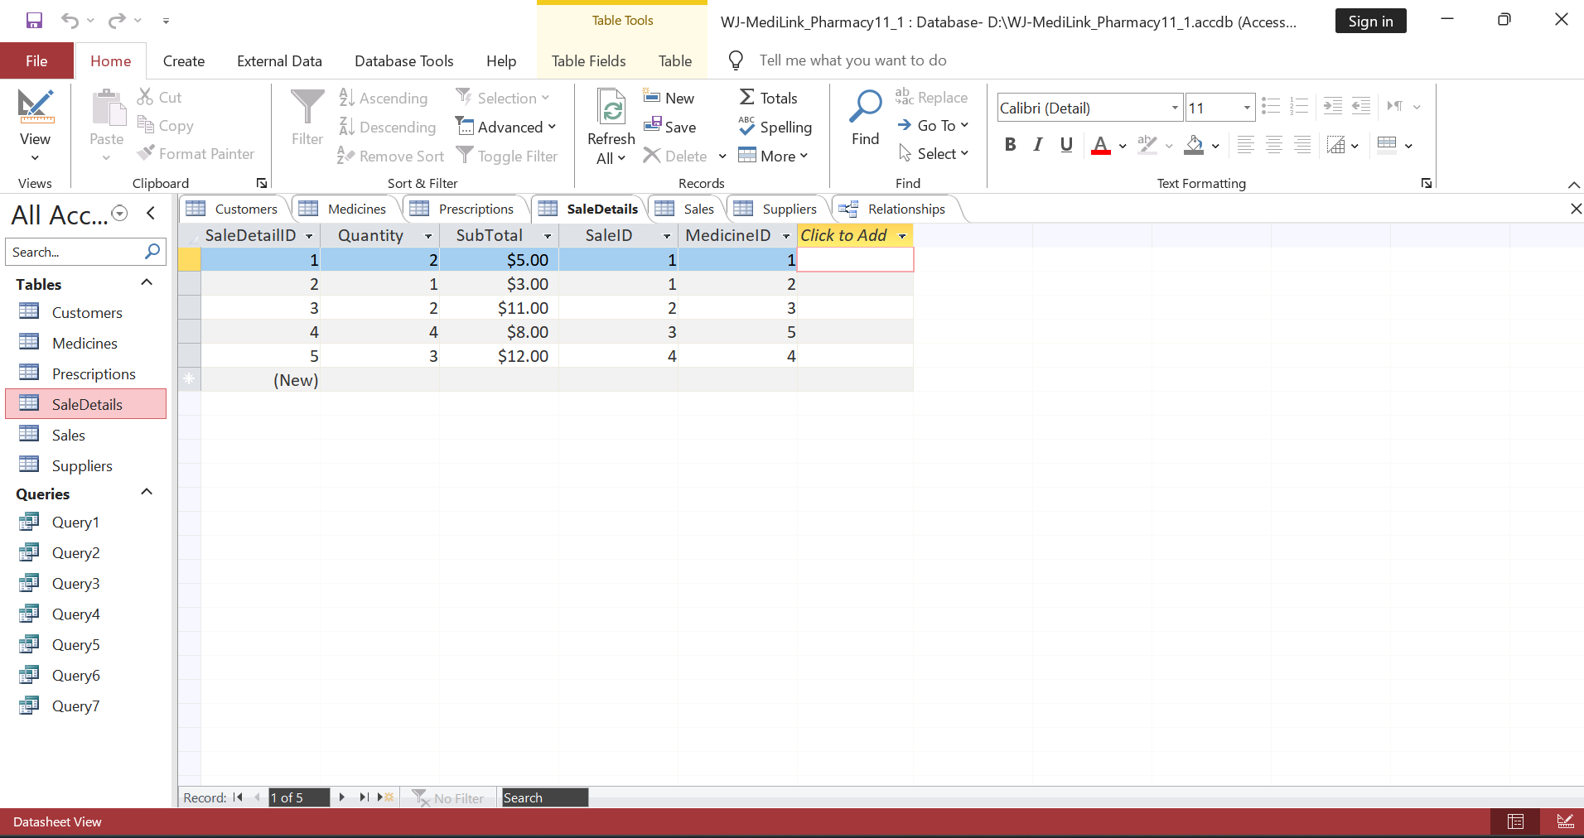
Figure 8: Table 5
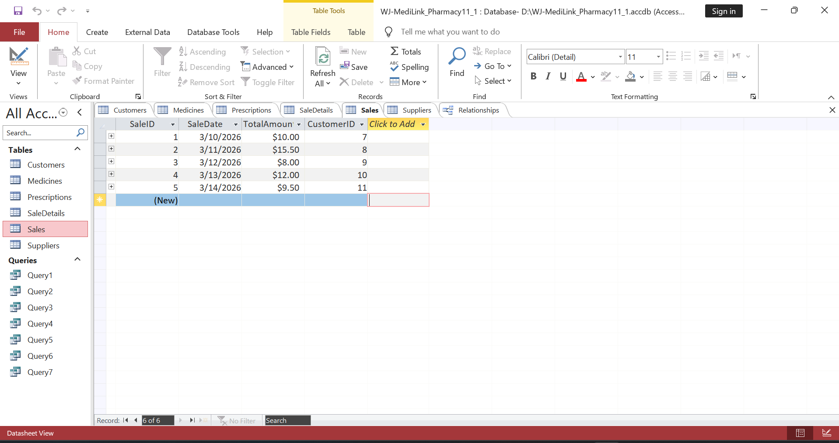
Figure 9: Table 6

7. Query Development
The queries were created in the database to provide pertinent and useful information that fosters decision-making and daily activities of the pharmacy. These are queries to illustrate how Structured Query Language (SQL) would be used in retrieving, filtering and analysing data that is stored in more than two related tables.

7.1 Low Stock Medicines Query
This query will locate the medicines that have a stock level, which is less than a certain level [7]. It assists the pharmacy staff in tracking the stock and taking corrective measures to refill the needed drugs within the stipulated time to prevent stock-outs.
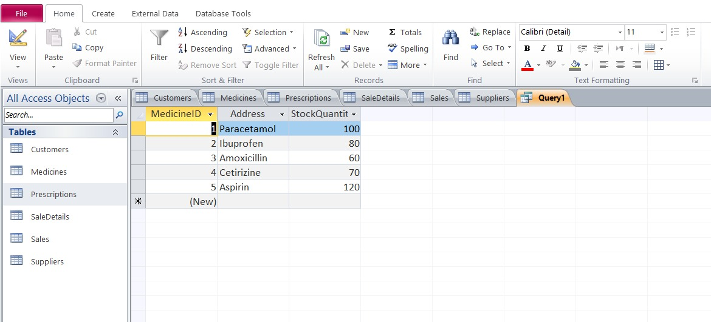
Figure 10: Query 1

7.2 Total Sales per Customer
This query will be an aggregate sum of all the money that the individual customers have spent under a cumulative sales consolidation. It makes it possible to study customer behaviour and identify high-value customers.
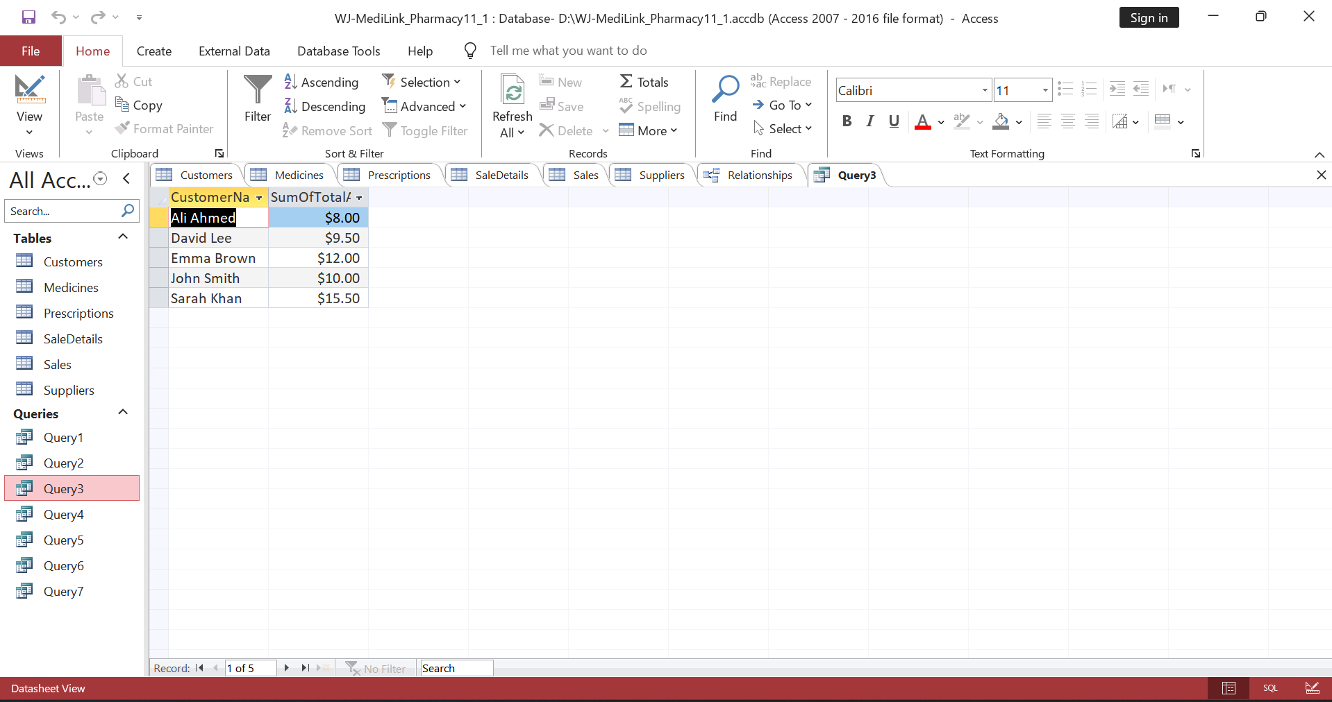
Figure 11: Query 2

7.3 Sales Transactions Query
The question will give a list of all the sales transactions in detail, giving the name of the customer, the date of the sale and the value. It may be applied to monitor the day-to-day operations of the business.
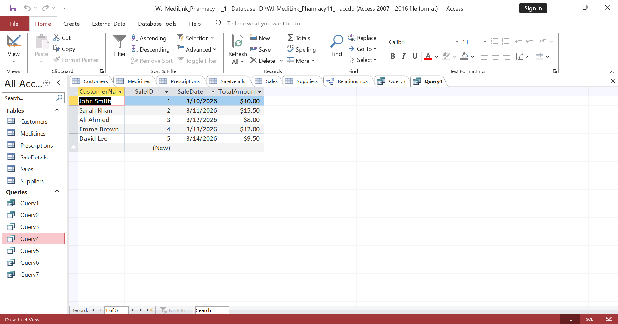
Figure 12: Query 3

7.4 Medicines Sold Query
This question will indicate the medicines on sale and also the quantity of the same [7]. It will assist in the analysis of the sales trend and demand for the products.
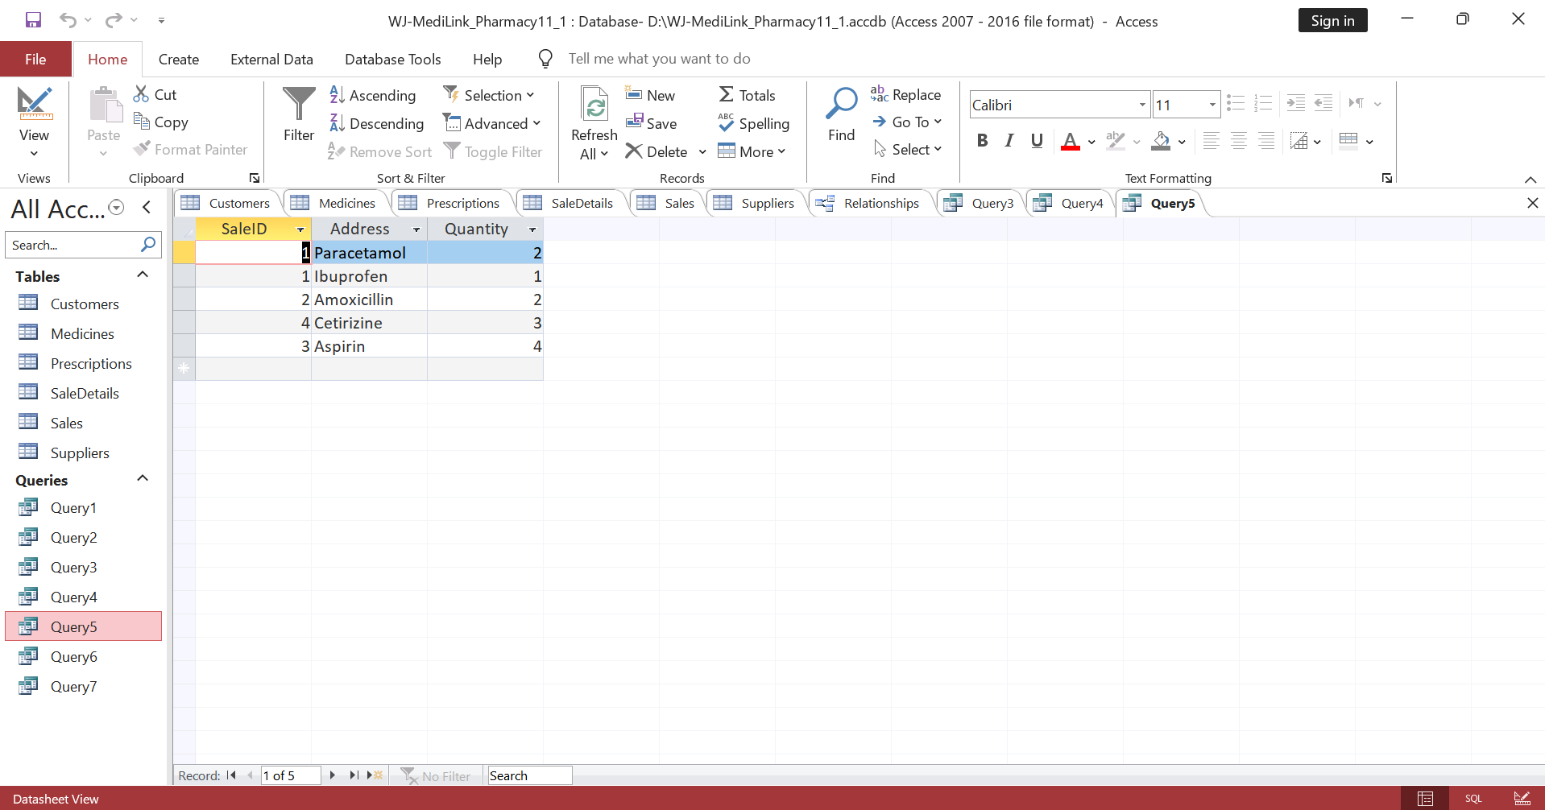
Figure 13: Query 4

7.5 Prescriptions Query
This query would locate the information regarding the prescriptions of all the customers and make them conform to the standards of health services, and maintain the records correspondingly.
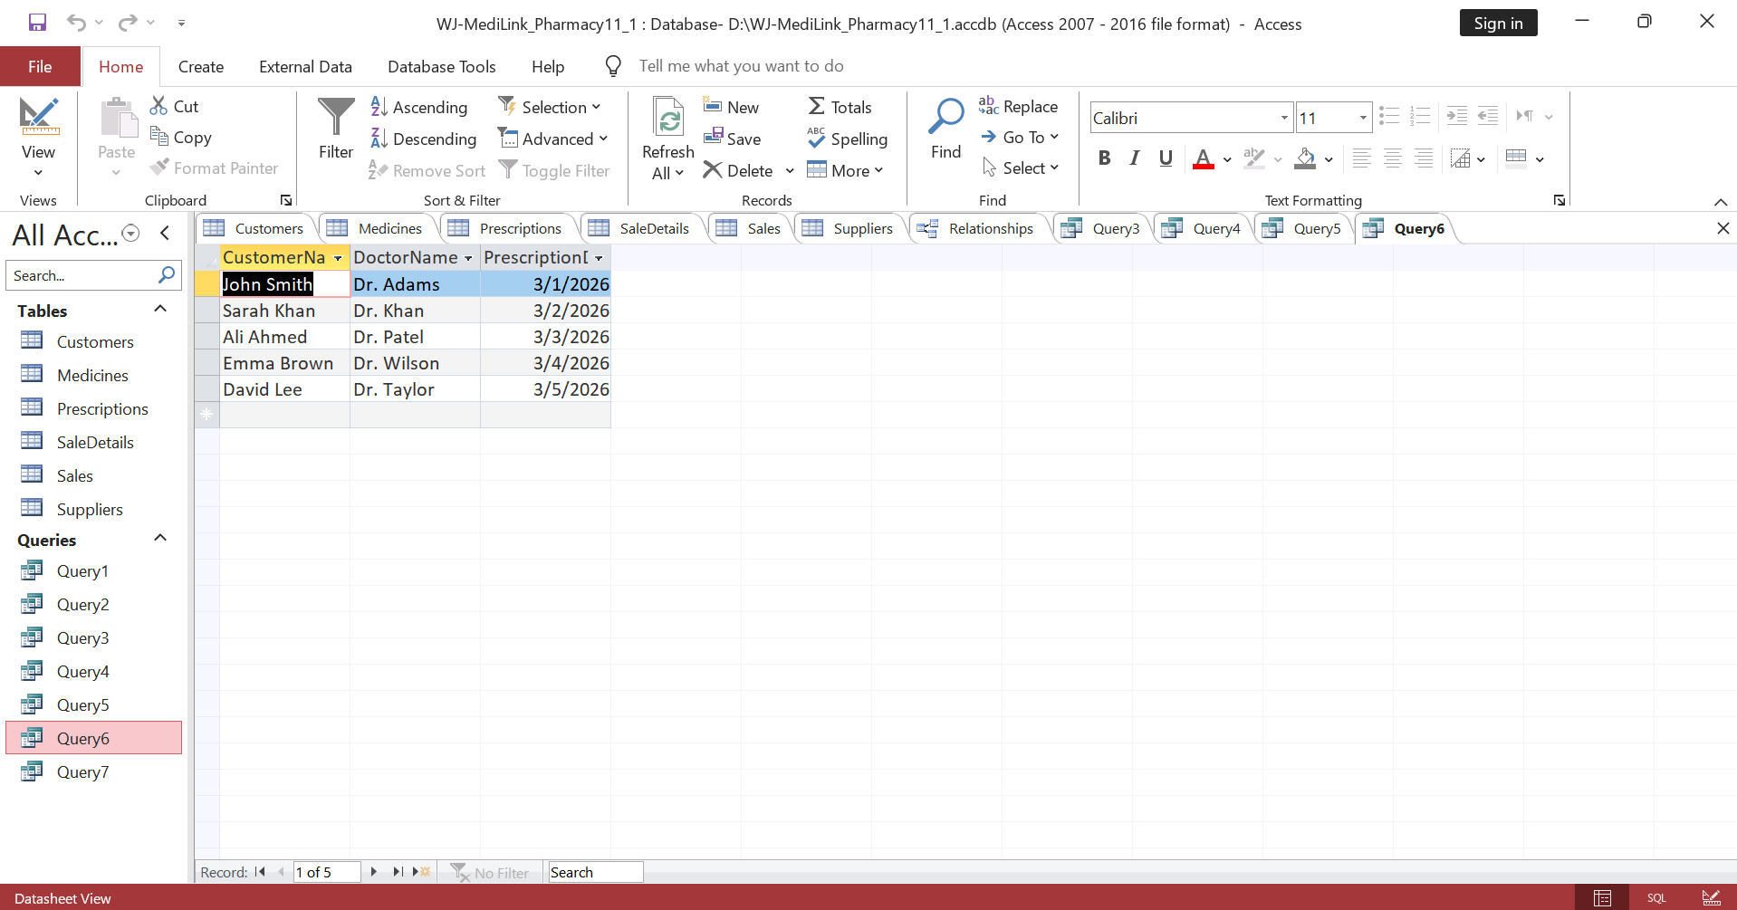
Figure 14: Query 5

7.6 Total Revenue Query
The tests and verification were done to verify the accuracy, reliability and general performance of the MediLink Pharmacy database system [7]. These kinds of activities will also be necessary to ensure that the system is operational and in accordance with the desired business requirements.
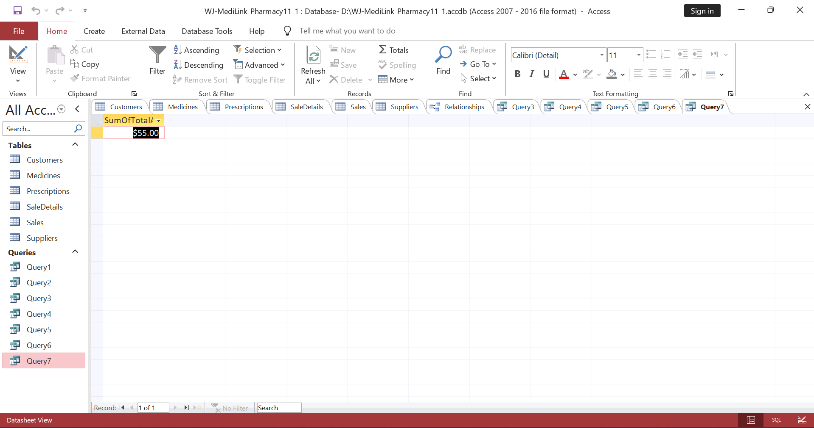
Figure 15: Query 6

8. Validation and Testing
The testing and validation were done to ensure the accuracy and reliability of systems.

8.1 Validation Techniques
A series of validation methods was used to guarantee the integrity of the data. The validation of data type will be used to make sure that the field is being entered correctly, like numbers or dates [6]. To limit the values, validation was done, e.g. ensuring that the quantity values should not go below zero. The required fields may be used to avoid the creation of incomplete records and referencing integrity to ensure that there are similar related relations between the tables, and orphan records are eliminated.
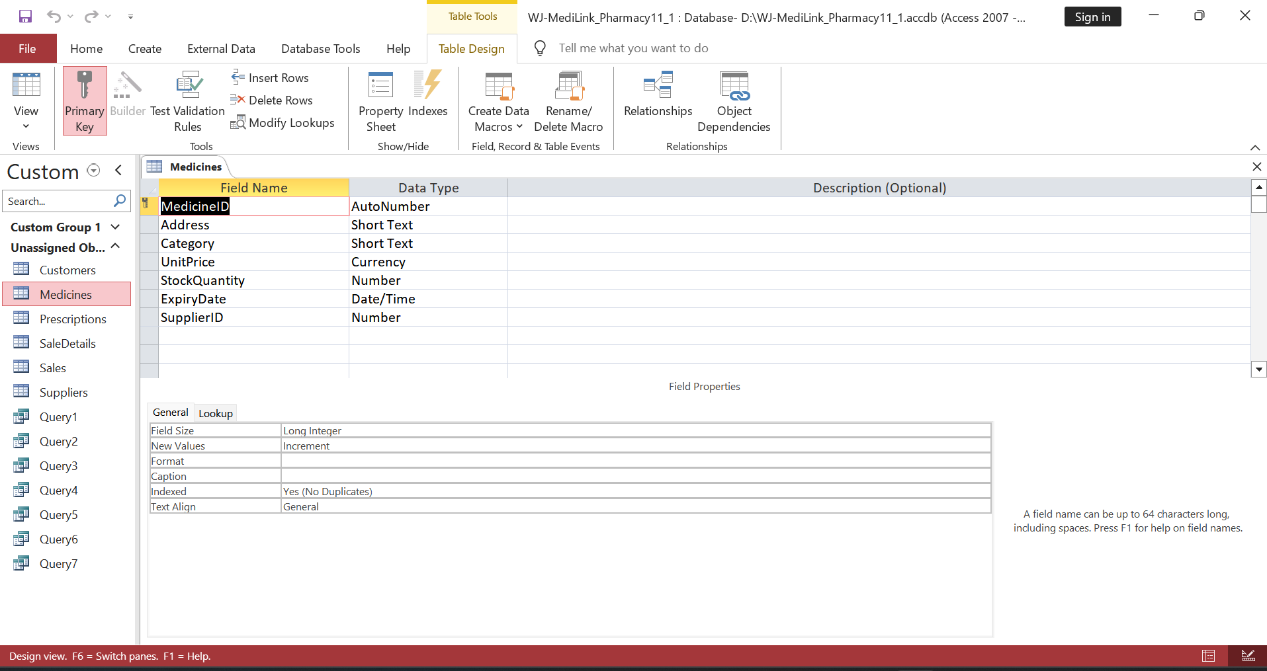
Figure 16: data type validation 1
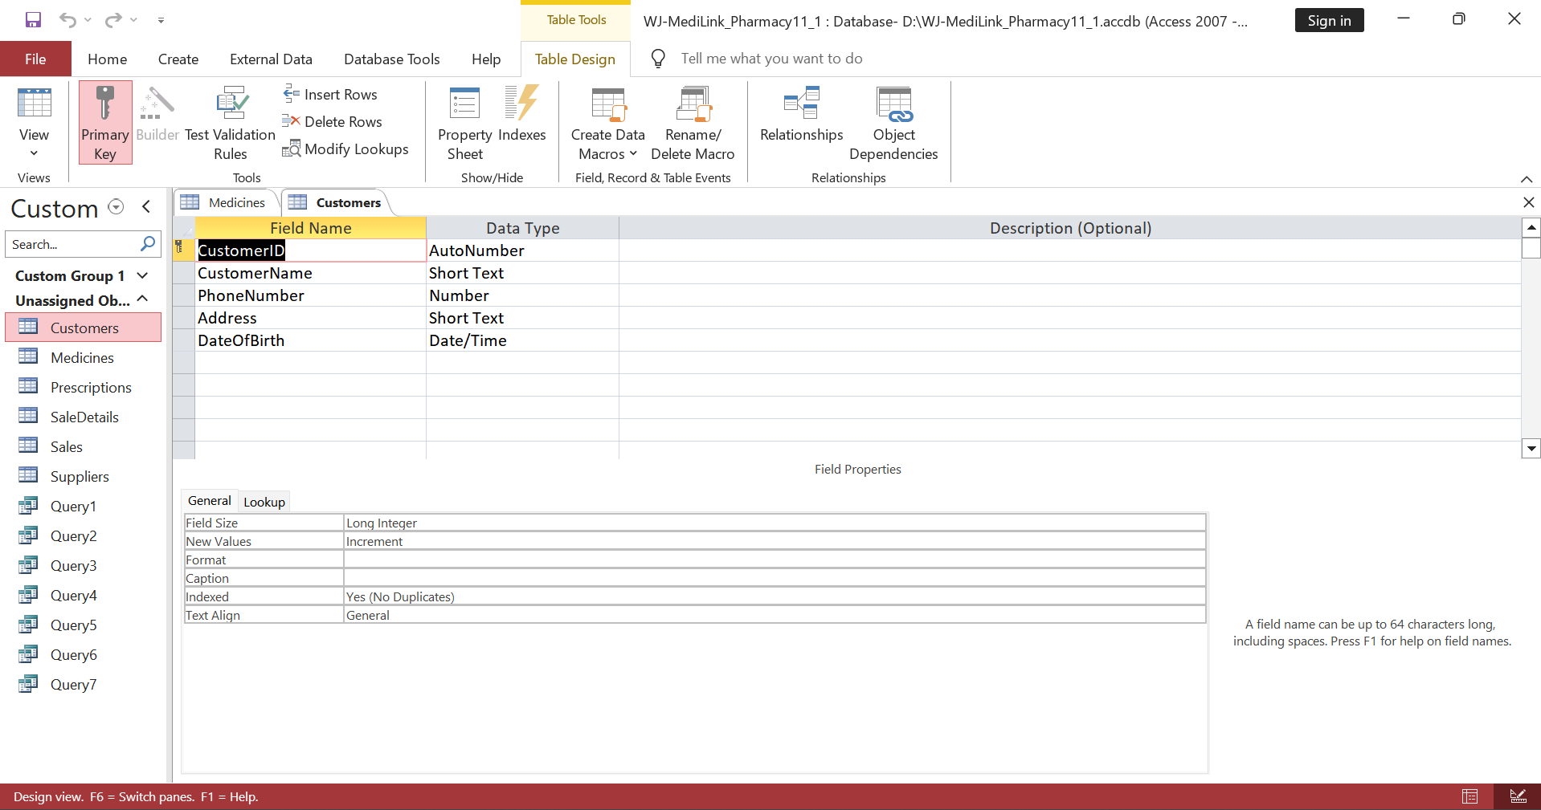
Figure 17: data type validation 2
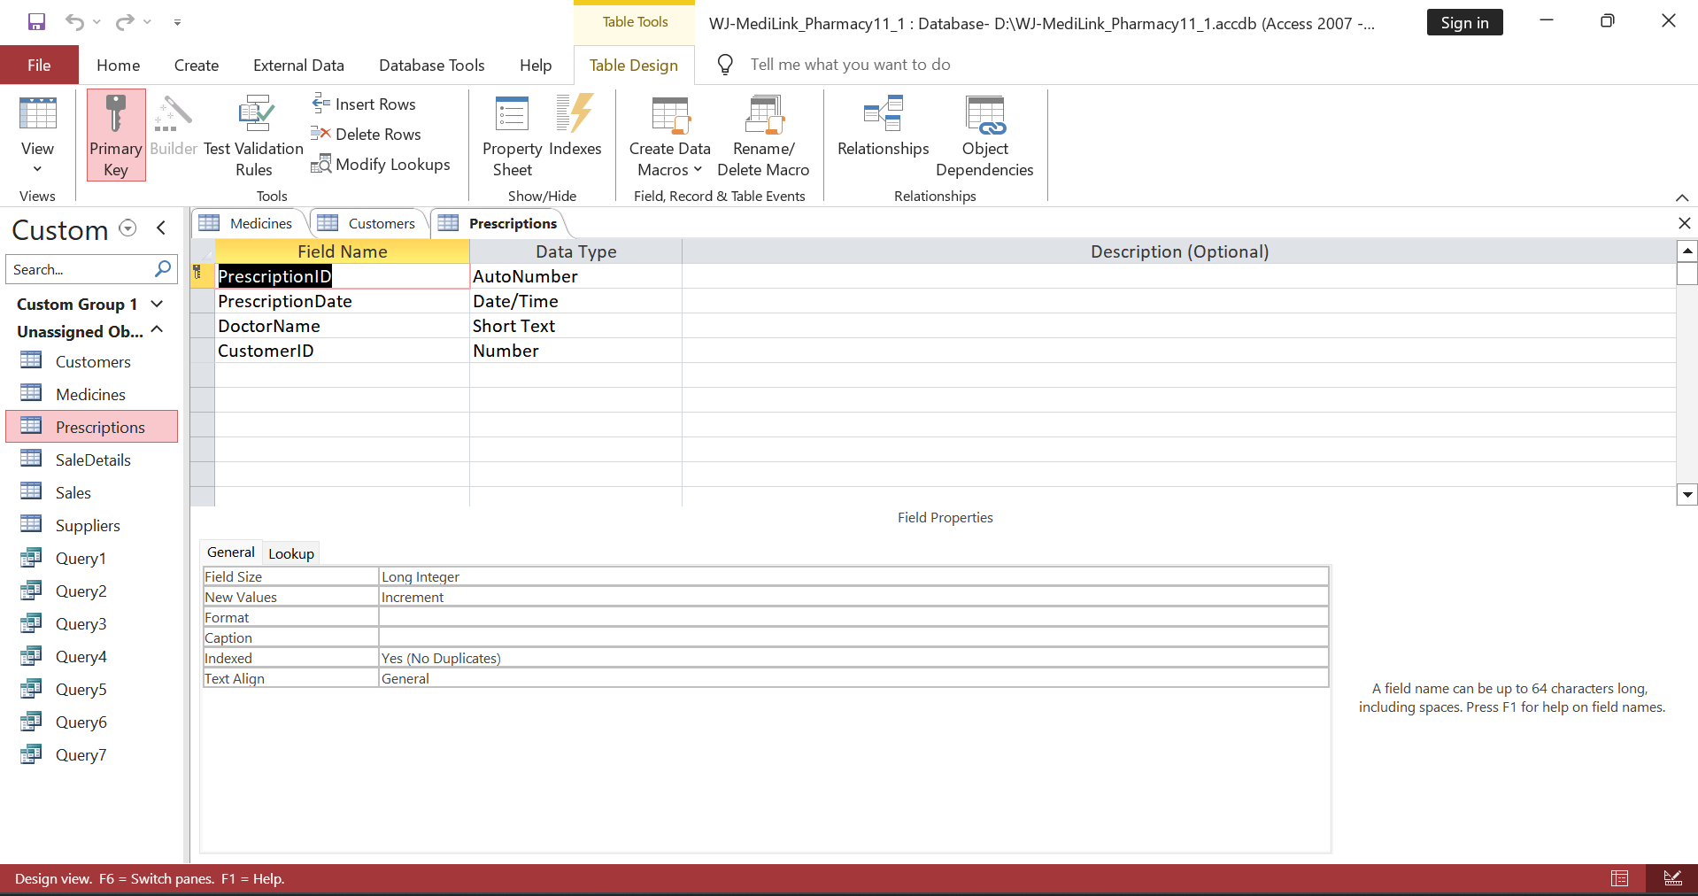
Figure 18: data type validation 3
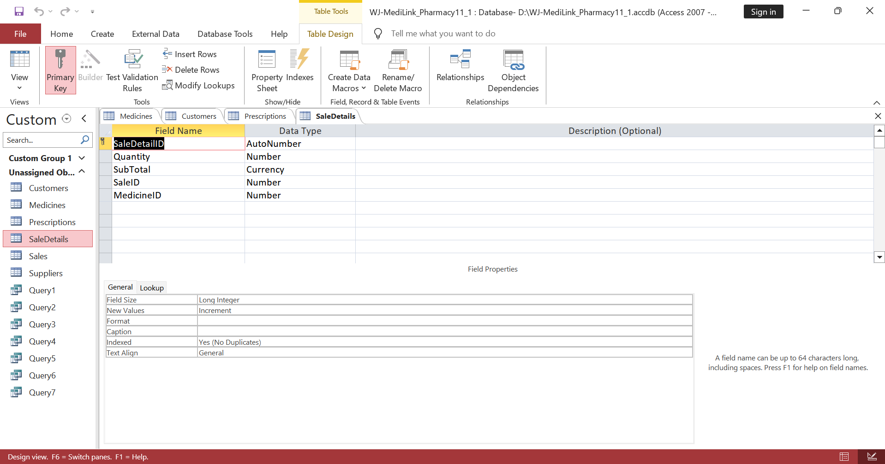
Figure 19: data type validation 4
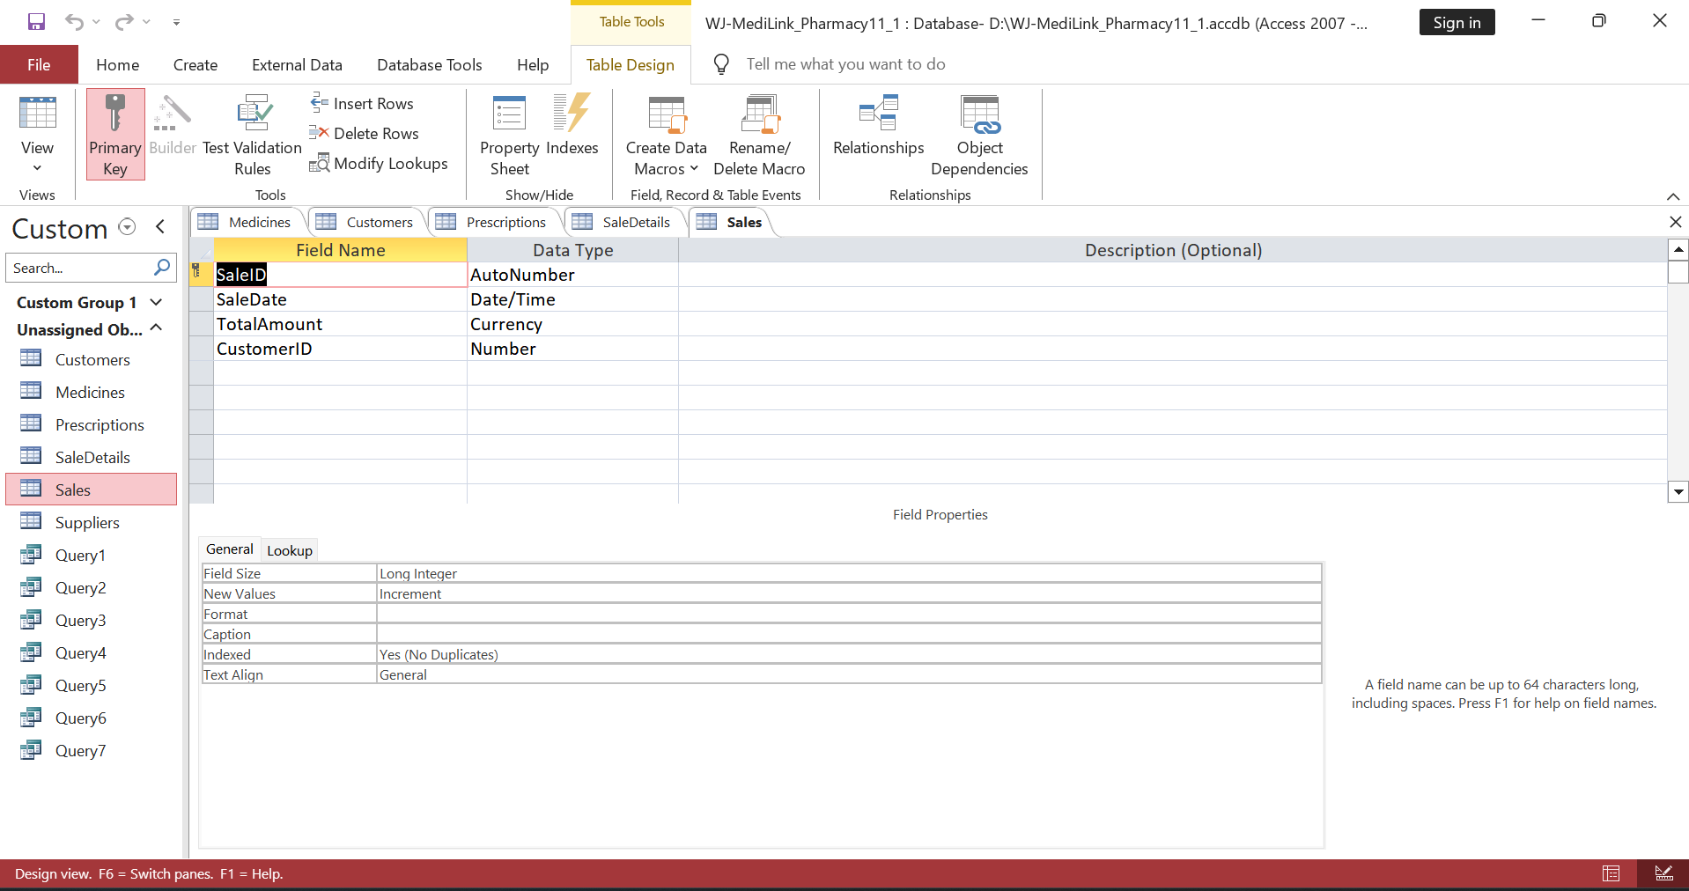
Figure 20: data type validation 5
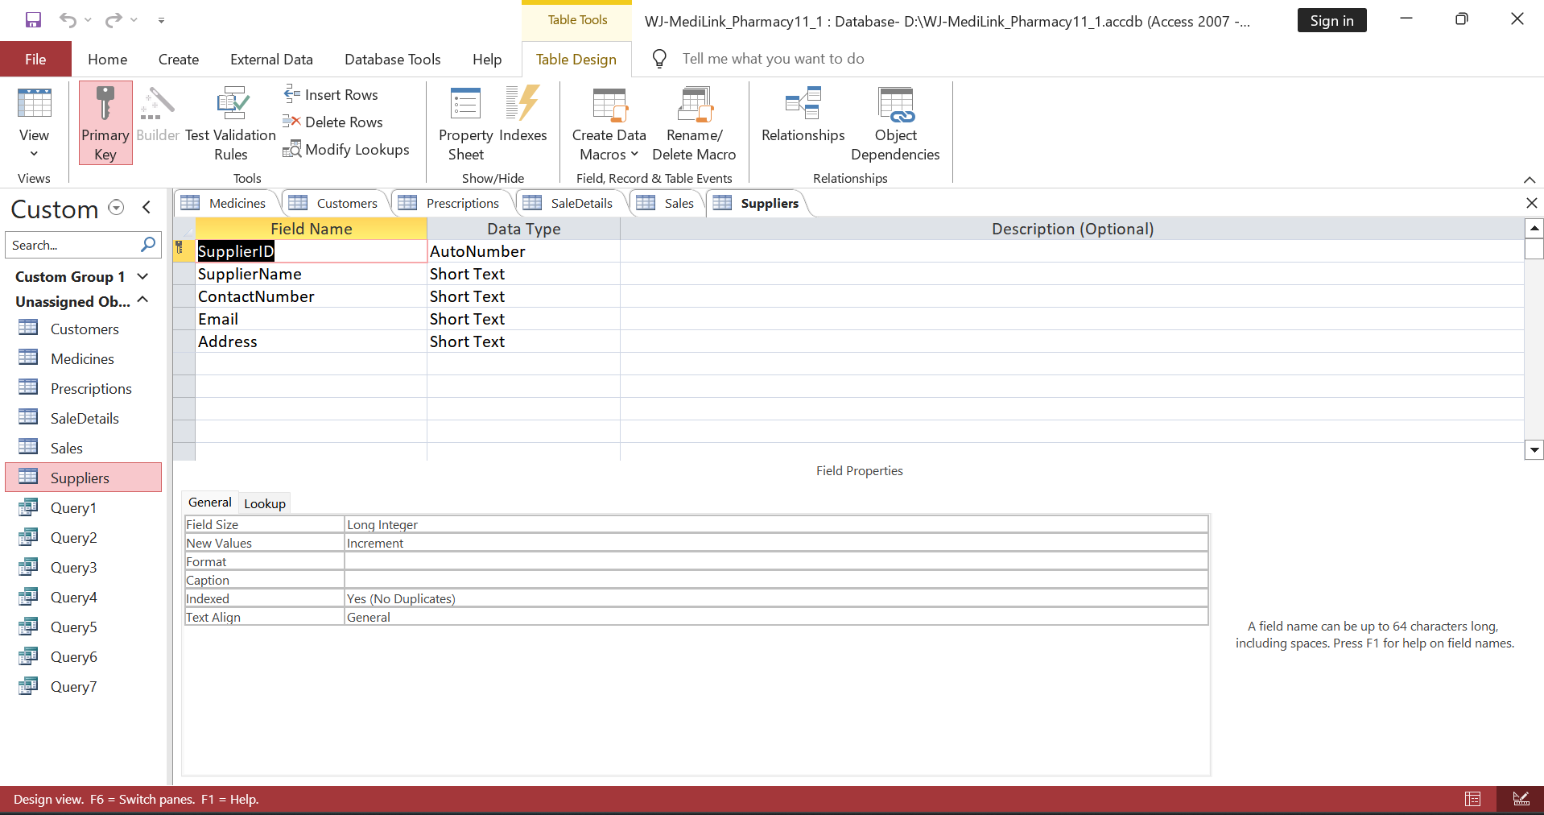
Figure 21: data type validation 6
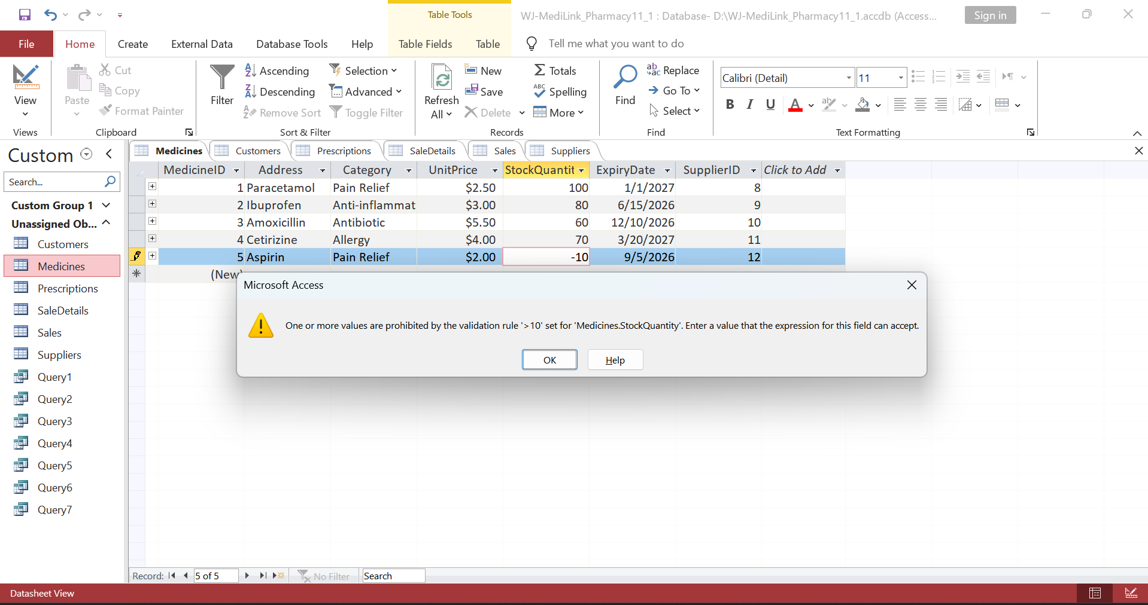
Figure 22: Data value validation

8.2 Testing Procedures
Several situations were tested as well, such as typing in invalid values of stocks, leaving the required fields empty, testing the association among the tables, and running queries to ensure that the correct output is returned. All tests were favourable, indicating that the system is working as intended.

8.3 Evaluation
The system is quite practical, yet its functions can be improved by adding a few functionalities to make the system more efficient, say with a user-friendly format, automatic notifications, etc.

8.4 Limitations and Improvements
The improvements can be made to:
- User-friendly forms
- Low stock automatic alerts.
- The integration with the external systems.

9. Conclusion
This database, developed during the report, provides a robust operational efficiency since it has been normalized and checked for all constraints. The Medi Link Pharmacy focused on developing this database so that it could utilize it to manage and support the administration. With the development of this database, key procedures would run with ease with its optimal design.
The database is designed so that it could offer scalability and optimal performance speed with its features like automation and friendly interfaces.

References
[1] S. Yadav, “Database Design for Enterprise Resource Planning Systems: A Comprehensive Approach,” International Journal of Advanced Research in Science, Communication and Technology, vol. 5, no. 1, 2025. Available: https://doi.org/10.48175/IJARSCT-24838
[2] R. Rashkovits and I. Lavy, “Mapping Common Errors in Entity Relationship Diagram Design of Novice Designers,” International Journal of Database Management Systems, vol. 13, no. 1, pp. 1–19, 2021. Available: https://doi.org/10.5121/ijdms.2021.13101
[3] N. Antonio and R. Amato, Mastering database normalization: A comprehensive exploration of normal forms, 2023. Available: https://www.researchgate.net/profile/Nicola-Antonio-Roberto-Amato/publication/374509386_Mastering_database_normalization_A_comprehensive_exploration_of_normal_forms/links/652106cffc5c2a0c3bbe361d/Mastering-database-normalization-A-comprehensive-exploration-of-normal-forms.pdf
[4] M. L. Gillenson, Fundamentals of Database Management Systems. John Wiley & Sons, 2023. Available: https://books.google.co.uk/books?hl=en&lr=&id=K6y7EAAAQBAJ&oi=fnd&pg=PA7&dq=Primary+key+and+foreign+key+constraints+in+databases+book+&ots=A7g84A4_XN&sig=yL0tuEayMXLSsSdqpsm6WxJl5Js#v=onepage&q&f=false
[5] A. Azcorra, Lightning guide to databases with Microsoft Access and SQL: A practical guide to database design with Microsoft Access and SQL. 2021. Available: https://books.google.co.uk/books?hl=en&lr=&id=TYlCEAAAQBAJ&oi=fnd&pg=PA1&dq=Microsoft+Access+database+implementation+techniques+book+&ots=842cnjDOMz&sig=1jDsYrW_ua2vFvuH2JVXmYDRUG0#v=onepage&q&f=false
[6] V. Yesin et al., “Ensuring Data Integrity in Databases with the Universal Basis of Relations,” Applied Sciences, vol. 11, no. 18, p. 8781, 2021. Available: https://doi.org/10.3390/app11188781
[7] L. Rockoff, The Language of SQL. Addison-Wesley Professional, 2021. Available: https://books.google.co.uk/books?hl=en&lr=&id=0NnPEAAAQBAJ&oi=fnd&pg=PT17&dq=Structured+Query+Language+(SQL)+for+database+queries+book+&ots=gDaQ3yWZLm&sig=xo7bzZZ_JFgvR1nodWeVwBXIaqQ#v=onepage&q=Structured%20Query%20Language%20(SQL)%20for%20database%20queries%20book&f=false
[8] B. R. Suman, “Integrated Healthcare Database Systems: A Review of Data Warehousing, Storage, and Integration Strategies,” International Journal of Information Technology and Computer Science Applications, vol. 3, no. 2, pp. 48–53, 2025. Available: https://www.researchgate.net/publication/391580552_Integrated_Healthcare_Database_Systems_A_Review_of_Data_Warehousing_Storage_and_Integration_Strategies
[9] J. I. Teleron, “Operations research design and implementation of pharmacy management information system,” International Research Journal of Advanced Engineering and Science, vol. 7, no. 2, pp. 318–325, 2022. Available: https://www.researchgate.net/profile/Jerry-Teleron-2/publication/364316092_Operations_Research_Design_and_Implementation_of_Pharmacy_Management_Information_System/links/6346c9f676e39959d6ba9d01/Operations-Research-Design-and-Implementation-of-Pharmacy-Management-Information-System.pdf
[10] S. Al-Fedaghi, “Conceptual Data Modeling: Entity-Relationship Models as Thinging Machines,” IJCSNS International Journal of Computer Science and Network Security, vol. 21, no. 9, p. 147, 2021. Available: https://doi.org/10.22937/IJCSNS.2021.21.9.33
[11] H. Manik, “Inventory Information System: Optimizing Inventory Management for Company Business Sustainability,” Information Technology and Systems, vol. 1, no. 1, pp. 26–35, 2023. Available: https://www.researchgate.net/publication/376712642_Inventory_Information_System_Optimizing_Inventory_Management_for_Company_Business_Sustainability

