Contemporary Challenges Making a difference.
Module code – ECIE4010
Sarah Mason
Student number – 2409978
Slide 1 – Front cover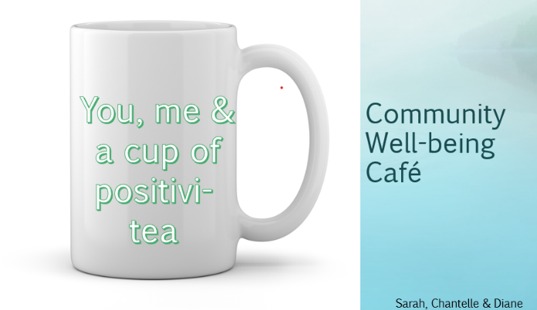
Slide 2 - 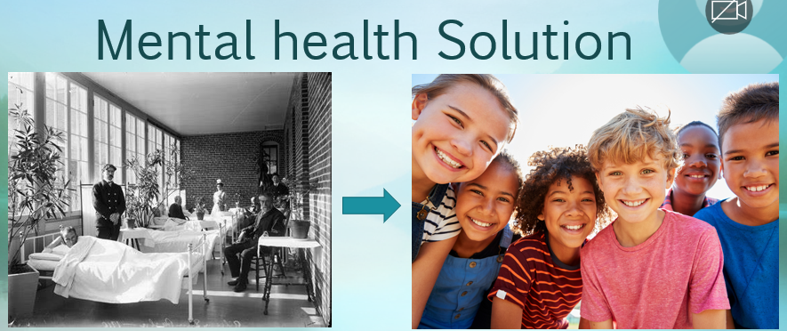
Hello, our mission is to get people talking! Globally there are still stigmas attached to talking, phrases like, man up or don’t cry is a past way of thinking. Today, talking is important for good mental well-being which enables us to cope with the daily pressures of life. Mental health problems can affect the way you think, feel and behave. They can affect anyone regardless of age, race, religion or income. We all have a responsibility to be active global citizens and can make a change for the better just by being given the space to be able to open up and this will empower our new generation to become happier humans!

Slide 3 - 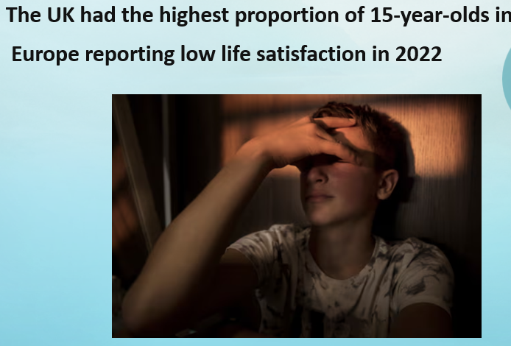
An international student assessment took place in 2022 and showed the UK had the highest proportion of low life satisfaction compared to Finland, Denmark, Romania, Portugal, Croatia and Hungary. Dutch teenagers are among the happiest teenagers in the world. Contributing factors for this are supportive parents, relaxed teaching styles, cycling to school and teachers who accept the feeling of all pupils and are willing to talk.

Slide 4 - 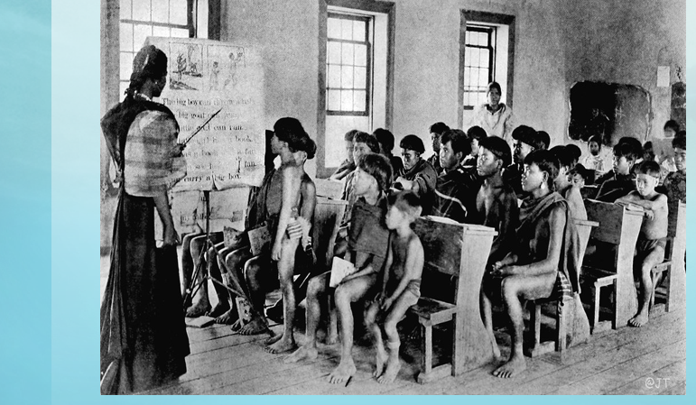
Past schooling however was completely different story. Skinner believed that we do have such a thing as a mind, but that it is simply more productive to study observable behaviour rather than internal mental events. He believed that as a positive reinforcements reward would be given, a negative reinforcement would result in an unpleasant consequence.

Slide 5 - 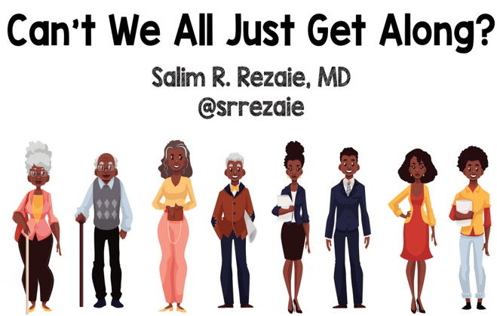
So, the question is why can't we just all get along? Intergenerational trauma both emotional and phycological if unresolved can be passed down from our ancestors, grandparents & parents can have old fashioned views & beliefs, the common negative emotions can cause guilt or shame with the family dynamic. Heightened stress responses can develop, fight, flight or fawn responses can manifest, and children would find it difficult to self-regulate their behaviours.

Slide 6 - 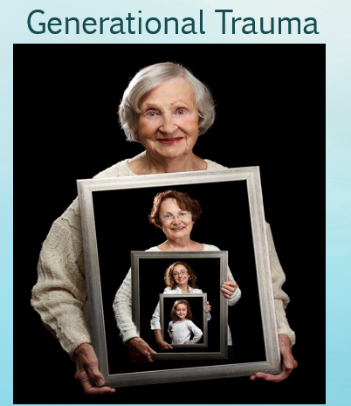
There are many examples of generational trauma, War, slavery, racism, abuse, violence, neglect, discrimination, parental loss, addiction and poverty. In the past talking about your feelings was looked down upon, the invisible inheritance influences our mental health, behaviours and physical
Well-being. Breaking the cycle with therapy available will help our future generations.
Slide 7- 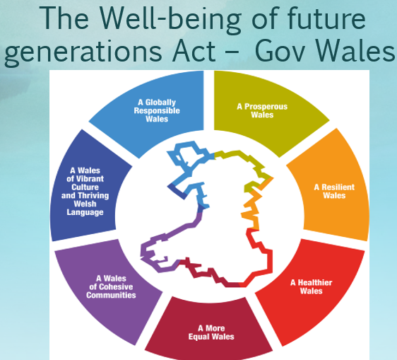
How can we overcome and what is to come for future generation? The wellbeing act for future generations was put in place in 2015, Cymru is the only country in the world with a future generation wellbeing act. Wales has several challenges to face now and in the future. The goal is to create a more prosperous, resilient, globally responsible Wales. Communities working together is essential for the wellbeing of our future generations.

Reference list
Alamy Limited (2025). Authentic Late 19th Century Vintage Milwaukee, Wisconsin Classroom Photograph: Diverse American Schoolchildren with Teacher, Historic Black and White Image of Early Education in the United States. [online] Alamy.com. Available at: https://www.alamy.com/authentic-late-19th-century-vintage-milwaukee-wisconsin-classroom-photograph-diverse-american-schoolchildren-with-teacher-historic-black-and-white-image-of-early-education-in-the-united-states-image516908288.html [Accessed 12 Apr. 2025].
Booth, R. (2024). ‘Happiness recession’: UK 15-year-olds at bottom of European satisfaction league. [online] the Guardian. Available at: https://www.theguardian.com/society/article/2024/aug/29/uk-teenagers-low-life-satisfaction-europe. [Accessed 12 Apr. 2025].
Godfer (2009). happy group kids, diversity. [online] Dreamstime. Available at: https://www.dreamstime.com/stock-photo-happy-group-kids-diversity-image12386690 [Accessed 12 Apr. 2025].
Gerome PhD, L. W (2025). Generational Shame and Other Secrets Passed on by Your Parents. [online] Psychology Today. Available at: https://www.psychologytoday.com/gb/blog/the-stories-we-tell/202501/generational-shame-and-other-secrets-passed-on-by-your-parents?msockid=1e5e7dd98b846fce0c5f692c8f846182 [Accessed 13 Apr. 2025].

McLeod, S. (2025a). Operant conditioning: What It is, How It works, and Examples. [online] Simply Psychology. Available at: https://www.simplypsychology.org/operant-conditioning.html. [Accessed 12 Apr. 2025].
McLeod, S. (2025b). Operant conditioning: What It is, How It works, and Examples. [online] Simply Psychology. Available at: https://www.simplypsychology.org/operant-conditioning.html. [Accessed 12 Apr. 2025].
McLeod, S. (2025b). Operant conditioning: What It is, How It works, and Examples. [online] Simply Psychology. Available at: https://www.simplypsychology.org/operant-conditioning.html. (Accessed 12th April 2025)
Meier, A. (2017). Studying the Design of a 19th-Century Mental Asylum. [online] Hyperallergic. Available at: https://hyperallergic.com/373920/architecture-of-an-asylum-building-museum/. [Accessed 12 Apr. 2025].
MIND (2019). Types of Mental Health Problems | Mind, the Mental Health Charity - Help for Mental Health Problems. [online] Mind.org.uk. Available at: https://www.mind.org.uk/information-support/types-of-mental-health-problems/. [Accessed 12 Apr. 2025].
Plantinga, K. (2024). 12 Examples & Scenarios of Generational Trauma. [online] Besttherapists.com. Available at: https://www.besttherapists.com/blog/generational-trauma-examples (accessed 13 Apr. 2025)
Rezaie, S. (2018). Can’t We All Just Get Along? A Generational Survival Guide - REBEL EM - Emergency Medicine Blog. [online] REBEL EM - Emergency Medicine Blog. Available at: https://rebelem.com/cant-we-all-just-get-along-a-generational-survival-guide/ [Accessed 12 Apr. 2025].
Rosetti, B. (2016). 81 Family Portraits That Will Touch Your Soul. [online] Pinterest. Available at: https://uk.pinterest.com/pin/608971180872413726/ [Accessed 12 Apr. 2025].
Welsh Government (2015). The Well-being of Future Generations. [online] GOV.WALES. Available at: https://www.gov.wales/well-being-of-future-generations-wales. [Accessed 12 Apr. 2025].
Welsh Government (2015b). Well-being of Future Generations (Wales) Act 2015: the essentials [HTML]. [online] GOV.WALES. Available at: https://www.gov.wales/well-being-future-generations-act-essentials-html.
Link below you-tube power point collaboration-
https://eur01.safelinks.protection.outlook.com/?url=https%3A%2F%2Fyoutu.be%2Fv9RZ23mgDPU&data=05%7C02%7C2409978%40student.uwtsd.ac.uk%7Cb8b3911d112f4634c7ef08dd7dbe1932%7C4e0f11f9046e45059cb8db2152311e21%7C0%7C0%7C638804977609653612%7CUnknown%7CTWFpbGZsb3d8eyJFbXB0eU1hcGkiOnRydWUsIlYiOiIwLjAuMDAwMCIsIlAiOiJXaW4zMiIsIkFOIjoiTWFpbCIsIldUIjoyfQ%3D%3D%7C0%7C%7C%7C&sdata=rYShi17C60fZtX5cnbl5xs3eqUSTW%2BaX39qoUL%2B2Mkw%3D&reserved=0

