BSC Applied Computing
Lecturer: Koushik Modak

Module Name: Usability Engineering
Module Code: ACCb6017

Lecturer: Koushik Modak
Trinity saint david University of Wales (London Campus)

USER INTERFACE AND PROTOTYPE

UNIVERSITY OF WALES TRINITY SAINT DAVID

Adelso Nataniel Fortes Oliveira Mendes (2226349)

Table of Contents
Abstract 2
Introduction 3
User Interface and Persona Designe 4
1. Method for User Research 4
2. Creating a Persona 4
3. Ideas and Effects on Design 6
Making things easy to use and developing storyboards 6
A. Designing for Usability 6
a. Seeing and Layout 6
b. Cognitive Load and Attention 6
c. Accessibility and Inclusion 7
d. Getting emotionally involved 7
B. Storyboard Development 7
Usability Evaluation of Storyboards 8
Feedback Collection and Usability Testing Results 9
1. A look at the evaluation method 9
2. How to Get Feedback 9
Observation Based on Tasks 9
Think-Aloud Protocol 9
Interviews after the session 9
Participant Coverage Across Personas 10
To achieve reliable and inclusive findings, each persona was represented: 10
Usability Findings 10
Constructive Feedback 10
Adverse Feedback 10
Insights into Emotional Responses 11
Analysis of Findings 11
Overview 12
Bibliography 13

Abstract
This report shows the first steps of the Usability Engineering process used to make a digital version of the famous board game Cluedo, which was rethought as the "UWTSD Murder Mystery." The project looks at the cognitive, perceptual, and social parts of how people and computers interact to make a mobile interface that is both useful and fun. The design process uses theories of perception, attention, and memory, and it includes user research through personas and scenarios that show the university's diverse community. We made wireframe storyboards and used feedback from possible users to find problems with usability that had to do with accessibility, navigation, and emotional involvement. The results show that user-centred design, visual hierarchy, and a continuous flow of interactions are all important for making the user experience better. The paper says that prototyping early on and getting feedback from users greatly improves how well design aspects fit with how people think and feel.

Introduction
Usability engineering aims to improve the interface between humans and computer systems via iterative design, evaluation, and testing. Norman (2019) asserts that effective design must acknowledge the constraints of human cognition and perception, tailoring systems to human requirements rather than compelling users to conform to technology [1]. This project employs these ideas to turn the board game Cluedo into a digital version that takes place on the campuses of the University of Wales Trinity Saint David (UWTSD). The goal is to investigate how interface design based on cognitive ergonomics can help make games easy to understand and accessible to a wide range of players.
The design approach focuses on the three main ways people sense things: sight, hearing, and touch. This is what the "Human I" usability lecture talked about. It makes sure that each part of the interface works with how people see, hear, and touch things. Personas were made to show distinct types of users, such as students with impairments and international pupils, by showing their different cognitive and emotional needs. After that, wireframe prototypes were made to show how interactions would flow, and users were asked to test them to get their thoughts.
This project aims to create a mobile interface that balances cognitive load, sustains engagement, and guarantees inclusion by integrating theories from usability engineering with practical design techniques. This method not only meets the learning objectives of the assignment but also exemplifies widely recognised best practices in human-computer interaction research, where user-centred evaluation is crucial for effective interface design.

User Interface and Persona Designe

Method for User Research
User research is a key part of usability engineering, as it helps designers learn about the end users, their goals, and the problems they encounter. To guarantee that the UWTSD Cluedo game accurately reflects the university's varied community, a combination of research methodologies was employed. A survey was administered to a group of 20 students and staff members to gather more information about their gaming habits, accessibility preferences, and emotional involvement. This was supplemented by semi-structured interviews with six participants to obtain qualitative data on player interactions with mobile games and their expectations for usability and inclusion [2].
The study of replies showed that consumers liked easy navigation, clear feedback cues, and story components that were connected to places they knew from their time at university. Several participants stressed how important it is to have accessible features like large text alternatives and colour modes with a lot of contrast. These findings informed the creation of avatars that embody various segments of UWTSD’s community, including undergraduate students, older learners, and staff with accessibility requirements.
I used the MoSCoW prioritising method (Must, Should, Could, Won't) to sort the user and experience needs. Accessibility compliance, responsive mobile engagement, and logical information flow were all "must-have" needs. "Should-have" features included making people feel emotionally involved through visual and audio signals. "Could-have" aspects were optional, such as letting players change the look of their characters.

Creating a Persona
Personas were created to represent actual user categories based on study findings rather than speculative guesses. The UWTSD Cluedo game's interface design and story flow are based on the demographic, behavioural, and psychological characteristics of each persona.
Persona 1: Gabriel (Undergraduate Explorer)

- Age: 19
- Profile: Student in the first year of Creative Media at UWTSD Swansea
- Needs: Easy to use, with visual feedback and a fast-learning curve
- Scenario: Uses the game on his mobile phone during breaks and enjoys discovering clues linked to her campus building.
- UX Requirements: Clear visual icons, intuitive tutorials, minimal text load.
Persona 2: Raphael (The Academic IT Technician)

- Age: 45
- Profile: Senior lecturer interested in technology and history
- Needs: Structured information flow and logical progression
- Scenario: Plays during lunch to relax and appreciates references to real campus locations.
- UX Requirements: Balanced complexity, clear objectives, subtle audio prompts.
Persona 3: Elly (International Student)

- Age: 22
- Profile: Erasmus student from Portugal with intermediate English proficiency
- Needs: Multilingual support and simplified text
- Scenario: Plays to improve English vocabulary while exploring the game’s mystery.
- UX Requirements: Language options, visual storytelling, contextual tooltips.

Persona 4: Jhony (The Inclusive Gamer)

- Age: 28
- Profile: Postgraduate student with mild colour-blindness and limited hand dexterity
- Needs: Accessibility, adjustable controls, and colour-contrast modes
- Scenario: Engages through touch-friendly interfaces and prefers audio feedback to visual overload.
- UX Requirements: Voice navigation support, large buttons, customisable colour schemes.

Ideas and Effects on Design
The personas collectively represent users with diverse cognitive skills, sensory preferences, and cultural backgrounds. This aligns with the Human I lecture's statement: "It is easier to redesign an interface than to redesign a human". The results show that usability in this project goes beyond only technical functionality; it also must encourage emotional engagement and social inclusion.
Using these personas in the design process ensures that every choice about the interface, like where to put buttons, what sound to use for feedback, or what colour scheme to utilise, matches what real users want. These personas helped with the storyboard design by showing how cognitive load limits, reaction-time variances, and accessibility standards like WCAG 2.2 compliance work.

Making things easy to use and developing storyboards

Designing for Usability
The UWTSD Cluedo project's usability design is based on the main ideas of human-computer interaction: effectiveness, efficiency, and satisfaction [3]. The interface must not only work properly, but it must also fit with how people naturally perceive, process, and respond to sensory information. In the Human I lecture, we spoke about how vision, hearing, and touch are the keyways we take in information and how fingers, eyes, and voice are the main ways we send it out. So, every part of the interface was made to make it easier on the brain, speed up reaction time, and make things clearer.

  - Seeing and Layout
The visual hierarchy was built with clear typography, high-contrast elements, and icons that were easy to find. Rusu and Mocanu (2022) say that task performance and visual fatigue are greatly affected by how clear and consistent colours are [2]. Following Fitts's Law, which says that how fast you can interact with anything depends on its size and distance, the primary navigation buttons (including Start Game, Select Character, and View Map) were put at the bottom of the screen so that your thumb could easily reach them [4].

Cognitive Load and Attention
Human working memory is restricted, usually able to hold 5 to 9 pieces of information at a time. To accommodate this limitation, the design uses progressive disclosure, displaying information only when necessary. Menu selections and clue details appear progressively rather than simultaneously to prevent overwhelm. The introduction of visual signals, such as glowing icons or arrows, helps steer user attention without producing distraction.

Accessibility and Inclusion
Inclusive design concepts were employed to ensure accessibility for individuals with visual, motor, or linguistic impairments. This features voice narration, colour-blind options, and vibration cues that you can turn on or off. The system also complies with the Web Content Accessibility Guidelines (WCAG 2.2), which stipulate that interface elements should be flexible and easily visible. Designing with inclusivity in mind guarantees that all players, regardless of ability, can experience equal enjoyment and usability, reflecting the notion that “users share common abilities but are individuals with individual differences”.

Getting emotionally involved
The interface design extends beyond mere functionality; it also aims to emotionally engage users, a crucial aspect of the overall user experience. Studies indicate that emotionally engaging interfaces enhance user happiness and retention [5]. Adding minor sound effects and interactions that are based on the story makes the game more immersive, and letting players customise their avatars helps them feel like they belong in the game world.

Storyboard Development
Wireframe storyboards were made to visualise the essential interaction sequences of the game. These were developed using canvas and follow normal mobile resolution proportions. Each storyboard illustrates both interface layout and user flow, ensuring logical transitions and obvious feedback loops.
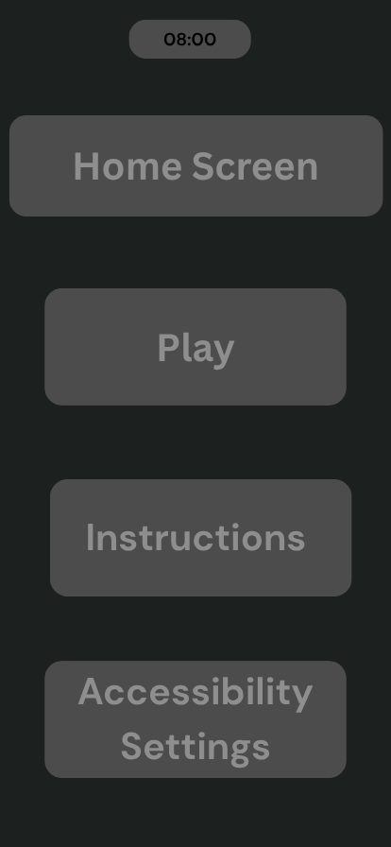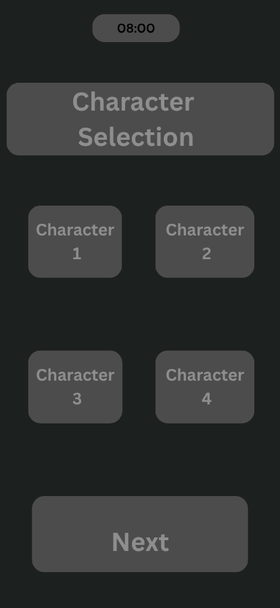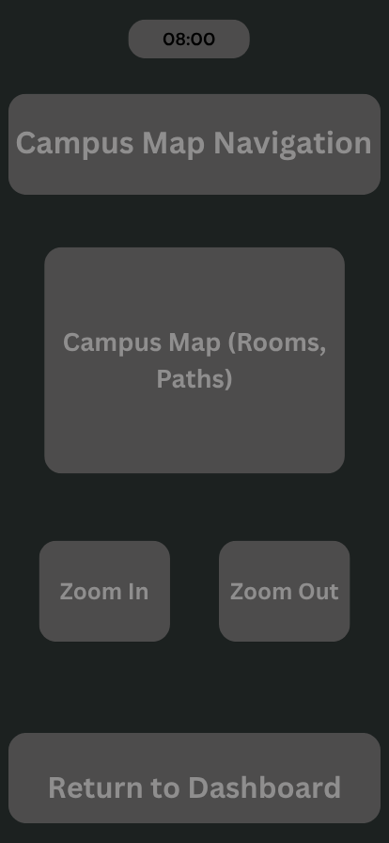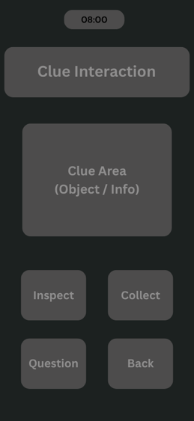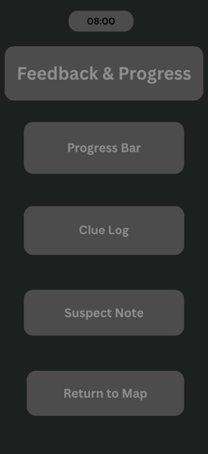
Storyboard 1: Home Screen Displays
The game title “UWTSD Murder Mystery” and options for Play, Instructions, and Accessibility Settings. The layout uses contrasting colours for legibility and a centred start button to draw visual attention.
Storyboard 2: Character Selection
Eight avatars represent different university roles (e.g., Lecturer, Librarian, Student Ambassador). Each avatar features a short bio, offering a glimpse into their personality and emotional connection. The design facilitates touch-based horizontal scrolling.
Storyboard 3: Campus Map Navigation
Players visit university buildings to gather clues. The map design follows real UWTSD landmarks and utilises visual scaling and shadows to simulate depth perception, enhancing realism through recognised visual cues of size and distance.

Storyboard 4: Clue Interaction Screen
Tactile icons represent possible actions (Inspect, Collect, Question). Visual feedback, such as button animation or sound effect, validates user contact. This stage uses colour-coded clues (green = safe, red = suspicious) to help players digest information naturally.
Storyboard 5: Feedback and Progress
A progress bar shows clue gathering, while accessibility indicators (sound toggle, zoom-in) appear consistently on all screens. Feedback messages are short, concise, and placed at the bottom of the interface to maintain visual flow.

Usability Evaluation of Storyboards
Preliminary usability testing includes five individuals representing the defined personas. Participants conducted tasks such as traversing the map and selecting hints. Observations and verbal instructions were recorded to assess intuitiveness and emotional response.
Key discoveries included:
- Users considered the layout intuitive and visually appealing.
- Accessibility elements, especially the colour-blind mode, received positive feedback.
- Some participants sought clearer instructions in the tutorial stage.
This input facilitates iterative refinement, as advised by Dix et al. (2022), who stressed that usability design is cyclical; each prototype informs subsequent progress [6].
The design and storyboard development of UWTSD Cluedo show how usability considerations may be used to make real interface choices. Through cognitive-informed design, accessibility adjustments, and emotional engagement tactics, the project offers an inclusive and efficient experience. The early-stage wireframes are the basis for more testing of colour, typeface, and interactions in the next step of the coursework.
Feedback Collection and Usability Testing Results
1. A look at the evaluation method
The evaluation phase was all about figuring out how well users engaged with the UWTSD Cluedo game's wireframe storyboards. Usability engineering stresses that testing should be done again to improve interface design and make sure it works with how people see and think [7]. To do this, feedback was gathered using task-based observation, think-aloud protocols, and brief post-test interviews. This combination gave us both behavioural and emotional information on how users felt about the encounter.
We made care to have people of all four identified personas so that there would be a range of ages, ways of thinking, accessibility needs, and language skills. Testing was done one-on-one, with mobile devices to mimic how people would use them in real life.

2. How to Get Feedback

Observation Based on Tasks
Participants were instructed to accomplish standard tasks such as:
    - Starting a new game
    - Selecting a character
    - Navigating the campus map
    - Inspecting an in-game clue
    - Viewing progress
The focus of the observation was on how well people navigated, how often they made mistakes, how long they hesitated, and how they interacted with each other.

Think-Aloud Protocol
Participants verbalised their thought processes while interacting with the wireframes. This strategy is particularly successful for spotting perplexity, cognitive overload, or imprecise visual clues, as verified by Nielsen and Molich’s heuristic evaluation methodology [7].

Interviews after the session
Short interviews (5 to 7 min) helped get people's emotional reactions, how easy they thought the product was to use, and ideas for how to make it better. These also made sure that individuals with visual or motor challenges were able to voice their accessibility concerns.

Participant Coverage Across Personas

To achieve reliable and inclusive findings, each persona was represented:
Persona | Represented By | Key Attributes Captured
Gabriel (Undergraduate Explorer) | 1 First-year undergraduate student | Efficient navigation, informal utilisation
Raphael (Academic Detective) | 1 Teacher | Logical progression and clarity of information
Elly (International Student) | 2 Students from Erasmos | Language acquisition, visual narrative
Jhony (Inclusive Gamer) | 1 Student with moderate colour vision deficiency | Accessibility and colour contrast

This distribution matches with suggested approaches for early-stage prototype testing, when 4 4 to 6 users often find many serious usability concerns.

Usability Findings

Constructive Feedback
Among the participants, multiple strengths were recognised:
    - Intuitive Layout: Users regarded the home screen and character selection screens as straightforward and visually well-organised.
    - Simplified Map Navigation: The map design, even in wireframe form, was characterised as "easy to comprehend" and "logically organised."
    - Accessibility Features Acknowledged: The colour-blind mode and enlarged button sizes were well received, corroborating evidence that inclusive design markedly enhances user satisfaction.
    - Emotional Engagement: Multiple users appreciated the narrative approach and expressed motivation to "identify the perpetrator," indicating effective emotional user experience design.
Adverse Feedback
Several usability concerns were likewise identified:
    - The tutorial was overly simplistic: Some users believed that the game required more comprehensive initial guidance to prevent perplexity during the initial engagement.
    - Limited Visibility of Feedback Messages: The positioning of pop-up notifications at the bottom of the screen resulted in some users overlooking essential information.
    - Ambiguity in Clue Icons: Several icons exhibited insufficient clarity in their affordances, underscoring the necessity for improved visual metaphors and descriptive labels.
    - Language Support: International participants requested the use of even simplified English phrases or optional icons to facilitate understanding.

Insights into Emotional Responses
Participants exhibited a combination of inquiry, engagement, and slight tension, appropriate for a mystery-themed game. Nevertheless, one participant remarked experiencing a "slight sense of being overwhelmed" when an excessive number of map elements were presented simultaneously, thereby emphasising the importance of managing cognitive load through progressive disclosure, as advocated by cognitive ergonomics research.

Analysis of Findings
The feedback was closely aligned with usability engineering expectations for initial prototypes. Areas identified for development are primarily concerned with clarity, onboarding processes, and the enhancement of visual affordances, common challenges encountered during the wireframing phase. The significant positive engagement concerning accessibility, navigation, and storyline indicates that the conceptual framework of the interface is solid.
Unanticipated feedback primarily concerns the intelligibility of the tutorial and the positioning of feedback components. These findings will be incorporated into the subsequent design phase, guaranteeing that the final interface provides an accessible, cognitively efficient, and emotionally engaging experience.

Overview
The feedback collection procedure confirmed the accuracy of the personas, the usability objectives, and the preliminary storyboard designs. By integrating diverse user perspectives and adhering to established usability assessment methodologies, the project demonstrated that user-centred design substantially improves interface quality. The insights obtained will directly inform the enhanced design in Coursework 2.
This project employed usability engineering approaches to construct the conceptual design of the UWTSD Cluedo game, ensuring that the interface adheres to human cognitive and perceptual capacities. User research and personas anchored the design in authentic demands, while wireframe storyboards transformed these requirements into usable interaction procedures. Preliminary usability testing suggested that consumers received the concept as intuitive and approachable, while also indicating areas for refinement, including more explicit teachings and enhanced iconography. This phase created a sturdy user-centred foundation for subsequent development, proving that effective design develops from iterative testing, consideration of human limitations, and attention to inclusive interaction.

Bibliography

[1] | D. Norman, The Design of Everyday Things, New: Nguyen.
[2] | D. A. Norman, The Design of Everyday Things, New York: Basic Books, 2019.
[3] | J. N. a. R. Molich, “Heuristic evaluation of user interfaces,” Commun. ACM, vol. 63, no. 2, pp. 30-39, 2020.
[4] | J. F. G. A. a. R. B. A. Dix, “Human-Computer Interaction,” 5th ed. Harlow, UK, 2020.
[5] | M. Hassenzahl, “Understanding the relationship between user and product,” Int. J. Design, vol. 13, no. 3, pp. 91-102, 2019.
[6] | J. F. G. A. a. R. B. A. Dix, “Human–Computer Interaction,” 5th ed. Harlow, 2022.
[7] | J. N. a. R. Molich, “Heuristic evaluation of user interfaces,” Commun. ACM, vol. 63, no. 2, pp. 30-39, 2020.

