Introduction

For the purpose of this report, will be looking at Newcastle Emlyn, a small Welsh town with a population of 1,914 (City Population, 2020). This report will be broken into to part with the first part focusing on the historical developments, the towns fortunes and its existing assets will be explored in more detail before addressing the town key Stakeholders and existing local development strategies. The second part will look at what can be done in the future to help regenerate this local area in a more sustainable way.
According to (Scottish Government, 2011) regeneration is “a complex concept that deals with many interrelated and multidimensional issues and challenges that are not easily solved”, this is very true for many Welsh towns that boomed during the industrial revolution.

Historical Development

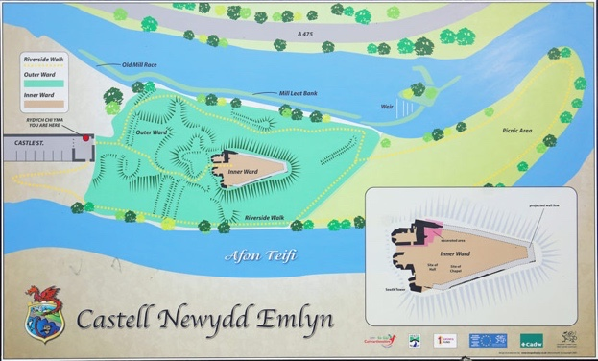
Newcastle Emlyn was made part of the Norman March in the 12th century and grew up around a natural crossing point in the river Teifi (Visit Newcastle Emlyn, n.d.), the town has a stone built castle that was destroyed in 1645 during the English civil war. Construction of the castle started around 1307 and wasn’t completed until 1349 (Visit Newcastle Emlyn, n.d.) as shown in the diagram from (Visit Newcastle Emlyn, n.d.) the castle is located on a meander of the river Teifi. By 1500 the castle had become more of about comfort than defence due mostly to its picturesque location (Newcastle Emlyn Town Council, n.d.). Following the English civil war in 1644, the castle was ‘blown up’ so that it could no longer be held against Royalists (Ross, n.d.).

According to (Visit Newcastle Emlyn, n.d.) by the 18th and 19th due to its river crossing Newcastle Emlyn evolved into a market and drovers town becoming an important stop on the route between West Wales and the English markets.

Existing assets, Structures and Economic Character

Newcastle Emlyn’s current economical structure is made up of a large Dairy company a few industrial areas and some private businesses (Carmarthenshire County Council, 2021). Over the past 10 years the population of Newcastle Emlyn has become older with only 25% of the local population in full time with, this figures is much lower than the average for Carmarthenshire (Carmarthenshire County Council, 2021). The market is still a very important aspect of the town with 11% of the local population working in the agriculture industry (Carmarthenshire County Council, 2021).
As part of this report some field work was carried out in Newcastle Emlyn, a survey (See appendix 1) of a number of local residents was conducted to discuss their town, why were they in town today, what improvements could be made, how they feel about their town and what they feel could have a negative effect on the local area.
As I can be seen in the attached graph 83% of participants surveyed lived and work in Newcastle Emlyn with 17% traveling their on the day.
The majority of participants surveyed stated that they would like to see the shopping are ‘High street” tidied up with less empty shops, although some called for larger chain stores the common concensus was that moer independatnt local stores would be the preferred option. Another area that was mentioned on many occasions was the traffic, it was noted that the town being a through road this would be very difficult to improve upon.
As mentioned above Newcastle Emlyn has an aging population with the median age for the area being 44 compared to the Welsh average of 41 (LiveHere.co.uk, n.d.) this in turn mean that health wise Newcastle Emlyn has a higher than average rating with 8.44% of the population describing their health as either Bad or Very bad with the average for Wales being 7.63% (LiveHere.co.uk, n.d.).
Another knock on effect from an older population is home ownership, Newcastle Emlyn has 41.4% home ownership with the average for the whole of Wales being 35.4%. According to (Right Move, 2021) the average price of a home in the area is £201,750, a 28% increase on the year before, this shows the with house prices increasing the relative wealth of the area will also increase. This will become clearer with the publication of the 2021 census, most data used for this report references the 2011 census.

Key Stakeholders and Interest Group

Understanding the key stakeholders is very important when it comes to any form of change, it is important to know that a stakeholder is considered to be an individual, a group or an organisation that is affected by what you are doing (BBC.co.uk, n.d.).
Stakeholder theory was first introduced by Edward Freeman in 1984, where he described that to become successful it was important for businesses to make their customers, suppliers, employees, community, financiers, banks and others value their need as a business (Stakeholder Map, n.d.).
The Key stakeholders for Newcastle Emlyn are outlined in the table below, as you can see there are a number of Stakeholders to be considered.

Local Residents
Tourists
Local Workforce
Business Owners
Town Council
County Council
Local Media
National Media

Local/Regional Development Strategies

in 2021 Carmarthenshire launched its ‘Ten Towns Initiative’ to try and boost the economic recovery for ten towns within Carmarthenshire, Newcastle Emlyn was one of this towns. The aim of the plan is to support COVID-19 recovery, grow business, create smart digital towns, boost tourism and to increase the reuse of building and land with development opportunities (Carmarthenshire County Council, 2021).
The development plan set out for Newcastle Emlyn suggests that the main priority is to address the working areas to help sustain existing business and create more jobs (Carmarthenshire County Council, 2021) they also plan to look at the impact that traffic is having on the area and to try and create a safer environment for everybody. With the increasing house prices in the area it is also important to provide affordable housing for the next generation of home buyer (Carmarthenshire County Council, 2021).

Future Opportunities

There are many options available to a small town such as Newcastle Emlyn in regard to regeneration, however not everything is practical and there will be many barriers to overcome to achieve the desired outcome.
There have been a number of options explored, however the following have been considered and researched and it is felt they will be the most inclusive, they will help to support local business and will also help to make Newcastle Emlyn a place to visit for years to come. This report has focused on three areas of improvement with Short-Term, Medium-Term and Long-Term success in mind.

Long-Term – Eco Town

Create an Eco Town that will help to produce a more sustainable way of living for local people, will introduce renewable forms of energy, natural wildlife habitats and other Green Initiatives.

A striking example of an Eco town is Freiburg in Germany, a self-proclaimed “900 years young” town (Barber, 2020). Following the second World War Freiburg had to rebuild, however rather than the car centric urban developments of many other parts of Germany Freiburg looked to the future. Freiburg has a population of 220,000 and has been support Green Initiatives since the early 90’s when they built the world’s first energy-plus house (Barber, 2020).
Freiburg also has a booming tourist industry with thousands of Eco-Tourists visiting the area each year and have also introduced the concept of Sustainable Tourism (Bragantini, 2018). Eco Tourism and Sustainable Tourism are relatively new terms and are both defined as

“Eco Tourism is a type of tourism that is founded primarily on a specific interest in the natural history of a region” (Fennell, 2009)

“Sustainable Tourism is practices in and by the tourism industry. It is an aspiration to acknowledge all impacts of tourism, both positive and negative. It aims to minimize the negative impacts and maximize the positive ones” (GSTC, n.d.)

Closer to home the United Kingdom has already created zero-carbon communities in places such as BedZED in South London where in 2002 100 mixed use homes were created (Bioregional, n.d.). The main benefits of this project are that the homes are warmer, more comfortable and cheaper to run. According to (Bioregional, n.d.) the average saving from all the additional green features of the building and the onsite car club is £1,391 per year. Although BedZED was a revolutionary idea and has created a desire for zero-carbon living, (Jacobson, 2012) does suggest that although a success there are many lessons that can be learnt from the development, an example of this is that unless the residents are willing to change their lifestyle and use services such as the car club the “big carbon savings” are not being made.

Newcastle Emlyn is a community with a population of approximately 1% of that of Freiburg, however the idea of creating an Eco-town could still be applied, it would require the local community to understand that the project would be focusing on longer term goals, with climate change being such a large global issue it would be a fantastic opportunity for the people of Newcastle Emlyn to be able to focus on creating a lasting legacy for the area.
According to (SCW, n.d.) there is support available in Wales through the Sustainable Communities Wales programme, successful applicants would be entitled to support with energy analysis, feasibility studies and specialist support as well as interest free loans to be able to make improvements to their local community. In 2021 Carmarthenshire County Council also launched their own ‘Zero Carbon’ plan, with the aim to be completely carbon neutral by 2030 (Lewis, 2021).

In conclusion the movement towards creating an Eco Town in Newcastle Emlyn would be in line with the local authorities view and would help to have them onboard with any changes that might need to be made, this would be a large scale long-term project but if the local community was accepting of the concept it could create a fantastic opportunity for the local area to become a mecca for Eco tourism in West Wales.

Medium Term – Regeneration of the High-Street

Create an environment that is welcoming and attractive to shoppers, using the existing infrastructure, promoting the town Long-Term project of being an Eco-Town and welcoming independent retailers.

Upon visiting the high street in Newcastle Emlyn, it has a very dated and dilapidated feel about it, there were a number of empty shops with traffic being a big issue for the town. As the roads through the town are quite narrow in places and with parking being some distance from shops it was noted that a number of people would use Blue Badges to park outside of the shop they intended to visit. One way to manage this would be the pedestrianisation of the area, however due to this route being the only crossing point of the river this would not be feasible.

According to (Audit Wales, 2021) nowhere has seen as much change in the past 75 years as the Highstreet, another hammer blow to the local economy of Newcastle Emlyn has been the impact of COVID-19.

By the local authority and town council coming to an agreement with local property owners through the offer of grants it might be possible to negotiate a reduction on rent for existing and empty shop units, this would allow smaller independent local business the opportunity to stay open or become a bricks and mortar business. There are a number of larger shop units that empty on the local Highstreet, these could be an ideal location for a Pop-Up shop style unit where local business could use areas of the store to sell products without agreeing to a long-term lease. Post COVID-19 the home business has never been more popular with e-commerce solutions meaning that people have been able to start up businesses (Voidonicolas, 2021). According to (Voidonicolas, 2021) a pop-up shop would allow many of these local businesses to test the water before agreeing to a long term deal, this ideal would alleviate much of the financial risk of opening a shop.

In conclusion, by reducing rent and creating a local pop-up shop local independent business owner would be able to see how their business might work in a face to face environment. This would help to make the Highstreet a more visually appealing place to shop as well as attracting both local customers and tourists to spend more money in the area.

Short Term – Newcastle Emlyn Duathlon

Create a yearly event to be held in Newcastle Emlyn, promoting the local area, its scenery, its history and helping to improve the general health of the local area through sport.

A duathlon is a multisport event made up of two event, generally these are running and cycling. The competitor will be expected to complete a run, then a bike leg and finally finish with a second run (Levison, 2022). According to (Levison, 2022) there are four distances that a Duathlon covers, there are

- Sprint Distance – 5km run | 20km bike | 2.5km run
- Standard Distance – 10km run | 40km bike | 5km run
- Middle Distance – 10km run | 60km bike | 10km run
- Long Distance – 10km run | 150km bike | 30km run

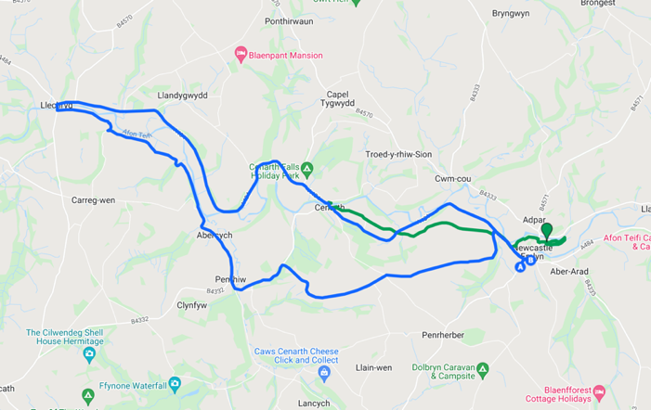
Generally, competitors would have a range of events available to them with Sprint and Standard distance being the most realistic for the Newcastle Emlyn area. The map attached shows both a proposed 10km Run Route (Green) and 24km Bike Route (Blue), the transition area could be located within the market car park allowing competitors space to be able to transition from each leg of the event (Discover Carmarthenshire, n.d.).
Sprint races would require a shorter run which would be located in the town and the bike route would require two loops should a competitor be completing a standard distance duathlon.

The benefit of a duathlon over a triathlon for this location is that without the swimming leg it makes the location ideal with its flat river basin for the run and the surrounding hills creating a more challenging environment for competitors. The average finish time for a duathlon is between 2 and 4 hours with the bike leg being completed on open roads. (Tisdall, 2016).
Duathlons generally take place at the start of the year as the waters are too cold for competitive swimming, this would fit in perfectly with Newcastle Emlyn and attract additional tourists to the area out of season, also with a strong bike leg many competitors will use the bike course for training legs and help Newcastle Emlyn to boost its popularity amongst the cycling community.

Carmarthenshire currently has one other Duathlon; this is the Wildflower duathlon which takes place on the second weekend in March. This event attracts up to 500 competitors and takes place in the ground of the National Botanic Garden of Wales (Tough Runner UK, n.d.). Another local event is the Mumbles Duathlon which takes place on the last weekend in March, this event attracts up to 600 athletes and countless spectators along the course (Active Wales, n.d.).

A huge drawback on this idea is the potential harm it could cause to the local environment, sadly multisport events tend to leave behind a large amount of rubbish. According to (Burgess, n.d.) in 2007 this was already being addressed by the Council for Responsible sport who suggested that to be awarded “Green status” each event would need to comply with a certain set of responsibilities such as Recycling, Composting of food waste, Reduction of water per participant, electric support vehicles and locally sourced food. This was further supported by (British Triathlon, 2021) who suggest that the health benefits of these events is well documented, however there is still much that could be done to benefit the environment.

In conclusion a multi-sport event in Newcastle Emlyn would help to bring people into the local area with much of the event marshalling being completed by local volunteers. To make this a truly sustainable and environmentally friendly event there would need to be strict rules in place to punish any competitors found to be disposing of plastic bottles around the course. This event would fit perfectly into an early March weekend, which would in turn help to give the local economy a boost following the post-Christmas period.

Conclusion

Newcastle Emlyn is an historic town with many picturesque views of winding meanders on the River Teifi, what started out as a market town frequented by drovers moving livestock from West Wales to England and coracle fisherman using the river to make a living has become run down and stagnant over the past few years.
Carmarthenshire County Council have created a plan to help rejuvenate the area through new affordable housing, better internet connectivity and better cycle routes in and around the town (Carmarthenshire County Council, 2021).
Further to the plan laid out by Carmarthenshire County Council this report has considered the possibility of creating an Eco-Town environment within Newcastle Emlyn, the rejuvenation of the tired Highstreet and the possibility of creating a sporting legacy with a annual Duathlon.
Each of these ideas would help to benefit the town, they would bring in additional tourism during the quieter winter months, they would support local businesses and entrepreneurs to help the local economy of Newcastle Emlyn to grow and flourish for many years to come.

