Introducing the Modern Workplace

Table of Contents
Introduction 3
Relation between people, culture, organizational performance, and structure 3
Nature of managerial work 4
Factors that affect individual behavior 5
Personal Factors: 6
Environmental factors: 6
Organizational factors: 6
Leadership and management style 7
Functions and responsibilities of line manager 9
Conclusions 9
Reference List 10

Introduction
Management and leadership styles help to make the behavior of the employees in any organization. The modern workplace demands various skills from the employees. In the competitive world, every organization wants its employees to have expertise in their work. To do that, the line manager in the organization plays an important role. Several leadership and management styles are discussed in Barclays Bank. Since Barclays Bank is a multinational organization, the employees of the organization require some sort of skills which can be achieved with the help of a line manager and with the help of proper management and leadership styles.

Relation between people, culture, organizational performance, and structure
For an effective organization, there should be a strong connection between the organization and the people involved in it, meaning employees. Along with this organizational culture and the performance of the organization also plays a crucial role in order to make an organization better.
Organizational culture helps the organization to change as per the requirement. The global world of the workplace is changing and as a result, businesses should have a culture that is flexible and can help to change as per the requirement (Alrowwad et al., 2017). Since Barclays Bank is in the field of banking processes and banking processes are updated frequently thus Barclays bank also has to maintain a culture that can help the bank to adopt the changes easily.
People in the organization are the main pillars of the organization for achieving the goals of the organization. To achieve the goals of the organization, individual skills and training are necessary to the employees. Thus, Barclay's bank hires those candidates which have some sort of skills for the work, and besides that, they also provide training to the employees in order to do the job.
Organizational structure helps to achieve the goals and it also supports the objectives of the organization. Organizational structure can be stronger by making specific rules and regulations for the organization (Felipe, Roldán and Leal-Rodríguez, 2017). In the case of Barclays bank, their structure is helpful to achieve the objectives of the business.
Along with all those factors, organizational performance is dependent. The better people of the organization, the culture of the organization, the better will be the organizational performance.

Nature of managerial work
The success of the organization depends on the manager of the organization. A manager in the organization has several roles to play. Those roles are discussed below:
Interpersonal roles: In the case of interpersonal roles, the main motive of this role is to provide information. In this process, there is a figurehead, liaison, and leader.
Figurehead: Figurehead is one who inspires the other employees and looks after them or her and motivates them to work hard (Foster et al., 2019). In every organization, the managers should be like figureheads so that employees follow and work more.
Leader: The leader is the one who manages the employees and manages the entire department's performance in the workplace. As a manager, one has to lead the team and take the responsibility for the groups' performance.
Liaison: In this role, one manager has to interact with external and internal sources of the organization in order to provide information to work efficiently for the organization.
Informational roles: In informational roles, the information is processed in order to achieve the objectives.
Monitor: In this role, managers have to regularly monitor or observe the work of the employees and the teams. In case of not being as productive as a team, managers can guide the team to achieve goals for the organization in an efficient way.
Disseminator: In this role, managers talk about the information with the team members and colleagues and consult with them to take their opinion.
Spokesperson: As a spokesperson, managers speak about the organization. The role of a spokesperson is to inform the people about the situation or the condition of the organization.
Decisional roles: In decisional roles, information is used. In decisional roles, there are entrepreneurs, resource allocators, negotiators, and disturbance handlers.
Entrepreneurs: In this role, managers work as entrepreneurs and help to solve several critical areas like - problem solving, generating new ideas for the organization.
Disturbance Handler: If there is any problem in the organization, then it is the managerial role to solve the problem as a disturbance handler and by solving the problems manager helps to work again efficiently (Mintzberg and Laasch, 2020).
Resource Allocator: In this role, the resources of the organization are used in the best possible way, where the resources should be used to get maximum output that decision is taken by the managers of the organization.
Negotiator: As a manager, negotiation is an important skill. This negotiation can be done among the teams, employees, and organizations as well.
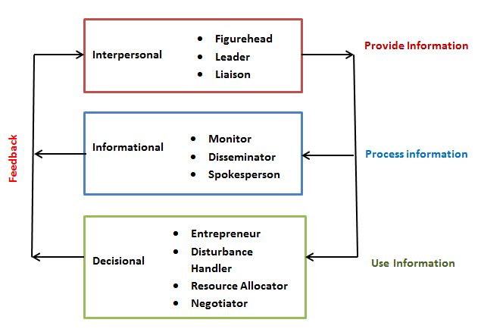
Figure 1: Mintzberg managerial roles
(Source: Mintzberg and Laasch, 2020)

Factors that affect individual behavior
The behavioral approach of the management works to build a good human relationship among the employees and the management of the organization. As a leader or in the leadership style, having a behavioral approach is essential as this helps the employees to give their best for their organizations. Along with the behavioral approach of management, the individual behavior of the employees also matters the most. There are few factors that can shape the behavior of individual employees. Those are:

Personal Factors:
Personal factors of the employees shape the behavior of the employees. Personal factors include personality, values, and perception of the employees.

Environmental factors:
Individual behavior also depends on the environment in which the employees are working. Various aspects of the organization help to shape the individual behavior of the employees, such as wage rate or salary. Individual behavior depends on the wage rates or the salary the employee is getting (Chatterjee, Pereira and Bates, 2018). Apart from that, the employment level of the employees is also an important aspect of the behavior of the employees.

Organizational factors:
Organizational factors also play a key role in order to affect individual behavior. The structure of the organization is one of the major organizational factors, if the organizational structure is good then it helps to motivate the employees and to their best. Along with that, if the organization has the reward or incentive systems for outstanding performance of the employees, then it motivates employees to do well in their workplace (Lisbona et al., 2018). Having a good organizational structure in Barclays Bank helps the employees to be motivated.
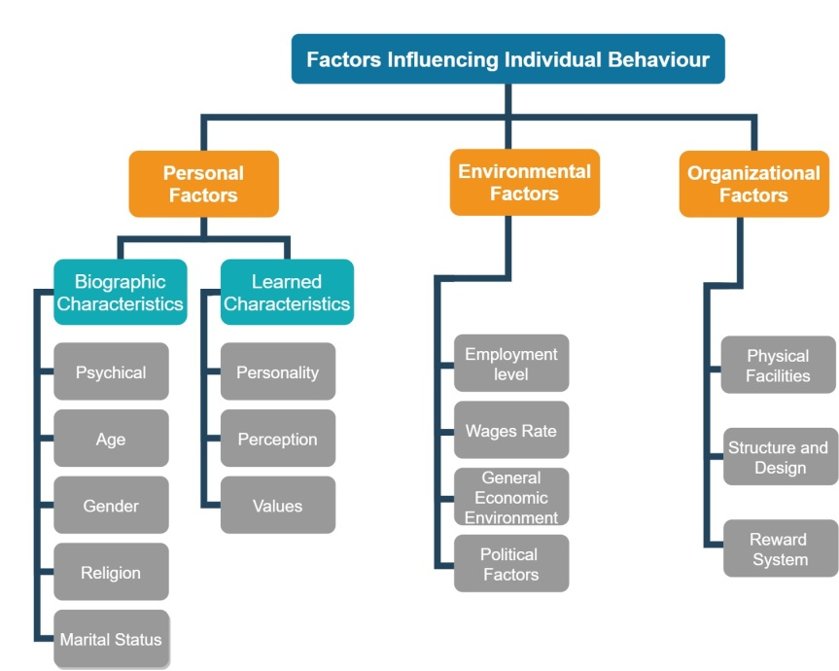
Figure 2: Factors influencing individual behavior
(Source: Chatterjee, Pereira and Bates, 2018)

Leadership and management style
There are several management and leadership styles that are required for the achievement of goals for the organization. Different organizations require different leadership and management styles. Those styles are:
1. Coach: This style of leadership is required mainly to motivate the employees of the organization. In the case of Barclays Bank, the employees are motivated organization to work enthusiastically and achieve the goals of the organization.
2. Visionary: Visionary leadership is that kind of leadership that focuses on the future achievements and targets for the organization and plans accordingly for the long run (Gallo Jr et al., 2019). In case of expansion of the business or the improvement of the operations in the banking system of Barclays bank, this leadership is implemented.
3. Servant: Servant leadership is a way of leadership in which the leaders also work as an employee for the growth of the organization.
4. Autocratic: This kind of leadership is result-oriented. The final result is only the most important in this form of leadership. Autocratic leadership depends on the authority or the kind of work the organization is doing on that.
5. Laissez-faire: In this kind of leadership, managers of the firm trust the employees and give them full permission to lead on their own. However, if they need help, then the leaders will definitely be there. This kind of leadership is also known as hands-off leadership (Alqatawenh, 2018). This leadership is a mix of autocratic and delegative leadership.
6. Democratic: this kind of leadership mainly focuses on innovation in the work or in the workplace. Along with this leadership is known for its supportive natures. This leadership supports the employees of the organization to work harder and to achieve the objectives of the organization.
7. Pacesetter: This form of leadership is helpful in order to achieve the speed of work for achieving goals. Pacesetter leadership is helpful to the employees and it also helps to motivate the employees for growth. If the workers are not so interested and unmotivated towards their work then this is the best way of leadership to motivate them.
8. Transformational: This form of leadership is probably the most challenging than others. This leadership form is based on communication. Employees of the organizations communicate and say their messages to their leaders in order to understand or realize the condition of the business and the wants of the business.
9. Transactional: In this form of leadership, the performance of the group or the individual is the utmost priority. The employees have to perform anyhow in order to achieve the goals of the organization. Most of the organization applies this form of leadership in order to achieve the goals of the organization easily.
10. Bureaucratic: This form of leadership is hierarchical and this leadership is mainly focused on the duty of the employees. Each employee is given a particular duty to perform and they have to do their parts efficiently, leaders are looking for that.
All the leadership forms are discussed. However, which type of leadership will be chosen depends on the organization and the goals or the objectives of the organizations and it also depends on the business on which they are in. Any business can choose multiple leadership styles at a single time to manage the employees of the organization. Barclays bank several of those leadership styles in the workplace depends on the time to time objectives of the organization.
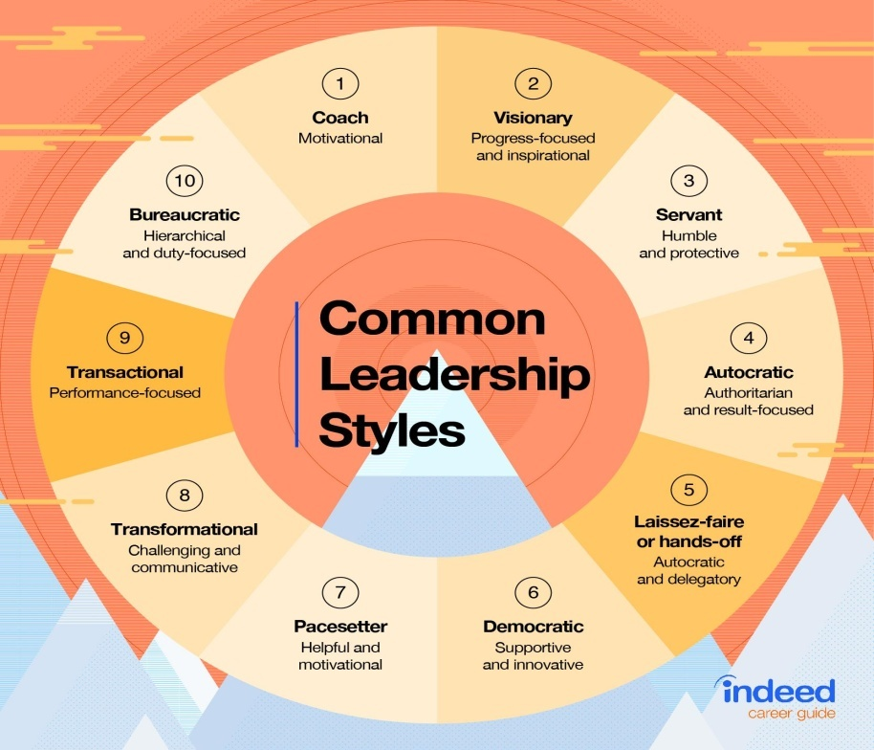
Figure 3: Leadership styles
(Source: Gallo Jr et al., 2019)

Functions and responsibilities of line manager
A line manager is a manager of the organization whose responsibility is to handle the employees and motivate them to do the best work for the organization (DiBenigno, 2020). Managing the employees for an organization is important. Thus, line managers are crucial for organizations. In the case of Barclays Bank, the line manager has to handle a wide range of employees and motivate them to achieve organizational goals. Functions of line manager are:
- Hiring and recruiting employees for the vacant positions in the organizations.
- Providing support to the employees and providing training to the employees who are new in the position and need training (Kehoe and Han, 2020).
- Measuring team progress along with the progress of the organization and if the progress is not happening as per the planning, then line managers can change the planning of doing work.
In Barclays bank, the line manager has an intensive role in the growth of the organization. The banking system is dependent to a large extent on the performance of the employees of the organization. To make better employees or hire efficient employees, the line manager helps Barclays Bank.

Conclusions
From the above discussion, the work process in the modern workplace is analyzed. In the case of Barclays bank, how the organization manages its work and culture along with the people of the organization in order to achieve the objectives of the organization is discussed. Several managerial functions along with the leadership functions are discussed and how those functions help the organization to achieve the objective is discussed. Through this report, one can get a proper idea regarding the organizational culture along with the several leadership and management styles and how those things are helping to achieve the competitive advantage in the workplace.

Reference List
Journals
Alqatawenh, A.S., 2018. Transformational leadership style and its relationship with change management. Verslas: teorija ir praktika, 19(1), pp.17-24.
Alrowwad, A.A., Obeidat, B.Y., Tarhini, A. and Aqqad, N., 2017. The impact of transformational leadership on organizational performance via the mediating role of corporate social responsibility: A structural equation modeling approach. International Business Research, 10(1), pp.199-221.
Chatterjee, A., Pereira, A. and Bates, R., 2018. Impact of individual perception of organizational culture on the learning transfer environment. International Journal of Training and Development, 22(1), pp.15-33.
DiBenigno, J., 2020. Rapid relationality: How peripheral experts build a foundation for influence with line managers. Administrative Science Quarterly, 65(1), pp.20-60.
Felipe, C.M., Roldán, J.L. and Leal-Rodríguez, A.L., 2017. Impact of organizational culture values on organizational agility. Sustainability, 9(12), p.2354.
Foster, W.M., Hassard, J.S., Morris, J. and Wolfram Cox, J., 2019. The changing nature of managerial work: The effects of corporate restructuring on management jobs and careers. Human Relations, 72(3), pp.473-504.
Gallo Jr, P., Čabinová, V., Onuferová, E., Gallo, P. and Gallo, J., 2019. The influence of leadership style on the work activity of employees in the selected financial institution. Calitatea, 20(170), pp.90-93.
Kehoe, R.R. and Han, J.H., 2020. An expanded conceptualization of line managers’ involvement in human resource management. Journal of Applied Psychology, 105(2), p.111.
Lisbona, A., Palaci, F., Salanova, M. and Frese, M., 2018. The effects of work engagement and self-efficacy on personal initiative and performance. Psicothema, 30(1), pp.89-96.
Mintzberg, H. and Laasch, O., 2020. Mintzberg on (ir) responsible management. In Research Handbook of Responsible Management. Edward Elgar Publishing.

